Appendix 1: Performance Data
Initial Baseline Appointment Data Sept 2022 –June 2025
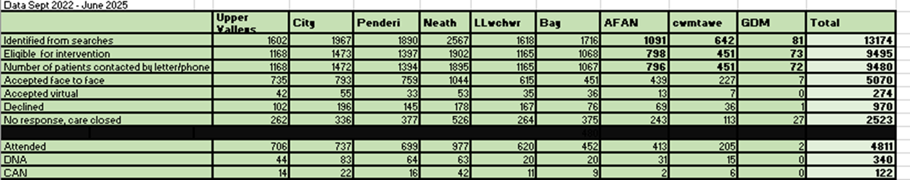

Follow Up Data of attendance -Sept 2023 – End of June 2025
