Meeting Date | 03 March 2026 |  | Agenda Item |  |  | 2.1
Name of Meeting | Population Health Committee
Report Title | The impact of maternal RSV vaccinations on infant respiratory hospitalisations and associated costs
Report Author | Sion Lingard, Consultant in Health Protection, SBUHB to introduce a presentation by Dr Simon Cottrell, Public Health Wales
Report Sponsor | Prof Gillian Richardson, Interim Executive Director of Public Health
Presented by | Dr Simon Cottrell, Public Health Wales
Freedom of Information | Open
Purpose of the Report | This report introduces a presentation to be provided to the committee by Public Health Wales on an evaluation of the impact of maternal RSV vaccinations on infant hospitalisations and associated costs.
Key Issues | This early evaluation provides a useful indication of the positive impact RSV vaccination of pregnant women can have on infant hospitalisation and other measures.  In children under 6 months of age, between the 2023/24 winter season and the 2024/25 winter season there was:  - A nearly 34% reduction in admissions  - An 18% reduction in direct NHS costs  The presentation highlights differences in the size of effect across the deprivation quintiles, however the significance of this may be discussed.  The uptake of RSV vaccination amongst pregnant women who gave birth in the Swansea Bay in the last 12 months ranges from 39.8% to 57.7%. Improved uptake will increase the benefits realised.
Specific Action Required  (please choose one only) | Information | Discussion |  | Assurance | Approval
Specific Action Required  (please choose one only) | ☐ | ☒ |  | ☐ | ☐
Recommendations | Members are asked to:  - RECEIVE the presentation for discussion. The study presents useful evidence of the effectiveness that the RSV vaccination programme and highlights the importance of maximising uptake to gain the greatest benefit possible.  - ACCEPT efforts by Swansea Bay University Health Board (SBUHB) through the activity of the Immunisation Team and primary care to improve uptake amongst eligible women.

THE IMPACT OF MATERNAL RSV VACCINATIONS ON INFANT RESPIRATORY HOSPITALISATIONS AND ASSOCIATED COSTS

- INTRODUCTION
The paper introduces a presentation that will be provided to the committee by Public Health Wales on the outputs from an early analysis of the impact of maternal Respiratory Syncytial Virus (RSV) vaccination on infant illness, admissions to hospital and other measures.

- BACKGROUND
The RSV vaccination programme was introduced in Wales in September 2024. There are two groups of people eligible for vaccination – older adults and pregnant women.

Pregnant women are offered the vaccine to offer protection to their unborn child. In most cases RSV infection will resolve on its own, with the person suffering from cold like symptoms. The focus of this paper in the maternal vaccination programme, so in young children – especially those under 6 months of age – RSV infection may result in shortness of breath, high temperature, difficulty feeding and a cough. The severity of symptoms may result in the child being admitted to hospital.

The presentation to be provided to the committee will outline the results from an early study in Wales on the effectiveness of the vaccination programme using several indicators.

- GOVERNANCE AND RISK ISSUES
The presentation clearly sets out benefits for the population (a reduction in serious illness) and for the health system (reduced infant admissions for respiratory illness and reduced direct costs to the NHS).
In children under 6 months of age, between the 2023/24 winter season and the 2024/25 winter season there was:
- A nearly 34% reduction in admissions
- An 18% reduction in direct NHS costs
A key challenge for Swansea Bay is maximising the potential benefits for our population and services by improving uptake.

Table 1: Coverage of RSV vaccination for women giving birth in the past 12 months (01/01/2025 – 31/12/2025), by month of delivery and Health Board, Wales
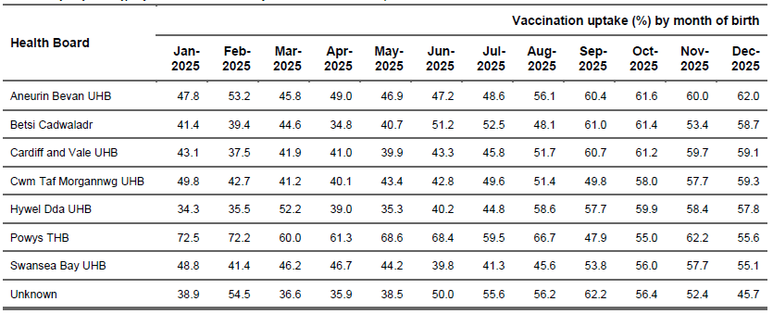
(Public Health Wales, 2026)

Table 1 shows that over the last 12 months SBUHB has reported a uptake of between 39.8% and 57.7% by month of birth, this puts us in the bottom half of performance amongst all Health Boards.

Currently Maternity Services are supported in offering the RSV vaccine to eligible women by SBUHB’s Immunisation Team. Staff are deployed to Antenatal Clinics to encourage uptake and administer the vaccine. RSV vaccination is also offered via the woman’s GP. Since April 2025, 488 doses have been provided by the Immunisation Team at Singleton Antenatal Clinic. 130 doses have been provided in Neath Port Talbot Antenatal Clinic.

As with other vaccines there are clear inequity implications due to a difference in update in different deprivation quintiles. The vaccination at antenatal clinics is of benefit at increasing uptake in deprived communities that may not access their GP.

Figure 1: Coverage of RSV vaccination for women giving birth 01/09/2025 to 31/12/2025, by deprivation quintile and month of delivery. Quintile 1 is most deprived, quintile 5 is least deprived
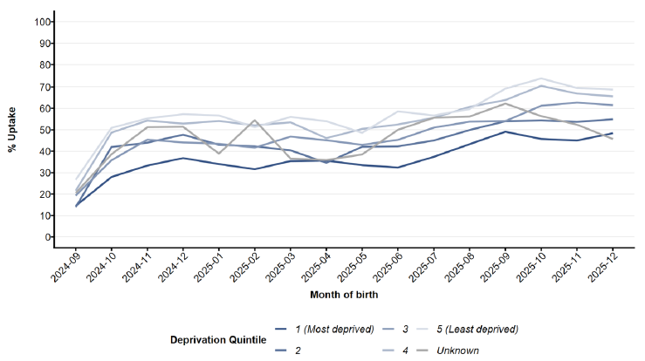
(Public Health Wales, 2026)

- FINANCIAL IMPLICATIONS
Improved uptake of RSV vaccination amongst eligible pregnant women has the potential to reduce the burden of illness amongst infants and reduce admission rates and direct NHS costs.

- RECOMMENDATION
embers are asked to:
- RECEIVE the presentation for discussion. The study presents useful evidence of the effectiveness that the RSV vaccination programme and highlights the importance of maximising uptake to gain the greatest benefit possible.
- ACCEPT efforts by Swansea Bay University Health Board (SBUHB) through the activity of the Immunisation Team and primary care to improve uptake amongst eligible women.

Governance and Assurance
Link to Enabling Objectives  (please choose) | Supporting better health and wellbeing by actively promoting and empowering people to live well in resilient communities
Link to Enabling Objectives  (please choose) | Partnerships for Improving Health and Wellbeing |  | ☒
Link to Enabling Objectives  (please choose) | Co-Production and Health Literacy |  | ☐
Link to Enabling Objectives  (please choose) | Digitally Enabled Health and Wellbeing |  | ☐
Link to Enabling Objectives  (please choose) | Deliver better care through excellent health and care services achieving the outcomes that matter most to people
Link to Enabling Objectives  (please choose) | Best Value Outcomes and High-Quality Care |  | ☒
Link to Enabling Objectives  (please choose) | Partnerships for Care |  | ☒
Link to Enabling Objectives  (please choose) | Excellent Staff |  | ☐
Link to Enabling Objectives  (please choose) | Digitally Enabled Care |  | ☐
Link to Enabling Objectives  (please choose) | Outstanding Research, Innovation, Education and Learning |  | ☐
Health and Care Standards
(please choose) | Staying Healthy |  | ☒
(please choose) | Safe Care |  | ☒
(please choose) | Effective Care |  | ☐
(please choose) | Dignified Care |  | ☐
(please choose) | Timely Care |  | ☐
(please choose) | Individual Care |  | ☐
(please choose) | Staff and Resources |  | ☐
Quality, Safety and Patient Experience
The presentation highlights the potential impact that the introduction of the RSV vaccination programme has had on NHS admission rates and illness, predominantly during the winter season. Additional benefits can be realised through improvements in vaccination uptake in the target groups.

Financial Implications
The presentation provides an estimate of the savings made by the NHS since the introduction of the RSV vaccination programme.

Legal Implications (including equality and diversity assessment)
Not applicable.

Staffing Implications
The presentation provides an estimate of productivity savings (for those that care for cases). It would be reasonable to assume that a proportion of these savings will relate to staff availability / carers leave associated with caring for those that are unwell due to RSV associated illness.
Long Term Implications (including the impact of the Well-being of Future Generations (Wales) Act 2015)
Recognising the benefits of vaccination and delivering adopted programmes directly supports the Well-being of Future Generations (Wales) Act 2015, specifically goals relating to a healthier and more equal Wales. As a sustainable programme the aim take account of the long term, are a key prevention (of illness) activity and involve taking a collaborative and integrated approach to maximising uptake and reducing inequity.

Report History |  | No report history.
Appendices |  | Appendix 1 - Public Health Wales presentation

