Meeting Date | 6 March 2025 |  | Agenda Item |  | 3.1
Name of Meeting | Population Health Committee
Report Title | Anchor Institution Baselining- Progress Update
Report Author | Marc Davies, Consultant in Public Health Medicine  James Rodaway, Associate Director Population Health Programme Development
Report Sponsor | Abi Harris, Chief Executive
Presented by | Marc Davies, Consultant in Public Health Medicine
Freedom of Information | Open
Purpose of the Report | This report updates on the progress made in support of baselining Swansea Bay University Health Board in pursuit of being a purposeful anchor institution, based on the phased approach and key deliverables outlined in the update provided to the Committee in September and December 2024.
Key Issues | - Progress is on track in line with key deliverables and timescales for this work outlined in the December update.  - Interviews with key stakeholders are complete, activities mapped against the working definition and emerging priorities for action identified. Case studies illustrating examples of current activity will be shared at the meeting.  - Risks to delivery are consistent with those identified in the December update.  - As part of the Regional Joint Committee between Hywel Dda and Swansea Bay University Health Boards there are ongoing discussions with Hywel Dda and Public Health Wales to link this work with developing priorities as a regional health economy.  - The 2025/26 technical planning guidance outlines a responsibility for NHS organisations to be exemplar anchor organisations. Utilising the benefits of anchor to mobilise and repurpose Health Board resources and position as an employer to build healthier communities and maximise long-term population health benefits.
Specific Action Required (please choose one only) | Information | Discussion |  | Assurance |  | Approval
Specific Action Required (please choose one only) | ☐ | ☒ |  | ☒ |  | ☒
Recommendations | Members are asked to:  - Receive the update on progress made in relation to anchor institution baselining  - Consider and approve the proposed priorities for action in order to progress the Health Board’s pursuit of being a purposeful anchor institution.

Becoming a Purposeful Anchor Institution – Progress Update

- INTRODUCTION
This report provides an update on the results of Phase 2 and Phase 3 of our work baselining Swansea Bay University Health Board as a purposeful anchor institution, as outlined in the phased approach provided to the Population Health and Partnerships Committee in September and December 2024.

- BACKGROUND
As part of SBUHB’s responsibilities as a population health organisation, acting as an effective anchor institution is a key component to support the medium to long-term recovery and sustainability of SBUHB and in delivering of our high-quality organisational vision and delivery of our strategic objectives.
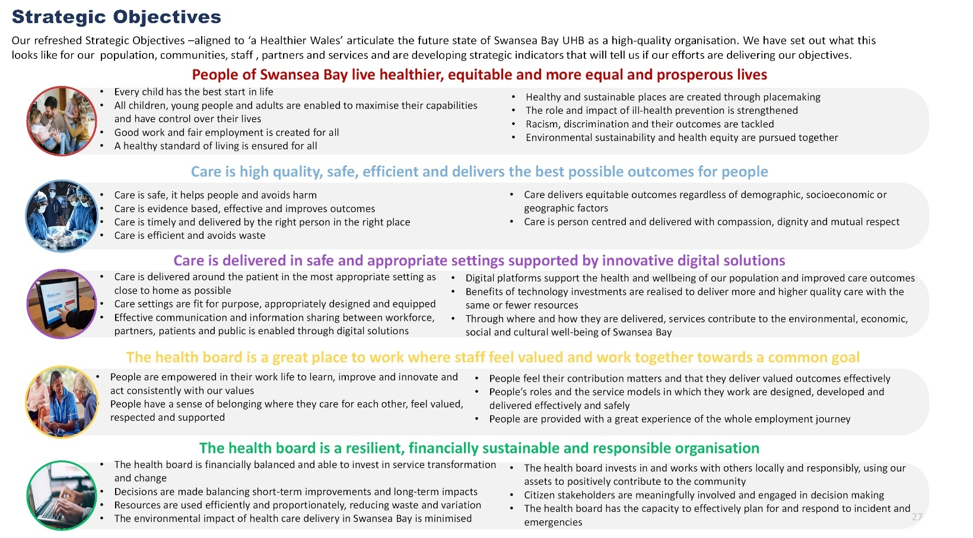In phase 1 a literature review was conducted and a working definition of an anchor institution within SBUHB developed. This was used as a framework to inform Phases 2 and 3.
“An anchor institution is a large place-based organisation that is closely connected to the local community.
By utilising its assets and everyday business operations (such as employment power, spending power and land assets) it aims to improve the physical, mental and social health and wellbeing of the local population, by impacting social determinants of health, reducing health inequalities and reducing the organisations environmental impact.”

Phase 2: Establish a baseline position for SBUHB and key partners (what is currently taking place)
Timescale for delivery: November 2024 - January 2025
Status: Completed
A further 11 interviews were conducted since the last update to take the total number of interviews to 21, with the majority consisting of internal colleagues at senior management level. Presentations were also delivered to five group meetings to update on progress and invite feedback.
Key themes emerging from this phase include:
Leadership and values- there was a consistent view around the significant assets that the Health Board possesses and the responsibility it holds to utilise these for maximum benefit for the population. It was recognised these assets could be used differently to how they are utilised now in order to maximise population health benefits but this requires a different mindset, culture and leadership to be able to make this change. Given the longer timescales and new ways of working required to deliver these changes, the Well-being of Future Generations Act was identified as a key enabler in driving the required leadership to support this work.
Governance and decision making- a range of existing activities were identified that could be categorised within the definition of ‘anchor.’ Activities centred around people and employment were best understood, followed by place. Current or potential activities around procurement and partnerships were less well understood by interviewees. Delivery is largely driven at the operational level and does not incorporate a concerted approach and commitment to delivering against the anchor and population health agendas. Areas of activity are often quite narrow in scope and do not consider the breadth of anchor roles and responsibilities. As a consequence these activities remained at a small scale and were not able to be developed at pace, with limited ability to drive impact on a larger scale. Despite this, a number of strategic levers were identified but greater join-up is required between the corporate strategy and delivery. Examples include the Population Health Strategy, NHS Performance Framework, People Strategy, Estates Strategy, and the Climate Action Plan.
Sharing learning within and across organisations- a small number of examples were identified where learning is shared across organisations, but there was a perceived lack of integration of this learning across these networks. Some interviewees felt that networks such as these had still not recovered since 2020. Strengths were identified from approaches outside the health sector, including the utilisation of the UK Shared Prosperity Fund and economic regeneration groups, but representation of the Health Board in these spaces is not fully optimised. There was limited appetite for a specific anchor network to be established but most were keen to ensure this work was embedded into existing networks.

Measurements- Working alongside the development of Health Board strategic indicators, 33 indicators were identified which would support measurement of anchor baselining. There were varying levels of familiarity and confidence across the system in measuring progress and impact on this agenda, with varying levels of detail and scrutiny of reporting on these activities.

Phase 3: Identification and agreement of priority areas in support of anchor mission
Timescale for delivery: March 2025
Status: In progress, on track
The 2025/26 NHS planning guidance places an explicit responsibility on health organisations to consider their role and status as anchor organisations to work in partnership to maximise benefits from procurement, estates and as employers to improve health and wellbeing of communities. The priority areas identified through this will continue to inform the development of the Health Board’s annual plan and ongoing expectations on delivery.
As part of the Regional Joint Committee between Hywel Dda and Swansea Bay University Health Boards, in February 2025 Swansea Bay initiated a discussion with Hywel Dda and Public Health Wales looking at agreeing regional priorities for addressing inequity driven healthcare demand and as a regional health economy. The role of both Health Boards as anchors featured prominently in these discussions and will be incorporated into the plan to undertake the baselining activity. This will include sharing intelligence across boundaries to understand and develop a regional approach in line with our ambition to develop an anchor system.
Emerging priority areas include:
People
  - Invest in workforce development to meet current and future population needs.
  - Develop a programme aimed at widening access to careers in health and care.
  - Increasing the number of apprenticeships across the breadth of health board activities.
  - Ensure anchor baselining is reflected in ongoing implementation of the Health Board’s People Strategy and Digital Strategy, understanding the required skills needed to deliver the ambitions within these strategies.
Place
  - Ensure anchor baselining is reflected in ongoing implementation of the Health Board’s Estates Strategy and Climate Action Plan, as well as future developments of the Clinical Services Plan.
  - Continuing to engage with local authority planning departments as part of the Local Development Plan (LDP) processes.

Procurement
  - Continued engagement in the NHS Foundational Economy Leadership Group to ensure shared learning across Wales is embedded locally.
  - Working with the Future Generations Commissioner’s Team to identify how prevention can be built into spending processes.
  - Continued review and monitoring of commissioning contracts to ensure the principles as part of becoming a purposeful anchor institution are embedded.
Partnerships
  - Health Board’s Annual Well-being of Future Generations Report to include a section on anchor baselining.
  - Ensuring anchor concepts and learning is an integral part of the developing programme of work around population health system indicators.
  - Progress partnership working around anchor baselining with the following:
    - Local authority and education, locally and through regional partnership board work.
    - Pan Cluster Planning Group (PCPG).
    - Public Service Boards, in particular through Regeneration Swansea and Neath Port Talbot’s Local Economic Partnership.
    - South West Wales Corporate Joint Committee, in particular a focus on regional transport plans, strategic development plans and regional economic development plans.
    - South West Wales Regional Learning and Skills Partnership.

- GOVERNANCE AND RISK ISSUES
In November 2024 work commenced to review the governance arrangements for population health. The role and function of the Population Health and Partnerships Committee may be subject to change. The specific requirements required to support this developmental agenda through our governance processes will require development in line with a revised Committee structure. What is known is that Swansea Bay will be required to report progress in line with the Welsh Government planning guidance.
Risks to delivery are consistent with those identified in the September update, with some reduction in risk through progress of this work. Ongoing focus of the Health Board on short-term changes and investments due to financial pressures without utilising the benefits of anchor to mobilise and repurpose Health Board resources, may impact on our ability as an anchor institution to maximise long-term population health benefits.

Fully understanding and progressing the role of Swansea Bay as an anchor organisation has the ability to drive a value driven approach across the Health Board and support the Recovery and Sustainability Programme.

- FINANCIAL IMPLICATIONS
£250k has been confirmed as being available for 2025/26 to support and enable the implementation of our population health ambition.
Given the targeted intervention/enhanced monitoring status of the Health Board during 2024/25 and the ongoing Recovery and Sustainability Programme, a decision was made to progress with baselining utilising existing internal resource, the caveats being that the inability to procure external expertise may impact baselining timescales. Given the ongoing developmental nature of this work the requirement to procure external support may need to be addressed during 2025/26 and agreed through existing approval mechanisms.

- RECOMMENDATION
Members are asked to:
- Receive the update on progress made in relation to anchor institution baselining
- Consider and approve the proposed priorities for action in order to progress the Health Board’s pursuit of being a purposeful anchor institution.

Governance and Assurance
Link to Enabling Objectives (please choose) | Supporting better health and wellbeing by actively promoting and empowering people to  live well in resilient communities
Link to Enabling Objectives (please choose) | Partnerships for Improving Health and Wellbeing |  | ☒
Link to Enabling Objectives (please choose) | Co-Production and Health Literacy |  | ☒
Link to Enabling Objectives (please choose) | Digitally Enabled Health and Wellbeing |  | ☒
Link to Enabling Objectives (please choose) | Deliver better care through excellent health and care services achieving the outcomes  that matter most to people
Link to Enabling Objectives (please choose) | Best Value Outcomes and High Quality Care |  | ☒
Link to Enabling Objectives (please choose) | Partnerships for Care |  | ☒
Link to Enabling Objectives (please choose) | Excellent Staff |  | ☐
Link to Enabling Objectives (please choose) | Digitally Enabled Care |  | ☒
Link to Enabling Objectives (please choose) | Outstanding Research, Innovation, Education and Learning |  | ☐
Health and Care Standards
(please choose) | Staying Healthy |  | ☒
(please choose) | Safe Care |  | ☐
(please choose) | Effective Care |  | ☒
(please choose) | Dignified Care |  | ☐
(please choose) | Timely Care |  | ☐
(please choose) | Individual Care |  | ☒
(please choose) | Staff and Resources |  | ☒
Quality, Safety and Patient Experience
Implementation of an effective whole of organisation population health approach will lead to a more consistent approach to prevention. The expectation is that opportunities for patients to be supported to make changes that will reduce their risk of ill-health and which will lead to improved well-being will be offered in a more systematic way across the sector.
Financial Implications
£250k has been confirmed as being available for 2025/26 to support and enable the implementation of our population health ambition. It also recognises the constraints of the current financial position of the health board.
Legal Implications (including equality and diversity assessment)
No legal implications identified. Enhancing our role as an anchor institution to address the wider determinants of health and invest in and reduce health inequity in our population supports fulfilling our legal duties under the Equality Act, Socioeconomic Duty and WBFG. The incorporation of population health approaches will allow for the identification of equality and diversity issues and development of appropriate responses.
Staffing Implications
The proposed programme will offer an opportunity to significantly increase the organisation’s capacity and capability to adopt different / new ways of working and thinking in order to implement the population health strategy aspirations through its anchor institution role/function. The Public Health Team remains small. Additional roles are being created and recruitment underway but progress remains slow. Development of the implementation plan will identify the skills and workforce requirements.
Long Term Implications (including the impact of the Well-being of Future Generations (Wales) Act 2015)
Population health approaches incorporate a prevention ethos and delivery is contingent on collaboration among
partners to deliver better outcomes for our population. A coproduction approach is integral to public health practice and seeks to involve communities and staff in designing services and programmes.
Report History |  | 17/12/23, 14/03/24, 06/06/24, 05/09/24, 3/12/24
Appendices |  | None.

