Meeting Date | 2026 | Agenda Item | 3.1
Name of Meeting | Population Health Committee
Report Title | Population Health and Primary care
Report Author | Sharon Miller, Associate Service Group Director
Report Sponsor | Executive Director of Public Health
Presented by | Sharon Miller, Associate Service Group Director
Freedom of Information | Open
FoI Closed detail | If closed, choose detail
Impact Assessment Summary Outcome |  | IA Completion date
Paper is for information and discussion. |  | Click or tap to enter a date.
Purpose of the Report | For Discussion
Report Summary; detailing any action required
Primary care plays a significant role in protecting the health of the Swansea Bay University Health Board (SBUHB) population. This report sets out some of the keyways in which primary care contributes to the prevention of ill health.
Key Issues
This report outlines the important role that primary care play in protecting the health and well-being of the SBUHB population.

This includes work undertaken in GP, dental, optometry and pharmacy practices and in local cluster collaboratives through multi-disciplinary arrangements.

Whilst it could be argued that every interaction is an opportunity to prevent ill health, the paper highlights those activities that are predominantly focused on prevention.
Decision / Action required | No
Recommendations
Members are asked to:
- RECIEVE the report and approve it for discussion at SBUHB.

Population Health and Primary Care

- INTRODUCTION
The report sets out the important contribution made by primary care in protecting population health and preventing ill health. The scope of this paper extends to the four primary care contractors and the local cluster collaboratives. There are many other services within the Primary, Community and Therapies service group that contribute significantly to the prevention of ill health, for example the All Wales pre - diabetes programme and the dental Designed to Smile programme. The committee have received previous reports on these services.

- BACKGROUND
The majority of patient contacts with the NHS take place in primary care.
In SBUHB there are over 2 million consultations with patients each year. This provides an excellent opportunity to prevent ill health, detect problems early and promote excellent health and well-being.

There are four main contractor services, General Medical Practitioners, Community Opticians, Community Pharmacies and General Dental Practitioners. For each of these services there is a national regulatory framework in place. For each contractor this paper will set out the keyways in which our primary care professionals contribute to the population health agenda. In addition, primary care professionals come together with colleagues in allied health professionals, nursing and the third sector to form multi-disciplinary local cluster collaboratives. The cluster work aimed at prevention will also be highlighted.

Primary care is uniquely placed to support population health; they often provide patients with care for many years and in the case of GP practices sometimes cradle to grave. The population / patients and their families are known to them and the GP record is the most complete record of patient care.

General Medical Services
There are 44 General Medical Services Practices in SBUHB – operating from 66 sites. In excess of 2 million consultations take place each year. Whilst the contract has a key focus on treating those who are ill or believe themselves to be ill and chronic condition management there is a section that focuses on lifestyle risk factor assessment and advice. Practices are expected to identify and address key lifestyle risks, including smoking and tobacco use, alcohol consumption, obesity and physical inactivity and diet and nutrition. This is often delivered opportunistically during routine consultations, health checks, and chronic disease reviews. In addition, there are a number of key prevention activities undertaken, these include:
- Provision of flu vaccinations to key target groups (2–3-year-olds/ under 65 at clinical risk/ over 65). Last year over 79,000 immunisations were given.
- Provision of a wide range of other immunisations such as COVID/ Shingles/ Hep A/B/ Pneumococcal/ Rota Virus/ Meningitis/ HPV/ MMR/ Pertussis. Last year over 29,000 immunisations were given.
- Childhood immunisations for children aged 2 and 5. A scheduled programme of vaccinations set out at a national level.
- Annual health checks for those with a learning disability.
- Cervical Screening - SBUHB has a rate of 66.6% coverage.
- Supplementary services with a key preventative focus such as the newly introduced service for people living with severe frailty in their own homes. 11 practices provided this service undertaking a total of 276 proactive comprehensive reviews.
- Quality Improvement Projects with a focus on case finding such as Cardiovascular disease and Chronic Kidney disease.

GMS practices also support several programmes by either signposting patients (for example to the national exercise referral scheme) or encouraging uptake of screening programmes.

Community Optometry
There are 32 community optician practices, and 7 domiciliary providers providing a range of services including sight tests, dispensing of glasses, emergency eye care and low vision services as-well as more advanced clinical pathways that traditionally would have been seen in hospital eye services.

Sight tests now have prevention and well-being included as part of a patient management plan. There were over 104,000 NHS sight tests paid for last year.
Optometrists play a key role in detecting conditions early and this includes systemic conditions such as hypertension, diabetes and neurological condition. Maintaining good vision also contributes to the prevention of falls and reduces accidents.

General Dental Services
There are 48 dental practices in SBUHB providing NHS dental care for our population. Dental teams have repeated contact with patients allowing reinforcement of healthy behaviours. The new contractual framework implemented from 1st April 2026 contains a 5% amount (£1.037 m) for prevention. This includes the following activities:

- Oral hygiene advice
- Dietary advice including the role of sugar in dental disease
- Application of fluoride varnish where clinically appropriate - last year 79.5% of patients received fluoride varnish
- Oral cancer awareness – including risk factors
- Smoking cessation advice
- Alcohol brief interventions
- Age specific advice including for infants/ adolescents/ pregnant women/ older adults

General Pharmaceutical Services
SBUHB has 90 community pharmacies, all ideally placed to give a wealth of health promoting information. Last year 11.6 million prescriptions were dispensed. In addition, a range of clinical services were provided as the role of the community pharmacist is expanded. Key prevention activities are listed below:
- Flu vaccinations - last year over 17,645 vaccinations were given
- COVID vaccine
- Smoking cessation services
- Blood borne virus screening
- Sexually Transmitted testing kits available at pharmacies

Local Cluster collaboratives

SBUHB has 8 local cluster collaboratives as set out in the map below:
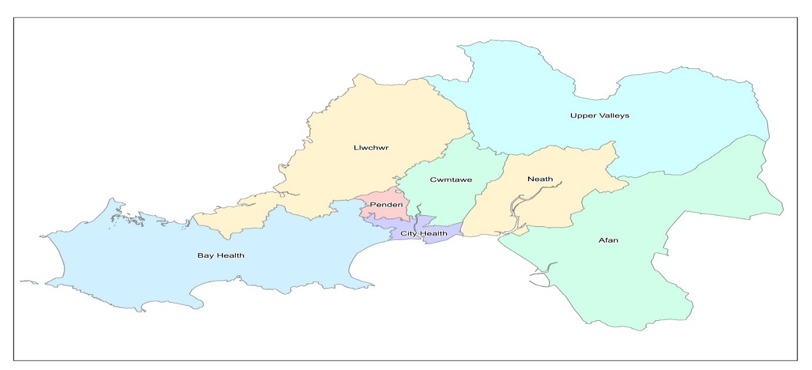
Clusters bring a range of partners together to look at ways in which their local population health can be improved.

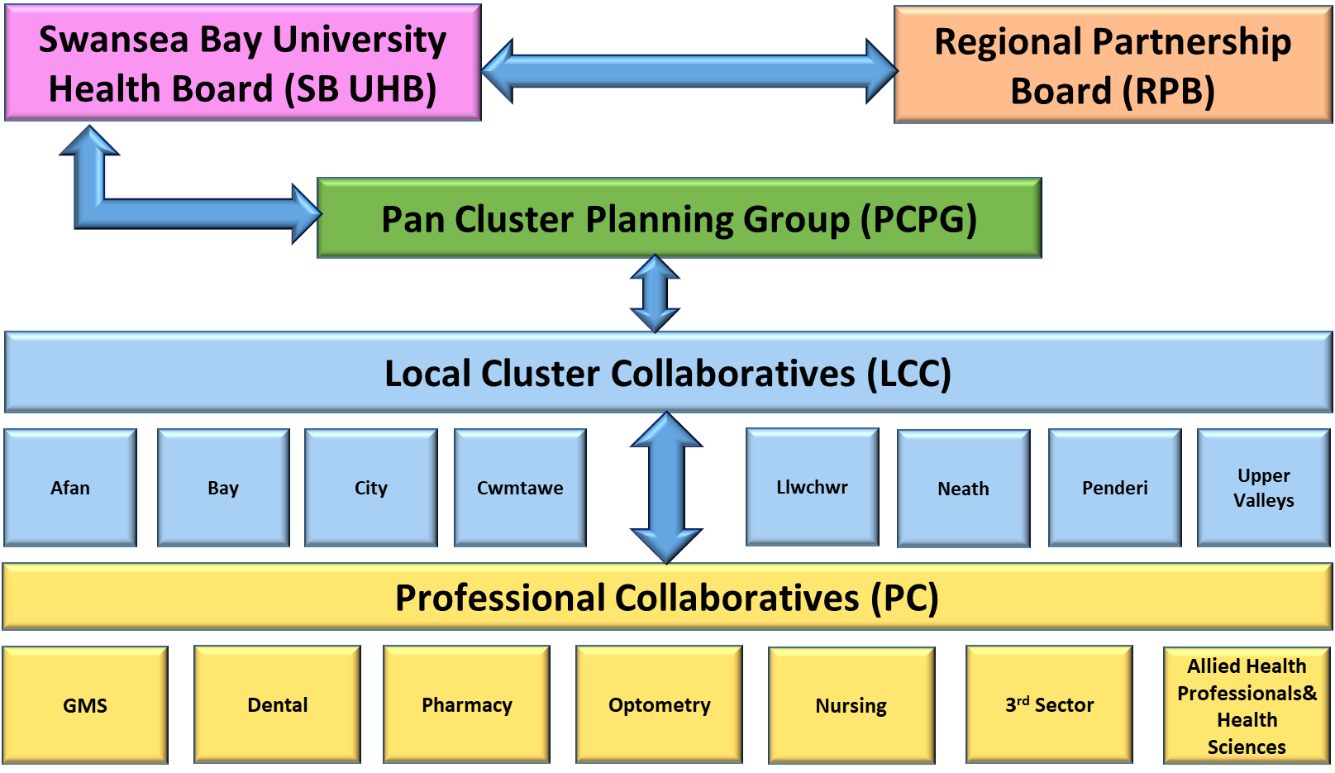

Welsh Government provide clusters with a budget to support the implementation of their plans. Each cluster develops an annual Integrated Medium-Term Plan (IMTP) as part of the Pan Cluster Plan. The cluster IMTPS all have the same themes, these are

- Planned care and cancer,
- Unscheduled care,
- Women children and perinatal,
- Mental health,
- Population health and prevention.

The prevention of ill health has always been a key priority for clusters in SBUHB. For example, since November 2023 clusters have delivered 18 well-being events engaging over 2,000 members of the public. Key projects that are planned for 26/27 are as follows:

- Increase awareness and uptake of health promotion programmes across the cluster, including screening, immunisations, Making Every Contact Count messaging, and lifestyle support.

- Winter Preparedness – Cluster Response and Resilience Planning: Each cluster will develop and implement an annual Winter Pressure Plan, incorporating flu and COVID-19 vaccination delivery.

- Improve early identification, signposting, and support for unpaid carers across Primary and Community Services within the cluster, ensuring carers are recognised, informed, and connected to local resources.

- Support a whole-system approach to healthy lifestyle improvement through the co-production and delivery of a Healthy Eating and Weight Management programme across the cluster.

- Continuation of Lifestyle Service supporting healthy behaviours, smoking cessation, and weight management through co-produced, community-based interventions.

- Continue to deliver Structured Diabetes Education including All Wales Diabetes Prevention Programme (AWDPP) to increase patient understanding and engagement in diabetes self-management. Encourage uptake of annual checks and promoting holistic lifestyle support through cross-collaborative pathways.

- Wellbeing hubs and Lifestyle events.

- Improve early identification and prevention of osteoporosis through integration within the Lifestyle Service and targeted awareness initiatives.

- Promote Women’s Health – Scope and develop a range of support to women encompassing menstrual health, menopause, contraception, incontinence, maternity and endometriosis support.

- Explore opportunity to extend a Social Prescriber service for Children Young People.

- Reduce cardiovascular morbidity and mortality by improving early identification, assessment, management, and signposting of patients at risk.

- Continuing to develop the community psychology project now running in 5 clusters where a psychologist works with the community to understand the needs and issues and design interventions that can address those needs.

General

It should be noted that as-well as specific projects and initiatives, due to the volume of primary care attendances practices and clusters are well placed to provide a variety of health promoting behaviour and to raise awareness of other services in the public or private sector that can support the population is staying well.

The primary care and cluster development team work closely with the communications department to promote and celebrate prevention activities that take place in cluster/primary care. Examples of previous initiatives are included in Appendix 1.

- GOVERNANCE AND RISK ISSUES
The national regulatory framework provides the governance for the provision of primary care services. Whilst many activities have a prevention focus primary care colleagues have considerable demands on them to treat ill health or manage long term conditions which are increasing. These increasing demands along with expansion of clinical roles for community optometry and community pharmacy, including the ability to prescribe independently for a range of conditions may cause a risk to the ability to maximise prevention activities.

- OPEN AUDIT RECOMMENDATIONS
There are none.

- FINANCIAL IMPLICATIONS
Primary Care Contracts are supported by Welsh Government allocation under national regulatory frameworks. SBUHB spends 131 million on primary care contractor services. This amount covers the treatment of ill health and chronic conditions management as-well as the preventative elements. Local Cluster Collaboratives also receive an amount of 2.5 million to spend on their projects from Welsh Government (via SBUHB).

- RECOMMENDATION
The population health committee is asked to receive the report setting out the role of primary care and local clusters in the prevention of ill health.

Governance and Assurance
Strategic Objectives
Strategic Objectives  (please choose which is impacted) | People of Swansea Bay live healthier, fairer and more prosperous lives | ☒
Strategic Objectives  (please choose which is impacted) | Care is high quality, safe, efficient and delivers the best possible outcomes for people in partnerships | ☒
Strategic Objectives  (please choose which is impacted) | Care is delivered in partnership with our communities in safe and appropriate setting, supported by innovation | ☒
Strategic Objectives  (please choose which is impacted) | The health board is a great place to work where staff feel valued and work together towards a common goal | ☐
Strategic Objectives  (please choose which is impacted) | The health board is a resilient, sustainable and responsible organisation | ☐
Health and Care Standards
Standards (please choose which applies) | Safe Care | ☐
Standards (please choose which applies) | Timely Care | ☐
Standards (please choose which applies) | Effective Care | ☐
Standards (please choose which applies) | Efficient Care | ☐
Standards (please choose which applies) | Equitable care | ☐
Standards (please choose which applies) | Person-centred Care | ☐
Standards (please choose which applies) | Staff and Resources | ☐
Enablers (please choose which applies) | Whole Systems Approach | ☒
Enablers (please choose which applies) | Leadership | ☒
Enablers (please choose which applies) | Workforce | ☐
Enablers (please choose which applies) | Culture | ☒
Enablers (please choose which applies) | Information | ☐
Enablers (please choose which applies) | Learning, Improvement and Research | ☐
Quality, Safety and Patient Experience
Primary care plays a significant role in the prevention of ill health for the population of SBUHB. This aims to ensure the population have a longer healthier life.
Financial Implications
Primary Care Contracts are supported by Welsh Government allocation under national regulatory frameworks. SBUHB spends approximately 131 million on primary care contractor services. This amount covers the treatment of ill health and chronic conditions management as-well as the preventative elements. Local Cluster Collaboratives also receive an amount of 2.5 million to spend on their projects from Welsh Government (via SBUHB).
Legal Implications (including equality and diversity assessment)
The prevention of ill health is sometimes explicitly set out in national contractual arrangements and may be reimbursed separately.
Staffing Implications
Primary Care colleagues are taking on expanding roles with a number of services having moved to the community from a traditional hospital setting. As a consequence, there is a need to support development and training including accredited training where needed. The national strategic workforce for primary care recognises the need to invest in and develop the workforce to meet future demands. The primary care academy has carried out training in Making Every Contact Count and Motivational Interviewing and intends to repeat this moving forward.
Long Term Implications (including the impact of the Well-being of Future Generations (Wales) Act 2015)
The work undertaken within primary care and clusters contributes to a number of the 5 ways of working. Prevention provides a long-term view, prevents problems from occurring or worsening, supports collaboration between sectors and colleagues to work for the common good of the population.
Report History
Not applicable.

Appendices
Appendix 1: Communication articles promoting health prevention within Swansea Bay University Health Board.

