Meeting Date | 02 June 2026 | Agenda Item | 2.4
Name of Meeting | Population Health Committee
Report Title | Population Health Strategy – Narrative Progress update following internal audit (update 2)
Report Author | Hugo van Woerden, Deputy Director of Public Health
Report Sponsor | Executive Director of Public Health
Presented by | Hugo van Woerden, Executive Director of Public Health
Freedom of Information | Open
FoI Closed detail | If closed, choose detail
Impact Assessment Summary Outcome |  | IA Completion date
N/A |  | Click or tap to enter a date.
Purpose of the Report | For Assurance
Report Summary; detailing any action required
This report provides a further narrative update to the Committee following the “Population Health Strategy – Narrative Progress Update following Internal Audit” considered by the Committee in March 2026.

It summarises key developments since that time and provides assurance on continued progress in embedding the Population Health Strategic Plan: A better future for all (2023) across the Health Board.

Key Issues
The Internal Auditors provided Limited Assurance in relation to the implementation of the Population Health Strategic Plan across the Health Board in November 2025.

The pace and sequencing of delivery continue to be influenced by capacity constraints within Public Health and the wider system, as well as ongoing organisational transformation. A work plan has been produced, which builds on the 2023 Strategic Plan.

Steps are being taken to arrange a population health session on a Board Development Day.

Key Points

- This report provides an update on progress against Internal Audit recommendations following Limited Assurance, evidencing movement from strategy narrative to delivery and assurance.
• Capacity constraints are recognised, as is dependency on wider organisational transformation. These are being mitigated through active governance and phased implementation.

Decision / Action required | No
Recommendations
Members are asked to:

- ACCEPT progress to date.

Population Health Strategy – Narrative Progress update following internal audit (update 2)

- INTRODUCTION

This report provides a further progress update on actions taken in response to the 2024/25 Internal Audit of the Population Health Strategic Plan: A better future for all (2023), which provided Limited Assurance. It summarises progress made to date in addressing the four audit recommendations and highlights factors influencing the pace of implementation.

The report outlines the steps being taken by the Public Health team to support the wider organisation in its responsibilities under the audit, strengthening the visibility and coherence of population health activity across the Health Board to improve health, reduce inequalities and embed prevention.

- BACKGROUND

The March 2026 update reported progress in response to the 2024/25 Internal Audit of the Strategy and the four recommendations:
- Limited strategic engagement at Executive Level
- Strategic context and system wide engagement
- Implementing planning and policy measures
- Governance Arrangements and identified gaps
Since that time, work has continued to move the Strategy from a primarily narrative framework towards a more explicit delivery and assurance model, whilst recognising the shared, system-wide ownership required for implementation.
Progress since the last update

2.1 Development of a clearer delivery framework
Further progress has been made in linking the Population Health Strategic Plan to operational planning and prioritisation. The Public Health Team Annual Plan and Work Programme for 2026–27 is underpinned by the Population Health Strategic Plan and provides a structured framework for progressing agreed priorities, including prevention and tackling health inequalities.
This represents a tangible step in developing a delivery plan for the Strategy, clarifying how strategic intent is translated into coordinated programmes of work, phasing, and prioritisation within available capacity, albeit solely from the Public Health team and not the wider organisation.
2.2 Strengthened implementation and assurance arrangements
The Population Health Committee continues to act as the primary assurance route for oversight of the Strategic Plan, providing regular visibility of progress and risks through the Committee’s cycle of business. Recent agenda planning and reporting arrangements reinforce this role, responding directly to Internal Audit feedback on the need for consistent reporting on implementation progress.
Population health priorities are reflected in the Board’s Annual Plan, recognising the need to be aligned to prevention and inequalities, supporting a more embedded and sustained approach to assurance.
2.3 Maturing use of population health intelligence to support delivery
The population health evidence base continues to mature and is increasingly integrated into strategic and planning processes. Population-level intelligence developed by the Public Health Team is now routinely referenced across published outputs, including the Director of Public Health Annual Report, Committee papers, State of the Population Report, and planning products.
2.4 Alignment of the 2023 Population Health Strategic Plan
These developments remain consistent with the intent of A Healthier Swansea Bay (2023), particularly:
• Embedding population health as a whole-organisation responsibility rather than a single-team function.
• Strengthening the Health Board’s role as an anchor institution and system partner.
• Maintaining a clear focus on prevention and health inequalities across the life course.

- GOVERNANCE AND RISK ISSUES

- Capacity within Public Health and across the wider system remains a critical consideration influencing pace and sequencing of delivery.

- Organisational transformation activity continues to shape elements of the delivery framework.
These risks are recognised and remain under active consideration through existing governance arrangements.

- OPEN AUDIT RECOMMENDATIONS

The open audit areas that require ongoing focus are:
- Strategic context and system wide engagement
- Implementing planning and policy measures
The organisation’s planned move towards six care groups will provide a structure where there is likely to be a more natural alignment to system wide integration of population health, based on planning and policy measures.

Figure 1 illustrates current intended routes of governance for the Board’s Annual Plan. These routes provide a mechanism of engagement with population level approaches across the organisation.

Figure 1: Annual Plan 2026/27 Monitoring and Reporting of Delivery
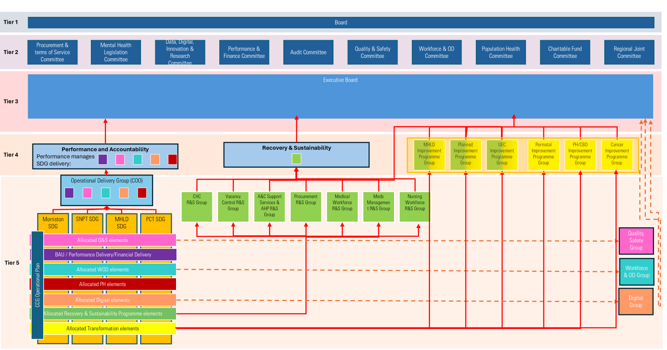

- FINANCIAL IMPLICATIONS

Not directly quantifiable.

- RECOMMENDATION

Members are asked to:
- ACCEPT progress to date.

Governance and Assurance
Strategic Objectives
Strategic Objectives  (please choose which is impacted) | People of Swansea Bay live healthier, fairer and more prosperous lives | ☒
Strategic Objectives  (please choose which is impacted) | Care is high quality, safe, efficient and delivers the best possible outcomes for people in partnerships | ☐
Strategic Objectives  (please choose which is impacted) | Care is delivered in partnership with our communities in safe and appropriate setting, supported by innovation | ☐
Strategic Objectives  (please choose which is impacted) | The health board is a great place to work where staff feel valued and work together towards a common goal | ☒
Strategic Objectives  (please choose which is impacted) | The health board is a resilient, sustainable and responsible organisation | ☒
Health and Care Standards
Standards (please choose which applies) | Safe Care | ☐
Standards (please choose which applies) | Timely Care | ☐
Standards (please choose which applies) | Effective Care | ☐
Standards (please choose which applies) | Efficient Care | ☐
Standards (please choose which applies) | Equitable care | ☐
Standards (please choose which applies) | Person-centred Care | ☐
Standards (please choose which applies) | Staff and Resources | ☐
Enablers (please choose which applies) | Whole Systems Approach | ☒
Enablers (please choose which applies) | Leadership | ☒
Enablers (please choose which applies) | Workforce | ☐
Enablers (please choose which applies) | Culture | ☒
Enablers (please choose which applies) | Information | ☐
Enablers (please choose which applies) | Learning, Improvement and Research | ☐
Quality, Safety and Patient Experience
There are no anticipated impacts on quality, safety or patient experience arising from this report.

Financial Implications
Not directly quantifiable.

Legal Implications (including equality and diversity assessment)
There are no legal, equality or diversity implications identified.

Staffing Implications
The staffing implications may require resolution.

Long Term Implications (including the impact of the Well-being of Future Generations (Wales) Act 2015)
The work supports long-term prevention and aligns with the Well-being of Future Generations (Wales) Act 2015.

Report History
Population Health Committee 3 March 2026: Population Health Strategy – Narrative Progress Update Following Internal Audit

Appendices
None

