Meeting Date | 5 June 2025 |  | Agenda Item |  |  | 4.2
Name of Meeting | Population Health Committee
Report Title | Influenza vaccination report 2024-25
Report Author | Cath Watts, Head of Immunisation; Gillian Jackson, Primary care manager
Report Sponsor | Gillian Richardson; Interim Director of Public Health
Presented by | Gillian Richardson; Interim Director of Public Health
Freedom of Information | Open
Purpose of the Report | To provide members the final position on Influenza vaccination uptake in 2024-25 and assurance on planning for the 2025-26 vaccination programme.
Key Issues | Uptake of the Influenza vaccination in SBUHB for 2024-25 was lower than the 2023/24 season:  - Over 65s cohort 68.5%; Below Welsh average of 70.3%. Ranked 6th out of 7 Health boards  - 6 months to 64 years at risk cohort 33.7%; Below Welsh average of 36.8%; SB UHB ranked 5th  - For the 2–3-year-old cohort 37%; below Welsh average of 43.6%. Ranked 7th  - For children in primary schools (aged 4-10 years) uptake is 51.1%, which is below the Welsh average of 61.6%. SB UHB are ranked 7^{th.}  - For children in secondary schools (aged 11-15 years) uptake is at 45.4%; below the Welsh average of 51.7%; SB UHB is ranked 6th.  Finalised commissioning arrangement are awaited, draft Primary Care Contracted Services: Immunisation Specification (PCCS:I) has been shared with health boards but awaits finalisation by Welsh Government, this will be a new approach to commissioning for both GMS and Community Pharmacy. Until this is received, along with the agreed planning framework commissioning and planning cannot proceed.  There will be centrally procured Influenza vaccination stock for the 2025/26 adult vaccination programme. Vaccine stock orders have already been placed for SB UHB in accordance with National guidance and overseen by a local Implementation group. The orders required further reductions, requested by the national team, i.e. not all requests were fulfilled in this order. However mechanisms will be in place to move stock if required, including allocation from Cefn Coed pharmacy and additional emergency orders. The Primary Care orders, if taken up fully with minimal wastage, would result in increased vaccine uptake.
Specific Action Required  (please choose one only) | Information | Discussion |  | Assurance | Approval
Specific Action Required  (please choose one only) | ☐ | ☐ |  | ☒ | ☐
Recommendations | Members are asked to:  - RECEIVE the uptake report on the 2024-25 Influenza vaccination campaign, which shows a reduction in uptake for 24/25.  - BE ASSURED that the SBUHB Winter Respiratory Vaccination Programme Planning Group (WRVPPG) will take forward the planning and actions to improve uptake for 25/26.  - BE ASSURED on the process taken for the order of central procurement of influenza vaccinations in 2025-26, which was undertaken in line with the national requirements.  - NOTE the financial cost if all vaccine ordered by the Health Board are administered.

Influenza vaccination campaign 2024/25

- INTRODUCTION

This paper presents the Swansea Bay University Health Board (SBUHB) final position on uptake of the Influenza Vaccination in Primary Care for 2024-25 in line with the national policy and guidance.
This paper also describes the 2025-26 planning process including the process followed to place the SBUHB Influenza Vaccination order for centrally procured stock to support the 2025-26 programme.

- BACKGROUND

In autumn 2022 the first Winter Respiratory Vaccination Programme (WRVP) for Wales was delivered by bringing together the COVID-19 and influenza vaccination programmes. This enabled health boards to coordinate the planning of both programmes and, where possible, to streamline delivery. To build on that success, in 2024/25 the National Influenza Immunisation Programme and the COVID-19 Vaccination Programme were again aligned to form a single Winter Respiratory Vaccination Programme. The programme is underpinned by the key principles:
- Protecting those at greatest risk
- Protecting children and young people
- Protecting frontline health and social care workers
- Protecting the NHS
2.1 Planning Guidance
The following national guidance was issued for the 2024/25 programme.
WHC 2023 047: Influenza vaccines and eligible cohorts for the 2024 to 2025 season | Guidance that set out the adult programme start date, eligible cohorts and reimbursable vaccines. The eligible cohorts for 2024-25 were:  - children aged two and three years on 31 August 2024  - school aged children from reception to year 11 (inclusive)  - people aged 6 months to 64 years in a clinical risk group  - people aged 65 years and older (age on 31 March 2025)  - all adult residents in Welsh prisons  - pregnant women  - carers of a person whose health or welfare may be at risk if the carer falls ill  - frontline health and care workers  - people experiencing homelessness  - household contacts of the immunocompromised  - poultry workers  This guidance clarified the Joint Committee for Vaccination and Immunisation (JCVI) advice to move a phased approach to the start of the programme, keeping the focus on the children’s programme from the start in September with the adult programme commencing October. It also recommended pregnant women should continue to be vaccinated in September, if delaying until October would mean they risk missing out on vaccination.  It detailed that, where a Primary Care contractor does not have confidence that it will be possible to vaccinate their entire eligible adult cohort between October and early  December, they should inform their Health Board. In this event, the health board  can agree for vaccination to begin in September, rather than risk failing to  complete the programme in a timely way.  It was hoped that this new approach would support effective planning for an improved uptake in 2024-25.
WHC 2024 028: National Influenza Vaccination Programme – 2024-25 | Detailed guidance clarifying the Programme ambitions, namely maximising uptake and ensuring equity in delivery. Also included an updated, detailed summary of eligible groups (Annex 1) and confirmed weekly surveillance data via Public Health Wales SharePoint site.
The Primary Medical Services (Influenza and Pneumococcal Immunisation Scheme) (Directed Supplementary Service) (Wales) Directions | Set out the requirements for the 2024-25 influenza and pneumococcal immunisation Programme, including robust call and recall systems. Makes clear the obligations important to local planning and delivery and remuneration for engaged GMS contractors. Came into force on 13th June 2024.
National Supplementary Service (NSS) specification for the childhood seasonal influenza vaccination programme | Set out the requirements for the vaccination of children aged two and three years as at 31st August 2024 as an Enhanced Service with which GP practices may choose to participate.
WHC 2024 033: The Winter Respiratory Vaccination Programme: Autumn-Winter 2024/25 | Set out the targets for the coming year and role of Influenza programme in the implementation of the WRVP for 2024-25 with coordinated planning across Influenza and COVID-19 delivery. Health Boards were required to response with plans identifying how the ambitions set out in this circular will be achieved. The SBUHB WRVP plan details achievement uptake plans and performance targets, including the undertaking of equality impact assessments, and this was shared with Vaccine Programme Wales.
WHC 2024 037: Winter Respiratory Framework 2024-2025 | Set out the public health context as we move into autumn and winter, highlighting priority areas of focus, setting out clear expectations of the health and social care system in responding to respiratory viruses and summarised modelling for respiratory viruses this winter.
The SBUHB Winter Respiratory Vaccination Programme Planning Group (WRVPPG) is a subgroup of the SBUHB Health Board Strategic Immunisation Group (SIG) that meets to plan and then oversee the Influenza programme delivery. Bi-weekly meetings took place throughout the season and service reports provided by each service lead. Risks and issues relating to delivery and uptake were raised, discussed as escalated as appropriate to SIG.
The Data and Epidemiology Group was stood up after the commencement of Influenza season as a project by the SBUHB Immunisation Teams to oversee a deeper understanding of the data, escalating risks relating to the data to SIG. Bi-weekly meetings took place throughout the season and service reports provided by each service lead, as for WRVPPG. Risks and issues relating to delivery and uptake were raised, discussed and escalated as appropriate to SIG.
2.2 Implementation and Monitoring
As per the Directed Supplementary Services Directions, General Practitioners were requested to submit flu plans via a Microsoft Forms template (Appendix 1) based on the advice contained within WHC 2024 028 and were supported by further practice guidance on how to order more stock if needed and good practice guide on maintaining cold chain and what to do in response to any fridge failures.
Responses were collated and fed into both WRVPPG and Data and Epidemiology meetings, with projected uptake based on GMS orders estimated. It was not possible to take account of Community Pharmacy orders or planned activity within this projection.
2.3 Uptake 2024/2025
Weekly reports for Wales are prepared by Public Health Wales Vaccine Preventable Disease Programme and Communicable Disease Surveillance Centre, with health board specific data available via Influenza Vaccine Online Reporting (IVOR). The schools nursing service, who offer the vaccine to all children in primary and secondary schools inform Public Health Wales of their respective uptake rates throughout the season.
There has been some fluctuation to weekly denominator figures this season as local data quality issues are addressed. Public Health Wales has put this down to a number of practices changing their practice IT systems.
SBUHB has seen a decline in uptake rates across all cohorts for the 2024-25 season, and as shown in Figure 1 below, this decrease is common across Wales.
Local Authority and Cluster uptake breakdown is detailed at Appendix 2.
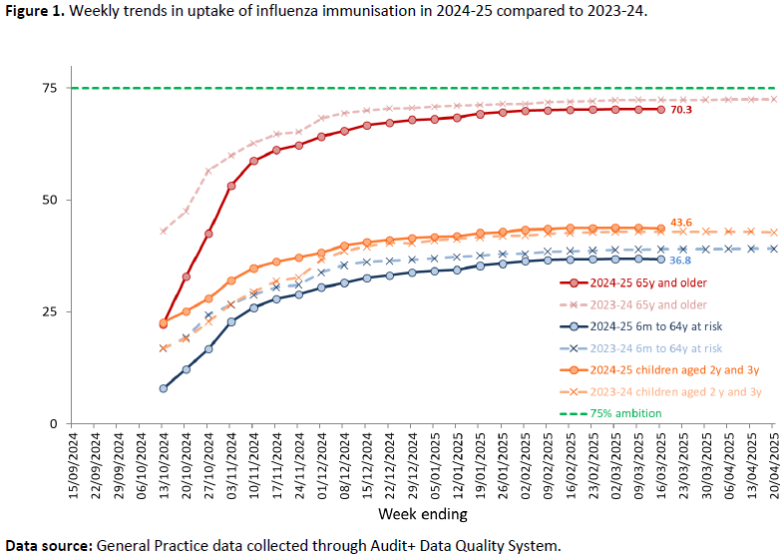
As shown in Appendix 2, where the local authority and cluster uptake is detailed, the decrease for SBUHB is comparable to that across Wales.
- Over 65s cohort 68.5% - 1% decrease, in this cohort. Bay cluster had the highest uptake with 74% and Neath had the lowest uptake at 64%. 3 out of 8 clusters showed an increase from last year’s figures.
- 6 months to 64 years at risk cohort 36.8% - 1.8% decrease, in this cohort Afan and Bay had the highest uptake with 37% and Cwmtawe and Neath had the lowest uptake at 31%. 3 out of 8 clusters howes an increase from last year’s figures.
- For the 2–3-year-old cohort 37% - a decrease of 1.1%. Upper valley had the lowest uptake with 26% and Bay had the highest at 44%. 5 out of 8 clusters showed an increase in this cohort uptake compared to last year’s figures. Targeted work was undertaken by both the immunisation team and primary care team, this included seeking assurance on delivery and recall and immunisation support.
- For children in primary schools (aged 4-10 years) uptake is 51.1%, which is below the Welsh average of 61.6%. SB UHB are ranked 7^{th.} This is a decrease of 14% from 2023/24, where uptake was at 65.1%.
- For children in secondary schools (aged 11-15 years) uptake is at 45.4%; below the Welsh average of 51.7%; SB UHB is ranked 6th. This is a decrease of 9.3% from 2023/24, where uptake was at 54.7%
GMS Contractors fed back concerns regarding duplication of effort with Immunisers from other HB teams attending care homes populations, difficulties in securing attendance at childhood vaccination clinics and language barriers particularly in more urban clusters.
These were discussed at meetings and actions taken forward to seek assurances on delivery to 2–3-year-olds, with practices confirming call and recall systems were in place and support provided by the Immunisation Team in contacting parents by telephone. A padlet to address language barriers is in development with a view to addressing the equity barriers identified.
There was also challenge regarding the process for allowing some contractors to start the programme delivery earlier than the agreed programme timeline, i.e. during September contractors were required to focus the programme on the 2&3 year old and pregnant cohort and commence the full programme in October.
On identifying practices that achieved less than 20% uptake in any patient cohort, the Primary Care Team followed up and sought:
- Feedback on the reasons for low uptake and the actions taken by the practice to overcome these
- Assurance on plans for the 2 and 3 year old cohort specifically (where less than 20%)
The following responses demonstrate the challenge faced:
“All eligible 2 & 3 year old patients were invited by text messages in September and October and then by a telephone call in November and December. Out of those that booked an appointment, 23 DNA’d and 13 cancelled on the day. 46 out of the eligible cohort declined…. following a meeting with Imms Team in December, a member of the Team rang all the eligible patients and booked some in a pop-up clinic at Singleton hospital, not one of these patients turned up.”
“Eligible patients were also invited to a walk-in clinic… , again no one turned up. We feel that as a practice we have done everything in our power to get these patients immunised, to no avail. I am unsure what we could have done differently but would welcome any suggestions for the coming season, as a lot of time and resources by ourselves and the immunisation team have been wasted.”
One practice struggled to commence in September due to fridge capacity taken up with COVID-19 vaccinations – this was fed back to the WRVPPG as a risk that would have been escalated to SIG, for consideration during future seasons.

2.5 Community Pharmacy provision
For the 2024-25 season, 89 of the 91 community pharmacies were commissioned to provide the Seasonal Flu Vaccination. 89 pharmacies are commissioned to offer the SFV service in SBUHB. 85 pharmacies have a named pharmacist or pharmacy technician listed against them to offer the service, with 45 having 2 or more clinical staff members listed to offer the service.
Of the 89 pharmacies commissioned, 26 pharmacies offered between 0-50 vaccines, 13 offered between 51-100, with the remaining 50 offering 101 or more, 9 of whom offered 500+. A total of 17,334 vaccines have been administered between the start of the season in September 2024 – 30th of March 2025, which is a 6.5% increase on the total 2023-24 season.
These numbers are captured in the overall uptake figures reported.
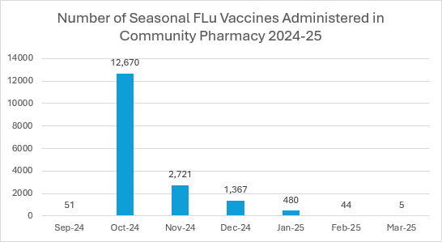

  - School immunisation sessions
The School Flu Vaccination programme this year saw a pilot of E-consent for the first time in SBUHB. The roll out of E-consent has been met with mixed results, and did take time to embed the process into the service. The E-consent tool was scoped and developed by both the Immunisation Team and the School nursing service, to ensure it was fit for purpose. Connectivity at some of the schools became problematic, however this has since been resolved and there is sufficient access to Wi-Fi networks within both local authorities now and going forward. The change in model, has impacted on the involvement from the schools, which may impact on the ability to chase outstanding consents from the schools. One of the benefits of the tool was the ability to clearly outline the demand for the Gelatine Free Vaccine across the schools. The tool also should enable the ability to forecast demand for vaccination across each school, in a timelier manner.
Towards the end of the programme, there had been the ability to offer mop up sessions within schools below the 50% uptake mark, however this was met with a mixed response in terms of uptake, and did require many phone calls and chasing from School nursing staff to chase consent, which previously would have been supported and managed by School resources.
Another pilot that took place this year was the non-registrant model for school nursing. This has been met with relative success and is a cost-effective model for delivery. Again, as this was a further change to the school nursing delivery model this year, it did take time to embed the process but is something that the school nursing programme wants to continue with in the future.
Overall, the uptake of Flu Vaccinations across primary schools in SBU has decreased to 51.1% 2024/25, this is a theme over previous years and is also seen across Wales. Decreased uptake rates is also seen in secondary school aged children.
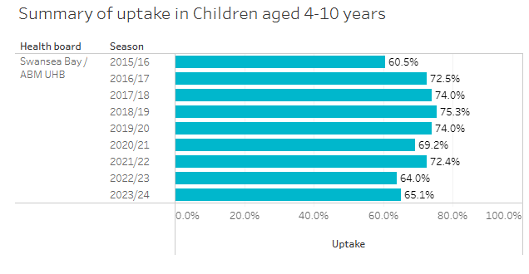
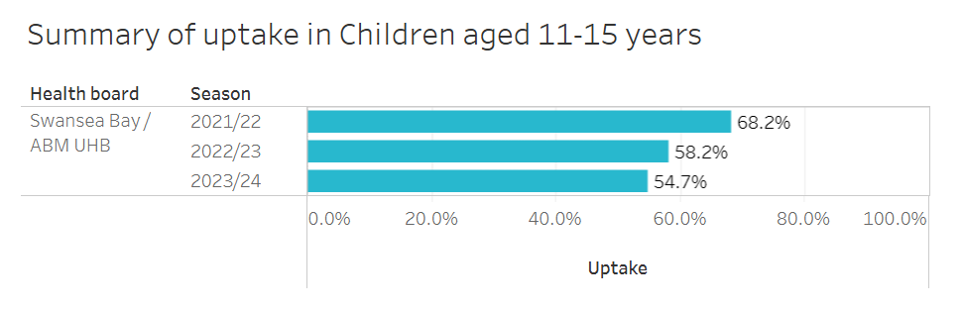
2.7 Flu vaccination uptake rates in pregnancy

We currently await release of the Point of Delivery report by PHW, however the provisional data in this report shows uptake to be at 60%. The point of delivery survey is a snap shot audit of women who have delivered over a 5 day period in January.
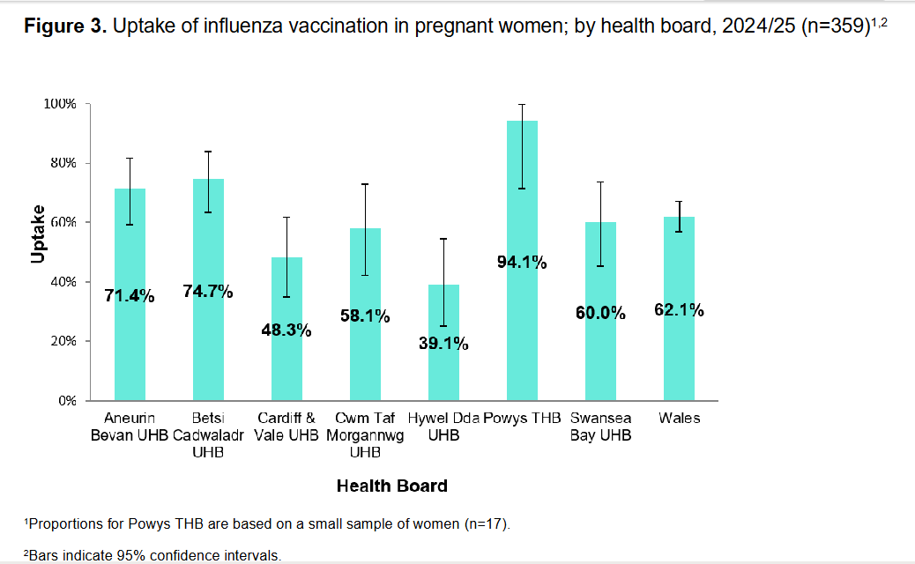

2.8 Planning for 2025-26 Programme
Finalised commissioning arrangement are awaited, draft Primary Care Contracted Services: Immunisation Specification (PCCS:I) has been shared with health boards but awaits finalisation by Welsh Government, this will be a new approach to commissioning for both GMS and Community Pharmacy. Until this is received, along with the agreed planning framework commissioning arrangements cannot proceed.
Planning will continue through the WRVPPG and will focus on increasing uptake for 25/26 and will include as a minimum:
- Review of feedback, lessons learned and areas of good practice.
- Scrutiny of commissioning arrangements and delivery plans
- Targeted efforts by the Health Board Immunisation Team and Primary Care Team in clusters and practices with low uptake. This includes a proposal for the immunisation team to support two clusters with the lowest uptake of fluenz in the 2 and 3 year olds, Upper Valleys and Cwmtawe to being in September 2025.
- Robust communication plan, which will begin with information (and video messaging) to remind individuals about the benefits of all vaccines. We will continue to engage with specialist nurses and teams who can actively promote the benefits of vaccines to their client group. Messaging throughout the influenza season will be tailored and adapted in accordance to the uptake rates within each cluster
The Winter Respiratory Vaccination Programme integrates the COVID-19 and seasonal influenza vaccination programmes, bringing together the strategy, planning and governance of these programmes. As part of this achieving the ambitions of the National Immunisation Framework, influenza vaccines will be centrally procured and supplied from autumn 2025. This will ensure that vaccination arrangements are fit for the future with the benefit of national infrastructure, have a strong value for money element and produce value-based outcomes.
SBUHB has placed orders as per the supply and distribution operating model guidance and order review guide. National Implementation group meetings commenced in December 2024 and continue to meet on the planning and logistics. A local SBUHB group was also stood up in December to coordinate this work.
The SBUHB order for centrally Procurement Influenza stock is as follows:
Order / delivery site type | aTIV (over 65 years) | TIVc (under 65 years)
HB Central Pharmacy | 700 | 8,000
Primary Care Contractors (GMS and Community Pharmacy | 63,710 | 27,090
Total | 64,410 | 35,090
The current denominators for flu are 84,432 (over 65 years) and 55,695 (under 65 years), the Primary Care orders, if taken up fully with minimal wastage, would result in increases in uptake from 2024-25 particularly in the under 65 years cohort, which will require significant focus and detailed planning to achieve.
The SBUHB order was overseen by the local implementation group and data that fed into local Implementation group meetings on 24th and 28th February for consideration included:
- Target uptake levels for cohorts: 75%;
- Uptake rates achieved in 2024-25 to date of 68.5% (over 65s) and 33.7% (under 65 at risk) *this incorporated CP activity within the data extracted and presented on IVOR;
- Uptake rates achieved in 2023-24 of 69.5% (over 65s) and 35.6% (under 65 at risk) *this incorporated CP activity within the data extracted and presented on IVOR;
- Individual GMS practice’s claims data for 2023-24 and 2024-25 to date for both cohorts;
- All practice orders over the above verifications; and
- Pack size (x10) misread errors amended.

Contractors were contacted by Primary Care Teams where they had ordered significantly more than what they had delivered in previous seasons, often this was due to confusion around the pack sizes and was easily rectified and amended. Two Pharmacies were contacted as they had ordered more than what they have delivered last season, both contractors confirmed that the amount ordered was accurate as they plan to increase their activity. A number of Community Pharmacy Contractors were also contacted due to ordering slightly less than last year’s delivery, they confirmed that the order is accurate and reflects their business priorities for the forthcoming season. Finally, any duplicate orders were amended and dates for additional deliveries agreed where fridge capacity could not accommodate orders.
Following submission, some orders were further reduced at the request of the national team, i.e. the final order submitted by the Health Board was not accepted without reducing some of the orders. However, all contractors have 100% + of last season’s delivery providing they have requested this. Stock held and Cefn Coed Pharmacy will also be allocated if required including the option to place ‘emergency orders’.
GMS Practices will continue to order Fluenz for the children’s programme via ImmForm commencing at the start of, and throughout, the 2025-26 season.
SBU Primary Care Academy have immunisations and vaccinations training sessions booked for summer 2025, with two dates for practice nurses and one for healthcare support workers.

- GOVERNANCE AND RISK ISSUES

Overall, uptake of the Influenza vaccination in Swansea Bay University Health Board for 2024-25 was lower than the previous year. This was despite planning for improved uptake.
Welsh Government has advised SBUHB that flu vaccines will be procured centrally in 2025/26, and that the health board’s allocation will be reduced by £1.34m to accommodate this change. This has been assessed as being cost neutral to the health board if current levels of uptake remain. However Welsh Government have an uptake target expectation of 75%. If this were to be achieved, then the fees paid to Primary Care Contractors would increase by around £300k.
The delay in receiving the finalised commissioning specification means arrangements for 25/26 programme cannot yet be confirmed. There is a need to ensure that the planning learns from lessons and areas of good practice to ensure no risk of challenge and improved uptake.
Planning will continue through the WRVPPG and will focus on increasing uptake for 25/26.
The central procurement of flu is a new process and has risks associated with planning and delivering. To mitigate any risks to low stock locally arrangements are being confirmed for allocation of health board held stock from Cefn Coed Pharmacy in addition to in-programme emergency orders.

- FINANCIAL IMPLICATIONS

The total cost for the Influenza programme 2024-25, paid to GMS Contractors in SBUHB to date was almost £705K (Item of Service) as well as circa £688K (Drug Tariff Reimbursement) totalling an estimated £1.41m.
The Community Pharmacy 2024-25 flu cost currently stands at £459,239.
Welsh Government wrote to SBUHB in November 2024 explaining that to fund the new system of centrally procuring, storing and distributing vaccine, the Welsh Government will retain a proportion of the overall funding currently spent by health boards on flu vaccine procurement and personally administered vaccines. It also noted that because of the savings made through a central procurement model, the amount of funding retained in 2025-26 will be significantly less than the sum currently spent by health boards.
The letter shared details of the impact of this change on the health board’s budget. To ensure the figures are commensurate with existing levels of expenditure, the amounts set out below are based on the proportion of population eligible for flu vaccination. They also take into account the health board split between the amount spent reimbursing procurement undertaken by General Medical Services and that spent on other procurement routes.
Whilst costs regarding Drug Tariff Reimbursement are mitigated due to Central Procurement and ImmForm ordering, the draft Commissioning arrangement described remuneration to be the standard Item of Service fee (currently £10.03 per dose) plus a time limited top-up of £2.75 per dose. If all vaccines ordered for Contractors are taken up, this will cost SBUHB almost £1.18m.

- RECOMMENDATION

Members are asked to:
- RECEIVE the uptake report on the 2024-25 Influenza vaccination campaign, which shows a reduction in uptake for 24/25.
- BE ASSURED that the SBUHB Winter Respiratory Vaccination Programme Planning Group (WRVPPG) will take forward the planning and actions to improve uptake for 25/26.
- BE ASSURED on the process taken for the order of central procurement of influenza vaccinations in 2025-26, which was undertaken in line with the national requirements.
- NOTE the financial cost if all vaccine ordered by the Health Board are administered.

Governance and Assurance

Link to Enabling Objectives  (please choose) | Supporting better health and wellbeing by actively promoting and empowering people to live well in resilient communities
Link to Enabling Objectives  (please choose) | Partnerships for Improving Health and Wellbeing |  | ☒
Link to Enabling Objectives  (please choose) | Co-Production and Health Literacy |  | ☐
Link to Enabling Objectives  (please choose) | Digitally Enabled Health and Wellbeing |  | ☐
Link to Enabling Objectives  (please choose) | Deliver better care through excellent health and care services achieving the outcomes that matter most to people
Link to Enabling Objectives  (please choose) | Best Value Outcomes and High Quality Care |  | ☒
Link to Enabling Objectives  (please choose) | Partnerships for Care |  | ☒
Link to Enabling Objectives  (please choose) | Excellent Staff |  | ☐
Link to Enabling Objectives  (please choose) | Digitally Enabled Care |  | ☐
Link to Enabling Objectives  (please choose) | Outstanding Research, Innovation, Education and Learning |  | ☐
Health and Care Standards
(please choose) | Staying Healthy |  | ☒
(please choose) | Safe Care |  | ☒
(please choose) | Effective Care |  | ☒
(please choose) | Dignified Care |  | ☐
(please choose) | Timely Care |  | ☒
(please choose) | Individual Care |  | ☐
(please choose) | Staff and Resources |  | ☐
Quality, Safety and Patient Experience
The provision of the flu campaign is a key strategic priority for Quarter 3 and Quarter 4 that made a contribution to the protection of public health and the ability of the NHS to cope with Winter pressures, as well as the health threats posed by COVID-19.
Language barriers identified have led to the development of a Padlet resource to support Practices in delivering equitable access to Health Protection Immunisations.
Financial Implications
Challenging position on GMS portion of retained funding in 2025-26 against projected uptake.
Legal Implications (including equality and diversity assessment)
There are a number of statutory regulations and directions relating to the provision of the flu campaign, guidance is set out in the paper.
Staffing Implications
None
Long Term Implications (including the impact of the Well-being of Future Generations (Wales) Act 2015)
Uptake of the flu vaccine in the 2-3yrs cohort continues to present challenges and the Health Board is seeking to identify and overcome barriers to uptake.
Report History
Appendices |  | Appendix 1 – GP Flu Plan Template 2024-25  Appendix 2 – Influenza vaccine uptake data

Appendix 1

Primary Care Delivery Plan for Seasonal Influenza Vaccination Programme 2024/25
In line with the Primary Medical Services (Directed Enhanced Services) (Wales) Directions 2007, those practices contracted by Health Boards to deliver the influenza immunisation programme should have agreements set out in a plan for delivering the programme effectively. This plan should include a register of all patients in at risk groups in addition to eligible age groups. Please complete the information below to inform the development of a Health Board Primary Care Delivery Plan.

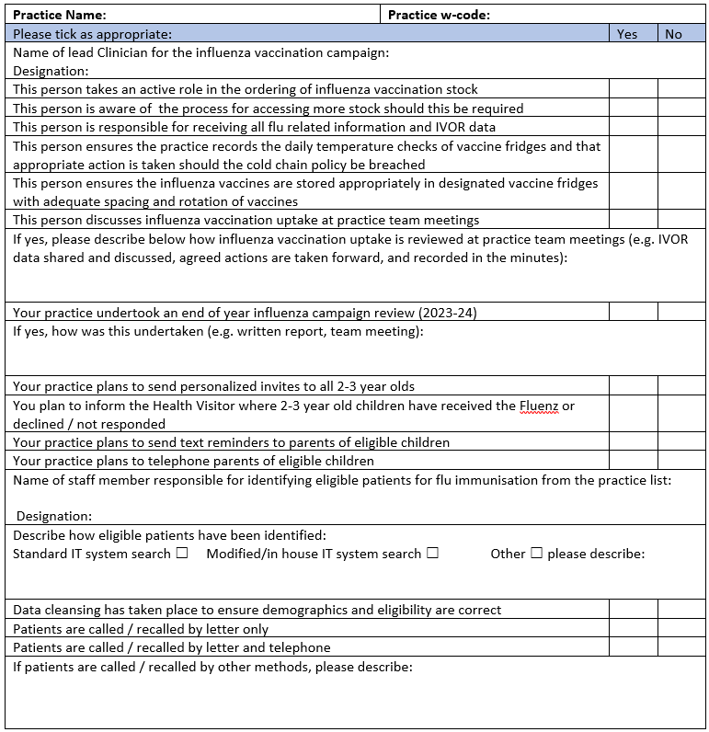

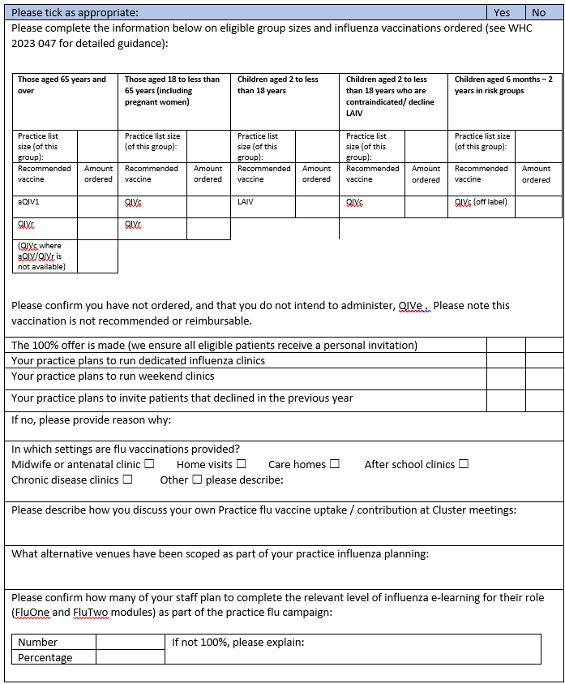

Appendix 2

2024-25 Influenza vaccine uptake summary by Local Authority

SBUHB Summary 2024-25
 | Children 2 to 3 years
 | Denominator | Immunised | Uptake (%) | 2023-24 | 2022-23
NPT | 2,580 | 895 | 34.7% | 34.8% | 37.10%
Swansea | 4,519 | 1,730 | 38.3% | 39.8% | 39.70%
SB Total | 7,099 | 2,625 | 37.0% | 38.0% | 38.80%
Wales | 60,023 | 26,190 | 43.6% | 42.8% | 44.00%
 | Clinical risk 6m to 64y
 | Denominator | Immunised | Uptake (%) | 2023-24 | 2022-23
NPT | 20,909 | 6,889 | 32.9% | 35.3% | 44.4%
Swansea | 34,786 | 11,881 | 34.2% | 35.8% | 43.4%
SB Total | 55,695 | 18,770 | 33.7% | 35.6% | 43.8%
Wales | 473,177 | 174,016 | 36.8% | 39.1% | 44.2%
 | 65y and older
 | Denominator | Immunised | Uptake (%) | 2023-24 | 2022-23
NPT | 31,312 | 20,488 | 65.4% | 67.9% | 75.3%
Swansea | 53,120 | 37,385 | 70.4% | 70.4% | 76.2%
SB Total | 84,432 | 57,873 | 68.5% | 69.5% | 75.9%
Wales | 710,796 | 499,466 | 70.3% | 72.5% | 76.3%

2023-24 & 2024-25 Cluster flu immunisation uptake by cohort
65 years and over
Cluster |  | Uptake
Afan | 2023-24 | 66%
 | 2024-25 | 67%
Bay | 2023-24 | 72%
 | 2024-25 | 74%
City | 2023-24 | 68%
 | 2024-25 | 66%
Cwmtawe | 2023-24 | 67%
 | 2024-25 | 68%
Llwchwr | 2023-24 | 73%
 | 2024-25 | 71%
Neath | 2023-24 | 67%
 | 2024-25 | 64%
Penderi | 2023-24 | 71%
 | 2024-25 | 69%
U Valleys | 2023-24 | 71%
 | 2024-25 | 67%
Under 65 at risk
Cluster |  | Uptake
Afan | 2023-24 | 33%
 | 2024-25 | 37%
Bay | 2023-24 | 36%
 | 2024-25 | 37%
City | 2023-24 | 37%
 | 2024-25 | 34%
Cwmtawe | 2023-24 | 29%
 | 2024-25 | 31%
Llwchwr | 2023-24 | 39%
 | 2024-25 | 34%
Neath | 2023-24 | 36%
 | 2024-25 | 31%
Penderi | 2023-24 | 36%
 | 2024-25 | 34%
U Valleys | 2023-24 | 38%
 | 2024-25 | 34%
