Meeting Date | 04 December 2025 |  | Agenda Item |  |  | 2.4
Name of Meeting | Population Health Committee
Report Title | Regional Whole Systems Approach to healthy weight – Progress Update
Report Author | Beth Cossins, Regional Principal Public Health Practitioner (Systems Working)
Report Sponsor | Prof Dr Gillian Richardson, Executive Director of Public Health (Interim)
Presented by | Prof Dr Gillian Richardson, Executive Director of Public Health (Interim)
Freedom of Information | Open
Purpose of the Report | This report updates the Committee on:  The implementation of the regional Whole Systems Approach (WSA) to healthy weight as a Ministerial priority under the ‘Leadership and Enabling Change theme in the Welsh Government Healthy Weight:Healthy Wales strategy (2019).
Key Issues | - Levels of overweight and obesity are increasing and have a disproportionate impact on our poorest communities.  - Considerable progress has been made since the full establishment of the WSA regional team (April 2024) in building a collaborative approach to improving the environmental conditions for a healthy weight with all 5 Public Services Boards (PSBs) across the region. As a result, all 5 have agreed on a regional collaborative focus on ‘access to food’.  - More recently, Swansea and Neath Port Talbot PSBs have come together and agreed ‘Food Procurement’ as an area for collaboration within the agreed regional priority  - Capability and capacity to deliver System change is developing slowly through structures put in place over the past 20 months, most notably widespread stakeholder engagement activities, PSB workshops and the development of a Regional Learning Network  - Implementation being owned by the whole of organisation / whole of system is slow to develop but has gathered pace following the identification of ‘access to food’ as a regional priority  - Organisation/system strategic intent with a clear understanding of reputational and population health risks to non-implementation is still not widespread or clearly articulated  - Embedding and adopting a WSA requires different thinking, behaviours and ‘ways of working’ across all parts of the system. Embedding system leadership, system working and tools more systematically, both internally in the UHB and in partnership is needed  - Governance for WSA, particularly across 5 PSBs requires different approaches and behaviours. A more federated style of governance is favoured and needs to be agreed and designed in order to effectively measure system change/shift over time  - The current system has a heavy focus on service-based activity and on individual lifestyle factors. Whilst these are important in supporting individuals with excess weight and related health conditions, equal (if not greater) emphasis and effort needs to be focussed in acting productively in partnerships and on the societal and environmental causes of excess weight through a focus on the wider determinants of health  - WSA is currently grant funded until the end of March 2026. Indications from Welsh Government are that a notification about future funding will be received ahead of Christmas 2025 but that this is likely to be for a further year only given Senedd elections in May 2025.
Specific Action Required  (please choose one only) | Information | Discussion |  | Assurance | Approval
Specific Action Required  (please choose one only) | ☒ | ☐ |  | ☐ | ☐
Recommendations | Members are asked to:  - RECIEVE this report and note the continued progress on implementing the WSA to a healthy weight across the region, particularly the more recent commitment to collaboration across Swansea and Neath Port Talbot Public Services Boards (PSBs) with a focus on food procurement.

REGIONAL WHOLE SYSTEMS APPROACH - HEALTHY WEIGHT

- INTRODUCTION
The Population Health Strategy (PHS), approved by Board in March 2023 commits the University Health Board (UHB) to action, in line with the evidence base, to improve the health and wellbeing of the population whilst tackling the significant and stubborn health inequalities that exist. This paper seeks to update and assure the Committee on progress over the past 20 months in embedding a regional Whole Systems Approach (WSA) to healthy weight - aimed at:

‘Building regional collaboration across Public Services Boards (PSBs) to help create the environmental conditions for a healthy weight and to reduce the unfair differences in healthy weight between different population groups.’

- BACKGROUND
UK obesity rates have doubled over the past 30 years and across Swansea Bay 64.4% of adults and a quarter of children (25.4%) starting school (aged 4-5 years) are living with overweight or obesity^{1,2}. This has profound implications for individuals and the NHS, but also for the wider economy and society.

Excess weight can shorten lives and lead to more years of life lived in poor health and with disability. It disproportionately impacts those living in the poorest circumstances leading to unfair differences in health and wellbeing outcomes and contributes to widening health inequalities across the region. Beyond individuals, obesity and overweight impacts wider society. Analysis undertaken by NESTA in 2025 shows that obesity and excess weight cost the UK economy around £31 billion a year in lower productivity³. These factors make addressing the issue of unhealthy weight an urgent priority.

In response to this global and domestic challenge, the Welsh Government launched the Healthy Weight: Healthy Wales (HW:HW) strategy⁴ in 2019. It aims to increase the proportion of the population who are a healthy weight and reduce inequalities. This 10-year strategy has a core focus on leadership and enabling change and as part of embedding that theme promotes a Whole Systems Approach (WSA) to foster local leadership, collaboration and involvement to enable system-wide action and improvement.

The WSA is co-ordinated nationally by Public Health Wales and implemented locally through implementation teams based at Health Board level. Welsh Government grant funding allocated via Public Health Wales (circa £222,000 annually) has enabled the recruitment of a small regional Whole System Approach to a Healthy Weight team which covers the Swansea Bay and Hywel Dda University Health Board areas. The regional team of 2.8 WTE was fully recruited in April 2024 but re-structured in September 2025 to meet delivery expectations for the current year.

- Public Health Wales (2025) using National Survey for Wales (Welsh Government). Online
- Public Health Wales (2025) Child Measurement Programme Report 2023-24. Online
- NESTA (2025), The economic and productivity costs of obesity and excess weight in the UK. Online
- Welsh Government (2019) Health Weight: Healthy Wales. Online

Guided by a Memorandum of Understanding between both UHBs, the team supports the two Directors of Public Health and through them the 5 Public Services Boards in Swansea, Neath Port Talbot, Carmarthenshire, Ceredigion and Pembrokeshire to build a collaborative approach to improving the environmental conditions for healthy weight. Key to this approach is a focus on reducing unfair differences in health and wellbeing outcomes associated with healthy weight across different population groups.

The systems approach
The systems approach is a dynamic way of working, that brings together partners to develop a shared understanding of the challenge, and integrate action to bring about sustainable, long-term system change. It recognises that people’s behaviours are strongly shaped by the circumstances in which they live and by the environment which surrounds them. This includes the education and support they receive in their early years, the resources they have to buy healthy food, access to shops in their local communities, and whether there are green spaces and safe streets to be physically active in.

There are also strong commercial factors at play. Evidence shows that advertising of less healthy food and drink products influences the eating habits of young people. Almost half (48%) of all food and drink adverts shown on commercial TV channels most watched by children are for high fat, salt and sugar (HFSS) products⁵. Unlike television and digital media advertising, public spaces remain largely unregulated, resulting in continued exposure to unhealthy food advertisements and studies indicate that outdoor advertising of unhealthy foods significantly impacts consumer cravings and diets, akin to online advertising. Children and adults from more deprived backgrounds are disproportionately targeted by HFSS marketing due to higher reliance on public transport and residence in areas with a higher density of outdoor advertisements.

Currently, the system is not producing good outcomes for health and wellbeing, for the economy or our communities so a focus on these ‘root causes’ is essential to achieve meaningful and sustainable system change.

Work to date
In early 2023, before the regional team was in place, the two Directors of Public Health agreed to utilise grant funding to commission Leeds Beckett University to support both Public Health Teams in undertaking participatory group model building on the drivers of excess weight in the local population. Drawing on PSB members and wider partners, a series of 5 county-level workshops led to the production of two regional system maps, one focussed on physical activity and the other on food. These contained 8 potential priority sub-systems sown below.

- Cairns G, Angus K, Hastings G. (2009).The extent, nature and effects of food promotion to children: a review of the evidence to December 2008. World Health Organization, WHO Press

Potential Priority Sub-systems
Pre-school and School Physical Activity
Recreational Opportunities for Physical Activity
Active Travel
Breastfeeding
School food
Affordability of Food
Availability of Unhealthy Food
Advertising & Marketing of Food

The team then delivered five further workshops to PSB structures during the Autumn and Winter of 2024 to agree which of those 8 potential sub-systems would be the priority focus across the region for the next phase of work. In December 2024, following consensus voting and individual ballots, it was proposed that the sub-system for the Swansea Bay and Hywel Dda region was ‘Access to Food’. This includes affordability and availability of both healthy and unhealthy food.

The focus on access to food meant a new range of stakeholders in the system so the team set about further engagement and facilitated workshops for local food partnership co-ordinators across the region and at the Swansea PSB Partnership Forum. Both were aimed at engaging with those working at an operational level in the system on the current opportunities and challenges in relation to access to food and the areas that they wanted to see the PSBs take forward. This insight and feedback added to that already gathered through PSB engagement and was used to develop an illustration depicting a draft shared vision for a future food system across the region.

To support systems working in practice the team have also co-designed a regional Learning Network. This is a space for PSB members and wider partners to come together to learn about system thinking tools, to try them out in practice and to reflect and share learning with peers. The network was launched in June and the WSA have worked with colleagues in the Shaping Places for Wellbeing in Wales programme to design a programme of content to meet the needs of members over the next 6 months.

Publications this year have reinforced the direction of travel for the WSA work. Most notably, The Future Generations Report⁶, with specific recommendations relating to the food environment, the Wales Community Food Strategy⁷ aimed at strengthening the local food system structures, including Local Food Partnerships and strengthening food resilience and a new Healthy Weight:Healthy Wales 2-year delivery plan (2025-27)⁸ with WSA at the core.

- Office of the Future Generations Commissioner (2025) Future Generations Report. Online
- Welsh Government (2025) Wales Community Food Strategy. Online
- Welsh Government (2025), Healthy Weight: Healthy Wales delivery plan 2025 to 2027. Online

Building on the commitment of Swansea and Neath Port Talbot PSBs to work together on access to food the team facilitated a Roots of Change workshop on October 2nd in the Swansea.com stadium. It aimed to narrowing the focus for collaborative work on improving food availability and affordability across Swansea and Neath Port Talbot.

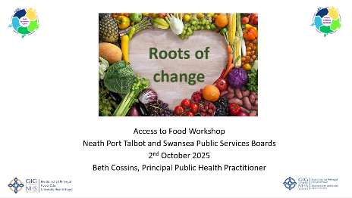
38 people attended the workshop, from a wide range of organisations and with equal representation across both PSBs. Working back from the vision for the future participants engaged with system prioritisation tools through a series of breakout session to refine the focus for collaboration and importantly, the steps to getting there. This was grounded in what participants felt was within the sphere of influence of the PSBs but could achieve system-wide impact.
Following voting on a shortlist of three areas including advertising, the planning system and food procurement, the latter emerged as the clear priority. This recognises the significant role that procurement plays in creating a sustainable and resilient food system and nutritious food for all cross our region.
Next steps:
- Now that food procurement has been agreed as the collaborative focus, the WSA team is supporting both PSBs to agree:
- The structures/processes needed to take the work forward across both PSBs
- The scope of the work and who should be involved
- The visual minutes capturing the discussion during the workshop are being finalised
- The feedback from participants on the 2050 food system vision is being incorporated into the illustration and a final version is being produced
- Conversations are underway with the 3 PSBs in Hywel Dda about a similar joint prioritisation workshop in the new year.

- GOVERNANCE AND RISK ISSUES
The draft national governance structure for WSA is illustrated below and will be finalised once the new Welsh Government governance structures for the Healthy Weight: Healthy Wales delivery plan are in place.

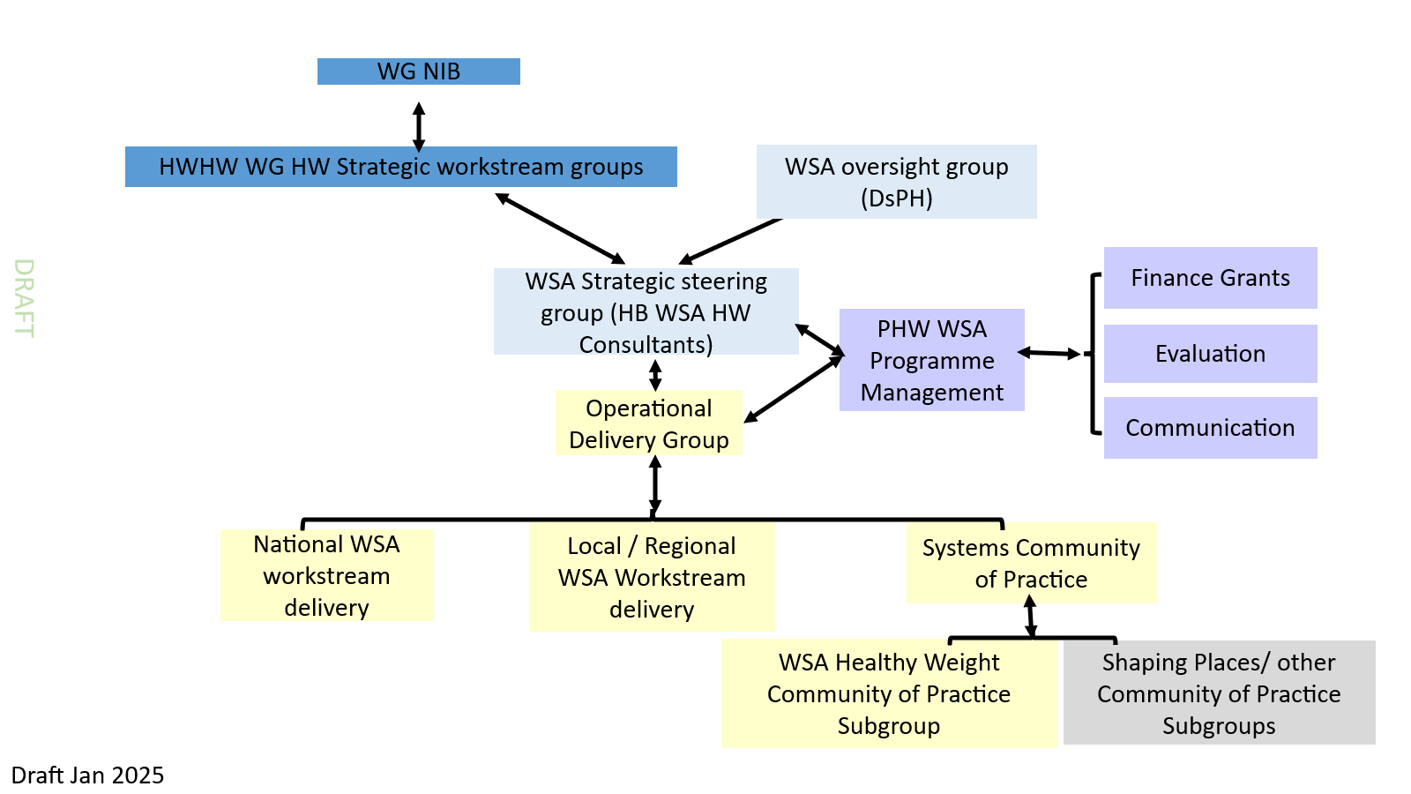

At a regional level, governance for WSA, particularly through the 5 PSBs requires different approaches and behaviours. A more federated style of governance is favoured and needs to be agreed and designed in order to effectively measure system change/shift over time.

- FINANCIAL IMPLICATIONS
WSA is currently grant funded until the end of March 2026. Indications from the Welsh Government are that a notification about future funding will be received ahead of Christmas 2025 but that this is likely to be for a further year only, given Senedd elections in May 2025.

Whilst it is reassuring to see WSA as central to the new 2-year delivery plan, this needs to be supported with longer-term funding cycles. This is a long-term approach linked to a 10-year strategy. It demands considerable capacity in establishing solid foundations for future collaborative work and partners require stability and consistency in terms of access to specialist support. Assurances regarding future funding for the next 2-3years needs to be a priority in conversations with funders beyond May of 2026.

- RECOMMENDATION
The committee is asked to receive this report and note the continued progress on implementing the WSA to a healthy weight across the region, particularly the more recent commitment to collaboration across Swansea and Neath Port Talbot Public Services Boards (PSBs) with a focus on food procurement.

Governance and Assurance

Link to Enabling Objectives  (please choose) | Supporting better health and wellbeing by actively promoting and empowering people to live well in resilient communities
Link to Enabling Objectives  (please choose) | Partnerships for Improving Health and Wellbeing |  | ☒
Link to Enabling Objectives  (please choose) | Co-Production and Health Literacy |  | ☒
Link to Enabling Objectives  (please choose) | Digitally Enabled Health and Wellbeing |  | ☐
Link to Enabling Objectives  (please choose) | Deliver better care through excellent health and care services achieving the outcomes that matter most to people
Link to Enabling Objectives  (please choose) | Best Value Outcomes and High-quality Care |  | ☒
Link to Enabling Objectives  (please choose) | Partnerships for Care |  | ☒
Link to Enabling Objectives  (please choose) | Excellent Staff |  | ☐
Link to Enabling Objectives  (please choose) | Digitally Enabled Care |  | ☐
Link to Enabling Objectives  (please choose) | Outstanding Research, Innovation, Education and Learning |  | ☒
Health and Care Standards
(please choose) | Staying Healthy |  | ☒
(please choose) | Safe Care |  | ☐
(please choose) | Effective Care |  | ☐
(please choose) | Dignified Care |  | ☐
(please choose) | Timely Care |  | ☐
(please choose) | Individual Care |  | ☐
(please choose) | Staff and Resources |  | ☐
Quality, Safety and Patient Experience
This paper outlines progress in the implementation of the WSA to healthy weight across the region which, if effective, will lead to a more consistent approach to improving the environmental conditions for healthy weight in the population over time but with a focus on shifting the system to consider the impacts of the wider determinants of health and inequities.
Financial Implications
The WSA is grant funded by the Welsh Government. A total of circa £222,000 is allocated to the region annually. Current funding will cease on the 31 March 2026, and confirmation of future funding is awaited.
Legal Implications (including equality and diversity assessment)
No legal implications identified. The implementation of the WSA will allow for the identification of equality and diversity issues and development of appropriate responses.
Staffing Implications
WSA offers an opportunity to significantly increase the organisation’s capacity and capability to adopt different / new ways of working and thinking to contribute to a healthy weight environment for all.

The WSA team is small consisting of a Principal Public Health Practitioner (System Working) and two part time Senior Public Health Practitioners (1.8 WTE) to embed the approach across stakeholders and partners. Both Senior Public Health practitioners are seconded to the WSA team, and their period of secondment can only be extended once confirmation of funding is received.

Action planning which will follow-on from the identification of a sub-system priority will identify the skills and any additional workforce requirements.
Long Term Implications (including the impact of the Well-being of Future Generations (Wales) Act 2015)
WSA is contingent on collaboration among partners to deliver better outcomes for the population. Involvement and coproduction are integral to the approach which seeks to involve communities in identifying system challenges and opportunities and in agreeing system goals and actions.

The seven goals and 5 ways of working of the WBFG Act are embedded within the systems approach. This approach helps the UHB and PSBs deliver against their duties under the Act.
Report History |  | ‘’Whole Systems Approach to Healthy Weight’ presented to the Population Health and Partnerships Committee 6 June 2024
Appendices |  | None

