Health impacts of smoking

Over the period 2020-22, an estimated 3,845 deaths per year amongst those aged 35 and over in Wales were due to smoking.
On average 10.7% of all deaths in Wales amongst those aged 35 and over in these years were attributable to smoking.
Smoking has major negative health impacts across population health and health service specialism outcomes:

Cancers

- It is estimated that smoking is responsible for almost one-fifth of new cancer diagnosis in the UK every year, and 7% of all cancer deaths [ASH, 2017].
- Smoking is the most common cause of lung cancer in the UK [ASH, 2017].
- More than a quarter of all cancer deaths in the UK can be attributed to smoking including lung, oral, throat, bladder, kidney, pancreatic, stomach, liver, and cervical cancers [ASH, 2017].

Complications in pregnancy and labour — smoking increases the risk of [NCSCT, 2014; NCSCT, 2016a; RCOG, 2020]:
  - Maternal deep vein thrombosis and pre-eclampsia.
  - Preterm birth.
  - Premature rupture of membranes.
  - Placental abruption.
  - Placenta praevia.
  - Ectopic pregnancy.
  - Miscarriage.

Fetal/infant complications — maternal smoking increases the risk of [WHO, 2013; NCSCT, 2014; RCOG, 2020; OHID, 2022a]:
  - The child having behavioural problems (such as attention and hyperactivity problems), learning difficulties, reduced educational performance, and childhood respiratory problems.
  - The child developing diabetes or obesity in later life.
  - Infant mortality.
  - Sudden infant death syndrome (SIDS).
  - Stillbirth.
  - Birth defects, such as cleft lip.
  - Intrauterine growth restriction.
  - Low birth weight — babies born to mothers who smoke are on average 200-250 g lighter than those whose mothers do not smoke.

Adverse outcomes following surgery — smoking is associated with adverse outcomes following surgery, such as [Delgado-Rodriguez, 2003; Theadom, 2006]:
  - Delayed wound healing.
  - Infections.
  - Prolonged hospital stay.
  - Repeated admissions after surgery.
  - Lower survival rates.

Other health problems — smoking causes [PHE, 2014; Peto, 2015; ASH, 2020c; ASH, 2020d; ASH, 2021b; ASH, 2021c]:
  - Cardiovascular disease — 20% of all deaths from cardiovascular disease are due to smoking.
  - Respiratory diseases, such as COPD — 40% of all respiratory deaths are due to smoking. Smoking triggers the development of asthma and exacerbates symptoms and increases the risk of developing pneumonia and tuberculosis.
  - Stomach and duodenal ulcers.
  - Erectile dysfunction.
  - Male and female infertility.
  - Progressive harm to the musculoskeletal system — smoking is a risk factor for osteoporosis, and there is an association between smoking and an increased risk of bone fracture. It is a cause of rheumatoid arthritis, especially among men.
  - Progressive harm to the cognitive system. People who smoke are over 50% more likely to develop cognitive impairment than those who do not. Smoking is an important environmental risk factor for the development of dementia, due to the increased vascular risk.
  - Smoking may be a risk factor for developing multiple sclerosis (MS), with evidence suggesting smoking rates are higher among people with MS than those seen in the general population.
  - Cataracts and age-related macular degeneration.
  - Periodontal disease and tooth decay.
  - An increased risk of developing meningococcal disease.
  - An increased risk of developing nephropathy and neuropathy for people with diabetes mellitus.
  - There is also an association between smoking and an increased risk of retinopathy.

Impact of smoking on hospital admissions

- Over the period 2020-22, an estimated 17,195 hospital admissions per year in Wales were due to smoking.
- On average 3.4% of all hospital admissions in Wales amongst those aged 35 and over in 2020-2022 were attributable to smoking.
- In Swansea Bay, the smoking attributable hospital admissions rate in people aged over 35 was 742 per 100,000

Benefits of stopping smoking

Immediate and Long-Term Health Benefits
- Risk Reduction: Quitting smoking lowers the risk of:
  - Lung cancer
  - Chronic obstructive pulmonary disease (COPD)
  - Heart disease
  - Dementia and frailty in later life

- Life Expectancy Gains:
  - Stopping before age 40 avoids over 90% of the excess risk of death.
  - Stopping before age 50 halves the risk of dying from smoking-related diseases.

Improved Surgical Outcomes
- Those who quit smoking approximately 4 weeks before surgery have a reduced risk of postsurgical complications.

Maternity: women and babies health benefit

- There is no safe level of smoking during pregnancy.
- Quitting at any stage is beneficial, but:
  - Stopping in the first trimester normalizes the risk of low birth weight to that of non-smokers.
  - Smoking in later pregnancy increases risks of:
    - Low birth weight
    - Stillbirth
    - Placental abruption

Mental health

- Reduced depression, anxiety and stress, and improved positive mood and psychological quality of life.
- Lower doses required for people on some psychotropic medication (this is because tobacco smoke interacts with some psychiatric medicines, often increasing the rate of their metabolism).

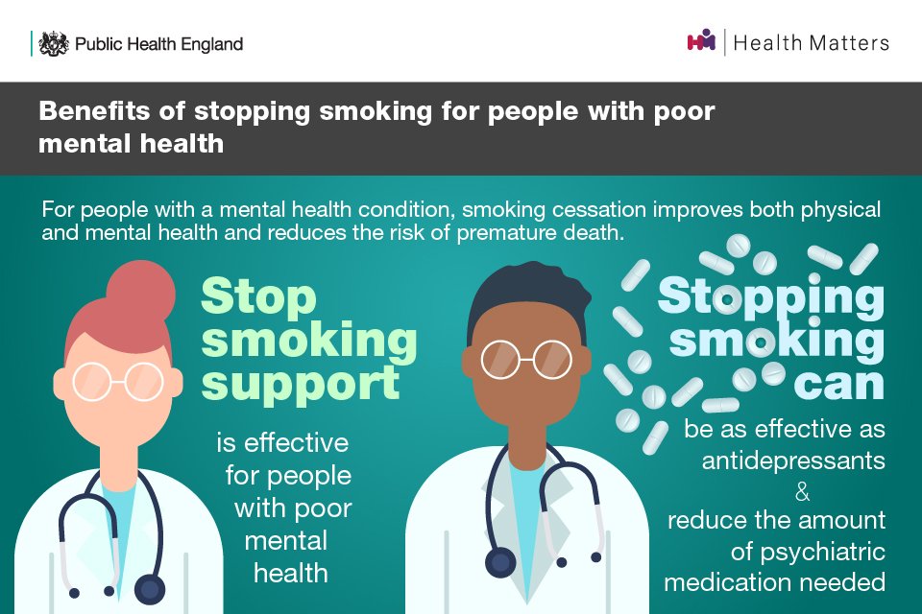

Quality Standards on Treating Tobacco Dependence/Stop Smoking Support
Smoking cessation support is evidence based and cost effective.
NICE Guideline NG209 details evidence based stop smoking support in community, pharmacies, primary care, secondary care, maternity services and mental health services.
NICE Quality Standard Q22: Antenatal Care
Quality Statement 5 : Pregnant women and partners who smoke are referred for stop-smoking support and treatment at routine antenatal appointments.

NICE Quality Standard Q207: Tobacco: Treating dependence (inclusive of mental health services)

Statement 1 People are asked if they use tobacco at key points of contact with a health or social care professional.
Statement 2 People who use tobacco receive advice on quitting.
Statement 3 People who want to stop using tobacco are offered tobacco cessation support and treatment by a healthcare professional.
Statement 4 People who do not want, or are not ready, to stop using tobacco in one go receive support to adopt a harm-reduction approach.
Statement 5 People who smoke receive treatment to stop smoking on admission to hospital.

Smoking attributable mortality and hospital admissions in Wales summary report V4.docx
As above
Harms caused by smoking | Background information | Smoking cessation | CKS | NICE
Smoking attributable mortality and hospital admissions in Wales summary report V4.docx
Benefits of stopping smoking | Background information | Smoking cessation | CKS | NICE
Recommendations | Dementia, disability and frailty in later life – mid-life approaches to delay or prevent onset | Guidance | NICE
content
Health matters: smoking and mental health - GOV.UK
Health matters: smoking and mental health - GOV.UK

