Meeting Date | 4th December 2025 |  | Agenda Item |  |  | 2.2
Name of Meeting | Population Health Committee
Report Title | Inequalities in premature mortality from cardiovascular disease in Swansea Bay
Report Author | Dr Penelope Cresswell-Jones, Specialty Registrar/Acting Consultant in Public Health Medicine, Swansea Bay University Health Board  Dr Marc Davies, Consultant in Public Health Medicine, Swansea Bay University Health Board  Dan Harris, Academic Pharmacist. Swansea University/Hywel Dda University Health Board
Report Sponsor | Prof Dr Gillian Richardson, Interim Director of Public Health, Swansea Bay University Health Board
Presented by | Dr Penelope Cresswell-Jones, Specialty Registrar/Acting Consultant in Public Health Medicine, Swansea Bay University Health Board  Dan Harris, Academic Pharmacist. Swansea University/Hywel Dda University Health Board
Freedom of Information | Open
Purpose of the Report | To highlight the key issues around premature mortality from cardiovascular disease in Swansea Bay, with a focus on risk factors and how this can be addressed at the local, regional, and national level.
Key Issues | - Swansea and Neath Port Talbot are two of the five local authority areas in Wales with the highest rates of premature mortality from cardiovascular disease in Wales; up to 80% of premature deaths from cardiovascular disease are preventable  - There is strong evidence of cost-effective clinical treatments for reducing morbidity and mortality from cardiovascular disease, however management and control of cardiovascular risk factors is sub-optimal and has worsened in recent years due to multiple factors.  - The scope for improving outcomes for cardiovascular disease will require a whole systems approach including local, regional, and national collaborations. Key challenges include current demand and capacity limiting proactive and preventative work and limited digital and data infrastructure which could support identification of people with risk factors.
Specific Action Required  (please choose one only) | Information | Discussion |  | Assurance | Approval
Specific Action Required  (please choose one only) | ☒ | ☒ |  | ☐ | ☐
Recommendations | Members are asked to:  - RECIEVE information on the current burden of cardiovascular disease in Swansea Bay and current approaches to management at local, regional and national levels.  - DISCUSS current approaches and further opportunities around cardiovascular disease prevention in the Health Board.

Inequalities in premature mortality from cardiovascular disease in Swansea Bay

- INTRODUCTION

Swansea Bay has some of the worst outcomes related to cardiovascular disease mortality across England and Wales. Despite the strong evidence base around modifiable risk factors associated with cardiovascular disease and effective clinical management of these risk factors, there is currently sub-optimal detection, prevention and treatment to reduce population morbidity and mortality. This is not limited to our health board area and is affected by a variety of factors, although it is worthy of specific exploration locally.

The report sets out the current known picture of cardiovascular disease in Swansea Bay University Health Board, current approaches and demonstrating key areas of work and further opportunities at local, regional, and national levels.

- BACKGROUND

It is estimated in Wales that around 340,000 people are living with cardiovascular disease, with the prevalence expected to rise further with an ageing and growing population and improving survival rates. Co-morbidities associated with cardiovascular disease, and living with the consequence of events such as heart attacks and strokes, has a wide impact on society, healthcare services, and individuals. The estimated healthcare costs in Wales related to heart and circulatory diseases (CVD) was £766.2 million in 2021/22, with wider societal costs of £879.8 million. Prevention and management of cardiovascular risk factors has also been shown to be cost-effective. Modelling has demonstrated that better control of cardiovascular risk factors, including hypertension and cholesterol, can lead to a reduction in potential cardiovascular events (including heart attacks and strokes) over three years, which would lead to significant NHS and social care savings.

Burden of cardiovascular disease in Swansea Bay

- Swansea Bay has more people dying early from cardiovascular disease compared to other areas

Premature mortality from cardiovascular diseases (unadjusted) was 117 per 100,000 in Neath Port Talbot (NPT) (95% CI 103-130 per 100,000) and 124 per 100,000 in Swansea (95% CI 113-135 per 100,000) between March 2021 to December 2023. Of 172 Local Authorities across England and Wales (which ranged from 50 per 100,000 in Richmond upon Thames to 146 per 100,000 in Blackpool), Swansea was ranked 9th highest, and NPT was ranked 22nd highest (Figure 1).

People living in Swansea Bay Health Board area are more than twice as likely to die prematurely due to cardiovascular disease compared to some regions in England. The incidence rate ratios for NPT and Swansea, compared to Richmond upon Thames (with one of the lowest rates), were 2.32 and 2.46 respectively. When ethnicity and being born outside of the UK were taken into account, the incidence rate ratios were 2.23 and 2.38 respectively. When ethnicity, being born outside of the UK, and socioeconomic status were taken into account, the incidence rate ratios were 1.34 and 1.69 respectively. This suggests that a significant amount of the higher incidence in NPT and Swansea may be driven by socioeconomic status.¹

- There are increasing numbers of people dying early from cardiovascular disease in Swansea Bay

Trend data from Public Health Wales shows that premature mortality from cardiovascular disease is increasing in Swansea Bay (Figure 2). There has been an upward trend in the rate of premature deaths from diseases of the circulatory system in SBUHB over the last reported 5 years, from 138 per 100,000 population in 2017-19 to 157 per 100,000 in 2021-23.²

During the last 2 years, the rate in SBUHB has become statistically significantly higher than the rate for Wales as a whole (157 versus 137 per 100,000 population).

Figure 2.
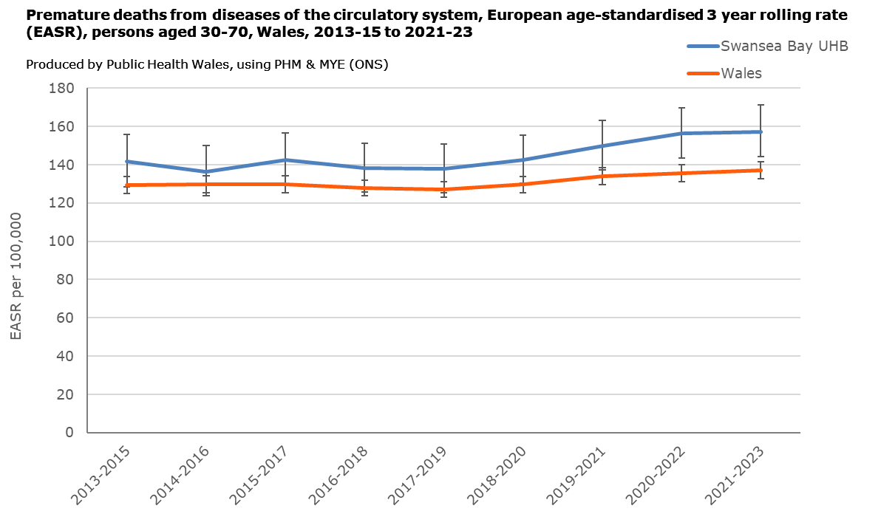

Evidence-based practice to reduce premature mortality

As the causes for cardiovascular disease are multi-factorial, approaches towards preventing the development or the worsening of cardiovascular disease and premature mortality require multiple approaches. These include:

- Early identification of risk factors and management
- Optimising the management of co-morbidities
- Enabling healthy lifestyle choices
- Cross-partnership working on the wider determinants of health, including reducing inequalities
- Taking a ‘community by design’ approach, ensuring care can be provided where possible in the community setting, utilising hospital-based care only when this is required by more complex or escalating clinical need

These strategies include primary prevention where people are at high risk of developing cardiovascular disease, secondary prevention who already have cardiovascular disease but could reduce ongoing risk, and population-based strategies to lower the average risk of cardiovascular disease in the population.

There are many people living with risk factors for cardiovascular disease in Wales. Within this, there are two key groups. Those who are known to be high-risk, with risk factors already identified, and those who are not yet known. For example, it is estimated that around three-quarters million people in Wales have hypertension, but only 530,000 are known.

These cohorts pose different challenges for healthcare. For patients who are known to be high-risk, there is the need to correctly identify them, risk stratify, and ensure they are receiving optimal treatment to achieve control to minimise their risk. For those who are yet to be diagnosed, there are the challenges around how to proactively identify these individuals.

There are multiple causes of cardiovascular disease (CVD). Appendix 1 summarises the modifiable risk factors.

High blood pressure (hypertension) is an early disease marker and the major common risk factor for CVD, CHD (Coronary heart disease) and CBVD (Cerebrovascular disease or Strokes) with the attributable proportion of these conditions being due to this as 40, 46 and 49% respectively. Other key risk factors include dietary factors, high levels of ‘bad’ cholesterol known as Low density lipoprotein (LDL-C), Tobacco use, and Obesity. (See Appendix 1 for full details).

Identification and management of hypertension has been identified as a key evidence-based target as “the leading modifiable risk factor for cardiovascular disease in Wales” and is one of the core priority areas within the Core20Plus5 framework for reducing healthcare inequalities for adults.

Despite the recognised value and effectiveness in cardiovascular risk management, delivery against the recommended standards across Wales for those known to be high risk is not being met both in terms of initiation of treatment and optimisation of treatment, as well as the population at-risk who are still unknown.

At a population level in Wales, data from 2010-2022 showed assessment and treatment of modifiable risk factors decreased, with the proportion of patients receiving lipid-lowering therapy (LLT) dropping from 75.3% to 67.1% (2010-22) and lipid testing also decreasing. Assessment and control of blood pressure in this group is also poor with the stark statistic that over one third of adult patients not having any blood pressure assessments.
Barriers to adequate detection and control include: removal of previous quality and outcome framework requirements for primary care providers to routinely measure blood pressure, lack of awareness by patients concerning symptoms, or appreciation of the severity, health system pressures meaning poor follow up once diagnosis confirmed, data and digital capabilities, the effects of health inequalities, and poor optimisation by professionals or non-adherence by patients to medication.¹⁰

The continued approach to cardiovascular disease management requires a multi-faceted approach and working with stakeholders and partners across the system to lead the better overall outcomes.

- Current approaches

In Swansea Bay, there is work ongoing at local, regional, and national levels to support reducing the risk from cardiovascular disease in our population.

- Local
At a strategic level, the Health Board’s organisational strategy ‘A Healthier Swansea Bay’ sets out a vision around prevention, early intervention, and reducing health inequalities, supporting the principles set out in the SBHUHB Population Health Strategic Plan. The Core20Plus5 framework includes cardiovascular risk detection and management as a key priority area, and the upcoming clinical strategic plan (with underlying clinical services plans) will provide opportunity to support system enablers towards cardiovascular risk management.

Primary care already proactively identifies opportunities around cardiovascular disease, such as a pilot of blood pressure machines in general practice waiting rooms in one cluster. However, this is ad hoc, and not a whole-system comprehensive systematic approach, unlikely to impact population health measures. The health board public health team will continue to work with primary and community care around their strategic approaches to cardiovascular disease in practice.

In consideration of wider risk factor management, Health Board services including weight management and smoking cessation are delivered at smaller scale than appropriate for the needs of the population, however these and are fragile and partially funded by annually occurring Prevention and Early Years funding. The risks associated with these services have been reported elsewhere, but maintaining evidence-based core services for prevention is an important component in the Health Board’s role in supporting the reduction of cardiovascular disease and reducing healthcare inequalities.

- Regional
In 2022 Swansea University, Swansea Bay & Hywel Dda University Health Boards and the Tritech institute entered the “Next Generation Population Health: Demonstrating a comprehensive approach to risk prediction and prevention for cardiovascular disease” strategic partnership funding by a research grant from Amgen.

The vision of this programme was to deliver a ‘population health to clinical pathway’ approach to addressing the challenges in CVD risk factor management in Wales. This approach would (i) utilise population health data to describe the gap (and opportunity) in the delivery of evidenced based, prognostically beneficial treatment to high-risk patients (ii) undertake clinical pathway evaluation to address gap closure. Informed by outputs from the population data and clinical evaluation, with expert input from stakeholders develop a value-based proposal for the delivering improvements in risk factor management.

Phase 2 of this programme involved the implementation and evaluation of pharmacist-led, multi-disciplinary team (MDT) supported cardiovascular risk management clinics. These clinics aimed to optimise risk factor management (blood pressure (BP) and/or low-density lipoprotein cholesterol (LDL-C) also known as lipids) in patients with or at high-risk of cardiovascular disease.150 patients were recruited into clinics across two regional health boards (Swansea Bay and Hywel Dda University Health Boards) in rural and urban Wales. The evaluation considers the efficacy, feasibility, barriers, economics and acceptability to patients and healthcare professionals.
The goals included:
• Provide a holistic approach to health and care needs
• Optimise therapeutic management of patients (blood pressure (BP) and lipid (LDL-C) levels)
• Transform the ways of working for our clinicians and healthcare professionals, by providing a new method of delivering care
• Develop a Value Based Healthcare approach to inform the requirements of the service.
• Support the independence and wellbeing of our population, by offering education around healthy living.
A total of 157 patients were recruited, including 51 with atherosclerotic cardiovascular disease (ASCVD) and 106 primary prevention patients with a mean QRISK score of 22% (The QRISK score assesses 10-year risk of cardiovascular disease – a score of 20% or higher is ‘high-risk’ with at least a 20 in 100 chance of developing cardiovascular disease within 10 years).
Preliminary results are presented in figures 3, 4 and 5.
Figure 3. Change in systolic BP in primary prevention patients (with uncontrolled BP at initiation).
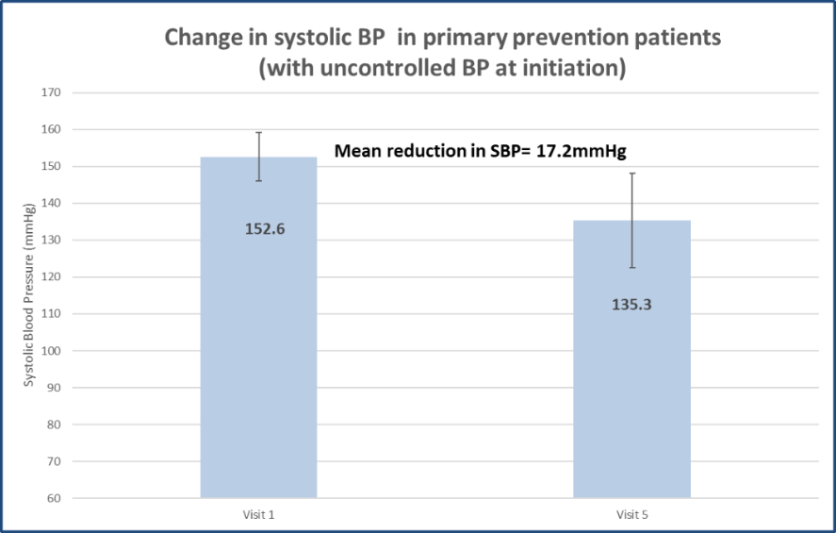

Figure 4. Change in systolic BP in secondary prevention patients with uncontrolled BP at initiation.
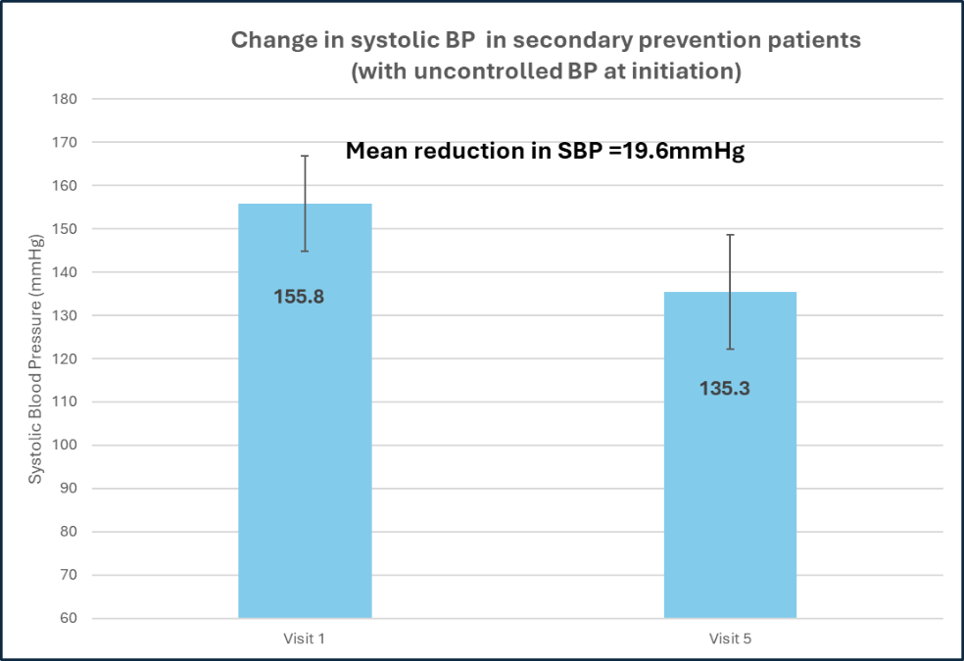

Figure 5: Changes in Low-density lipoprotein cholesterol (LDL-C) level in all secondary prevention patients
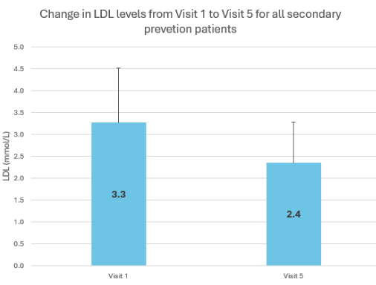

Discussions are ongoing to identify opportunities to build on the learning to date from this regional collaboration and to streamline translation from the research setting into clinical pathways.

- National

Cardiovascular disease risk management is a national priority supported through the National Strategic Clinical Networks and with the recent release of the ‘Cardiovascular Disease Prevention Plan for Wales: An ‘ABCD Plus’ Approach’ from Public Health Wales in September 2025.⁶ The plan highlights the ambition to identify people at high-risk of developing cardiovascular disease, treat ABCD risk factors, and support people to have healthy behaviours. Using the prevention-based health and care framework, it identifies the need for long-term capacity, knowledge and skills across the primary & community care workforce, and the system enablers including data and digital (to streamline identification), tools for primary & community care to undertake risk stratification and prioritisation and support the ongoing monitoring of population health indicators collaborating with stakeholders.⁶ However as demonstrated in the Appendix – ABCD highlights certain risk factors but not necessarily the most appropriate ones, so a Steering group to examine evidence nationally has been established, with Swansea Bay Deputy Director of Public Health on the membership.

- GOVERNANCE AND RISK ISSUES

Swansea Bay University Health Board has one of the highest rates for premature mortality from cardiovascular disease across England and Wales, and optimisation of those who are currently known to be high risk is sub-optimal, as well as people within the population who have risk factors which have not yet been identified.

There are risks to established services which support reduction of cardiovascular risk, including smoking cessation services and weight management services. Where these services are destabilised further, this is likely to have significant implications on the cardiovascular health of the population at risk.

- FINANCIAL IMPLICATIONS

No specific financial implications identified at this stage. However, if decisions are made to explore further initiatives for cardiovascular disease, this may have financial implications.

- RECOMMENDATION

Members are asked to:
- Receive information on the current burden of cardiovascular disease in Swansea Bay and current approaches to management at local, regional and national levels

- Discuss current approaches and further opportunities around cardiovascular disease prevention in the Health Board

Governance and Assurance

Link to Enabling Objectives  (please choose) | Supporting better health and wellbeing by actively promoting and empowering people to live well in resilient communities
Link to Enabling Objectives  (please choose) | Partnerships for Improving Health and Wellbeing |  | ☒
Link to Enabling Objectives  (please choose) | Co-Production and Health Literacy |  | ☐
Link to Enabling Objectives  (please choose) | Digitally Enabled Health and Wellbeing |  | ☐
Link to Enabling Objectives  (please choose) | Deliver better care through excellent health and care services achieving the outcomes that matter most to people
Link to Enabling Objectives  (please choose) | Best Value Outcomes and High Quality Care |  | ☒
Link to Enabling Objectives  (please choose) | Partnerships for Care |  | ☒
Link to Enabling Objectives  (please choose) | Excellent Staff |  | ☐
Link to Enabling Objectives  (please choose) | Digitally Enabled Care |  | ☐
Link to Enabling Objectives  (please choose) | Outstanding Research, Innovation, Education and Learning |  | ☒
Health and Care Standards
(please choose) | Staying Healthy |  | ☒
(please choose) | Safe Care |  | ☐
(please choose) | Effective Care |  | ☒
(please choose) | Dignified Care |  | ☐
(please choose) | Timely Care |  | ☒
(please choose) | Individual Care |  | ☐
(please choose) | Staff and Resources |  | ☐
Quality, Safety and Patient Experience
By improving how cardiovascular risk is managed and enhancing compliance with evidence-based prevention, cardiovascular health outcomes can be improved and enable more people to stay healthy for longer, as well as reduce healthcare inequalities.

Financial Implications
No specific financial implications identified at this stage. However, if decisions are made to explore further initiatives for cardiovascular disease, this may have financial implications.

Legal Implications (including equality and diversity assessment)
No legal implications identified. Improved identification and management of cardiovascular risk factors will particularly benefit people from more deprived backgrounds and higher-risk groups, who typically have higher rates of cardiovascular disease risk factors.

Staffing Implications
No direct staffing implications identified at this stage.

Long Term Implications (including the impact of the Well-being of Future Generations (Wales) Act 2015)
Cardiovascular disease has a widespread impact on the health of the population, including on the individual and the wider population and economy. The focus is on prevention to support ‘A Healthier Wales’, with optimisation of cardiovascular risk factors having the opportunity to improve the long-term health and well-being of the population.

Report History |  | No previous papers
Appendices |  | Appendix 1 - Relative contribution of modifiable risk factors for CVD, CHD and CBVD England 2021

British Heart Foundation. 2025. BHF Wales CVD Factsheet
British Heart Foundation 2024. Heart and Circulatory Statistics bhf-cvd-statistics-compendium-2024-v3.pdf
UCL Partners Health Innovation Size of the Prize for high blood pressure
Geographical inequalities in premature mortality in England and Wales - Office for National Statistics
Public Health Wales Observatory. 2025. Premature deaths by two disease types.
Community by Design - Primary Care One
NICE 2025. Strategies for CVD prevention | Background information | CVD risk assessment and management | CKS | NICE
National Strategic Clinical Network for Cardiovascular conditions. 2025. CVD_AtlasOfVariation_v1 - Power BI
British Heart Foundation 2025. Heart & Circulatory Disease Statistics 2025
British Heart Foundation 2025. Tackling High Blood Pressure: Wales’ silent killer.
NHS England. NHS England » Core20PLUS5 (adults) – an approach to reducing healthcare inequalities
Harris DE, King D, Akbari A, Gravenor M, Lawrence M, Weston C, et al. Trends in Atherosclerotic Cardiovascular Disease and lipid management. A population-level observational cohort study in Wales. Eur J Prev Cardiol 2024. doi: https://doi.org/10.1093/eurjpc/zwae233
British Heart Foundation 2025. QRISK: how it works and what your score means - BHF

