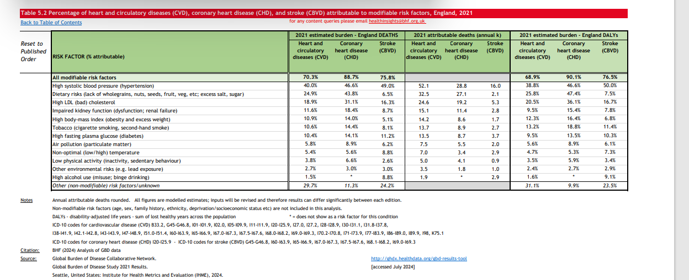

Appendix 1
Relative contribution of modifiable risk factors for CVD, CHD and CBVD England 2021
https://www.bhf.org.uk/-/media/files/for-professionals/research/heart-statistics/bhf-statistics-compendium-2025

