Meeting Date | 04 December 2025 |  | Agenda Item |  |  | 2.1
Name of Meeting | Population Health Committee
Report Title | Lung Cancer Screening
Report Author | Chris Coslett, Lung Health Check Programme Manager & Heather Lewis, Public Health Wales
Report Sponsor | Prof Dr Gill Richardson Executive Director Public Health (Interim)
Presented by | Chris Coslett, Lung Health Check Programme Manager
Freedom of Information | Open
Purpose of the Report | To update the Committee on the planning and implementation of Lung Cancer Screening in Wales and the implications for Swansea Bay University Health Board
Key Issues | To inform the Committee of the planned implementation of Lung Cancer Screening and its implications for Swansea Bay University Health Board
Specific Action Required  (please choose one only) | Information | Discussion |  | Assurance | Approval
Specific Action Required  (please choose one only) | ☒ | ☒ |  | ☐ | ☐
Recommendations | Members are asked to:  - RECIEVE the report for information and to inform future planning.

Lung Cancer Screening in Wales

- INTRODUCTION

The paper will provide an update to the Committee in relation to the planning and implementation of Lung Cancer Screening in Wales and the implications for Swansea Bay University Health Board.

- BACKGROUND

Lung cancer is the third most common type of cancer in Wales but is by far the leading cause of cancer deaths, and the fifth most common cause of death in Wales overall. Whilst there have been numerous advances in the diagnosis and treatment of lung cancer over recent years, there has been little improvement in survival from lung cancer in Wales, which has consistently been the lowest in the UK and amongst the lowest in the developed world. Most cases of lung cancer in Wales (around 75%) are detected at a late stage (stage 3 or 4), when the cancer has spread beyond the lung and is rarely curable. In comparison, early-stage lung cancer (stage 1 or 2) can often be cured by surgery or radiotherapy, leading to excellent long-term survival.

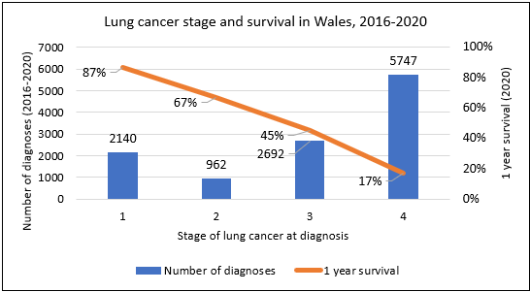

Screening of people who are at high risk of lung cancer (based on their age, smoking history and other risk factors) by low-dose CT (LDCT) scan of the chest is proven to detect lung cancer at an earlier stage and to reduce lung cancer mortality by around 25%.

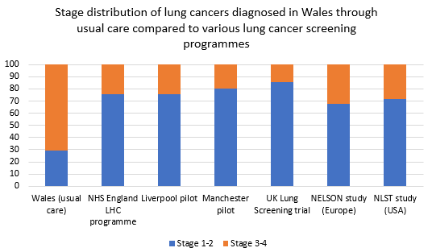

In recognition of the evidence in favour of lung cancer screening, the UK National Screening Committee published a positive recommendation for lung cancer screening in 2022: ‘Targeted screening for lung cancer is recommended for people aged 55 to 74 identified as being at high risk of lung cancer. Evidence shows that screening with low dose computed tomography: reduces lung cancer mortality, is acceptable to patients and professionals if adequately resourced and quality assured.’ The UK NSC recommended that the 4 nations move towards implementation of targeted lung cancer screening with integrated smoking cessation service provision. In November 2022 the Wales Screening Committee accepted the UK NSC recommendation in principle and supported that work be taken forward to establish a national targeted lung cancer screening programme in Wales.

In 2023 an operational pilot (OP) of lung cancer screening commenced in the North Rhondda area in Wales, with the aim of delivering LDCT screening scans to 500 participants. The OP has now been completed, having delivered over 600 LDCT screening scans and leading to the diagnosis of 12 lung cancers, 67% at an early stage and 82% necessitating radical treatment. An evaluation report was published in September 2024, concluding that: (1) lung cancer screening can be delivered effectively within the Welsh healthcare system; (2) lung cancer screening is likely to yield benefits similar to those seen in studies, pilots and programmes elsewhere; and (3) a lung cancer screening programme would significantly improve lung cancer outcomes compared to current care in Wales.

The Welsh Government commissioned Public Health Wales to undertake an exercise scoping how lung cancer screening could be delivered in Wales in the future and making recommendations in relation to this. It was initially agreed that an interim report would be provided in March 2025, with a final report in September 2025, however it was subsequently requested that the March report be as complete as possible to potentially support an early decision regarding the introduction of a lung cancer screening programme in Wales. A report was submitted to the Welsh Government on the 27 March 2025, setting a recommended pathway and delivery model for lung cancer screening in Wales, estimated costs and an indicative timeline for implementation.

A letter was received by Public Health Wales (PHW) from the Welsh Government on 26 June 2025 advising that the Cabinet Secretary had agreed to the recommended model of delivery and the phased approach to delivering the programme. A public statement was then published on the 28 June 2025, stating that the Welsh Government would be introducing a lung cancer screening programme in Wales.

- Delivery Model

Following approval from the Welsh Government to the recommendations made in the scoping report, PHW are tasked with implementing the agreed pathway and delivery model for lung cancer screening. This has been summarised into a plan on a page, setting out the high-level pathway and approach to delivery at each stage:

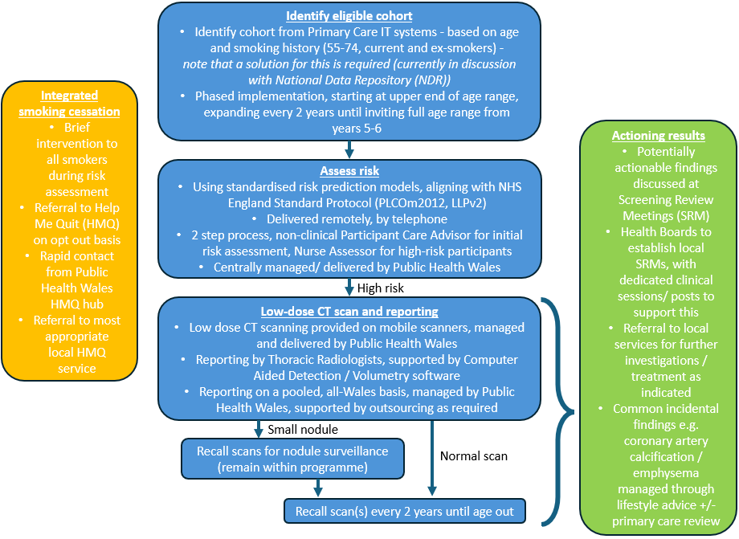

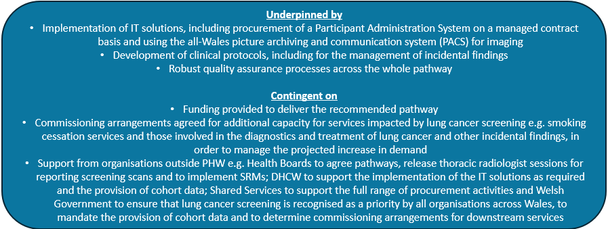

- Implications for Swansea Bay University Health Board

Screening Review Meetings
In order to allow findings requiring actions to be efficiently linked up to local pathways, Screening Review Meetings will be delivered by each Health Board.

SRMs would require facilities similar to those used for MDTs such as a meeting room where imaging and clinical records can be reviewed including videoconferencing equipment to facilitate remote attendance as necessary. It is estimated, based on the pilot in CTMUHB, that a weekly, 90 minute long meeting would be required within each Health Board.

The Programme would commission the HBs to undertake the SRMs and would usually include:
- Senior Respiratory clinician
- Thoracic Radiologist
- Specialist Nurse
- Navigator/Administrator

The diagram below illustrates how SRMs fit into the lung cancer screening pathway.
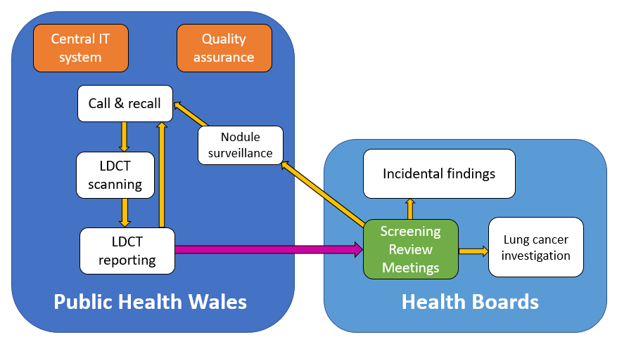

Lung Cancers Detected

Based on modelling data derived from multiple sources, the anticipated change in demand on lung cancer diagnostic services for Swansea Bay UHB is shown below over the first 10 years of the programme.
 | Year of phased roll-out
 | 1 | 2 | 3 | 4 | 5 | 6 | 7 | 8 | 9 | 10
Screen-detected lung cancers diagnosed/yr | 30 | 30 | 38 | 38 | 45 | 45 | 45 | 45 | 46 | 46
Additional lung cancers diagnoses/year (offset by when same cancers would have been detected without screening) | 26 | 20 | 20 | 13 | 13 | 10 | 6 | 5 | 5 | 5
Additional Single Cancer Pathway cases/yr | 38 | 32 | 50 | 42 | 58 | 54 | 43 | 42 | 43 | 43
Additional PET scans/yr | 32 | 29 | 46 | 43 | 58 | 57 | 48 | 48 | 49 | 49
Additional Lung function tests/yr | 35 | 32 | 51 | 47 | 64 | 62 | 53 | 52 | 53 | 53
Additional CT-guided lung biopsy/yr | 20 | 18 | 30 | 28 | 38 | 37 | 31 | 31 | 32 | 32
Additional EBUS/yr | 14 | 11 | 15 | 10 | 14 | 12 | 8 | 7 | 7 | 7

Incidental Findings

Protocols for the reporting and actioning of incidental findings will be in place to support delivery of the screening programme. These are likely to align with protocols and guidance already in use elsewhere, such as the Joint Clinical Practice Statement on incidental findings in lung cancer screening published by the European societies for Respiratory Medicine, Radiology, Thoracic Surgeons, and Nuclear Medicine.
Very common incidental findings
Emphysema and coronary artery calcification are very common in the population eligible for lung cancer screening, being present in more than half of those undergoing LDCT in the LHC Operational Pilot for Wales. The approach to these findings is undergoing specific review and consultation with primary care representatives.
Other incidental findings
In the LHC Operational pilot for Wales, 12.8% of baseline LDCT scans had a potentially actionable incidental finding. However, this reduced to 7.3% (-5.5%) after review at a weekly SRM meeting, most commonly due to determining that the finding was previously known and therefore did not require further action. This highlights the importance of SRMs in the lung cancer screening pathway.
Of the remaining actionable incidental findings, the most common was moderate/severe aortic valve calcification, which occurred on 2.3% of baseline LDCT scans. Engagement with the National Strategic Clinical Network for Cardiovascular Conditions is underway regarding this.
All other actionable incidental findings occurred on less that 1% of baseline scans. Based on the results of the LHC Operational Pilot for Wales, and a phased roll-out the table below shows the projected number of actionable respiratory incidental findings per year for Swansea Bay UHB over the first 10 years of roll-out.

 | Year of phased roll-out
 | 1 | 2 | 3 | 4 | 5 | 6 | 7 | 8 | 9 | 10
Interstitial lung disease | 8 | 8 | 9 | 9 | 8 | 8 | 3 | 3 | 3 | 3
Inflammatory change | 4 | 4 | 4 | 4 | 4 | 4 | 2 | 2 | 2 | 2
Pleural | 10 | 10 | 11 | 11 | 11 | 11 | 4 | 4 | 4 | 4
Bronchiectasis | 4 | 4 | 4 | 4 | 4 | 4 | 2 | 2 | 2 | 2
Mediastinal lesion | 2 | 2 | 2 | 2 | 2 | 2 | 1 | 1 | 1 | 1

Thoracic Surgery
A summary of the outputs from this work in relation to the projected impact on Thoracic Surgery is provided below. It is important to note that this is based on implementation being phased over six years with a steady state being achieved in year 7.
Projected additional thoracic surgery from Lung Cancer Screening, by year (based on phased roll out starting at 67-74 and expanding to 55-74 year olds from year 5):
Region | Year
Region | 1 | 2 | 3 | 4 | 5 | 6 | 7 | 8 | 9 | 10
SE Wales* | 59 | 53 | 63 | 56 | 65 | 62 | 58 | 57 | 58 | 58
S&W Wales* | 33 | 30 | 35 | 31 | 36 | 34 | 32 | 32 | 32 | 32
North Wales* | 30 | 27 | 32 | 28 | 33 | 31 | 29 | 29 | 29 | 29
Powys | 7 | 6 | 7 | 6 | 7 | 7 | 6 | 6 | 6 | 6
Total | 128 | 116 | 137 | 122 | 141 | 134 | 126 | 123 | 126 | 126
*SE Wales assumed to include activity from ABHB, C&V and CTM UHBs; S&W Wales assumed to include HD and SB UHBs; North Wales assumed to include BCU UHB.

Radiotherapy and SACT
The modelling work has been developed based on evidence from a number of sources, including the NHS England Targeted Lung Health Check Programme, the Lung Health Check Operational Pilot for Wales, previous trials e.g. NELSON/ National Lung Screening Trial (NLST), StatsWales and the UK National Screening Committee Cost Effectiveness report.
The outputs from this work in relation to the projected impact on Radiotherapy and SACT is provided below. Lung cancer screening will be gradually phased over a period of time, with the service initially being offered to 67-74 year olds and the age range then expanded every 2 years until meeting the full cohort of 55-74 from year 5.

Projected impact on demand for SACT following the implementation of Lung Cancer Screening, by year (based on phased roll out starting at 67-74 and expanding to 55-74 year olds from year 5):
Region* | Treatment** | Year
Region* | Treatment** | 1 | 2 | 3 | 4 | 5 | 6 | 7 | 8 | 9 | 10
SE Wales | Chemo-radiotherapy/ Immuno Oncology | 3 | 2 | 1 | -1 | -2 | -3 | -3 | -4 | -4 | -4
SE Wales | Chemotherapy | 1 | -1 | -2 | -4 | -5 | -6 | -7 | -7 | -7 | -7
SE Wales | Chemotherapy doublet | 6 | 4 | 3 | 0 | -2 | -3 | -4 | -5 | -5 | -5
SE Wales | Immunotherapy | 3 | 0 | -2 | -6 | -9 | -11 | -12 | -13 | -13 | -13
SE Wales | Chemo-immunotherapy | 3 | -2 | -6 | -11 | -15 | -17 | -19 | -20 | -21 | -21
SE Wales | Tyrosine kinase inhibitor (TKI) | 5 | 2 | 0 | -4 | -6 | -7 | -9 | -10 | -10 | -10
S&W Wales | Chemo-radiotherapy/ Immuno Oncology | 2 | 1 | 1 | -1 | -1 | -1 | -2 | -2 | -2 | -2
S&W Wales | Chemotherapy | 1 | 0 | -1 | -2 | -3 | -3 | -4 | -4 | -4 | -4
S&W Wales | Chemotherapy doublet | 3 | 2 | 2 | 0 | -1 | -2 | -2 | -3 | -3 | -3
S&W Wales | Immunotherapy | 2 | 0 | -1 | -4 | -5 | -6 | -7 | -7 | -7 | -7
S&W Wales | Chemo-immunotherapy | 1 | -1 | -3 | -6 | -8 | -10 | -11 | -11 | -12 | -12
S&W Wales | Tyrosine kinase inhibitor (TKI) | 3 | 1 | 0 | -2 | -3 | -4 | -5 | -5 | -5 | -5
North Wales | Chemo-radiotherapy/ Immuno Oncology | 2 | 1 | 1 | 0 | -1 | -1 | -2 | -2 | -2 | -2
North Wales | Chemotherapy | 1 | 0 | -1 | -2 | -3 | -3 | -3 | -4 | -4 | -4
North Wales | Chemotherapy doublet | 3 | 2 | 1 | 0 | -1 | -1 | -2 | -2 | -2 | -2
North Wales | Immunotherapy | 2 | 0 | -1 | -3 | -4 | -5 | -6 | -6 | -7 | -7
North Wales | Chemo-immunotherapy | 1 | -1 | -3 | -6 | -8 | -9 | -10 | -10 | -11 | -11
North Wales | Tyrosine kinase inhibitor (TKI) | 2 | 1 | 0 | -2 | -3 | -4 | -4 | -5 | -5 | -5
*SE Wales assumed to include activity from ABHB, C&V and CTM UHBs; S&W Wales assumed to include HD and SB UHBs; North wales assumed to include BCU UHB.
Projected impact on demand for Radiotherapy following the implementation of Lung Cancer Screening, by year (based on phased roll out starting at 67-74 and expanding to 55-74 year olds from year 5):
Region* | Treatment | Year
Region* | Treatment | 1 | 2 | 3 | 4 | 5 | 6 | 7 | 8 | 9 | 10
SE Wales | Radiotherapy for curative intent (SABR) | 14 | 13 | 16 | 14 | 17 | 16 | 15 | 15 | 15 | 15
SE Wales | Radiotherapy for curative intent (non-SABR) | 6 | 5 | 5 | 4 | 4 | 4 | 3 | 3 | 3 | 3
SE Wales | Palliative radiotherapy | 4 | -4 | -11 | -22 | -30 | -34 | -38 | -39 | -41 | -41
S&W Wales | Radiotherapy for curative intent (SABR) | 8 | 7 | 9 | 8 | 9 | 9 | 8 | 8 | 8 | 8
S&W Wales | Radiotherapy for curative intent (non-SABR) | 3 | 3 | 3 | 2 | 2 | 2 | 2 | 2 | 2 | 2
S&W Wales | Palliative radiotherapy | 2 | -2 | -6 | -12 | -17 | -19 | -21 | -22 | -23 | -23
North Wales | Radiotherapy for curative intent (SABR) | 7 | 7 | 8 | 7 | 8 | 8 | 8 | 8 | 8 | 8
North Wales | Radiotherapy for curative intent (non-SABR) | 3 | 3 | 3 | 2 | 2 | 2 | 2 | 1 | 1 | 1
North Wales | Palliative radiotherapy | 2 | -2 | -6 | -11 | -15 | -17 | -19 | -20 | -21 | -21
*SE Wales assumed to include activity from ABHB, C&V and CTM UHBs; S&W Wales assumed to include HD and SB UHBs; North wales assumed to include BCU UHB.
Smoking Cessation
Projected impact on Help me Quit services from Lung Cancer Screening, by year (based on phased roll out starting at 67-74 and expanding to 55-74 year olds from year 5):

- Total referred to HMQ services from lung cancer screening:
Year | AB | BCU | C&V | CTM | HD | PT | SB | Total
1 | 385 | 480 | 278 | 284 | 284 | 105 | 244 | 2059
2 | 385 | 480 | 278 | 284 | 284 | 105 | 244 | 2060
3 | 583 | 727 | 420 | 430 | 430 | 159 | 370 | 3118
4 | 583 | 727 | 420 | 430 | 430 | 159 | 370 | 3118
5 | 769 | 960 | 555 | 567 | 568 | 210 | 488 | 4116
6 | 769 | 960 | 555 | 567 | 568 | 210 | 488 | 4116

- Total additional people accept support from HMQ services:
Year | AB | BCU | C&V | CTM | HD | PT | SB | Total
1 | 202 | 167 | 146 | 137 | 173 | 57 | 127 | 1009
2 | 202 | 167 | 146 | 137 | 173 | 57 | 127 | 1009
3 | 336 | 335 | 243 | 236 | 273 | 94 | 212 | 1728
4 | 336 | 335 | 243 | 236 | 273 | 94 | 212 | 1728
5 | 463 | 493 | 334 | 330 | 366 | 128 | 293 | 2407
6 | 463 | 493 | 334 | 330 | 366 | 128 | 293 | 2407

- Total additional people access community services and % impact on current activity:
Year | AB | BCU | C&V | CTM | HD | PT | SB | Total
1 | 114 | 70 | 82 | 74 | 105 | 33 | 71 | 549
2 | 114 | 70 | 82 | 74 | 105 | 33 | 71 | 549
3 | 199 | 176 | 144 | 136 | 167 | 56 | 125 | 1003
4 | 199 | 176 | 144 | 136 | 167 | 56 | 125 | 1003
5 | 279 | 275 | 201 | 195 | 226 | 78 | 176 | 1431
6 | 279 | 275 | 201 | 195 | 226 | 78 | 176 | 1431

Year | AB | BCU | C&V | CTM | HD | PT | SB | Total
1 | 9% | 6% | 10% | 9% | 10% | 9% | 9% | 9%
2 | 9% | 6% | 10% | 9% | 10% | 9% | 9% | 9%
3 | 16% | 15% | 17% | 16% | 16% | 16% | 16% | 16%
4 | 16% | 15% | 17% | 16% | 16% | 16% | 16% | 16%
5 | 23% | 23% | 23% | 23% | 22% | 22% | 23% | 23%
6 | 23% | 23% | 23% | 23% | 22% | 22% | 23% | 23%

- Total additional people access Pharmacy L3 support and % impact on current activity:
Year | AB | BCU | C&V | CTM | HD | PT | SB | Total
1 | 88 | 97 | 63 | 63 | 69 | 24 | 56 | 459
2 | 88 | 97 | 63 | 63 | 69 | 24 | 56 | 459
3 | 138 | 159 | 99 | 100 | 105 | 38 | 87 | 726
4 | 138 | 159 | 99 | 100 | 105 | 38 | 87 | 726
5 | 185 | 218 | 133 | 134 | 140 | 51 | 117 | 977
6 | 185 | 218 | 133 | 134 | 140 | 51 | 117 | 977

Year | AB | BCU | C&V | CTM | HD | PT | SB | Total
1 | 7% | 7% | 8% | 7% | 7% | 7% | 7% | 7%
2 | 7% | 7% | 8% | 7% | 7% | 7% | 7% | 7%
3 | 11% | 11% | 12% | 11% | 11% | 11% | 11% | 11%
4 | 11% | 11% | 12% | 11% | 11% | 11% | 11% | 11%
5 | 15% | 15% | 16% | 15% | 15% | 15% | 15% | 15%
6 | 15% | 15% | 16% | 15% | 15% | 15% | 15% | 15%

- GOVERNANCE AND RISK ISSUES
No governance and risk issues have been identified at this stage.

- FINANCIAL IMPLICATIONS
Public Health Wales advises that financial implications have not been fully identified at this stage. Resources will be needed to implement weekly screening review meetings in SBUHB in – house, and meet the additional demand placed on cancer diagnostic and treatment services, and smoking cessation services, as listed above. These have not been quantified in financial terms at this stage but will feed into financial planning. PHW will advise of timescales for introduction as soon as Ministerial decisions can be communicated.

- RECOMMENDATION
To receive the paper for information and to inform future planning

Governance and Assurance

Link to Enabling Objectives  (please choose) | Supporting better health and wellbeing by actively promoting and empowering people to live well in resilient communities
Link to Enabling Objectives  (please choose) | Partnerships for Improving Health and Wellbeing |  | ☐
Link to Enabling Objectives  (please choose) | Co-Production and Health Literacy |  | ☐
Link to Enabling Objectives  (please choose) | Digitally Enabled Health and Wellbeing |  | ☐
Link to Enabling Objectives  (please choose) | Deliver better care through excellent health and care services achieving the outcomes that matter most to people
Link to Enabling Objectives  (please choose) | Best Value Outcomes and High Quality Care |  | ☒
Link to Enabling Objectives  (please choose) | Partnerships for Care |  | ☒
Link to Enabling Objectives  (please choose) | Excellent Staff |  | ☐
Link to Enabling Objectives  (please choose) | Digitally Enabled Care |  | ☒
Link to Enabling Objectives  (please choose) | Outstanding Research, Innovation, Education and Learning |  | ☐
Health and Care Standards
(please choose) | Staying Healthy |  | ☐
(please choose) | Safe Care |  | ☒
(please choose) | Effective Care |  | ☒
(please choose) | Dignified Care |  | ☐
(please choose) | Timely Care |  | ☒
(please choose) | Individual Care |  | ☒
(please choose) | Staff and Resources |  | ☐
Quality, Safety and Patient Experience
None

Financial Implications
Public Health Wales advises that financial implications have not been fully identified at this stage. Resources will be needed to implement weekly screening review meetings in SBUHB in – house, and meet the additional demand placed on cancer diagnostic and treatment services, and smoking cessation services, as listed above. These have not been quantified in financial terms at this stage but will feed into financial planning. PHW will advise of timescales for introduction as soon as Ministerial decisions can be communicated.

Legal Implications (including equality and diversity assessment)
None

Staffing Implications
It is not known to what extent, at this stage, additional demand placed on cancer diagnostic and treatment services, and smoking cessation services, will have staffing implications.

Long Term Implications (including the impact of the Well-being of Future Generations (Wales) Act 2015)
None

Report History |  | N/A
Appendices |  | N/A

