
O 
Meeting Date | 26th September 2023 |  | Agenda Item |  |  | 5.1
Report Title | Urgent and Emergency Care Improvement
Report Author | Richard Lee, Senior Project Director - 6 Goals  Jonathon Baglow, Business Intelligence
Report Sponsor | Deb Lewis, Chief Operating Officer
Presented by | Richard Lee, Senior Project Director - 6 Goals
Freedom of Information | Open
Purpose of the Report | To provide a summary of the Morriston Urgent and Emergency Care (U&E) improvement programme to improve the delivery of timely, safe patient care and the U&E care standards.
Key Issues | U&E care performance has been escalated into enhanced performance monitoring with the Chief Operating Officer holding oversight and assurance against developing and monitoring a U&E care improvement programme.  The delivery of the 4-hour standard remains a significant challenge and the risk of patients coming to harm due to delays in both assessment and treatment remains a key focus for the ED clinical management team. In addition, the overcrowding of the ED linked to poor flow and delayed admission of patients into the in-patient bed pool results in poor patient experience, reduced ED capacity to assess new attendees to the department and frequently prevents protection of resuscitation capacity to treat very sick patients who require immediate clinical intervention.  There are key system performance indicators that explain the challenges associated with delivering timely and safe patient care and thus the required levels of performance and these are discussed in the paper.  Service development schemes are in place and continue to be developed and implemented to support the recovery of UEC performance.  A structured approach for the UEC programme, approved by NHS Wales 6 goals programme is in place to support, deliver and monitor the schemes reporting to the UEC Board
Specific Action Required  (Please choose one only) | Information | Discussion |  | Assurance | Approval
Specific Action Required  (Please choose one only) | ☒ | ☐ |  | ☒ | ☐
Recommendations | Members are asked to:  - NOTE the U&E care performance position and the ongoing actions taken to support its recovery and Improvement.

Urgent and Emergency Care Recovery Plan 2022-23

- INTRODUCTION

The report below describes urgent and emergency care activity and performance to date including progress against the U&E care standards. Wider system indicators are also used to demonstrate the flow constraints that exist resulting in poor access to timely urgent and emergency care and poor patient experience. The report provides an update on the strategic programme to improve the delivery of acute medical services to patients and on local improvement actions.

- BACKGROUND

Patient flow at Morriston continues to be significantly compromised due to the high occupancy level in which the hospital is operating. This is further exacerbated by the system flow challenges which impact patients transferring in a timely way into services outside of Morriston which increases delays in clinically optimised patients and increases the number of patients being treated outside of their core bed base. The impact of the lack of flow also has unintended consequences in other parts of the urgent and emergency care system including:

- Delay in patients being offloaded from ambulances into the ED;
- Delays in patients accessing ward beds and requiring ‘boarding’ within the ED, including resuscitation;
- Delay in step down from ITU onto general wards;
- Delay in patients gaining access to the ‘right ward first time’ as reflected in stroke and # NoF performance;
- Delay in transferring major trauma and regional specialty patients into the specialist services at SBUHB;
- Delays in patients transferring to the next stage of their recovery – complex and general rehabilitation at NPT and Singleton;
- Inability to increase elective capacity on the Morriston site to treat ‘Morriston Only Patients’ and the impact this has from a patient safety, quality and experience perspective;

To improve and ensure focused delivery on the U&E care performance, there has been a further review of the Morriston U&E care improvement plan, incorporating ambulance handover improvement plans, in addition to the implementation of the AMSR programme which commenced in a transitional phase on 5th December 2022, and is now fully implemented.

Wider health board schemes targeting admission avoidance and earlier discharge are also in place to support the wider system flow agenda.

- PERFORMANCE –Tier 1 urgent & emergency care standards

The SPC Charts below demonstrate performance against the ED Access Standards and Ambulance handovers (12-month rolling position). Overall, 4-hour performance has improved during 2023 when compared to 2022, underpinned by a noticeable improvement within the Morriston site. Similarly, the number of patients waiting for 12 hours or more also reduced back to the 2022 baseline level.
Despite the recent improvement, the ongoing challenging situation and generally poor performance in the 4-hour standard at Morriston translates operationally to poor patient experience and risk as patients can wait several hours for assessment by a clinician during which period their condition may be more serious than as assessed at triage, or may have deteriorated. Health Inspectorate Wales action plans continue to be monitored via weekly escalation meetings.
The department continues to have additional capacity open and whilst respiratory pathways are now in place the demands and acuity in the department cannot support closing these areas. The resulting impact would be increased offload delays and a risk to patient safety.
The workforce paper has been reviewed by the MSG management team and will now be submitted for financial approval.
The overall non-delivery of the 12-hour urgent and emergency care target relates predominantly to the system flow challenges and unavailability of in-patient beds. Patients waiting in ED for admission to an acute specialty bed will have been referred through several routes. There are those patients who will have presented as ‘walk-in’ to the department in addition to the ambulance arrivals. Due to the tertiary services on site, there are also urgent clinical transfers that are admitted from other hospitals that also default to ED due to lack of capacity. The 12-hour standard is directly linked to system flow and the challenges experienced within SBUHB are common across NHS Wales.

36 months to 31st August 2023
Front Door Measures
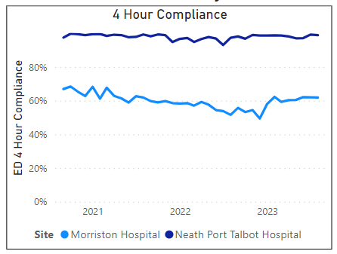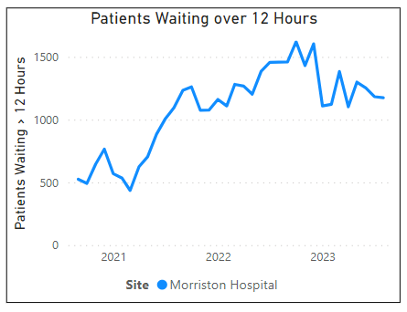

3.1 Ambulance attendance and handover delays >1 hour

Ambulance attendance to ED remains at a reduced level compared to pre-covid levels. A new baseline / stable level of arrivals is occurring on a month–by–month basis. This can be explained by several factors including:

- WAST Clinical Safety Plan is the escalation framework for WAST. Their actions will vary depending on the level of escalation reported however at moderate to high levels of escalation, ambulance response is ‘rationed’ and persons in lower acuity categories will not receive an ambulance response. Whilst ambulance arrival levels are reduced, this has increased in high acuity walk-in patients needing to go directly to the resuscitation spaces, and so the impact upon ED is not negated;

- Advanced practice paramedic screening of the waiting demand with redirection of appropriate patients to alternative pathways thus avoiding ED – the Advanced paramedics have recently moved into the acute hub and work alongside the acute GPs in Same Day Emergency Care which will allow improved opportunity for non-conveyance and redirection;

- GP review of the waiting ambulance demand with redirection into alternative community pathways, self-care or SDEC;

- Introduction of training to Nursing homes around the management of patients that have fallen ensures appropriate conveyance if required;

- Ambulance handover, whilst variable, remains stable and within control limits throughout the majority of the period (both in terms of the number of delays at an average of 658 and the average time for handover of 128 minutes)

- The time lost to delayed handover has reduced from an average of 174 minutes per vehicle in 2022 to circa 128 minutes this year so far, with periods of low handover delays (circa 20 minutes) to periods of high handover delays (circa 250 minutes) within the data. This is despite several ongoing initiatives at the front door including ‘fit to sit’, redirection to OPAS, and discharge direct from an ambulance, along with the opening of AMU (note, all ambulance data reflects ALL specialities and not just medicine):

36 months to 31st August 2023
Number of Emergency Ambulances Waiting for Handover

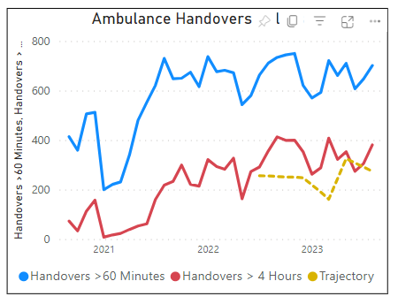

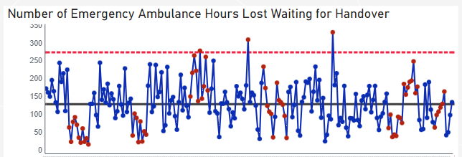
1st January to 31st August 2023
Number of Emergency Ambulance Hours Lost Waiting for Handover

1st January 2023 to 31st August 2023
Mean Number of Emergency Ambulance Hours Lost Waiting For Handover

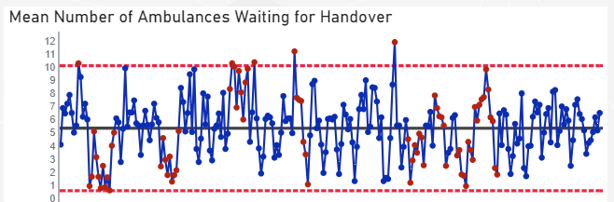

The reasons for the delays in ‘offloading’ are multi-factorial and include:
- Surges in demand from the ambulances or self-presenting patients;
- Availability of ‘red’ capacity to manage respiratory pathways
- Overcrowding in the ED caused by poor system flow site-wide resulting in the inability to admit patients into the hospital

The introduction of 2-hourly huddles in ED has re-focused attention on prioritising ambulance offloads and maintaining safety within the department.

Welsh Ambulance Service Trust (WAST) implemented its immediate release policy in July 2022 which has also put additional pressure on the teams through the addition of ‘amber 1’ (serious) calls extending this to cover both life-threatening (red) and serious (amber 1) calls. A robust escalation pathway which includes Bronze (Clinical Site Matron), Silver (Director of the Day chairing the safety huddle calls), Gold (Exec of the Day) and CEO in the event of 3 failures to release is in place to support this policy. Risks to patient safety for those in the ED are considered as part of the ‘amber 1’ release and since the introduction of this policy, there has been minimal ability to support the ‘amber 1 release’ but all requests for ‘red’ release have been supported.

Service improvement schemes have commenced in September to support the flow of patients out of AMU and the ED. These include:
- an Intergrated Discharge Hub to support complex discharges and return patients to community setting before admission
- criteria led discharge is being formalised in AMU and the ward areas with a roll out based on the successful roll out of SAFER
- the flow of ambulatory patients has been redesigned so attendees present at SDEC in the first instance
- changes to the acute physician rota to support the above schemes

The UHB has engaged with the national team and will be one of three sites in Wales to develop a flow model known as continuous flow. This model sets times that patients will move from the AMU to the medical wards throughout the day, 7 days per week. Once the improvement schemes listed above are evaluated this model will be implemented as a service development project. It has been implemented in parts of NHS England and as part of Swansea Bay’s approach we will be to evaluating this model Wales on behalf of the national team.

  - Wider system measures:

To understand performance in ED there is a requirement to explore wider system performance, the performance outputs in ED are directly impacted by performance in other parts of the health and social care system. There are internal measures that help to explain the ED crowding including:
- Length of stay
- Admission activity
- Clinically optimised position

    - Average Length of Stay (LOS)

The summary table overleaf provides an overview of the LOS for general medicine to highlight the challenges faced currently with regards to having sufficient capacity within the medicine bed base across the Health Board to support effective flow of patients from the ED.

The table above highlights a decrease in the acute LOS at Morriston for NON-COP medical patients (and for the overall average) so far in 2023/24 (post-AMSR). COP LOS for corrosion has also been reduced. The LOS of patients with a COP flag is however a significant issue directly affecting front-end performance and severely restricts the ability to maintain flow into, and through, the hospital system.

Length of stay reduction remains a key factor in successfully delivering the AMSR programme and these are being monitored via the Urgent and Emergency Care Board, chaired by the Chief Operating Officer.

    - Stay of Admitted Patients

The chart below demonstrates that the Length of Stay of all admitted emergency patients (whilst in a hospital bed in Morriston, Neath Port Talbot, or Singleton) suggests a spike occurred during July 23 in the number of long-stay patients (22days or more), before returning to the baseline level of circa 250 patients. Within this, circa 150 patients in Morriston Hospital have a LOS of 22-day or more, with an apparent increase in recent months. This level remains a critical factor requiring reduction; the majority of these patients will be clinically optimised, and the level directly affects the ability of front-end clinical systems (ED / AMU) to offload ambulances promptly, reduce/avoid overcrowding and ensure good flow occurs much earlier in the patient pathway.

Health Board WIDE 1st Jan 23 to 31st Aug 23

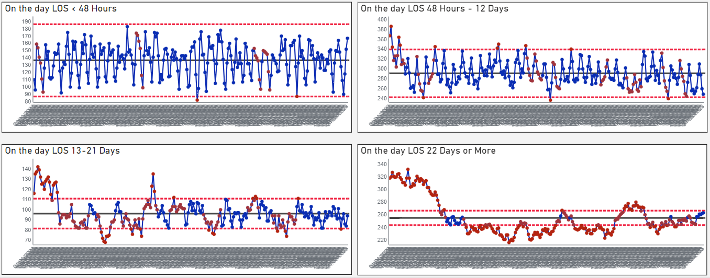
Morriston Hospital1st Jan 23 to 31st Aug 23
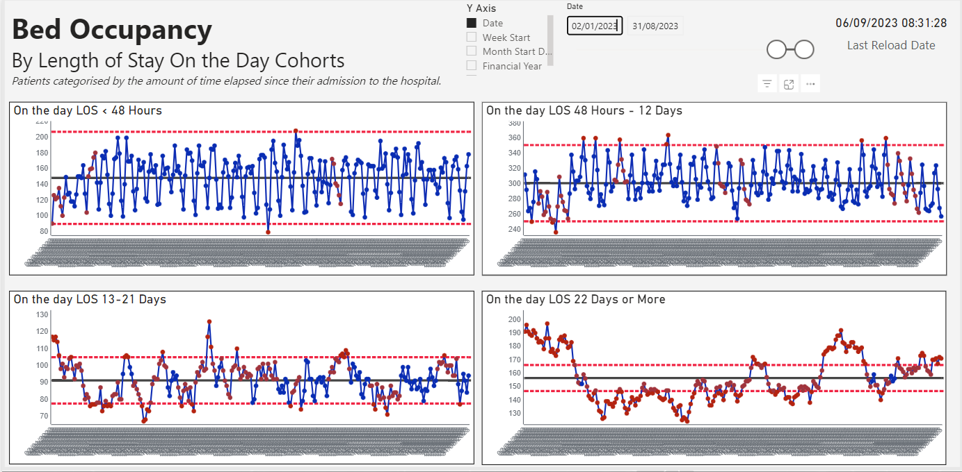
    - Weekly Admission activity (Acute Medical Emergencies, Morriston & Singleton):

At an aggregate level, acute Emergency Weekly Medical Admissions during 2023 (excluding ZERO DAY admission) peaked on March 23, and have remained above the average (bar April 23) level since September 2022, illustrating the year-round pressure experienced in the Health Board (i.e. not just Winter pressures).

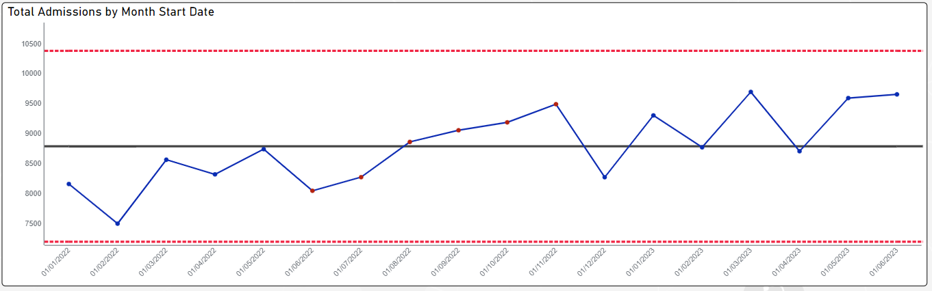

The data above does not include the level of patients in ED awaiting admission, which had remained relatively constant throughout the last 12 months at circa 40 patients (Jun 22 to July 23), but rose to 46 patients during August 2023.

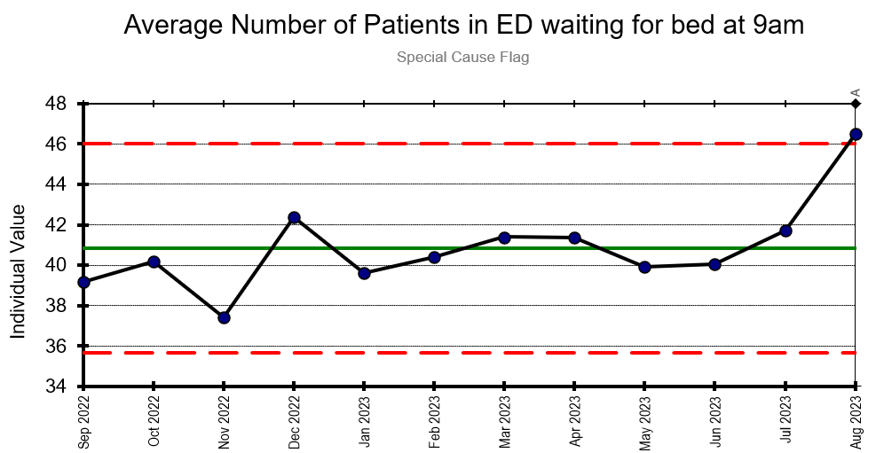

Clinically optimised position

The clinically optimised position in the Health Board remains a critical issue with significantly high numbers of patients occupying acute beds waiting to move to more appropriate settings to continue their care pathway or waiting for community support/placement.

There is operational focus on this patient group in all hospital sites with weekly review meetings with LA and community partners to expedite the pathways of these patients.

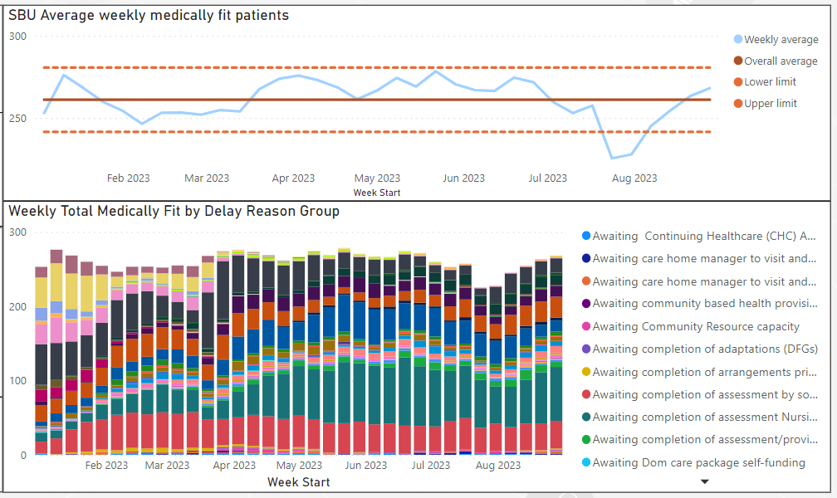

Morriston Hospital Clinically Optimised Patient Level 5th December 22 to 9th Sept 23

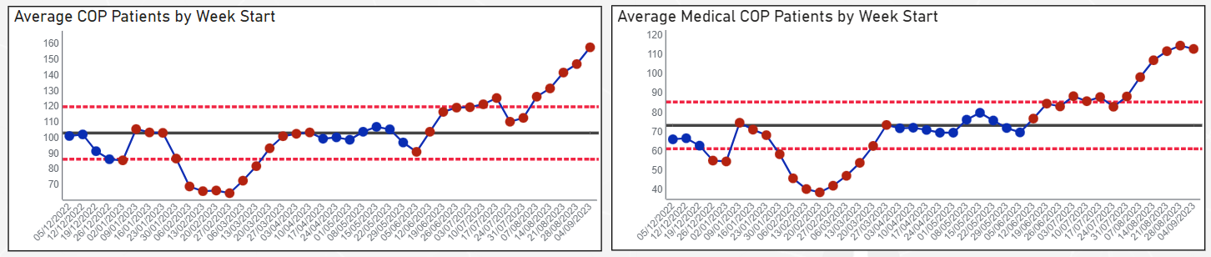

There is a ‘step up, step down programme of work being led by Primary Care, Community and Therapies services to the right size community services and thus prevent the prolonged patient delays in hospital beds. There is also a national and local focus on the delivery of the Discharge to Recover and Assess pathways to improve system flow. However, prevention of clinically optimised patients is demonstrating the greatest opportunity with services and teams aimed at avoiding admission of frail older persons who following an acute hospital stay often join the clinically optimised queue. The key question for the frail older person patient group is ‘Does the need to treat their acute presentation outweigh the well-evidenced risk of the negative impacts of hospitalisation in this patient population?’

Virtual wards are designed to increase the number of patients that can be discharged from an acute hospital ward (or not be admitted in the first place) and a working partnership between the Clinical Site team, ED and virtual wards has been established with a focus on increasing the number of patients discharged from the wards with support from the virtual ward teams. Currently, the majority of referrals are from primary care and community however there is joint work with the hospital sites to promote a ‘push/pull’ mechanism into virtual wards to balance the referral numbers between primary and secondary care.
Admission avoidance pathways have been developed with the OPAS team in Morriston and an ED in-reach pilot demonstrates a strong opportunity to pull patients from the ED directly into virtual wards.

The OPAS service co-located with the Emergency Department has been expanded based on the success of the service in terms of admission avoidance for frail older persons. The multi-disciplinary team undertake comprehensive geriatric assessment at the point of contact with the front door and with support from community teams and latterly virtual wards are very practised in admission avoidance for this patient group. In addition, WAST now has direct admission pathways into OPAS thus avoiding ED.

The Same Day Emergency Care service is also focussed on admission avoidance managing people with ambulatory-sensitive conditions on a same-day basis without the need for admission. The Health Board participated in the NHS Benchmarking of SDEC services (England and Wales) at the end of 2022 and participated in the National feedback review where considerable discussion took place about the actions and next steps required to further develop SDEC services.

- Recommendation
Members are asked to:
- NOTE the U&E care performance position and the ongoing actions taken to support its recovery and Improvement.

