


Meeting Date | 20 September 2023 |  | Agenda Item |  |  | 3.1
Report Title | Acquisition of Ty Maes y Gruffydd, Cefn Coed Hospital, Swansea
Report Author | Ian MacDonald, Assistant Director of Finance  Simon Davies, Capital Programme Manager
Report Sponsor | Darren Griffiths, Director of Finance and Performance
Presented by | Darren Griffiths, Director of Finance and Performance
Freedom of Information | Open
Purpose of the Report | This report requests Performance and Finance Committee to recommend the approval of the acquisition of Ty Maes y Gruffydd, a vacated building and associated land, currently in the ownership of the Welsh Ambulance Services NHS Trust (WAST).  The land is needed to provide sufficient space for the design and development of the Health Board’s Adult Acute Mental Health In-patient facility.
Key Issues | Board approval is required to acquire ownership of the land and building at Ty Maes y Gruffydd, Cefn Coed Hospital. Agreement on transfer of ownership to WAST has been reached with WAST and Welsh Government (WG).  The preferred location at Cefn Coed Hospital for the proposed new Adult Acute Mental Health In-patient and PICU (Psychiatric Intensive Care Unit) requires use of the land which the Ty Maes y Gruffydd building stands upon.  The transfer process will be run under the NHS Wales Estate Code in conjunction with NHS Wales Shared Services to ensure that the Health Board comply with governance procedures.  The value of the proposed area of land and building to be transferred from WAST is estimated at £675k as at 31st March 2023 [WAST to provide updated value for proposed 1st October 2023 transfer]. There will be no impact on the Health Board’s Capital Resource Limit.  Health Board governance requires Management Board support and this was received at the meeting on the 20th September 2023 before onward consideration of approval and ratification at the Performance and Finance Committee and the Health Board respectively.
Specific Action Required  (please choose one only) | Information | Discussion |  | Assurance | Approval
Specific Action Required  (please choose one only) | ☐ | ☐ |  | ☐ | ☒
Recommendations | The committee is asked to: -  - RECOMMEND APPROVAL of the ownership transfer of Ty Maes y Gruffydd, Cefn Coed Hospital from WAST to the Health Board from 1st October 2023.

ACQUISITION OF TY MAES Y GRUFFYDD, CEFN COED HOSPITAL, SWANSEA

- INTRODUCTION
The preferred option at Cefn Coed Hospital for the proposed new Adult Acute Mental Health In-patient PICU (Psychiatric Intensive Care Unit) requires use of the land which contains a building known as Ty Maes y Gruffydd. This paper is to agree support for the transfer for ownership of the building from WAST (Welsh Ambulance Services NHS Trust) to Swansea Bay UHB.

- BACKGROUND
Following endorsement by WG of the Strategic Outline Case (SOC) in August 2021, a consultation process concluded the preferred site location as Cefn Coed Hospital.

To allow the design of the new unit to commence at OBC (Outline Business Case) stage, the actual location on the Cefn Coed site approved by the Acute Mental Health Reprovision Project Board, is to the west of the existing site - which straddles the Ty Maes y Gruffydd building.

The plans were included within the Cefn Coed DCP (Development Control Plan), which was approved as part of the overall Health Board Estates Strategy approved by the Health Board in May 2023.

Cefn Coed DCP - Extract from Health Board Estates Strategy May 2023
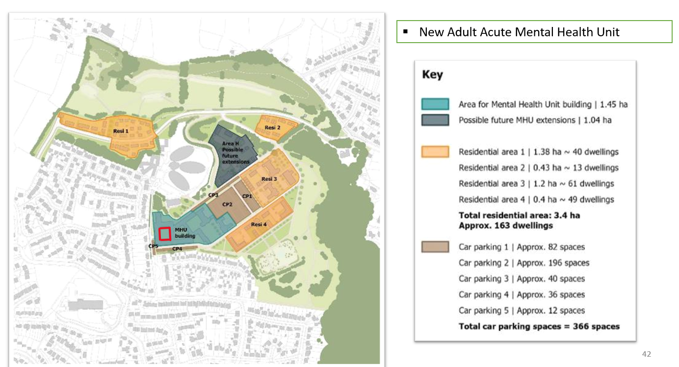.
Following the final transfer of services out of the Ty Maes y Gruffydd building, the building is no longer required by WAST. Agreement has been reached with WAST and WG to transfer ownership of the building to Swansea Bay Health Board.

- GOVERNANCE AND RISK ISSUES
The site comes under the management of the Mental Health and Learning Disabilities SDU, who have agreed the transfer.

The transfer process will be run under the NHS Wales Estate Code in conjunction with NHS Wales Shared Services to ensure that the Health Board comply with governance procedures.

Management Board have supported the disposal for onward consideration of approval and ratification at the Performance and Finance Committee and the Health Board respectively.

- FINANCIAL IMPLICATIONS
The value of the proposed area of land and building to be transferred from WAST is estimated at £675k as at 31st March 2023 [WAST to provide updated value for proposed 1st October 2023 transfer]. There will be no impact on the Health Board’s Capital Resource Limit.

Following the formal transfer of ownership, the Health Board will need to take on the annual rates and utility bills from 1st October 2023 until demolition. The annual cost based on 2023 costs are around £36k. Once the Health Board assumes ownership, it may be possible to reduce the rateable value by including the building in the overall Cefn Coed site.

- RECOMMENDATION
Members are asked to:
- RECOMMEND APPROVAL of the ownership transfer of Ty Maes y Gruffydd, Cefn Coed Hospital from WAST to the Health Board from 1st October 2023

Governance and Assurance

Link to Enabling Objectives  (please choose) | Supporting better health and wellbeing by actively promoting and empowering people to live well in resilient communities
Link to Enabling Objectives  (please choose) | Partnerships for Improving Health and Wellbeing |  | ☒
Link to Enabling Objectives  (please choose) | Co-Production and Health Literacy |  | ☐
Link to Enabling Objectives  (please choose) | Digitally Enabled Health and Wellbeing |  | ☐
Link to Enabling Objectives  (please choose) | Deliver better care through excellent health and care services achieving the outcomes that matter most to people
Link to Enabling Objectives  (please choose) | Best Value Outcomes and High Quality Care |  | ☒
Link to Enabling Objectives  (please choose) | Partnerships for Care |  | ☐
Link to Enabling Objectives  (please choose) | Excellent Staff |  | ☐
Link to Enabling Objectives  (please choose) | Digitally Enabled Care |  | ☐
Link to Enabling Objectives  (please choose) | Outstanding Research, Innovation, Education and Learning |  | ☐
Health and Care Standards
(please choose) | Staying Healthy |  | ☐
(please choose) | Safe Care |  | ☐
(please choose) | Effective Care |  | ☐
(please choose) | Dignified Care |  | ☐
(please choose) | Timely Care |  | ☐
(please choose) | Individual Care |  | ☐
(please choose) | Staff and Resources |  | ☒
Quality, Safety and Patient Experience
Enabler for the proposed new Adult Acute Mental Health In-patient PICU (Psychiatric Intensive Care Unit) at Cefn Coed. Will rebuild our infrastructure in support of modern standards of service delivery that enables excellent patient care.

Financial Implications
Annual revenue building running costs until demolition £36k.

Legal Implications (including equality and diversity assessment)
The transfer process will been run under the NHS Wales Estates Code in conjunction with NHS Wales Shared Services.

Staffing Implications
None
Long Term Implications (including the impact of the Well-being of Future Generations (Wales) Act 2015)
Enabler for the proposed new Adult Acute Mental Health In-patient PICU (Psychiatric Intensive Care Unit) at Cefn Coed. Will rebuild our infrastructure in support of modern standards of service delivery that enables excellent patient care.
Report History |  | n/a

