

Meeting Date | 26th September 2023 |  | Agenda Item |  |  | 2.1
Report Title | Financial Report – Period 05 2023/24
Report Author | Samantha Moss, Deputy Director of Finance  Crystal Davies, Principal Finance Manager
Report Sponsor | Darren Griffiths, Director of Finance and Performance
Presented by | Darren Griffiths, Director of Finance and Performance
Freedom of Information | Open
Purpose of the Report | The report advises the Performance & Finance Committee of the Health Board on the financial position for Period 05 (August 2023) 2023/24 and sets out the current forecast revenue year end outturn.
Key Issues | The report invites the Performance & Finance Committee to note the detailed analysis of the financial position for Period 05 (August 2023) 2023/24.  The report includes a summary of the key drivers of the position either at Service level or by expenditure type (i.e. Non Pay / Pay). It also provides information of the current position with regard to Health Board reserves to ensure transparency in the overall Health Board position.  The report sets out key issues and alerts the Committee to the increased level of risk of delivery of the financial plan following the revision of the Morriston outturn forecast. The risk score will be revised once any additional Welsh Government adjustment is known.  The report does not yet consider any further forecast reduction required by Welsh Government to improve upon the forecast deficit of £86.6m  Whilst the key messages are provided within the main body of the report, further information is provided in Appendix 1.
Specific Action Required  (please choose one only) | Information | Discussion |  | Assurance | Approval
Specific Action Required  (please choose one only) | ☐ | ☐ |  | ☒ | ☐
Recommendations | Members are asked to:  - NOTE the agreed 2023/24 financial plan.  - Consider and comment upon the Board’s financial performance for Period 05 2023/24.  - NOTE the actions to ensure delivery of the financial forecast with a specific focus on savings delivery: -  - Enhanced monitoring meetings in place above standard Finance & Performance Meetings to oversee and agree actions to mitigate run rates and deliver savings. Morriston / NPTS Service Group Directors  - Focused attention to ensure that 100% of the schemes are identified at the end of Q1 23/24. All Service Group Directors and Corporate Directors  - Focused attention to ensure that 100% of the schemes identified at the end of Q1 are green and amber by the end of Q2 23/24. All Service Group Directors and Corporate Directors  - Where savings delivery is not on track there will be further meetings with the Director of Finance and CEO. All Service Group Directors and Corporate Directors  - NOTE actions to ensure the operational pressures are mitigated and areas return to financial balance.  - Enhanced monitoring meetings in place above standard Finance & Performance Meetings to oversee and agree actions to mitigate run rates and deliver savings. Morriston / NPTS Service Group Directors  - Embed and deliver opportunities identified via the Independent Financial support provided to the Service Group to review run rate and savings. Morriston Service Group Directors  - NOTE the risks position at Month 5.  - NOTE the position with regard to Health Board Reserves  - NOTE all actions and updates to support the management of the 2023/24 financial position.

FINANCIAL REPORT – PERIOD 05

- SUMMARY OF REVENUE PERFORMANCE

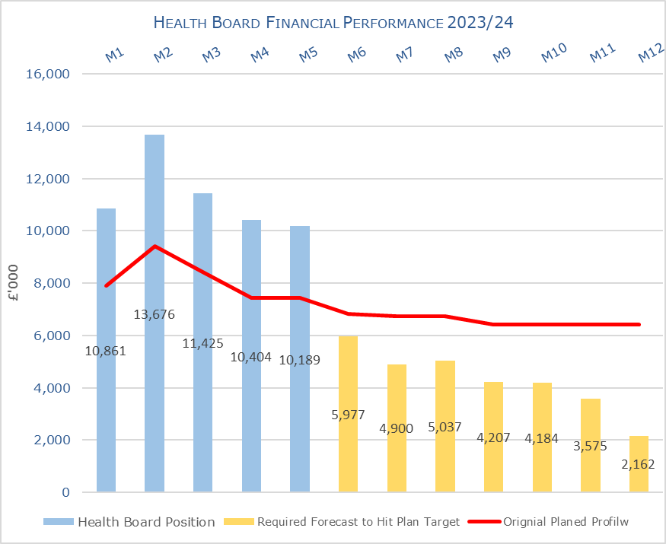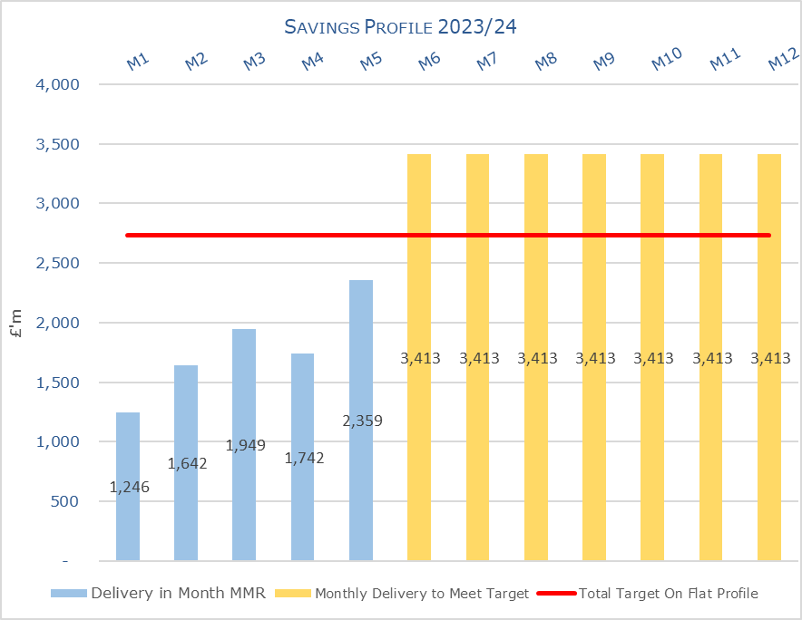

Target | In Month  £M | Year To Date (YTD)  £M
Delivery Against Revenue Resource Limit (RRL) DEFICIT / (SURPLUS) | 10.189 | 56.554
Delivery Against Financial Plan DEFICIT / (SURPLUS) | 2.763 | 15.940
Delivery Against Total Savings Target In Ledger DEFICIT / (SURPLUS) | 0.658 | 4.528

- FINANCIAL PLAN 2023/24

The revised plan at 31st May 2023 reported a deficit of £86.6m.

Table 1: Financial Plan 2023/24
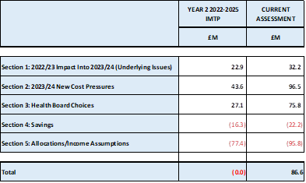

The plan was developed on a tapering basis to allow the Health Board time to work on reducing the run rates, reduce COVD spend and identify savings. Performance against the plan and the agreed tapered values is summarised below:

Table 2: Plan & Performance 2023/24

- KEY PERFORMANCE AREAS
Performance is summarised from two different perspectives. Section 3.1 provides the reported position by Service Group/Directors and section 3.2 onwards looks at the reported positon from the components of the ledger i.e. Income, Pay and Non Pay, with further details provided in Appendix 1.

  - Summary By Service Area

Table 3: Summary

Key points of notes by Service Area:

- Morriston
The key variances:
  - Income = Month 5 was £0.004m under achieved but Year To Date (YTD) £1.4m under achieved. This is driven by WHSSC performance. Plans are being developed to recover this via the Enhanced Monitoring meetings and there has been some improved against this in Month 5.
  - Pay = Month 5 £1.6m overspent, which was a £0.4m reduction from Month 4 but remains £7.9m overspent YTD. Spend on variable pay was £3.0m in month this reduced by £0.5m from Month 4.
  - Non-Pay (exc Savings) = Month 5 £1.2m overspent and YTD £4.4m. Of the £4.4m, YTD £3.4m relates to clinical supplies and general consumables.
  - Savings = Month 5 £0.8m variance as there remains a shortfall in the delivery of the savings target and this takes the YTD position to £4.3m

- Neath Port Talbot Singleton (NPTS)
The key variances:
  - Income = Month 5 £0.05m under achievement and YTD £0.4m underachievement. This is primarily driven by the loss of Private Patient income.
  - Pay = Month 5 £0.2m overspent but this is an improvement on Month 4 which was £0.8m overspent. The YTD position is £1.64m overspent.
  - Non Pay (exc Savings) = Month 5 £1.3m variance and YTD £2.6m which relates to clinical supplies and primary care prescribing.
  - Savings = Month 5 £0.16m over achieved in month but YTD shows £0.14m underachievement.

  - Summary By Type Expenditure

- Income
The WHSCC Income in Month 3 was unachieved by £0.531m but improved performance relating to WHSSC activity from Month 4 resulted in the income improving and the variance reduced to zero in Month 5 (this included backdated renal activity), but still remains at £1.3m YTD.

As reported for the previous 4 months of 2023/24 the pressure as a result in the loss of Dental Contract Income continues, with the YTD shortfall increasing to £0.755m. However, it is assuming that the underperformance from 2022/23, estimated to be £1m, will be used by the Health Board to offset this pressure non-recurrently, which has been reflected in the overall Health Board financial performance in Month 5.

- Pay
The Month 5 pay was overspent by £1.3m (a reduction from Month 4 of £1.2m) taking the YTD overspend to £8.7m. On Variable Pay overall spend reduced by £0.6m, with the reduction in Non-Medical Agency, Bank and Overtime. Across Pay this reduction was reflected in the overall Qualified Nursing position which reduced by £0.7m and Additional Clinical Supplies (includes HCSW) which reduced by £0.3m. Within both these areas, the HB also saw an increase in WTE, which will reflect the appointment of staff on a permanent basis in part linked to the Oversea Nurse recruitment programme.

Therefore, the Health Board clearly needs to address both the underlying run rate issue and the continued spend on variable pay, which is driving the in-month pay variance.

- Prescribing
There is currently a £3.2m pressure from primary care prescribing based on the April PAR and trend from the last 2-3 months of 22/23. However, the May PAR showed a potential deterioration of a further £2m FYE on the forecast outturn and the June PAR has increased this further by £1.7m driven in the main by item increases. If the trends from May and June PAR continue this could force the £3.2m to increase to £6.7m FYE.

The Month 5 position reflects the actual costs for Month 1-3 based on the PAR reported position and then Month 4-5 using the forecast of £5m. There is considerable work required to refine this over the coming weeks before the end of Q2. However, at this point it is important to note that the risk may increase further if prescribing continues at its current rate of growth.

- Non Delivery Savings
The Health Board has set a 3.5% savings target for 2023/24, after two years of achieving 4%. In additional there is a further £10.6m of unmet recurrent savings b/f from 2022/23. However, there remains a gap in the delivery of savings to meet the target sets, which has resulted in a £0.6m variance in Month 5 (deterioration of £0.2m from Month 4) and £4.5m YTD. (Savings are covered in more detail later in this report).

  - Action being Taken to Mitigate Position

The previous reports detailed the actions being driven by the Health Board to mitigate the planned deficit and the risks. Updates or additional actions above those reported in previous months are captured below: -

- Enhanced Monitoring – both Neath Port Talbot Singleton (NPTS) Service Group and the Morriston Service Group remain in enhanced monitoring with the weekly meetings continuing chaired by the CEO. The output of this focus is contributing to the slowing down of both the Morriston and NPTS Service Group overspend rate aligned to the tapering of the plan. For Morriston Service Group there has been a review and subsequent change in the independent financial support following the commencement of the new Service Group Director on 1st September. One of the additional posts will cease in early September leaving one senior and experienced advisor in place supported by the existing Finance PMO to ensure actions to deliver both increased savings and reduced run rate pressure are carefully monitored and kept on track.

- SAVINGS
Based on the report from 4th September 2023, the schemes identified for delivery in 2023/24 by service areas are summarised below:

Table 4a In Year Performance Against 2023/24 Requirements
Table 4b Recurrent Performance Against 2023/24 Requirements

- RISK
Two Board level financial risks: -

- Achieving financial plan (HBR92) with the key elements as follows: -

  - Risk of delivery of savings quantum
  - Risk of operational overspend being in excess of funding available agreed via the Financial Plan
  - Risk of commitment of reserves (e.g. NICE) being above reserves available.

Whilst there has been improvement in the assessment of the delivery of the savings, an assessment of the Morriston Service Group and NPTS Service Group following Month 4, which continued to demonstrate a significant, overspend, has resulted in the risk increasing by £17.7m from that reported in Month 4. This does not reflect the Health Board’s acceptance of the position but is a balanced assessment of the risk of delivering the £86.6m. The Health Board Corporate Risk Register is currently reporting this risk as a 20 score and as previously discussed this may need to change depending full assessment of the deliverability of the plan as part of the Mid Year assessment along with incorporating any further reduction in deficit required by Welsh Government.

The individual elements of the risk behind this score are provided in detail below and reflect the information reported to WG in the month 5 MMR and is aligned to the risks recognised as part of the signed of plan at the end of May 2023:

- Availability of capital (HBR93). This risk was re-opened in 2022/23 given the reduction in discretionary capital allocation. Whilst work is underway to manage schemes to reduce commitments in 2023/24 and to produce a balanced plan, the risk varies during the year as more details on schemes emerge and potential slippage funding is made available by Welsh Government. A score of 20 is suggested at this stage as whilst the plan is now balanced, a number of schemes are on hold and the flexibility within the plan is extremely limited given the reduction in the allocation.

- RECOMMENDATIONS

Members are asked to: -
- NOTE the agreed 2023/24 financial plan.
- Consider and comment upon the Board’s financial performance for Period 05 2023/24.
- NOTE the actions to ensure delivery of the financial forecast with a specific focus on savings delivery: -
  - Enhanced monitoring meetings in place above standard Finance & Performance Meetings to oversee and agree actions to mitigate run rates and deliver savings. Morriston / NPTS Service Group Directors
  - Focused attention to ensure that 100% of the schemes are identified at the end of Q1 23/24. All Service Group Directors and Corporate Directors
  - Focused attention to ensure that 100% of the schemes identified at the end of Q1 are green and amber by the end of Q2 23/24. All Service Group Directors and Corporate Directors
  - Where savings delivery is not on track there will be further meetings with the Director of Finance and CEO. All Service Group Directors and Corporate Directors
- NOTE actions to ensure the operational pressures are mitigated and areas return to financial balance.
  - Enhanced monitoring meetings in place above standard Finance & Performance Meetings to oversee and agree actions to mitigate run rates and deliver savings. Morriston / NPTS Service Group Directors
  - Embed and deliver opportunities identified via the Independent Financial support provided to the Service Group to review run rate and savings. Morriston Service Group Directors
- NOTE the risks position at Month 5.
- NOTE the position with regard to Health Board Reserves
- NOTE all actions and updates to support the management of the 2023/24 financial position.

Governance and Assurance

Link to Enabling Objectives  (please choose) | Supporting better health and wellbeing by actively promoting and empowering people to live well in resilient communities
Link to Enabling Objectives  (please choose) | Partnerships for Improving Health and Wellbeing |  | ☐
Link to Enabling Objectives  (please choose) | Co-Production and Health Literacy |  | ☐
Link to Enabling Objectives  (please choose) | Digitally Enabled Health and Wellbeing |  | ☐
Link to Enabling Objectives  (please choose) | Deliver better care through excellent health and care services achieving the outcomes that matter most to people
Link to Enabling Objectives  (please choose) | Best Value Outcomes and High Quality Care |  | ☒
Link to Enabling Objectives  (please choose) | Partnerships for Care |  | ☒
Link to Enabling Objectives  (please choose) | Excellent Staff |  | ☐
Link to Enabling Objectives  (please choose) | Digitally Enabled Care |  | ☐
Link to Enabling Objectives  (please choose) | Outstanding Research, Innovation, Education and Learning |  | ☐
Health and Care Standards
(please choose) | Staying Healthy |  | ☐
(please choose) | Safe Care |  | ☐
(please choose) | Effective Care |  | ☐
(please choose) | Dignified Care |  | ☐
(please choose) | Timely Care |  | ☐
(please choose) | Individual Care |  | ☐
(please choose) | Staff and Resources |  | ☒
Quality, Safety and Patient Experience
Financial Governance supports quality, safety and patient experience.

Financial Implications
The Board is reporting a forecast year-end deficit financial outturn.

Legal Implications (including equality and diversity assessment)
No implications

Staffing Implications
No implications

Long Term Implications (including the impact of the Well-being of Future Generations (Wales) Act 2015)
No implications

Report History |  | Updates on the financial position are provided at every meeting
Appendices |  | App 1-2 providing further detail

APPENDIX 1 – FURTHER DETAIL ON VARIANCES BY TYPE OF SPEND

- Overview of Income

- Overview of Pay Variances

Overall Variance by month
Note – movement between Month 2 and 3 and Month 4 and 5 budget relates to the one-off funding for the Recovery pay award and changes to the budget profiling linked to year-end accruals for Leave, Overtime and Time owing.

Actual Variable Pay by month and type
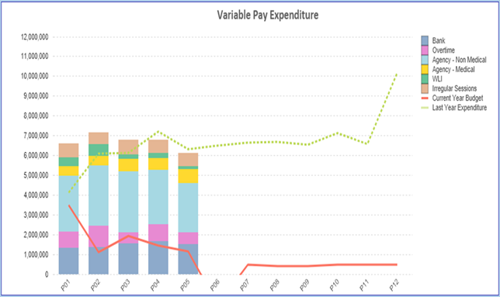

- Overview Non Pay

Note – movement between Month 2 and 3 budget relates to the one-off adjustment for Losses, which is normally reflected at year end only and so had to be adjustment between months.

Below are further details on the keys areas of Non Pay (excluding savings that is addressed in main body):

  - Clinical Consumables
This area continues to be a significant pressure and we saw an additional cost pressure of £0.3m above the month 4 variance. There are 80+ subjective lines within this category including secondary care drugs but areas seeing most pressures YTD continue to be blood products, general consumables (M&SE), laboratory products and for Month 5 pacemakers which is under review.

  - Utilities
The financial forecast still remains aligned to the plan. In addition, whilst there has been a recent update on the forecast from £14.5m to £13.3m based on the email from NWSSP dated 7th September, the Health Board needs to work some key issues through before assessing the true impact on the delivery of the plan and these include:

- Level of usage built in and whether the reduced demand from the Morriston site as a result of the solar farm has been reflected correctly;
- What the actual bills have been from Q1 compared to the forecast provided;
- Both points above build on the lessons learnt from 2022/23 where the forecast provided by British Gas and the actual costs were materially different.

  - CHC
The variance against budget for CHC is at £0.180m (underspend) in month reflecting the additional funding allocated to CHC through the financial plan. An analysis of actual spend and patient numbers for 2023/24, along with the average values from 2023/24 is provided in table below.

CHC Analysis By Month
(Please note: PCT Group does not include the Singleton/NPT element - which covers Children and Young People as it is provided internally).

  - Prescribing
See commentary in section 3.2 above

  - LTA Performance
Historically LTA contracts have been based on a Cost and Volume approach, which reflects adjustments for under and over performance. From the start of the COVID pandemic in April 2020 all LTA agreements in both England and Wales transferred to a block arrangement, whereby commissioners funded providers on 2019/20 levels uplifted by nationally agreed rates with no adjustment for performance. From 1st April 2022 the previous block arrangements have ceased and a hybrid model adopted where under or over performance adjustments will become applicable above a tolerance level. This became relevant to both services we commission from other Health Boards and services commissioned from SBU HB. In 2022/23 the tolerance level was 10% but in 2023/24 the tolerance level has reduced to 5%.

Table below is the performance of Swansea Bay HB at the end of Month 4 as a provider, for services commissioned by other Health Boards. Under the previous Long Term Agreements the full year forecast for underperformance would be £1.889m, under the interim arrangements that risk has reduced and delivers a benefit of £0.995m.

The Table below is the performance of contracts provided by other Health Boards in Wales but commissioned by Swansea Bay. Here under the previous LTA arrangements we would have seen a benefit of £5.2m but under the interim arrangement that has reduced to £3.5m.

Of the net impact of £4.5m, some is already accounted for in the YTD position however at this point there is £2.4m that is not yet assumed in full. However it is still early in the financial year for some of the benefits to be assumed. Updates will be provided as we progress through the year.
APPENDIX 2 – DETAILS ON RESERVES & CENTRAL BUDGETS

- SUMMARY RESERVES
Overall management of the reserves is as per the Health Board Budget Management document.

  - Balances Main & NICE
For 2023/24, the Health Board will hold two central reserves and the purpose of these reserves are below: -
- Main – this holds funding from WG or the plan that has yet to be issued to Budget Holders. These items are not surplus but either due to timing have not been issued or is an area where funding is issued based on actual values consumed in future month.
- NICE – this holds the total Health Board funding for all of NICE costs (drugs and infrastructure) and is issued to the service each month based on the actual costs consumed as reported through the Pharmacy system.

Details on the balances and movements are provided in the Table below:

- Changes to Deficit
The Board supported a £86.6m deficit plan. The deficit is held centrally with an element reflected each month in the reported performance against RRL (see Section 3.4 on Non-Pay) on a tapered basis, as previously agreed with the Board.

The Budgetary management process for 2023/24 stated that where the Board agreed additional investment, this could only be funded by increasing the deficit plan. Therefore, a table will be included within this paper each month showing the opening deficit plan figure and the changes made within the financial year to arrive at the current deficit held centrally. This is summarised in the below:

