Meeting Date | 22 September 2026 | Agenda Item | 3.3
Name of Meeting | Finance and Performance Committee
Report Title | Theatre Utilisation and Efficiency
Report Author | Rhodri Davies, Associate Service Group Director Surgery  Jonathan Gates, Head of Nursing Surgery
Report Sponsor | Chief Operating Officer
Presented by | Rhodri Davies, Associate Service Group Director, Surgery
Freedom of Information | Open
FoI Closed detail | If closed, choose detail
Impact Assessment Summary Outcome |  | IA Completion date
N/A |  | Click or tap to enter a date.
Purpose of the Report | For Assurance
Report Summary; detailing any action required
To highlight to the committee the next steps taken in improving utilisation and efficiency across SBUHB Theatres
Key Issues
1. Theatre Utilisation Performance
2.Specific specialty performance impacting on higher performing specialties, bringing overall performance down

Decision / Action required | No
Recommendations
Members are asked to:
- ACKNOWLEDGE the Theatres efficiency update and the actions being taken to improve the overall performance in a sustainable and consistent manner.

Theatre Utilisation and Efficiency

- INTRODUCTION

This report provides an update to the Performance and Finance Committee on progress made in improving theatre utilisation and operational efficiency across Swansea Bay University Health Board (SBUHB). It outlines the actions being implemented to maximise productivity, reduce unwarranted variation, and optimise the use of existing theatre capacity to support elective recovery and long-term sustainability.

- BACKGROUND

Improving theatre utilisation remains a critical organisational priority, with a Welsh Government expectation of achieving and sustaining 85% utilisation across all theatre capacity.

Performance across the Health Board continues to demonstrate variation between sites and specialties. While Morriston Hospital consistently achieves expected utilisation levels, Singleton Hospital and Neath Port Talbot Hospital (NPTH) continue to operate below the required benchmark, highlighting opportunities to release additional capacity.

In June’s update to the Performance and Finance Committee, the Health Board reported the May performance data, which highlighted, for the first time, theatre utilisation had reached an average of 80% across the three theatre sites. The Health Board reported that there were specific initiatives underway as part of establishing the monthly Theatre Operational Group, with a particular focus on late theatre starts at NPTH.

- Site-Level Performance Overview
Overall performance for the reporting periods June and July show performance has plateaued and remains around the 80% utilisation. Morriston Hospital continues to deliver utilisation levels at or near the 85% target. Singleton Hospital and NPTH remain below target.
This variation reflects differing levels of operational maturity, pathway alignment, and consistency in theatre management practices across sites.

Theatres (Morriston)​ | Target​ | June-26​ | Jul-26​
Theatre Utilisation Rate​ | > 85%​ | 84%​ | 84%​
Percentage of Late Starts (15-minute target)​ | < 20%​ | 31%​ | 30%​
Percentage of Early Finishes (60-minute target)​ | < 10%​ | 33%​ | 30%​
Theatres (Neath Port Talbot Hospital)​ | Target​ | June-26​ | Jul-26​
Theatre Utilisation Rate​ | > 85%​ | 73%​ | 75%​
Percentage of Late Starts (15-minute target)​ | < 20%​ | 25%​ | 19%​
Percentage of Early Finishes (60-minute target)​ | < 10%​ | 42%​ | 39%​
Theatres (Singleton Hospital)​ | Target​ | June-26​ | Jul-26​
Theatre Utilisation Rate​ | > 85%​ | 78%​ | 79%​
Percentage of Late Starts (15 minute target)​ | < 20%​ | 36%​ | 28%​
Percentage of Early Finishes (60 minute target)​ | < 10%​ | 24%​ | 19%​

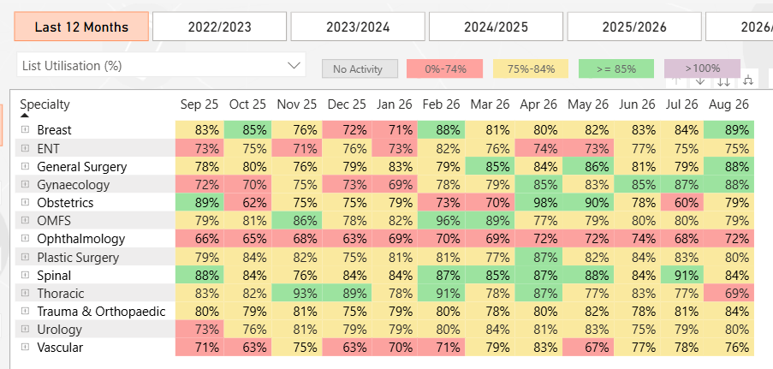The table above highlights an important point where overall improvements in theatre utilisation performance is impacted by a small number of specialties that are under-performing, which drags the overall performance down.

  - Morriston

Performance remains stable at 84%. Late starts improved from 31% to 29% and early finishes from 33% to 29%, demonstrating strengthening operational discipline. Morriston continues to provide the benchmark model across the Health Board. The gap between Morriston and the other sites remains significant, highlighting additional / emergency capacity, 3 session lists and overrunning lists influencing the upward utilisation trajectory.

  - NPT

The table below highlights the performance in percentages per surgical specialty. There has been significant work conducted in Trauma, Orthopaedics and Spinal surgery to implement a weekly scheduling approach. The updated graphs illustrate ongoing variation between specialties who have now implemented elective operating toolkit actions.

NPTH remains the most significant opportunity for improvement. Utilisation is unchanged overall and remains substantially below target. Early finishes remain exceptionally high at 40%. Specialty analysis shows Trauma & Orthopaedics reaching 85% and Spinal Surgery sustaining strong performance, demonstrating that MDT planning and weekly scheduling are effective where consistently applied.

A focused piece of work within Theatres Operational Group (TOG) has been on late starts at NPTH theatres. A dedicated session with key consultant colleagues took place with consultant level data presented on reasons for late starts. Given this was at consultant level, it promoted accountability and personal performance improvement required. The July data for late starts at NPTH has seen a reduction in target performance and illustrates this approach can be effective. However, further validation is required on whether it was just this approach or wider theatre initiatives that contributed to such an improvement.
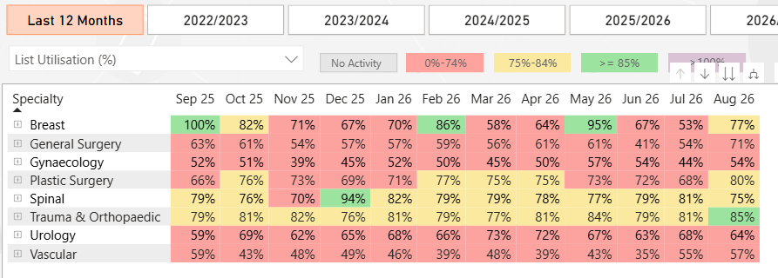

  - Singleton

Singleton continues to perform below target with deterioration during August. Ophthalmology improvements remain evident; however, utilisation gains have not translated into sustained site-wide performance. Late starts increased to 35%, suggesting operational reliability issues remain.

Following validation, the aim will be to roll out the same approaches carried out to late starts in NPTH to Singleton, with a view to seeing a sustained improvement trajectory.

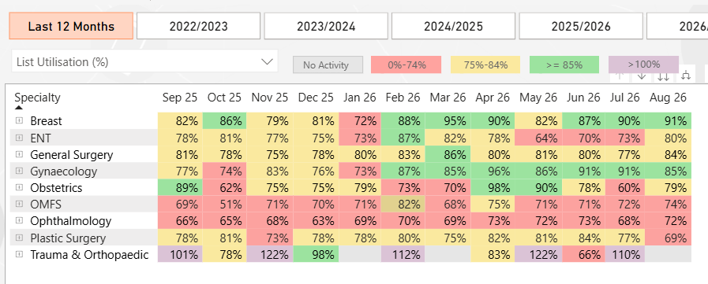

- ACTIONS GOING FORWARD

The Theatres Scheduling Group is responsible for ensuring scheduling and organisation of theatre lists complies with the 6-4-2 process. The actions that have been set for the group following quarter 2 performance reporting are as follows:

- Expand MDT scheduling and weekly list validation to all specialties.
- Implement consultant-level exception reporting for late starts and early finishes.
- Prioritise recovery plans for Vascular, General Surgery, and Gynaecology.
- Embed the Elective Surgery Toolkit across all sites.

- GOVERNANCE AND RISK ISSUES

The current position reflects variation in operational maturity and consistency across sites and specialties. Key risks include:

- Failure to achieve the 85% utilisation target
- Continued inefficiencies resulting in lost elective capacity
- Inability to maximise productivity within existing resources

Mitigating actions include:

- Increased performance scrutiny at specialty and site level
- Standardisation of processes across the Health Board
- Continued implementation of the elective surgery toolkit

- OPEN AUDIT RECOMMENDATIONS

There are actions open against the theatre utilisation internal audit from September 2025. An updated action plan has been requested by internal audit in September 2026 and will therefore be submitted to Theatre Board for ratification.

- FINANCIAL IMPLICATIONS

Additional Welsh Government funding has been allocated to the Health Board for Planned care performance. The first phase of this funding particularly focuses on Orthopaedics and Ophthalmology activity which will impact theatre capacity and pre-assessment capacity. Work is underway to understand the additional ask on both of these specialties so that capacity can be allocated efficiently.

- RECOMMENDATION
The Performance and Finance Committee is asked to:

- ACKNOWLEDGE the Theatres utilisation and efficiency update and the actions being taken to improve the overall performance in a sustainable and consistent manner.

Governance and Assurance
Strategic Objectives
Strategic Objectives  (please choose which is impacted) | People of Swansea Bay live healthier, fairer and more prosperous lives | ☐
Strategic Objectives  (please choose which is impacted) | Care is high quality, safe, efficient and delivers the best possible outcomes for people in partnerships | ☒
Strategic Objectives  (please choose which is impacted) | Care is delivered in partnership with our communities in safe and appropriate setting, supported by innovation | ☐
Strategic Objectives  (please choose which is impacted) | The health board is a great place to work where staff feel valued and work together towards a common goal | ☐
Strategic Objectives  (please choose which is impacted) | The health board is a resilient, sustainable and responsible organisation | ☐
Health and Care Standards
Standards (please choose which applies) | Safe Care | ☒
Standards (please choose which applies) | Timely Care | ☒
Standards (please choose which applies) | Effective Care | ☒
Standards (please choose which applies) | Efficient Care | ☐
Standards (please choose which applies) | Equitable care | ☐
Standards (please choose which applies) | Person-centred Care | ☐
Standards (please choose which applies) | Staff and Resources | ☐
Enablers (please choose which applies) | Whole Systems Approach | ☐
Enablers (please choose which applies) | Leadership | ☐
Enablers (please choose which applies) | Workforce | ☐
Enablers (please choose which applies) | Culture | ☐
Enablers (please choose which applies) | Information | ☐
Enablers (please choose which applies) | Learning, Improvement and Research | ☐
Quality, Safety and Patient Experience
Improved theatre utilisation will directly enhance patient outcomes and experience by:

- Increasing the number of procedures undertaken
- Reducing waiting times for surgery
- Improving pathway reliability

All improvement activity continues to align with:

- Safe care principles
- Effective and timely treatment delivery
Maintenance of clinical quality standards.

Financial Implications
The additional financial implications have been identified as part of this report.
Legal Implications (including equality and diversity assessment)
There are no legal implications to consider.

Staffing Implications
Briefly identify the known and/or potential staffing implications of this proposal/paper.

Long Term Implications (including the impact of the Well-being of Future Generations (Wales) Act 2015)
Efficient theatre utilisation is dependent on the availability and coordination of skilled theatre practitioners, Surgical and anaesthetic workforce and staff involved in the pre-operative and post-operative pathway staff

This includes ensuring alignment across outpatient services, pre-assessment, bed capacity and patient flow. Workforce engagement remains a key enabler of sustainable improvement in the NPTSSG Surgical Division.
Report History
January 2026 – PFC report

Appendices
None.

