Meeting Date | 28 July 2026 | Agenda Item | 4.2
Name of Meeting | Finance and Performance Committee
Report Title | Clinically Optimised Patients – overview, patient stories and work programme.
Report Author | Alison Gallagher, Interim Assistant Director of Operations: UEC.
Report Sponsor | Chief Executive Officer
Presented by | Alison Gallagher, Interim Assistant Director of Operations: UEC.
Freedom of Information | Open
FoI Closed detail | If closed, choose detail
Impact Assessment Summary Outcome |  | IA Completion date
Purpose of the Report | For Assurance
Report Summary; detailing any action required
The purpose of this report is to present an overview of the current clinically optimised patient cohort, following a deep dive presented to the Committee in April 26.
The report explores the clinically optimised patient cohort in respect of service impact, patient safety, patient experience through the presentation of patient stories and finance.
Key Issues
- Clinically optimised patients continue to occupy hospital beds for prolonged periods of time.
- The number of clinically optimised patients and the bed days consumed by this patient group drive the use of temporary surge capacity and workforce solutions which is unaffordable and often results in patients being cared for in non-clinical environments.
- The harms associated with prolonged lengths of nonmedical value-added hospital stay include deconditioning, falls, hospital acquired infections and can prevent persons returning to a level of independence they may have met pre-hospitalisation and can add to the long-term care burden
- There is a programme of work in place that reports into the Older Persons Regional Partnership Board.
Decision / Action required | No
Recommendations
The Committee is asked to:
- CONSIDER the overview as requested by the Committee.
- CONSIDER the patient stories and the difference in patient experience driven by complexity and pathway.
- CONSIDER the work programme in place to reduce the clinically optimised patient cohort.

Clinically Optimised Patients – overview, patient stories and work programme.

- INTRODUCTION

Clinically Optimised Patients (COPs) are individuals whose acute hospital medical treatment has been completed but who remain in hospital awaiting the next stage of their care pathway. The size of this cohort presents significant challenges for patient safety, operational performance and financial sustainability across Swansea Bay University Health Board.

This report provides an overview of the current position, the impact of delayed discharge on patients and services, the actions being taken to minimise the number, and the opportunities available through a more effective implementation of the Welsh Government's Discharge to Recover and Assess (D2RA) model.

- BACKGROUND

Reducing the number of clinically optimised patients is a breakthrough objective for the Health Board. The breakthrough objectives are the Board’s agreed priority measures for 2026/27. They identify the specific, measurable improvements that will demonstrate whether the Health Board is making sufficient progress in delivering its strategic objectives and annual plan. Together, they provide a clear focus for organisational effort, enable the Board to monitor delivery and hold services to account, highlighting where corrective action is required.

As at 7 July 2026, there were 234 clinically optimised patients across the Health Board, occupying approximately 17% of available beds. Over half of these patients were located within Morriston Hospital, where any delay to discharging patients has a direct impact on urgent and emergency care capacity and flow, and increases risk to patients in the hospital and the community.

COP patients remain in hospital for extended periods, often waiting for health or social care assessments, care packages, placements, funding decisions or legal processes before discharge can occur.

April to end June 2026 Overview

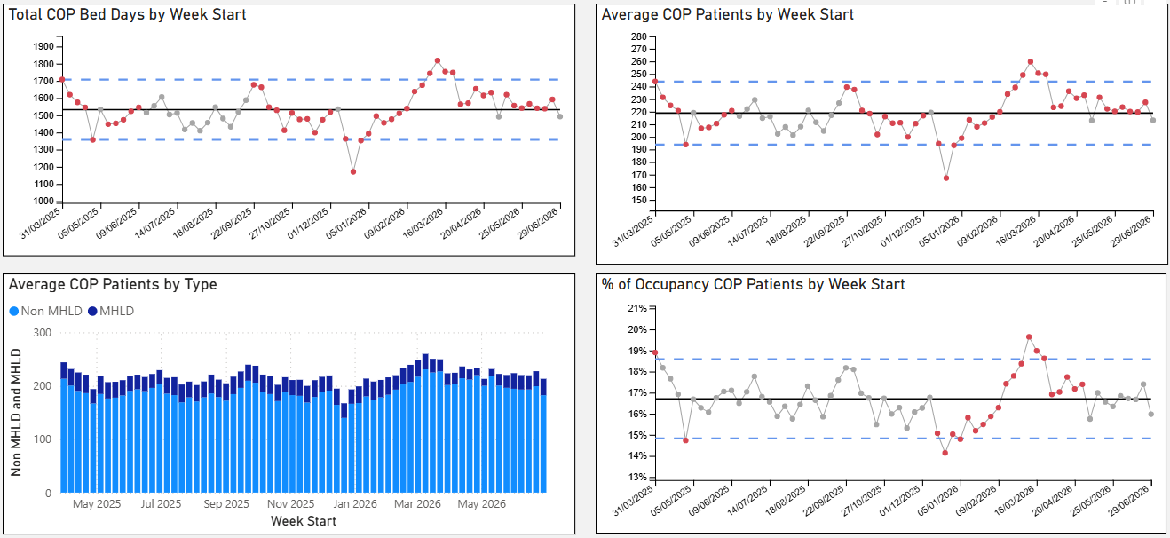

A key breakthrough objective of the Health Board is to reduce the number of patients from the baseline 218 to 100 by end March 27. The graph below demonstrates number of clinically optimised patients against monthly trajectory.
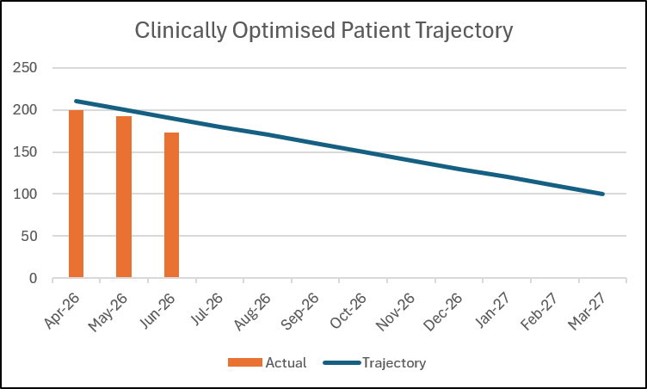

The trajectory is being maintained but a revised trajectory is needed to meet the bed reconfiguration plan as part of the Health Board’s £65m savings plan.

- GOVERNANCE AND RISK ISSUES

  - Impact on Patients

Extended hospital stays have been shown to negatively impact the welfare of patients. Clinically optimised patients, particularly older people, are at risk of a range of harmful outcomes. These include:

- Loss of mobility and muscle strength.
- Functional decline and reduced independence.
- Increased risks of falls, infection, delirium and cognitive deterioration.
- Greater likelihood of requiring long-term care.
- Reduced quality of life and increased mortality risk.

Prolonged delays and subsequent extended hospital stays may prevent individuals from returning to their previous level of independence and can increase future health and social care costs.

  - Patient stories

The use of patient stories demonstrates the complex assessment processes and the pathway delays experienced by patients from both a health and social care perspective.

Below are two examples of patient journeys. One shows an elongated stay while the other demonstrates that there are examples of good practice due to recent changes implemented by health and social care partners where the patient pathway has improved and more timely discharge can be achieved.

Patient A:

Case History:
A patient was admitted in July 2026 with increased shortness of breath, was de-saturating on mild exertion to 70% (low oxygen level). Patient is on long term oxygen therapy. Diagnosis on admission: Infective exacerbation of Chronic Obstructive Pulmonary Disease, (COPD)

Social History:
  - Lives at home alone
  - Receives help from a relative
  - Ex-smoker

Pathway:
  - Day 1 – Admitted to Emergency Department
  - Day 1 – transferred from ED to Acute Medical Assessment
  - Day 2 – Transferred to Ward J (Respiratory Ward)
  - Day 3 – Patient deemed Clinically Optimised
  - Day 4 – Referred to Occupational Therapy
  - Day 5 – Assessed by Occupational Therapy
  - Day 6 – Referral sent to Integrated Discharge Hub, (IDH) for P1 reablement
  - Day 8 – Accepted by IDH for P1 reablement- on single staffed call per day.
  - Day 9 - Transport booked for 10am ‘Home for Lunch’

Patient B:

Case History:
Patient discharged from Older Persons Short Stay Unit in May following an episode of acute confusion. Patient was supported by a relative with no package of care in place.
Re-presented to the Emergency Department 8 days later via ambulance following a fall. Patient was then transferred to the Older Persons Assessment Unit.

Social History:
- Lives with a relative who cares for the patient
- No package of care
- Stairlift at home
- Mobility; step transfers and uses rollator zimmer frame around the house
- Welsh Ambulance Service Trust submitted a referral to Safeguarding raising concerns around the safety of the property and the ability of the relative to support the patient.

Pathway:
- Day 1 -Admitted to the Emergency Department at 14:08 hrs and transferred to Older Persons Assessment Unit, (OPSS).
- Day 2 - Transferred to Ward G, (Trauma & Orthopaedic Ward) as a medical outlier.
- Day 2 & 3 Transferred back to OPSS for isolation due to Infection Control reasons.
- Day 9 Patient deemed clinically optimised.
- Day 9 Occupational Therapy assessment and referral for package of care. Relative happy to look after patient until package of care available however safeguarding issues prevents this from happening.
- Day 9 Accepted for Pathway 3 as complex discharge planning issues identified. Referred to Social Worker
- Day 21 Transferred to Ward E. On arrival to Ward E patient is confused and disorientated.

- Day 21 NPT Hospital Social Work Team checked named Social Worker allocation.
- Day 24 Awaiting Social Work allocation
- Day 30 Social Worker allocated
- Day 30 Social Work assessment started
- Day 30 Pt flow coordinators request update from Social Work colleagues
- Day 30 to Day 37 Social Worker visits patient on ward to discuss discharge destination
- Day 37 Accepted for Pathway 3 - new placement
- Day 39 Waiting for Social Worker to agree to FNC assessment
- Day 44 Waiting for placement acceptance

These two patient stories show how the process for patients can easily elongate. The first story demonstrates a rapid turnaround of a patient requiring a package of care in their own home. The recent standardisation of the Pathway 1 processes across both Local Authorities is resulting in more timely discharge of this patient group. Conversely, the latter patient required Social Worker input for a new care placement in a nursing home. The patient had a length of stay that was 33 days longer due to the assessment process that takes place in a hospital bed for all Pathway 3 patients. 21 of these days were due to waiting for a Social Worker to be allocated.

  - Impact on the Health and Social Care System

Delayed discharge reduces the availability of hospital beds and contributes directly to congestion throughout the urgent and emergency care pathway. Beds occupied by clinically optimised patients are unavailable for individuals requiring acute treatment, leading to:

- Emergency Department overcrowding.
- Delays in admission from assessment areas.
- Ambulance handover delays.
- Increased clinical risk for patients awaiting an emergency care response.

Whilst the Welsh Government advocates a Home First approach through the Discharge to Recover and Assess (D2RA) model, current processes largely operate in reverse as an Assess to Discharge system, with many assessments completed in hospital before discharge can occur. This significantly prolongs lengths of stay and contributes to system inefficiency.

  - Key Challenges

The principal barriers to reducing the clinically optimised patient cohort include:
- Internal processing delays: steps in the patient pathway that are reliant on health care professionals to complete.
- Clarification of reasons for hospital stay beyond being clinically optimised; the development of pathway event timescales will address this and allow operational focus on the pathway constraints.
- Limited social care and domiciliary care capacity with poor understanding of capacity and demand.
- Pathway 2 and 3 beds are in hospital sites as opposed to Community Hospitals.
- Delays in joint assessments and decision-making processes.
- Complex patient needs requiring multi-agency input.
- Legal, safeguarding and capacity assessment processes.
- Family disagreement or delays in accepting discharge options.

These challenges reflect a complex discharge/transfer picture where the emphasis on assessment remains hospital based making timely discharge difficult to achieve.

  - Pathway of Care Delays work programme:

The work programme to drive down the clinically optimised patient, or ‘Pathway of Care Delays’ cohort is overseen by the Older Persons Regional Partnership Board where priorities are set and agreed by both Health and Social Care Directors.

Current work activities include:

Improvement activity | Lead/Programme | Timescales | Anticipated benefits
All pathway delays:
Internal Delay management: a focus on the health-related delays for the clinically optimised patient cohort forms part of the optimal hospital flow framework which is an operational toolkit for ward based multi-disciplinary teams aimed at eradicating pathway delays and promoting best practice in terms of flow management | Optimal Hospital Flow Lead  UEC Programme | Accelerated roll out plan Morriston August 26 to cover all wards as part of the UEC Programme.  Roll out plan in development NPT/Singleton.  - Morriston complete by end August 26  - NPT/Singleton complete | Improved engagement between agencies.  Potential reduction in LOS if patients are able to leave the hospital earlier.  Aimed impact 5 beds.
Realignment of existing meetings in relation to Pathway of Care Delays to eradicate duplication and place greater focus on the ‘Ready to Go’ patient cohort. | D2RA Regional work programme. | - Revised meeting schedule being presented to the Regional Operational Assurance Group Monday 27th July 26.  - Implementation planned Monday 3rd August 26. | Reduce duplication, release of health and social care staff time.  Aimed impact 5 beds.
Review and development of policies in relation to the discharge pathway. | Interim Assistant Director of Ops: UEC | - For sign off at UEC Board August 26. | Standardisation of discharge/transfer activity across the Health Board.  Improved process for managing ‘reluctant discharge’ and ‘choice’.  Aimed impact 4 beds
Development of pathway event timescales underpinned by a health and social care escalation framework | D2RA Regional work programme. | For sign off in Older Persons Board September 26. | Reduced length of stay for all clinically optimised patients with escalation of delays.  Aimed impact 15 beds
Pathway 1:
Standardisation of Pathway 1 adopting a regional Pathway 1 model where both Neath Port Talbot and Swansea Local Authority processes are aligned. | D2RA Regional work programme. | Completed June 26 | Reduction in the number of clinically optimised patients – Pathway 1.
Review of Pathway 1 capacity and demand to inform pathway turnaround opportunity – aim 72 hours. | D2RA Regional work programme. | End August 26. | Informed decisions by regional partners regarding use of existing resources.  Aimed impact 36 beds
Pathway 3:
Development of an operating model to cohort the Pathway 3 patients in one designated ward area with Discharge Liaison and Social Worker presence being a key feature of the service. | Service Manager NPT/Singleton Hospitals | - Standard operating proposal to be completed end August 26.  - Ward base to be agreed by NPT/S Director team end August 26.  - Launch Pathway 3 Ward by end September 26. | To reduce joint assessment timescales and total patient journey time to 6 weeks for 50% of pathway 3 patients.  Aimed impact 14 beds

Total aimed impact is 79. The remainder would be through admission avoidance actions and demand management through Single Point of Access.
- FINANCIAL IMPLICATIONS
The financial impact of clinically optimised patients remaining in hospital is significant. The annual cost associated with managing this cohort in hospital beds is estimated at £14.7 million of ward costs, with additional expenditure incurred through surge capacity and temporary staffing arrangements. Total costs associated with delayed discharge and mitigating actions are estimated at approximately £18.1 million based on calculations April to October 25/26.

Expending costs in this way provides limited clinical or financial value. Reducing the clinically optimised population would improve patient outcomes, release acute capacity and support the Health Board's financial recovery plans. Achievement of the maximum 100 COP would result in a saving of approximately £8.5m of ward costs.

Analysis is underway on the most effective impact of these improvements to COP patients bed numbers. Once achieved, taking the 134 beds out, would not improve patient flow but would maintain the risks to patients in surge spaces and ED. The evolving bed reconfiguration plan is to replace the surge and ED overcrowding with released COP beds. Achieving this is expected to improve flow and further improve costs through variable and substantive pay costs associated with ED overcrowding, outliers, surge etc. This benefit is being costed and will be compared to the cost of simply removing the released COP beds.

- RECOMMENDATIONS

The Committee is asked to:

- CONSIDER the overview as requested by the Committee.
- CONSIDER the patient stories and the difference in patient experience driven by complexity and pathway.
- CONSIDER the work programme in place to reduce the clinically optimised patient cohort.

Governance and Assurance
Strategic Objectives
Strategic Objectives  (please choose which is impacted) | People of Swansea Bay live healthier, fairer and more prosperous lives | ☐
Strategic Objectives  (please choose which is impacted) | Care is high quality, safe, efficient and delivers the best possible outcomes for people in partnerships | ☒
Strategic Objectives  (please choose which is impacted) | Care is delivered in partnership with our communities in safe and appropriate setting, supported by innovation | ☐
Strategic Objectives  (please choose which is impacted) | The health board is a great place to work where staff feel valued and work together towards a common goal | ☐
Strategic Objectives  (please choose which is impacted) | The health board is a resilient, sustainable and responsible organisation | ☐
Health and Care Standards
Standards (please choose which applies) | Safe Care | ☐
Standards (please choose which applies) | Timely Care | ☒
Standards (please choose which applies) | Effective Care | ☐
Standards (please choose which applies) | Efficient Care | ☒
Standards (please choose which applies) | Equitable care | ☐
Standards (please choose which applies) | Person-centred Care | ☒
Standards (please choose which applies) | Staff and Resources | ☐
Enablers (please choose which applies) | Whole Systems Approach | ☒
Enablers (please choose which applies) | Leadership | ☐
Enablers (please choose which applies) | Workforce | ☐
Enablers (please choose which applies) | Culture | ☐
Enablers (please choose which applies) | Information | ☐
Enablers (please choose which applies) | Learning, Improvement and Research | ☐
Quality, Safety and Patient Experience
The quality, safety and variation in the patient experience are set out in the paper supported by patient stories. The work programme both in the Recovery and Sustainability arena and the regional partnership are focussed on improving the pathways of care for the clinically optimised patient cohort.
Financial Implications
The bed pools occupied by the clinically optimised patient cohort are part of the core funded capacity of the Health Board. This is poor use of acute and non-acute hospital capacity as these patients don’t require the level of staffing that is available on these wards and no longer gain a clinical benefit from their hospital stay as well as being exposed to the harms described in the paper.
Legal Implications (including equality and diversity assessment)
There are elements of the discharge/transfer pathway that have legal im-plications and are subject to challenge. There are patients who are subject to the Court of Protection where there is conflict in achieving safe discharge/transfer arrangements. This paper does not explore the legal elements of the discharge/transfer process.
Staffing Implications
Nil specific
Long Term Implications (including the impact of the Well-being of Future Generations (Wales) Act 2015)
Report History
Report presented to Committee in April 2026.
Appendices
None.

