Meeting Date | 28 July 2026 | Agenda Item | 2.4
Name of Meeting | Finance and Performance Committee
Report Title | Recovery and Sustainability Board Update
Report Author | Callum Allen-Ridge, Head of Project Management Office (PMO)
Report Sponsor | Executive Director of Finance
Presented by | Callum Allen-Ridge, Head of PMO
Freedom of Information | Open
FoI Closed detail | If closed, choose detail
Impact Assessment Summary Outcome |  | IA Completion date
n/a |  | Click or tap to enter a date.
Purpose of the Report | For Assurance
Report Summary; detailing any action required
The report is provided to update the committee on the current actions and work in progress of the Recovery & Sustainability (R&S) Board.

Key Issues
The Recovery and Sustainability Board reviewed the Quarter 1 position against the Health Board’s £65m savings requirement and has considered both the progress made and the risks emerging in relation to financial delivery.

At Month 3, cumulative savings delivery stands at £5.8m against a planned run-rate of £16.2m, representing a £10.4m delivery variance. Whilst Green and Amber schemes total £30.9m and achieved the Quarter 1 target of identifying 48% of the savings requirements, the R&S Board remains concerned a significant portion of the remaining £34.1m requirement has not yet been moved into mature, validated and credible savings schemes.

The R&S Board’s assessment is therefore that assurance can be provided regarding the strengthening of governance, programme management and pipeline controls, but that further work is required before equivalent assurance can be provided regarding delivery of the full £65m programme.

The board has identified particular delivery concerns in:
- Medical Workforce
- Planned Care
- Nursing Workforce
- Procurement

In response, formal letters of concern have been issued to relevant programme leads mirroring the Performance and Accountability Framework. These letters require specific recovery actions, revised delivery trajectories, mitigation plans and pipeline development proposals to be reported back to the next Recovery and Sustainability board.

The R&S Board has also directed all programmes with delivery gaps and or slippage in delivery to identify mitigating actions and develop new pipeline opportunities. Since the previous Board, the Pipeline has increased by a further £6m, providing additional opportunities to offset emerging delivery risks and strengthen the overall programme position. Work will continue in generating pipeline schemes as it will also support next year’s financial position.

Alongside these actions, the R&S Board is undertaking a review of its own operating arrangements to strengthen capacity, capability, accountability and delivery focus. This includes the introduction of standard reporting templates, clearer action and tracking, named executive ownership and a structured roadmap for maturation of Board assurance processes of the coming months.

The R&S Board recognises that future assurance will be determined not by the volume of opportunities identified, but by the conversion of those opportunities into recurrent, cash-releasing savings.

The R&S Board’s primary focus for Quarter 2 is therefore the conversion of identified opportunities into delivered recurring savings, supported by accountability, benefits realisation and active management of delivery actions and risks.

Decision / Action required | No
Recommendations
Members are asked to:
  - Receive the report for assurance.
  - Note that Quarter 1 objectives for scheme identification were achieved, with Green and Amber Schemes totalling £30.9m (48% of the overall savings requirement).
  - Note that savings delivery at Month 3 remains £10.4m behind the required trajectory and that significant delivery risks remain with the Medical workforce, Planned Care, Nursing Workforce and Procurement programmes.
  - Take assurance that formal escalation and recovery actions have been initiated through the Performance and Accountability Framework, with specific actions and mitigations being reported back to the future Recovery and Sustainability Boards.
  - Take assurance that the savings pipeline continues to develop, having increased by approximately £6m since the previous review, providing additional opportunities to mitigate emerging delivery gaps.
  - Note the continued development of the Recovery and Sustainability Board operating model, including improvements in accountability arrangements, standardised reporting and enhanced focus on delivery and benefits realisation.
  - Consider whether future deep-dive reviews should be scheduled through the Performance and Finance committee for:
    - Medical Workforce
    - Planned Care
    - Nursing Workforce
    - Procurement
RECOVERY AND SUSTAINABILITY BOARD UPDATE

- INTRODUCTION
This paper provides the monthly update to the Performance & Finance Committee regarding the progress of the Recovery and Sustainability (R&S) Programme, the activities undertaken by the Recovery and Sustainability Board, and the current position against the Health Board's £65m savings requirement

- BACKGROUND
The Recovery and Sustainability Board meets twice monthly and is chaired by the Chief Executive, with executive leadership of each thematic programme. The Delivery Unit continues to provide programme management, governance oversight, risk management and support to scheme development across the organisation. Formal project management arrangements, programme reporting, RAID management and joint working between Finance and the Delivery Unit have continued to mature throughout Quarter 1.

The Performance & Finance Committee has previously received assurance regarding the strengthening of governance arrangements, scheme oversight and pipeline management processes. Whilst these improvements have enhanced organisational visibility and control of the savings programme, the Recovery and Sustainability Board has increasingly focused its attention on the translation of these arrangements into demonstrable financial delivery.

- R&S PROGRAMME UPDATE

  - R&S Board 24 June 2026
The R&S Board reviewed the Month 2 savings position and maturity of the R&S programme against the £65m.
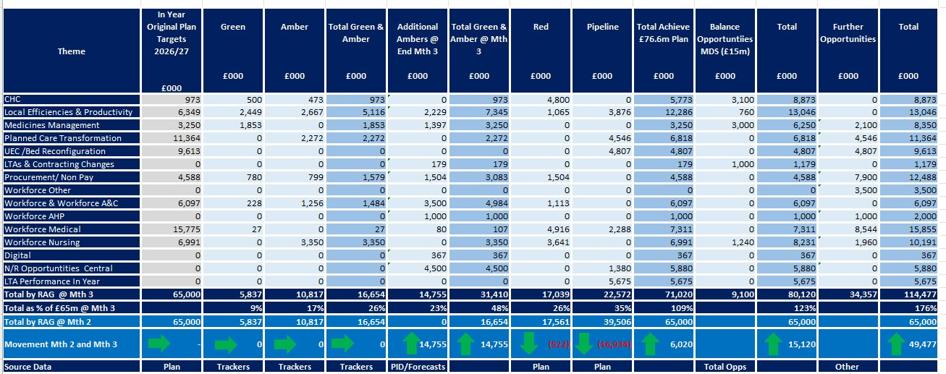
At Month 2, £16.6m of schemes were assessed as Amber or Green, representing 26% of the overall savings requirement, against a target of £31.4m (48%) by the end of Quarter 1.
The R&S Board have identified a few recurring themes across programmes:
- Variable quality and maturity of Project Initiation Documents (PIDs)
- Insufficient focus on translating plans into delivery
- Limited clarity regarding the specific budget lines and cost-code reductions associated with some schemes
- A requirement for all schemes to have clear delivery plans supported by validated financial assumptions
Actions to address each of these points and targeted feedback was provided to individual project schemes to support imminent improvement.
Detailed reviews focused on:
- Workforce and Medical Workforce
- Medicines Management
- Nursing Transformation
- Planned Care
- Bed Rationalisation and Patient Flow
Key risks and next steps have been identified for each of these areas.

The R&S Board concluded that Q1 priorities should focus on:
- Acceleration of Pipeline – Red – Amber – Green
- Financial validation and benefits realisation
- Improving quality and actionability of PIDs
- Establishing a credible trajectory to achieve the Quarter 1 target

  - R&S Board 8 July 2026

The financial update from the M3 position is shared below for awareness.

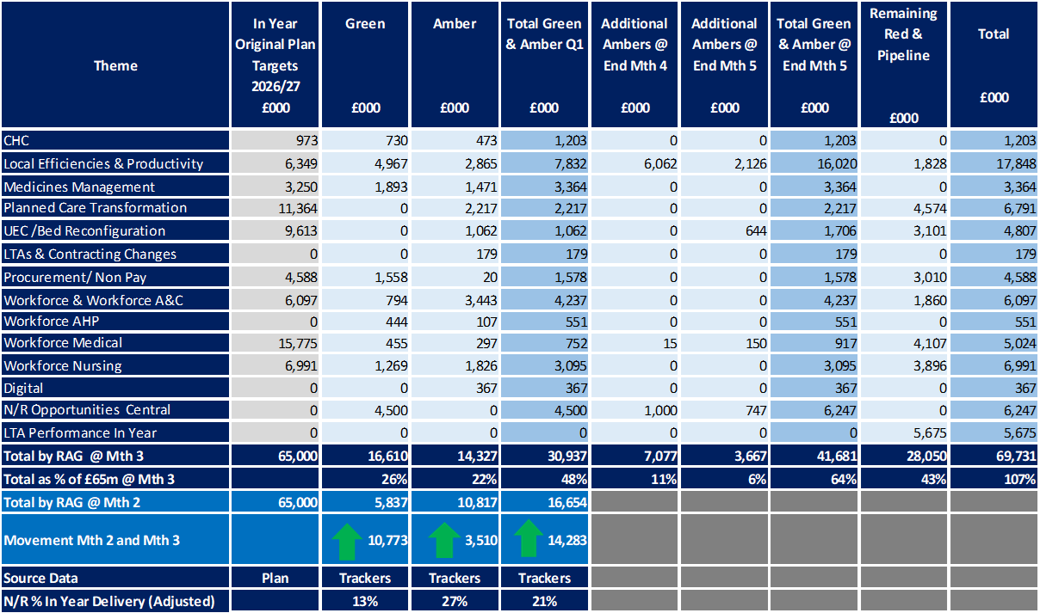

Pipeline processes and new scheme idea generation was outlined at the R&S Board and actions were agreed that would add these to the pipeline.

R&S also tasked members with ensuring that local savings trackers align with thematic PIDs and any new savings opportunities were shared as part of every £ count.

Service Group performance form M3 is outline below:
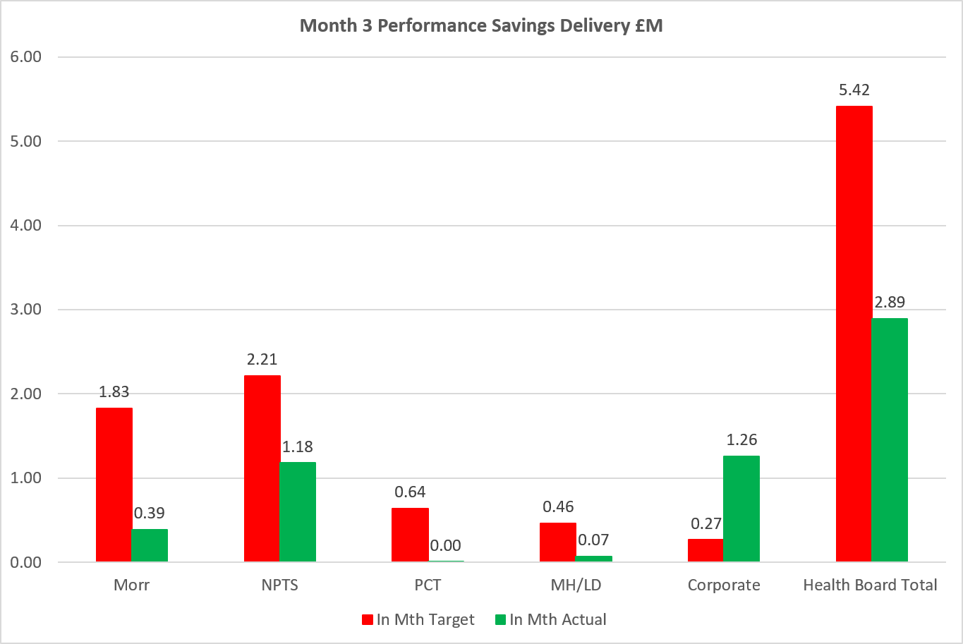

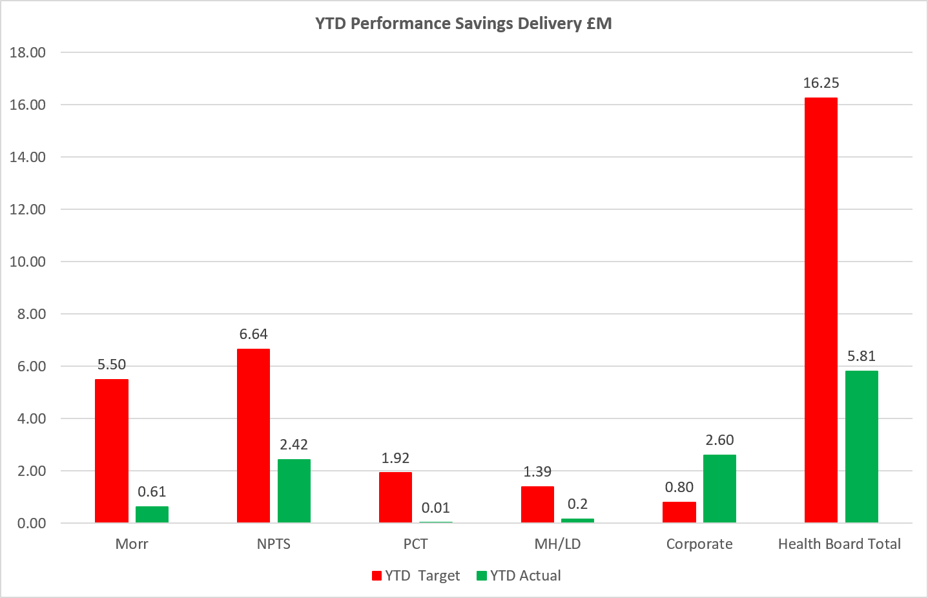

The R&S Board recognise that whilst Quarter 1 objectives relating to scheme identification and programme maturity had been achieved, delivery of recurrent financial benefits remains below the trajectory required to achieve the Health Board’s savings target.

As a result, the R&S Board agreed a series of immediate recovery actions:
- Formal letters of concern have been issued to programme areas with significant delivery gaps through the Performance and Accountability Framework.
- Programme leads have been instructed to produce revised delivery trajectories and mitigation plans.
- All programmes have been tasked with identifying additional savings opportunities to support delivery shortfalls.
- Delivery Unit and Finance colleagues will continue joint scrutiny of schemes where benefits remain unvalidated or delivery confidence is low.
- Progress against these actions will be reviewed at the next Recovery and Sustainability Board.

The R&S Board received assurance that the overall savings pipeline continues to grow and has increased by approximately £6m since the previous review. Whilst these opportunities do not yet represent validated delivery, they provide additional mitigation against emerging risks and strengthen the Health Board’s ability to respond to shortfalls in existing schemes.

The R&S Board are working to streamline meetings, bringing together and aligning Service Group Check and Challenge meetings and Performance and Finance meetings to ensure closer collaboration between Finance and the Delivery Unit aligning actions.

The R&S Board agreed that future meetings will place increased emphasis on delivery, benefits realisation and accountability for financial performance.

- GOVERNANCE AND RISK ISSUES

The principal risk facing the Recovery and Sustainability Programme is no longer the identification of opportunities but the conversion of opportunities into recurrent financial benefit at the pace required to achieve the Health Board’s £65m savings requirement.

The R&S Board can provide assurance that governance, programme management and delivery oversight arrangement have improved during Quarter 1. However, the Month 3 position demonstrates that identified opportunities are not yet converting into recurrent savings at the rate required to deliver the Health Board’s £65m programme.

The most significant delivery risks remain within:
- Medical workforce
- Planned care
- Nursing Workforce
- Procurement

The principal risks associated with each of theme’s schemes is summarised in the table below:

Theme | Principal Risk
Medical Workforce | Significant shortfall against planned delivery, validation work continues £2.9m of opportunities against an original savings expectation of £15.7m.
Planned Care | Delayed implementation with the theatre workstreams resulting in slippage against planned delivery milestones.
Nursing Workforce | Delivery risk arising from delayed implementation of planned workforce initiatives.
Procurement | £1.5m year-to-date delivery shortfall and requirement to identify delivery against a further £5m savings challenge.

These areas are now subject to enhanced scrutiny through the Recovery and Sustainability Board mirroring the Performance and Accountability Framework, with specific recovery actions, mitigation plan and accountability arrangement being monitored between R&S board meetings.

The R&S Board is also reviewing its own operating model to ensure future meetings focus on delivery, accountability and benefit realisation, supported by clear actions, ownership and reporting expectations.

The Delivery Unit is now focusing on capacity and capability to meet the expectations of the executive team and the Board. Work is continuing to quantify this resource, and a paper has been drafted outlining:
- Current make of the Delivery Unit
- Gaps in planned model and current state
- Proposed future state
- Alignment to other Health Board teams and services

- FINANCIAL IMPLICATIONS
The financial implications of this report are set out within it.

- RECOMMENDATION
Members are asked to:
  - Receive the report for assurance.
  - Note that Quarter 1 objectives for scheme identification were achieved, with Green and Amber Schemes totalling £30.9m (48% of the overall savings requirement).
  - Note that savings delivery at Month 3 remains £10.4m behind the required trajectory and that significant delivery risks remain with the Medical workforce, Planned Care, Nursing Workforce and Procurement programmes.
  - Take assurance that formal escalation and recovery actions have been initiated through the Performance and Accountability Framework, with specific actions and mitigations being reported back to the future Recovery and Sustainability Boards.
  - Take assurance that the savings pipeline continues to develop, having increased by approximately £6m since the previous review, providing additional opportunities to mitigate emerging delivery gaps.
  - Note the continued development of the Recovery and Sustainability Board operating model, including improvements in accountability arrangements, standardised reporting and enhanced focus on delivery and benefits realisation.
  - Note that Medical Workforce, Planned Care, Nursing Workforce and Procurement remain areas of heightened delivery risk and will continue to received enhanced scrutiny through the Recovery and Sustainability Board.

Governance and Assurance
Strategic Objectives
Strategic Objectives  (please choose which is impacted) | People of Swansea Bay live healthier, fairer and more prosperous lives | ☐
Strategic Objectives  (please choose which is impacted) | Care is high quality, safe, efficient and delivers the best possible outcomes for people in partnerships | ☐
Strategic Objectives  (please choose which is impacted) | Care is delivered in partnership with our communities in safe and appropriate setting, supported by innovation | ☐
Strategic Objectives  (please choose which is impacted) | The health board is a great place to work where staff feel valued and work together towards a common goal | ☐
Strategic Objectives  (please choose which is impacted) | The health board is a resilient, sustainable and responsible organisation | ☒
Health and Care Standards
Standards (please choose which applies) | Safe Care | ☐
Standards (please choose which applies) | Timely Care | ☐
Standards (please choose which applies) | Effective Care | ☒
Standards (please choose which applies) | Efficient Care | ☒
Standards (please choose which applies) | Equitable care | ☐
Standards (please choose which applies) | Person-centred Care | ☐
Standards (please choose which applies) | Staff and Resources | ☒
Enablers (please choose which applies) | Whole Systems Approach | ☒
Enablers (please choose which applies) | Leadership | ☒
Enablers (please choose which applies) | Workforce | ☐
Enablers (please choose which applies) | Culture | ☐
Enablers (please choose which applies) | Information | ☐
Enablers (please choose which applies) | Learning, Improvement and Research | ☐
Quality, Safety and Patient Experience
Recovery & Sustainability programme, whilst addressing the need for a sustainable financial position, is focused on undertaking through delivery of good quality, safety, and patient experience.

Financial Implications
No direct financial implications
Legal Implications (including equality and diversity assessment)
No implications
Staffing Implications
No direct implications
No implications
No implications
Report History
n/a

Appendices
n/a

