Meeting Date | 25 August 2026 | Agenda Item | 2.3
Name of Meeting | Finance and Performance Committee
Report Title | Recovery and Sustainability Board Update
Report Author | Callum Allen-Ridge, Head of PMO
Report Sponsor | Executive Director of Finance
Presented by | Callum Allen-Ridge, Head of PMO
Freedom of Information | Open
FoI Closed detail | If closed, choose detail
Impact Assessment Summary Outcome |  | IA Completion date
n/a |  | Click or tap to enter a date.
Purpose of the Report | For Assurance
Report Summary; detailing any action required
The report is provided to update the committee on the current actions and work in progress of the Recovery & Sustainability (R&S) Board.

Key Issues
The Recovery and Sustainability Board has continued to focus on the delivery of the Health Board's £65m savings requirement, with particular emphasis on converting identified opportunities into recurrent, cash-releasing savings and strengthening confidence in year-end delivery. The Board's focus has now shifted from opportunity identification to implementation, benefits realisation and financial delivery.

The Month 4 position demonstrated continued progress in the maturity of the savings programme. Green and Amber schemes increased to £40.1m, representing 62% of the savings requirement, rising further to £42.8m at Month 5 and representing 66% of the overall programme target. Identified opportunities now exceed the £65m savings requirement, providing a credible route to achieving a fully developed savings programme by the end of Quarter 2.

The Board noted an improvement in the financial position during Month 4, with an in-month deficit of £5.952m and a cumulative deficit of £29.3m. Whilst part of this improvement relates to non-recurrent measures, it demonstrates increasing conversion of recovery actions into financial performance.

The principal challenge remains the development and implementation of the remaining opportunities required to complete the £65m programme. Approximately £24m-£25m of opportunities require further validation and progression into mature Green and Amber schemes. Medical Workforce, Planned Care, Procurement and Workforce continue to represent the most significant delivery risks and remain subject to enhanced scrutiny, recovery plans and executive oversight.

The Board is focused on pipeline opportunities which have now been identified across the organisation to support development of a fully assured £65m programme by the end of Quarter 2, with current efforts focused on validation, implementation and conversion into recurrent financial benefit.
Decision / Action required | No
Recommendations
Members are asked to:
- RECEIVE the report for assurance.
- NOTE the Month 4 improvement in the financial position, including a reported monthly deficit of £5.952m and cumulative deficit of approximately £29.3m.
- NOTE that Green and Amber schemes have increased to approximately £40m (62% of target), rising to £42.8m including additional opportunities identified at Month 5.
- TAKE ASSURANCE that pipeline development continues across all programme areas, with opportunities identified now exceeding the £65m savings requirement.
- NOTE that approximately £24m-£25m of opportunities still require validation and progression into mature Green and Amber schemes.
- TAKE ASSURANCE that enhanced scrutiny arrangements remain in place for Medical Workforce, Planned Care, Nursing Workforce, Procurement and Variable Pay.
- NOTE the continued focus of the Recovery and Sustainability Board on benefits realisation, delivery assurance, workforce expenditure reduction and development of the Health Board's three-year recovery roadmap.
RECOVERY AND SUSTAINABILITY BOARD UPDATE

- INTRODUCTION
This paper provides the monthly update to the Performance & Finance Committee regarding the progress of the Recovery and Sustainability (R&S) Programme, the activities undertaken by the Recovery and Sustainability Board, and the current position against the Health Board's £65m savings requirement

- BACKGROUND
- The Recovery and Sustainability Board meets twice monthly and is chaired by the Chief Executive, with executive leadership of each thematic programme. The Delivery Unit continues to provide programme management, governance oversight, risk management and support to scheme development across the organisation. Formal project management arrangements, programme reporting, Risks, Actions, Issues, Decisions (RAID) management and joint working between Finance and the Delivery Unit have continued to mature throughout Quarter 1 and into Quarter 2.

The Committee has previously received assurance regarding the strengthening of governance arrangements, scheme oversight and pipeline management processes. Whilst these improvements have enhanced organisational visibility and control of the savings programme, the Recovery and Sustainability Board has increasingly focused its attention on the translation of these arrangements into demonstrable financial delivery.

- R&S PROGRAMME UPDATE

  - R&S Board 22 July 2026

The Recovery and Sustainability Board undertook a series of programme deep dives focusing on Planned Care, Medical Workforce, Urgent and Emergency Care (UEC), Procurement, Administrative and Clerical Workforce, and Nursing Workforce. The Board's primary focus was assurance regarding delivery assumptions, benefits realisation and the translation of operational improvements into demonstrable financial benefit.

The Board noted that several programmes were demonstrating operational progress but required stronger evidence of financial delivery and recurrent benefit. Focus was placed on Planned Care, Medical Workforce and UEC, where revised assumptions, operational pressures and changing service requirements had impacted original savings trajectories. Programme leads were instructed to review forecasts, validate assumptions and strengthen benefit realisation arrangements.
Positive progress was noted within Nursing Workforce and Administrative and Clerical Workforce programmes, with opportunities identified through workforce redesign, vacancy management and establishment reviews. The Board emphasised the importance of ensuring identified savings are reflected within financial plans and budgets and supported through robust monitoring arrangements.

The Board concluded that future programme reporting should focus on evidencing cash-releasing savings, delivery against forecast trajectories and the conversion of operational improvements into recurrent financial benefit. Enhanced scrutiny arrangements were subsequently established for programmes identified as presenting the greatest delivery risk.

  - R&S Board 12 August 2026

The Recovery and Sustainability Board reviewed the Month 4 financial position and noted continued progress in the maturity of the savings programme and development of the savings pipeline. Green and Amber schemes increased to £40.1m at Month 4 and £42.8m at Month 5, representing 66% of the overall savings requirement. The Board noted that identified opportunities now exceed the £65m target, with the focus moving to validation, implementation and delivery.

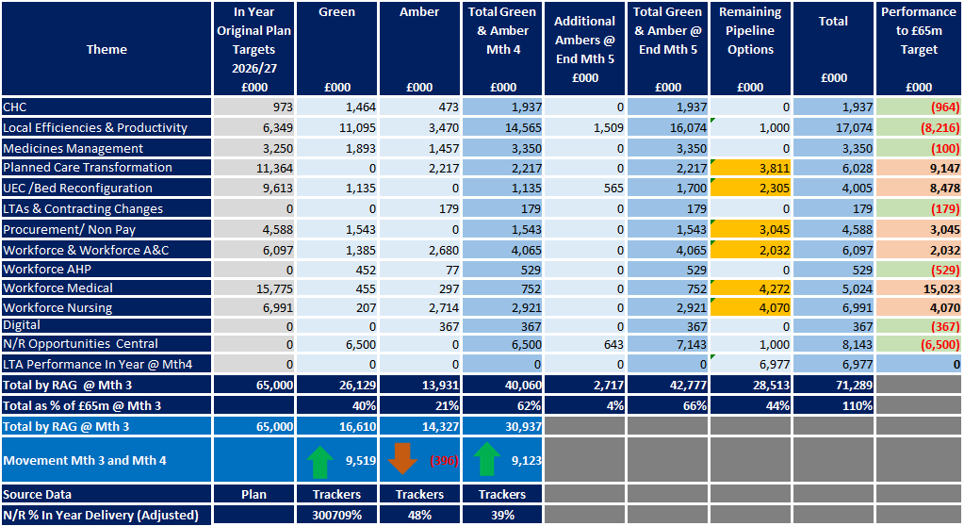

The Board received an update on the organisation's financial position, including confirmation that the savings requirement remains £65m and that Welsh Government expectations continue to focus on delivery of a credible recovery trajectory supported by a robust savings programme and longer-term recovery plan. Work is progressing to develop a comprehensive three-year recovery roadmap for consideration by the Board and the Welsh Government.

The Month 4 position demonstrated an improving financial trajectory, with an in-month deficit of £5.952m and a cumulative deficit of approximately £29.3m. Whilst the Board recognised that some improvement was driven by non-recurrent benefits, members noted increasing evidence that savings actions are beginning to translate into financial performance.

The Board reviewed delivery performance across each programme area and confirmed that Planned Care, Medical Workforce, Procurement and Workforce continue to present the most significant delivery risks. These areas remain subject to enhanced scrutiny, revised delivery trajectories and targeted recovery actions.

Workforce expenditure remained a significant area of focus. The Board reviewed opportunities to reduce variable pay expenditure through strengthened vacancy management, recruitment controls, workforce redesign and enhanced scrutiny of agency, bank and waiting list initiative expenditure. Additional opportunities were identified through procurement and non-pay expenditure reviews which will continue to be developed during Quarter 2.

The Board concluded that opportunities have been identified to support development of the full £65m programme by the end of Quarter 2 and agreed that priority should now focus on accelerating delivery, increasing recurrent savings and strengthening assurance around benefits realisation.

- GOVERNANCE AND RISK ISSUES

The principal risk to the Recovery and Sustainability Programme remains the conversion of identified opportunities into recurrent financial benefits at the pace required to achieve the Health Board's savings requirement. Whilst governance arrangements, programme management disciplines and programme maturity have improved significantly during the first four months of the year, delivery risk remains within several strategic programmes.

The most significant risks continue to relate to Medical Workforce, Planned Care, Procurement and Workforce schemes where delivery remains dependent upon implementation of planned actions and completion of outstanding validation work. These programmes remain subject to enhanced scrutiny through the Recovery and Sustainability Board and Performance and Accountability Framework, with recovery actions, revised trajectories and mitigation plans monitored between Board meetings.

Notwithstanding these risks, the Board has gained increasing assurance from the Month 4 position. The growth in Green and Amber schemes from £30.9m at Quarter 1 to £42.8m at Month 5 provides a credible route to achieving the end of Quarter 2 objective of a fully developed £65m savings programme. The primary focus for the remainder of Quarter 2 is therefore the continued maturation of pipeline opportunities and acceleration of recurrent savings delivery.

Key Thematic risks are outlined below:

Theme | Principal Risk
Medical Workforce | Significant shortfall against planned delivery, validation work continues £2.9m of opportunities against an original savings expectation of £15.7m.
Planned Care | Delayed implementation with the theatre workstreams resulting in slippage against planned delivery milestones.
Nursing Workforce | Delivery risk arising from delayed implementation of planned workforce initiatives.
Procurement | £1.5m year-to-date delivery shortfall and requirement to identify delivery against a further £5m savings challenge.

These areas are now subject to enhanced scrutiny through the Recovery and Sustainability Board and Performance and Accountability Framework, with specific recovery actions, mitigation plan and accountability arrangement being monitored between R&S board meetings.

- FINANCIAL IMPLICATIONS

The financial implications are set out within this report. The Month 4 position demonstrates continued progress in programme maturity, with Green and Amber schemes increasing to £40.1m and rising further to £42.8m during Month 5. Whilst further work is required to convert opportunities into recurrent financial benefit, identified opportunities now exceed the £65m savings requirement and provide a credible route to completion of a fully developed savings programme by the end of Quarter 2.

- RECOMMENDATION
Members are asked to:
- RECIEVE the report for assurance.
- NOTE the Month 4 improvement in the financial position, including a reported monthly deficit of £5.952m and cumulative deficit of approximately £29.3m.
- NOTE that Green and Amber schemes have increased to approximately £40m (62% of target), rising to £42.8m including additional opportunities identified at Month 5.
- TAKE ASSURANCE that pipeline development continues across all programme areas, with opportunities identified now exceeding the £65m savings requirement.
- NOTE that approximately £24m-£25m of opportunities still require validation and progression into mature Green and Amber schemes.
- TAKE ASSURANCE that enhanced scrutiny arrangements remain in place for Medical Workforce, Planned Care, Nursing Workforce, Procurement and Variable Pay.
- NOTE the continued focus of the Recovery and Sustainability Board on benefits realisation, delivery assurance, workforce expenditure reduction and development of the Health Board's three-year recovery roadmap.

Governance and Assurance
Strategic Objectives
Strategic Objectives  (please choose which is impacted) | People of Swansea Bay live healthier, fairer and more prosperous lives | ☐
Strategic Objectives  (please choose which is impacted) | Care is high quality, safe, efficient and delivers the best possible outcomes for people in partnerships | ☐
Strategic Objectives  (please choose which is impacted) | Care is delivered in partnership with our communities in safe and appropriate setting, supported by innovation | ☐
Strategic Objectives  (please choose which is impacted) | The health board is a great place to work where staff feel valued and work together towards a common goal | ☐
Strategic Objectives  (please choose which is impacted) | The health board is a resilient, sustainable and responsible organisation | ☒
Health and Care Standards
Standards (please choose which applies) | Safe Care | ☐
Standards (please choose which applies) | Timely Care | ☐
Standards (please choose which applies) | Effective Care | ☒
Standards (please choose which applies) | Efficient Care | ☒
Standards (please choose which applies) | Equitable care | ☐
Standards (please choose which applies) | Person-centred Care | ☐
Standards (please choose which applies) | Staff and Resources | ☒
Enablers (please choose which applies) | Whole Systems Approach | ☒
Enablers (please choose which applies) | Leadership | ☒
Enablers (please choose which applies) | Workforce | ☐
Enablers (please choose which applies) | Culture | ☐
Enablers (please choose which applies) | Information | ☐
Enablers (please choose which applies) | Learning, Improvement and Research | ☐
Quality, Safety and Patient Experience
Recovery & Sustainability programme, whilst addressing the need for a sustainable financial position, is focused on undertaking through delivery of good quality, safety, and patient experience.

Financial Implications
No direct financial implications
Legal Implications (including equality and diversity assessment)
No implications
Staffing Implications
No direct implications
No implications
No implications
Report History
N/A.

Appendices
None.

