Meeting Date | 28 October 2025 |  | Agenda Item |  |  | 2.4
Name of Meeting | Performance & Finance Committee
Report Title | Capital Resource Plan Update Month 6
Report Author | Ian MacDonald, Assistant Director of Finance
Report Sponsor | Darren Griffiths, Executive Director of Finance & Performance
Presented by | Ian MacDonald, Assistant Director of Finance
Freedom of Information | Open
Purpose of the Report | To provide an update on the financial performance of the Health Board’s capital programme at month 6 and the impact of emerging risks and opportunities on the projected outturn position for 2025/26.
Key Issues | The Health Board approved a balanced capital financial plan for 2025/26 as part of the submitted Annual Plan.  The forecast outturn position reported at Month 6 shows an overspend position of £2.250m. Additional income from Welsh Government and disposal proceeds are anticipated to provide a balanced position.  Following the outcome of the national capital prioritisation exercise, the national funding situation remains unclear. A small number of urgent projects have commenced to scope immediate and interim solutions.  The programme contingency has been fully utilised. As requests for additional capital funding continue to emerge from the service, alongside the national funding challenges, the risk of the plan shifting from balance to imbalance remains material and is reflected in Risk 93 on the Health Board Risk Register.
Specific Action Required  (please choose one only) | Information | Discussion |  | Assurance | Approval
Specific Action Required  (please choose one only) | ☐ | ☐ |  | ☒ | ☐
Recommendations | Members are asked to:  - ACKNOWLEDGE the month 6 reported financial position and forecast outturn.  - ACKNOWLEDGE the additional allocation bids submitted to Welsh Government.  - SUPPORT and DISCUSS the update on business cases.  - ACKNOWLEDGE the programme contingency has been fully utilised.

CAPITAL RESOURCE PLAN

- INTRODUCTION
This report provides an update to the financial performance of the Health Board’s capital programme and the impact of emerging risks and opportunities on the projected outturn position for 2025/26.

- BACKGROUND
The Health Board approved a balanced capital financial plan for 2025/26 as part of the Annual Plan submitted to Welsh Government (WG) in March 2025. The plan included an uplift of 24%/£2.7m to £13.875m. It also included income assumptions on the payback of business case fees from WG and disposals proceeds.

The forecast outturn position reported at month 6 shows an overspend position of £2.250m with anticipated allocations which would provide a balanced position.

The extensive £13m additional slippage bid funding provided by WG last year, alongside the national increase to discretionary allocations, mean the opening financial position is much more positive than at this stage over the last few years. There are however significant financial requests for additional funding for medical equipment replacement and estates and so the pressure to retain a balanced capital position will likely remain fragile as there is very little remaining flexibility in the programme to manage emerging service and infrastructure risks.

The national funding situation continues to be challenging following the outcome of the national capital prioritisation exercise, with several projects either on hold or working through interim solutions. There continues to be some uncertainty on the future approval of capital funding following correspondence from Welsh Government around the unapproved revenue financial plan for the Health Board as per Judith Paget’s letter of 6th June 2025. As a result of the national funding pressures, during September several capital bids have been placed on hold and additional bids to reinvest additional VAT recovery into capital projects have been rejected.

Month 6 Position

The forecast outturn position reported at month 2 shows an over-commitment of £1.750m, which alongside planned disposal proceeds of £500k provides a total anticipated income of £2.250m. These allocations shown in table 1 are anticipated to provide a balanced year-end outturn position. However, the RAG risk rating in table 2 highlights that just over 50% of this anticipated income is now rated as red/high-risk of not being received. The major items are both new risks related to the recent national funding challenges. The original TEF funded Roof replacement scheme for the Tonna Mother & Baby Mental Health Unit came in over budget, alongside a late request to install a compliant cooling system in the unit. The estimated £598k shortfall alongside the additional £350k for the Morriston steam project have both progressed at risk given the significant business continuity risk. It was expected that both elements were to be funded by WG, but at this stage they are being held by WG pending the national funding review.

There is a significant risk of a material imbalance on the plan without these national funding streams, however there are options available to bring the plan back into balance. As well as options to place a hold on some of the equipment replacement schemes within the discretionary plan, there are several Welsh Government funded projects which either have underspends that the Health Board would be looking to request reinvestment or schemes where completion has slipped into next year and will form part of the normal mid-year discussions with Welsh Government about fixing the CRL position on approved individual projects by 31st October.

Table 1 - Month 6 Forecast Outturn Position (exc IFRS 16) 2025/26
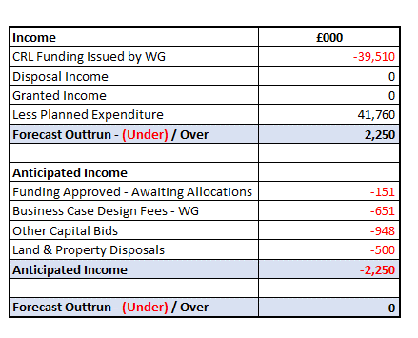

Table 2 - Anticipated Income 2025/26

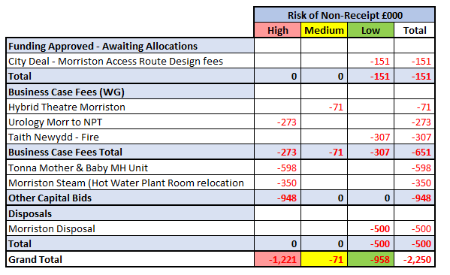

Capital Funding Allocations – All Wales Capital Programme

There has been a net increase of 2.643m funding received into the CRL since month 2.

A number of additional allocations for £10.049m are detailed in section A. The largest allocation is through the national diagnostic programme which has provided £6.475m this year (£7.275m over 2 years) to replacing CT1 and Fluoroscopy 2 both in Morriston.

Construction work on the new PET-CT at the West Wales Cancer Centre commenced in Singleton on 15th September and has a planned operational date of February 2027. As discussed in the month 2 report, further work has taken place to firm up some the contract terms and programme. Following completion of these items, £8.8m was returned to Welsh Government during July and August for reprovision in 2026-27.

As indicated in the month 2 report, a submission was made to Welsh Government to accelerate approved funding from the 2026/27 Targeted Estates Fund (TEF) allocation, which has subsequently been approved.

There are no approved allocations where allocations are outstanding.

Table 3 - Summary Approved Allocations 2025-26
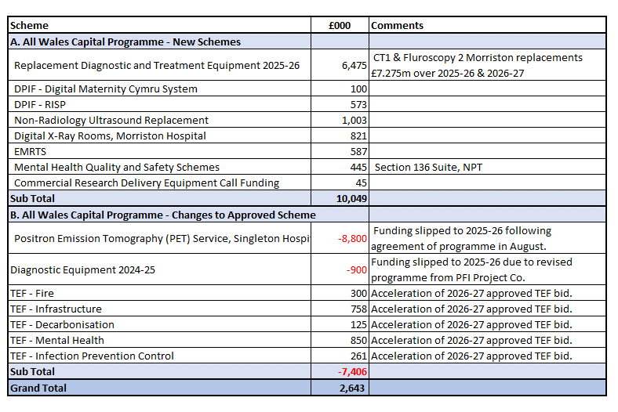

Additional funding bids of £14.094m are currently with Welsh Government for consideration. These include the two anticipated allocations for Tonna and Morriston steam included in table 2. There are two large bids for slippage funding which were submitted in September as requested by Welsh Government in the normal way. This normally allows Welsh Government to allocate additional funding they may receive during the latter half of the financial year. We have in recent years been very successful with these bids, including an additional £11m last year. It is not yet clear what the scale of any additional funding availability will be this year, as this will depend on the outcome of the current national funding challenges and the level of specific scheme slippage that is returned to WG from across NHS Wales when the CRLs are fixed on 31st October. However, the work undertaken to submit these two large bids for £10.597m ensures the Health Board is in the best possible position should the opportunity for funding become available.

Table 4 - Funding Bids Submitted
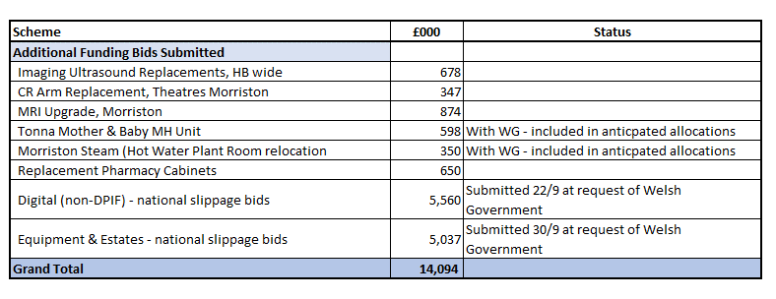

Equipment

The significant investment of £5.4m into digital last year from the Welsh Government slippage bids, allowed investment into some large service critical infrastructure projects, including replacement of the core network in Morriston & Singleton and replacement of the wireless network in NPT. The focus of the discretionary allocation this year is initially around replacement of devices and data centre systems.

Although the investment into medical equipment of £5.6m last year across 53 separate projects from Welsh Geoverment slippage bids was welcomed, there are still a large number of bids for replacement equipment that are being assesed by the Capital Prioritisation Group and many of these were submitted to Welsh Government as part of the slippage bid in table 4 . Work is progressing on the procurement for 3 main replacement programmes included within the approved plan:-

- Anaesthetic Machine replacement, Morriston £800k (£1.8m over a 2 year programme). The procurement has been completed and it is anticipated that an order will be placed by the end of October.
- Pharmacy £1.160m. Replacement for the Pharmacy Robot, NPT and replacement of the automated medicine stock cabinets. (potentially a 2 year programme). The procurement is nearing completion and it is anticpated that a decision will be made by the end of October.
- Cardiology MacLab System Upgrade £540k. The procurement has been completed and it is anticipated that an order will be placed by the end of October.

Programme Contingency

Although there are contingencies built into major projects across the capital programme, the remaining general discretionary programme contingency has been fully utilised.

Update on All Wales Capital Schemes

Following the outcome of the national Capital Prioritisation process for major business cases in January, the Estates Task Force group has continued to meet. As described in the submitted Annual Plan in March, the focus has been on developing funding solutions for the four urgent risk schemes and also developing plans for possible land and property disposals to support the national housing crisis.

Work is continuing on the four priority schemes and a detailed update with be provided through the Estates Taskforce into a future Performance and Finance Committee. In summary: -

- Adult Acute Mental Health Wards, Morriston. Immediate improvement works at Tawe clinic funded through the TEF allocation are due to commence in early November and likely to run into early 2026-27. The interim options for the relocation of the Tawe Adult MH wards from Cefn Coed is expected to be presented to the November Health Board meeting.
- Emergency Department Improvements, Morriston. A number of interim solutions utilising the current estate are under consideration. Capital funding support for design works has been requested from Welsh Government.
- Regional Cellular Pathology. Following the report on the two off-hospital site options presented to both Health Boards in September, additional technical feasibility work is being undertaken. An options workshop is scheduled for December with a decision on the preferred option expected by January. Positive discussions are continuing with Welsh Government on capital funding support.
- Taith Older Persons Ward, Glanrhyd (Fire reinstatement).
A fully designed and tendered business case was submitted to Welsh Government on 26th September following approval at the September Health Board. The case is going through Welsh Government scrutiny and given the very urgent nature of the project, a decision is expected in November.

Business Cases submitted to WG.
- Urology OR1 Theatres, NPT, September 2024 c£4.285m. Scrutiny comments received from Welsh Government. Awaiting final design and tendered costs from PFI partners which has been subject to further delay and is now likely to be received in Q4.
- Hybrid Vascular Theatre, Morriston, May 2024 £10.436m. Case was presented to the Welsh Government Investment Infrastructure Board (IIB) on 16th October 2025. Awaiting Welsh Government approval.

Business Case in Production through All Wales Capital Programme
- Seclusion Suites, Caswell Medium Secure Unit, Glanrhyd.
Following a business case scoping meeting held with Welsh Government on 4th September 2025, it was agreed to proceed with producing a single stage business case for submission to Welsh Government. The works will require to be split into two phases as it is linked into the Taith reinstatement business case. Design has already been undertaken up to RIBA Stage 2 and the Health Board has released £139k funding from contingency to allow the final RIBA stages 3 and 4 design to be completed. It is expected that a fully designed and tendered case will be presented to the March 2026 meeting of the Health Board.
- 5th Linacc / 6th Bunker Expansion
A business case scoping meeting is scheduled with Welsh Government on 22nd October 2025.

Business Case in Production through Regional Partnership Board
- Dan y Deri Learning Disabilities £9.9m. The Business Case was approved at the July Health Board meeting and is currently going through Welsh Government scrutiny. It is expected to be presented at the November/December Welsh Government Housing for Care (HCF) panel.
- Croeserw Health and Wellbeing Centre c£5.8m. Design nearing completion. Expected to shortly progress to tender, with a fully designed and tendered solution expected to be ready for Health Board and Welsh Government scrutiny in Quarter 4.

Overall Assessment

Whilst the extensive £11m additional slippage bid funding provided by WG last year, alongside the national increase to discretionary allocations mean the opening financial position is much more positive than at this stage over the last few years, there remains significant financial requests for additional funding for medical equipment replacement and estates. The capital programme contingency has been fully utilised and alongside the national funding challenges, the pressure to retain a balanced capital position will likely remain fragile as there is very little remaining flexibility in the programme to manage emerging service and infrastructure risks.

- GOVERNANCE AND RISK ISSUES
There is an increased possibility that new service requests, including those with a high-risk score will be unable to be receive capital funding during 2025/26 within the capital resources made available to the Health Board. These risks will continue to be assessed through the Capital Prioritisation Group and raised up through the Management Board. A risk register entry (Risk 93) has been included in the Health Board risk register and is currently assessed as a 20-score risk.

- FINANCIAL IMPLICATIONS
The financial implications and funding risks are as detailed within the body of the report. In summary, the approved balanced capital plan is assuming additional funding of £2.250m in order to deliver a balanced outturn position. The remaining contingency in the plan has been fully utilised.

- RECOMMENDATIONS
Members are asked to:
- ACKNOWLEDGE the month 6 reported financial position and forecast outturn.
- ACKNOWLEDGE the additional allocation bids submitted to Welsh Government.
- SUPPORT and DISCUSS the update on business cases.
- ACKNOWLEDGE the programme contingency has been fully utilised.

Governance and Assurance

Link to Enabling Objectives  (please choose) | Supporting better health and wellbeing by actively promoting and empowering people to live well in resilient communities
Link to Enabling Objectives  (please choose) | Partnerships for Improving Health and Wellbeing |  | ☐
Link to Enabling Objectives  (please choose) | Co-Production and Health Literacy |  | ☐
Link to Enabling Objectives  (please choose) | Digitally Enabled Health and Wellbeing |  | ☐
Link to Enabling Objectives  (please choose) | Deliver better care through excellent health and care services achieving the outcomes that matter most to people
Link to Enabling Objectives  (please choose) | Best Value Outcomes and High Quality Care |  | ☐
Link to Enabling Objectives  (please choose) | Partnerships for Care |  | ☐
Link to Enabling Objectives  (please choose) | Excellent Staff |  | ☐
Link to Enabling Objectives  (please choose) | Digitally Enabled Care |  | ☐
Link to Enabling Objectives  (please choose) | Outstanding Research, Innovation, Education and Learning |  | ☐
Health and Care Standards
(please choose) | Staying Healthy |  | ☐
(please choose) | Safe Care |  | ☐
(please choose) | Effective Care |  | ☐
(please choose) | Dignified Care |  | ☐
(please choose) | Timely Care |  | ☐
(please choose) | Individual Care |  | ☐
(please choose) | Staff and Resources |  | ☐
Quality, Safety and Patient Experience
Without additional funding support from WG, further requests for capital funding will not be affordable within the allocated resources. This may impact on new service requests for additional capital funding for estates, medical equipping and digital services.

Financial Implications
The financial implications and funding risks are as detailed within the body of the report. In summary, the approved balanced capital plan is assuming additional funding of £2.250mm. The remaining contingency in the plan is nil.

Legal Implications (including equality and diversity assessment)
None
Staffing Implications
None

Long Term Implications (including the impact of the Well-being of Future Generations (Wales) Act 2015)
n/a

Report History |  | Month 2 position, PFC 24 June 2025
Appendices |  | None

