Meeting Date | 28 October 2025 |  | Agenda Item |  |  | 2.3
Name of Meeting | Performance and Finance Committee
Report Title | Monthly Recovery and Sustainability Update
Report Author | Deborah Longman – Head of Recovery and Sustainability  Samantha Moss – Deputy Director of Finance
Report Sponsor | Darren Griffiths, Executive Director of Finance and Performance
Presented by | Samantha Moss – Deputy Director of Finance
Freedom of Information | Open
Purpose of the Report | The report is provided to update the committee on the current actions and work in progress of the Recovery & Sustainability Board.
Key Issues | The report invites the Performance & Finance Committee to note the work undertaken by the Recovery & Sustainability programme, overseen by the Recovery & Sustainability (R&S) Board.  The report includes an overview of the key actions arising from the latest Recovery & Sustainability Boards as well as an update on the thematic programmes. It also provides high level information on the delivery regarding the Health Board savings.
Specific Action Required  (please choose one only) | Information | Discussion |  | Assurance | Approval
Specific Action Required  (please choose one only) | ☐ | ☐ |  | ☒ | ☐
Recommendations | Members are asked to: -  - ACKNOWLEDGE the updated report for ASSURANCE of ongoing delivery associated with the Recovery and Sustainability Programme
MONTHLY RECOVERY & SUSTAINABILITY PROGRAMME UPDATE

- PURPOSE
The paper provides the monthly formal update to the committee regarding the actions and progress within the Recovery and Sustainability programme.

- INTRODUCTION
Phase 1 of the external strategic support commissioned by the Health Board in collaboration with Welsh Government commenced in July 2025. There were 9 deliverables from Phase 1, which are summarised below and a full update on progress is planned to be jointly shared with Welsh Government at a review session on 21October.

- Assessment of the quality and effectiveness of the Board’s delivery structures = A detailed diagnostic of financial improvement governance, reporting, accountabilities, delivery ownership and reporting, with targeted recommendations to strengthen grip, accountability and mechanisms to mitigate delivery risk.
- Assessment of the control environment in key material expenditure and risk areas = Assessment of controls in key spend areas (e.g. temporary workforce, non-pay), identifying gaps, proposing revisions and clear actions to improve control and assurance. Support the implementation of priority controls to rapidly begin tackling run-rate pressures.
- Assessment of financial baseline and deficit drivers = An independent assessment of the robustness of deficit assessment to date, and investigation of the reasonableness of classification of key items. Testing of the deficit drivers work to date with focus on UEC and CHC.
- Urgent and emergency investment review and service redesign to deliver recurrent savings = An assessment of UEC investment versus impact, with disinvestment recommendations and a prioritised set of redesign opportunities (e.g. SDEC, AMU, discharge), focused on unlocking flow and releasing acute capacity.
- Opportunities for sustainable CHC spend reduction = CHC opportunity and cost-driver assessment, including brokerage models, panel decisions, case mix and commissioning routes — with identified savings options and system-wide enablers.
- Assessment of Health Board savings plan for 2025/26 (identifying actions for improvement) = A risk-rated review of the current plan — testing scheme-level deliverability, phasing, ownership and grip — with recommended actions to address gaps and improve forecast certainty.
- Fully identified savings plan for 2025/26 = A fully identified and phased savings plan, with in-year mitigations through scheme stretch, substitution, addition and grip improvements.
- Pipeline of further savings options in 2026/27 and 2027/28 = A structured pipeline of future schemes segmented by opportunity area (e.g. workforce, elective, CHC), delivery risk and timeline — enabling financial planning beyond FY25/26.
- Plan to support and embed changes for the remainder of 2025/26 = An implementation roadmap for second half of 2025/26 with sequenced priorities, delivery tracking, and resourcing plan to support in-year impact and sustain progress beyond the diagnostic.

Phase 2 of the programme commenced on 6th October and it provisionally for a 4 week period.

- UPDATES R&S PROGRAMME

  - R&S Board 8th October 2025
As this was the first meeting of the month the focus was on the work of the Thematic programmes and associated schemes. Key points included:

- A detailed presentation on ‘Spans of Control and Workforce Benchmarking’ was presented but the Director of Workforce. The analysis compared the Health Board’s workforce structure against:

- Other Health Boards across Wales; and
- A comparable group of NHS Trusts in England.

The benchmarking considered workforce size, composition (by whole-time equivalent), cost, and productivity across staff groups.

The data highlighted areas of further review on the organisation’s overall workforce base and that productivity levels were substantially lower.

- The Chair set clear actions for the next 2-4 week period which were: -
- Workforce Control – ban booking overtime in excess of 6 weeks for clinical areas and 1 week for all other areas to strengthen the existing controls further, based on the evidence presented to the R&S Board.
- Workforce Admin Priority areas – Clinical Administration, Booking Teams and Business Administration were areas where immediate actions could be undertaken to explore centralisation and support reduction in Administrative and Clerical (A&C) WTE, which is based on Clinical Staff to A&C Staff ratio being higher than comparable peers in England.
- Workforce Medical – challenge and review of all Medical and Dental (M&D) staff where baseline assessment of current job plans exceeds 12 PAs.
- Workforce Nursing – amendment to the 26.9% head room, with a change to 21%, with the 5.9% balance used to create a nursing pool to support roster gaps and reduce the use of variable pay.
- Procurement – finalisation of the contract review which has potential to deliver £1m in year and £4m recurrently.
- UEC Bed De-escalation – of the £1.8m planned there was confidence in £0.7m, which need to be finalised in the next 2 weeks, with further work required to address full £1.8m in Q3/Q4.
- UEC Investments – work with our external strategic partner is being finalised on plans of £1.6m and work to be accelerated in the next 4 weeks.

- Delivery leads and executive sponsors were expected to consider the pipeline schemes and look to move as many to green and amber, within the principles set by Welsh Government on what constitutes a green or amber scheme.

  - R&S Board 24th September 2025
Focus of the second meeting of the month is on updates from Service Groups and their performance against savings target. For the meeting on 24 September there was also a discussion on variable pay reduction and further enhancements to non-clinical variable pay. Key points:

- Variable pay: -

- Usage remained static across workforce groups over the preceding six weeks. A significant reduction in variable pay is essential to achieving savings targets over the next six months.
- There is a need to significantly reduce non-clinical variable pay, with an aim of an 80% reduction. In areas where a continued use is still required, services must redesign delivery models rather than rely on ongoing approvals.
- To further enhance workforce control compliance, the options appraisal outlined three potential approaches to strengthen compliance and oversight of A&C bank, agency, and overtime requests. Each option was designed to improve control and reduce variable pay expenditure, while balancing the need for operational flexibility and service continuity. An approach was agreed and communication issued.

- Morriston service group reported progress in reclassifying several schemes from red to green or amber.
- Neath Port Talbot Singleton service group provided assurance in the delivery of £1.9m of the current identified amber schemes.
- PCT service group confirmed that all current identified schemes are green and confidence of delivery is high.
- MHLD service group confirmed that significant progress has been made in private bed usage with a 50% reduction to be increased to a 75% reduction in by next reporting period.

  - Savings Delivery and £55.4m
At the 6 October progress against the £55.4m target aligned to the 11 September plan is summarised in the table below. Full details on the savings performance can be found in Agenda item 2.2 on the month six financial position.

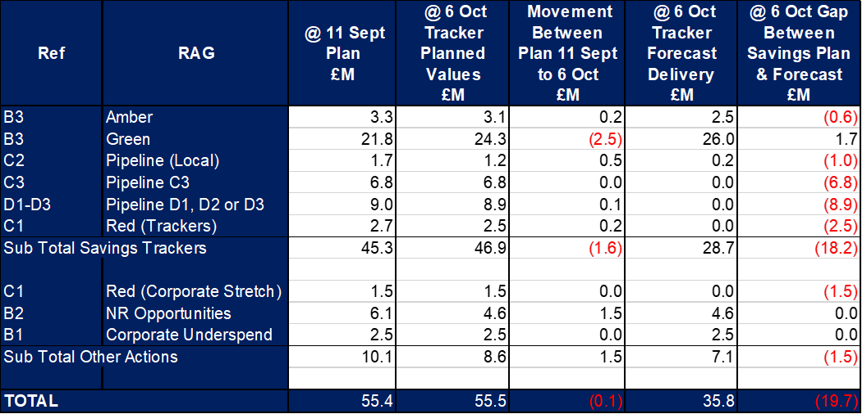

- GOVERNANCE AND RISK ISSUES
The work summarised in section 3.3 provides the Heath Board with a line of sight to £55.4m savings required, which addresses the plan submitted on 31 March 2025. From the 11 September paper and submission to WG, which provided plans with a combined savings value of £55.4m, work must ensure this delivers in full. The risk on delivery of these are detailed in Agenda item 2.2 on the month six financial position.

The 11 September, and subsequent monthly financial position papers (Agenda item 2.2) also incorporate the full level of financial risks both national and local. At Month 6 three of these risks were materialising through the position. There are no detailed plans on how these can be mitigated by increasing savings delivery, until the initial £55.4m is addressed.

- FINANCIAL IMPLICATIONS
The financial implications of this report are set out within it.

- RECOMMENDATION
Members are asked to:
- ACKNOWLEDGE the updated report for ASSURANCE of ongoing delivery associated with the Recovery and Sustainability Board.

Governance and Assurance

Link to Enabling Objectives  (please choose) | Supporting better health and wellbeing by actively promoting and empowering people to live well in resilient communities
Link to Enabling Objectives  (please choose) | Partnerships for Improving Health and Wellbeing |  | ☐
Link to Enabling Objectives  (please choose) | Co-Production and Health Literacy |  | ☐
Link to Enabling Objectives  (please choose) | Digitally Enabled Health and Wellbeing |  | ☐
Link to Enabling Objectives  (please choose) | Deliver better care through excellent health and care services achieving the outcomes that matter most to people
Link to Enabling Objectives  (please choose) | Best Value Outcomes and High-Quality Care |  | ☒
Link to Enabling Objectives  (please choose) | Partnerships for Care |  | ☐
Link to Enabling Objectives  (please choose) | Excellent Staff |  | ☐
Link to Enabling Objectives  (please choose) | Digitally Enabled Care |  | ☐
Link to Enabling Objectives  (please choose) | Outstanding Research, Innovation, Education and Learning |  | ☐
Health and Care Standards
(please choose) | Staying Healthy |  | ☐
(please choose) | Safe Care |  | ☒
(please choose) | Effective Care |  | ☒
(please choose) | Dignified Care |  | ☐
(please choose) | Timely Care |  | ☒
(please choose) | Individual Care |  | ☒
(please choose) | Staff and Resources |  | ☒
Quality, Safety and Patient Experience
No Implications
Financial Implications
No Implications
Legal Implications (including equality and diversity assessment)
No Implications
Staffing Implications
No Direct Implications
Long Term Implications (including the impact of the Well-being of Future Generations (Wales) Act 2015)
No Implications

Report History |  | Routine report to Performance and Finance Committee
Appendices |  | n/a

