Meeting Date | 28 October 2025 |  | Agenda Item |  |  | 2.2
Name of Meeting | Performance & Finance Committee
Report Title | Financial Report – Month 6 2025/26
Report Author | Samantha Moss, Deputy Director of Finance  Gemma Pearson, Finance Business Partner  Crystal Davies, Principal Finance Manager
Report Sponsor | Darren Griffiths, Executive Director of Finance and Performance
Presented by | Samantha Moss, Deputy Director of Finance
Freedom of Information | Open
Purpose of the Report | The report advises the Performance & Finance Committee of the Health Board on the financial position for Month 6 2025/26 (September 2025) and risks regarding the current forecast revenue year end outturn.
Key Issues | The report invites the Performance & Finance Committee to note the detailed analysis of the financial position for Month 6 2025/26 (September 2025).  The report includes a summary of the key drivers of the position either at Service level or by expenditure type (i.e. Non-Pay/Pay). It also provides information of the current position with regards to Health Board reserves to ensure transparency in the overall Health Board position.  Risk will have been considered on the basis of the information provided within the report and the score updated where necessary.  Whilst the key messages are provided within the main body of the report, further information is provided in the Appendices.
Specific Action Required  (please choose one only) | Information | Discussion |  | Assurance | Approval
Specific Action Required  (please choose one only) | ☐ | ☐ |  | ☒ | ☐
Recommendations | Members are asked to: -  - CONSIDER the 2025/26 Financial Plan, and the Health Board’s and Welsh Government’s inability to approve it given the planned deficit of £58.7m.  - CONSIDER the actions in place with regard to Welsh Government’s expectation that the Health Board delivers the £55.4m savings to support the delivery of the 2025/26 Financial Plan.  - Consider and comment upon the Health Board’s financial performance for Month 6 2025/26 and the Year to Date (YTD) position.  - CONSIDER the risks to the position at Month 6.  - SUPPORT the position with regards to Health Board reserves.

FINANCIAL REPORT – MONTH 6 2025/26

- INTRODUCTION
The Annual Plan submitted to Welsh Government on 31 March 2025 included a financial assessment, as summarised in the table below:
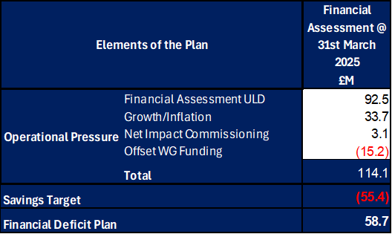

Welsh Government (WG) issued a letter to the Health Board on 6 June 2025 indicating that the planning process has been closed in order to focus on delivery and improvement. WG issued a further letter on 18 August requesting an update on the Annual Financial Plan and actions being taken by the Health Board for submission by 11 September. This document was presented at the Special Board Meeting on the 11 September which provided full details of the actions and milestones to achieve the original £55.4m savings to support the delivery of the original plan submission made in March 2025. Progress against this Plan and further actions required are detailed in Section 2 below.

Therefore, at Month 6 the forecast for 2025/26 remained as per the original plan submission of £58.7m.

- FINANCIAL PERFORMANCE

KEY PERFORMANCE INDICATORS
TARGET | ACTUAL PERFORMANCE
Cash Balance Bank < £6.0m | £9.161m
In Month Performance Revenue Resource Limit < £58.7m | £5.280m
YTD Performance Revenue Resource Limit < £58.7m | £43.038m
YTD Performance Capital Resource Limit < £0m | (£0.783m)
YTD Performance Public Sector Payment Policy > 95% | 96.16%

FINANCIAL REPORT REVENUE – MONTH 6

The Health Board’s original plan had three components Operational Pressure, Savings Target, and Planned Deficit. Performance against these three elements at Month 6 is summarised in Table 1 below. At Month 6 there was an In-Month deficit of £5.3m, which is £0.4m above the £58.7m planned deficit, with the YTD position reporting a £43.0m deficit, which is £13.7m above £58.7m plan.

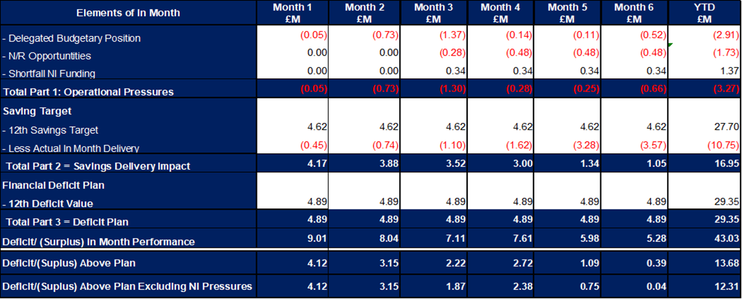

It is clear from Table 1 that the issue remains the non-delivery of savings. The submission made on 11 September set out the Plan to deliver the £55.4m savings in 2025/26. This was a combination of savings delivery supported by our external strategic partner, alongside an increased and sustained delivery of underspends in the operational budget specifically around the corporate directorates and N/R opportunities. The actual delivery on the latter two elements is reflected in Part 1 of Table 1 above. The 11 September 2025 Annual Plan – Financial Update excluded actions to mitigate known and future risks, which are detailed in Section 5.
There remains a clear plan for the £55.4m, noting that at the point of submission of the Month 6 MMR there remains risk in delivery as not all schemes are Green/Amber. Based on the savings trackers at 6 October 2025 the forecast delivery against the plan in summarised in Table 2 below:

Table 2: Summary Performance against £55.4m
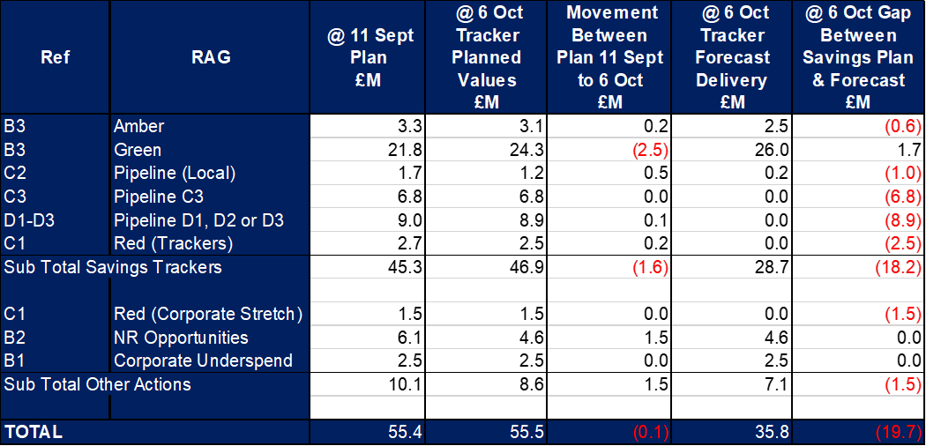

It is recognised that the remaining gap in planned savings requirement was expected to be closed by Month 6 with all schemes required to meet the ‘Green’ criteria. For noting, not all of the £55.4m plan would be transacted via the trackers. At Month 6 £8.6m of the plan would be delivered through operational underspends and non-recurrent slippage, as per Part 1 of Table 1.

Of the planned quantum of £55.4m the assessed gap between the plan and the forecast delivery is twofold: -

- £18.2m on savings as per the trackers
In applying the ‘Green and Amber Criteria’ as part of the MMR Guidance at this point the planned schemes would not meet the criteria in full. This was discussed in detail at the R&S Board held on 8 October 2025 with a focus on driving all planned schemes to Amber and then Green as quickly as possible. There were numerous actions to address this from the 8 October 2025 R&S Board, with updates to presented at the next meeting on 22 October 2025.

- £1.5m of other actions linked to Corporate
With regards to the Red Corporate Stretch (£1.5m), work will continue to address this and the £2.5m (Table 2, Ref B1) during October. There were, in Month 6, a number of one-off pressures in the area of Estates and also Losses, with a further correction provided by Legal and Risk regarding PIP claims, which had a £0.250m impact in-month for claims relating to first 6 months of the year. A review will be undertaken during October 2025 of all Corporate areas to provide further confidence in the delivery of the corporate underspend target.

It is critical that the vast majority of these identified areas of saving are converted to green and amber schemes as a matter of urgency. The Health Board’s delivery confidence will only increase if there are substantially more savings identified as green and amber building on the £35.8m already identified.

With regard to the overall financial performance, Graph 1 below reflects the actual financial performance in each month, with the orange bars reflecting the performance requirements to achieve the original plan of £58.7m. Graph 2 outlines the savings delivered to date as the blue bars against the monthly target set (red line), and the orange bars reflect the level of savings required in future months to achieve the £55.4m target aligned to the £58.7m plan.

Graph 1: Performance Graph 2: Savings
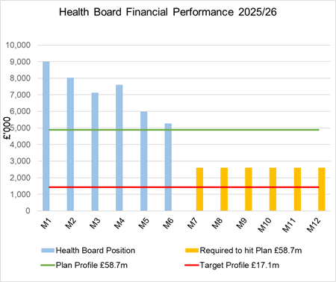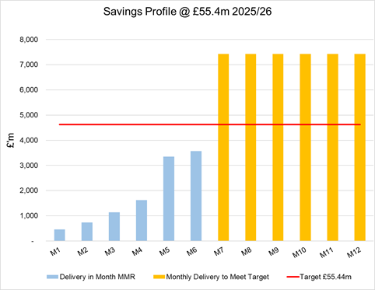

- KEY DRIVERS OF THE IN-MONTH POSITION
The key drivers of the Month 6 position are summarised in the table below. Further detail at a Health Board level of expenditure on Income, Pay and Non-Pay, is also provided in Appendix 1.

  - Key Drivers by Service Area In-Month

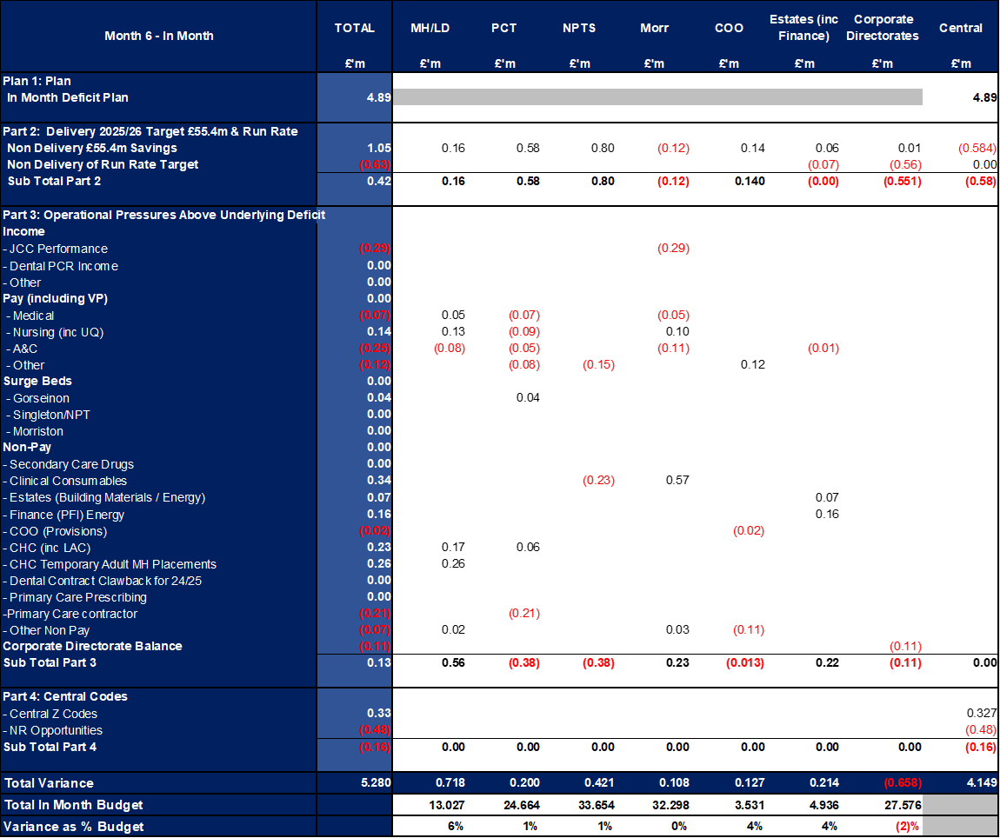

  - Key Drivers by Service Area YTD

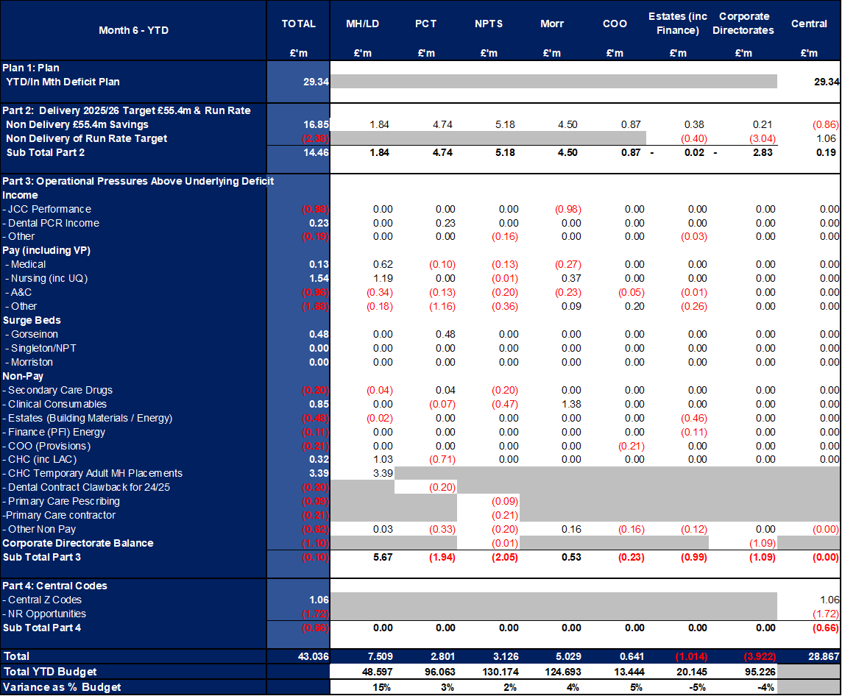

  - Summary By Expenditure Type

- Income
The Joint Commissioning Committee (JCC) Income as a provider over-performed by £0.4m in-month (£1.1m YTD). This has been driven by both improved performance in Renal, NICU, TAVI and Cardiology.

- Pay
Month 6 Pay (once normalised for the 2025/26 Pay Award arrears) is in line with prior months; the continued vacancy freeze primarily in Admin & Clerical and other Pay Controls being the driver for this. There was also a further reduction to variable pay expenditure in month.

- Clinical Consumables
(see Appendix 1)

- Prescribing
(see Appendix 1)

- SAVINGS

A full assessment of the Savings position and further opportunities was provided in the ‘Annual Plan Financial Update’ document dated 11 September (Appendix 5), and is summarised below.

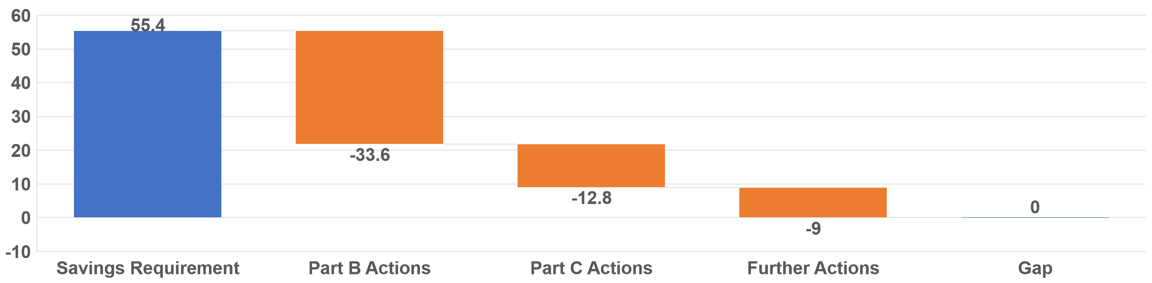
Part C Actions
- Part C1: Savings Trackers Red & Corporate Stretch @ 4 September 2025
- Part C2: Savings Trackers Pipeline @ 4 September 2025
- Part C3: In-year impact of the thematic Scheme Summaries (adjusted to avoid double count)
Further Actions
- Additional interventions to close the gap to the original savings plan
  - Exec oversight of variable pay
  - Additional capacity reduction
  - Non pay bans / restrictions

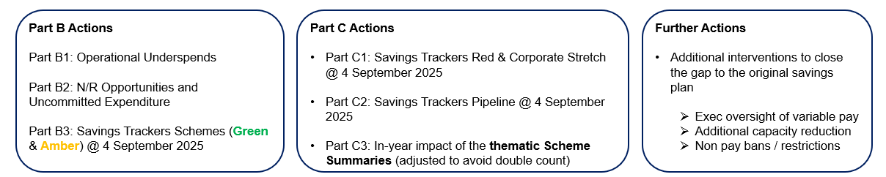

Full details on savings is provided Appendix 3, but in summary the in-month delivery in Month 6, was £3.6m against a target of £4.6m; on a YTD basis the undelivered savings gap is £16.9m and remains the key driver of the Health Board overspend.

Whilst at Month 6 the Health Board is unable to turn all the planned schemes from 11 September submission to Amber/Green, of the £18.2m gap between plan and forecast delivery, 90% of the schemes were not due to commence until Q3/Q4. So, with the further actions supported by our strategic partner and the work of the R&S Team, progress on increasing the current level of Green/Ambers will continue. The savings tracker will be run again on 20 October 2025, for presentation at the R&S Board on 22 October 2025.

- GOVERNANCE AND RISK ISSUES
Two Board level financial risks:

Achieving financial plan (HBR92) with the key elements as follows: -

  - Risk of delivery of savings quantum
  - Risk of operational overspend being in excess of funding available agreed via the Financial Plan
  - Risk of commitment of reserves (e.g. NICE) being above reserves available.
  - Risk of achieving the actions and options outlined in the 2025/26 Financial Recovery & Sustainability Assessment.

Based on the financial performance at Month 6 and the shortfall in the identification of the savings at this point that is required to deliver the deficit plan of £58.7m, it is recommended that the Health Board Corporate Risk Register continues to reflect a risk score of 25.

The assessment at the end of September of the Risks, totalling £33.7m, is summarised in the table below:

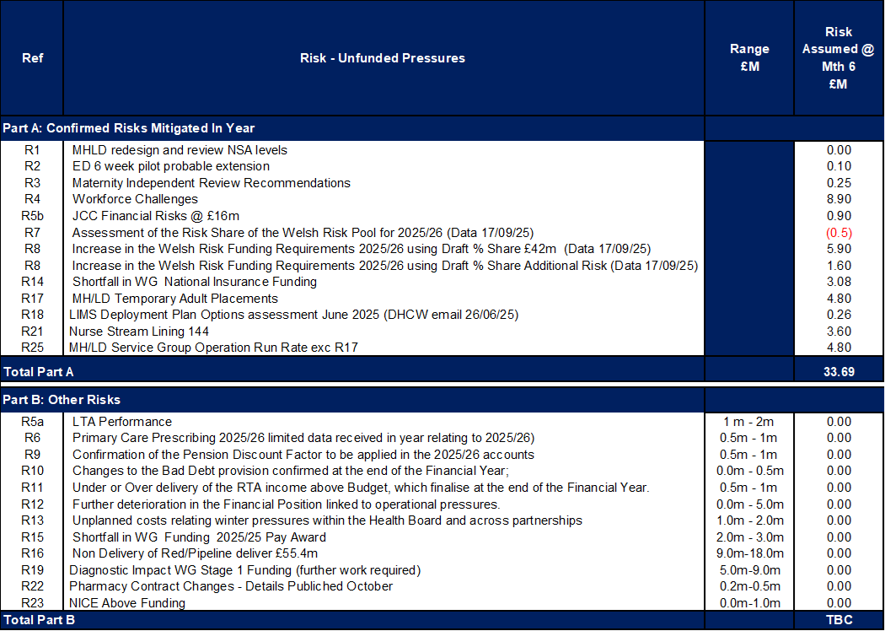

Of note are the three items (referenced R14, R17 and R25), which have already materialised within the YTD position. The impact of Risk R25 is partly masked within the overall Health Board position due to Operational Underspends in other Service Groups. If these underspends reduce the level of Risk impacting the position will increase.

Availability of capital (HBR93). This risk was re-opened in 2022/23 given the reduction in discretionary capital allocation. Due to the additional capital funding provided during 2024/25 the risk score was reduced to 12. The score was increased in June 2025 to reflect risks regarding Emergency Department and Adult Acute Mental Health. The current assessment is to continue with the risk score of 20.

- RECOMMENDATIONS
Members are asked to:
- CONSIDER the 2025/26 Financial Plan, and the Health Board’s and Welsh Government’s inability to approve it given the planned deficit of £58.7m.
- CONSIDER the actions in place with regard to Welsh Government’s expectation that the Health Board delivers the £55.4m savings to support the delivery of the 2025/26 Financial Plan.
- Consider and comment upon the Health Board’s financial performance for Month 6 2025/26 and the Year to Date (YTD) position.
- CONSIDER the risks to the position at Month 6.
- SUPPORT the position with regards to Health Board reserves.

Governance and Assurance

Link to Enabling Objectives  (please choose) | Supporting better health and wellbeing by actively promoting and empowering people to live well in resilient communities
Link to Enabling Objectives  (please choose) | Partnerships for Improving Health and Wellbeing |  | ☐
Link to Enabling Objectives  (please choose) | Co-Production and Health Literacy |  | ☐
Link to Enabling Objectives  (please choose) | Digitally Enabled Health and Wellbeing |  | ☐
Link to Enabling Objectives  (please choose) | Deliver better care through excellent health and care services achieving the outcomes that matter most to people
Link to Enabling Objectives  (please choose) | Best Value Outcomes and High Quality Care |  | ☐
Link to Enabling Objectives  (please choose) | Partnerships for Care |  | ☐
Link to Enabling Objectives  (please choose) | Excellent Staff |  | ☐
Link to Enabling Objectives  (please choose) | Digitally Enabled Care |  | ☐
Link to Enabling Objectives  (please choose) | Outstanding Research, Innovation, Education and Learning |  | ☐
Health and Care Standards
(please choose) | Staying Healthy |  | ☐
(please choose) | Safe Care |  | ☐
(please choose) | Effective Care |  | ☐
(please choose) | Dignified Care |  | ☐
(please choose) | Timely Care |  | ☐
(please choose) | Individual Care |  | ☐
(please choose) | Staff and Resources |  | ☐
Quality, Safety and Patient Experience
Financial Governance supports quality, safety, and patient experience

Financial Implications
The Board is reporting a forecast year-end deficit financial outturn.

Legal Implications (including equality and diversity assessment)
No implications

Staffing Implications
No implications

Long Term Implications (including the impact of the Well-being of Future Generations (Wales) Act 2015)
No implications

Report History |  | Updates on the financial position are provided at every meeting.
Appendices |  | Appendix 1 – Variances by Area and Type of Expenditure  Appendix 2 – Reserves and Central Budgets  Appendix 3 – Savings  Appendix 4 – Accountability Letters

APPENDIX 1 – FURTHER DETAIL ON VARIANCES BY AREA & TYPE OF EXPENDITURE
- Overview Financial Position

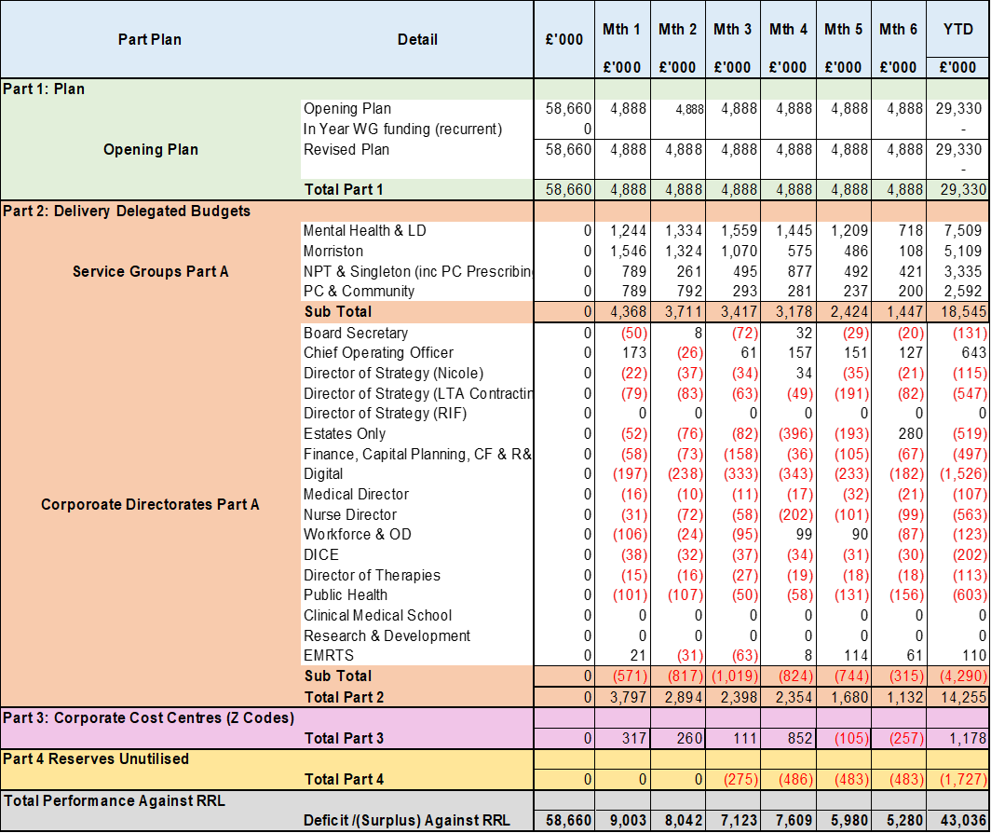

- Overview of Income

The table below compared the income performance in Month 6 to the average levels of 2023/24 and 2024/25.

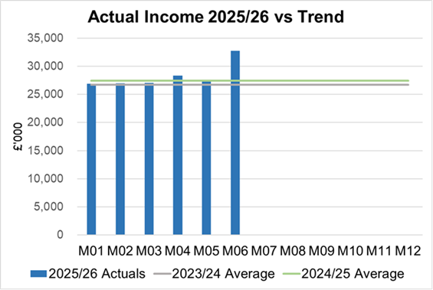

Income has increased in M06 due the quarterly receipt from HCRW in relation to the Clinical Research Unit, and a catch up for periods 1-6 of HEIW funding in relation to training grade posts.

  - Anticipated Income
The below table highlights anticipated income the Health Board expects to receive during 2025/26. The current deficit plan of £58.7m is predicated on receipt of these Welsh Government funds at the levels anticipated.

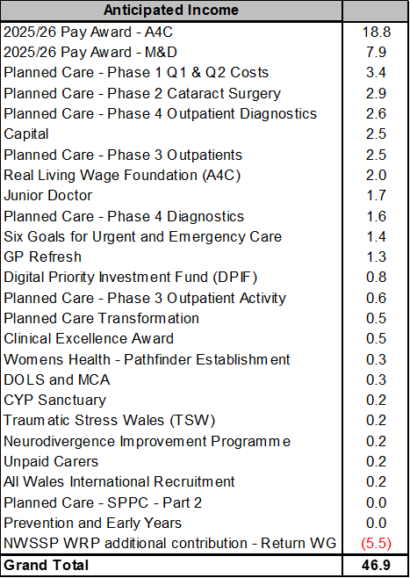

- Pay, Agency & Other Variable Pay Expenditure

Total Pay

The Month 6 total remains higher than the prior two years average (as shown in the graph below).

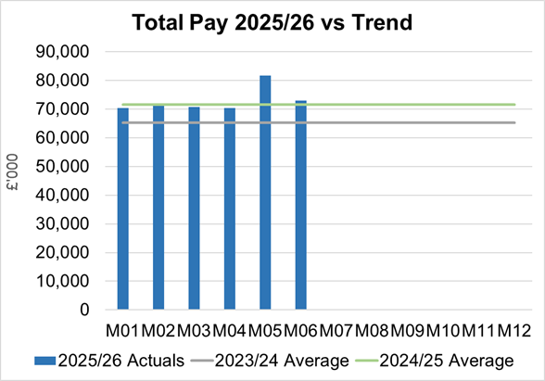
Note - 2023/24 and 2024/25 values have been notionally increased by pay award uplifts to allow for comparison to current value of 2025/26 pay value.

Variable Pay

Variable pay is £0.180m lower in Month 6 2025/26 (£4.676m vs £4.856m) when compared to the same period last year (graph below shows this year’s actual versus prior year’s average) and is £0.243m lower than Month 5.

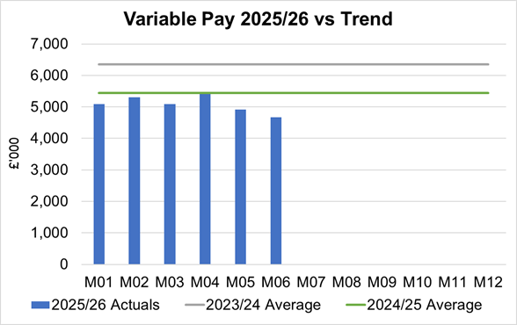

Variable Pay is classified by the Health Board into the following categories: Agency, Bank, Overtime, Waiting List Initiatives (WLI) and Irregular Sessions, a breakdown of the expenditure into these categorise is provided below.

Variable Pay by Expenditure Type

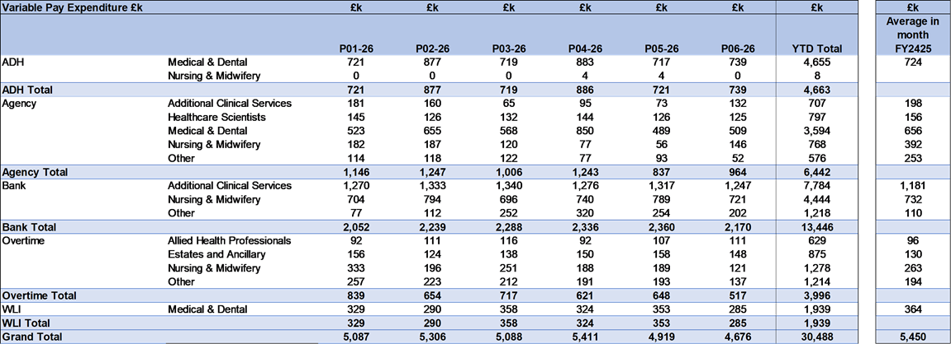

- Overview Non-Pay

Actual Non-Pay expenditure for Month 6 is higher than the last 2 year’s average expenditure levels (as shown in the graph below):

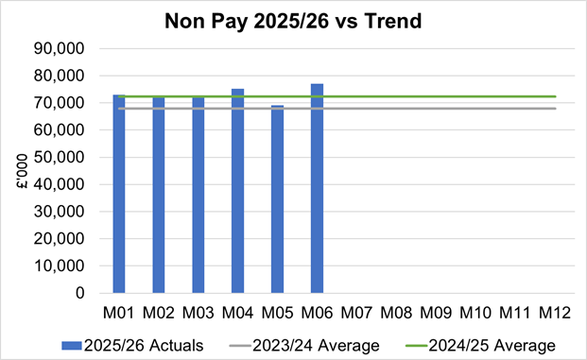

Below are further details on the key areas of non-pay:

  - Clinical Consumables
In Month 6 CHC was overspent by £0.4m (YTD £3.6m). Whilst there continues to be a reduction in the expenditure on Adult Mental Health placements versus that seen YTD, the pressure remains at £0.26m in month in addition to standard CHC growth in excess of the Plan.

  - Primary Care Prescribing
Prescribing was almost breakeven in month and YTD following receipt of the latest datasets (July 2025).

  - CHC
In Month 6 CHC was overspent by £0.4m (YTD £3.6m). Whilst there continues to be a reduction in the expenditure on Adult Mental Health placements versus that seen YTD, the pressure remains at £0.26m in month in addition to standard CHC growth in excess of the Plan.
An analysis of actual expenditure and patient numbers for 2025/26, along with the average values from 2024/25 is provided in table below.
CHC Analysis by Month

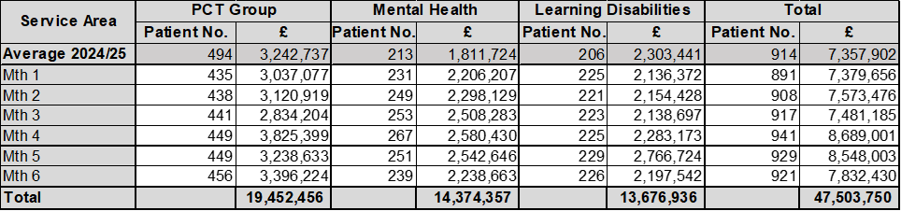
Please note:
- PCT Group numbers are based on bed days
- MHLD Group are based on cases
- PCT Group does not include the Singleton/NPT element. The NPTS element which covers Children and Young People CHC patients is provided internally by the Health Board and as such is part of the wider NPTS position and is not recorded in the ledger as PCT/MH/LD CHC.

  - Maternity Review
The total costs for this are allocated to a dedicated Cost Centre (6F34). The full £0.438m YTD cost is coded to the legal fees subjective.

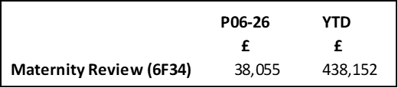

  - Z Codes (Section 1,3-4 Table Point 1 Appendix 1)
The narrative below groups together the key elements of the Z codes detailed in Point 1 of this appendix.

- Contracting: SLA /LTA performance: JCC (previously WHSSC), LTA and SLA contract income and expenditure are transacted within this area and financial performance reported. NICE approved high-cost drugs and associated LTAs are also transacted and monitored against targets set. In addition to this, non-contracted activity income in relation to English foundation trusts invoiced on a quarterly basis are reported.

- Capital: The Finance Capital Team manage a number of cost centres covering the PFI, IFRS16 and Depreciation charges for assets both owned and donated are transacted here.

- RRL and Central Reserves: The Welsh Government funding received at the start of the year is tracked within this area. Any anticipated allocations in year are also transacted through these codes. Other HB wide funding received from HEIW and SIFT is also captured in here. All central reserves remain within the Z cost centres and details of these are provided in Appendix 2.

- Corporate income and expenditure. Any income and expenditure that is not service group specific is transacted and reported through a number of corporate Z cost centres, examples include, payroll and pension costs, VAT recovery, losses and receipts in relation to funding from Welsh Risk Pool, overseas visitors’ income and Road Traffic Accident income.

  - LTA Values & Forecast performance
The table below is based on Month 5 activity undertaken by other Health Boards and Trusts for Swansea Bay residents (SBU Commissioner) and activity undertaken by Swansea Bay for residents of other Health Boards.

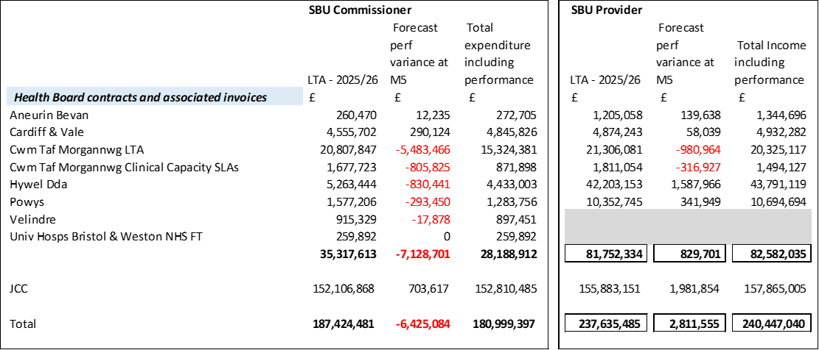
The above figures include annual contract values plus additional invoices relating to patient activity. SBU Commissioner performance variances are based on information received from each organisation.
Forecast performance variances are subject to fluctuation given the early point of the year from which to forecast. Values exclude NICE drug recharges.

APPENDIX 2 – DETAILS ON RESERVES & CENTRAL BUDGETS

- SUMMARY RESERVES
Overall management of the reserves is as per the Health Board Budget Management document.

  - Balances: Main & NICE
For 2025/26, the Health Board will hold two central reserves and the purpose of these reserves are below:
- Main – this holds funding from Welsh Government or the plan that has yet to be issued to Budget Holders. These items are not surplus but either due to timing have not been issued or is an area where funding is issued based on actual values consumed in future month.
- NICE – this holds the total Health Board funding for all NICE costs (drugs and infrastructure) and is issued to the service each month based on the actual costs consumed as reported through the Pharmacy system.

Details on the balances and movements are provided in the Table below:

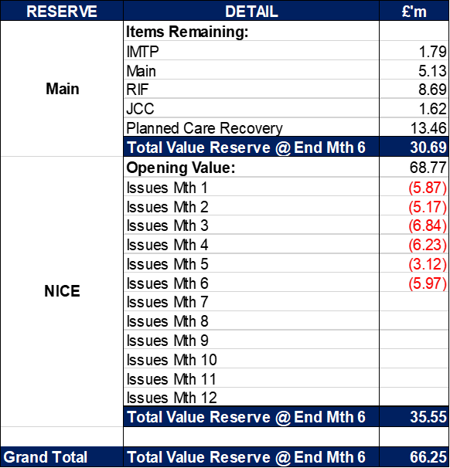

- COVID RECOVERY
As part of the Financial Plan Welsh Government Funded £15.2m for Local COVID Recovery and £19.5m for Regional COVID Recovery. The funding remains in Central Reserves and is reported in Main reserves in Section 1 above. This funding is then issued to service areas based on the actual costs committed. A summary of the forecast costs against the original funding total of £34.7m is summarised in the table below:

Welsh Government are also issuing additional non-recurrent funding to support the reduction of the 52 week and 104 week target, alongside diagnostic targets. This is in addition to the original Planned Care Recovery £34.7m detailed in the table above. This non-recurrent funding for Planned Care is held in Main or Service Group local reserves until the costs are committed at which point funding is issued to the relevant budget line.
APPENDIX 3 – SAVINGS

The section below reflects performance against the original £55.4m requirement taken from the Savings Trackers.

- Summary of Savings Position as at September 2025 (Month 6)

The below graph clearly shows the gap between the YTD savings target in red and the level of actual savings delivered in green, with full details provided in the table.

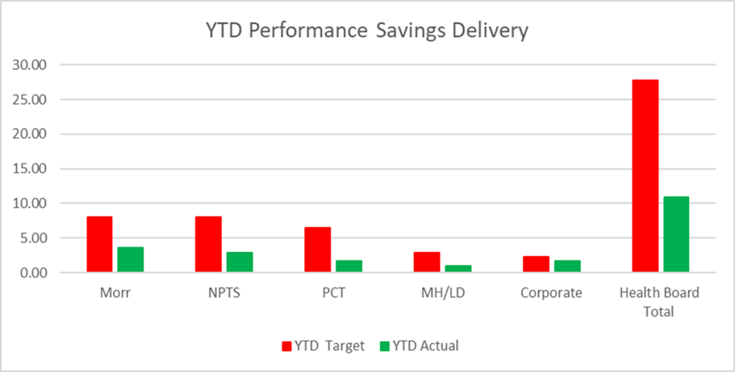

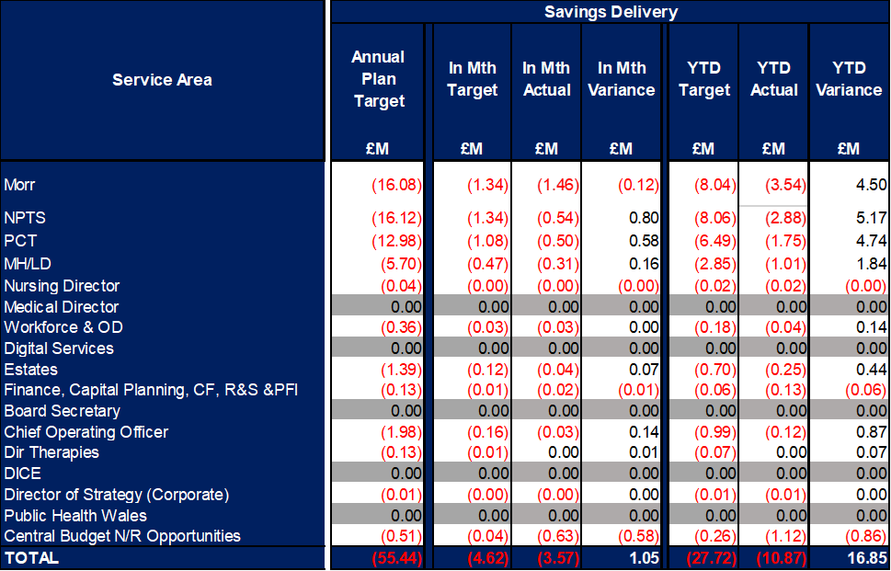
In summary the £58.7m plan required the Health Board to deliver £55.4m of savings. But in Month 6 it was £1.05m short of the target and Year to Date is currently £16.9m short of the target. This is the key issue in the delivery of the 2025/26 financial position.

- Savings schedule as at September 2025
An element of £55.4m plan submitted on the 11 September was not going to be delivered through savings, a proportion was to be achieved via Non-Recurrent Opportunities and underspend in operational budgets. The first below table provides a summary of the planned savings schemes, which total £46.9m, broken down by Pipeline, Red, Amber and Red. The second table provides the full reconciliation of the £55.4m and how the £8.6m will be achieved.

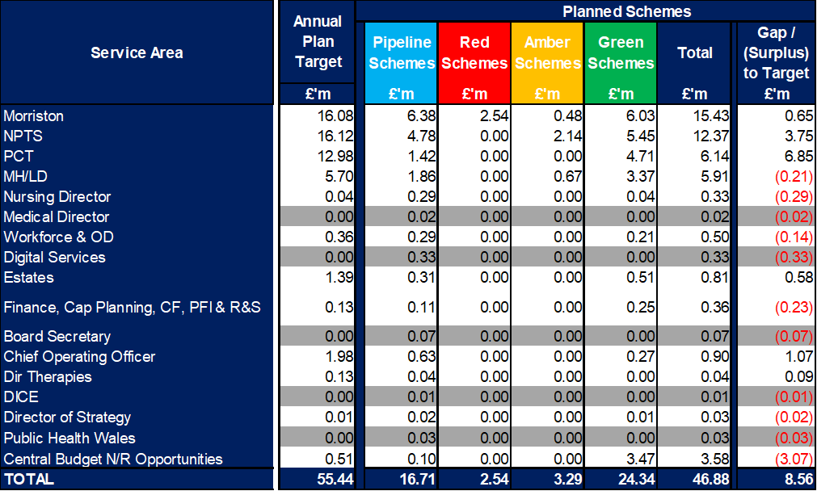

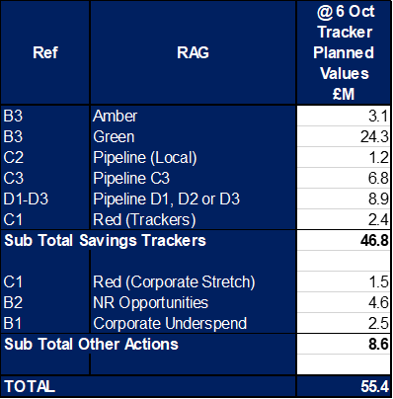

APPENDIX 4 – SUMMARY OF THE REPLIES TO THE ACCOUNTABILITY LETTERS (@13th October 2025)

No: | Name | Date Proforma Returned
 | Ceri Gimblett – NPTS | 13/05/25 – signed proforma + covering letter to CEO / DoF
 | Sue Moore – Morriston | 12/05/25 – no proforma, but a letter to CEO
 | Dermot Nolan – MH&LD | 09/05/25 – proforma signed + narrative added
 | Craige Wilson – PCTSG
 | Hazel Lloyd – Corporate Governance | 28/04/25
 | Deb Lewis – COO | 07/05/25
 | Richard Thomas – DICE
 | Matt John – Digital | 10/06/25
 | Richard Evans – Medical | 30/04/25
 | Liz Rix – Nursing | 28/04/25
 | Gill Richardson – Public Health | 22/05/25 – no proforma, but a letter to CEO
 | Marie Davies – Planning & Partnerships | 27/06/25
 | Tina Ricketts – W&OD | 13/05/25
 | Darren Griffiths – Finance and Estates | 20/04/25
 | Christine Morrell – Allied Health Professions & Health Science | 14/05/25

