

HEALTH BOARD RISK REGISTER
September 2024
PERFORMANCE & FINANCE COMMITTEE RISKS

Datix ID Number: 738  Health & Care Standard: |  |  | HBR Ref Number: 1  Risk Target Date: 31/03/2025 |  | Current Risk Rating  5 x 5 = 25
Objective: Urgent & Emergency Care |  | BAF Ref: 2.4 | Director Lead: Deb Lewis, Chief Operating Officer  Assuring Committee: Performance & Finance Committee  For information: Quality & Safety Committee
Risk: Access to Unscheduled Care  If we fail to provide timely access to Unscheduled Care then this will have an impact on quality & safety of patient care as well as patient and family experience and achievement of targets. There are challenges with capacity/staffing across the Health and Social care sectors. (This risk includes ED, AMU and impact in community from ability to release ambulances at both front doors.) |  |  | Date last reviewed: September 2024
Risk Rating  (consequence x likelihood):  Initial: 4 x 5 = 20  Current: 5 x 5 = 25  Target: 3 x 4 =12 | 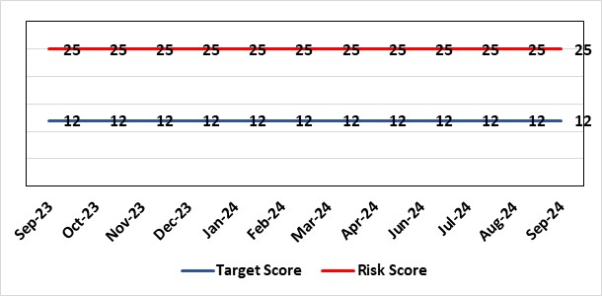 |  | Rationale for current score:  The UEC system continues to see high demand, with ambulance attendances in particular being higher than seen previously. This is coupled with reduced flow out of hospital beds due to an imbalance of acute / community / care service provision. These factors are resulting in unacceptable delays in patients accessing UEC services and therefore the risk score remains high.
Level of Control  = 50% |  |  | Rationale for target score:  The HB is currently under escalating performance monitoring from WG (Targeted Intervention or TI) for delivery of UEC services. The improvement plan developed as a response to TI and that already included in the HB annual plan is to implement models of care that reflect best practice and focus on areas that will benefit patients, staff and the UEC system most. The implementation of this plan will improve patient flow, length of stay and reduce emergency demand.
Date added to the HB risk register
26.01.16
Controls (What are we currently doing about the risk?) |  |  | Mitigating actions (What more should we do?)
Five main areas of work within the plan:  - Frailty strategy – approved via Management Board  - Grip & control operational management  - Senior decision makers at front door services  - Pathway of care delays (PoCD)  - Home First  - ACT  - Interface with local authority  - Reconfiguration of Emergency Dept  In addition to BAU improvement actions:  - Continued focussed roll-out of 6-Goals schemes of work  - D2RA / Trusted assessor model  - SAFER  - Criteria-led discharge  - Continuous Flow Model (CFM)  - Robust SDEC model |  |  | Action | Lead |  | Deadline
 |  |  | Review of senior decision making capacity within SDEC and AMU | GMD Morriston SG |  | 31/12/2024
 |  |  | Implementation of 7-day community services such as VW | Interim EMD |  | 31/12/2024
 |  |  | Monitoring of Continuous Flow Model continues to be implemented despite the challenge of flow. It will be monitored over 12 month period. | COO |  | On Hold
 |  |  | Criteria led discharge roll out | Corporate patient flow team |  | Progress: Rolled out in Medicine. Other specialties to follow by 31/12/2024  .
Assurances (How do we know if the things we are doing are having an impact?)  - Urgent & Emergency Care Board is meeting monthly chaired by the COO.  - Six Goals programme reviews the pan on a monthly basis |  |  | Gaps in assurance (What additional assurances should we seek?)  The need to deliver sustained service.
Additional Comments / Progress Notes
08/05/2024: Risk assessment rationale, controls and actions fully refreshed. Focus on the implementation of the Frailty strategy, to be operational during September 2024.
14/10/2024: Actions remain current with the exception of the CFM, which is now on hold pending improvement from other actions. UEC summit held in October to consolidate system approach. This will be repeated in six weeks.

Datix ID Number: 840  Health & Care Standard: |  |  | HBR Ref Number: 16  Risk Target Date: 31/03/2025 | Current Risk Rating  5 x 4 = 20
Objective: Planned Care |  | BAF Ref: 2.5 | Director Lead: Deb Lewis, Chief Operating Officer  Assuring Committee: Performance & Finance Committee  For information: Quality & Safety Committee
Risk: Access and Planned Care  There is a risk of harm to patients if we fail to diagnose and treat them in a timely way. |  |  | Date last reviewed: September 2024
Risk Rating  (consequence x likelihood):  Initial: 4 x 4 = 16  Current: 5 x 4 = 20  Target: 4 x 2 = 8 | 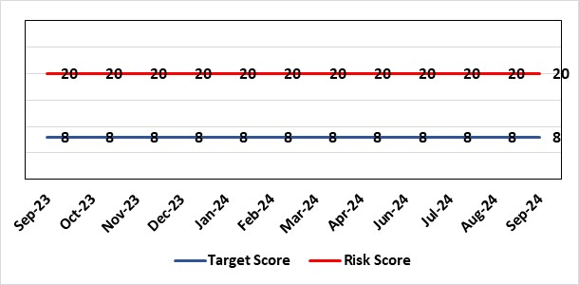 |  | Rationale for current score:  Whilst the HB has eradicated very long waits for surgery, patients are still waiting in excess of 104 weeks for surgical intervention, which is outside of national policy on RTT. The HB is currently under escalating performance monitoring from WG (Targeted Intervention or TI) for delivery of Planned Care services. The improvement plan developed as a response to TI mirrors that already included in the HB
Level of Control
= 90%
Level of Control  = 90% |  |  | Rationale for target score:  There is scope to reduce the likelihood score to reduce the overall risk to an acceptable level. The Risk target date indicates when we expect to see some reduction in waiting lists – albeit the overall risk level may remain as work continues.
Date added to the HB risk register
January 2013
Controls (What are we currently doing about the risk?) |  |  | Mitigating actions (What more should we do?)
- There is a bi-weekly Targeted Intervention (TI) meeting specifically for assurance on the recovery of our elective programme.  - Specialty level capacity and demand models set out the baseline capacity and identify solutions to bridge the gap this financial year.  - A focused intervention is in train to support to the 10 specialties with the longest waits.  - Long waiting patients are being outsourced to the Independent Sector, where appropriate  - Additional internal activity is being delivered on weekends (via insourcing), although this is currently at risk due to changes in policy pertaining to the payment of enhanced rates to A4C staff.  - Planned care trajectories are being developed and submitted to WG as part of the annual plan by the end of May 2024.  - Governance process put in place to monitor performance against trajectories internally, and with Welsh Government as part of Targeted Intervention.  - External & internal validation continues.  - All long waiting patients are receiving clinical reviews to ascertain continued need for surgery. |  |  | Action |  | Lead | Deadline
 |  |  | Theatre Optimisation Programme now in place to maximise efficient use of theatre capacity |  | NPTSSG SGD | 31/03/2025
 |  |  | Revised demand and capacity planning underway to utilise additional funding from WG to clear 104 week waits by the end of March 2025. |  | Chief Operating Officer | 31/10/2024
Assurances (How do we know if the things we are doing are having an impact?)  - TI dashboard developed to monitor performance in a live state  - Weekly TI monitoring meetings chaired by the COO  - Bi-weekly planned care meetings chaired by the COO  - Monthly TI monitoring meetings with WG |  |  | Gaps in assurance (What additional assurances should we seek?)
Additional Comments / Progress Notes
08/05/2024: All patients breaching the 104 week target are at treatment stage. Therefore all have a treatment plan in place.
14/06/2024: Actions completed: Development of comprehensive demand & capacity plans for 2024/25; Work with Finance colleagues to establish the funding allocation for elective recovery for 2024/25.
22/07/2024: All specialties with the exception of gynaecology have cleared their 156 week waits. 104 weeks continue to reduce.
14/10/2024: Progress against the Planned Care agenda continues with 52 weeks maintained and 156 weeks now removed.

Datix ID Number: 1761  Health & Care Standard: |  |  | HBR Ref Number: 50  Risk Target Date: 31/03/2025 |  | Current Risk Rating  5 x 5 = 25
Objective: Cancer Care |  | BAF Ref: 2.6 | Director Lead: Deb Lewis, Chief Operating Officer  Assuring Committee: Performance & Finance Committee  For information: Quality & Safety Committee
Risk: Access to Cancer Services  There is a risk of delay in diagnosing patients with cancer, and consequent delay in commencement of treatment, which could lead to poor patient outcomes and failure to achieve targets.  The HB remains unable to deliver on the target of 75% of patients being treated within 62 days and is currently under targeted intervention by WG to improve performance. The HB has been given an initial target of 60% to be delivered by the end of Dec-24, increasing to 70% by the end of March 2025. The most recent performance reported in for March 24, where the HB attained 56%. |  |  | Date last reviewed: September 2024
Risk Rating  (consequence x likelihood):  Initial: 4 x 5 = 20  Current: 5 x 5 = 25  Target: 4 x 3 = 12 |  |  | Rationale for current score:  Risk score based on being off trajectory for SCP.
Level of Control  = 70% |  |  | Rationale for target score:  Target score reflects the challenge this area of work present the Board and where small numbers of patients impact on the potential to breach target.
Date added to the HB risk register: April 2014
Controls (What are we currently doing about the risk?) |  |  | Mitigating actions (What more should we do?)
- Tight management processes to manage each individual case on the Single Cancer Pathway (SCP). Enhanced monitoring & weekly monitoring of action plans for top 6 tumour sites.  - Initiatives to protect surgical capacity to support SCPs have been put in place  - Tumour sites have been given additional targets to achieve by the end of Qtr1:  - Achieve the 10-day 1st Outpatient target  - Deliver a decision to treat (DTT) by day 31  - A specific plan is being delivered to support Pathology services and ensure SCP tests are turned around within 5 days. |  |  | Action | Lead |  | Deadline
 |  |  | Cancer Performance Group to monitor improvement trajectories for both cancer backlog and SCP performance on a monthly basis | Deputy COO |  | 31/12/2024
 |  |  | Full review of gynaecology / gynae-oncology pathway given service constraints to be done. Additional theatre capacity for gynaecological cancer to be agreed to reduce current backlog | Deputy COO |  | 31/12/2024
Assurances (How do we know if the things we are doing are having an impact?)  - TI dashboard developed to monitor performance in a live state  - Weekly TI monitoring meetings chaired by the COO  - Bi-weekly Cancer meetings chaired by the Dep COO  - Monthly TI monitoring meetings with WG |  |  | Gaps in assurance (What additional assurances should we seek?)  Performance and activity data monitored, but delays to treatment continue while sustainable solutions found.
Additional Comments / Progress Notes
29/01/2024: Slight in improvement in SCP performance during November and December, 52% and 53% respectively. Improvement in Upper GI performance (73%) but further work required in other tumour site area e.g. gynaecology, urology and breast.
08/05/2024: Further improvement seen in March 2024 with 56% delivered against the target.
18/05/2024: Sustained improvement for April (56%) and improvement in two-week first outpatient appointment target and decision to treat within 31 days evident
22/07/2024: Further improvement in May (57%) and noticeable improvement in first outpatient appointment in breast and gynaecology as a result introduction of daily monitoring meetings.
14/10/2024: August performance reduced against the trajectory (56% v 59%). The target of 60% for end of Sept remains in place.

Datix ID Number: 1763  Health & Care Standard: |  |  | HBR Ref Number: 52  Risk Target Date: TBC |  | Current Risk Rating  4 x 4 = 16
Objective: People of Swansea Bay live healthier, equitable and more equal and prosperous lives |  | BAF Ref: 1 | Director Lead: Richard Thomas, Director of Communications and Engagement  Assuring Committee: Performance & Finance Committee
Risk: Impact Assessment Requirements  The Health Board does not have sufficient skills & resource in place to undertake integrated equality impact assessments in line with strategic service change and policy development. |  |  | Date last reviewed: September 2024
Risk Rating  (consequence x likelihood):  Initial: 4 x 4 = 16  Current: 4 x 4 = 16  Target: 4 x 2 = 8 | 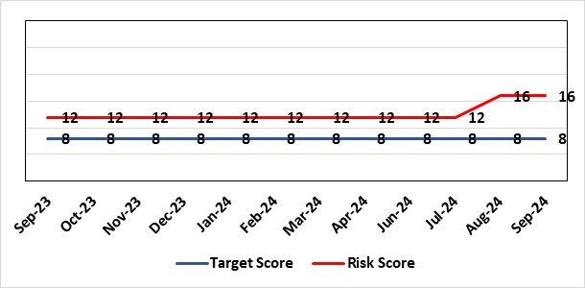 |  | Rationale for current score:  - Current lack of required skills / staff to deliver requirements.  - Judicial Review has been applied for in relation to EMRTS / Air Ambulance Changes which implicates the Health Board. This may indicate a rising likelihood of such challenges being launched in relation to service change.
Level of Control  = 50% |  |  | Rationale for target score:  - All of these areas need to have adequate resourcing and robust processes / policies in place for the organisation to make robust plans, engage public confidence and meet our statutory and public duties.
Date added to the HB risk register
November 2018
Controls (What are we currently doing about the risk?) |  |  | Mitigating actions (What more should we do?)
- Head of EDI to be appointed to support equality impact assessment – funding previously agreed, paper going to Management Board and then Board on 25th January 2024. Funding to be agreed to allow appointment to be made.  - Creation of DICE has led to some additional capacity within Engagement Team but alongside a significant increase in demand for activity.  - Robust policies and processes to be in place for Impact Assessment going forward.  - EIA responsibilities incorporated into wider Impact Assessments.  - Development of Strategic Equality Group across organisation to support processes. |  |  | Action | Lead |  | Deadline
 |  |  | Appoint Head of EDI  Delayed due to vacancy suspension | Assistant Director of Insight, Engagement & Fundraising - DICE |  | 31/12/2024
 |  |  | Review of the current process for developing Equality Impact Assessments around service change, engagement and consultation. Progress slowed as delay in recruitment of Head of EDI. | Assistant Director of Insight, Engagement & Fundraising - DICE |  | 31/01/2025  In progress
 |  |  | Robust policies and processes to be in place for Impact Assessment going forward. | Assistant Director of Insight, Engagement & Fundraising - DICE |  | 30/03/2025  In progress
 |  |  | Roll out Impact Assessment process across organisation. | Assistant Director of Insight, Engagement & Fundraising - DICE |  | 30/06/2025
Assurances (How do we know if the things we are doing are having an impact?)  Advice on Equality Impact Assessment and then wider Impact Assessments available across organisation supported by robust policies and procedures, overseen by Strategic Equality Group. |  |  | Gaps in assurance (What additional assurances should we seek?)  Participation from across organisation in Strategic Equality Group.
Additional Comments / Progress Notes
19/01/2024: Reviewed – no change currently
02/09/2024: Risk level increased – rationale added. Action target dates refreshed.

Datix ID Number: 2522  Health & Care Standard: |  |  | HBR Ref Number: 75  Risk Target Date: TBC |  | Current Risk Rating  5 x 2 = 10
Objective: Care is high quality, safe, efficient, and delivers the best possible outcomes for people |  | BAF Ref: 2 | Director Lead: Deb Lewis, Chief Operating Officer  Assuring Committee: Performance & Finance Committee
Risk: Whole-Service Closure  Risk that services or facilities may not be able to function if there is a major incident or a rising tide that renders current service models unable to operate |  |  | Date last reviewed: September 2024
Risk Rating  (consequence x likelihood):  Initial: 5 x 4 = 20  Current: 5 x 2 = 10  Target: 5 x 1 = 5 | 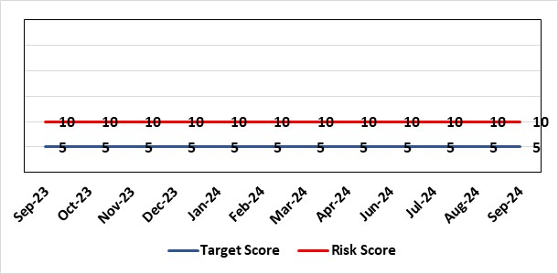 |  | Rationale for current score:  Risk reflects transition to business as usual as part of living with Covid strategy. BCP plans in place. There is still fluctuation in patient numbers and new variants continue to emerge so score maintained as watching brief.
Level of Control  = 25% |  |  | Rationale for target score:  The strategy of moving towards living with Covid will eventually lower the risk level to target.
Date added to the HB risk register
May 2021
Controls (What are we currently doing about the risk?) |  |  | Mitigating actions (What more should we do?)
- Sites have business continuity plans and the impact of one site being overwhelmed by COVID demand has been reviewed.  - Monitoring of associated risks has been being transferred to appropriate forums such as UEC Board, Elective Care Board and Nosocomial Group with overall oversight by Management Board.  - Ongoing surveillance of epidemiology data for early warning and further change to risk level via live Covid dashboard. |  |  | Action | Lead |  | Deadline
 |  |  | Periodic review of risk | COO |  | See Notes Below
Assurances (How do we know if the things we are doing are having an impact?)  Monitored via Management Board for early warning signs. |  |  | Gaps in assurance (What additional assurances should we seek?)
Additional Comments / Progress Notes
03/11/2023: Consideration currently being given to replacement of this risk with fresh entry on wider organisational business continuity arrangements

Datix ID Number: 3444  Health & Care Standard: |  |  | HBR Ref Number: 92  Risk Target Date: 31/03/2025 | Current Risk Rating  5 x 5 = 25
Objective: The health board is a resilient, financially sustainable and responsible organisation |  | BAF Ref: 6 | Director Lead: Darren Griffiths, Director of Finance and Performance  Assuring Committee: Performance & Finance Committee
Risk: Forecast Deficit  Forecast deficit is not met due to insufficient progress on run rate reduction and £26.1m saving targets across all areas which is required to ensure the planned in month deficit is achieved. |  |  | Date last reviewed: September 2024
Risk Rating  (consequence x likelihood):  Initial: 5 x 4 = 20  Current: 5 x 5 = 25  Target: 5 x 1 = 5 | 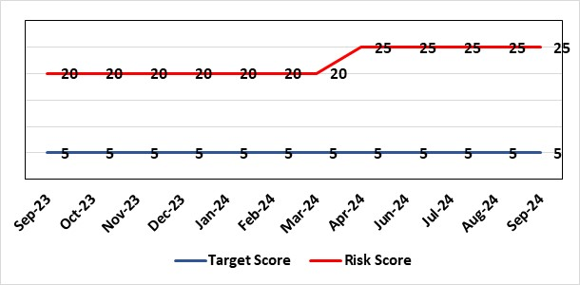 |  | Rationale for current score:  - Delivery of the deficit plan is predicated on a combination of savings and run rate reductions  - Consequence is significant as failure to deliver the plan could impact service delivery if cost reduction required later in the year  - A deficit plan is a failure to meet a statutory duty
Level of Control
= 25%
Date added to the risk register  June 2023 |  |  | Rationale for target score:  - The consequence will not change given the important of financial delivery and its relationship with the delivery of the Health Board recovery and sustainability plan  - Reducing likelihood to 1 supports a confidence that the deficit plan will be delivered.
Controls (What are we currently doing about the risk?) |  |  | Mitigating actions (What more should we do?)
The Health Board is doing the following:  - Enhanced governance arrangements in place from April 2024, including the submission of Financial Strategies from all Service Groups on 31st May 2024, which lead to the options discussed below.  - Establishment of the Recovery and Sustainability (R&S) Team from July 2024 to support both immediate actions and longer term sustainability. With a Recovery & Sustainability Board overseeing the delivery, which will be in place from October 2024.  - Review of all controllable expenditure and directions issued via the R&S Team, including Variable Pay targets.  - From end June through to August, Service Areas have submitted options to address current pressures, which have been scrutinised through a number of Star Chamber meetings and via Executive Team. This links to the work required via the Accountability Letters issued in April 2024 and the submission of the Financial Strategies on 31st May 2024  - Clear action requested directly from interim CEO and agreed via Management Boards on the management of Variable Pay at the meeting on 15th May 2024, followed by control totals set by Director of R&S in July for delivery in Q2 and Q3.  - Further actions set by interim CEO for Executive Directors above Thematic programmes.  - Outlined in the plan submitted 28th March 2024 the Health Board has been focusing on its Thematic Programmes to support the reduction of the £50.1m, which are aligned to the national Value & Sustainability programmes. The progress on these will also info the revised Plan due for consideration on 25th September and is linked to action 3 opposite.  - Transparent exchange of position with NHS Executive & Welsh Government, with both weekly and monthly meetings with the NHS Executive.  - Clear financial plan in place for 2024/25, with further work being undertaken at the request of WG for presentation to the Board on 25th September.  - Savings Programme Management Office (PMO) in place to support savings delivery. The PMO team have expanded their remit to support the Recovery & Sustainability Programme  - Enhancement of reporting by exploring options on weekly reporting of drivers of expenditure  - Focus on efficiency of core resource to avoid spending premium cost resource  - Publication of control targets at end September to all Service Areas for 2024/25 to provide additional controls in the process following the work on Star Chambers and associated options. |  |  | Action | Lead | Deadline
 |  |  | 1. Continuation of financial performance meetings and escalation as necessary | Director of Finance & Performance | Will run until targets met
 |  |  | 2. Develop robust cross system service change plans which improve quality of care and reduce system cost | Director of Finance & Performance and Chief Operating Officer | Will run until target is met
 |  |  | 3. Recommendations following Star Chamber and Executive Team meetings to be presented as part of the revised Financial Plan at the Board meeting on 25th September. This will then set the trajectory to the 31st March 2025. | Director of Finance & Performance | 30/09/2024
 |  |  | 4. Building on the work from point 3, all service areas will be issued with control totals to deliver, recognising the areas of options and controllable expenditure. Oversight of this will be via the Recovery & Sustainability Board commencing in October. | Director of Finance & Performance to issue targets.  Service and Corporate Directors to deliver targets | 30/09/2024  31/03/2025
Assurances (How do we know if the things we are doing are having an impact?)  The Health Board financial performance is reviewed and monitored through:  - Monthly financial recovery meetings  - Performance & Finance Committee  - Routine reporting to Board of most recent monthly position and financial forecasts  - Development of weekly reporting of drivers of expenditure.  - Weekly meetings with the NHS Executive  - Monthly Enhanced Monitoring Meetings  - Monthly Financial Face to Face meetings with Director Finance for NHS Wales from August onwards  - Comprehensive mid-year and Q3 review of trajectory to 31st March 2025 will be completed in October and January for discussion with WG and Board. |  |  | Gaps in assurance (What additional assurances should we seek?)
Additional Comments / Progress Notes
03/05/24 - Letter from WG dated 3rd May outlined that the plan as it stands is unacceptable and unsupportable and resubmission is required by 31st May 2024.
13/05/24 – Interim CEO set out clear action in the financial position
15/05/24 – Discussions with Management Board and setting position regarding agency spend
05/06/24 – Presentation to WG by DOF/Deputy DOF on Financial Plan and the position at Month 1
11/06/24 – Presentation and further actions agreed by Independent Members
23/07/24 – Update on actions to mitigate financial position and next steps shared with PFC.
12/08/24 – Full details of all actions to mitigate position described in MMR submission, which is part of PF papers
19/09/24 – Actions updated. Check and challenge meeting planned with WG 09/10/24 on Financial Position and trajectory to 31st March 2025.

Datix ID Number: 3448  Health & Care Standard: |  |  | HBR Ref Number: 93  Risk Target Date: TBC |  | Current Risk Rating  5 x 4 = 20
Objective: The health board is a resilient, financially sustainable and responsible organisation |  | BAF Ref: 6 | Director Lead: Darren Griffiths, Director of Finance and Performance  Assuring Committee: Performance & Finance Committee
Risk: Reduced Capital Funds  Reduced discretionary capital funds and reduced National NHS funds requiring a restricted Capital Plan for 2024/25. |  |  | Date last reviewed: September 2024
Risk Rating  (consequence x likelihood):  Initial: 5 x 4 = 20  Current: 5 x 4 = 20  Target: 5 x 1 = 5 | 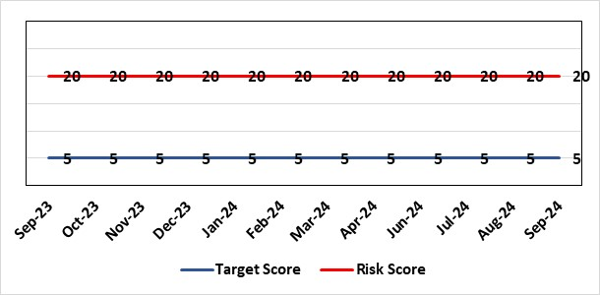 |  | Rationale for current score:  - The Health Board has been advised that its discretionary capital allocation for 2024/25 is £11.168m.  - The funding available within the Capital Resource Limit (CRL) will not meet the demands for capital investment. Discretionary capital is deployed to replace ageing medical devices & equipment; to address backlog maintenance of premises; and to support small scale, non-National service improvements with capital investments  - The current Health Board assessment of the carry forward and previously agreed commitments for inclusion in the 2024/25 capital plan currently suggests a requirement for an additional £8.4m to balance the plan and meet highest risk priorities only.  - WG are currently assessing the outputs from the national capital prioritisation exercise, which means some major capital scheme business cases are on hold.  - The approved plan assumes additional disposal income of £850m which is yet to complete.  - Assumed income of £1.124m from WG for business case fees has been removed from the plan due to the on-going national capital prioritisation exercise. A temporary hold of estates allocations agreed to mitigate this risk following receipt of an additional £4.4m capital funding from WG for estates backlog maintenance.  - There is potential for further capital requirements arising from service model changes which will need to be managed.  - Potential consequences of this risk are the inability to achieve the ambitions set out within health board plans; the potential failure of ageing equipment leading to service disruption; the exposure to potential environmental health & safety risks.
Level of Control
= 25%
Date added to the risk register  June 2023  (refreshed June 2024) |  |  | Rationale for target score:  The target score expresses the aspiration of the health board for addressing this risk. The target date indicated above reflects the point which the current actions are anticipated to reduce the risk, though knowledge of the actual funding available is required to reduce it further and this is not available until some months into the financial year.
Controls (What are we currently doing about the risk?) |  |  | Mitigating actions (What more should we do?)
The Health Board is doing the following: -  - Regular dialogue with Welsh Government regarding capital requirements.  - Clear communication and reporting of the capital position, the risks and limitations.  - Close management of all schemes to ensure slippage is understood along with the impact on service.  - Clear prioritisation of any new requirements recognising the current constraints |  |  | Action | Lead |  | Deadline
 |  |  | Routine review and flexing of plan as spending is committed through the year. Routine monitoring processes will identify any potential slippage and will deploy this on risk based basis. | Director of Finance & Performance |  | Monthly through the financial year as plan is dynamic
 |  |  | Slippage bids to WG. | Assistant Director of Finance (Strategy & Planning) |  | 30/09/2024
Assurances (How do we know if the things we are doing are having an impact?)  The Health Board capital position is reviewed and monitored through:  - Quarterly capital prioritisation group  - Performance & Finance Committee quarterly finance report  - Monthly Monitoring Returns to Welsh Government. |  |  | Gaps in assurance (What additional assurances should we seek?)  Reporting on impact of constraints to the capital programme on service delivery.
Additional Comments
Board members will be aware that capital plans are dynamic through the year with mitigating actions taken and opportunities for slippage and further support from WG sought on a consistent basis. This process will continue in 2024/25 in efforts to de-risk the capital plan.
18/06/24: Updated for 2024/25 position.
02/09/24: Risk level rational updated
23/09/24: Updated for latest position.

Datix ID Number: 3516  Health Care Standards: |  |  | HBR Ref Number: 94  Risk Target Date: TBC |  | Current Risk Rating  4 x 3 = 12
Objective: Mental Health & Learning Disability Services |  | BAF Ref: 2.3 | Director Lead: Deb Lewis, Chief Operating Officer  Assuring Committee: Performance & Finance Committee  For information: Quality & Safety Committee
Risk: CAMHS failure to meet required standards of performance  The CAMHS service is unable to meet the required level of performance due to workforce deficits in the team across all staff groups including medics, psychological therapies and nursing.  Links to other CAMHS risk register entries: (Ref: 3410/3373/3351/3346/3349/3350) |  |  | Date last reviewed: September 2024
Risk Rating  (consequence x likelihood):  Initial: 4 x 5 = 20  Current: 4 x 3 = 12  Target: 3 x 3 = 9 | 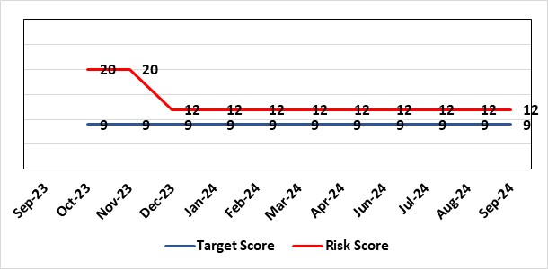 |  | Rationale for current score:  Marked improvement in the performance against the Mental health Measure for CAMHS. Data validation for new patients complete. Current risk score reduced to 12 in view of improved performance however this reflects the fragility in the workforce to deliver sustained performance.
Level of Control  = % |  |  | Rationale for target score:  The rationale for the target score is linked to successful recruitment and more timely access to services for children and young persons which will reduce risk.
Date added to the risk register
October 2023
Controls (What are we currently doing about the risk?) |  |  | Mitigating actions (What more should we do?)
-Ongoing recruitment into all staff groups  -Temporary agency workforce in nursing at premium pay rates to sustain current levels of performance  -Use of locum medical staff due to high vacancy level on medical workforce.  -Recent appointment into psychological therapies lead posts. |  |  | Action | Lead |  | Deadline
 |  |  | Continued efforts at recruitment | Acting Associate Service Director |  | Monthly review
Assurances (How do we know if the things we are doing are having an impact?)  -Monthly CAMHS Directorate meeting in place where performance and workforce are scrutinised  -Reporting into Weekly Business Team and MH & LD management board.  -Reporting into SBU Performance & Finance Committee and IQPD (Integrated Quality & Performance Delivery) meeting with Welsh Government  -Ongoing validation of the waiting list to ensure robust reporting going forward |  |  | Gaps in assurance (What additional assurances should we seek?)
Additional Comments / Progress Notes
03/09/2024: There has been sustained improvement performance against the Mental Health Measure for CAMHS since last review date in line with the predicted trajectories increases from 40% compliance against Part 1a in May to 62% in June and 72% in July. We are continuing to try and recruit to substantive nursing posts for part 1a of the service to reduce the need for agency nursing, to make the service provision more clinically and financially sustainable.
19/09/2023 August compliance figures have risen again to 84%. We have been unsuccessful with the recruitment to substantive nursing posts so still reliant on the agency workforce so the risk score will need to remain the same. Current risk score remains at 12 in view of improved performance over a period, however this reflects the fragility in the workforce to deliver sustained performance.

Datix ID Number: 3571  Health & Care Standard: |  |  | HBR Ref Number: 96  Target Date: 31st March 2025 |  | Current Risk Rating  4 x 5 = 20
Objective: The health board is a resilient, financially sustainable and responsible organisation |  | BAF Ref: 6 | Director Lead: Nerissa Vaughan, Interim Director of Strategy  Assuring Committee: Performance & Finance Committee
Risk: Failure to Develop an Approvable IMTP (statutory compliance)  Failure to have an approvable (Integrated Medium Term Plan) IMTP for 2024/5 and for 2025/26 then we will lose public confidence and breach legislation. |  |  | Date last reviewed: September 2024
Risk Rating  (consequence x likelihood):  Initial: 4 x 5 = 20  Current: 4 x 5 = 20  Target: 4 x 2 = 8 | 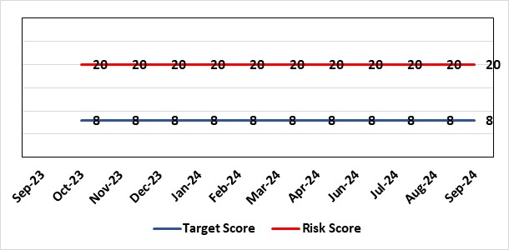 |  | Rationale for current score:  The Health Board does not have a WG approved IMTP and has been placed in enhanced monitoring for Finance, Strategy and Planning following the inability of the Health Board to submit a balanced IMTP in March 2023. Given the All Wales financial context the Health Board was not able to submit an IMTP in March 2024 and has instead developed an Annual Plan 24/25 set in a three year context. It is also unlikely that the HB will be able to submit financially balanced IMTP in March 2025
Level of Control
= 70%
Date added to the HB risk register
October 2023
Date added to the HB risk register  October 2023 |  |  | Rationale for target score:  The target remains to develop a financially balanced IMTP so that we meet our statutory duties.
Controls (What are we currently doing about the risk?) |  |  | Mitigating actions (What more should we do?)
- An integrated process is in place to develop the Annual Plan 2025/26.  - The existing IMTP Executive Steering Group will provide oversight of the Annual Plan/IMTP, Performance and Finance Plans assured by P&F Committee. W&OD Committee reviews the workforce plan, Q&S Committee the Q&S elements. JET meetings with WG  - An Annual Plan was submitted to WG in March 2024 along with an Accountability Officer Letter  - As per the Welsh Government de-escalation criteria for Strategy and Planning work has commenced to refresh the HB’s Clinical Services Plan with a view to develop a draft that can be shared with WG in March 2025.  - As per the Welsh Government de-escalation criteria for Strategy and Planning work in being undertaken to assess the HB against the Planning maturity Matrix and develop an action plan in response. The baseline assessment should go to Board in September at the latest. |  |  | Action | Lead |  | Deadline
 |  |  | Establish baseline assessment against the Planning Maturity Matrix with an associated action plan | Interim Director of Strategy |  | 30/09/2024
 |  |  | Development of a draft Clinical Services Plan to be shared with WG in March 2025. | Interim Director of Strategy |  | 31/03/2025
 |  |  | Amended: Development of a robust Annual Plan for 2025/26 in a three year context to be submitted to WG in March 2025. | Interim Director of Strategy |  | 31/03/2025
Assurances (How do we know if the things we are doing are having an impact?)  Robust arrangements are in place to execute the Annual Plan and for 2025/26 these arrangements are being strengthened with updated reporting and monitoring arrangements through the newly established Annual Plan Oversight Group chaired by the COO. |  |  | Gaps in assurance (What additional assurances should we seek?)
Additional Comments / Progress Notes
20/06/2024: Risk refreshed

Datix ID Number: 3692  Health & Care Standard: |  |  | HBR Ref Number: 98  Target Date: TBC | Current Risk Rating  5 x 4 = 20
Objective: Care is delivered in safe and appropriate settings |  | BAF Ref: 3 | Director Lead: Darren Griffiths, Executive Director of Finance & Performance  Assuring Committee: Performance & Finance Committee
Risk: Overall condition/compliance and suitability of Health Board Estate  6 FACET survey undertaken in 2022 confirmed the poor condition and suitability of premises where health care services are provided. The backlog maintenance costs are in excess of £200 million. |  |  | Date last reviewed: September 2024
Risk Rating  (consequence x likelihood):  Initial: 5 x 4 = 20  Current: 5 x 4 = 20  Target: 3 x 3 = 9 | 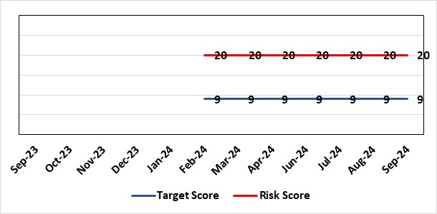 |  | Rationale for current score:  6 FACET survey  Estates Strategy and Development control plans  General compliance with fire regulations and WHTM/WHBN requirements.  Backlog maintenance  Health Board estates strategy and DCP task and finish group  Audit and Assurance limited assurance report  Access to funding
Level of Control  = 50% |  |  | Rationale for target score:  Through the 6 FACET survey a number of key items have been identified covering the Physical condition, Functional suitability, Space utilisation, Quality audit, Statutory compliance and Environmental management. In addition an equality review was undertake on sites. All of which identified significant issues with the current estate, with very few areas achieving condition ‘B’. The overall backlog maintenance is in excess of £200m.
Date added to the HB risk register
07/02/2024
Controls (What are we currently doing about the risk?) |  |  | Mitigating actions (What more should we do?)
- Planned preventative maintenance, prioritising highest risk depending on funding available (EFAB – Discretionary) – linked to creation of decant space through service changes  - Regular reviews of the estate.  - Reactive maintenance.  - 20% annual review/update of 6 FACET surveys  - Undertaken capital schemes where funded  - Address issues where practicable through EFAB/Discretionary capital  - Estates Strategy and development control plans task and finish group |  |  | Action |  | Lead | Deadline
 |  |  | Maintain effective engagement with Welsh Government to provide funding to implement estates strategy and development control plans to address all areas outlined. |  | Assistant Director of Capital Planning | 31 March 2025
 |  |  | Work with Welsh Government to source alternative solutions to funding the HB estates strategy and development control plans |  | Assistant Director of Capital Planning | 31 March 2025
Assurances (How do we know if the things we are doing are having an impact?)  - Monitoring through quality & Safety, Audit & Assurance and Performance and Finance committee to receive assurance and or identify gaps for key compliance and adherence to applicable legislation.  - NWSSP internal audits  - Site visits/tours to identify compliance and gaps in compliances.  - Completion of FRA’s within targeted schedule  - Estates strategy and development control plans being implemented  - Half yearly Board oversight of strategy implementation |  |  | Gaps in assurance (What additional assurances should we seek?)  Suitable funding to implement the estates strategy and development control plans, this will be over a 10 – 15 year period.  Allocate funds where available to address issues outlined  Detailed work to be commissioned to consider primary and community estates strategy along with mental health services
Additional Comments
Through the 6 FACET survey a number of key items have been identified covering the Physical condition, Functional suitability, Space utilisation, Quality audit, Statutory compliance and Environmental management. In addition an equality review was undertake on sites. All of which identified significant issues with the current estate, with very few areas achieving condition ‘B’. The overall backlog maintenance is in excess of £200m.
Key areas include ventilation and cooling with major infection control and other implications. Theatres/Wards/ED and general acute settings including mental health and learning disabilities being old and not compliant with the latest WHBN’s and WHTM’s. The heating, power and medical gas systems have also been identified as issues for concern in the 6 FACET surveys and from independent audits. The health board’s latest NWSSP estates audit received a limited assurance due to limited Welsh Government funding available to undertake backlog maintenance and implementation of estates strategy.
19/07/24 & 22/07/2024: Positive works continue through EFAB and additional funding through WG covering backlog maintenance during 2024, with plans in place to address backlog maintenance, within funding available. In addition to the existing £4.983m WG capital allocation for EFAB (Estates Funding Advisory Board), an additional capital allocation of £4.460m has been received from WG for estates backlog maintenance. No change in current risk score
05/09/2024: Some backlog maintenance issues are currently being addressed in accordance with the allocated WG funding.
To date a total of 11 schemes are being BLM addressed by Capital Planning and Estates teams using EFAB capital allocation. With a number of other areas for action pending further funding allocation. The expenditure and progress of associated schemes is being closely monitored via a monthly steering group and reported back to WG on a bi-monthly basis.

Risk Score Calculation

For each risk identified, the LIKELIHOOD & CONSEQUENCE mechanism will be utilised. Essentially this examines each of the risks and attempts to assess the likelihood of the event occurring (PROBABILITY) and the effect it could have on the Health Board (IMPACT). This process ensures that the Health Board will be focusing on those risks which require immediate attention rather than spending time on areas which are, relatively, a lower priority.

