

HEALTH BOARD RISK REGISTER
September 2023
RISKS ASSIGNED TO THE
PERFORMANCE & FINANCE COMMITTEE



Datix ID Number: 738  Health & Care Standard: 5.1 Timely Care |  |  | HBR Ref Number: 1  Risk Target Date: 31/03/2024 |  | Current Risk Rating  5 x 5 = 25
Objective: Networked Hospitals – A Systems Approach – Urgent & Emergency Care |  | BAF Ref: 3.3 | Director Lead: Deb Lewis, Chief Operating Officer  Assuring Committee: Performance and Finance Committee  For information: Quality & Safety Committee
Risk: Access to Unscheduled Care  If we fail to provide timely access to Unscheduled Care then this will have an impact on quality & safety of patient care as well as patient and family experience and achievement of targets. There are challenges with capacity/staffing across the Health and Social care sectors. |  |  | Date last reviewed: September 2023
Risk Rating  (consequence x likelihood):  Initial: 4 x 5 = 20  Current: 5 x 5 = 25  Target: 3 x 4 =12 | 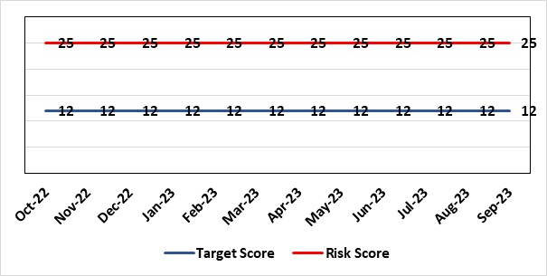 |  | Rationale for current score:  Post wave 2 of COVID 19 Morriston and Singleton have experienced a steady increase in emergency demand to pre-covid levels. Capacity is limited due to covid response and therefore remains a high risk. Current score raised due to increasing pressures. Recent implementation of All Wales Immediate Release Protocol puts additional pressure on already overcrowded ED dept.
Level of Control  = 50% |  |  | Rationale for target score:  Our annual plan is to implement models of care that reflect best practice. This will improve patient flow, length of stay and reduce emergency demand.
Date added to the HB risk register
26.01.16
Controls (What are we currently doing about the risk?) |  |  | Mitigating actions (What more should we do?)
- Increased reporting as a result of escalation to targeted intervention status.  - Development of a Phone First for ED model in conjunction with 111 to reduce demand.  - OPAS (Older People’s Assessment Service) have undertaken training with nursing homes (on management of patient falls) & set up direct contact details with nursing homes  - Frailty short-stay unit re-established  Additionally, actions to improve the discharge of clinically optimised patients (risk HBR80) expected to assist with patient flow, are anticipated to free capacity to assist to address this risk HBR1 also.  Acute Medical Unit (AMU)  - Medical patient flow within Morriston has been refined between ED, AMU and wards.  Patient flow  Roll out SAFER continues across all hospitals, 23 wards at Morriston, Gorseinon completed and started at SGH and NPT  - WAST direct access to SDEC  - Expected medical patients conveyed by WAST go direct to AMU rather than ED, medical patients in ambulances outside ED diverted to AMU after initial assessment  - Stroke rehab pathway between MGH and NPT embedded  - Morning “golden” patients identified for early moves to discharge lounge freeing up beds earlier in the day  Criteria Led discharge to commence on pilot wards September 2023 |  |  | Action | Lead |  | Deadline
 |  |  | Increase of hours in SDEC planned. | SGD (Morriston) |  | 01/03/2024
 |  |  | OPAS – exploring internal & external funding options | SDEC Clinical Lead |  | 30/09/2023
 |  |  | Work ongoing in ED/SDEC to pilot additional initiatives. | Chief Operating Officer / Deputy Medical Director |  | 30/09/2023
 |  |  | Redesign GP referral flow so that all referrals are directed to SDEC in the first instance rather than attend AMU | SDEC and AMU clinical leads |  | 11/09/2023
 |  |  | Surgical SDEC opening | Corporate flow team Surgical Division |  | 01/09/2024
 |  |  | Continuous flow model | COO |  | 31/08/2023
Assurances (How do we know if the things we are doing are having an impact?)  - New Urgent & Emergency Care Board is meeting monthly.  - Six Goals programme has been reviewed, programme leads appointed  - Update UEC dashboard has been developed and released by digital |  |  | Gaps in assurance (What additional assurances should we seek?)  The need to deliver sustained service.
Additional Comments / Progress Notes
30/06/2023: Business case being drafted currently to cover points above for CEO review.
31/07/2023: The HB is working in partnership with the national Six Goals team and NHS Wales to pilot an alternative flow model call continuous flow. This is part of a pilot to develop a standardised toolkit for NHS Wales. Action completed – Implement criteria led discharge – Implementation completed, review to take place.
11/08/23: SB confirmed as 1 of 3 pilot sites in Wales. Pilot will commence as a service improvement project in Aug 23’. Collaborating with WAST to identify further opportunities for partnership working around falls in the community. Action completed - Care home pilot with pharmacist medicines review and rapid response to avoid hospital admission, monthly reporting in place.

Datix ID Number: 840  Health & Care Standard: 5.1 Timely Care |  |  | HBR Ref Number: 16  Risk Target Date: 31/10/2023 | Current Risk Rating  5 x 4 = 20
Objective: Networked Hospitals – A Systems Approach – Planned Care |  | BAF Ref: 3.4 | Director Lead: Deb Lewis, Chief Operating Officer  Assuring Committee: Performance and Finance Committee  For information: Quality & Safety Committee
Risk: Access and Planned Care  There is a risk of harm to patients if we fail to diagnose and treat them in a timely way. |  |  | Date last reviewed: September 2023
Risk Rating  (consequence x likelihood):  Initial: 4 x 4 = 16  Current: 5 x 4 = 20  Target: 4 x 2 = 8 | 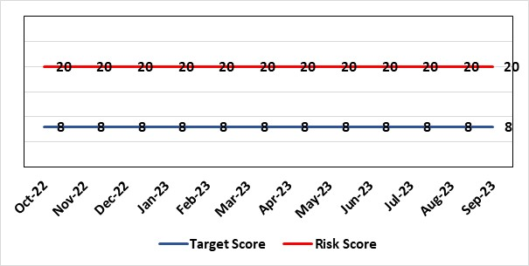 |  | Rationale for current score:  All non-urgent activity was cancelled due to response to the Covid-19 pandemic and has increased the backlog of planned care cases across the organisation. Whilst mitigating measures such as virtual clinics have been put in place new referrals are still being accepted which is adding to the outpatient backlog particularly in Ophthalmology and Orthopaedics. The significant reduction in theatre activity during the pandemic increased the number of patients now breaching 36 and 52 week thresholds.
Level of Control
= 90%
Level of Control  = 90% |  |  | Rationale for target score:  There is scope to reduce the likelihood score to reduce the overall risk to an acceptable level. The Risk target date indicates when we expect to see some reduction in waiting lists – albeit the overall risk level may remain as work continues.
Date added to the HB risk register
January 2013
Controls (What are we currently doing about the risk?) |  |  | Mitigating actions (What more should we do?)
- Post Covid 19 the focus is on minimising harm by ensuring that the patients with the high clinical priority are treatment first. The Health Board is following the Royal College of Surgeons guidance for all surgical procedures and patients on the waiting list have been categorised accordingly.  - There is a bi-weekly recovery meeting for assurance on the recovery of our elective programme.  - Specialty level capacity and demand models set out the baseline capacity and identify solutions to bridge the gap. Non-recurring pump – prime funding is available to support initial recovery measures. Fortnightly performance reviews track progress against delivery.  - A focused intervention is in train to support to the 10 specialties with the longest waits.  - Long waiting patients are being outsourced to the Independent Sector  - Additional internal activity is being delivered on weekends (via insourcing)  - Planned care trajectories developed and submitted to WG as part of IMTP.  - Governance process put in place to monitor performance against trajectories internally, and with Welsh Government.  - External & internal validation has commenced.  - A 10 bedded orthopaedic ward was created at Morriston Hospital in December to address the longest waits in the specialty that can only be operated on at Morriston.  - All long waiting patients are receiving clinical reviews to ascertain continued need for surgery. |  |  | Action |  | Lead | Deadline
 |  |  | Implement demand management initiatives |  | Deputy COO | 31/03/2024
 |  |  | Work ongoing with Finance colleagues to establish the funding allocation for elective recovery for 2023/24. |  | Deputy COO | 31/10/2023
Assurances (How do we know if the things we are doing are having an impact?)  - Weekly meetings in place to ensure patients with greatest clinical need are treated first. |  |  | Gaps in assurance (What additional assurances should we seek?)
Additional Comments / Progress Notes
19/06/2023 – The new elective surgical hub for orthopaedics and urology in NPTH has been opened. This will provide additional capacity for up to 60 cases per week once fully operational.
20/07/2023 – No further updates to report.
18/08/2023 – The Health Board has received an additional allocation of £14m for orthopaedic (NPTH development) which will support the delivery of the 104 week target. The first additional theatre at NPTH will be available from 28 August, providing additional capacity for 20 cases per week. Following the approval of the additional funding, the end of year trajectory based on the service plan will be finalised by the end of August.

Datix ID Number: 1563  Health & Care Standard: Safe Care 5.1 Access This risk is being re-drafted currently |  |  | HBR Ref Number: 48  Risk Target Date: 31st March 2023 | Current Risk Rating  4 x 3 = 12
Objective: Children, Young People & Maternity Services |  | BAF Ref: 3.6 | Director Lead: Deb Lewis, Chief Operating Officer  Assuring Committee: Performance and Finance Committee, Health Board  For information: Quality & Safety Committee
Risk: Failure to sustain Child and Adolescent Mental Health Services |  |  | Date last reviewed: September 2023
Risk Rating  (consequence x likelihood):  Initial: 4 x 4 = 16  Current: 4 x 3 = 12  Target: 4 x 2 = 8 | 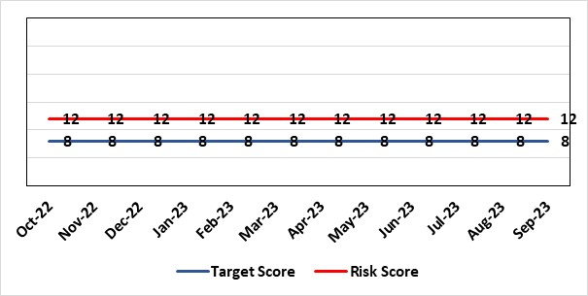 |  | Rationale for current score:  Difficulties with sustainable staffing affecting performance. Due to improvements being made within the service the current score is on track to be reduced next month.
Level of Control  = 50% |  |  | Rationale for target score:  New service model and improved performance.
Date added to HB the risk register
31/05/2018
Controls (What are we currently doing about the risk?) |  |  | Mitigating actions (What more should we do?)
- Performance Scrutiny - is undertaken at monthly commissioning meetings between Swansea Bay & Cwm Taf Morgannwg University Health Boards. Improved governance - ensures that issues and concerns are discussed by all interested parties including local authorities to support the network identify local solutions.  - New Service Model was established by Summer 2019 which gave further stability to service.  - Staffing of service is being strengthened & supplemented by agency staff  - External support secured to determine future delivery arrangements and more immediate performance improvements.  - Following a service review, and option appraisal, the Health Board approved the preferred option – to repatriate Swansea Bay CAMHS at its September Board meeting. |  |  | Action |  | Lead | Deadline
 |  |  | The ongoing utilisation of agency staff to fill vacancies has been agreed via the commissioning arrangements and the Service have had ongoing agency workers in the service since April. The Service will continue to look for opportunities for agency to support the service. |  | Assistant Director of Strategy | 01/04/2023
 |  |  | Repatriation of Service to SBUHB |  | Assistant Director of Strategy | 01/04/2023
 |  |  | CAMHS Implementation Plan to be progressed in line with the agreed timelines to manage demand & capacity and improve waiting times. |  | Assistant Director of Strategy | Ongoing (multiple milestones)
Assurances (How do we know if the things we are doing are having an impact?)  As a result of focussed work, the vacancy rate has improved considerably. Utilisation of agency will continue to improve the backlog, and support the trajectories received.  % Patients waiting < 28 days  The number of referrals reduced to 138 in August 2022, compared to 259 in May 2022 when referrals were at their highest this year. The proportion of referrals redirected/not accepted increased in August to 55% reflecting the average for 21/22.  The number of patients on the waiting list at the end of August 2022 has decreased from 324 in May to 100. The current waiting time for assessment as at 23rd September 2022, is included within the table below: |  |  | Gaps in assurance (What additional assurances should we seek?)
  Team | Total waiting | Waiting >28 days | % compliance | Average wait (weeks)
  CAMHS Swansea Bay | 100 | 31 | 69% | 2.7
Additional Comments / Progress Notes
21.11.2022 – Action complete – The Network is seeking to recruit agency staff to fill existing and upcoming vacancies to ensure that core capacity is maximised.

Datix ID Number: 1761  Health & Care Standard: Timely Care 5.1 Access |  |  | HBR Ref Number: 50  Risk Target Date: 30/09/2023 |  | Current Risk Rating  5 x 5 = 25
Objective: Networked Hospital – A Systems Approach – Cancer Care |  | BAF Ref: 3.5 | Director Lead: Deb Lewis, Chief Operating Officer  Assuring Committee: Performance and Finance Committee  For information: Quality & Safety Committee
Risk: Access to Cancer Services A backlog of patients now presenting with suspected cancer has accumulated during the pandemic, creating an increase in referrals into the health board which is greater than the current capacity for prompt diagnosis and treatment. Because of this there is a risk of delay in diagnosing patients with cancer, and consequent delay in commencement of treatment, which could lead to poor patient outcomes and failure to achieve targets. |  |  | Date last reviewed: September 2023
Risk Rating  (consequence x likelihood):  Initial: 4 x 5 = 20  Current: 5 x 5 = 25  Target: 4 x 3 = 12 |  |  | Rationale for current score:  Risk score updated based on being off trajectory for SCP and Backlog increasing.
Level of Control  = 70% |  |  | Rationale for target score:  Target score reflects the challenge this area of work present the Board and where small numbers of patients impact on the potential to breach target.
Date added to the HB risk register
April 2014
Controls (What are we currently doing about the risk?) |  |  | Mitigating actions (What more should we do?)
- Tight management processes to manage each individual case on the Urgent Suspected Cancer Pathway. Enhanced monitoring & weekly monitoring of action plans for top 6 tumour sites.  - Initiatives to protect surgical capacity to support USC pathways have been put in place  - Additional investment in MDT coordinators, with cancer trackers appointed in April 2021.  - Prioritised pathway in place to fast track USC patients.  - Ongoing comprehensive demand and capacity analysis with directorates to maximise efficiencies. This will form part of the remit of the Cancer Performance Group.  - Weekly cancer performance meetings are held for both NPTS and Morriston Service Groups by specialty.  - The top 6 tumour sites of concern have developed cancer improvement plans – weekly monitoring arrangements have been put in place.  - Additional work being undertaken as part of diagnostic recovery and theatre recovery workstreams.  - Endoscopy contract has been extended for insourcing. |  |  | Action | Lead |  | Deadline
 |  |  | Cancer Performance Group to monitor improvement trajectories for both cancer backlog and SCP performance on a monthly basis | Deputy COO |  | 31/03/2024
 |  |  | Additional theatre capacity for gynaecological cancer agree to reduce current backlog | Deputy COO |  | 31/09/2023
Assurances (How do we know if the things we are doing are having an impact?)  Backlog trajectories updated at Management Board and will be going to Performance & Finance Committee in August. Cancer Performance Group established to support execution of the services delivery plans for improvements and meeting regularly. |  |  | Gaps in assurance (What additional assurances should we seek?)  Performance and activity data monitored, but delays to treatment continue while sustainable solutions found.
Additional Comments / Progress Notes
19/06/2023 Additional surgical treatment capacity has been made available for OMFS and colorectal. A National Cancer Recovery and Improvement Task Force has been established to support health board in the areas of urology, colorectal and gynaecology. Three actions complete - Phased and sustainable solution for the required uplift in endoscopy capacity that will be key to supporting both the Urgent Suspected Cancer backlog and future cancer diagnostic demand on Endoscopy Services. Expand OMF & colorectal operating capacity. Developing trajectory for 2023/24 for sign off in March 2023.
20/07/2023 – No further updates to report.
18/08/023 – Issues identified with tracking of cancer patients and variability of approach taken by the Service Groups. Agreement to move management of trackers and MDM co-ordinators to the central cancer team with effect from September 2023. Additional financial support agreed for cellular pathology outsourcing to help reduce current backlog position which is contributing to delay in some pathways.

Datix ID Number: 1763  Health & Care Standard: Staff & Resources 7.1 Workforce |  |  | HBR Ref Number: 52  Risk Target Date: TBC |  | Current Risk Rating  4 x 3 = 12
Objective: Focus on Population Health Needs |  | BAF Ref: 4 | Director Lead: Richard Thomas, Director of Communications and Engagement  Assuring Committee: Performance and Finance Committee
Risk: The Health Board does not have sufficient skills & resource in place to undertake impact assessments in line with strategic service change and policy development. |  |  | Date last reviewed: September 2023
Risk Rating  (consequence x likelihood):  Initial: 4 x 4 = 16  Current: 4 x 3 = 12  Target: 4 x 2 = 8 |  |  | Rationale for current score:  - Current lack of required skills / staff to deliver requirements.
Level of Control  = 50% |  |  | Rationale for target score:  - All of these areas need to have adequate resourcing and robust processes / policies in place for the organisation to make robust plans, engage public confidence and meet our statutory and public duties.
Date added to the HB risk register
November 2018
Controls (What are we currently doing about the risk?) |  |  | Mitigating actions (What more should we do?)
- Head of EDI to be appointed to support equality impact assessment – funding agreed, recruitment planned for Q4.  - Creation of DICE has led to additional resource within Engagement Team.  - Robust policies and processes to be in place for Impact Assessment going forward.  - EIA responsibilities incorporated into wider Impact Assessments.  - Development of Strategic Equality Group across organisation to support processes. |  |  | Action | Lead |  | Deadline
 |  |  | Appoint Head of EDI  Delayed due to need to confirm budget | Assistant Director of Insight, Engagement & Fundraising - DICE |  | 30/09/2023
 |  |  | Review of the current process for developing Equality Impact Assessments around service change, engagement and consultation. | Assistant Director of Insight, Engagement & Fundraising - DICE |  | 31/10/2023  In progress
 |  |  | Robust policies and processes to be in place for Impact Assessment going forward. | Assistant Director of Insight, Engagement & Fundraising - DICE |  | 31/10/2023  In progress
 |  |  | Roll out Impact Assessment process across organisation. | Assistant Director of Insight, Engagement & Fundraising - DICE |  | 30/09/2023
Assurances (How do we know if the things we are doing are having an impact?)  Advice on Equality Impact Assessment and then wider Impact Assessments available across organisation supported by robust policies and procedures, overseen by Strategic Equality Group. |  |  | Gaps in assurance (What additional assurances should we seek?)  Participation from across organisation in Strategic Equality Group.
Additional Comments / Progress Notes
24.07.2023 – Action closed - Establishing HB-wide Strategy Equality Group.

Datix ID Number: 2522  Health & Care Standard: 5.1 Timely Care |  |  | HBR Ref Number: 75  Risk Target Date: 30/09/2023 |  | Current Risk Rating  5 x 2 = 10
Objective: Services working effectively through a systems approach |  | BAF Ref: 3 | Director Lead: Deb Lewis, Chief Operating Officer  Assuring Committee: Performance and Finance Committee
Risk: Whole-Service Closure  Risk that services or facilities may not be able to function if there is a major incident or a rising tide that renders current service models unable to operate |  |  | Date last reviewed: September 2023
Risk Rating  (consequence x likelihood):  Initial: 5 x 4 = 20  Current: 5 x 2 = 10  Target: 5 x 1 = 5 | 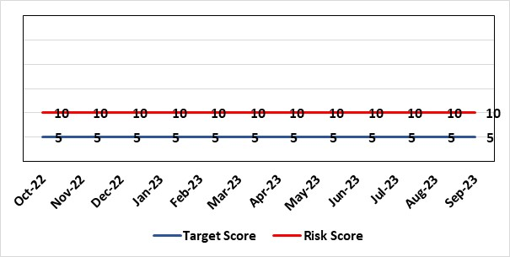 |  | Rationale for current score:  Risk reflects transition to business as usual as part of living with covid strategy. BCP plans in place. There is still fluctuation in patient numbers and new variants continue to emerge so score maintained as watching brief.
Level of Control  = 25% |  |  | Rationale for target score:  The strategy of moving towards living with Covid will eventually lower the risk level to target.
Date added to the HB risk register
May 2021
Controls (What are we currently doing about the risk?) |  |  | Mitigating actions (What more should we do?)
- Sites have business continuity plans and the impact of one site being overwhelmed by COVID demand has been reviewed.  - Monitoring of associated risks has been being transferred to appropriate forums such as UEC Board, Elective Care Board and Nosocomial Group with overall oversight by Management Board.  - Ongoing surveillance of epidemiology data for early warning and further change to risk level via live Covid dashboard. |  |  | Action | Lead |  | Deadline
 |  |  | Periodic review of risk | COO |  | 30/09/2023
Assurances (How do we know if the things we are doing are having an impact?)  Monitored via Management Board for early warning signs. |  |  | Gaps in assurance (What additional assurances should we seek?)
Additional Comments / Progress Notes
06/01/2023: Risk reviewed – no change. Health Board has received updated local choices framework from WG to aid decision-making if required.
07/02/2023: Risk score reviewed – no change
31/07/2023: Risk reviewed.

Datix ID Number: 2554  Health & Care Standard: Standard 5.1 Timely Access |  |  | HBR Ref Number: 82  Risk Target Date: 1st December 2023 |  | Current Risk Rating  4 x 4 = 16
Objective: Networked Hospitals – A Systems Approach – Urgent & Emergency Care |  | BAF Ref: 3.3 | Director Lead: Raj Krishnan, Acting Executive Medical Director  Assuring Committee: Performance & Finance Committee  For Information: Quality & Safety Committee, Workforce & OD Committee
Risk: Risk of closure of Burns service if Burns Anaesthetic Consultant cover not sustained  There is a risk that adequate Burns Consultant Anaesthetist cover will not be sustained, potentially resulting in closure to this regional service, harm to those patients would require access to it when closed and the associated reputational damage. This is caused by:  - Significant reduction in Burns anaesthetic consultant numbers due to retirement and long-term sickness  - Inability to recruit to substantive burns anaesthetic posts  - The reliance on temporary cover by General intensive care consultants, and Consultants from the Morriston General on-call and Paediatric Anaesthesia rotas, to cover while building work is completed in order to co-locate the burns service on General ITU  - Reliance on capital funding from Welsh Government to support the co-location of the service |  |  | Date last reviewed: September 2023
Risk Rating  (consequence x likelihood):  Initial: 4 x 3 = 12  Current: 4 x 4 = 16  Target: 3 x 1 = 3 | 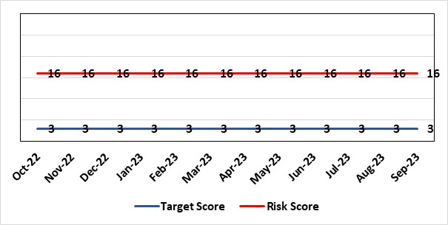 |  | Rationale for current score:  This risk was increased due to closure of the Burns Unit due to staffing levels, and reduced from 25 to 20 having secured the agreement of the general ITU consultants to provide cross-cover while enabling capital works are completed. Propose reduce risk to 16 now and reduce to 12 when funding confirmed by WG.
Level of Control  = |  |  | Rationale for target score:  This is a small clinical service with staff with highly specialised skills. While a small service may always be vulnerable to challenges (eg staff) the intention will be to operate a more resilient clinical model that is supported by other clinical groups.
Date added to the HB risk register
December 2021
Controls (What are we currently doing about the risk?) |  |  | Mitigating actions (What more should we do?)
- The general ITU consultants, and some Consultants from the Morriston General and Paediatric Anaesthetists to support the Burns service on a temporary basis, supporting the remaining burns anaesthetic colleagues to provide cover for the Burns service.  - The agreement reached is that they will cover the current Burns Unit on Tempest ward at Morriston hospital for 6-9 months while capital work is underway on general ITU to enable co-location of the service.  - Capital works will be completed by mid-2023 to co-locate the burns patients within the GICU footprint.  - WHSSC as commissioners of the service have been kept fully informed, as has the South West (UK) Regional Burns Network  - Other UK burns units have ICU co-located with Burns ICU, removing the need for dual certified consultants |  |  | Action | Lead |  | Deadline
 |  |  | WG have agreed funding in principle for capital works to progress. Scoping document submitted to WG and discussions ongoing about expediting a decision on an outline/full business case. | Morriston Service Group |  | 30th November 2023
Assurances (How do we know if the things we are doing are having an impact?)  Effect on patients of the temporary closure of the burns service in Swansea is mitigated by maintaining an urgent assessment/stabilisation service for patients in Wales with severe burns, with onward transfer for inpatient care to another unit in the UK following the initial assessment.  The service reopened fully on 14/02/2022. |  |  | Gaps in assurance (What additional assurances should we seek?)
Additional Comments / Progress Notes
17.01.23 No change to consultant cover, which remains reliant on cross-cover from general critical care and anaesthetics. A business case for the strategic and capital investment of £7.3m has been completed and will be presented to the Board on the 26th January.

Datix ID Number: 3100 *Proposed for Closure*  Health Care Standards: 4.1 Dignified Care, 2.1 Managing Risk & 7.1 Workforce |  |  | HBR Ref Number: 88  Target Risk Date: 31/03/2023 | Current Risk Rating  4 x 5 = 20
Objective: Networked Hospitals – A Systems Approach – Urgent & Emergency Care |  | BAF Ref: 3.3 | Director Lead: Deb Lewis, Chief Operating Officer  Assuring Committee: Performance & Finance Committee  For Information: Quality & Safety Committee
Risk: Non-delivery of AMSR programme benefits  There is a risk that the Acute Medical Service Re-Design (AMSR) programme may not deliver the expected performance & financial benefits in a timely way. The principal potential causes of this risk are: workforce (OCP and recruitment requirements), capacity constraints linked to significant number of clinically optimised patients (COP), financial affordability linked to 90 beds in Singleton hospital that are due to close in Q3 2023. |  |  | Date last reviewed: September 2023
Risk Rating  (consequence x likelihood):  Initial: 4 x 5 = 20  Current: 4 x 5 = 20  Target: 4 x 4 = 16 | 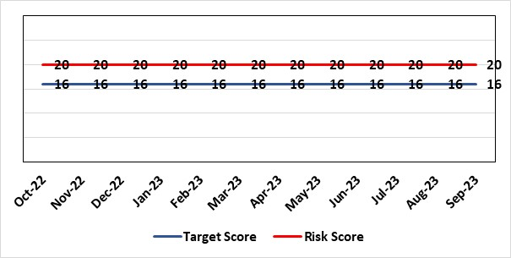 |  | Rationale for current score:  Current score reflects the size and complexity of the programme. Whilst partial benefits of the programme have been realised, operational performance fluctuates mainly due to continuous high numbers of clinically optimised patients (See risk HBR80). Sustained improvement needs to be experienced prior to reduction in score.
Level of Control  = % |  |  | Rationale for target score:  When measures identified are implemented it is anticipated that this will increase the likelihood of success.
Date added to the risk register
July 2022
Controls (What are we currently doing about the risk?) |  |  | Mitigating actions (What more should we do?)
- AMSR Programme Board reporting to UEC (Urgent & Emergency Care) Board  - Dedicated workstreams & workstream leads – all work streams have weekly assurance meetings where the sub groups provide updates on their specific tasks  - OCP (Organisational Change Policy) workstream – supporting staff engagement  - Workforce workstream – Focus on recruitment & retention. Dedicated sub groups with recruitment trackers and action plans.  - AMU (Acute Medical Unit) model workstream - focus on development of the operating policy for the AMU, including the interaction with the admitting units, WAST and specialist wards. Triage process has been agreed – system same as Emergency Department. Draft Standard Operating Procedure (SOP) created.  - SDEC (Same Day Emergency Care) collaborative workstream – focus on further development of SDEC model. SOP developed, focusing on hospital pre admission, data sessions to assist with finalising pathways.  - Specialist wards workstream – focus on role & operating model of specialist wards and interfaces. Agreement on patient criteria with preference of sub-acute /round rounds for singleton wards/ SOP template for all wards. Future – dedicated sub group on Discharge and flow hosting a work shop to standardise process across the health board & internal flow from Morriston to Singleton and Neath.  - Estates workstream focus on capital work.  - Communications – Project team have employed Freshwater to assist with communications for the programme. Focusing on shop floor communication across all hospitals with use of storyboards and TV screens providing updates at main entrances.  - Governance arrangements agreed for go / no go gateways via management board  - Assurance to Performance & Finance Committee (PFC) and (Quality & Safety Committee (QSC) and escalation to Health Board if required. |  |  | Action |  | Lead | Deadline
 |  |  | AMSR as a programme is to be formally discussed for potential closure on 1st August at the UEC Programme Board. Any remaining risks will be reflected on existing HBRR risks (eg HBR1, 80) |  | Chief Operating Officer | Discussed and recommend to go as BAU
Assurances (How do we know if the things we are doing are having an impact?)  Regular gateway reviews via Management Board  Assurance to PFC and QSC and escalation to Health Board if required. |  |  | Gaps in assurance (What additional assurances should we seek?)  Capacity and capability gaps to support the programme and drive forward actions and provide adequate assurance. Operational site pressures impacting on AMSR programme deliverables. Lack of progress in reducing bed occupancy for medicine patients.
Additional Comments / Progress Notes
28/7/23: AMSR as a programme is to be formally being discussed for closure on 1st August at the UEC Programme Board. Any remaining risks will be reflected on existing HBRR risks (eg HBR1, 80). Former action has been replaced by COO.
11/08/23: AMSR discussed at 1st August UEC Board. Recommend closure as a defined programme and become BAU (Business As Usual). Risks identified on HBRR and open risks, benefits still to be fully realised to be transferred to Medicine Division.

Datix ID Number: 3444  Health & Care Standard: 2.1.1 Managing Financial Risk |  |  | HBR Ref Number: 92  Risk Target Date: 31st March 2024 | Current Risk Rating  5 x 4 = 20
Objective: Maintain and Deliver Sustainable Financial Health |  | BAF Ref: 6 | Director Lead: Darren Griffiths, Director of Finance and Performance  Assuring Committee: Performance and Finance Committee
Risk: Forecast deficit is not met due to insufficient progress on COVID cost reduction, savings identification, run rate reduction and the potential for new in-year pressures. |  |  | Date last reviewed: September 2023
Risk Rating  (consequence x likelihood):  Initial: 5 x 4 = 20  Current: 5 x 4 = 20  Target: 5 x 1 = 5 | 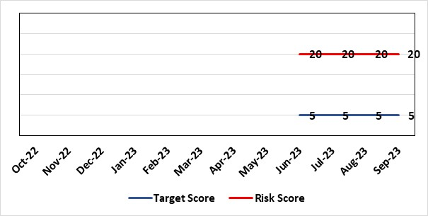 |  | Rationale for current score:  - Delivery of the deficit plan is predicated on a combination of £63.5m of savings and cost reduction which is a significant ask  - Consequence is significant as failure to deliver the plan could impact service delivery if cost reduction required later in the year  - A deficit plan is a failure to meet a statutory duty  - At the time of writing the Health Board still has t identify £31m of the risk mitigation to achieve the deficit plan leading to a high likelihood at this stage
Level of Control
= 25%
Date added to the risk register  June 2023 |  |  | Rationale for target score:  - The consequence will not change given the important of financial delivery and its relationship with the delivery of the Health Board recovery and sustainability plan  - Reducing likelihood to 1 supports a confidence that the deficit plan will be delivered.
Controls (What are we currently doing about the risk?) |  |  | Mitigating actions (What more should we do?)
The Health Board is doing the following: -  - Finance Review Meetings with Units to agree cost exit plans  - Escalation plan for highest pressure areas (Morriston and Neath Port Talbot Singleton)  - Transparent exchange of position with NHS Executive & Welsh Government  - Clear financial plan in place for 2023/24  - Savings PMO in place to support savings delivery  - Additional support being targeted to key areas of pressure |  |  | Action | Lead | Deadline
 |  |  | Continuation of weekly escalation meetings and escalation of other areas as necessary | DoF&P | Will run until targets met
 |  |  | Focus on efficiency of core resource to avoid spending premium cost resource | COO | Through weekly escalation meetings
 |  |  | Develop robust cross system service change plans which improve quality of care and reduce system cost | DoF&P and COO | Will run until target is met
Assurances  (How do we know if the things we are doing are having an impact?)  The Health Board financial performance is reviewed and monitored through:  - Monthly financial recovery meetings  - Performance and Finance Committee  - Routine reporting to Board of most recent monthly position and financial forecasts  - Weekly escalation meetings with CEO and DoF&P – temporary escalations until delivery is assured – each meeting has run rate trackers  - Weekly savings tracker reports from Savings PMO.  - Comprehensive mid-year review of trajectory to 31st March 2024 will be completed in October for discussion with WG and Board. |  |  | Gaps in assurance  (What additional assurances should we seek?)
Additional Comments
Update 16.08.2023 - Letter from WG dated 3rd August outlined that the Health Board had failed to meet its statutory duty to submit an IMTP and to have an IMTP approved by the Welsh Ministers. Although the deficit financial plan is not agreed with Welsh Government, the Board is working to deliver the deficit number unless advised to the contrary. Since submission of the plan the Health Board has also been required to identify options to reduce the deficit below the £86.6m which was submitted to Welsh Government on 11th August along with an Accountability Officer Letter.

Datix ID Number: 3448  Health & Care Standard: 2.1.1 Managing Financial Risk |  |  | HBR Ref Number: 93  Risk Target Date: 31st March 2024 |  | Current Risk Rating  5 x 4 = 20
Objective: Best Value Outcomes from High Quality Care |  | BAF Ref: 6 | Director Lead: Darren Griffiths, Director of Finance and Performance  Assuring Committee: Performance and Finance Committee
Risk: Reduced discretionary capital funds and reduced National NHS funds requiring a restricted Capital Plan for 2023/24 |  |  | Date last reviewed: September 2023
Risk Rating  (consequence x likelihood):  Initial: 5 x 4 = 20  Current: 5 x 4 = 20  Target: 5 x 1 = 5 |  |  | Rationale for current score:  - The Health Board has been advised that its discretionary capital allocation for 2023/24 is £9.8m.  - The funding available within the Capital Resource Limit (CRL) will not meet the demands for capital investment. Discretionary capital is deployed to replace ageing medical devices & equipment; to address backlog maintenance of premises; and to support small scale, non-National service improvements with capital investments  - The current Health Board assessment of the carry forward and previously agreed commitments for inclusion in the 2023/24 capital plan currently suggests a requirement for an additional £9.8m to balance the plan and meet highest risk priorities only.  - It is likely that due to slippage on capital schemes, this over-commitment will reduce.  - There is potential for further capital requirements arising from service model changes which will need to be managed.  - Potential consequences of this risk are the inability to achieve the ambitions set out within health board plans; the potential failure of ageing equipment leading to service disruption; the exposure to potential environmental health & safety risks.
Level of Control
= 25%
Date added to the risk register  June 2023 – new for 2023/24 |  |  | Rationale for target score:  The target score expresses the aspiration of the health board for addressing this risk. The target date indicated above reflects the point which the current actions are anticipated to reduce the risk, though knowledge of the actual funding available is required to reduce it further and this is not available until some months into the financial year.
Controls (What are we currently doing about the risk?) |  |  | Mitigating actions (What more should we do?)
The Health Board is doing the following: -  - Regular dialogue with Welsh Government regarding capital requirements.  - Clear communication and reporting of the capital position, the risks and limitations.  - Close management of all schemes to ensure slippage is understood along with the impact on service.  - Clear prioritisation of any new requirements recognising the current constraints |  |  | Action | Lead |  | Deadline
 |  |  | Routine review and flexing of plan as spending is committed through the year. Routine monitoring processes will identify any potential slippage and will deploy this on risk based basis. | Director of Finance & Performance |  | Monthly through the financial year as plan is dynamic
Assurances (How do we know if the things we are doing are having an impact?)  The Health Board capital position is reviewed and monitored through:  - Monthly capital prioritisation group  - Performance and Finance Committee monthly finance report  - Monthly Monitoring Returns to Welsh Government. |  |  | Gaps in assurance (What additional assurances should we seek?)  Reporting on impact of constraints to the capital programme on service delivery.
Additional Comments
Board members will be aware that capital plans are dynamic through the year with mitigating actions taken and opportunities for slippage and further support from WG sought on a consistent basis. This process will continue in 2023/24 in efforts to de-risk the capital plan.
21/09/23: No additional information, therefore, no change.

Risk Score Calculation

For each risk identified, the LIKELIHOOD & CONSEQUENCE mechanism will be utilised. Essentially this examines each of the risks and attempts to assess the likelihood of the event occurring (PROBABLILITY) and the effect it could have on the Health Board (IMPACT). This process ensures that the Health Board will be focusing on those risks which require immediate attention rather than spending time on areas which are, relatively, a lower priority.

