


Meeting Date | 24 October 2023 |  | Agenda Item |  |  | 4.3
Report Title | Follow up report on progress achieved on tackling the Orthopaedic Waiting List Backlog
Report Author | Rhodri Davies, Divisional Manager and Charlotte  Le Brocq, Directorate Manager
Report Sponsor | Deb Lewis, Chief Operating Officer
Presented by | Ceri Gimblett, Group Service Director,  Rhodri Davies, Divisional Manager
Freedom of Information | Open
Purpose of the Report | Follow Up Report on Orthopaedic Planned Care Performance
Key Issues | The Wales Audit report (November 2022) SBUHB reported a high number of patients waiting for orthopaedic services within SB compared to other health boards in Wales.
Specific Action Required  (please choose one only) | Information | Discussion |  | Assurance | Approval
Specific Action Required  (please choose one only) | ☐ | ☐ |  | ☒ | ☐
Recommendations | Members are asked to:  a) Note the progress made in achieving the Ministerial Targets.  b) Note the progress in implementing the recommendations of the GIRFT report.  c) Note the forward plan for achieving stage 1 and stage 5 performance, further noting the risks associated with this

The Orthopaedic Waiting List Backlog For
Swansea Bay University Health Board

- INTRODUCTION

This paper provides an update on progress against the Planned Care Ministerial targets, improvement plans in place for achievement of the target and risks involved in delivery.

- BACKGROUND

Orthopaedics is the branch of surgery that relates to musculoskeletal conditions. Common surgical procedures include hip and knee joint replacement, and diagnostic intervention such as arthroscopy. Orthopaedic surgeons tend to sub-specialise focussing on areas such as major joints, or foot and ankle, shoulder, or wrist.

Prior to the pandemic, the number of people on the orthopaedic waiting list was one of the biggest challenges facing NHS Wales and specifically Swansea Bay, where waiting lists were unacceptably long. These already long waits have been made significantly worse by the impact of COVID-19.

As demonstrated below the wait for a new outpatient appointment increased significantly during and post pandemic. The Ministerial target was zero patients waiting over 52 weeks at the end of June 2023, unfortunately SB was unable to achieve this target within Orthopaedics. However, the HB is on target to achieve this at the end of October 2023.

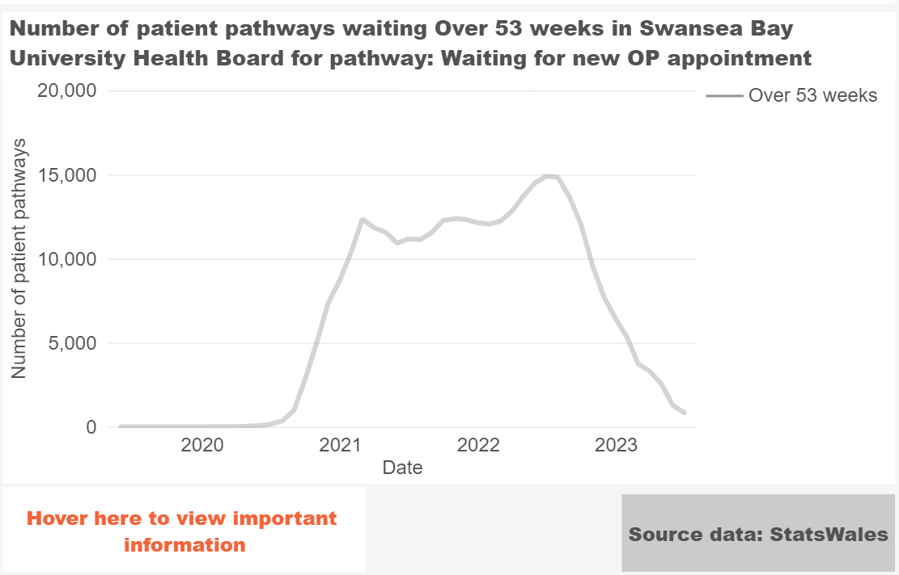
The service has undertaken additional outpatient clinics for almost a year to reduce the backlog of patients created by the Covid pandemic and other changes that occurred to outpatient capacity during that time.

The Health Board had long waiting times for orthopaedic surgery pre Covid due to reduced access to the orthopaedic ward in Morriston and a demand that outstripped the capacity available. The situation was compounded during the pandemic due to a loss of outpatient capacity, a focus on trauma surgery and the establishment of the Ortho-plastic Service. The inability to ring fence beds for the more complex patients due to the demand for medical patients, unscheduled care, trauma, and cancer surgery on the acute site has been a major issue. Consequently, the Health Board has some of the longest waits for orthopaedic surgery in Wales.
The Health Board has previously highlighted its strategy for Orthopaedics, which is consistent with the GIRFT recommendations. A demarcation has been established between trauma and elective surgery, with all inpatient trauma being undertaken at Morriston Hospital and ambulatory trauma where possible being performed in Neath Port Talbot and Singleton Day Surgery Units. There is still currently a need to maintain an elective ward in Morriston to accommodate the Low-volume, High-complexity (LVHC) patients, whilst Neath Port Talbot Hospital (NPTH) is being developed as a High-volume, Low-complexity (HVLC) centre to serve both Swansea Bay and neighbouring health boards (as part of a regional partnership arrangement).
Of the three additional laminar air flow theatres installed at NPTH over the last two years, the first opened in August 2023, the second theatre will open at the end of October 2023 and the third theatre in January 2024. The delay in fully commissioning the additional capacity is due to training and recruitment issues. These theatres will see increasing numbers of orthopaedic patients over the coming months as the newly recruited theatre and anaesthetic staff join the team. The NPTH service includes the development of the high-level care unit (HLCU) to ensure the maximum number of patients, including revision and spinal surgery can be accommodated in future plans.
The ambition is that the elective orthopaedic centre in NPTH becomes an accredited GIRFT facility. Criteria to gain this status is very robust and there are currently eight centres in England; none currently in Wales.
Current Position
The below demonstrates the current waiting times in SB for patients waiting for surgical intervention. The numbers have increased due to the volume of patients seen at the new outpatient stage and their subsequent conversion to Inpatient / Day-case treatment (stage 5). This has resulted in the overall volume of patients waiting to increase; however the HB has reduced the longest waits for surgery. The overall waiting list has also increased due to the CTM disaggregation process which meant an additional 800 patients were added in August 2023.

 | Total Number on waiting list | Total over 156 weeks | Percentage of waiting list over 156 weeks
April 2023 | 4833 | 1354 | 2.09%
May 2023 | 4831 | 1301 | 26.93%
June 2023 | 4788 | 1248 | 26.07%
July 2023 | 5010 | 1112 | 22.20%
August 2023 | 5544 | 1079 | 19.46%
September 2023 | 6474 | 1024 | 15.82%
October 2023 | 6965 | 899 | 12.91%

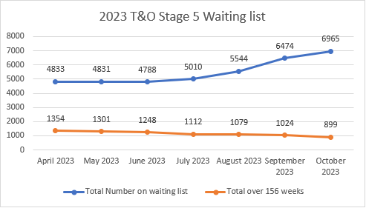

- GOVERNANCE AND RISK ISSUES

The long waiting times for orthopaedic surgery results in risks to both patient experience and outcomes and the reputation of the Health Board.

During 2023/24 the significant investments that have been made in orthopaedic services will address the excessive waiting times.

- FINANCIAL IMPLICATIONS

The required resources to increase orthopaedic surgery both in Morrison and NPTH is already accounted for and available in the 2023/24 financial plan.

There are also funding implications around the Outsourcing contracts with private providers.

- FORWARD PLAN
To maintain the stage 1 performance the service has built robust capacity across the sub specialties to be able to maintain the target in the longer term, providing continuation of HBSUK capacity until end of March in order to provide contingency capacity and potentially reducing the waiting times further.

In order to achieve zero over 156 weeks by end of March 2024, we need to maximise the outsourcing capacity available in order to treat suitable patients within this cohort. There is a comprehensive exercise underway as part of the national orthopaedic programme exploring regional solutions to capacity issues to treat long waiting patients. Both SBU and Hywel Dda have embarked on patient validation to identify suitability for NPTH, PPH and Morriston only. For patients requiring Morriston only, it is important to point out the risk in treating these patients before end of March due to their complexity and limited theatre and bed capacity. This capacity may also be impacted by winter unscheduled care pressures affecting currently ring-fenced bed capacity for this cohort of patients.

- RECOMMENDATION

- Note the progress made in achieving the Ministerial Targets.
- Note the progress in implementing the recommendations of the GIRFT report.
- Note the forward plan for achieving stage 1 and stage 5 performance, further noting the risks associated with this

Governance and Assurance

Link to Enabling Objectives  (please choose) | Supporting better health and wellbeing by actively promoting and empowering people to live well in resilient communities
Link to Enabling Objectives  (please choose) | Partnerships for Improving Health and Wellbeing |  | ☐
Link to Enabling Objectives  (please choose) | Co-Production and Health Literacy |  | ☐
Link to Enabling Objectives  (please choose) | Digitally Enabled Health and Wellbeing |  | ☐
Link to Enabling Objectives  (please choose) | Deliver better care through excellent health and care services achieving the outcomes that matter most to people
Link to Enabling Objectives  (please choose) | Best Value Outcomes and High Quality Care |  | ☒
Link to Enabling Objectives  (please choose) | Partnerships for Care |  | ☐
Link to Enabling Objectives  (please choose) | Excellent Staff |  | ☐
Link to Enabling Objectives  (please choose) | Digitally Enabled Care |  | ☐
Link to Enabling Objectives  (please choose) | Outstanding Research, Innovation, Education and Learning |  | ☐
Health and Care Standards
(please choose) | Staying Healthy |  | ☐
(please choose) | Safe Care |  | ☒
(please choose) | Effective Care |  | ☒
(please choose) | Dignified Care |  | ☐
(please choose) | Timely Care |  | ☒
(please choose) | Individual Care |  | ☐
(please choose) | Staff and Resources |  | ☐
Quality, Safety and Patient Experience
The ongoing work to address excessive waits for orthopaedic surgery in SBUHB will have a positive impact on patient experience.

Financial Implications
The expansion of orthopaedic inpatient services at NPTH has been included in the financial plan.

Legal Implications (including equality and diversity assessment)
N/A.

Staffing Implications
The expansion of staffing resource to deliver orthopaedics has been taken forward under the NPT Orthopaedic Project board.

Long Term Implications (including the impact of the Well-being of Future Generations (Wales) Act 2015)
Report History
Appendices

