

Meeting Date | 24th October 2023 |  | Agenda Item |  |  | 4.2
Report Title | Cancer Performance Update
Report Author | Marisa Bennett, Cancer Performance & Information Manager
Report Sponsor | Deb Lewis, Chief Operating Officer
Presented by | Deb Lewis, Chief Operating Officer
Freedom of Information | Open
Purpose of the Report | The following report provides an update on the delivery of the Single Cancer Pathway for Swansea Bay UHB patients. It focusses on recovery plans in place for the top tumour sites:  - Lower Gastrointestinal  - Breast  - Upper Gastrointestinal  - Gynaecological  - Urological  - Lung
Key Issues | This report will highlight areas where there are significant service delivery challenges.
Specific Action Required  (please choose one only) | Information | Discussion |  | Assurance | Approval
Specific Action Required  (please choose one only) | ☐ | ☐ |  | ☒ | ☒
Recommendations | Members are asked to:  - NOTE the performance and backlog volumes in the main tumour sites.  - NOTE the additional work required to improve both performance and backlog.  - NOTE the recommendations and actions from the internal audit report.

Cancer Performance Update
- INTRODUCTION
In October 2022 Welsh Government (WG) initiated the enhanced monitoring (EM) intervention process for the Health Board (HB) due to quality issues relating poor performance and long waiting times, the HB meets with WG EM on a monthly basis. This process was applied to the HB performance against the Single Cancer Pathway (SCP). The areas of greatest focus both locally and nationally for improvement, resulting in improvement workshop being held in July and September, have been identified as:
- Lower Gastrointestinal (LGI)
- Gynaecological
- Urological
However, there are other areas of concern for the Health Board which are also being closely monitored i.e. upper GI, breast and lung.

- BACKGROUND

The Health Board monitors two main metrics for the single cancer pathway:
- % Performance within the 62-day target
- Backlog volumes (patients waiting over 62 days)

Performance 2022/23

Graph 1 – SCP Performance 22-23

The graph above shows the HB’s SCP performance over the last 13 months. It represents the patients receiving first definitive treatment (FDT) within the 62-day target against the target of 75%. Performance in July and August was maintained at 49%.

In-line with all Wales reporting schedules, data pre-April 2023 reflects the quarterly resubmission position (final reported position). Data for April to June 2023 will be resubmitted at the end of October 2023, preliminary indications are that performance will increase to 61%; 51%; and 49% respectively. The improved performance largely reflects an increase in the volume of patients confirmed as treated in target with a confirmed malignancy as a result of delayed pathology reporting. As pathology reporting times reduce, the variation between first and final reported position should also reduce.

As can be seen below for August 2023, the performance in Gynaecology, Lower GI, Breast and Urology were major factors in overall drop in performance, but most tumour sites did not meet the required time to treatment timescales.

Tumour Site | Total No. of patients treated | No. of patients treated within target | % | Tumour Site | Total No. of patients treated | No. of patients treated within target | %
Head and neck | 9 | 3 | 33% | Breast | 26 | 11 | 42%
Upper GI | 24 | 11 | 46% | Gynaecological | 7 | 2 | 29%
Lower GI | 23 | 7 | 30% | Urological | 44 | 23 | 52%
Lung | 26 | 9 | 35% | Haematological | 17 | 8 | 47%
Sarcoma | 2 | 0 | 0% | Acute Leuk | 2 | 1 | 50%
Skin(c) | 30 | 27 | 90% | Children's | 0 | 0 | N/A
Brain/CNS | 2 | 1 | 50% | Other | 4 | 2 | 50%

Although performance continues to fall short of the HB plans and aspiration, it is acknowledged that this is partially as a result of the removal of the backlog volumes.
As can be seen below significant improvement has been made since the beginning of the year; through August backlog increased again, leave across multiple disciplines over the period being one of the contributory factors. The Health Board is just above the trajectory agreed.

The trajectories were developed based on the anticipated improvement for individualised tumour site basis whilst reflecting what happened last year around bank holidays and key periods such as summer and Christmas. Some tumour groups were set at zero for backlog throughout the year: Children’s Cancer, Acute Leukaemia and Brain/CNS, the reason for this is that referrals trigger backlog infrequently and volumes do not impact on the overall position.

The table below shows the current backlog, which now stands at 360 patients, the largest percentage of these patient are in gynaecology, closely followed by lower GI, then urology.
 | Total | % | Compared with Trajectory
Gynaecological | 64 | 18% | -35
Lower Gastrointestinal | 60 | 17% | +7
Urological | 53 | 15% | -1
Skin | 50 | 14% | +35
Upper Gastrointestinal | 45 | 13% | +22
Head and Neck | 24 | 7% | +11
Lung | 23 | 6% | +5
Breast | 16 | 4% | +8
Haematological | 14 | 4% | -4
Sarcoma | 6 | 2% | -3
Other | 3 | 1% | -8
Brain/CNS (central nervous system) | 2 | 1% | +1

Within the current backlog:

- 35% of all patients in backlog do not have dates confirmed for next step
- 50% of backlog is at diagnostic stage
  - 10% endoscopy,
  - 26% cellular pathology.
- 44 patients do not yet have a date from treatment, shown below.

 | Surgery | SACT/Radiotherapy
Breast | 5 | 0
Gynaecological | 7 | 0
Haematological | 0 | 1
Head and Neck | 2 | 0
Lower Gastrointestinal | 6 | 0
Lung | 3 | 0
Sarcoma | 1 | 0
Skin | 3 | 0
Upper Gastrointestinal | 6 | 0
Urological | 9 | 1

Alongside the improvement in the overall numbers of patients waiting over 62 days, an improvement in the actual percentage performance against the target is also required. There is no direct correlation between the two and therefore difficult to gauge this with a high degree of accuracy. This is due to the backlog consisting of patients with a cancer diagnosis and those who do not yet have a clear diagnosis. However, with the recovery plans that have been developed, the following trajectory has been mapped.

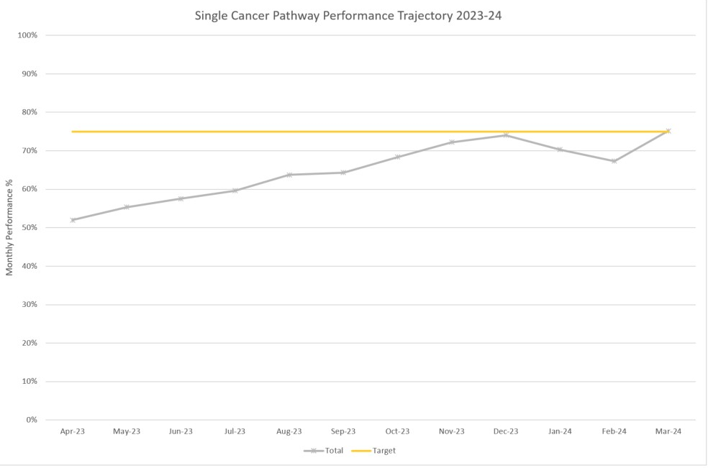

- RECOVERY PLANS

As described in the introduction to this paper, the recovery plans are currently focussing on Gynaecology, Urology and Lower GI, however improvement actions are noted across disciplines and key actions are outlined below. In addition to overall improvements against the 62-day target, tumour site leads, and service managers are tasked with addressing the longest waits and eradicating unnecessary waits over 100 days (for reasons noted above it may not be necessary to reduce this to zero).

Via the bi-weekly Performance Scrutiny Groups, action plans have been requested from each of the services to address bottlenecks at all key stages of the pathway.

Cellular Pathology
- The cellular pathology service remains under extreme pressure consequently we continue to outsource specimens for processing and reporting and this will remain in place for the remainder of 23/24.
- The department are employing four administrative staff via agency in October 2023, these staff will confirm the SCP status of any specimens received to improve prioritisation within the department for processing and reporting enabling tracking within the service.

Radiology
- Detailed demand and capacity work has commenced within radiology, led by the Health Care Systems Engineering team.
Breast
The position in Breast is currently slightly over trajectory. Some waits have been impacted by periods of patient unavailability and ability to consent. In terms of action:
- Treatment (surgical) capacity is a theme of those in backlog. Therefore, work is ongoing to identify two additional theatre sessions per week. Capacity at Morriston is a requirement for very small volume caseload, where patients have been assessed as high risk for anaesthetic. The service has been regularly utilising backfill opportunity for theatre on Mondays in recent months, this will stop from October. In the short term, four additional theatre sessions have been secured in October, with a view to operate on 5 patients per list.
- Disaggregation of the SLA (service level agreement) with Cwm Taf Morgannwg (CTM) from January 2024, with the caveat that they will continue to support until end of March 2024.
- Following the resignation and departure of the lead consultant surgeon in September 2023, a new lead has been appointed and a locum breast surgeon began in post in September 2023.

Date | PTL Volume | Backlog Volume / %
Oct-22 | 161 | 29 (18%)
Mar-23 | 138 | 11 (8%)
Jun-23 | 212 | 13 (4%)
Sep-23 | 223 | 16 (7%)

Gynaecology
Gynaecology continues to the area of greatest challenge for the Health Board
- Continuation of additional sessions for the post-menopausal bleeding (PMB)/endometrial pathway utilising WLI (waiting list initiatives) and insourcing activities.
- To increase the number of patients booked to scheduled PMB and hysteroscopy clinics per week.
- To ensure appropriate vetting of referrals, such as patients referred to the PMB service having recently commenced on HRT (hormone replacement therapy) not to be prioritised as USC (urgent suspected cancer), as is practice elsewhere.
- Additional theatre capacity on Saturdays continues.
- A former gynae-oncology surgeon has re-joined the service in a locum capacity, enabling the service to fully utilise its dedicated gynae-oncology surgical capacity and reducing overall waiting times.
- Booking of PMB clinics in NPTH is managed by CTM staff, agreement to fund the post locally, this will now progress to advert imminently. The benefits of which means there will be control over the process and the ability to book and fill slots at short notice. It would also enable the service to contact patients prior to clinic to ensure their attendance, improving DNA (did not attend) rates and slot utilisation.
- Appointment of a Senior Clinical Fellow, awaiting a start date.
- Discussion of repatriation of CTM activity is progressing.
- PMB service meetings have been reinstated from October 2023, membership has been extended to CTM.

Date | PTL Volume | Backlog Volume / %
Oct-22 | 435 | 91 (21%)
Mar-23 | 484 | 160 (33%)
Jun-23 | 426 | 93 (22%)
Sep-23 | 331 | 64 (19%)

Urology
The in urology the waits for robotic treatment (RALP) remain exceptionally long. Additional capacity has been identified at Cardiff and Vale (C&V), amounting to an additional list per month. C&V have invited the HB to engage in further communication on this matter during October, date to be agreed.
- Constraints within the diagnostic phase for a group of patients with poor comorbidity, requiring admission to Morriston and the constraints on site for theatre and available beds.
- Longer term actions include improvements to Ward A to deliver high care services (two beds); Establishment of a robotic service at SBU; Development of a business case for a 9th consultant surgeon with an interest in robotic surgery, providing cross cover arrangements for theatre lists and facilitating additional operating capacity at Neath.
- The Urology MDT (multi-disciplinary team) and wider support services are working with Improvement Cymru to identify constraints and pathway improvements in relation to the diagnostic phase of pathway for Bladder and Prostate. A number of the team are undertaking Toyota Production System Training during September and October.

Date | PTL Volume | Backlog Volume / %
Oct-22 | 289 | 127 (44%)
Mar-23 | 237 | 64 (27%)
Jun-23 | 222 | 45 (20%)
Sep-23 | 226 | 53 (23%)

Lower GI
The envisaged impact of improved endoscopy waiting times and additional theatre sessions has not demonstrated improved performance at this time.
- A task and finish group has been established to advance progress with the accelerated diagnostics project/pilot. The project aims are to include pathology services within its scope, in order to align both imaging and biopsy results, ensuring prompt discussion at MDT, streamlining the diagnostic phase.
- All patients referred at MDT for surgery will be allocated a named consultant based on capacity and expertise held. An additional clinical nurse specialist (CNS) has been appointed within General Surgery and now commenced in post; they will act as gate keeper for patients progressing through the MDM (multi-disciplinary meeting) process.
- Amgen have been undertaking a pathway mapping exercise of the LGI pathway at SBU. This initial piece of work is due to conclude by the end of October 2023. A feedback meeting and workshop will be arranged to discuss findings; consider and prioritise actions for improvement.

Date | PTL Volume | Backlog Volume / %
Oct-22 | 890 | 258 (29%)
Mar-23 | 493 | 102 (21%)
Jun-23 | 336 | 36 (11%)
Sep-23 | 366 | 60 (16%)

Lung
There are still a number of key delays in the pathway for lung cancer patients, in particular diagnostic delays around access to CT biopsy and complex immunohistochemistry and molecular analysis of pathology specimens. Diagnostic difficulty has contributed to the breach position, where repeat biopsies have been required to establish a confirmatory diagnosis as well as synchronous presentation of multiple separate primary tumours.
- Radiology is progressing developments for dedicated radiology rooms to accommodate patients requiring CT guided biopsy currently requiring admission to hospital for post procedure monitoring.

Date | PTL Volume | Backlog Volume / %
Oct-22 | 97 | 42 (43%)
Mar-23 | 112 | 34 (30%)
Jun-23 | 74 | 26 (35%)
Sep-23 | 80 | 23 (29%)

Cancer Performance & Information Team
The Cancer Trackers & Multidisciplinary Team Coordinators, within the former Singleton and Morriston hubs, have been centralised within the Health Board from 2nd October to help ensure consistency of approach across all specialties with an immediate focus on tracking arrangements, including day to day processes, efficiencies, cover arrangements and escalation.

A meeting has been held with the NHS Executive (Wales Cancer Network) regarding training and support opportunities that could be developed centrally, benefitting these groups of staff across Wales, an ‘on demand’ model, replacing in person training modules such as cancer focused Anatomy & Physiology and Medical Terminology courses previously but no longer provided by the Welsh Cancer Intelligence and Surveillance Unit (WCISU).

- ACCESS TO CANCER SERVICES – INTERNAL AUDIT REPORT
In June 2023, internal audit issued a report following review of the health board’s approach to manage the waiting list backlog within cancer services in order to ensure timely access to services for patients.
Reasonable assurance was issued on this area. The matters requiring management attention include:
- Recovery plan structures should be standardised to offer consistency.
- Tumour site recovery meetings lack formal records.
- Committee reporting does not include updates on previously reported actions.
- Outcomes from breach reports not regularly shared with services.

Initial discussions have been held with the Medical Director regarding reinstatement of the Cancer Programme Board, further discussions are scheduled to agree proposed terms of reference and relationship of this group with the Cancer Performance Group and its alignment to the Planned Care Board and agree the first meeting date.

Notes following the Cancer Performance Group meeting are shared with the group and actions reviewed as part of the standard agenda.

Although very challenging to deliver due to volumes, a breach report is produced for each reported breach and shared with services and MDT leads. The Cancer Performance Group will have oversight of new and emerging themes identified for action.

The cancer standards and escalation policy remains under review; a need to identify key personnel to facilitate the escalation process has been identified and this information is being gathered prior to review and sign-off via the Cancer Performance Group.

- RECOMMENDATION

The Committee is asked to:

- NOTE the performance and backlog volumes in the main tumour sites.
- NOTE the additional work required to improve both performance and backlog.
- NOTE the recommendations and actions from the internal audit report.

Governance and Assurance

Link to Enabling Objectives  (please choose) | Supporting better health and wellbeing by actively promoting and empowering people to live well in resilient communities
Link to Enabling Objectives  (please choose) | Partnerships for Improving Health and Wellbeing |  |  | ☒
Link to Enabling Objectives  (please choose) | Co-Production and Health Literacy |  |  | ☐
Link to Enabling Objectives  (please choose) | Digitally Enabled Health and Wellbeing |  |  | ☒
Link to Enabling Objectives  (please choose) | Deliver better care through excellent health and care services achieving the outcomes that matter most to people
Link to Enabling Objectives  (please choose) | Best Value Outcomes and High Quality Care |  |  | ☒
Link to Enabling Objectives  (please choose) | Partnerships for Care |  |  | ☒
Link to Enabling Objectives  (please choose) | Excellent Staff |  |  | ☒
Link to Enabling Objectives  (please choose) | Digitally Enabled Care |  |  | ☒
Link to Enabling Objectives  (please choose) | Outstanding Research, Innovation, Education and Learning |  |  | ☐
Health and Care Standards
(please choose) | Staying Healthy |  |  | ☐
(please choose) | Safe Care |  |  | ☒
(please choose) | Effective Care |  |  | ☒
(please choose) | Dignified Care |  |  | ☐
(please choose) | Timely Care |  |  | ☒
(please choose) | Individual Care |  |  | ☐
(please choose) | Staff and Resources |  |  | ☒
Quality, Safety and Patient Experience
Accurate, comprehensive demand and capacity plans can increase safety and quality whilst reducing risk and can lead to efficiency gains within clinical services. They will also facilitate more timely treatment of patients and enhance patient experience.

Financial Implications
There are no direct financial implications associated with this paper. Inputs (additional activity) into the demand and capacity models are funded via Recovery Money. However, the outputs from the modelling will inform the development of the Health Board’s IMTP and financial plans for sustainable services.

Legal Implications (including equality and diversity assessment)
There are no legal implications to consider.

Staffing Implications
There are no immediate staffing implications as a result of this paper but there is a need to be mindful that this is a very specialist area and we need to build robust and sustainable capacity in this area.

Long Term Implications (including the impact of the Well-being of Future Generations (Wales) Act 2015)
Report History |  | Previous reports have been presented to Management Board in November 2021 and February / August 2022.
Appendices

