


Meeting Date | 24 October 2023 |  | Agenda Item |  |  | 2.2
Report Title | Capital Resource Plan Q2 Update &  City Deal Secondary Funding Agreement Update
Report Author | Ian MacDonald, Assistant Director of Finance (Strategy & Planning)
Report Sponsor | Darren Griffiths, Director of Finance & Performance
Presented by | Ian MacDonald, Assistant Director of Finance (Strategy & Planning)
Freedom of Information | Open
Purpose of the Report | To provide an update on the Quarter 2 financial performance of the Health Board’s capital programme and the impact of emerging risks and opportunities on the projected outturn position for 2023/24. Also provides an update on the City Deal Campuses Secondary Funding Agreement,
Key Issues | The Health Board approved a balanced capital financial plan for 2023/24 as part of the approved Recovery and Sustainability Plan.  The forecast outturn position reported at Month 6 shows an overspend position of £2.983m. Additional income from Welsh Government (WG) and the City Deal is anticipated to provide a balanced position.  Funding constraints in WG have now increased the risk level on some of the assumed income. The impact of the WG reductions to the discretionary capital funding over the last two years are emerging. The small programme contingency is under pressure, as requests for additional capital funding continue to emerge from the service.  The risk of the plan shifting from balance to imbalance remains material. This is reflected in Risk 93 on the Health Board Risk Register
Specific Action Required  (please choose one only) | Information | Discussion |  | Assurance | Approval
Specific Action Required  (please choose one only) | ☐ | ☐ |  | ☒ | ☐
Recommendations | Members are asked to:  - NOTE the month 6 reported position of the capital plan.  - NOTE the emerging funding risks and the material risk of the plan shifting from balance to imbalance.  - NOTE the mitigating actions that will require further exploration.  - NOTE the contingency sum to maintain the balanced plan is £206k.  - NOTE the update on the City Deal secondary funding agreement.

QUARTER 1 CAPITAL UPDATE

- INTRODUCTION
To provide an update on the Quarter 2 financial performance of the Health Board’s capital programme and progress on the City Deal Secondary Funding Agreement.

- BACKGROUND
The Health Board approved a balanced capital financial plan for 2023/24 as part of the Recovery and Sustainability Plan submitted to Welsh Government (WG) in March 2023.

The plan included a positive uplift of 50%/£1.3m against the previous years’ reduction in discretionary capital of 24%/£2.671m (following the national £100m reduction in the core capital budget allocated to the Health and Social Care department within WG).

The national funding situation continues to be challenging, with very little uncommitted capital funding remaining; this could have an impact on not just the Health Board’s discretionary capital programme, which is primarily for replacement of the existing asset base, but also larger service continuity, service recovery and service change schemes, including those contained within the recently identified within the approved Health Board Estates Strategy.

The additional national slippage funding provided during Q4 in 2022/23 was much lower than expected from previous years, meaning little headway was made with high-risk backlog equipment replacement as would normally have been expected – which is having a large impact this year.

The approved plan also included the repayment of existing commitments from the All- Wales Capital Programme of £5m. These included: -

- Reprovision of funding for schemes that had slipped during the last quarter of 2022/23 and where the Health Board had to manage the slippage across years through its discretionary programme,
- Gamma Camera/SPEC-CT replacement in Morriston, where discretionary repaid £1.8m following agreement to use the WG funding to support the 2022-23 discretionary capital position.
- Over the last 2 years, discretionary funding has also been utilised to either enhance the funding provided by WG for some of the COVID recovery schemes or in some schemes provide the full funding. Although this pressure was mainly focussed on last year, the position today reflects the direction of resources to these key strategic projects.

The approved plan also includes income assumptions, including the receipt of business case fees from WG and disposals proceeds.

Month 6 Position

The forecast outturn position reported at month 6 shows an overspend of £2.983m (£2.783m + £200k disposals). Allocations shown below in table 1 are anticipated to provide a balanced position. There are however continuing risks to this assumption due to the national funding challenges. Also, locally the impact of the reductions to the discretionary capital funding continues to have an impact. The ability to retain a balanced capital position remains increasingly challenging as there is very little remaining flexibility in the programme to manage emerging service and infrastructure risks.

Table 1 Month 6 Forecast Outturn Position 2023/24
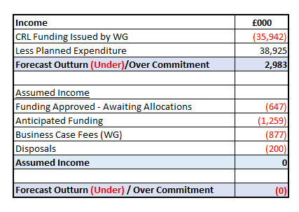

Risks

The approved plan contained an assumption of additional income to offset planned in-year spend or the repayment of business case fees incurred in prior-years. An update on the probability of receipt is shown below in table 2. There is a deteriorating position on the level of low probability which has increased to £566k. To mitigate against this increasing risk, an equal level of approved allocations are being held back at this point.

As always there is a risk around timing, for example if a business case can’t either be submitted this year or is submitted but not approved until next year. There is now a tangible emerging risk that due to the on-going national financial challenges, the confidence levels for the receipt of previously expended business case design fee income are lower than normal at this time of the year. These funding assumptions have been shared with WG officials and were discussed at the bi-monthly WG Capital Review Meeting held on 5 September. There is also a timing issue linked to the receipt of funding from the City Deal.

Table 2 Anticipated Income 2023/24
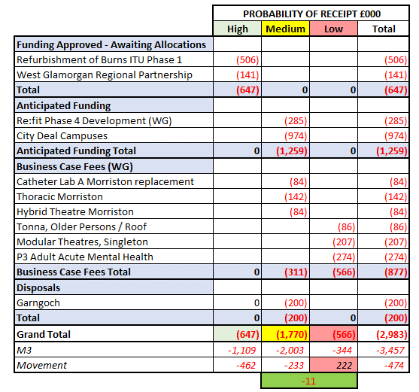

WG have indicated that as the national funding challenges with capital are expected to remain for the short to medium term, they are considering the introduction of a prioritisation exercise using a Multi Criteria Decision Analysis to form a framework to support decision making in the future. The guidance is still under review with the Minister.

Approved Business Cases

Minister approval was received in September for works to commence on phase 1 of the co-location of burns cubicles at General ICU at Morriston Hospital. This will provide £7.727m capital investment from WG over the next 2 years. No approval has been given for subsequent phases, to include the expansion of general ICU capacity and these will require further discussions before any business case design can commence.
Contingency

In addition to the funding being held back to mitigate the risk with business case income from WG, there have been a few positive outcomes which have allowed some funding to be released for the highest medical equipping risks identified by the Capital Prioritisation Group (CPG). There is a remaining contingency of £206k which is likely to be allocated out in the next few weeks to manage other emerging risks and in particular additional equipping requirements for the soon to be opened Surgical Assessment Unit (SAU) in Morriston Hospital.
Overall Assessment

At this stage the relatively small allocations provided for estates, medical equipping and digital are holding firm. However, the CPG (Capital Prioritisation Group) is assessing capital bids of £5.3m for medical equipment (mostly replacement) with a risk score of 15,16 & 20. These will continue to be risk assessed through the CPG. However, given the current national funding constraints and the limited ability to cease spending on schemes due to most already being contractually committed or for high service risks, the risk of the plan shifting from balance to imbalance remains material.

Table 3 CPG Bids Medical Equipment Risk Score ≥ 15

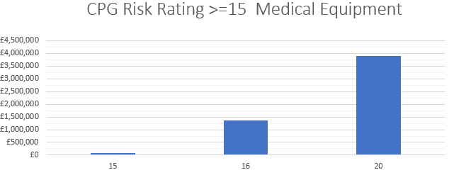

Table 4 CPG Bids Medical Equipment - Risk Score 20 By Department

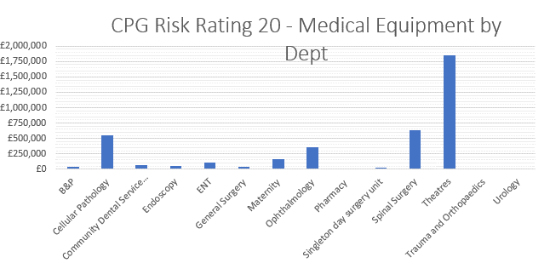

As it looks unlikely that any material sums of additional national funding will be released in the next few months, if the plan is to remain balanced within the resources provided, it would be prudent to continue to explore further mitigations, including,

- Charitable funds
- Slipping schemes
- Revenue solutions, in particular leases where value for money available. These would need the agreement of WG to provide technical capital funding, as all new leases are treated on-balance sheet following the introduction of IFRS 16 in the UK public sector from 1st April. There will of course then be an additional annual revenue payment.

The Health Board is already making use of, and actively investigating, the availability of alternative sources of funding, which include: -

- EFAB (Estates Funding Advisory Board). The plan includes the 2023/24 element of the approved £7.9 (of which 30%/£2.4m is a contribution from discretionary capital) over the next two years for high priority estates infrastructure replacement schemes. These include schemes for roof repairs, replacement of nurse call systems and fire alarm replacement.
- Making good use of the new national funding streams being managed through the RPB Capital Group - Housing for Care Fund (HCF) and the IRCF (Integration and Rebalancing Capital Fund)
- Active discussions are taking place on the disposal of 3 parts of the Health Board Estate. If these were to proceed to completion this year, there is the potential to receive an additional £500k to £700k in addition to the assumed £200k included in the approved balanced plan.

All NHS Wales organisations have as normal been asked to fix their CRL positions for major WG funded capital schemes by 31st October. Assessments of the position are under way. Whilst there are likely to be modest sums of slippage from our position, there are also 3 schemes going through the business case design process that may require some element of redesign. Any additional design costs may need to be offset against these scheme slippages.

City Deal Secondary Funding Agreement

The Campuses project being led by Swansea University and delivered in partnership with Swansea Bay University Health Board (UHB), Hywel Dda UHB and Swansea Council, is one of 9 projects under the Swansea Bay City Deal.
The Campuses OBC was approved by the Swansea Bay City Deal in October 2021 and subsequently by Welsh and UK Governments in December 2021. Delivering the project has been delayed by an extended period of negotiation between the Swansea Bay City Deal and Swansea University over details in the primary funding agreement. Following agreement of the primary funding agreements, the Health Board recently received a draft of the secondary funding agreement between Swansea University and the Health Board. An initial legal review of the agreement has taken place by the Health Board and is currently back with Swansea University for comment.

Once finalised the agreement will allow funding to be released from the City Deal for the ILS Innovation Centre at Morriston (Refurbishment of the Morriston Management Centre) for Swansea University £1.250m and a contribution to the design fees for the proposed new Morrison Hospital Access Route £960k (note this is part of the assumed £974k income to manage the capital programme described above).

Whilst there is reasonable optimism that the secondary funding agreement should be finalised in the next 4 to 6 weeks, there are some complex areas linked to project outputs and outcomes for these and future projects. These require careful consideration prior to finalisation.

- GOVERNANCE AND RISK ISSUES
There is an increased possibility that new service requests, including those with a high-risk score will be unable to be receive capital funding during 2023/24 within the capital resources made available to the Health Board. These risks will continue to be assessed through the Capital Prioritisation Group and raised up through the Management Board.

A risk register entry (Risk 93) has been included in the Health Board risk register and is currently assessed as a 20 score risk.

- FINANCIAL IMPLICATIONS
The financial implications and funding risks are as detailed within the body of the report. In summary, the approved balanced capital plan is assuming additional funding of £2.983m, which has several emerging risks, including whether national funding is available for the repayment of business case fees.

The remaining contingency in the plan is £206k. Without additional funding support from WG and/or additional internal mitigations, further requests for capital funding may not be affordable with the allocated resources.

The City Deal secondary funding agreement for the Campuses business case includes funding of £960k which is part of the Health Board’s approved balanced capital programme this year.

- RECOMMENDATION
Members are asked to:
- NOTE the month 6 reported position of the capital plan.
- NOTE the emerging funding risks and the material risk of the plan shifting from balance to imbalance.
- NOTE the mitigating actions that will require further exploration.
- NOTE the contingency sum to maintain the balanced plan is £206k.
- NOTE the update on the City Deal secondary funding agreement.

Governance and Assurance

Link to Enabling Objectives  (please choose) | Supporting better health and wellbeing by actively promoting and empowering people to live well in resilient communities
Link to Enabling Objectives  (please choose) | Partnerships for Improving Health and Wellbeing |  | ☐
Link to Enabling Objectives  (please choose) | Co-Production and Health Literacy |  | ☐
Link to Enabling Objectives  (please choose) | Digitally Enabled Health and Wellbeing |  | ☐
Link to Enabling Objectives  (please choose) | Deliver better care through excellent health and care services achieving the outcomes that matter most to people
Link to Enabling Objectives  (please choose) | Best Value Outcomes and High Quality Care |  | ☒
Link to Enabling Objectives  (please choose) | Partnerships for Care |  | ☐
Link to Enabling Objectives  (please choose) | Excellent Staff |  | ☐
Link to Enabling Objectives  (please choose) | Digitally Enabled Care |  | ☐
Link to Enabling Objectives  (please choose) | Outstanding Research, Innovation, Education and Learning |  | ☐
Health and Care Standards
(please choose) | Staying Healthy |  | ☐
(please choose) | Safe Care |  | ☐
(please choose) | Effective Care |  | ☐
(please choose) | Dignified Care |  | ☐
(please choose) | Timely Care |  | ☐
(please choose) | Individual Care |  | ☐
(please choose) | Staff and Resources |  | ☒
Quality, Safety and Patient Experience
Without additional funding support from WG, further requests for capital funding will not be affordable within the allocated resources. This may impact on new service requests for additional capital funding for estates, medical equipping and digital services.

Financial Implications
The financial implications and funding risks are as detailed within the body of the report. In summary, the approved balanced capital plan is assuming additional funding of £2.983m, which has several emerging risks, including whether national funding is available for the repayment of business case fees. The remaining contingency in the plan is £206k. Without additional funding support from WG and/or additional internal mitigations, further requests for capital funding may not be affordable within the allocated resources. The City Deal secondary funding agreement for the Campuses business case includes funding of £960k which is part of the Health Board’s approved balanced capital programme this year.

Legal Implications (including equality and diversity assessment)
None
Staffing Implications
None
Long Term Implications (including the impact of the Well-being of Future Generations (Wales) Act 2015)
n/a
Report History |  | Approved Capital Plan (R&S Plan) Board March 2023  Q1 Capital Resource Plan Update P&FC July 2023
Appendices |  | None

