Meeting Date | 25 November |  | Agenda Item |  |  | 3.3
Name of Meeting | Performance and Finance Committee
Report Title | Population Health Briefing
Report Author | Prof Dr Gillian Richardson, Interim Executive Director of Public Health  Ffion Green, Programme Lead  Suzannah Rees, Executive PA  James Ruggerio, Deputy Head of Immunisations
Report Sponsor | Prof Dr Gillian Richardson, Interim Executive Director of Public Health
Presented by | Prof Dr Hugo van Woerden, Deputy Director of Public Health
Freedom of Information | Open
Purpose of the Report | This briefing paper outlines:  - Performance and finance issues relating to service driven Ministerial priorities and health protection.  - Capability and capacity requirements to implement the Population Health Strategy at scale.  - the potential consequences of reducing the Public Health budget within Swansea Bay University Health Board (SBUHB).  - It highlights key risks, strategic implications, and provides recommendations for mitigating adverse impacts
Key Issues | - Progressing priorities adopted by Board from the Population Health Strategy has been constrained by 2025/26 budget reduction, compounded by 2024/25 cost savings and organisational spending restrictions against ability to deliver key workstreams. This impacts on work to protect and improve public health, limiting spend on prevention driving demand towards costly secondary care.  - Organisational focus on recovery and sustainability is impacting delivery of key projects intending to underpin organisational-wide enablement work, including health needs assessment that underpins Clinical Service Plan and long-term strategic planning.  - Underspends in Health Protection and Immunisations budgets could lead to further cuts to recurrent allocation from the Welsh Government, as highlighted by £2m reduction between 2024/25 and 2025/26 budget allocation, however post freeze has affected ability to fulfil ambitions eg Inclusion health.  - Population health resource within budget for, Population Health based Primary Care development and implementation of Core20PLUS5 focussing on key areas including prevention of cancer, cardiovascular and respiratory disease in areas of increased deprivation and need has also therefore been restricted  - Potential additional in-year £500K control total added to initial savings and allocation mid-year, though confirmation awaited.
Specific Action Required  (please choose one only) | Information | Discussion |  | Assurance | Approval
Specific Action Required  (please choose one only) | ☒ | ☒ |  | ☒ | ☐
Recommendations | - ALERT members to the impact of restrictions on the use of the Public Health budget to the Public Health Team to support the residents of Swansea Bay’s population health and wellbeing and build organisation capacity to build a sustainable approach and benefits realisation as outlined in the Population Health Strategy.  - Provide members with ASSURANCE on progress towards key measures and drivers that will position the organisation to assess its performance on population health.

Population Health Briefing

- INTRODUCTION

The report is intended to provide assurance on our ongoing progress, challenges to implementation and how we intend to address. The report is also intended to raise awareness on the impact of Recovery and Sustainability activities on the Public Health Directorate budget allocation and freedom to utilise during 2025/26 and highlight the risks restrictions have on delivering population health-related activities.

The focus of the Public Health team is to provide our population with the ability to be:
- Safe (Health Protection – protecting residents of Swansea Bay in relation to communicable disease outbreaks, prevention of antimicrobial resistance and blood borne viruses, Immunisations and Environmental hazards).
- Strong (Health Care Public Health - tackling major preventable conditions such as - cancers, cardiovascular and respiratory, including health inequity aspects, through Core20PLUS5 approach)
- Supported (Health Promotion- through a suite of actions addressing health across life course from Healthy schools to lifestyle behavioural factors, Healthy Weight Health Wales and Wider determinants - optimised through partnership working and our Public Health Strategy ‘Better Health for All’,)

- BACKGROUND

The Population Health Strategy was formally adopted by Board in March 2023. Since that time, a significant amount of work been conducted to imbed the principles and ways of working that enables the Health Board to become a Population-health focussed organisation.

Despite the significant efforts to enact the strategy at scale, an internal audit report published in January 2025 (APPENDIX 1) highlighted that assurance on progress and capability to deliver population health gains was ‘Limited’.

Since the publication of the above audit, and the appointment of the Interim Director of Public Health in April 2025, the approach to ways of working on population health has been refined. An approach to ‘earth’ the population health strategy was adopted by Executives and the Population Health Committee in May 2025.

Progress against actions in Q2/3 2025/26

Progress has been made against measuring implementation of Population Health Strategy across the organisation through development of indicators of success. This work has included definition of indicators, co-designed with Service Group Directorates, and accountability for leading, supporting and advocating. Adoption of indicators anticipated in quarter 4 following further engagement with Service Group Directorates

The team now has a temporary Advanced Information Analyst resource now in post until end of financial year, which will support digital ambitions and provided enhanced intelligence function (for targeted population health interventions). Additional support to create a digital solution/dashboard to create visual intelligence using support from our Digital colleagues is in discussion.

An investment plan using Population Health core funding has been developed with the aim of increased preventative care in Primary Care, looking at Core20PLUS5 areas for adults in areas of increased deprivation and need. This will be a 2-year strategy for initial investment with recruitment of sessional time for GP with specialist interest in Population Health plus pharmacy and practice nurse sessions to enable population health risk stratification of practice lists to identify unmet need for intervention. This will be supported by a consultant specialising in Population Health in Primary Care and Inclusion Health. Adoption of the CORE20PLUS5 methodology could provide a specific focus for targeted impact across key conditions if it were to be widely integrated.

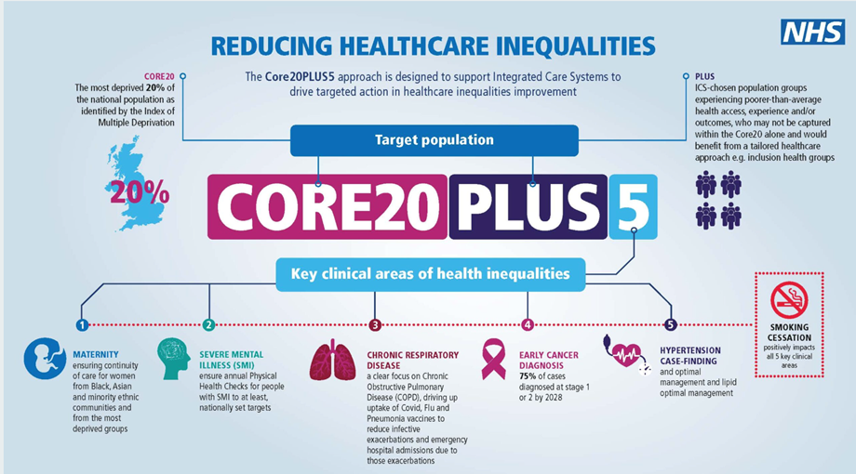

A screening action plan to increase uptake of cancer screening is being implemented, working with Primary care and our immunisation team for promotion of screening, our work includes promoting cervical screening in practices with low uptake in deprived areas focusing on symptomatic patients that have not taken up screening offers. A proof-of-concept pilot using capacity within the Immunisation Team call centre is being conducted to contact non-responders in practices in more deprived clusters with low uptake of screening.

Our Healthy Schools team continues deliver on their ambitious targets to implement support for schools in Swansea Bay to achieve targets relating to emotional and mental wellbeing, both for the pupil and staff cohorts. The team are supporting our local authority partners to deliver pre-school programme strategic priorities. In addition, the team are also supporting our organisations ambitions on the early years, children and young people agenda, shaping the agenda around early years principles aimed at addressing key health and wellbeing outcomes for children and young people.

Our Healthy Weight Health Wales team has secured support with the five Public Service Boards across our regional partnership (Swansea Bay University Health Board and Hywel Dda University Health Board) to agree development of a whole systems approach. The first subsystem priority has been agreed as Access to Food, with a focus for improving the availability and affordability of healthy and sustainable food across the region. This builds on previous work which has highlighted that our current food system is not serving us well and that urgent action is needed. All Public Service Boards are working together on this as key partners, together with the Future Generations Office.

In terms of the Health Board’s strategic targets for Prevention and early intervention, we are providing support to the development of the Clinical Strategic Plan and Clinical Service Plans, including development of a strategic “State of the Population” report, with a strong emphasis on prevention and health improvement.

Following the confirmation of UK Government funding to commission a Health Impact Assessment of the Tata transition, the team have provided technical expertise to commissioning ensuring a suitable supplier has been procured to deliver this critical piece of work.

Beyond our own organisation, the team has played a key role in the ongoing collaboration with Hywel Dda University Health Board on a regional health economy programme that serves almost 800,000 people across South West Wales, ensuring the programme is rooted in the Marmot Principles and Social Model for Health and Wellbeing and focusing on four P’s People, Place, Procurement and Partnerships.

​
Integrated Help Me Quit smoking cessation services are operational in Swansea Bay. A national PHW led review of Help Me Quit services across Wales highlighting link between number of Whole Time Equivalent employed in Help Me Quit services and smoking quit rates of Health Boards is expected to be published imminently.

Help Me Quit in Hospital and Maternal Smoking Cessation programmes are operational in the Health Board, funded through Prevention and Early Years (PEY) funding in 24/25 and 25/26. However, the short-term funding is impacting on staff retention and long-term planning. Delivery of services is affected by the need for additional recruitment and training, and while we await Welsh Government confirmation around PEY funding beyond 25/26, service continuation remains fragile in the meantime.

Governance of the Adult Weight Management Pathway has been agreed. A Task and Finish Group has been established under executive leadership of the Dir of Therapies to produce plan for development of Adult Weight Management Pathway in line with expectations outlined in All Wales Weight Management Pathway. There will be a focus on Level 3 provision, maternity provision and creating an aligned pathway. However,
Weight Management Pathway Lead has been hired on a fixed term basis using Prevention and Early Years (PEY) funding until March 2026, and as with smoking cessation, service continuation remains fragile while we await Welsh Government confirmation around PEY funding beyond 25/26.
We have however been working on a UK level Innovate bid for funding for Weight management services, which if successful would enable us to implement fully comprehensive pathways using a digitally delivered service model. The Executive Director for Public Health has been Executive sponsor for this bid.

A multi-disciplinary Level 2 & 3 service ​for the Children and Young People’s Pathway, has been operational in Swansea Bay since July 2022 utilising Healthy Weight Healthy Wales funding. ​Plans are in place to ensure alignment of the Children and Young Peoples weight management service with the wider pathway development work being undertaken.​

Immunisation & Vaccination Service
The Immunisation Service are currently delivering and supporting commissioned services for all Winter Respiratory Vaccination Programmes. With regards to Influenza, the current uptake and all Wales position as at 14/11/25 is below:

Eligible cohorts | SBUHB | Welsh Average | Position
Staff flu vaccination | 37.3% | 38.6% | 5th
Over 65’s | 57.7% | 59.1% | 5th
At risk groups (16 to 64) | 24.4% | 27.9% | 5th
2- and 3-year-olds | 30.4% | 35.4% | 7th
There have been challenges associated to the influenza programme this year, with the introduction of the central procurement of flu, as well as issues with the introduction of the Welsh Immunisation System (WIS)app.
Respiratory Vaccination Programmes SBUs Performance is slightly below all Wales average for the catch up and routine cohort, and targeted work planned with GPs to improve performance.

 | Catch up | Routine
SBUHB | 61.4% | 42.3%
All Wales Average | 65.3% | 42.4%
For COVID Vaccination uptake, SBUHB are currently second in Wales with an uptake of 43.9%.
There has recently been a positive increase in uptake seen with relation to 4CMenB vaccine delivered within Sexual Health services, since the introduction of the programme July this year. There are also targeted pieces of work progressing with Human Papillomavirus vaccine (HPV) / Meningococcal A, C, W, and Y. (MenACWY) and Measels, Mumps and Rubella (MMR) uptake across the health board, specifically to liaise with school nursing services, universities and colleges, as well as sexual health. These will be progressing in Quarter 4.

- GOVERNANCE AND RISK ISSUES

Financial position and implications
While support for the population health agenda is strong, the ability of the Public Health team to make the gains necessary and increase the focus on prevention has been significantly impacted by the organisational wide Recovery and Sustainability activities.

The Public Health directorate was subject to disproportionately significant cost savings, run rate targets and spending freezes in 2024/25, which equated to 54.1% of the actual Directorate budget for the year, and resulted in a £2.1m reduction to the recurrent Health Protection and Immunisations budget.

An initial savings total equating to 12.1% was allocated to the Directorate for the 2025/26 budget. However, it was recognised that this could only be achieved by allocating this to Public Health core budget and the Population Health programmes budget, as any savings against Health Protection and Immunisations budgets could jeopardise future recurrent allocations from Welsh Government. A further £500k target has been imposed but formal communication is awaited in October 2025, based on Month 1-5 savings, which disregards the prudent financial planning developed by the team’s budget holders in conjunction with Finance Business Partners, and the need for Winter pressures surge eg Flu immunisation and Covid, Respiratory Syncytial Virus (RSV) to be accommodated with additional costs these months.

The Directorate recognises the scale of the challenge facing the organisation and is keen to play its part in achieving the Welsh Government targets for finance. However, the approach applied to the Directorate has the potential to lead to missed opportunities to prevent worsening health in our population, with attendant focus on front door pressures rather than integrated prevention through adequate anticipatory measures. The likelihood of health inequalities widening through non adoption of population health approaches is significant.

Moreover, there are several broader operational and reputational risks, including:

- Increased risk to population health due to reduced capacity for prevention, screening, and vaccination programs.
- Greater pressure on acute and emergency services as preventable conditions escalate, particularly around seasonal illnesses such as flu if the Immunisation programme cannot be delivered at scale and pace due to resource utilization constraints.
- Reduced ability to deliver strategic goals under the Recovery & Sustainability Plan and Well-being of Future Generations Act.
- Workforce and partnership impact, including potential loss of specialist staff and weakened collaboration with local authorities.
- Increased risk of Welsh Government intervention due to further deterioration in financial and planning performance.
- Widening health inequities within Swansea Bay UHB area

- FINANCIAL IMPLICATIONS

- Financial sustainability risks, as prevention programs are cost-saving in the long term.

- Failure to realise Population Health Strategy ambitions using Core 20 Plus 5 approach inhibits planning for long-term reconfiguration of health services towards early case finding, diagnosis and decreasing dependency on expensive secondary care. Restricting spending within the remaining Public Health and Population Health budgets will limit opportunities to work more closely with primary care on the prevention agenda and will actually cost the Health Board far more in downstream treatment services.
- Underspend in designated Welsh Government Health Protection and Immunisations budgets is likely to be deducted from future recurrent budgets (as occurred last year) and allocated to other Health Boards by Welsh Government, placing the service at risk with inability to respond to surge and future health protection challenge. Restrictions on the ability to use resources for these budget lines should be addressed to ensure future financial allocation from WG and stability.

- Fragility of several services, including weight management and smoking cessation as these currently rely on Welsh Government funding that is anticipated to cease in the next 1-2 years.

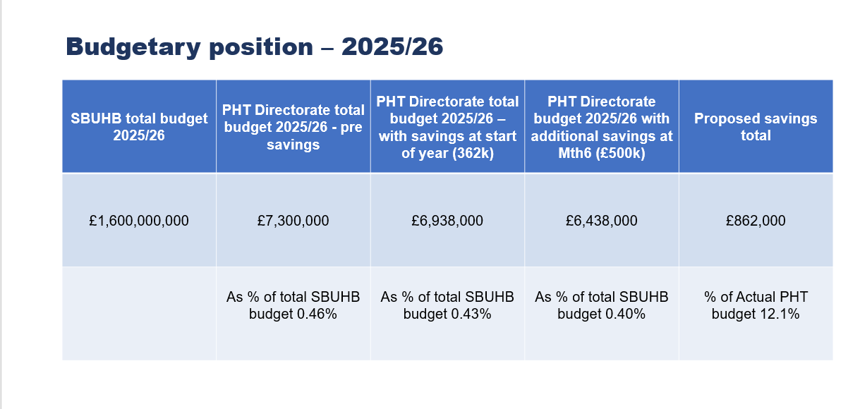
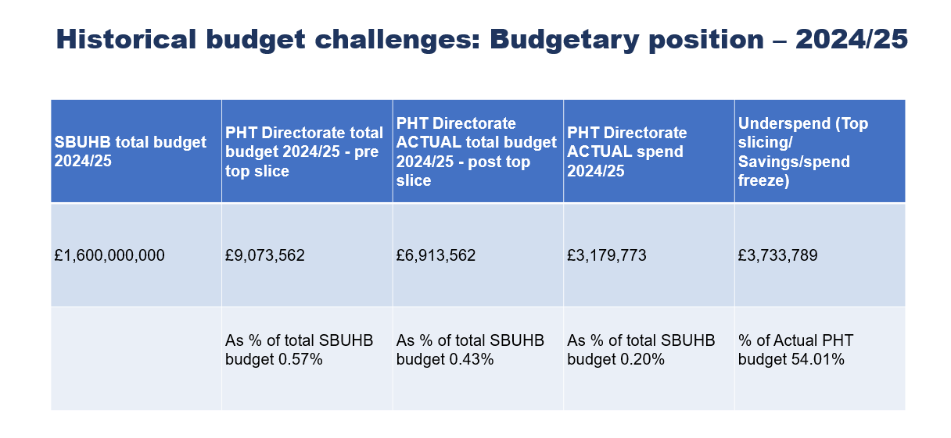
The Health Promotion and Immunisation Health Protection & Immunisation’s budget accounts for approximately £7.4 million of the total figure. Due to previous reductions resulting from top-slicing, there is no scope for achieving further savings within these budgets. Existing staffing commitments mean that the allocated budget will be fully utilised in the next financial year.

- RECOMMENDATION

The Committee is asked to be:

- Assured of the commitment and plans for progress outlined and noted in the report.

- Advised on the limitations and risks to delivering/implementing at scale.

- Advised on high risk of long-term losses in HB budget if universal brakes on spend affect designated grant funds for Health Protection and advise on mitigations.

- Alerted to the likely impact of the overall financial constraints to progressing this agenda, including the ministerial priorities, in the short to medium term.

Governance and Assurance

Link to Enabling Objectives  (please choose) | Supporting better health and wellbeing by actively promoting and empowering people to live well in resilient communities
Link to Enabling Objectives  (please choose) | Partnerships for Improving Health and Wellbeing |  | ☒
Link to Enabling Objectives  (please choose) | Co-Production and Health Literacy |  | ☐
Link to Enabling Objectives  (please choose) | Digitally Enabled Health and Wellbeing |  | ☒
Link to Enabling Objectives  (please choose) | Deliver better care through excellent health and care services achieving the outcomes that matter most to people
Link to Enabling Objectives  (please choose) | Best Value Outcomes and High-Quality Care |  | ☒
Link to Enabling Objectives  (please choose) | Partnerships for Care |  | ☒
Link to Enabling Objectives  (please choose) | Excellent Staff |  | ☒
Link to Enabling Objectives  (please choose) | Digitally Enabled Care |  | ☐
Link to Enabling Objectives  (please choose) | Outstanding Research, Innovation, Education and Learning |  | ☐
Health and Care Standards
(please choose) | Staying Healthy |  | ☒
(please choose) | Safe Care |  | ☐
(please choose) | Effective Care |  | ☐
(please choose) | Dignified Care |  | ☐
(please choose) | Timely Care |  | ☐
(please choose) | Individual Care |  | ☐
(please choose) | Staff and Resources |  | ☐
Quality, Safety and Patient Experience
- Quality: Reduced preventive services will increase avoidable illness, undermining care standards, and long-term health outcomes.
- Safety: Lower capacity for outbreak control and emergency preparedness heightens the risk of infectious disease spread and system strain.
- Patient Experience: Delays in access to screening and prevention programs will lead to poorer health journeys and increased anxiety.
- Equity: Cuts disproportionately affect vulnerable populations, widening health inequalities, and reducing fairness in service delivery.
- System Impact: Rising acute care demand compromises timely treatment and continuity of care, eroding confidence in the Health Board.
Financial Implications
- The proposed expenditure is unbudgeted and will require reallocation from existing cost centers or additional funding approval.
- Timing of expenditure is expected in Q4 of the current financial year, impacting year-end financial position and reporting.
- Immediate cash flow pressure is anticipated, as upfront costs for implementation will precede any efficiency savings.
- No contingency provision currently exists, increasing the risk of overspending against the Health Board’s financial recovery plan.
- Potential offset through targeted grants, though these are not guaranteed.
- Failure to invest may lead to higher downstream costs in acute care, creating a “false economy” scenario.
- Capital requirements are minimal; the majority of expenditure relates to workforce and service delivery.
- Financial risk includes non-compliance with statutory duties if funding is not secured.

Legal Implications (including equality and diversity assessment)
- Legal Duty & Governance: The Health Board must comply with the Health Board Governance Framework, the Health and Social Care (Quality and Engagement) (Wales) Act 2020, and the Duty of Quality, which requires continuous improvement in safety, effectiveness, and patient experience. [phw.nhs.wales]
- Statutory Compliance: Failure to maintain core Public Health functions (e.g., outbreak control, screening) risks breaching statutory obligations under the NHS (Wales) Act 2006 and related regulations, exposing the Board to legal challenge and reputational harm. [legislation.gov.uk]
- Equality & Diversity Impact: Cuts may disproportionately affect vulnerable groups (e.g., older adults, ethnic minorities, low-income communities), contravening duties under the Equality Act 2010 and Welsh-specific equality regulations. [phw.nhs.wales]
- Mitigation Approach: An Equality Impact Assessment (EIA) must be completed, with actions to safeguard access for protected groups, embed inclusive service design, and align with the Board’s Strategic Equality Plan. [phw.nhs.wales]
- Human Rights & Language Duties: Recommendations must uphold the Human Rights Act 1998 and the Welsh Language (Wales) Measure 2011, ensuring equitable communication and culturally appropriate services. [academiwal....gov.wales]

Staffing Implications
- Workforce Reduction: Cuts will likely lead to loss of specialist Public Health roles reducing expertise and capacity.
- Service Impact: Fewer staff will compromise delivery of core functions such as outbreak management, screening, and health improvement programs.
- Increased Workload: Remaining staff face higher workloads, increasing risk of burnout, sickness absence, and reduced morale.
- Skills Gap: Loss of experienced personnel may weaken multi-agency coordination and emergency preparedness.
- Redeployment Pressure: Potential need to redeploy staff from other areas, impacting service continuity and creating training costs.

Long Term Implications (including the impact of the Well-being of Future Generations (Wales) Act 2015)

Impact on 5 Ways of Working
- Long-term: Budget reductions undermine preventive health strategies, increasing future demand on acute services and worsening population health outcomes.
- Prevention: Cuts reduce capacity for early intervention (e.g., screening, immunization), contradicting the Act’s emphasis on preventing problems before they occur.
- Integration: Reduced resources weaken collaboration between health, social care, and community partners, impacting holistic service delivery.
- Collaboration: Financial constraints may limit joint initiatives with local authorities and third-sector organizations, reducing shared responsibility for well-being.
- Involvement: Service changes risk excluding communities and vulnerable groups from decision-making, requiring robust engagement and Equality Impact Assessments to comply with the Act.

Report History |  | N/A
Appendices |  | Appendix 1. Population Health Strategy  Internal Audit Report

