Meeting Date | 25 November 2025 |  | Agenda Item |  |  | 3.2
Name of Meeting | Performance & Finance Committee
Report Title | Continuing NHS Healthcare (CHC) Performance Report- 2025/26 Quarter 2
Report Author | Hannah Roan, Assistant Director of Planning & Partnerships (Commissioning & Sustainability)  Amanda Davies, Deputy Head of Nursing for Long  Term Care  Richard Mugford, Finance Business Partner PCTSG  Colin Jones, CHC & Commissioning Manager MHLD  Janet Millward, Deputy Head of Nursing for  Children’s Services
Report Sponsor | Marie Davies, Executive Director of Planning & Partnerships
Presented by | Marie Davies, Executive Director of Planning & Partnerships
Freedom of Information | Open
Purpose of the Report | This report provides an update on the quarter 2 2025/26 activity and highlight areas of relevance to the Performance & Finance Committee relating to Continuing Health Care (CHC) which includes complex care and continuing care for children and young people.
Key Issues | Demand for CHC continues to grow. The Health Board (HB) has a transformation programme in place with the aim of creating a centralised commissioning function for CHC. One of the outputs from the programme is the development of a performance dashboard that will give a complete HB view of CHC activity and performance. The format of this report will continue to be refined over the year to ensure that committee members receive the right level of information.  An update on the Health Board’s CHC Transformation Programme is also included in this report.  Key risks and issues identified in this quarter 2 report for CHC include:  - Increaisng demand  - Introduction of Direct Payments for CHC  - Increasing cost pressures associated with CHC
Specific Action Required  (please choose one only) | Information | Discussion |  | Assurance | Approval
Specific Action Required  (please choose one only) | ☐ | ☐ |  | ☒ | ☐
Recommendations | Members are asked to:  - Consider the content of this report

Continuing NHS Healthcare (CHC) Performance Report- 2025/26 Quarter 2

- INTRODUCTION
This report provides an update on the Quarter 2 2025/26 activity and highlight areas of relevance to the Health Board (HB) relating to CHC funded care.

- BACKGROUND
The revised National Framework for CHC was implemented on 1 April
2022.

As part of the CHC Performance Framework required by Welsh Government, HBs are required to receive a quarterly report on CHC, and this paper fulfils that requirement. Its intention is to inform the Committee of developments and current issues relevant to CHC, both nationally and locally.

Commissioning of CHC including complex care and continuing care, sits across three Service Groups in the HB:
- Mental Health and Learning Disabilities (MH&LD)
- Long Term Care (LTC)
- Childrens and Young People (CYP) (Provider and Commissioner)

  - CHC Performance Dashboard
Swansea Bay University Health Board (SBUHB) has a transformation programme in place to strengthen the commissioning arrangements for CHC and Complex Care. A key deliverable of the programme is the creation of a central commissioning function for CHC within the Corporate Commissioning Team that would aid in providing a HB view of CHC commissioning across the organisation.

The initial iteration of the CHC summary report was presented to the Performance & Finance Committee in August 2025. In response to the constructive feedback provided by committee members, the format of the Quarter 2 report has been revised to better align with their expectations. The report will continue to evolve throughout the year to ensure it remains fit for purpose and provides the level of detail and insight required by the Committee.

A summary report for the Health Board is included in Appendix 1, with the following sections providing a detailed analysis of activity trends, key challenges, and financial performance at the Service Group level.

- Mental Health and Learning Disabilities (LD) Quarter 2 2025/26 Overview
Figure 1 provides an overview of performance for key measures as at Q2 25/26. The percentage variance has been calculated by comparing Q2 25/26 with Q2 24/25.
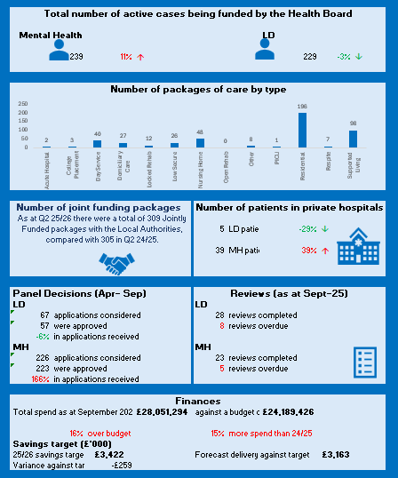
Figure 1: MH& LD Performance Summary-

  - Mental Health and Learning Disabilities Performance Overview

    - Key highlights for Q2 25/26
- Demand for Mental Health (MH) packages has increased by 11% whereas LD packages have decreased by 3%.
- Residential placements account for the largest proportion of commissioned care (42%) and these packages also saw the largest increased compared with 24/25 with 8 more cases at the end of Q2 25/26.
- 82% of MH reviews were completed on time in September 2025, of these only 1 individual was deemed no longer eligible for CHC.
- 78% of LD reviews were completed on time in September 2025, of these 8 (32%) require a review of funding responsibilities

    - Key drivers/ issues
- Several drivers contribute to the level of demand within the month, primarily a continuation of pressure within adult mental health services and unscheduled care which appears to be overflowing into complex care commissioning.
- Increasing number of routine reviews have identified a significant number of recipients of NHS Continuing Healthcare (CHC) requiring review of their CHC status – where this applies Decision Support Tools (DSTs) are being booked in conjunction with the applicable Local Authority. This process with the LAs is protracted as a result of resource issues within the LA whereby they do not have enough Social Workers to support in a timely manner. To address this issue a new process has been agreed with City and County of Swansea whereby DST’s will be allocated in turn i.e. we will carry out 1 DST that has been requested by the LA and then one DST that has been requested by the Health Board. It is hoped that this approach will lead to a more equitable use of resources when scheduling DST’s and will lead to greater traction in addressing the Health Board DST request back log.
- There are increasing requests for additional observations by both our own clinical teams and independent sector providers on existing packages. This issue will be closely monitored by the Service Group via Scrutiny Panel and Complex Case Panel.

    - Finances
The end of Q2 position (Table 1) was reported as an overspend against budget of £351k which is a decrease of £(351)k compared to the previous month’s overspend of £702k. Table 1 provides a summary of the Month 6 financial position and Table 2 provides a breakdown of the overspend.

Table 1: Month 6 on-month financial position for Mental Health and Learning Disabilities

The in-month budget is greater than the baseline expenditure following the successful repatriation and right-sizing of some packages in 24/25 which has reduced the level of expenditure this year.

New cases compared to baseline in the month totalled £413k which was a decrease of £ (36)k compared to the previous month, as Month 5 recognisedseveralf retrospective charges relating to new cases. The same reason contributed to the reduction in step ups from £162k in Month 5 to £69k in Month 6.

During September 2025, CHC has seen a further improvement in the commissioning of private Inpatient and PICU beds. As a result of the efforts of staff within the directorate, the flow has continued to improve within the three inpatient wards which has resulted in no admissions during the month and existing patients being able to be repatriated back to SBUHB inpatient beds. At the end of August 2025, the Service Group reported an in-month spend of £263k which was an improvement of £(55)k compared to the previous months total of £318k. Patients residing in private beds reduced from 14 at the end of August 2025 to 3 at the end of September 2025 with the trajectory of these reductions continuing in future months.

Additional observation expenditure reduced slightly in month to £78k which was a reduction of £ (7)k compared to the previous month at £85k.

Within the “All other reductions” section, there was a significant release in month following the retrospective termination of two packages dating back to last financial year. This benefitted the CHC position in month by £ (136) k.

The Service Group achieved Savings of £ (68)k during the month which was in line with the Service group’s current savings plan and an improvement of £ (8)k compared to the previous month. Divisions are continuing to work collaboratively with the Commissioning team to ensure patients are commissioned to receive the appropriate levels of care are placed appropriately based on their level of need.

Following the approval of inflationary uplifts by the Management Board in May 2025, inflationary uplift costs of £320k were recognised in the month and this was match funded against the reserve issued to the Service group as part of the annual plan.

Further funding in respect of growth was not issued as part of the annual plan and as such, any further growth in demand must be managed within the current budget. Unfunded net growth in the month totalled £310k which was an improvement of £ (130) k compared to Month 5.

CHC Expenditure trend
The budget and actual position have changed due to the number of days in the month (Month 5 having 31 and 6 having 30 days). The budget has also changed due to the recognition of the on-going processing the inflationary uplifts of packages where uplifts were transacted across several packages and they all had a retrospective element dating back to April 2025. This is an on-going process and further increases in budget and actuals will continue in the next couple of months. Chart 1 provides a 12-month view of performance against the budget.

Chart 1 Mental Health and Learning Disabilities expenditure against budget
The spike in budget in P12-25 recognises several provisions and accruals identified as part of the year end accounts process for which the Service group were funded for.

The step up in total actual expenditure during the last 12 months is reflective of the additional Private packages being commissioned to support pressures in Adult Inpatient and recognises a recent increase in additional observations costs. The step up in Private Inpatient expenditure occurred from P12-25 (March 2025) following the de-commissioning of surge beds in Tawe clinic. This number has started reducing over the last couple of months following the reduction in demand across inpatient services.

High-cost cases
The MH & LD Directorate commissioned 6 high-cost placements for Q2 (Table 2).

Table 2: High-cost placements (over £150,000 per annum)
Category | Care Type | Current HB Cost Per Week | Placed
Learning Disabilities | Supported Living | £3,108.37
Mental Health | PICU | £6,193.39
Mental Health | Low Secure Unit | £3,809.33
Mental Health | Low Secure Unit | £9,100.00
Mental Health | Low Secure Unit | £5,124.00

However, 3 high-cost cases ceased during Q2 25/26 all of which were Mental Health Placements. The total cost of these placements was c£12k per week/ c£622k per annum.

Savings Plans
The Service Group has been set a savings target for this financial year of £5.696m. The Service Group has currently identified savings to the value of £3.804m in year and recurrent value of £3.140m. Within this value are a number which relate to CHC.

Identified savings have increased by £55k in year and £100k recurrently compared to the savings identified last month. Actions being progressed to achieve the savings target include:
- Ongoing work in relation to the proposed repatriation lists that require progression as a matter of urgency. This is being taken forward with the Divisional Triumvirate following the recent changes in service managerial structures, with the inclusion of the Commissioning Team.
- Cases will be categorised as below which will allow the Case Manager’s to prioritise the Review of Commissioned Hours cases where we can realise cost savings through discussions with the Care Coordinator Teams and the Provider.
- Review of CHC Eligibility Required – Awaiting decision from talks with Service Partners on how these are to be progressed. Feedback from one Community Mental Health Team (CMHT) has indicated that requests for Continuing Healthcare (CHC) eligibility review are not taking place due to unavailability of Social Workers to attend.
- Review of Commissioned Hours Required – These are the quicker wins where savings can be realised in the short/medium term.
- Identified Voids – These need to be considered as a whole in order to understand where we can fill any voids with existing/new service users.
    - Actions planned for Q3
- Discussions are ongoing with Neath Port Talbot (NPT) LA to look at the existing Brokerage process to see where changes can be made to streamline the process to increase efficiencies and provide education and resources to the Care Co-ordinator population. NPT LA have recently recruited into the Brokerage Manager role and meetings have been arranged with the Brokerage Team, the LA’s and Health Commissioning to understand where these improvements can be realised.
- Ongoing work with both Local Authorities to put in place a joint funding agreement. This has been escalated via the Health Board Executive to try and get some progress on the issue.
- Health Board review of Complex Care structures across the three Service Groups is still ongoing.
- Work has taken place to create a new Patient Care & Financial Sustainability Review Pro Forma – this will provide greater focus on the financial sustainability of commissioned care packages whilst at the same time ensuring that patient care remains a key review measure.

- Long Term Care Quarter 2 2025/26 Overview
Figure 2 provides an overview of performance for key measures as at Q2 25/26. The percentage variance has been calculated by comparing Q2 25/26 with Q2 24/25.
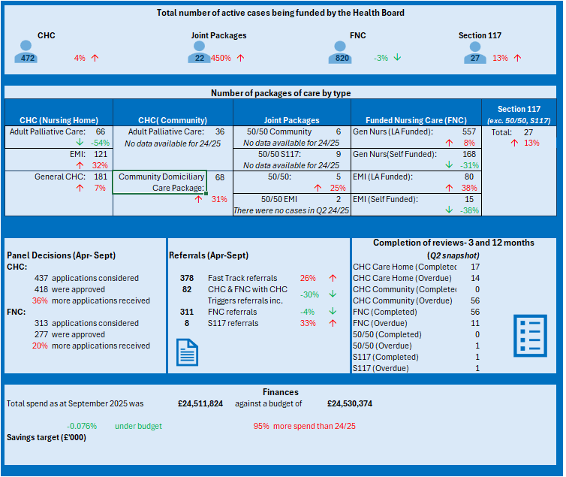
Figure 2: Long Term Care Performance Summary-
  - Long Term Care Performance Overview

    - Key highlights for Q2 25/26
- Demand for CHC, Joint packages and Section 117 have all increased compared with 2024/25. Nursing Home packages account for the largest proportion of commissioned care for CHC, with Elderly Menal Illness (EMI) seeing the largest increase compared with last year.
- Residential placements account for the largest proportion of commissioned care (42%) and these packages also saw the largest increased compared with 24/25 with 8 more cases at the end of Q2 25/26.
- Fast track referrals continue to increase with 26% more referral received compared with 24/25
- 246 statutory care home reviews were completed in Q2, with 27 outstanding reviews on 1st October 2025. Outstanding reviews are due to hospital admissions and care homes in incident status. The Long-Term Care Team are working at a staffing deficit of 2.6 WTE Band 6. Recruitment has been completed with new starters undertaking induction training July and August 2025. Of the 246 completed reviews, 2 were downgraded
- 2 community reviews were completed for Q2. 56 out of compliance, both remain eligible for CHC.

    - Key drivers/ issues
- Backlog of reviews
  - District Nursing Community Nurse Assessor Team had a 66.6% staffing deficit for Q2. An independent Community Review is being undertaken by SBU Corporate.
  - Majority of outstanding reviews have fastrack eligibility. Due to DN capacity the data cleansing of the review list is resource intensive and not all RIP’s are being reported in a timely manner. A new process to be implemented to mitigate this risk.
  - A weekly scrutiny panel meeting with Director PCTSG is to be implemented November 2025 to monitor performance of all reviews and timescales to complete.
  - Induction programme underway for 2 WTE band 6 Nurse Assessors for the LTC Team. Induction programme will be completed by November 2025.
  - Outstanding reviews are being prioritised in Q3.
- Care Homes- The overall occupancy in the independent sector for Swansea & Neath Port Talbot Locality is 91%.
- Legal Challenge- The Health Board is an active partner with Swansea LA in the process of considering the costs of providing care and accommodation for care home providers. Care home fees have significantly increased since 1st October 2021 in recognition of the increased costs of food, fuel and inflation. Recent concerns have been raised from Care Home Providers on the increase in employers’ contribution to National Insurance (NI) and Real Living Wage for 2025/26. A Finance Sub Group Meeting has been undertaken with Health, LA, Care Forum Wales and providers to discuss 2025/26 rates. Both LA’s have approved 6.1% uplift for 2025/26. Swansea care home providers are challenging this rate. Swansea LA received a legal challenge on 7th May 2025 relating to the fees set for 2025/26. At time of reporting, no further response has been received by Swansea LA from care home providers.
- Escalating Concerns- One Care Home in the Port Talbot area remains in escalating concerns (EC) and suspension of placements during the Quarter 2 period. Care home placed into EC and suspension of placements 5th February 2025. Concerns raised:
- Governance Process
- Management & Leadership
- Safeguarding Concerns
- Infection Prevention & Control (IP&C)
Improvement noted June 2025 and suspension of placements lifted. Due to inconsistency in improvements to action plan, panel agreed to reinstate suspension of placements in July 2025 and increase frequency of monitoring. Risk score increased to 12. Risk remains significant but controls and assurances remain in place to mitigate risks. Update October 2025 showed improved and stabilisation of care home. JIMP meetings continue to take place monthly.

    - Finances
The Funded Nursing Care (FNC) rate is set nationally using an agreed methodology which references A4C pay awards and CPI to calculate the % increase to be applied to the previous year’s rate. The current year rate is described as interim due to it using an estimate of the A4C pay award as it was unknown on 1 April 2025. Any difference between the interim rate and final rate is backdated to April 1. Table 3 shows the elements that make up the FNC rate and a comparison in the rate compared with last year.

Table 3: Funded Nursing Care Interim Rate 25/26
Year | Registered Nursing | Continence | FNC Health rate | RN Social care | FNC Full Rate
2024/25 | £203.06 | £15.06 | £218.12 | £8.83 | £226.95
2025/26 | £213.66 | £15.51 | £224.26 | £9.08 | £233.34

The HB is an active partner with Swansea LA in the process of considering the costs of providing care and accommodation for providers. Swansea LA residential rates are used for the regional fee setting process as they are higher than the NPT residential rates and provider engagement is more extensive given the respective sizes of the markets in those areas.
The HB CHC base rate fee setting methodology is determined by a 3-yearly cycle of extensive engagement with providers and a lighter touch annual review, where in year and unexpected costs (e.g., utilities and living wage increases) are considered.

The base HB CHC base rate therefore is an amalgamation of the agreed care and accommodation costs plus a sum added to reflect nursing care requirements, together with any inflationary uplift and cost of living rises.
Continuing this methodology results in the rate for 2025-26 outlined in Table 4.

Table 4: Continuing Health Care (CHC) rate 25/26
CATEGORY | LA 24/25 | UPLIFT | LA 25/26 | FNC | HB CHC rate
Res Care | £848 | 6.1% | £900 | 224.26 | N/A
Gen Care | £888 | 6.1% | £942 | 224.26 | £1166.26
EMI Care | £937 | 6.1% | £994 | 224.26 | £1218.26

Table 5 shows the CHC expenditure for the SBUHB since April 24, through to the current quarter.

Table 5: Quarterly CHC expenditure
Care | Q1-25 | Q2-25 | Q3-25 | Q4-25 | Q1-26 | Q2-26
CHC | 9,320 | 10,027 | 10,390 | 9,541 | 8,879 | 10,718
FNC | 2,419 | 2,503 | 2,441 | 2,643 | 2,442 | 2,620
Total | 11,740 | 12,529 | 12,831 | 12,185 | 11,321 | 13,338

Expenditure has plateaued over the last 12 months. Changes in expenditure is linked to:
- NHS led pay inflation and general inflation linked to CPI
- Changes in availability base rate packages versus higher rate packages
- Changes in demand and capacity

Q1 and Q2 have seen a drop in expenditure versus all quarters in 24-25. Reduction in the number of packages in existence is the main driver. The number and cost per package of non-base rate placements have grown year on year since covid. Last year saw an increase of 7%. The impact on this year is expected to be circa 8% as homes pass on increases in employers NI and pay legislation.

High-Cost Placements
The Long-Term Care Team commissioned 6 high-cost placements for Q2 (Table 6).

Table 6: High-cost placements (over £150,000 per annum)
Criteria if High Cost | Funding Type | Current HB Cost Per Week | placed
Specialist Placement Care Home | CHC | £3,525.00 | 01/07/2025
Specialist Placement Care Home | CHC | £3,525.00 | 25/07/2025
Specialist MH Hospital | CHC | £4,278.83 | 07/08/2025
Specialist Placement Care Home | CHC EMI | £3,525.00 | 13/08/2025
Specialist Placement Care Home | TR | £3,525.00 | 04/07/2025
Specialist Placement Care Home | CHC | £3,912.90 | 08/09/2025

However, 5 high-cost cases ceased during Q2 25/26 all of which were Specialist Care Home placements. The total cost of these placements was c£16k per week/ c£853k per annum.

    - Actions planned for Q3
- Continue to progress with Direct Payment implementation date of 1st April 2026.
- Prioritise outstanding reviews

- Children and Young People Continuing Care Q2 2025/26 Overview
Figure 3 provides an overview of performance for key measures as at Q2 25/26. The percentage variance has been calculated by comparing Q2 25/26 with Q2 24/25.
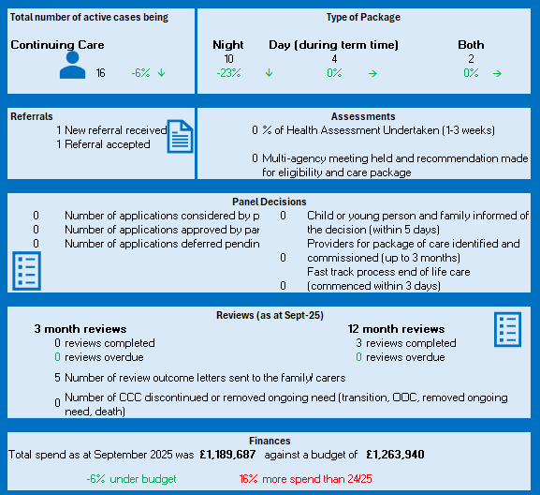
Figure 3: Children and Young People Performance Summary Q2 25/26
    - Key highlights for Q2 25/26
- 16 Packages of Care active at the end of Q2
- The 16 Packages of Care (POC) delivered a total of 1,058.5 hours consisting of 112.5 day care hours (term time), 841 night support hours per week and 105 day support hours per week
- The staffing supporting the packages were:
  - 8 POC supported with 1-1 Band 4
  - 5 POC supported with 1-1 Band 3
  - 1 POC supported with 2-1 Band 3
  - 3 POC supported with 2:1 Band 3 & 4
- Continuing Care Panel not held July and August due to not being Quorate.
- 15 missed care which is a notable reduction. Episodes of care broken down as follows:-
  - 7 missed care (July) – care reverted back to parents
  - 5 missed care (Sept) – care reverted back to parents
  - 2 missed care and 1 part missed care (where only 1 staff available for 2-1) care reverting back to parents.
  - 1 new referral received in September 2025. Delay in nursing assessment due to CYP receiving respite/access and handover of the nurse assessor role.
- Reviews:
  - 2 Reviews continue to be eligible for POC (July)
  - 1 new POC eligible for CC (July)
  - 1 increase to existing POC (July)
  - 1 CYP not eligible for CC (July)

    - Key drivers/ issues
- Workforce risk on Register at score 16, with target score of 12. This relates to the challenges in recruitment and unavailability in the unregistered Health Care Support Workers Band 3 & 4 (HCSW) workforce.
- Increase of complexities of CYP and for POC requiring B4 HCSW. Increase in packages and new POC
- Increase in unregistered workforce reducing hours and terminations
- Commissioned care with external agencies known to SBUHB to fulfil Package of Care is in progress
- Mitigation includes backfill with bank increasing bank only staff contracts, reducing missed care and trained within the service. Recruitment and retention continue to be a challenge.
- Scrutiny of rota management and employment of Rota Co-ordinator.
- Long-term and short-term sickness and absence within nonregistered workforce. Robust sickness and absent monitoring and management

    - Finances
As at the end of Quarter 2 2025/26, the Service Group were reporting a spend £1,189,687 against a budget of £1,263,940 resulting in an underspend of £74,253. This trend has continued with Month 7 seeing an underspend of £88,967

    - Actions planned for Q3
- Missed care continues to be supported by management to exhaust all available options including, staff swaps, bank staff and additional hours.
- Robust scrutiny weekly and Datix reporting.
- Maximising staffing capacity through bank, scrutiny of rota management and robust application of the Attendance At Work policy.

- CHC Transformation Programme Update
The Health Board’s Continuing Healthcare (CHC) Transformation programme continues to progress. To date the Transformation programme has focused on creation of a centralised CHC function. The team has started to take shape with the Commissioning Manager commencing in post on 3rd November 2025 and existing capacity with the Corporate Commissioning Team being realigned to support the centralised function. Key outputs from the function to date include development of an agreed Standard Operating Protocol (SOP), the establishment of an Executive level high-cost case approval process and development of a joined up performance reporting process.

With the support of Deloitte, areas of targeted work have been identified that should result in efficiencies and cost savings. The workstreams identified as part of the Health Board’s Recovery and Sustainability Programme are:
- Joint Funding Arrangements- To work closely with Local Authority partners to standardise both joint funding processes and funding splits across the system
- Operating Model- Optimising the CHC operating model to deliver high-quality, person-centred care and ensure financial sustainability, requiring more efficient, integrated working across SBUHB and Local Authorities to meet rising demand amid limited resources.
- Market Management- Proactively manage and shape the market to improve value for money by engaging large/critical suppliers for renegotiation of packages, inflation management and to understand the opportunity to reduce spot purchasing.
- Package Rightsizing and Reviews- Ensuring timely completion of outstanding reviews and implementation of outcomes to ensure care packages are accurately aligned with people’s needs.

The workstreams are underpinned by an ambitious project plan with multiple task and finish groups with the vast majority of outputs planned for delivery by the end of March 2025 with the benefits being realised throughout 2026/27. The centralised commissioning team will be leading and supporting these workstreams.

Effective joint working with Local Authorities is essential for successful delivery. To support this, a Regional Commissioning Group has been established, chaired by the Health Board’s Executive Director of Planning & Partnerships. The group brings together representatives from across Health and Social Care, alongside members of the Regional Programme Board (RPB). Internally, the monthly CHC Programme Board will oversee programme delivery, while the Regional Commissioning Group will focus on fostering collaborative opportunities and driving integrated working across partner organisations.

- Governance and Risk
The CHC programme is overseen by the monthly CHC Programme Board, chaired by the Executive Direcor of Planning, with issues escalated to Management Board as appropriate. Monthly updates on delivery against the savings plan is also presented to Recovery & Sustainability Board.

Risk: Direct Payments
The introduction of Direct Payments for CHC remains a significant risk for the Health Board. Recent legislation in Wales enabled the introduction of Direct Payments (DP) for CHC; further legislative steps are required to develop regulations which will pass these Directed Functions on to Health Boards (HBs); this work is now underway in Welsh Government (WG) and includes a formal consultation process that commenced on the 16th July 2025 for 12 weeks. Following this, policy guidance will be developed for issue in April 2026.

Until recently, the requirement had been for DPs for CHC to be implemented in Wales by the end of 2026; the implementation timeline has now changed with HBs informed of a requirement to implement the model in early 2026, prior to the pre-election cut off of end March 2026 and in readiness for the May 2026 Senedd elections.

This reduces the implementation time by nine months and will be extremely challenging given there is no previous experience or expertise on any form of personal health budget in Wales and the policy guidance will not be available until April 2026. Implementation will therefore take place without access to published policy guidance, posing a significant risk.

Given this, it is highly unlikely that HB systems would be fully functional to respond to an unknown number of DP requests immediately; managing expectations and partner and public perception will be essential. An options paper has been presented to the Welsh Government from the Welsh CHC Leads with the preferred option to be a staged approach (option 3), with a national hub undertaking all Wales requirements on a ‘Once for Wales's basis along with operational and care management responsibilities managed on a regional/HB footprint basis. This will allow HBs to drive safe, high quality and effective implementation, and mirrors the approach adopted in England. Evidence supports this approach to ensure the safe and robust application of the policy.

Welsh Government have declined Health Boards’ CHC Leads request for option 3. SBUHB is actively engaged and participating in the all-Wales DP working group to ensure that we are as prepared as possible for implementation. Funding has been made available for a national project manager to aid implementation across Health Boards.

Risks and mitigation
- Financial Risk- No clear direction from the Welsh Government if additional resources are to be provided to implement DPs. Funding has been made available for a national project manager to aid implementation across Health Boards.
- Short time frame will place Health Boards at risk due to limited time to implement governance processes to provide safe sustainable care.
- Risk increased to 15 on PCTSG Risk Register. Risk to also be added to MHLD’s Risk Register
- SBUHB is actively engaged and participating in the all-Wales DP working group to ensure that we are as prepared as possible for implementation.

- Finances
As at Q2 25/26 the Health Board has spent c£54m against a budget of c£50m resulting in an overspend of c£4m. Table 7 provides a breakdown of expenditure by Service Group and it shows that as of Q2, Mental Health and Learning Disabilities account for the overspend. Details of actions to reduce the in-year spend were outlined in section 3.1.3 of this report.

Table 7: Summary of expenditure against budget (Q2 25/26)
 | MHLD | Long Term Care | CYP | HB Total
Spend  (Apr-Sep 25) | CHC/ Complex Care= £24,690,757 | £24,511,824 | £1,189,687 | £53,752,804
Spend  (Apr-Sep 25) | Private MH Inpatients= £3,360,536 | £24,511,824 | £1,189,687 | £53,752,804
Spend  (Apr-Sep 25) | Total= 28,051,294 | £24,511,824 | £1,189,687 | £53,752,804
Budget  (Apr-Sep 25) | £24,189,426 | £24,530,374 | £1,263,940 | £49,983,740
Variance | £3,861,868 | -£18,550 | -£74,253 | £3,769,064

- RECOMMENDATION
Members are asked to:
- Consider the content of this report and ADVISE on any further improvements that members would like to see in the Quarter 3 report

Governance and Assurance

Link to Enabling Objectives  (please choose) | Supporting better health and wellbeing by actively promoting and empowering people to live well in resilient communities
Link to Enabling Objectives  (please choose) | Partnerships for Improving Health and Wellbeing |  | ☐
Link to Enabling Objectives  (please choose) | Co-Production and Health Literacy |  | ☐
Link to Enabling Objectives  (please choose) | Digitally Enabled Health and Wellbeing |  | ☐
Link to Enabling Objectives  (please choose) | Deliver better care through excellent health and care services achieving the outcomes that matter most to people
Link to Enabling Objectives  (please choose) | Best Value Outcomes and High-Quality Care |  | ☐
Link to Enabling Objectives  (please choose) | Partnerships for Care |  | ☐
Link to Enabling Objectives  (please choose) | Excellent Staff |  | ☐
Link to Enabling Objectives  (please choose) | Digitally Enabled Care |  | ☐
Link to Enabling Objectives  (please choose) | Outstanding Research, Innovation, Education and Learning |  | ☐
Health and Care Standards
(please choose) | Staying Healthy |  | ☐
(please choose) | Safe Care |  | ☐
(please choose) | Effective Care |  | ☐
(please choose) | Dignified Care |  | ☐
(please choose) | Timely Care |  | ☐
(please choose) | Individual Care |  | ☐
(please choose) | Staff and Resources |  | ☐
Quality, Safety and Patient Experience
The Health Board has a responsibility to ensure that its duty of care extends to NHS provision.
Standardisation of policies and strengthening commissioning processes are centred around quality of care.
Financial Implications
MH&LD and PCS Service Groups have identified financial risks and have
implemented improvement plans.
Strengthening of the commissioning arrangements will create efficiencies.
Delivery of financial savings is being managed by the CHC programme board.
Legal Implications (including equality and diversity assessment)
The Health Board is required to provide NHS funded care in line with
agreed procedures. The sustainability of the independent sector, quality
and governance concerns and the pre–Judicial Review from the Caron
Group challenging the methodology of setting the CHC rates for the
Health Board have been identified as potential risk. This has now been
resolved.
Staffing Implications
There are staffing issues in the private care sector which require a
revised approach to ensure the sector remains positive and suitable for
continued commissioning of NHS funded care.
Long Term Implications (including the impact of the Well-being of Future Generations (Wales) Act 2015)
- Long Term – centralised commissioning function ensures a balance of short-term needs with the need to safeguard the ability to meet the longer-term commissioning needs.
- Prevention – strengthening the commissioning function is acting to prevent further problems occurring and current problems getting worse to help the Health Board meet our objectives
Report History |  | Q1 25/26 Performance Report- August 2025
Appendices |  | Appendix 1- CHC Dashboard

Appendix 1: Swansea Bay UHB CHC and FNC Summary

