Meeting Date | 25 November 2025 |  | Agenda Item |  |  | 2.3
Name of Meeting | Performance and Finance Committee
Report Title | Monthly Recovery and Sustainability Update
Report Author | Deborah Longman – Head of Recovery and Sustainability  Samantha Moss – Deputy Director of Finance
Report Sponsor | Darren Griffiths, Executive Director of Finance and Performance
Presented by | Samantha Moss – Deputy Director of Finance
Freedom of Information | Open
Purpose of the Report | The report is provided to update the Performance & Finance Committee on the current actions and work in progress of the Recovery & Sustainability (R&S) Board.
Key Issues | The report invites the Performance & Finance Committee to note the work undertaken by the Recovery & Sustainability programme, overseen by the Recovery & Sustainability Board.  The report includes an overview of the key actions arising from the latest Recovery & Sustainability Boards as well as an update on the thematic programmes. It also provides high level information on the delivery regarding the Health Board savings.
Specific Action Required  (please choose one only) | Information | Discussion |  | Assurance | Approval
Specific Action Required  (please choose one only) | ☐ | ☐ |  | ☒ | ☐
Recommendations | Members are asked to: -  - ACKNOWLEDGE the updated report for ASSURANCE of ongoing delivery associated with the Recovery and Sustainability Programme
MONTHLY RECOVERY & SUSTAINABILITY PROGRAMME UPDATE

- PURPOSE
The paper provides the monthly formal update to the committee regarding the actions and progress within the Recovery and Sustainability programme.

- INTRODUCTION
Phase 1 of the external strategic support commissioned by the Health Board in collaboration with the Welsh Government commenced in July 2025. There were nine deliverables from Phase 1, which are summarised below alongside latest information of the outputs:

Deliverable | Update On Outputs
- Assessment of the quality and effectiveness of the Board’s delivery structures | Document complete – final Quality Assurance (QA) underway
- Assessment of the control environment in key material expenditure and risk areas | Document complete – final Quality Assurance (QA) underway
- Assessment of financial baseline and deficit drivers | Document at final draft stage
- Urgent and emergency investment review and service redesign to deliver recurrent savings | Document complete – final Quality Assurance (QA) underway
- Opportunities for sustainable CHC spend | Document complete – final Quality Assurance (QA) underway
- Assessment of Health Board savings plan for 2025/26 (identifying actions for improvement) | Updated document expected 18/11/25
- Fully identified savings plan for 2025/26 | Updated document expected 18/11/25
- Pipeline of further savings options in 2026/27 and 2027/28 | Document at final draft stage – included in deliverable 3
- Plan to support and embed changes for the remainder of 2025/26 | Already in place

Phase two of the programme commenced on 6 October and it provisionally for a 4-week period, with further discussions on the medium-term support to be provided.

- UPDATES R&S PROGRAMME

  - R&S Board 12 November 2025
As was the first meeting of the month with the focus on the work of the Thematic programmes and associated schemes. Key points included:

- A detailed presentation on ‘Cost to Serve’ by the Health Board strategic external support. This highlighted that our services are costing approximately £49m to deliver than our allocation of funds. It was noted that significant additional investigations and service reviews will be needed to ensure we are able to run services to budget.

- It was noted that savings are still behind where they needed to be, and urgent and difficult decisions need to be made. The membership discussed options, with the following decisions made:
  - Ban on agency nurse spend with an exception process.
  - Continued control on vacancies with further considerations to be explored on increasing controls and oversight.
  - Agreed to explore the creation of a COP ward in the Neath Port Talbot Singleton service group to allow decant of IPC patients in Morriston and to prevent deconditioning of COP patients
  - Increase in authorisation level of eight key discretionary spend subjective codes
  - Pre-approval required for non-essential travel
  - Review of taxi contracts
  - Training expenditure ban with the exception of mandatory and clinical delivery training
  - Review of removal expenses policy

  - R&S Board 22 October 2025
Focus of the second meeting of the month is on updates from Service Groups and their performance against savings target. Key points:

- R&S Alignment and support. Recovery & Sustainability Team is positioned to support and enable the Service Groups (SGs) in delivering their part of the thematic programmes, and the team are an enabling function with the key focus being on the executive led themes.

- Oracle approval limits to be halved to gain more traction on non-pay spend, with further recommendations to be explored at next board.

- Morriston Service group reported additional schemes totalling £101k moved to green. Although reported concerns around UEC savings projections in year.

- Neath Port Talbot/Singlton Service group reported that forecast delivery had improved from £7.21m to £7.48m (up £270k); £420k committed through pipeline adjustments. £400k still to be resolved.

- Primary, Community and Therapies Service group reported that controls were beginning to show traction with an £85k reduction in variable pay. Run rate and overspend both reduced in month six.

  - Savings Delivery and £55.4m
At Month seven progress against the £55.4m target aligned to the 11 September plan is summarised in the table below. Further details on the savings performance can be found in Monthly Financial Performance report Agenda item 2.2.

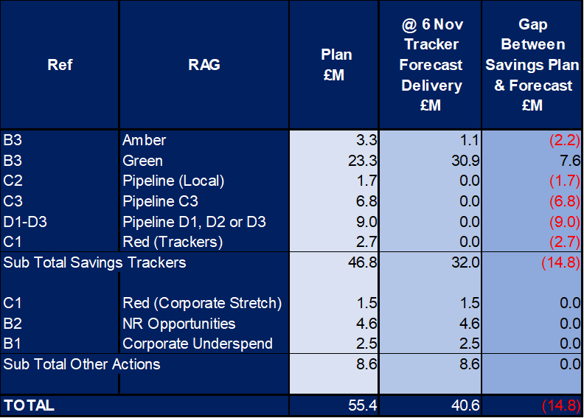

- GOVERNANCE AND RISK ISSUES
The work summarised in section 3.3 provides the Heath Board with a line of sight to £55.4m savings required, which addresses the plan submitted on 31 March 2025. From the 11 September paper and submission to the Welsh Government, which provided plans with a combined savings value of £55.4m, work must ensure this delivers in full. The risk on delivery of these are detailed in Agenda item 2.2 on the month six financial position.

The 11 September, and subsequent monthly financial position papers (Agenda item 2.2) also incorporate the full level of financial risks both national and local. At Month six three of these risks were materialising through the position. There are no detailed plans on how these can be mitigated by increasing savings delivery, until the initial £55.4m is addressed.

- FINANCIAL IMPLICATIONS
The financial implications of this report are set out within it.

- RECOMMENDATION
Members are asked to:
- ACKNOWLEDGE the updated report for ASSURANCE of ongoing delivery associated with the Recovery and Sustainability Board.

Governance and Assurance

Link to Enabling Objectives  (please choose) | Supporting better health and wellbeing by actively promoting and empowering people to live well in resilient communities
Link to Enabling Objectives  (please choose) | Partnerships for Improving Health and Wellbeing |  | ☐
Link to Enabling Objectives  (please choose) | Co-Production and Health Literacy |  | ☐
Link to Enabling Objectives  (please choose) | Digitally Enabled Health and Wellbeing |  | ☐
Link to Enabling Objectives  (please choose) | Deliver better care through excellent health and care services achieving the outcomes that matter most to people
Link to Enabling Objectives  (please choose) | Best Value Outcomes and High-Quality Care |  | ☒
Link to Enabling Objectives  (please choose) | Partnerships for Care |  | ☐
Link to Enabling Objectives  (please choose) | Excellent Staff |  | ☐
Link to Enabling Objectives  (please choose) | Digitally Enabled Care |  | ☐
Link to Enabling Objectives  (please choose) | Outstanding Research, Innovation, Education and Learning |  | ☐
Health and Care Standards
(please choose) | Staying Healthy |  | ☐
(please choose) | Safe Care |  | ☒
(please choose) | Effective Care |  | ☒
(please choose) | Dignified Care |  | ☐
(please choose) | Timely Care |  | ☒
(please choose) | Individual Care |  | ☒
(please choose) | Staff and Resources |  | ☒
Quality, Safety and Patient Experience
No Implications
Financial Implications
No Implications
Legal Implications (including equality and diversity assessment)
No Implications
Staffing Implications
No Direct Implications
Long Term Implications (including the impact of the Well-being of Future Generations (Wales) Act 2015)
No Implications
Report History |  | Routine report to Performance and Finance Committee
Appendices |  | N/A

