

Meeting Date | 26th November 2024 |  | Agenda Item |  | 2.2
Report Title | Financial Report – Month 07 2024/25
Report Author | Samantha Moss, Deputy Director of Finance  Gemma Pearson, Finance Business Partner
Report Sponsor | Darren Griffiths, Executive Director of Finance and Performance
Presented by | Samantha Moss, Deputy Director of Finance
Freedom of Information | Open
Purpose of the Report | The report advises the Health Board Performance & Finance Committee of the financial position for Month 07 2024/25 (October 2024) and the risks regarding the current forecast revenue year end outturn.
Key Issues | The report invites the Performance & Finance Committee to note the detailed analysis of the financial position for Month 07 2024/25 (October 2024).  The report includes a summary of the key drivers of the position both by Service level and expenditure type (i.e. Non-Pay/Pay). It also provides information of the current position with regard to Health Board reserves to ensure the transparency of the overall Health Board position.  Key points are provided within the main body of the report and further information is provided in the Appendices.
Specific Action Required | Information | Discussion | Assurance | Approval
Specific Action Required | ☐ | ☐ | ☒ | ☐
Recommendations | Members are asked to:  - Consider and comment upon the Board’s financial performance for Month 07 2024/25.  - TAKE ASSURANCE from the actions to ensure delivery of the financial assessment submitted on 26th September 2024, with a line of sight to £50.8m, which now includes:  - Update on the delivery of all Green/Amber and Pool 1 Red schemes  - Continual review by Service Areas of Pool 2 Red Schemes to identify further opportunities to support the £4.3m stretch target.  - Ongoing reporting of the Variable Pay Performance against the 25% and 25% reduction target set in August 2024.  - Publication of control targets aligned to the Health Boards Financial Assessment.  - Progress of the R&S Board, with updates provided via a separate report to the PFC, aligned to the agreed governance route.  - Continued work to refine ‘Year End Delivery Plan’ for 2024/25 (Previously referred to as the Landing Plan) and identification of non-recurrent opportunities.  - Oversight of the formal responses from the Accountability Letters provided in Appendix 4.  - Deep dive of the Health Boards financial performance provided to Independent Members on the 19th November following the publication of the Month 7 position.  - CONSIDER the risks to the position at Month 07.  - SUPPORT the position with regards to Health Board Reserves.  - CONSIDER all actions and updates to support the management of the 2024/25 financial position.

FINANCIAL REPORT – MONTH 07

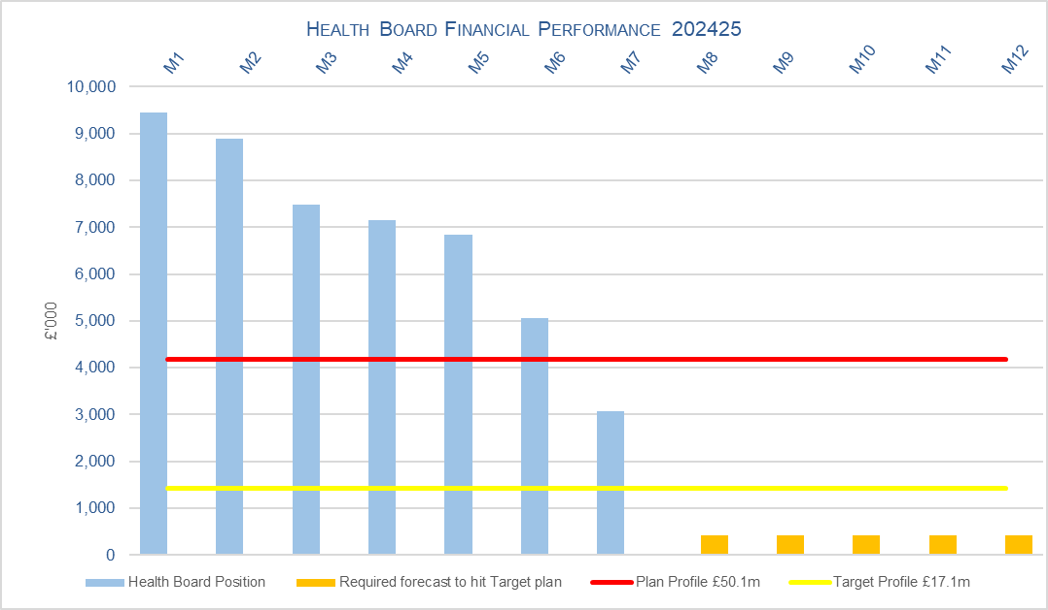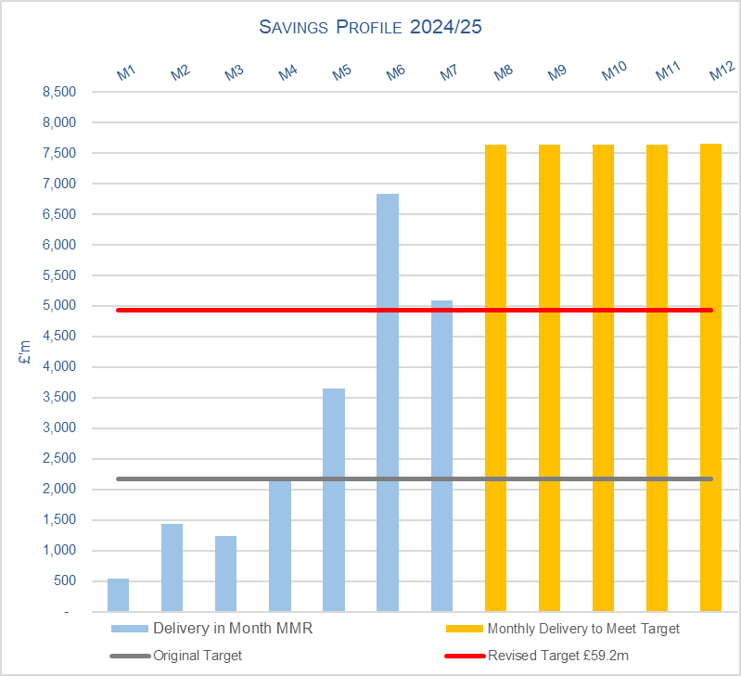

SUMMARY OF REVENUE PERFORMANCE

Target | In Month  £’m | Year To Date (YTD)  £’m
Delivery Against Revenue Resource Limit (RRL) DEFICIT / (SURPLUS) | 3.067 | 47.954
Performance Against Plan DEFICIT / (SURPLUS) | (1.108) | 18.729

In summary, the Month 7 financial position was £3.1m overspent, this was £1.1m better than the original forecast deficit for the month.

The Annual Plan submitted on 28th March 2024 reported a deficit of £50.1m after the delivery of £26.1m of savings. The expectation was that the in-month position would reflect a 12th of the £50.1m deficit. For Month 7 the Health Board (HB) has reported a deficit of £3.1m against a 12th of the deficit plan of £4.2m and is £48.0m overspent against cumulative deficit plan of £29.2m. Clearly this position is unacceptable and immediate actions are being taken.

- FINANCIAL PLAN 2024/25
The Health Board (HB) submitted an Annual Plan on 28th March 2024 which reported a deficit of £50.1m. This has not been approved by WG who have requested as a minimum the HB reduces its deficit to £17m. In order to meet the £50.1m deficit plan operational savings totalling £26.1m needed to be achieved and all service areas were required to breakeven to their delegated budgets.

Given both the in-year financial challenges and gap between the £50.1m deficit plan and the £17m control total, the Health Board was asked to submit a revised Financial Assessment for 2024/25; this was presented at the Public Board on 25th September, having already gone through a robust internal sign off process and was submitted to WG on 26th September. The assessment and accompanying letter summarised a high degree of confidence in the delivery of £64.1m deficit position by the 31st March 2025, with further opportunities of £13.3m giving the Health Board line of sight to £50.8m.

A summary of the Financial Assessment and details on the position following Month 6 were also discussed with representatives from Welsh Government (WG) and the NHS Executive (NHSE) on 9th October 2024. The risks around the delivery of the £50.8m were recognised but with a line of sight to £50.8m which had been presented to the Board as its meeting on 25th September, the forecast for 2024/25 remains at £50.1m.

WG was clear in the meeting on 9th October 2024 that the Health Board was required to achieve £50.1m (or better) and that if the Health Board was unable to deliver the position, WG will insist for more options to achieve this. De-risking of the financial position and the full delivery of the savings identified is essential which will be driven through the Recovery and Sustainability Board.

The elements of the Financial Assessment are summarised in the Table:
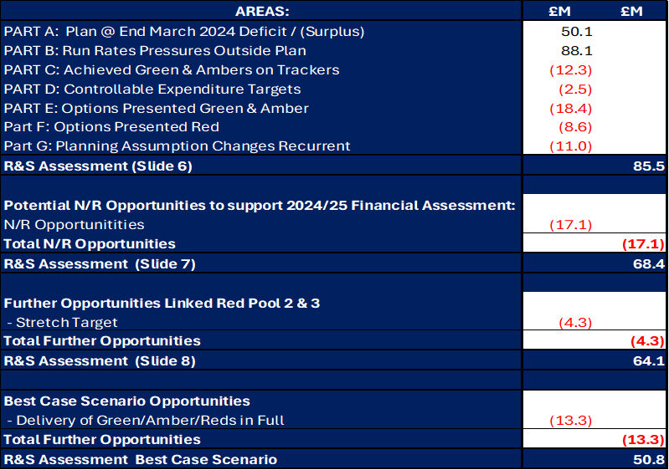

Updates on the risks and achievements to date were shared as part of the Independent Member briefing on the 19th November 2024 and further updates will be shared within the Month 8 report.

- KEY DRIVERS OF THE IN-MONTH POSITION
The key drivers of the Month 7 and YTD position are summarised in the tables below. Further detail at a Health Board level of expenditure on Income, Pay and Non-Pay, is also provided in Appendix 1.

  - Key Drivers by Service Area In-Month

  - Key Drivers by Service Area YTD

  - Summary By Expenditure Type

- Income
The Joint Commissioning Committee (JCC) Income as a provider slightly overperformed in-month with improved activity across most specialities; the in-month overachievement was £0.15m. The YTD underachievement is £0.6m.

Dental Contract Income underachieved by £0.1m in-month, with an YTD underachievement of £0.8m.

- Pay
The Month 7 pay overspend (after excluding the Accountancy Gain of £1.5m) was £0.5m (Month 6, £0.1m), this deterioration in-month was largely driven by the increase in variable pay across Nursing (Registered and Unregistered) and Medical & Dental. The YTD pay pressures are driven by a number of factors including the continuation of staffing surge bed capacity, pressures on services across the organisation and high levels acuity, coupled with high levels of sickness.

- Clinical Consumables
(see Appendix 1)

- Prescribing
(see Appendix 1)

- SAVINGS

The position reported in the Monthly Monitoring Return (MMR) only allows the reporting of Green and Amber schemes and this is provided in the table below:

Savings Table 1
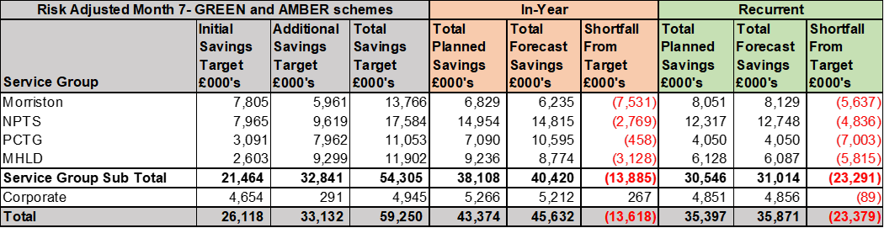

A summary of the total opportunities, including Red Schemes at 7th November 2024, is provided in the table below:

Savings Table 2
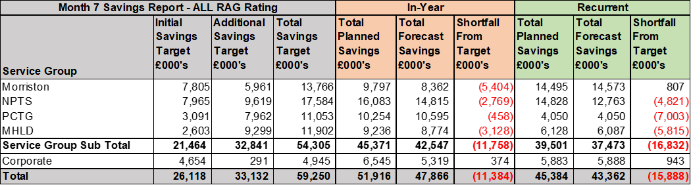
The total level of opportunities forecast in year is £47.9m.

Further details on savings are provided in Appendix 3.

- GOVERNANCE AND RISK
Two Board level financial risks:

- Achieving financial plan (HBR92) with the key elements as follows: -

  - Risk of delivery of savings quantum
  - Risk of operational overspend being in excess of funding available agreed via the Financial Plan
  - Risk of commitment of reserves (e.g. NICE) being above reserves available.
  - Risk of achieving the actions and options outlined in the 2024/25 Financial Recovery & Sustainability Assessment.

Based on the financial performance at Month 7, it is proposed that the Health Board Corporate Risk Register retain the existing risk score to 25 given YTD variance from the original £50.1m deficit plan. This will be reviewed through Q3 to assess delivery of the revised financial assessment and the associated actions/savings to support the revised assessment.

- Availability of capital (HBR93). This risk was re-opened in 2022/23 given the reduction in discretionary capital allocation. Whilst work is underway to manage schemes to reduce commitments in 2024/25 and to produce a balanced plan, the risk varies during the year as more details on schemes emerge and potential slippage funding is made available by Welsh Government.

A score of 20 is suggested at this stage as whilst the plan is now balanced, a number of schemes are on hold and the flexibility within the plan is extremely limited given the reduction in the allocation.

- RECOMMENDATIONS
Members are asked to: -
- Consider and comment upon the Board’s financial performance for Month 07 2024/25.
- TAKE ASSURANCE from the actions to ensure delivery of the financial assessment submitted on 26th September 2024, with a line of sight to £50.8m, which now includes:
  - Update on the delivery of all Green/Amber and Pool 1 Red schemes
  - Continual review by Service Areas of Pool 2 Red Schemes to identify further opportunities to support the £4.3m stretch target.
  - Ongoing reporting of the Variable Pay Performance against the 25% and 25% reduction target set in August 2024.
  - Publication of control targets aligned to the Health Boards Financial Assessment.
  - Progress of the R&S Board, with updates provided via a separate report to the PFC, aligned to the agreed governance route.
  - Continued work to refine ‘Year End Delivery Plan’ for 2024/25 (Previously referred to as the Landing Plan) and identification of non-recurrent opportunities.
  - Oversight of the formal responses from the Accountability Letters provided in Appendix 4.
  - Deep dive of the Health Boards financial performance provided to Independent Members on the 19th November following the publication of the Month 7 position.
- CONSIDER the risks to the position at Month 07.
- SUPPORT the position with regards to Health Board Reserves.
- CONSIDER all actions and updates to support the management of the 2024/25 financial position.

Governance and Assurance

Link to Enabling Objectives  (please choose) | Supporting better health and wellbeing by actively promoting and empowering people to live well in resilient communities
Link to Enabling Objectives  (please choose) | Partnerships for Improving Health and Wellbeing |  | ☐
Link to Enabling Objectives  (please choose) | Co-Production and Health Literacy |  | ☐
Link to Enabling Objectives  (please choose) | Digitally Enabled Health and Wellbeing |  | ☐
Link to Enabling Objectives  (please choose) | Deliver better care through excellent health and care services achieving the outcomes that matter most to people
Link to Enabling Objectives  (please choose) | Best Value Outcomes and High-Quality Care |  | ☒
Link to Enabling Objectives  (please choose) | Partnerships for Care |  | ☒
Link to Enabling Objectives  (please choose) | Excellent Staff |  | ☐
Link to Enabling Objectives  (please choose) | Digitally Enabled Care |  | ☐
Link to Enabling Objectives  (please choose) | Outstanding Research, Innovation, Education and Learning |  | ☐
Health and Care Standards
(please choose) | Staying Healthy |  | ☐
(please choose) | Safe Care |  | ☐
(please choose) | Effective Care |  | ☐
(please choose) | Dignified Care |  | ☐
(please choose) | Timely Care |  | ☐
(please choose) | Individual Care |  | ☐
(please choose) | Staff and Resources |  | ☒
Quality, Safety and Patient Experience
Financial Governance supports quality, safety, and patient experience.

Financial Implications
The Board is reporting a forecast year-end deficit financial outturn.

Legal Implications (including equality and diversity assessment)
No implications

Staffing Implications
No implications

Long Term Implications (including the impact of the Well-being of Future Generations (Wales) Act 2015)
No implications
Report History |  | Updates on the financial position are provided at every meeting.
Appendices |  | Appendix 1 – Variances by Area and Type of Spend  Appendix 2 – Reserves and Central Budgets  Appendix 3 – Savings  Appendix 4 – Accountability Letters

APPENDIX 1 – FURTHER DETAIL ON VARIANCES BY AREA & TYPE OF SPEND

- Overview Financial Position

- Overview of Income

A correction was made in Month 2 to reflect the subjective being used in R&D between Income & Non-Pay totalling £3.9m

- Overview of Pay Variances

Variable Pay by Quarter and type

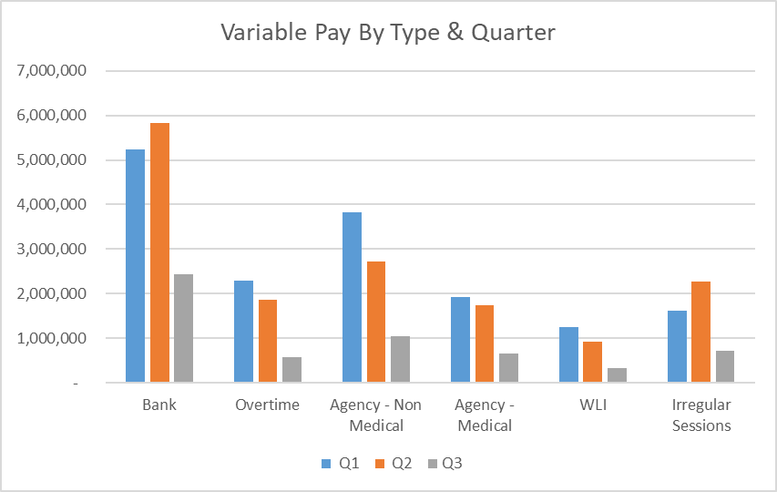

Performance Against Variable Pay Target

- Overview Non-Pay

A correction was made in Month 2 to reflect the subjective being used in R&D between Income & Non-Pay totalling £3.9m

Below are further details on the key areas of non-pay:

  - Clinical Consumables
This area continues to be a pressure with an in-month position of £2.6m (Month 6, £0.6m). Part of the increase is linked to the higher activity relating to the JCC income above. There are 80+ subjective lines within this category including secondary care drugs but areas seeing most pressures YTD continue to be general consumables (M&SE), laboratory products and implants (which in part will be driven by activity).

  - Energy Forecast
Energy costs are procured via an All Wales contract, with NWSSP centrally co-ordinating forecast associated with this contract. An update was received on 10th June 2024 from NWSSP regarding the 2024/25 forecast which has been validated and included from Month 3. There has been no national changes to the forecast since Month 3 and the local team continues to work with Finance colleagues to assess the position.

  - Primary Care Prescribing
Currently prescribing is balanced in month and there is a small YTD underspend of £0.3m. We have at this point received 5 months of PAR data. The Q1 data is below the anticipated levels at this point in the year. However, the data developed in partnership with Pharmacy colleagues is indicating that price concessions linked to Cat M and NCSO may increase significantly in Q2. Apixaban has now left the NCSO basket however the price remains higher than earlier in the year which means previously anticipated savings are not being fully delivered. Therefore, the position is being maintained as relatively balanced pending further PAR data in the coming months.

  - CHC
The overall variance against budget for CHC is £0.1m overspent in-month. An analysis of actual expenditure and patient numbers for 2024/25, along with the average values from 2024/25 is provided in table below.

CHC Analysis by Month

Please note:
- The above numbers include Domiciliary care cases.
- PCT Group does not include the Singleton/NPT element. The NPTS element which covers Children and Young People CHC patients is provided internally by the Health Board and as such is part of the wider NPTS position and is not recorded in the ledger as PCT/MH/LD CHC is recorded.

  - COVID Public Enquiry
The costs for this are allocated to a dedicated Cost Centre (6F25). A breakdown of spend YTD is provided below:

  - Maternity Review
In the 2024/25 Financial Plan £0.7m was set aside to support the Maternity Review. In August to improve the oversight of this area a dedicated Cost Centre was established (6F34). A breakdown of spend YTD as per the financial ledger is provided below:

  - Z Codes (Section 1,3-4 Table Point 1 Appendix 1)
The narrative below groups together the key elements of the Z codes detailed in Point 1 of this appendix.

- Contracting: SLA /LTA performance: JCC (previously WHSSC), LTA and SLA contract income and expenditure are transacted within this area and financial performance reported. NICE approved high-cost drugs and associated LTA’s are also transacted and monitored against targets set. In addition to this, non-contracted activity income in relation to English foundation trusts invoiced on a quarterly basis are reported.

- Capital: The Finance Capital Team manage a number of cost centres covering the PFI, IFRS16 and Depreciation charges for assets both owned and donated are transacted here.

- RRL and Central Reserves: The WG funding received at the start of the year is tracked within this area along with the £50.1m deficit. Any anticipated allocations in year are also transaction through these codes. Other HB wide funding received from HEIW and SIFT is also captured in here. All central reserves remain within the Z cost centres and details of these are provided in Appendix 2.

- Corporate income and expenditure. Any income and expenditure that is not service group specific is transacted and reported through a number of corporate Z cost centres, examples include, payroll and pension costs, VAT recovery, losses and receipts in relation to funding from Welsh Risk Pool, overseas visitors income and Road Traffic Accident income.

APPENDIX 2 – DETAILS ON RESERVES & CENTRAL BUDGETS

- SUMMARY RESERVES
Overall management of the reserves is as per the Health Board Budget Management document.

  - Balances Main & NICE
For 2024/25, the Health Board will hold two central reserves and the purpose of these reserves are below:
- Main – this holds funding from WG or the plan that has yet to be issued to Budget Holders. These items are not surplus but either due to timing have not been issued or is an area where funding is issued based on actual values consumed in future month.
- NICE – this holds the total Health Board funding for all NICE costs (drugs and infrastructure) and is issued to the service each month based on the actual costs consumed as reported through the Pharmacy system.

Details on the balances and movements are provided in the Table below:

- COVID RECOVERY
As part of the Financial Plan WG Funded £15.2m for Local COVID Recovery and £19.5m for Regional COVID Recovery. The funding remains in Central Reserves and reported in Main reserves in Section 1 above. This funding is then issued to service areas based on the actual costs committed. A summary of the actuals to date and forecast costs against the funding total of £34.7m is summarised in the table below.

APPENDIX 3 – SAVINGS

1. Summary, as at October 2024 (Month 7)
Section 3 in the core report focuses on both performance attributed to the original £26.1m target plus the required savings for the run rate pressures across the health board, bringing the total savings target to £59.2m. The tables below reflect the detail held within the monthly savings trackers, aiming to address the total target.

In summary, the table below shows a forecast savings delivery of £47.9m in year, and £43.3m forecast recurrently which includes red schemes and those schemes in progress of being developed. For 2024-25, against a target of £59.2m, this delivers a shortfall of £11.4m.

Within the £47.9m forecast, £45.6m is considered deliverable with a Green/Amber risk rating. However, £2.2m (4.5%) are considered high risk of delivery this year (£7.5m, 17.3% recurrently), rated as Red, a significant improvement on the previous month.

Focussing on the Green/Amber schemes which stand a higher chance of delivery, Morriston Service Group has the lowest % of Green / Amber Savings, and so the highest risk of delivering on their total Savings Target in 2024-25. The high value red schemes are CPAP Activity, reduction of locums’ targets, limiting pump prescribing and reduction of medical rota backfill. Singleton/Neath Service Group, and MHLD group has the highest confidence of delivery in-year with no red schemes. However, service groups are required to develop mitigating schemes to address the savings shortfall.

Recurrently, Morriston and Corporate Directorates have the highest risk of delivery, whilst Singleton/Neath, MH+LD and PCCT have the highest chance of delivery with no/slight savings classified as Red.

- Profiling of Savings against £59.2m 24-25 In Year

The profile shows the timeline of the forecast savings for 24-25 (this is for all Risk rated schemes, £45.6m is achievable excluding red schemes). against the £59.2m target.

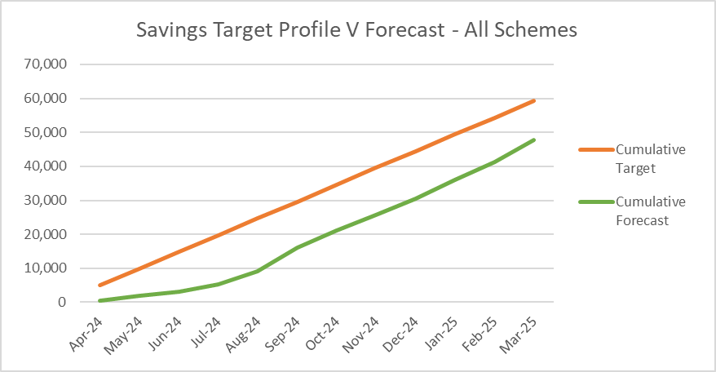
Sept offered the highest level of expected savings – as we enter into the second half of the year, efficiencies are more clearly identified, in addition to the recommendations from the recent Star Chambers. Whilst good progress has been made, focus will be put towards mitigating actions to close the in year savings gap of £11.4m
.

- Type of Savings Forecast at Month 7

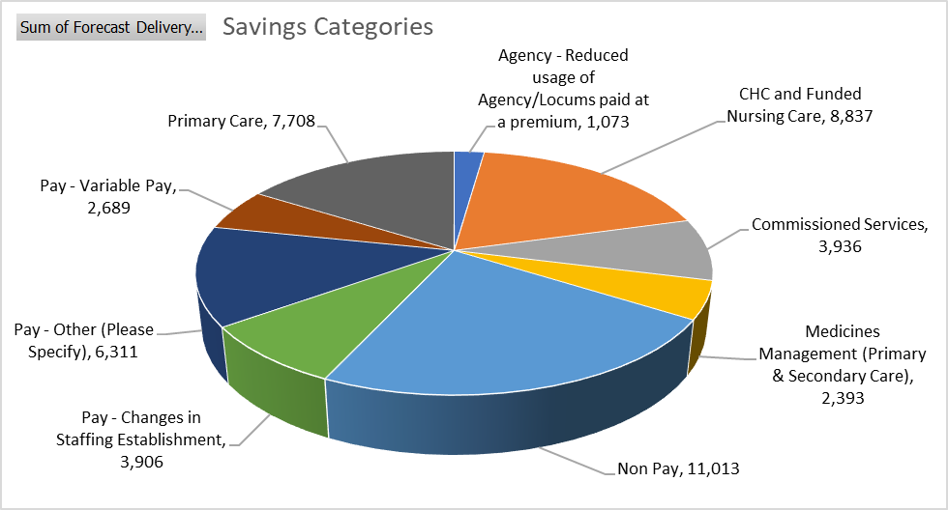

The largest type of savings to month 7 are Non Pay / Procurement at £11m (22.9%) and include savings identified by local and All Wales procurement teams, managing SLA’s, capping investments and managing maintenance contracts., CHC and Funded Nursing Care at £8.8mm (18.4%) which include managing CHC growth and inflation, reviewing support, decommissioning, planned step downs and repatriations. Primary Care savings at £7.7m (15.9%) include management of Optometry and Pharmacy contracts, managing levels of investments, dental clawback and in year slippage.

- SBUHB Savings Repository

To continually support the identification of opportunities for the Recovery & Sustainability programmes in 2024/25 and in future years, as well as ensuring all opportunities from the National Value & Sustainability are captured and shared within the Health Board, the Repository of Opportunities introduced as part of the Planning process is being re-developed to ensure ease of navigation of the data.

The Repository is now live and can be access using the link below:

https://sbushare.cymru.nhs.uk/sites/Finance/Corp/Resources/savresp

The Repository is split into three sections:
- National Efficiency Reports - this will include details of the NHSE FP+D Vault, NHS Wide Value and Sustainability Board Updates including Medicines, and the Carter Report
- National Benchmarking – this will include the latest CHKS Benchmarks, NHSBN reports and analysis, and summary of the NHS Wide Savings schemes for comparisons.
- Local Reports and Benchmarking to include SBUHB Procurement dashboard, Medical Staffing, and some Pay and non-Pay potential opportunities.

A demonstration to PFC members is scheduled for 17th December 2024.

- Value and Sustainability Update

Procurement and Non Pay – The group led by Hywel Jones (WG) focusses on the following priorities; Price and Volume, Contract Negotiations and Management, Management of Service Contracts.

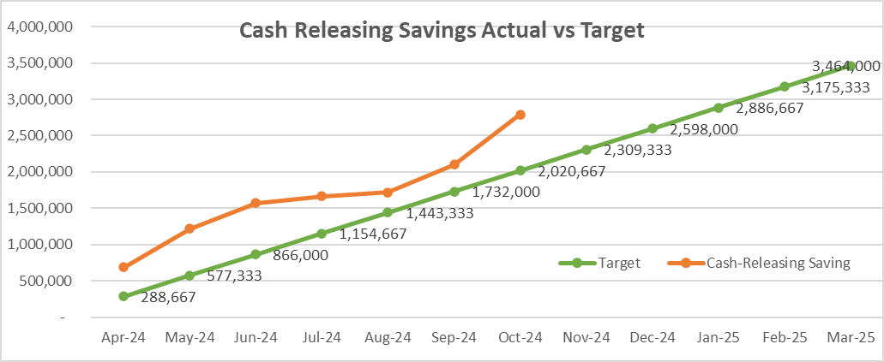
The NWSSP has set an annual target of cash releasing savings of £37m across NHS Wales. The savings achieved to September 2024 was £13m across Wales. The SBUHB savings plan target has been updated to £3.464m. Currently SBUHB are reporting a cash releasing saving of £2.10m to September 2024, against a profile target of £1.732m.

Workforce – The group is led by Liz Rogers (WG) focusses on the following priorities: monitoring reduction in agency costs, development of an international recruitment plan, nurse staffing levels and roster management and benchmarking. SBUHB update: Working to agree an all wales rate for ADH’s to avoid competition between HB’s; SBUHB already a leader for International Recruitment with an estimated 75 International nurses expected by end of year; Working to reduce Agency costs with added controls; working on Nurse Staffing Headroom to ensure consistency across 25B Wards.

CHC – The group is led by Jeremy Griffith (WG) focusses on the following priorities: High cost cases, private provider model, data on commissioned care, invest to save. During 2023/24, the NCCU, working alongside the FP&D, were tasked with reviewing high-cost patients utilising services across Wales. For 23/24, the NHS Wales saved £5.6m on a recurrent basis with a £14m of full year effect opportunities. SBUHB identified 46% of patients identified by NCCU with financial opportunity valuing £32k in 23/24. Key actions for 2024/25 include, a national management information system, upskilling of assessors, review of inflationary and cost pressures, and continuing of high cost patients, and potential benchmarking across Wales. SBUHB Update - SBUHB has agreed to progress all 7 recommendations from the National V+S Board.

Medicines Value and Sustainability – The group is led by Alex Slade and Andrew Evans (WG) and focusses on the following priorities: Reducing spend through lower cost biosimilar, exclusive use of generic medicines, ending outsourcing of particular medicines, reviewing off contract procurement, reducing spend on low priority drugs. Oct Update - A Heat map report has been created to provide a one-page point in time overview of achievement against each of the opportunities and provide an indication of relative performance between Health Boards. A trend report has also been developed, this multi-page slide deck will provide trend information using both financial and volume measures. The heat map report and the trend report will be shared with Health Boards each month going forward.

APPENDIX 4 – SUMMARY OF THE REPLIES TO THE ACCOUNTABILITY LETTERS

No: | Name | Date Pro Forma Returned
 | Ceri Gimblett – SNTP | Formal reply letter received 31/05/24 but not the set pro forma
 | Sue Moore – Morriston | 31st May 2024
 | Janet Williams & Dermot Nolan – MH&LD | 30th May 2024
 | Brian Owens – PCTSG | 6th Sept 2024
 | Hazel Lloyd – Corporate Governance | 16th May 2024
 | Deb Lewis – COO | 12th June 2024
 | Richard Thomas – DICE | 3rd June 2024
 | Matt John – Digital | 22nd May 2024
 | Anjula Mehta – Medical  Raj Krishnan - Medical | 22nd May 2024
 | Anjula Mehta – Medical  Raj Krishnan - Medical | 14th May 2024
 | Gareth Howells/Hazel Powell – Nursing | Pro forma from HP signed 13th May 2024
 | Jennifer Davies – Public Health | Queries on specific funding streams which under review
 | Nerissa Vaughan – Strategy | 31st May 2024
 | Sarah Jenkins – W&OD | 30th May 2024
 | Darren Griffiths – Finance and Estates | 13th May 2024
 | Christine Morrell – Therapies | 23rd May 2024

