

Meeting Date | 28 November 2023 |  | Agenda Item |  |  | 5.2
Report Title | Planned Care Performance Update
Report Author | Craige Wilson, Deputy COO
Report Sponsor | Deb Lewis Chief Operating Officer
Presented by | Deb Lewis Chief Operating Officer
Freedom of Information | Open
Purpose of the Report | In May 2022, Welsh Government set out its ambitious intention for planned care recovery. The output of that ambition was a requirement for Health Boards to submit recovery trajectories against two specific priority areas:  - No patient will wait more than 52 weeks for a first outpatient appointment by end of 2022.  - Patients will wait less than 104 weeks for treatment within most specialties by the end of 2022/23  These targets were subsequently revised to October 2023 for 52 weeks outpatient waiting times and March 2024 for 99% of 104 week waiting times at all stages.  This paper provides an update on improvement plans to deliver against the trajectories submitted to Welsh Government and progress against the revised target dates.  Note: the data was correct at the time of writing the paper.
Key Issues | SBUHB achieved the delivery of the 52 week target by the end of October 2023, as required. This will need to be maintained on a monthly basis. The HB remains focussed on achieving the Ministerial Target of 99% of patients waiting less 104 week but a concerted focus is on achieving zero patients waiting over 156 weeks.
Specific Action Required  (please choose one only) | Information | Discussion |  | Assurance | Approval
Specific Action Required  (please choose one only) | ☒ | ☒ |  | ☐ | ☐
Recommendations | Members are asked to:  To note the progress made to date to achieve the Ministerial Targets, support the additional actions being undertaken to deliver the target by March 2024 and acknowledge the associated risks.

Planned Care Performance Update

- INTRODUCTION
In May 2022, Welsh Government set out its ambitious intention for planned care recovery. The output of that ambition was a requirement for Health Boards to submit recovery trajectories against two specific priority areas:
- No patient will wait more than 52 weeks for a first outpatient appointment by end of 2022.
- Patients will wait less than 104 weeks for treatment within most specialties by the end of 2022/23
No Health Boards achieved these targets and they have subsequently been revised to October 2023 for 52 weeks outpatient waiting times and March 2024 for 99% of 104 week waiting times at all stages.
This paper provides an update on improvement plans to deliver against the trajectories submitted to Welsh Government and progress against the revised target dates.

- BACKGROUND

The Recovery and Sustainability (R&S) Plan 2022-25 was endorsed by Management Board on March 2022, approved by Board, and subsequently submitted to Welsh Government for consideration.

One of the core components of the R&S Plan was the recovery of planned care, which had been impacted significantly by the pandemic. The WG recovery plan ask assumed that planned care activity levels have resumed to pre-pandemic levels (19/20) and will be exceeded as a result of the additional recovery funded provided.

The Health Board submitted initial trajectories but highlighted that further work would be undertaken to refine the modelling and strengthen the plan in the following areas:

- Strengthening GP led services to prevent referral to secondary care and diagnose and/or treat at source.
- Developing demand management solutions across our systems of care.
- Considering the application of referral management criteria to be applied to existing lists and new referrals.
- Increasing core capacity for open pathways by diverting capacity previously assigned to follow up pathways as a result of:
  - modernisation of follow up system,
  - better use of clinic slots through partial bookings,
  - individual consultant productivity and
  - rigorous enforcement of DNA protocols
- The opening of further planned capacity in our system at Neath and Port Talbot

The Health Board exceeded the submitted trajectory of 9,767 for 52 weeks at the end of December when 7,776 breaches were reported.

The summary position for Stage 1 for end of October 2023 was as follows:

- Stage 1 > 52 weeks: 0 Patients

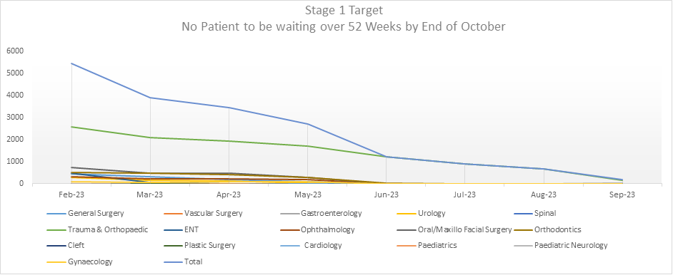

The summary position all Stages for end of March 2024 is as follows:

- As of 7 November 2023, the reported number of all 104 weeks that will breach by the end of March is 6202.
- The total volume of patients currently waiting over 104 weeks is 4202.

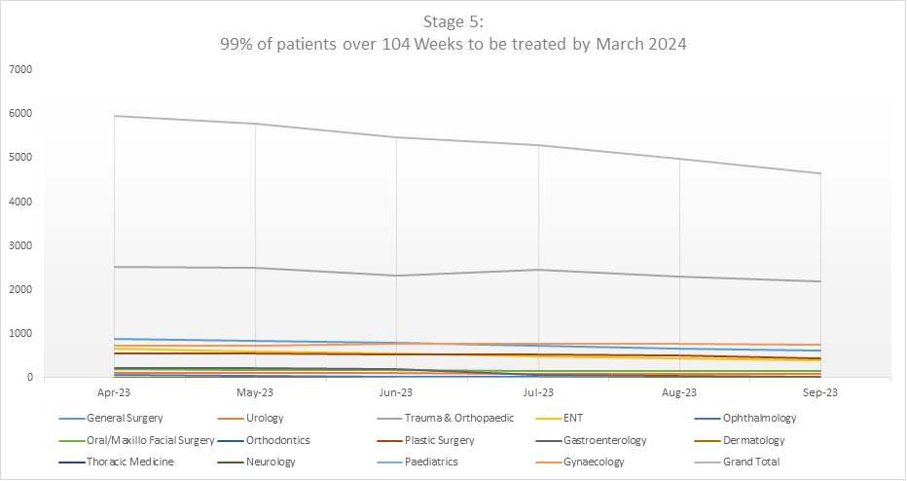

- Assessment of Progress

An assessment has been undertaken in line with the above targets and are explained below in detail which is broken down by stage.

3.1 Assessment of Progress: Stage 1

As previous stated, the target for Stage 1 for October 2023 has been achieved there is an expectation that this is a continuous target and as a Health Board we work towards achieve 36 weeks.

The table below shows the volume of patients that will breach 52 weeks by the End of November.

- 126 patients are currently waiting for an appointment to be arranged but assurance has been provided from each of the services that there is capacity to book these appointments before the end of November.

Service | Appointed | Waiting | Total
Cardiology | 6 |  | 6
ENT | 11 |  | 11
Gastroenterology | 71 | 14 | 85
General Surgery | 13 | 14 | 27
Gynaecology | 92 | 22 | 114
Neurology | 1 |  | 1
Ophthalmology | 147 | 28 | 175
Oral/Maxillo Facial Surgery | 5 |  | 5
Orthodontics | 10 |  | 10
Paediatrics | 1 |  | 1
Plastic Surgery | 6 |  | 6
Spinal | 20 |  | 20
Trauma & Orthopaedic | 55 | 10 | 65
Urology | 17 | 3 | 20
Vascular Surgery | 15 | 36 | 51
Total | 470 | 126 | 597

3.1.1 Identified Risks

Reduced outpatient’s appointments in gastroenterology due to increased clinical sessions into Same Day Emergency Care (SDEC) and additional sessions dedicated to endoscopy. In mitigation, it has been agreed to insource additional capacity with the understanding that this is not a sustainable plan. Health Care Engineering and Performance Team are undertaken a deep dive with the service to understand the current demand.

3.2 Assessment of Progress: Current Position for all stages

The end of March 2023 position, for patients waiting in excess of 104 weeks was 6,012 and good progress has been made in reducing this number with the provisional. Position (subject to further validation) at the end of October position is 4,202:

- 1866 waiting over 156 weeks; 686 waiting over 208 weeks.
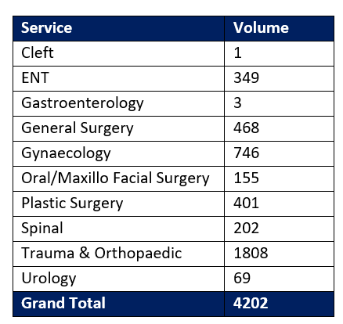

  - 104 Week Cohort for March 2024

In order to achieve the 104-week target there are currently 6202 patients in the cohort of patients who need to be seen, receive any diagnostics investigations and be treated by the end of March 2024.

Whilst Orthopaedics has the greatest number of patients in this cohort there are also significant numbers in other specialties, notably General Surgery, OMFS, ENT, Gynaecology, and Plastics; as shown in the table below.

Insourcing and outsourcing arrangements are now secured with the plan of deployment from November. Additional internal capacity is being commissioned to achieve the best possible position and administrative and clinical validation is ongoing.

As an example of the clinical validation recently undertaken, General Surgery consultants have undertaken an MDT approach to clinical validation in conjunction with Care of the Elderly (COTE) Physicians. A total of 574 patients (incl. 104-week patients) were reviewed with the below outcomes.

- 28 given dates for surgery to be undertaken | - 33 referred to Care of the Elderly (COTE)
- 61 given provisional dates for surgery to be undertaken | - 11 Removed from Waiting List
- 129 outsourced (pre-arranged) for surgery with private providers | - 14 Clinician specific, plan to be secured by 6th of November.
- 4 complex pancreatic cases to be outsourced to King’s in London | - 98 specialist consultant clinic review/ consultant opinion
- 123 for Mega Clinics | - 73 to be reviewed in general OPD.

Other specialties with large numbers of long waiting patients are in discussion with their clinical team regarding taking the same approach.

As shown in Appendix 1, the latest trajectory (September 2023) shared with Welsh Government from the plans developed indicates that there will be just under 1700 breaches of the 104 week target at the end of March 2024. This number will need to be reduced by approximately 800-1000 patients in order to achieve the 99% target.

This trajectory currently assumes validation removals (ROTT), the implementation of the Interventions Not Normally Undertaken (INNU) policy and a local Body Mass Index (BMI) Policy will yield the numbers set out in Appendix 1. The indications at present are that the ROTT rate number will be achieved and probably exceeded those detailed in the trajectory but the INNU removals will not be as great as anticipated and at present the BMI policy is only currently being applied to the orthopaedic (arthroplasty) cohort of patients; the Interim Medical Director is working with colleagues to introduce this more widely but there is some opposition from some clinical staff.

Where there is a current shortfall in the plans, all other options are being explored this include further insourcing and outsourcing, including NHS providers in England, where specialist surgery is required. Discussions are also ongoing with colleagues in Hywel Dda to utilisation theatre capacity in Prince Phillip Hospital to treat some of the “Morriston only” cohort of orthopaedic patients with a target of commencing these sessions end of November/early December.

  - 156 Week Cohort

Due to the volume of patients and the requirement to remove the longest waiting patients the fortnightly Performance Scrutiny meetings with the Service Groups are at present focusing particularly on the 156 weeks cohort of patients.

For the services highlighted in green below, there are plans to clear this cohort and the services in red are still currently working on treatment plans for the remaining patients; these will be finalised by the third week of November. The services that are currently at risk of delivering are Plastics, Spinal and Gynaecology, additional solutions for these services are being sought; as referred to above.
SERVICE | APPOINTED | WAITING | TOTAL | PLANS
Cleft |  | 1 | 1 | Plans to Clear
ENT | 20 | 229 | 249 | Further Outsourcing to Werndale & Weekend Lists
General Surgery | 13 | 259 | 272 | Clinical Validation & Mega Clincs Planned: Four complex pancreatic case – outsource to Kings
Gynaecology | 9 | 372 | 381 | Action Plan to be completed. Additional Patients to be Outsourced. Gap remains.
OMFS | 8 | 101 | 109 | Plans to Clear
Plastics | 14 | 266 | 280 | Require additional theatre sessions at Morriston and Singleton. Discussions with WHSCC about alternatives provision. Therapy Support Required to clear Hand Cohort.
Spinal | 8 | 155 | 163 | Additional Lists Planned
T&O | 53 | 926 | 979 | Plans to Clear
Urology | 13 | 22 | 35 | Plans to Clear
Grand Total | 138 | 2331 | 2469

  - Scrutiny and Assurance Process

Accountability and Monitoring of the Trajectories
The dynamic nature of the recovery necessitates scrutiny and monitoring, both internal and external to the organisation. The following outlines the monitoring and reporting structure that is in place and the mechanism for directorates to be held to account for delivery.

External Monitoring
Monthly monitoring meetings are scheduled with WG / NHS Executive officials and HB is represented at the monthly meetings by the COO and Deputy COO.

The monthly meetings focus on:
  - Validation
  - Treat in turn
  - Plans for longest waits
  - Detailed speciality discussions / issues / areas of concerns
  - Progress on HB transformation measures
  - Progress on developing patient support and communication

A weekly individual patient level submission on the plan for all patients waiting over 5 years, a summary of which can be seen below, is also being provided to the NHS Executive; this will change in the next month to all waiting over 4 years.

Internal Monitoring
There are fortnightly meetings with the Service Groups where they are held to account for delivery of the trajectories. Escalation for the non-delivery against the submitted levels will be to the Service Group Directors in the first instance and subsequently to the Planned Care Board and Management Board.

- Operational monitoring - the current performance management meetings:
  - monitor delivery of the trajectories and the areas of efficiency noted above
  - ensure core capacity is at or above 2019/20 levels
  - ensure robust housekeeping is in place for RTT pathways
  - further develop recovery plans as required for approval via Planned Care Board

- Formal monitoring / assurance
  - Service Group Performance Reviews
  - Planned Care Board
  - Management Board via the Performance Report
  - Performance & Finance Committee

To help support directorates a Planned Care Dashboard has been developed with specialty level performance information.

Risks
The Health Board has achieved the 52 week target for first outpatient appointments and services will be expected to maintain this position. However, there are significant risks associated with meeting the 104 week target:

- Pre-assessment Capacity – this is becoming an ongoing issue for the Health Board as the current capacity for pre-operative assessment (POA) is insufficient to adequately populate theatre sessions. The HSCE has undertaken work in orthopaedic and identify means to increase capacity by around 50% similar work is required for general preoperative assessment.

- Theatre Capacity – the current shortfalls in theatre staff and anaesthetists are currently limiting the delivery of optimum theatre capacity. Recruitment of theatre staff is ongoing and improving but the recruitment of anaesthetic staff is providing more of a challenge.

- FINANCIAL IMPLICATIONS

As a result of the additional funding secured for the NPTH development there is now £38.4m allocated to Planned Care Recovery. However, the current recovery plans exceed this figure by approximately £7.5 (month 6 position). There are a number of assumptions in this figure including the anticipated spend on the NPTH development and full utilisation of the outsourcing capacity.

The Health Board’s financial recovery plans assume that no more than £38.4 will be spent and if this continue to exceed this allocation then a reduction of outsourcing and insourcing will be necessary and the impact on waiting list calculated with revised trajectories.

- RECOMMENDATION

Management Board are asked to:
- NOTE the considerable progress made to date to achieve the Ministerial Target,
- SUPPORT the additional actions being undertaken to deliver the target by March 2024 and acknowledge the associated risks.

Governance and Assurance

Link to Enabling Objectives  (please choose) | Supporting better health and wellbeing by actively promoting and empowering people to live well in resilient communities
Link to Enabling Objectives  (please choose) | Partnerships for Improving Health and Wellbeing |  | ☐
Link to Enabling Objectives  (please choose) | Co-Production and Health Literacy |  | ☐
Link to Enabling Objectives  (please choose) | Digitally Enabled Health and Wellbeing |  | ☐
Link to Enabling Objectives  (please choose) | Deliver better care through excellent health and care services achieving the outcomes that matter most to people
Link to Enabling Objectives  (please choose) | Best Value Outcomes and High Quality Care |  | ☐
Link to Enabling Objectives  (please choose) | Partnerships for Care |  | ☐
Link to Enabling Objectives  (please choose) | Excellent Staff |  | ☐
Link to Enabling Objectives  (please choose) | Digitally Enabled Care |  | ☐
Link to Enabling Objectives  (please choose) | Outstanding Research, Innovation, Education and Learning |  | ☐
Health and Care Standards
(please choose) | Staying Healthy |  | ☐
(please choose) | Safe Care |  | ☐
(please choose) | Effective Care |  | ☐
(please choose) | Dignified Care |  | ☐
(please choose) | Timely Care |  | ☐
(please choose) | Individual Care |  | ☐
(please choose) | Staff and Resources |  | ☐
Quality, Safety and Patient Experience
The successful implementation of the plans outlined have the ability to improve the quality and safety of services and in turn patient experience. However, the report has outlined a number of risks, which have the potential to delay benefit realisation.

Financial Implications
There is a significant risk that the financial allocation in 2023/24 for the Planned Care Recovery Programme will limit the progress that the Health Board is able to make in reducing waiting times further.

Legal Implications (including equality and diversity assessment)
There are no legal implications to consider as a direct result of this report.

Staffing Implications
A number of the improvement plans are facing challenges with recruitment and the availability of re-current funding.

Long Term Implications (including the impact of the Well-being of Future Generations (Wales) Act 2015)
This paper outlines how service areas within the Planned Care Programme are working in collaboration not only to look at the short term, but also to develop services across Swansea Bay in the long-term including the new theatres and the plans to enhance innovation and new ways of working.

Report History |  | May 23 – Planned Care Update
Appendices |  | Appendix 1 - SBUHB Trajectory - Delivery of 104 Weeks by End of March 2024

Appendix 1
SBUHB Trajectory - Delivery of 104 Weeks by End of March 2024  Target: 800 (to achieve 99%) |  |  | Monthly (Aug 23 - March 24) |  |  |  |  |  |  |  | Variance
 |  |  | August | September | October | November | December | January | February | March | Total | Variance | Variance  Core + Additional
STARTING BACKLOG POSITION - STAGE 5 | ⁸¹⁷⁸ | ^{BREACH NUMBER PER SERVICE}
STARTING BACKLOG POSITION - STAGE 2/3 | ⁸⁷⁸
^{ACTIVITY TYPE} | ^{SERVICE}
^{CORE} | ^{ENT} | ⁶⁶² | 28 | 28 | 28 | 28 | 28 | 28 | 28 | 28 | 224 | -438
^{CORE} | ^{GASTRO} | ⁵⁶⁵ | 17 | 17 | 17 | 17 | 17 | 17 | 17 | 17 | 136 | -429
^{CORE} | ^{GENERAL SURGERY} | ¹³⁰⁴ | 58 | 58 | 58 | 58 | 58 | 58 | 58 | 58 | 464 | -840
^{CORE} | ^{GYNAE} | ⁹¹⁸ | 44 | 44 | 44 | 44 | 44 | 44 | 44 | 44 | 352 | -566
^{CORE} | ^{NEURO} | ⁶ | 0 | 2 | 0 | 2 | 0 | 2 | 0 | 0 | 6 | 0
^{CORE} | ^{OPHTHALMOLOGY} | ⁹⁹ | 29 | 29 | 29 | 12 | 0 | 0 | 0 | 0 | 99 | 0
^{CORE} | ^{OMFS} | ²⁴⁹ | 6 | 6 | 6 | 6 | 6 | 6 | 6 | 6 | 48 | -201
^{CORE} | ^{PLASTICS} | ⁷³⁴ | 38 | 38 | 38 | 38 | 38 | 38 | 38 | 38 | 304 | -430
^{CORE} | ^{ORTHOPAEDICS} | ³⁰⁴⁷ | 109 | 109 | 109 | 109 | 109 | 109 | 109 | 109 | 872 | -2175
^{CORE} | ^{UROLOGY} | ²¹³ | 19 | 19 | 19 | 19 | 19 | 19 | 19 | 19 | 152 | -61
^{CORE} | ^{VASCULAR} | ³ | 0 | 1 | 0 | 1 | 0 | 1 | 0 | 0 | 3 | 0
^{CORE} | ^{CLEFT} | ³ | 0 | 1 | 0 | 1 | 0 | 1 | 0 | 0 | 3 | 0
^{CORE} | ^{SPINAL} | ³⁷⁵ | 10 | 10 | 10 | 10 | 10 | 10 | 10 | 10 | 80 | -295
^{ADDITIONAL} | ^{ENT} |  | 42 | 72 | 72 | 72 | 72 | 72 | 72 | 72 | 546 |  | -108
^{ADDITIONAL} | ^{GENERAL SURGERY} |  | 16 | 63 | 63 | 63 | 63 | 63 | 63 | 63 | 457 |  | 383
^{ADDITIONAL} | ^{OMFS} |  | 24 | 24 | 24 | 24 | 24 | 24 | 24 | 24 | 192 |  | 9
^{ADDITIONAL} | ^{ORTHOPAEDICS} |  | 0 | 181 | 181 | 181 | 181 | 181 | 181 | 181 | 1267 |  | 2652
^{ADDITIONAL} | ^{GYNAE} |  | 0 | 22 | 22 | 22 | 22 | 22 | 22 | 22 | 154 |  | 412
^{ADDITIONAL} | ^{SPINAL} |  | 11 | 11 | 11 | 11 | 11 | 11 | 11 | 11 | 88 |  | 284
^{ADDITIONAL} | ^{PLASTICS} |  | 0 | 69 | 69 | 69 | 69 | 69 | 69 | 69 | 483 |  | -53
^{ADDITIONAL} | ^{UROLOGY} |  | 0 | 14 | 14 | 0 | 14 | 5 | 0 | 14 | 61 |  | 0
Total Planned Activity |  |  | 451 | 818 | 814 | 787 | 785 | 780 | 771 | 785 | 1488
Backlog Forecast |  |  | 7727 | 6909 | 6095 | 5308 | 4523 | 3743 | 2972 | 2187
Expected Increase of 20% Conversion from Stage 2/3 |  |  |  |  |  |  |  |  |  | 176
 |  | Backlog Reduction with ROTT at 20% |  |  |  |  |  |  |  | 437
 |  | Backlog Reduction with INNU at 5% |  |  |  |  |  |  |  | 109
Backlog Forecast with BMI POLICY at 15% |  |  |  |  |  |  |  |  |  | 328

