Meeting Date | 24 March 2026 |  | Agenda Item |  |  | 2.2
Name of Meeting | Performance & Finance Committee
Report Title | Financial Report – Month 11 2025/26
Report Author | Samantha Moss, Deputy Director of Finance  Gemma Pearson, Finance Business Partner  Crystal Davies, Principal Finance Manager
Report Sponsor | Claire Osmundsen-Little, Interim Director of Finance
Presented by | Samantha Moss, Deputy Director of Finance
Freedom of Information | Open
Purpose of the Report | The report advises the Performance & Finance Committee of the Health Board on the financial position for Month 11 2025/26 (February 2026) and risks regarding the current forecast revenue year end outturn.
Key Issues | The report invites the Performance & Finance Committee to note the detailed analysis of the financial position for Month 11 2025/26 (February 2026).  The report includes a summary of the key drivers of the position either at Service level or by expenditure type (i.e. Non-Pay/Pay). It also provides information of the current position with regards to Health Board reserves to ensure transparency in the overall Health Board position.  Risk will have been considered on the basis of the information provided within the report and the score updated where necessary.  Whilst the key messages are provided within the main body of the report, further information is provided in the Appendices.
Specific Action Required  (please choose one only) | Information | Discussion |  | Assurance | Approval
Specific Action Required  (please choose one only) | ☐ | ☐ |  | ☒ | ☐
Recommendations | Members are asked to: -  - CONSIDER the 2025/26 Financial Plan, and the Health Board’s and Welsh Government’s inability to approve it given the planned deficit of £58.7m.  - CONSIDER the actions in place with regards to Welsh Government’s expectation that the Health Board delivers the £55.4m savings to support the delivery of the 2025/26 Financial Plan.  - Consider and comment upon the Health Board’s financial performance for Month 11 2025/26 and the Year to Date (YTD) position.  - CONSIDER the risks to the position at Month 11.  - SUPPORT the position with regards to Health Board reserves.

FINANCIAL REPORT – MONTH 11 2025/26

- INTRODUCTION
The Annual Plan submitted to the Welsh Government on 31 March 2025 included a financial assessment, as summarised in the table below:
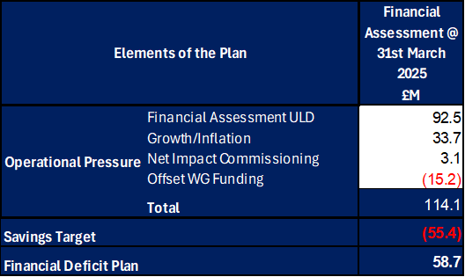

The Welsh Government issued a letter to the Health Board on 6 June 2025 indicating that the planning process has been closed to focus on delivery and improvement. The Welsh Government issued a further letter on 18 August requesting an update on the Annual Financial Plan and actions being taken by the Health Board for submission by 11 September. This document was presented at the Special Board Meeting on the 11 September which provided full details of the actions and milestones to achieve the original £55.4m savings to support the delivery of the original plan submission made in March 2025. Progress against this Plan is detailed in sections below. Therefore, at Month 11 the forecast for 2025/26 remains as per the original plan submission of £58.7m.

- FINANCIAL PERFORMANCE

KEY PERFORMANCE INDICATORS
TARGET | ACTUAL PERFORMANCE
Cash Balance Bank < £6.0m | £10.761m
In Month Performance Revenue Resource Limit ≤ 1/ 12th £58.7m | (£0.093m)
YTD Performance Revenue Resource Limit ≤ £ 11/12th 58.7m | £57.251m
YTD Performance Capital Resource Limit ≤ £0m | £0.446m
YTD Performance Public Sector Payment Policy > 95% | 96.4%

FINANCIAL REPORT REVENUE – MONTH 11

The Health Board’s assessment on performance against the £58.7m deficit has three components Operational Pressure, Savings Target, and Planned Deficit. Performance against these three elements at Month 9 is summarised in Table 1 below. At Month 11 there was an In-Month underspend of (£0.1m), which is £5.0m below the £58.7m planned deficit, with the YTD position reporting a £57.3m deficit, which is £3.5m above £58.7m plan.

Table 1: Delivery YTD
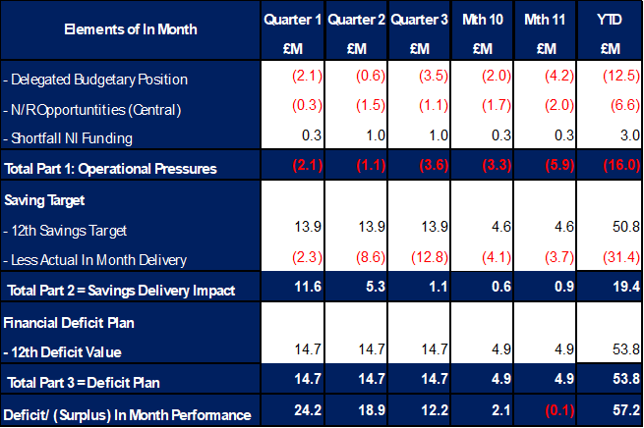

It has been clear all year and as detailed in Table 1 that the In-Year issue has remained the non-delivery of savings. This shortfall in delivery YTD is in part mitigated by ‘Delegated Budget’ position underspending and the central N/R opportunities as set out in the 11 September 2025 submission delivering. Whilst excluding the non-delivery of saving most areas are within the delegated operational budgets, the key exception remains Mental Health & LD Services. Throughout the year there have been pressures linked to pay and CHC but also Temporary Adult Placements. The latter issue has resulted in an in-month pressure of £0.7m, with YTD expenditure of £6.8m.

On savings performance the submission made on 11 September 2025 set out the Plan to deliver the £55.4m savings in 2025/26. This was a combination of (1) Part A - budgetary releasing savings delivery supported by our external strategic partner; alongside (2) Part B - delivery of underspends in the operational budgets specifically around the corporate directorates and N/R opportunities. The monitoring of the performance for Part A is undertaken through the existing governance arrangements, using the Health Board’s savings trackers. This data is then used to complete the Welsh Government Monthly Monitoring Return (MMR) Savings Tables. However, as Part B are improvements in run rate and not a formal budgetary savings this element of the plan is not reported in Savings Tables but is incorporated in the wider run rate position. A summary of the assessed performance is provided in Table 2a:

Table 2a: Summary Forecast Performance against £55.4m
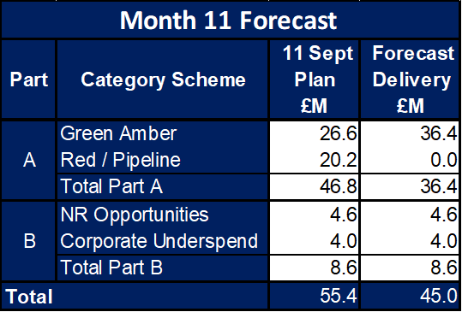

Regarding the delivery of the £46.8m the top section of Table 2b below demonstrates the original plan on 11 September 2025, the plans as per the trackers at Month 11 and the forecast delivery at Month 11. The scheme type is split based on the Amber and Green as per the MMR, Local Red schemes, Local Pipeline ideas and those schemes presented by Deloitte. From Month 10 to Month 11 there has been no movement in the overall delivery, simply a movement of all Ambers to Greens.

Table 2b: Summary of Savings Plan and Forecast Delivery
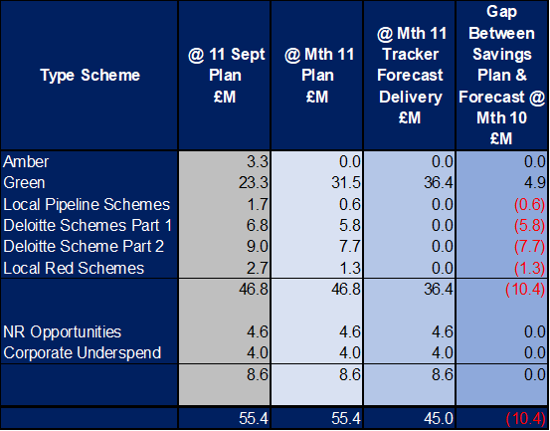

The pressures seen in operational areas such as Mental Health as detailed above as well as non-delivery of the £55.4m savings target, alongside the pressures linked to ENIC and Nurse Streamline numbers has culminated in the Health Board needing to identify further actions to address the £58.7m deficit plan. Details on the actions taken over the financial year have been provided in previous submissions both to PFC and the Board. At the end of February 2026 further actions were agreed by the Executive Team and the Board, which will also support the opening Quarter of 2026/27, prior to a further review at the start of the next financial year. A summary of these additional actions and their assumed savings is summarised in the table below:

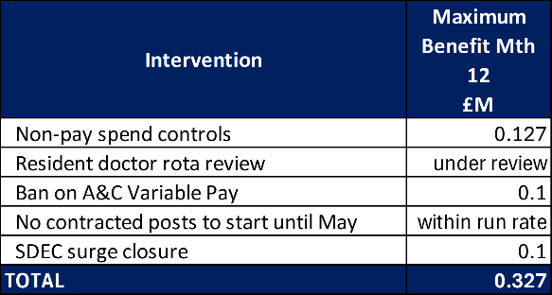

Whilst the Health Board has set out actions (see 4.6 Appendix 1), the delivery of the £58.7m and mitigations of the in-years challenges has been driven by the identification of non-recurrent opportunities. Since Month 9 a summary of further opportunities has been shared. The latest assessment of opportunities that may deliver in the last month of 2025/26 is provided in the table below. Those items highlighted in yellow have now been accounted for within the financial year (Month 11) and have contributed to the in-month improvement.

Table 3: Summary N/R Opportunities @ Month 11
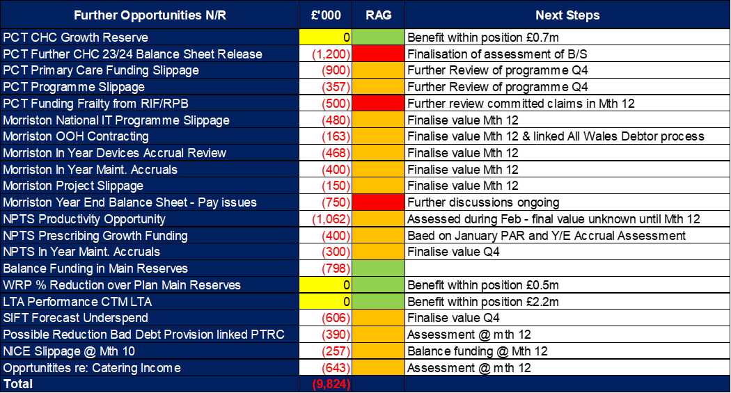

Note – since assessment N/R Opportunities were reviewed post Month 11 the Welsh Government has issued an update on 10/03/26, which materially impacts on £0.9m PC Funding Slippage, and the team are working through this urgently to assessment as part of Month 12

With regards to the overall financial performance, Graph 1 below reflects the actual financial performance in each month, with the orange bars reflecting the performance required to achieve the original plan of £58.7m. Graph 2 outlines the savings delivered to date as the blue bars against the monthly target set (red line), and the orange bars reflect the level of savings required in future months to achieve the £55.4m target aligned to the £58.7m plan.

Graph 1: Performance Graph 2: Savings
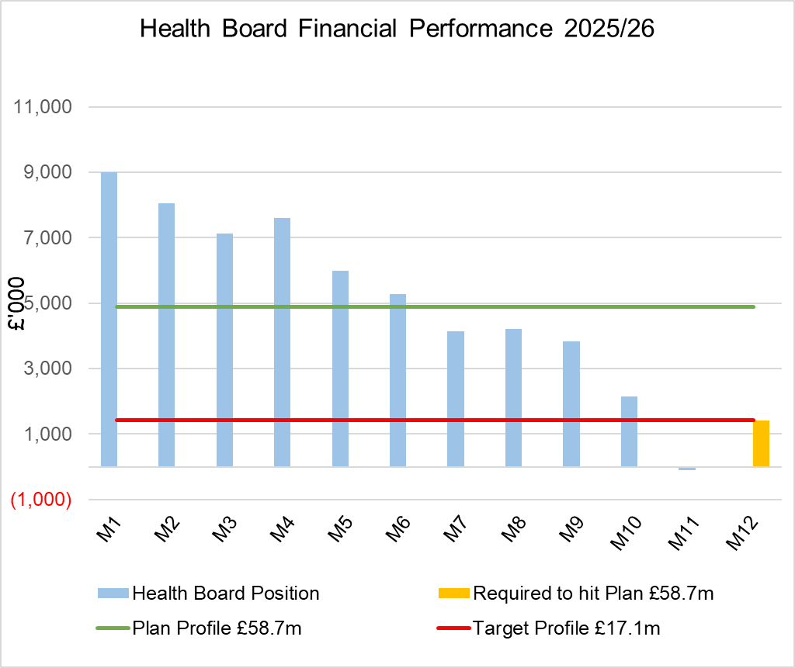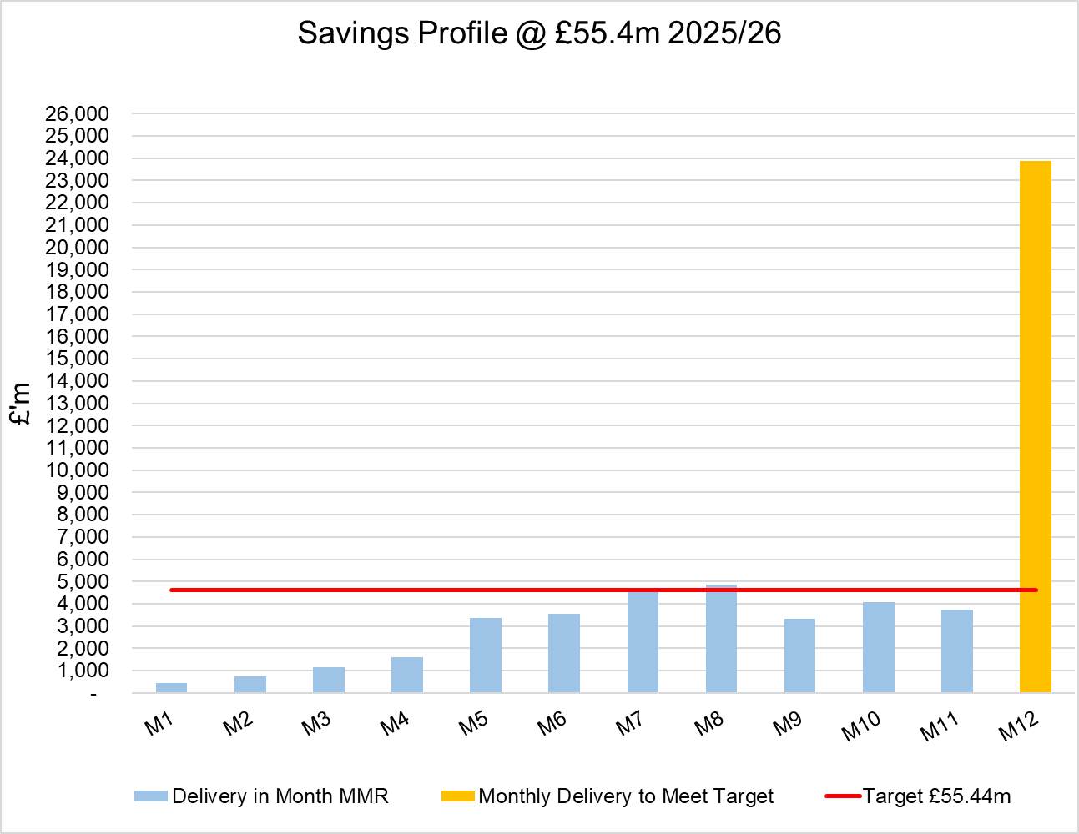

- KEY DRIVERS OF THE IN-MONTH POSITION
The key drivers of the Month 11 position are summarised in the table below. Further detail at a Health Board level of expenditure on Income, Pay and Non-Pay, is also provided in Appendix 1.

  - Key Drivers by Service Area In-Month

  - Key Drivers by Service Area YTD

  - Summary By Expenditure Type

- Income
The Joint Commissioning Committee (JCC) Income as a provider under-performed by £0.1m in-month (£2.4m over-performance YTD). This has been driven by the Caswell clinic settlement.

- Pay
Month 11 pay is broadly in line with the prior month; the continued vacancy freeze primarily in Admin & Clerical and other Pay Controls being the driver for this. Variable pay expenditure has decreased slightly from January levels (£4.4m in-month vs £4.5m in Month 10).

- Clinical Consumables
(see Appendix 1)

- Prescribing
(see Appendix 1)

- SAVINGS
Full details on savings are provided Appendix 3, but in summary the in-month delivery in Month 11, was £3.75m against a target of £4.62m; on a Year To Date (YTD) basis the undelivered savings gap is £19.4m and remains the key driver of the Health Board overspend. This is before the application of the non-recurrent opportunities set out in table 2a and 2b, as these are not classified as savings.
Part C Actions
- Part C1: Savings Trackers Red & Corporate Stretch @ 4 September 2025
- Part C2: Savings Trackers Pipeline @ 4 September 2025
- Part C3: In-year impact of the thematic Scheme Summaries (adjusted to avoid double count)
Further Actions
- Additional interventions to close the gap to the original savings plan
  - Exec oversight of variable pay
  - Additional capacity reduction
  - Non pay bans / restrictions

- GOVERNANCE AND RISK ISSUES
Two Board level financial risks:

Achieving financial plan (HBR92) with the key elements as follows: -

  - Risk of delivery of savings quantum
  - Risk of operational overspend being more than funding available agreed via the Financial Plan
  - Risk of commitment of reserves (e.g. NICE) being above reserves available.
  - Risk of achieving the actions and options outlined in the 2025/26 Financial Recovery & Sustainability Assessment.

Whilst there are Non-Recurrent Opportunities to support Month 12 and the journey to £58.7m, based on the financial performance YTD and the shortfall in the delivery of savings both in year and recurrent, it is recommended that the Health Board Corporate Risk Register continues to reflect a risk score of 25.

Within the YTD and assessment to 31 March 2026 the Health Board is managing the following pressures: -

  - Employer National Insurance Contribution Shortfall Funding
  - Nurse Streamlining (144 WTE)
  - Mental Health and Learning Disabilities Service Group (MHLD SG) Temporary Adult Placements
  - MHLD SG Operational Pressures Variable Pay and CHC

Whilst these may currently be mitigated on a non-recurrent basis there will be a recurrent impact on the Underlying Deficit.

The additional risks to the in-year position above those noted in the opening sections of the paper, yet to be mitigated and reported to the Welsh Government are:
  - Non-delivery of the current planned and unplanned pressure and associated mitigating actions.
  - JCC General Risk = £0.5m

JCC position linked to Caswell has been addressed and is now reflected within the Month 11 position.

Availability of capital (HBR93). This risk was re-opened in 2022/23 given the reduction in discretionary capital allocation. Due to the additional capital funding provided during 2024/25 the risk score was reduced to 12. The score was increased in June 2025 to reflect risks regarding Emergency Department and Adult Acute Mental Health. However, following further assessment at start Quarter 4 2025/26 and based on funding received the risk score has reduced to 12.

- RECOMMENDATIONS

Members are asked to:

- CONSIDER the 2025/26 Financial Plan, and the Health Board’s and Welsh Government’s inability to approve it given the planned deficit of £58.7m.
- CONSIDER the actions in place with regards to the Welsh Government’s expectation that the Health Board delivers the £55.4m savings to support the delivery of the 2025/26 Financial Plan.
- Consider and comment upon the Health Board’s financial performance for Month 11 2025/26 and the Year to Date (YTD) position.
- CONSIDER the risks to the position at Month 11.
- SUPPORT the position with regards to Health Board reserves.

Governance and Assurance

Link to Enabling Objectives  (please choose) | Supporting better health and wellbeing by actively promoting and empowering people to live well in resilient communities
Link to Enabling Objectives  (please choose) | Partnerships for Improving Health and Wellbeing |  | ☐
Link to Enabling Objectives  (please choose) | Co-Production and Health Literacy |  | ☐
Link to Enabling Objectives  (please choose) | Digitally Enabled Health and Wellbeing |  | ☐
Link to Enabling Objectives  (please choose) | Deliver better care through excellent health and care services achieving the outcomes that matter most to people
Link to Enabling Objectives  (please choose) | Best Value Outcomes and High-Quality Care |  | ☐
Link to Enabling Objectives  (please choose) | Partnerships for Care |  | ☐
Link to Enabling Objectives  (please choose) | Excellent Staff |  | ☐
Link to Enabling Objectives  (please choose) | Digitally Enabled Care |  | ☐
Link to Enabling Objectives  (please choose) | Outstanding Research, Innovation, Education and Learning |  | ☐
Health and Care Standards
(please choose) | Staying Healthy |  | ☐
(please choose) | Safe Care |  | ☐
(please choose) | Effective Care |  | ☐
(please choose) | Dignified Care |  | ☐
(please choose) | Timely Care |  | ☐
(please choose) | Individual Care |  | ☐
(please choose) | Staff and Resources |  | ☐
Quality, Safety and Patient Experience
Financial Governance supports quality, safety, and patient experience

Financial Implications
The Board is reporting a forecast year-end deficit financial outturn.

Legal Implications (including equality and diversity assessment)
No implications

Staffing Implications
No implications

Long Term Implications (including the impact of the Well-being of Future Generations (Wales) Act 2015)
No implications

Report History |  | Updates on the financial position are provided at every meeting.
Appendices |  | Appendix 1 – Variances by Area and Type of Expenditure  Appendix 2 – Reserves and Central Budgets  Appendix 3 – Savings  Appendix 4 – Accountability Letters

APPENDIX 1 – FURTHER DETAIL ON VARIANCES BY AREA & TYPE OF EXPENDITURE
- Overview Financial Position

- Overview of Income

The table below compared the income performance in Month 11 to the average levels of 2023/24 and 2024/25.

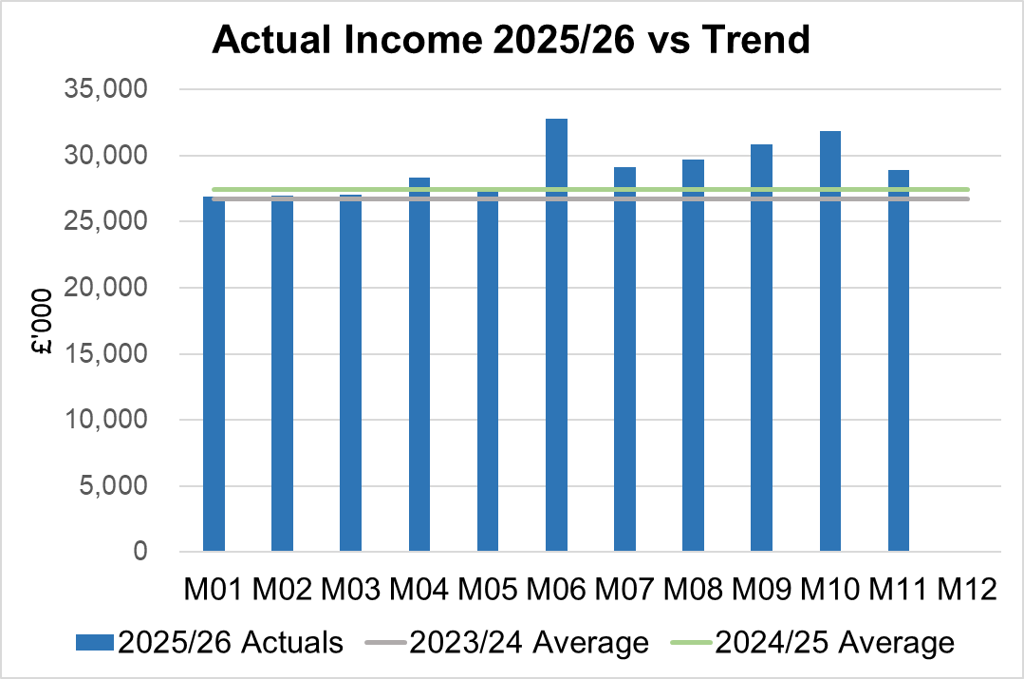

Income had decreased in Month 11 due to a one-off settlement in relation to the Caswell Clinic reducing JCC income. This has been partly offset by an increase in the level of rebate for the Mounjaro drug, with the YTD increase being recognised in relation to the price increases confirmed from September (£1.1m); a continuation of the one-off income for neonatal intensive care unit (NICU) English patients of £0.2m; one off income in relation to substance misuse due to a caseload transfer (£0.1m); and further income in relation to Digital Mental Health Connecting Care programme “Rio”.

2.1 JCC Income

The Health Board monitors performance on a monthly basis for JCC activity, which is predominantly delivered via the Morriston Service Group. Throughout the financial year there are variance movements linked to performance. The table below provides a summary of the performance at Month 11 for each speciality area.

  - Anticipated Income
The below table highlights anticipated income the Health Board expects to receive during 2025/26. The current deficit plan of £58.7m is predicated on receipt of these Welsh Government funds at the levels anticipated.

- Pay, Agency & Other Variable Pay Expenditure

Total Pay

The Month 11 total remains higher than the prior two years average (as shown in the graph below). Within Month 9 & 10 actuals are the recognition payments and arrears linked to the Workforce uplift for the Band 2-3.

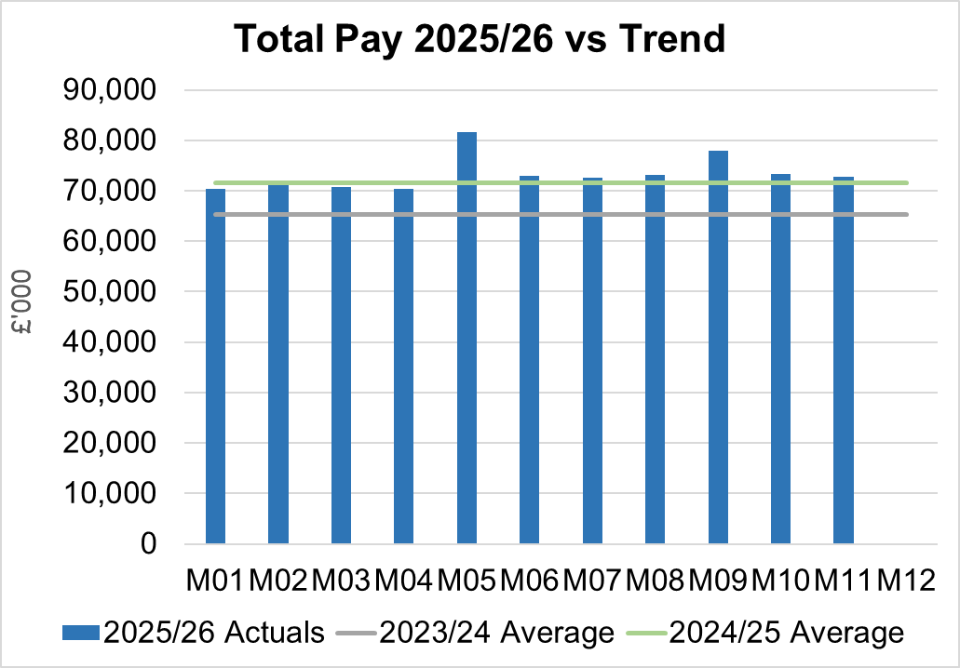
Note - 2023/24 and 2024/25 values have been notionally increased by pay award uplifts to allow for comparison to current value of 2025/26 pay value.

Variable Pay

Variable pay is £0.969m lower in Month 11 2025/26 (£4.353m vs £5.322m) when compared to the same period last year (graph below shows this year’s actual versus prior year’s average) and is £0.174m lower than Month 10 2025/26.

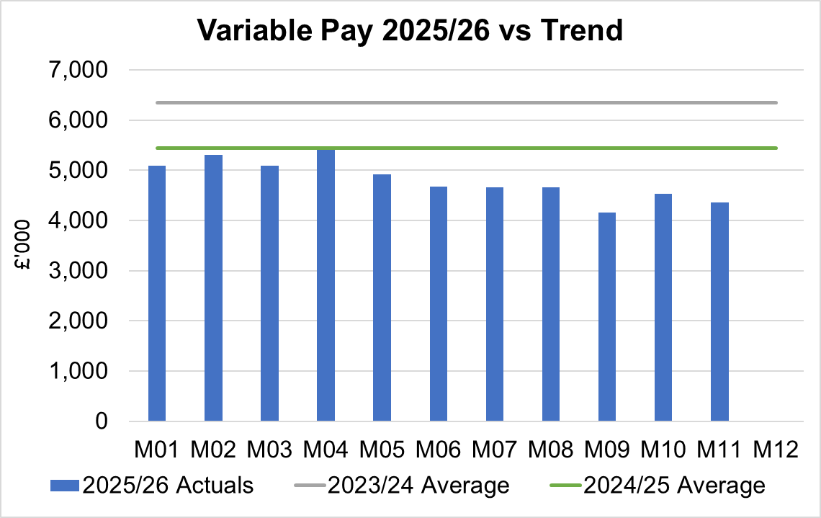

Variable Pay is classified by the Health Board into the following categories: Agency, Bank, Overtime, Waiting List Initiatives (WLI) and Irregular Sessions, a breakdown of the expenditure into these categorise is provided below.

Variable Pay by Expenditure Type

Health Care Support Workers (HCSW) Variable Pay and Vacancies by Service Group

It is recognised that the Health Board is holding significant levels of vacancies for HCSW, which will drive the need for some variable pay.

The four graphs below show the vacancies as reported in the ledger against the level of variable spend for the same period over the current financial year.

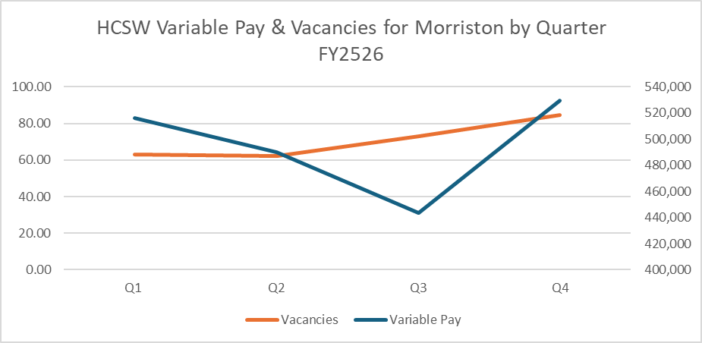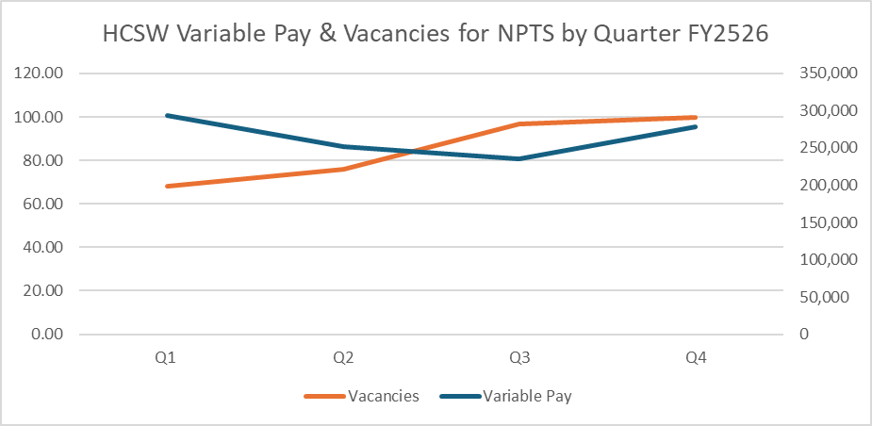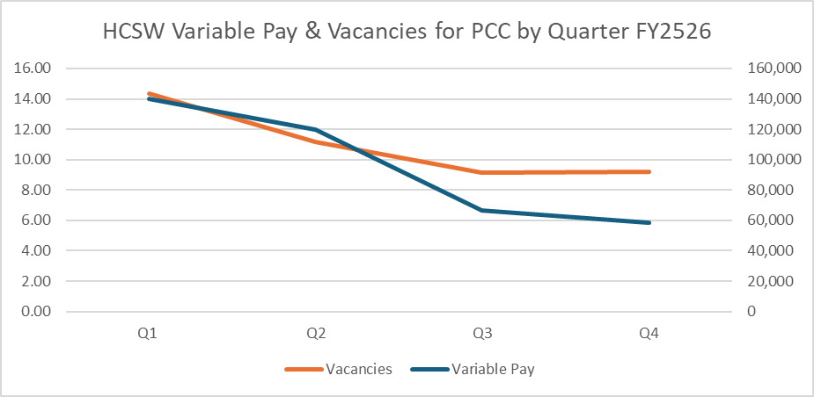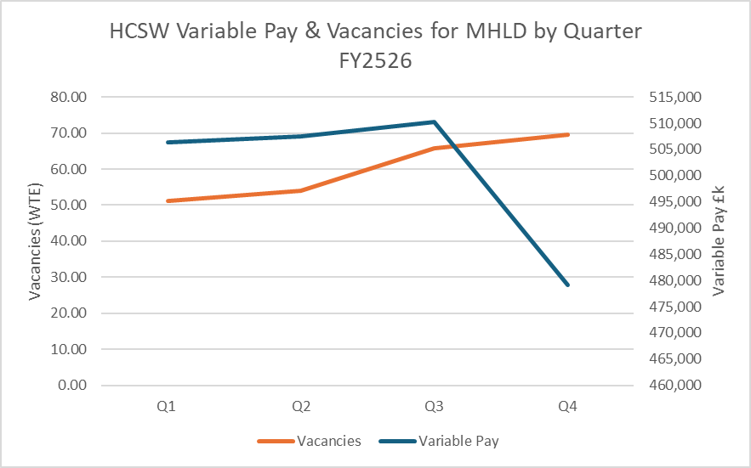

- Overview Non-Pay

Actual Non-Pay expenditure for Month 11 is higher than the last 2 year’s average expenditure levels (as shown in the graph below). This increase is mainly linked to the recognition of the costs of the Phase 2 extension of External Consultancy.

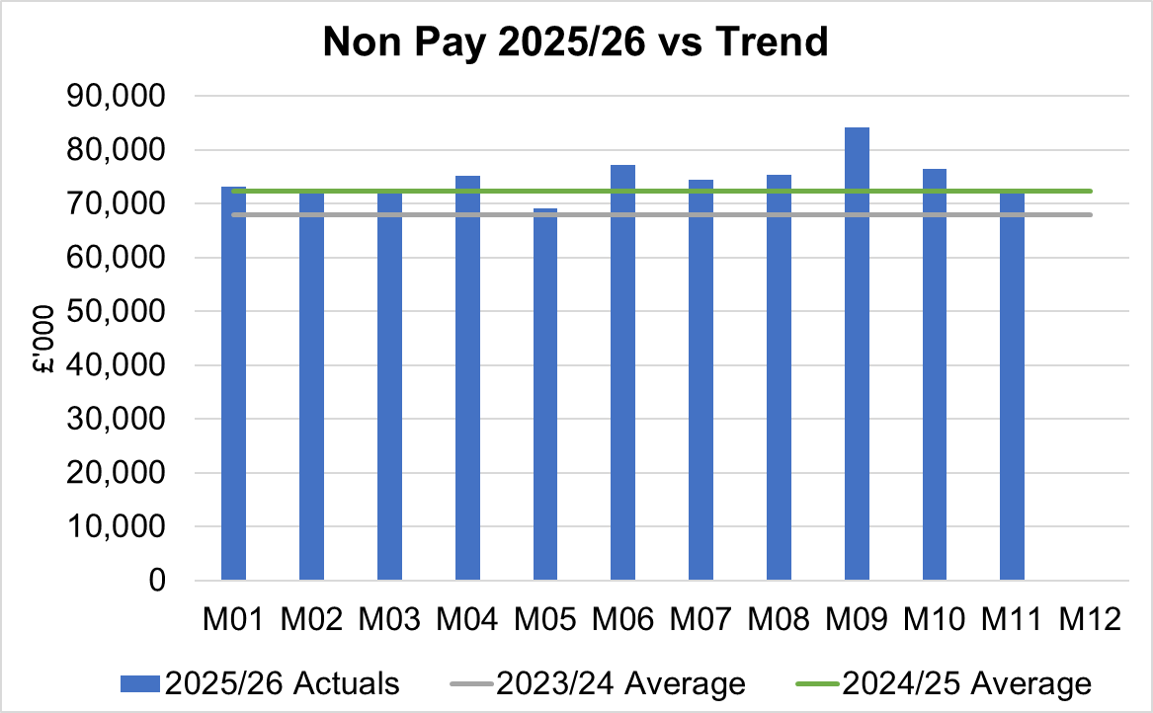

Below are further details on the key areas of non-pay:

  - Clinical Consumables
This area overall has an in-month overspend of £0.1m. Within the ledger the gross JCC income is reflected within the income lines and not netted off against expenditure and so overall the Health Board position is not adversely affected. If JCC activity increases the gross level of expenditure and income will increase. The main drivers within this category of clinical consumable expenditure include heart valves & pacemakers, linked to some JCC activity. This category also includes secondary care drugs, a breakdown of the categories of Clinical Consumables is provided below:

  - Primary Care Prescribing
Prescribing was slightly underspent (£0.1m) in-month and YTD is £0.04m overspent following receipt of the latest dataset (December 2025).

  - CHC and Adult Mental Health Placements
In Month 11 CHC was overspent by £0.4m (YTD £3.0m). The pressure continues at £0.5m for growth (Month 10, £0.6m) more than the Plan.

An analysis of actual expenditure and patient numbers for 2025/26, along with the average values from 2024/25 is provided in table below. The table also includes the Temporary Adult Mental Health Placements for transparency.

Analysis by Month
Please note:
- PCT Group numbers are based on bed days
- MHLD Group are based on cases
- PCT Group does not include the Singleton/NPT element. The NPTS element which covers Children and Young People CHC patients is provided internally by the Health Board and as such is part of the wider NPTS position and is not recorded in the ledger as PCT/MH/LD CHC.

Post Month 9 a review of the categorisation of the Temporary Adult Placements was undertaken with other Health Boards. Following this review in Month 10 these costs were re-categorised within the ledger to subjective ‘Out of Area Treatments’, under the heading of ‘Other Private & Voluntary Sector. To maintain a comparison to the Month 9 report, a separate column has been included in the table above to reflect the split of CHC and the Temporary Adult Placements.

  - Maternity Review
The total costs for this are allocated to a dedicated Cost Centre (6F34).

  - Z Codes (Section 1,3-4 Table Point 1 Appendix 1)
The narrative below groups together the key elements of the Z codes detailed in Point 1 of this appendix.

- Contracting: SLA /LTA performance: JCC (previously WHSSC), LTA and SLA contract income and expenditure are transacted within this area and financial performance reported. NICE approved high-cost drugs and associated LTAs are also transacted and monitored against targets set. In addition to this, non-contracted activity income in relation to English foundation trusts invoiced on a quarterly basis are reported.

- Capital: The Finance Capital Team manage a number of cost centres covering the PFI, IFRS16 and Depreciation charges for assets both owned and donated are transacted here.

- RRL and Central Reserves: The Welsh Government funding received at the start of the year is tracked within this area. Any anticipated allocations in year are also transacted through these codes. Other HB wide funding received from HEIW and SIFT is also captured in here. All central reserves remain within the Z cost centres and details of these are provided in Appendix 2.

- Corporate income and expenditure. Any income and expenditure that is not service group specific is transacted and reported through a number of corporate Z cost centres, examples include, payroll and pension costs, VAT recovery, losses and receipts in relation to funding from Welsh Risk Pool, overseas visitors’ income and Road Traffic Accident income.

  - Summary Actions from December 2025 Special Board
The table below summarised the actions agreed at the meeting held 16 December 2025, and the delivery of these actions through Q4.

  - LTA Values & Forecast performance
The table below is based on Month 10 activity undertaken by other Health Boards and Trusts for Swansea Bay residents (SBU Commissioner) and activity undertaken by Swansea Bay for residents of other Health Boards.

The above figures include the annual contract values plus invoices relating to patient activity. SBU Commissioner Performance variances are based on information received from each organisation. Forecast performance variances are subject to fluctuations and exclude NICE drug recharges.

APPENDIX 2 – DETAILS ON RESERVES & CENTRAL BUDGETS

- SUMMARY RESERVES
Overall management of the reserves is as per the Health Board Budget Management document.

  - Balances: Main & NICE
For 2025/26, the Health Board will hold two central reserves and the purpose of these reserves are below:
- Main – this holds funding from Welsh Government or the plan that has yet to be issued to Budget Holders. These items are not surplus but either due to timing have not been issued or is an area where funding is issued based on actual values consumed in future month.
- NICE – this holds the total Health Board funding for all NICE costs (drugs and infrastructure) and is issued to the service each month based on the actual costs consumed as reported through the Pharmacy system.

Details on the balances and movements are provided in the Table below:

- COVID RECOVERY
As part of the Financial Plan the Welsh Government Funded £15.2m for Local COVID Recovery and £19.5m for Regional COVID Recovery. The funding remains in Central Reserves and is reported in Main reserves in Section 1 above. This funding is then issued to service areas based on the actual costs committed. A summary of the forecast costs against the original funding total of £34.7m is summarised in the table below:

The Welsh Government are also issuing additional non-recurrent funding to support the reduction of the 52 week and 104 week target, alongside diagnostic targets. This is in addition to the original Planned Care Recovery £34.7m detailed in the table above. This non-recurrent funding for Planned Care is held in Main or Service Group local reserves until the costs are committed at which point funding is issued to the relevant budget line.
APPENDIX 3 – SAVINGS

The section below reflects performance against the original £55.4m requirement taken from the Savings Trackers.

- Summary of Savings Position as at February 2026 (Month 11)

The below graph clearly shows the gap between the YTD savings target in red and the level of actual savings delivered in green, with full details provided in the table.

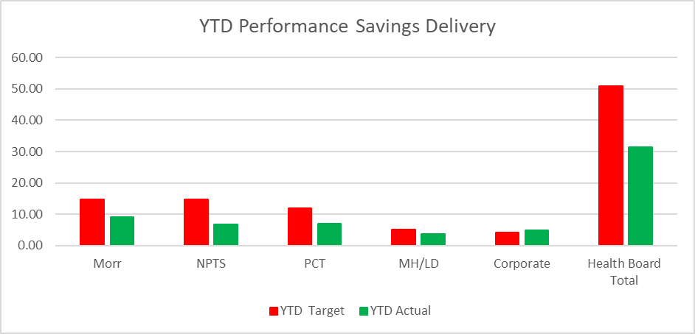

In summary the £58.7m plan required the Health Board to deliver £55.4m of savings. In Month 11 there was an underachievement of savings totalling £0.87m. YTD there remains a shortfall of £19.4m, excluding the £8.6m of Non-Recurrent opportunities in Table 2a and 2b. This is the key issue in the delivery of the 2025/26 financial position.

- Planned Savings schedule as at Month 11
The table below provides a summary of the planned savings schemes, which total £46.8m, broken down by Pipeline, Red, Amber and Red. The second table provides the full reconciliation of the £55.4m including the Non-Recurrent Opportunities referred to in 11th September submission . The forecast against the plan of £55.4m is noted in a table under section 2 of this report.

APPENDIX 4 – SUMMARY OF THE REPLIES TO THE ACCOUNTABILITY LETTERS (@12th March 2026)

No: | Name | Date Proforma Returned
 | Ceri Gimblett – NPTS | 13/05/25 – signed proforma + covering letter to CEO / DoF
 | Sue Moore – Morriston | 12/05/25 – no proforma, but a letter to CEO
 | Dermot Nolan – MH&LD | 09/05/25 – proforma signed + narrative added
 | Craige Wilson – PCTSG | Outstanding
 | Hazel Lloyd – Corporate Governance | 28/04/25
 | Deb Lewis – COO | 07/05/25
 | Richard Thomas – DICE | 01/10/25
 | Matt John – Digital | 10/06/25
 | Richard Evans – Medical | 30/04/25
 | Liz Rix – Nursing | 28/04/25
 | Gill Richardson – Public Health | 22/05/25 – no proforma, but a letter to CEO
 | Marie Davies – Planning & Partnerships | 27/06/25
 | Tina Ricketts – W&OD | 13/05/25
 | Darren Griffiths – Finance and Estates | 20/04/25
 | Christine Morrell – Allied Health Professions & Health Science | 14/05/25

