

Children and Young Person’s Neurodevelopmental Services All Wales Review

Swansea Bay University Health Board October 2023



Context

Improving access to Neurodevelopmental (ND) services in Wales has been identified as a key Welsh Government priority. A recent independent review of all-age ND provision identified significant gaps in services and very long waiting times for assessment and support. Therefore, the Welsh Government have established a three-year ND service improvement programme to address immediate pressures within services as well as developing sustainable integrated needs-led services for the future. In addition to this review of HB services, a further review has been commissioned by WG to understand the extent to which the duties of the Code of Practice on the Delivery of Autism Services (WG21-60) are being met across agencies.

Introduction to the review

As part of the ministerial programme of reform, the NHS Executive Performance and Assurance division have been asked to undertake a snapshot review of children and young people’s Neurodevelopmental Services within all Health Boards across Wales.

The review aims to understand how services are organised including areas of consistency and variation between policy, performance, and clinical guidelines in each Health Boards service offer, waiting times, reporting arrangements, and performance management processes. The review also sought to identify factors challenging the delivery of timely assessment, and the actions taken by Health Boards to support and improve access and high-quality care.

Data collected from Neurodevelopmental Services in all Health boards in Wales will be collated to support the primary objective of the review to produce a national snapshot of current service delivery arrangements including factors that challenge and support performance. This information will be used to inform the ND ministerial improvement programme and support the determination of national actions to improve access to ND diagnostic assessment. Each Health board will also receive a report outlining alignment with key standards and reporting definitions, demand, performance against the target, and performance management and improvement actions. Improvement recommendations will be provided if applicable.

The approach

The review consisted of three phases:

Phase 1: Desktop Information (April & May 2023)

- Collection of desktop information from all HB’s including completion of a structured excel workbook and a request to provide recovery plans, policies, and pathways where available.

Phase 2: Fieldwork and Reporting (June to September 2023)

- Semi-structured interviews with service managers and clinical leads

- Analysis and triangulation of desktop information, interview findings, and nationally reported demand and waiting list data for each HB.

- Completion of local briefings reflecting service process and reporting arrangements to identify any variation between service delivery and reporting processes and national guidance, and a summary of recommendations outlining opportunities for improvement if applicable.

Phase 3: National Report (September to November 2023)

- Following accuracy checking of local reports by HB’s, a national thematic report will be produced for Welsh Government, aggregating key findings to produce national themes and provide recommendations to service and performance improvement.

Report of Swansea Bay Neurodevelopmental Disorder Assessment Services for Children and Young People

This report provides an overview of Swansea Bay Neurodevelopmental Disorder Assessment Service for Children and Young People.

Desktop information was received from the HB on 28th April 2023. The Performance and Assurance Division met with representatives of the service on the 15thJune 2023.

Key Findings

- The HB provide ASD assessments for CYP up to the age of 17 years and 6 months, and ADHD assessment for CYP aged five years old to 17 years and 6 months. Dual ADHD and ASD assessments are delivered in a single assessment episode.

- The service has a written referral pathway for the early years neurodevelopmental (EYND) under five’s service. The ND (over five’s) service was able to give a clear verbal and written description of referral and assessment processes but did not share any written pathways.

- The service has multiple points of access. Children under the age of five access ASD assessments via locality community child health services. There is a single point of access for all school age (5-17.5 years old) ND referrals.

- Desktop and self-reported descriptions suggest that the service is strongly adherent to All-Wales ND standards 2-5 and NICE Guidance.

- The HB provides support for CYP waiting for an assessment. Children under five may be signposted to a range of community child health teams and partner agencies. The school age service signposts CYP to advice and support and have established an advice and consultation line for families and referrers seeking advice. The advice line has been received positively by users.

- The HB deliver training to health colleagues and partner agencies to improve identification of all Neurodevelopmental Disorders.

- The assessment process for ASD and ADHD is multidisciplinary across age groups and presentations.

- Post diagnostic advice and signposting is available for CYP diagnosed with ASD and/or ADHD during feedback and follow up appointments. Additionally, a rolling 6-week programme of advice and guidance is available for the families of children under five diagnosed with ASD, and a psychoeducation session is offered following diagnosis of ADHD. Psychoeducation is mandatory prior to initiation of medication.

- ASD and ADHD assessments including initiation of medication for ADHD are completed within 6 months of the first appointment.

- The children’s ND service has arrangements in place to transfer referrals of
CYP aged 17 years and 6 months to the adult ASD service. Transition to adult ADHD services is currently organised on a case-by-case basis.

- The service has a clear process for management of second opinions, re- assessments, and quality assurance of external diagnostic assessments.

- Performance is regularly reviewed at team, service, and divisional levels.

- Performance data is collected and monitored using electronic patient
administration systems and manual spreadsheets. At the time of review, the EYND was due to migrate to WPAS and expected this to enhance data quality and accessibility.

- Reporting of referrals received, accepted, and rejected is in line with guidance as is application of the waiting time clock stop on the date of the first assessment appointment.

- The HB is not meeting the 26-week target for starting a neurodevelopmental assessment. At the time of review, that average wait for ASD assessment of a child under the age of five was a year (52 weeks) with the longest wait at 53 weeks. Over fives waiting for ADHD and ASD assessment waited 2.2 years on average with longest wait at 2.3 years.

- Of those waiting, significantly more CYP were waiting for ASD assessment than ADHD only. However, the service is seeing an increase in need for ADHD and dual ASD and ADHD assessments.

- Referral demand has increased over the last two years. Referrals accepted have decreased slightly, however, increase in triage activity, supporting

families and referrers of CYP whilst on the waiting list, and number of dual ASD/ADHD assessments has increased the capacity needs of the service.

- The service has reviewed its referral and assessment pathways across the age range to support prudent use of resources.

- Services reported insufficient administrative and clinical capacity to meet the current performance target. The service is piloting the introduction of education-based expertise to referral triage and consultation using non- recurrent funding. The HB have also agreed to maintain the current budgeted establishment when services are repatriated to CTMUHB. Whilst both were welcomed, the service indicated this would not be sufficient to recover performance to meet the target.

- A business case outlining the funding requirements and suggested workforce model to address performance challenges has been presented to the board and is used to inform bids for national funding.

- The ND (over five’s) service offers Attend Anywhere, telephone, and face to face appointments. Increasing face to face activity would be challenging at present due to the limited availability of clinic space. However, future service needs in the event of workforce expansion are included in wider HB planning.

- Services reported that availability of accessible and appropriate clinical environments can be challenging.

- There are opportunities to deliver a service in Welsh and other languages through use of interpretation services.

- Services highlighted the need for recurrent investment to enable longer term planning and workforce development, supported by a national approach to facilitate connectivity between agencies and their statutory duties to support CYP with additional needs.

Recommendations

- The HB should ensure there is a plan in place to reduce the number of children and young people waiting to commence an ND assessment with a focus on those waiting the longest.

- Arrangements for transition between children’s and adult ADHD assessment services should be clarified and strengthened to ensure young adults are not disadvantaged in relation to access, waiting time, or age-appropriate skills and expertise.

- The HB should ensure that patient administration systems enable the collection of data to support clinical and service need and national reporting requirements.

- The HB should review availability of accessible and appropriate accommodation for Neurodevelopmental Disorder assessment of CYP with sensory sensitivities and physical impairments.

- The HB should continue to support the service to engage with opportunities to contribute to national planning and practice sharing forums.

Clinical Service Model

Service Context

Local Health boards must:
    - Provide access to services which can assess for autistic spectrum and associated conditions which take account of NICE best practice guidance for multidisciplinary involvement.
    - Ensure the provision, publication and regular review of assessment and diagnostic pathways for children, young people and adults which take into account NICE best practice guidance.

Code of Practice for the Delivery of Autism Services WG21-60 p.12

Mental health services for children, young people and adults, and child health services, should form multidisciplinary specialist ADHD teams and/or clinics for children and young people. These teams and clinics should have expertise in the diagnosis and management of ADHD, and should:

    - provide diagnostic, treatment and consultation services for people with ADHD who have complex needs, or where general psychiatric services are in doubt about the diagnosis and/or management of ADHD

Attention deficit hyperactivity disorder: diagnosis and management. NICE guideline [NG87] (Section 1.1.2)

The Health Board provide autism (ASD) diagnostic assessment for CYP up to the age of seventeen and six months, and attention deficit hyperactivity disorder (ADHD) assessments for CYP aged five to seventeen and six months.

The early years neurodevelopmental (EYND) team deliver autism spectrum diagnostic assessment for children under five. A standalone multidisciplinary neurodevelopmental disorder diagnostic team offers assessment of ASD, ADHD, or both, to CYP aged five and over. The over five’s team also benefits from sessional capacity from paediatricians and a psychiatrist.

Both services sit in the children and young people’s division.

At the time of the review, the HB was commissioned by CTMUHB to provide neurodevelopmental assessments for CYP aged eleven to eighteen residing in Bridgend. The service level agreement was due to end in July 2023.

Descriptions of referral and assessment processes were provided by the service in the review desktop information workbook and interview. The EYND service provided a written referral pathway. No written pathways referral or assessment or protocols were provided by the ND (over fives) service.

Findings

- The HB offers ASD assessment for children up to the age of seventeen and six months and ADHD assessment for children aged five to seventeen and six months.
- The HB has separate services for children under five and those between the ages of five and seventeen and a half.
- Both services sit in the children and young people’s division.
- A referral pathway was provided for EYND service, but no written referral or assessment pathways were provided by the ND (over fives) service. Both were able to give a clear verbal description of pathways and processes.
- The service offers joint assessment of ASD and ADHD for CYP over five years old.

Access and assessment pathways

An all-Wales neurodevelopmental pathway for referral, assessment, and diagnosis of of neurodevelopmental disorder was produced in 2016 by the Neurodevelopment Workstream Steering Group. The pathway sets out six high level standards based on the Code of Practice for the Delivery of Autism services.

An updated version of the standards produced in 2018 included two additional standards concerning the provision of follow up support and post diagnostic intervention. These have been challenging to implement due to high levels of assessment demand. Consequently, this review will aim to understand the alignment of HB service delivery processes and pathways with the 2016 standards as included on the Autism Wales website. However, a summary of follow up support and interventions provided will be described in the report.

Standard 1: There is a single point of access for diagnostic assessment of all neurodevelopmental disorders

Under five’s access ASD assessment through referral to one of two locality community paediatric teams. The referral pathway is the same in both localities.

There is a single point of access for ASD and ADHD referrals of CYP aged five to seventeen years and six months old. Referrals can be e-mailed or sent by post.
Referrers can also contact the service for advice about prospective referrals.

Finding: Standard 1 – not met

- There are three points of access for children’s neurodevelopmental services.
- Access pathways are differentiated by age, with a single process replicated in two localities for under-fives and a single point of access for CYP over five.

Standard 2: The decision as to whether to accept a referral or not is made on the quality of information provided (as outlined in NICE guidelines). Where there is adequate information to support concern access should not be subject to permitted referrers, the use of screening questionnaires or other specifications.

The service accepts referrals from a wide range of professionals. For CYP over the age of five, the service also accepts self-referrals.

Referrers of children under five are advised to consult with a health visitor who will undertake initial assessment of the child’s functioning, and screen using SOGS and MCHAT tools. If the health visitor and parent share concern about the presence of features suggestive of ASD, a referral is made to a community paediatrician for initial developmental/medical assessment. Families may also be signposted to a speech and language drop-in session. While it is preferred that referrals have been screened by a health visitor, the EYND service also accepts referrals from other clinicians including community paediatricians, GP’s, and primary schools.

Over fives referrals to the ND team can be made by e-mail or post. Admin and clinical team members may contact the family or referrers for more information if required. Referral information includes history and context of concerns, information about signs and symptoms, a summary of any support already offered to the CYP,

and documentation outlining existing assessments and support provided by school or local authority (e.g., Individual Development Plans).

A six-month pilot adding educational expertise to the triage and consultation process commenced in April 23. Initial indications suggest a positive response from education partners and the team. Evaluation of the pilot will be undertaken in September 23 to measure the efficacy of this new initiative.

Finding: Standard 2 – met
- Services accept referrals from a wide range of professionals.
- The HB accepts self-referrals of CYP over the age of five.
- A referral form supports the collection of relevant information.
- Administrative and clinical support is in place help families and referrers provide the necessary information to outcome referrals.

Standard 3: When referrals are not accepted, the referrer is provided with a rationale for this, alongside advice on how to improve the referral or which other service to refer to as appropriate

EYND service referrals are discussed twice a month at a multidisciplinary panel. Referral decisions are usually made within one to two months of referral. The referrer is informed of the reason for decline and any advice or signposting recommendations. The referrer is expected to communicate the outcome and advice to the family.

School aged referrals are triaged daily and usually outcomed within eight to ten weeks. Occasionally, triage timescales may be extended due to increases in referral demand, depleted workforce capacity, and delays receiving information due to school holiday closures. The school age service informs families and referrers of referral outcome by letter or telephone.

Finding: Standard 3 – met

- The service aims to triage referrals within eight weeks of receipt.
- The service informs referrers of referral outcome.
- Advice and signposting is provided where appropriate.

Standard 4: Assessments are planned in a child centred way ensuring sufficient information to create a profile of the child’s need is gathered (as outlined in NICE guidelines), whilst ensuring a prudent, flexible approach to the use of resources.

NICE Guidance for ASD in under 19’s: recognition, referral, and diagnosis (CG128) recommends allocation of a single point of contact/care coordinator during the assessment process, collection of information about parental and CYP concerns and current functioning across domains, developmental history based on diagnostic criteria, interaction with and observation of the child, medical history and physical examination, and consideration of differential diagnosis.

NICE Guidance for ADHD diagnosis and management (NG87) recommends that diagnostic assessment includes a clinical and psychosocial assessment including behaviours and symptoms across multiple domains, a developmental and psychiatric history, and include observer reports and assessment of a mental state. Rating scales and school observations may provide valuable adjuncts in the event of diagnostic uncertainty.

SBUHB assessment process is determined by age and clinical presentation.

Assessment information is gathered via referral form and pre-referral screening, virtual or face to face parent/carer interview, and face to face clinical observation. The service has close links with other children and young people’s health clinicians and teams in the event further investigations are needed to reach a differential diagnosis.

Under five’s EYND ASD pathway

Assessment includes a developmental and medical screening appointment with a community paediatrician. ASD parental interview may be incorporated into this appointment followed by referral for an Autism Diagnostic Observation Schedule (ADOS) if indicated, or children may be referred to a joint community paediatric and SALT assessment clinic. The structure of the assessment and steps in the process are determined by clinical presentation and family context and wishes. Additional observations and assessments may be requested where there is diagnostic uncertainty or to better understand impact on functioning.

ND (over fives) ASD and ADHD pathways

The service indicated that ASD assessments accounts for approximately 60% of activity. Assessments include community paediatric physical examination, completion of parent/carer interview proforma and administration of the 3Di assessment instrument. Families attend a clinic based ADOS observation. Other

non-routine steps in the process may be added as needed to reach a diagnostic formulation.

ADHD assessment includes review of referral and pre-assessment screening information, including medical history, followed by an appointment with a consultant psychiatrist to complete a clinical history and assessment of current presentation.
Other non-routine steps in the process may be added as needed to support diagnostic formulation. Examples include school observation, teacher interview, or administration of the QB test.

The HB noted an increasing prevalence of referrals requiring both ASD and ADHD assessment. The process for dual assessment begins with a consultant psychiatry appointment to assess ADHD followed by steps in the ASD assessment process.

The service aims to complete assessments, including initiation of medication for CYP diagnosed with ADHD, within 6 months of the first appointment. Assessments for ASD include a minimum of four virtual or face to face appointments though some CYP may need additional assessments or observations.

Finding: Standard 4 – met

- The pathways described demonstrated good adherence to NICE Guidance.
- Non-routine assessment components or observations are added flexibly as needed to support clinical formulation and prudent use of resource.
- Pathways facilitate an MDT approach at triage (under-fives), assessment, and diagnostic stages.

Standard 5: There is a timely multi-disciplinary discussion (NICE/ ICD-10/DSM 5) involving all those involved in the assessment process which leads to a decision about the outcome of the assessment, and a profile of the child’s strengths and difficulties.

Diagnosis may be made for routine cases following discussion between two or more professionals involved in information gathering and/or virtual or face to face assessment process. An AHP diagnostician provides clinical leadership and is available for consultation with members of the assessing team.

Complex cases are discussed at MDT panels. The service assured reviewers that there are are no significant delays between assessment and diagnostic discussion.

Based on the clinical observation, within the final report, strengths, differences and needs are described. The decision is based on DSM-5 criteria so the diagnostic formulation reflects the specification as stated in DSM.
.
Finding: Standard 5 – met

- There is MDT discussion between two or more professionals involved in the assessment process.
- A consensus statement confirms outcome.
- There is no significant delay between assessment and diagnostic discussion.
- During feedback, the profile of individual strengths, differences and needs is discussed.

Standard 6: A professional who has been involved in the assessment process will communicate the outcome of the assessment with the family (and where appropriate the child). This is followed up in writing, and where consent is given, should be shared with other professionals who support the child. For children who have received a diagnosis, advice about how best to meet the child’s needs and support or signposting is provided.

All CYP and families are offered a feedback appointment with a senior clinician who has been involved in part of the assessment.

Feedback is usually given via attend anywhere or telephone and followed up by a written report confirming formulation, diagnosis if applicable, and recommendations. A guidance document supports consistency of advice given about the legal rights of the child and family and signposting resources which can be selected and matched to an individuals needs.

The service offers a follow up consultation as needed.

Finding: Standard 6 met

- Feedback is provided by a senior clinician who has participated in the assessment process.
- The service confirms diagnostic formulation and recommendations in writing.

- Services offer targeted advice and signposting information based on the CYP’s individual profile of need.
- Follow up is available.

Interventions
Nice Guidance (ADHD – NG87) recommends:
Children under 5: offer ADHD focussed group parent training programme and seek tertiary/specialist advice and consultation if group interventions are not effective Children over 5: Give information and support through brief one to one or group- based session, consider parent training/individual programmes of support in presence of oppositional defiant/conduct presentation, or medication if significant impairment exists after environmental modifications have been implemented.

NICE Guidance (ASD – CG128) recommends:
Provision of individual information or support available locally according to the family’s needs.

Children under five diagnosed with ASD can access targeted advice via a rolling six week ‘next steps programme’. However, at the time of review there was a six-month waiting list to access this provision. Advice and signposting is provided to families and CYP over five.

The service offers a psychoeducation session for families of CYP diagnosed with ADHD. Attendance is mandatory prior to commencing a trial of medication.
At the time of review, the assessment and advice session took place separately, however, the service intends to establish a one-stop shop so that diagnosis and initiation of medication can be commenced within a single visit. Medication is initiated and titrated by the ND service with ongoing review provided by CAMHS and/or GP’s.

Findings: Interventions

- Advice and signposting is available across ages and presentations.
- There is a six month wait for the under-five’s ‘next steps’ post diagnostic advice programme.
- One to one psychoeducation is available for CYP diagnosed with ADHD.
- Initiation of medication for ADHD takes place within six months of the first assessment appointment.

Equality and Diversity

The review sought to understand whether services could undertake assessment through a young person and their family’s language of choice, and whether adaptations could be made to support assessment where CYP or family members have additional physical or cognitive impairments.

The service reported that it is rarely asked to undertake Welsh Language assessments but can access interpretation services for any language as needed.

The team considered that the multidisciplinary nature and high level of specialism in team enable them to make informed adaptations to meet the needs of CYP with multisensory impairments. The team have also made referrals to tertiary specialist centres such as Great Ormond Street when required. However, they also noted that clinical space is not always suitable or comfortable for CYP with additional needs or sensory sensitivities. This has been recognised by the HB who are considering more suitable provision in new capital projects.

Transfers & Transitions

Second opinions

The service has a protocol clearly outlining the second opinion request process. The protocol differentiates requests for second opinions and re-assessment and establishes the parameters and timescales for such requests.

A second opinion can be requested by parents or those with delegated responsibility for the CYP. Following receipt of a request, a clinician not involved in the original assessment conducts a file review within 30 days. Requests are approved where evidence is found of insufficient multidisciplinary oversight or absence of essential steps in the assessment process e.g., parent/carer interview or clinical observation.

The family are informed in writing of the outcome of their request and the rationale for the decision.

In the event a second opinion is agreed, an alternative team of clinicians within the ND service will re-assess the CYP.

Validation of external assessments

The service reported increasing demand for review of private diagnoses and/or prescribing after a private diagnosis.

The service provides advice on whether the private assessment meets recommended standards by demonstrating an equivalent quality to one available on the NHS. The team does not ratify diagnoses made outside the HB. A parental advice leaflet has been produced to inform parents how to check an external assessment meets clinical guidance.

Parents seeking medication for their child following external or private assessment must continue or make their own arrangements pending review of diagnosis.

Transition to Adult Services

The service has developed a strong partnership with the Integrated Autism Service (IAS). Referrals of CYP aged seventeen and a half or over are forwarded to the IAS as are CYP who will not reach the top of the waiting list by their eighteenth birthday. Initial date of referral is honoured in both cases.

Adult ADHD assessments are completed by one of two CMHT’s in Swansea and Neath Port Talbot localities. At the time of review, transition and transfer of referrals were discussed with the team on a case-by-case basis. However, discussions were underway with the IAS manager to develop a clearer transition process for CYP with a potential dual diagnosis of ASD and ADHD and young adult referrals for ADHD assessment.

Findings: Transitions and Transfers

- The service has a clear protocol for second opinion and re-assessment requests.
- The ND service does not ratify external or private diagnosis but provides advice on the degree to which they meet recommended standards.

- The HB has robust transition arrangements in place with the IAS for CYP aged seventeen and a half referred for ASD assessment.
- Work is in progress to enhance transition arrangement with CMHT’s for young adults requiring assessment of ASD and ADHD or ADHD alone.

Reporting
Local Health boards must:
Ensure the collection of information on waiting times for assessment for children, young people and adults complies with current national waiting time standards for autism assessment and diagnosis Code of Practice for the Delivery of Autism Services WG21-60 p.12

Number of neurodevelopmental referrals received by the neurodevelopmental service during the month and number of referrals accepted and rejected at triage.

The HB reports referrals received, accepted, and rejected for ASD or ADHD assessment of CYP up to the age of seventeen years and six months old.

Number of patients waiting to start an ADHD or ASD neurodevelopmental assessment. Clock start is defined as the date the referral is received by the service.

The HB enters CYP on an electronic patient administration system on the day the referral is received. CYP accepted for an assessment following triage are placed on the waiting list as of the date of referral.

Reporting guidance advises that CYP can be removed from waiting status on the date of the first face to face or virtual attendance at the first appointment of the assessment process (may be with parent/guardian only).

The CYP is removed on the date of the first face to face or virtual assessment appointment.

Findings: Reporting

- HB reporting is compliant with the reporting guidance

Demand and Capacity

Demand

The number of children and young people referred for a diagnostic assessment in neurodevelopmental disorders services has been reported nationally since 2020 (Figure 1). Data presented in this report has been sourced from monthly HB data submission reports.

The number of referrals received by SBUHB is shown in Figure 2. Although there is fluctuation in monthly referral demand, data shows a 5% increase in the twelve months prior to the review with 1066 referrals received between August 2022 and July 2023, compared to 1016 over the same period during 2021/22.

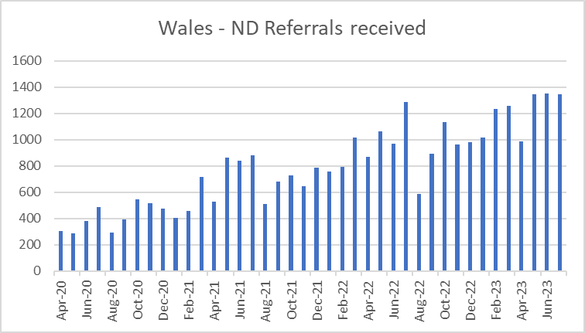
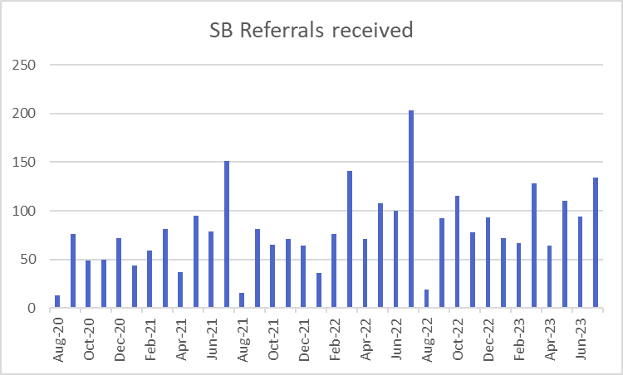
Fig 1 Fig 2

The number of children and young people accepted on to the waiting list for a diagnostic assessment across Wales is shown in figure 3. All Wales data shows an upward trend in demand since data collection began with a sharp increase in referrals in the three months of the review (May, June, July). However, apart from n increase in referrals received in February 22 and July 22, the HB shows a fairly consistent seasonal demand pattern with marginally less referrals accepted between August 22 and July 23 (262), compared to 298 between August 21 and July 22
(Figure 4).

SBUHB will cease to provide assessments for Bridgend eleven to seventeen and half year-olds when on its repatriation to CTMUHB in July 2023.

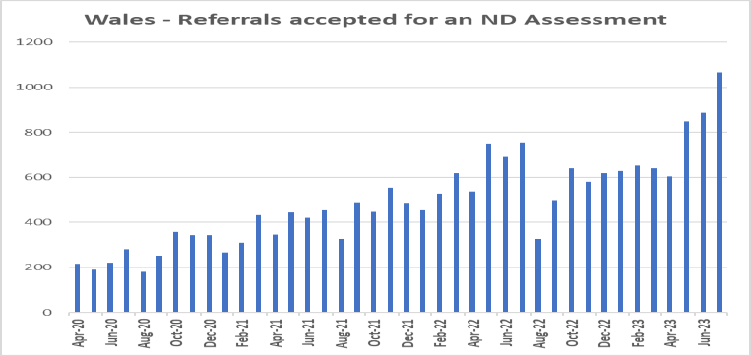
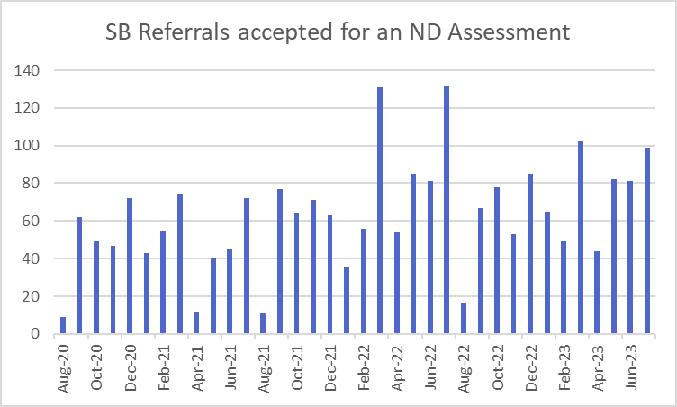
Fig 3 Fig 4

Although accepted referral demand was lower in the twelve months prior to review, an increase in referrals results in increased capacity needed for triage activity including gathering supporting information for referrals from referrers and families, clinical review of referrals information, and provision of advice and signposting letters for accepted and rejected referrals.

Findings: Demand

- Referral demand increased in the twelve months prior to review requiring additional capacity for triage, advice, and signposting activity.
- Accepted referrals decreased slightly in the twelve months prior to review
- Referrals received and accepted may change following repatriation of CTMUHB secondary school aged referrals for the Bridgend locality.

Workforce

The HB provided a workforce summary of clinical and administrative staff working in the service. This is shown in Table 1 and 2.

Both services are multidisciplinary and include professions recommended by NICE Guidance.

Table 1: Early Years ASD assessment workforce

Clinical Role | Actual WTE Budgeted (Budgeted  WTE minus exc vacancies) |  | Comment
Community paedaitrician | 3.2 | 3.2 | 2WTE long term sick
Speech and Language therapy (Band 7) | 1.5 | 0.5
Total | 4.7 | 3.7
Managerial/Administrative support | Budgeted Actual WTE WTE |  | Comment
Operational manager (Band 7) | 1 | 1
Administrative staff (Band 4) | 1 | 1
Total | 2 | 2

Table 2: School age ND assessment workforce

Clinical Role | Actual WTE Budgeted (Budgeted  WTE minus exc vacancies) |  | Comment
Clinical lead / Service manager (Band 8A) | 1 | 1 | ASD (clinical)
Psychiatry | 1.9 | 1.9 | ADHD
Medical (middle grade) | 0.44 | 0
Nurse (Band 7) | 3.6 | 2.6 | ASD & ADHD
SALT (7) | 0.9 | 0.9 | ASD & ADHD
Health Visitor | 0.6 | 0.6 | Provides pre-assessment support
Total | 8.44 | 7
Managerial/Administrative support | Budgeted Actual WTE WTE |  | Comment
Business manager (Band 5) | 1 | 1
Administrative staff (Band 4) | 1 | 1
Medical secretary (Band 3) | 3 | 3
Total | 5 | 5

Insufficient capacity to meet service demand and deliver a timely as well as a high quality and clinically adherent service was highlighted by both services. Both reported challenges recruiting to vacancies across many of the recommended professional groups.

Capacity demand modelling has been undertaken to develop a business case outlining investment required to build a sustainable workforce that meets demand. The suggested workforce strategy includes plans to diversify the workforce to grow skills and expertise through internal development posts at Band 6 and recruitment of further advanced practice posts. Non-recurrent funding been used to second a teacher into the service to provide specialist advice to support the triage process and provide consultation to families and referrers.

The EYND service highlighted the disproportionate impact of short and long-term sickness and absence on the performance capabilities of a small team and a need for additional administrative and service development capacity to support transformation and efficient day to day management. They suggested that posts such as an ND coordinator and/or service improvement managers could add further value to the team.

In addition to the function of delivering diagnostic assessments, the service highlighted the capacity needed to support wider system capability to identify and support CYP presenting with neurodiverse profiles through training, consultation, and joint working. Although the ND (over fives) service delivers training and provides consultation through their advice line, they highlight that the drive to meet performance targets inhibits the capacity that can be directed towards these activities.

Whilst further investment need has been identified by the service, they reported that the HB have agree to maintain current staffing levels following repatriation of services to CTMUHB.

Findings: Workforce

- SBUHB ND services are multidisciplinary in line with NICE Guidance.
- Due to the small size and specialist nature of the service, absence has disproportionate impact on operational delivery.
- The service reports insufficient clinical and administrative capacity to meet demand based on capacity and demand modelling.
- The service has developed a business case and suggested workforce plan to guide investment decisions.
- The HB has agreed to maintain current staffing levels following repatriation of services to CTMUHB.

Waiting List Management & Booking Processes

Waiting List
Local Health boards must:
Comply with current national waiting time standards for assessment and diagnosis and deliver diagnostic assessment within 26 weeks of referral. Code of Practice for the Delivery of Autism Services WG21-60 p.12

Reporting guidance indicates that first assessment appointment is considered the point at which a CYP is no longer considered waiting.

The number of children and young people on the waiting list for a diagnostic assessment in neurodevelopmental disorders services has been reported nationally since 2019.
Across Wales the number of CYP waiting for assessment has grown from 4561 in April 2019 to 14,332 in July 2023. Although the number of CYP waiting for an assessment has varied, SBUHB waiting list profile shown in Figure 5 does not reflect the exponential growth seen in the All-Wales position. April 2019 saw 813 CYP waiting for assessment, with the list reaching its highest number in March 2020 (1147) and July 2023, 1053.

Fig 5
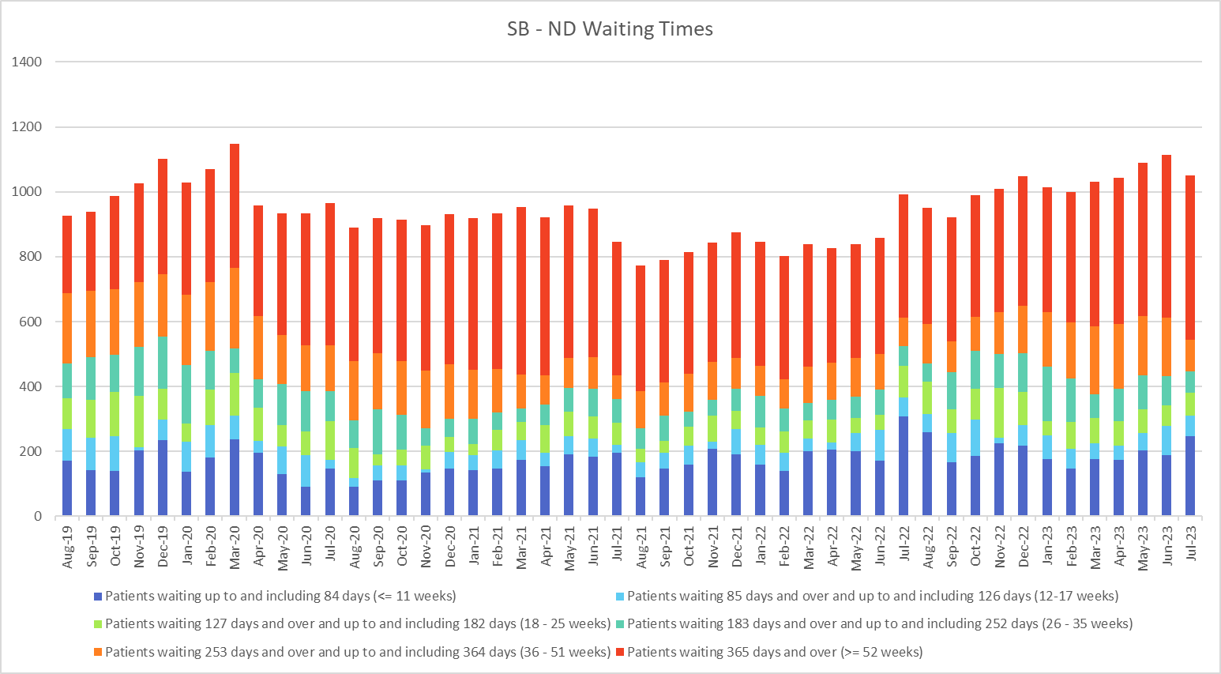

Waiting Times as at 31.3.23 snapshot reported by the HB

HBs are asked to report numbers waiting up to and including 11 weeks, 12-17 weeks, 18-25 weeks, 26-35 weeks, 36-51 weeks, and over 52 weeks.
Nationally reported data shows that over 52 week waits increased in SBUHB from 35% in April 2019 to 48% in July 2023.
Current reporting does not request length of longest waits if over 52 weeks. The review requested a snapshot of average and longest waits as of 31.3.23.

Table 3 shows that average and longest waits for under-five’s ASD assessment is around 1 year, with CYP over five waiting over 2 years across clinical conditions. At the time of census, 84% were waiting for an ASD assessment with 13% of ASD waits requiring both ASD and ADHD assessment. The service reported seeing an increase in CYP needing assessment for both conditions.

Table 3
Suspected Clinical Condition | Number  on List | Longest Wait  (weeks) | Average Wait  (weeks)
ADHD (5-18) | 208 | 51 weeks | 26.5 months
ASD | 669 | 124 weeks | 26.5 months
Dual | 154 | 115 weeks | 26.5 months
Under five’s ASD | 309 | 53 | 52

Organisation of the Waiting List

The HB has separate waiting lists for CYP aged under five referred for assessment of ASD, and over five’s referred for assessment of ADHD, ASD, or both.

Under five waits were recorded on PIMS at the time of review with plans to migrate to WPAS over July and August 2023.

ND (over five) services use WPAS.

Support for CYP on the waiting list
People on the autism referral pathways must be offered support whilst awaiting assessment, this includes the provision of clear information on the diagnostic process and the autism condition, in plain language format with consideration given to first language, ethnicity and cultural differences.
Code of Practice for the Delivery of Autism Services WG21-60 p.8

Under-fives may be signposted to other community child health services including specialist health visitors, playgroups, and flying start.

The over fives service has developed a guidance document to support consistent provision of advice and signposting at triage or if families contact the service while waiting for assessment. The team have recently established an advice line and offer 45-minute bookable telephone slots to provide consultation to families and referrers requesting advice and/or support. This advice line was reported to have been well received by service users.

The service offers training to other professionals to increase the capacity and capability of external partners supporting CYP presenting with a possible or diagnosed neurodevelopmental disorder.

Arrangements for expediting CYP on the waiting list.

Under five’s referrals are prioritised on a case-by-case basis depending on clinical presentation and age. All over five’s referrals are given equal priority.

Although treat in turn is the overarching approach adopted by the service, referrals may be expedited by exception. The most common reason for expediting a referral is a family crisis such as the terminal illness of a parent or carer.

MDT discussion and agreement is required to expedite a CYP’s assessment.

Referral management & booking

At the time of review the service were using a combination of electronic patient administration systems and manual spreadsheets to manage and monitor referral progress.

The ND (over fives) ask families to opt in at the point of triage. The EYND service does not require families to opt in.

Referral management and booking of initial and follow up appointments is managed by the administrative team. First appointments are booked in chronological order 4 weeks in advance. Where possible, the service offers choice about time and date of appointments. If a family DNA’s an appointment, the decision to offer a further appointment or remove the CYP from the waiting list is made by a senior clinician. The HB has a policy outlining the process for management of WNB (was not brought).

Findings: Waiting list and booking processes

- Although the WL has increased, SBUHB has not seen an increase equivalent to the All-Wales profile.
- Over 52-week waits have increased from 35% in July 2019 to 48% in July 2023.
- Average and longest waits for EYND assessments are approximately 1 year, with ND (over fives) waiting over 2 years.
- CYP may be expedited by exception, however the overarching approach is to treat in turn.
- All aged referrals have access to advice and signposting while waiting for an assessment. Families and referrers of CYP over five can access consultation via an advice line.
- Referral and waiting list management decisions are guided by clinical advice but actioned by the administrative team.

Performance Management and Improvement

Performance management arrangements

Both services have performance assurance and management processes in place at team, service, and divisional levels.

Monthly performance data is validated by the service manager and booking clerks in the EYND service and waiting list coordinator in the ND (over five) service. A divisional manager oversees data quality and performance.

The EYND team review performance on a weekly basis and at a monthly EYND MDT review meeting. Performance is reviewed daily in the ND service. Service and division level review of performance take place monthly at departmental business meetings.

Performance Improvement strategies undertaken/planned

Pathway and the service offer reviews have been undertaken to support effective use of resource whilst ensuring adherence to clinical guidelines.

Examples of performance and quality improvement initiatives shared by the service included:

    - Training for referrers and other professionals to support them to identify referrals appropriately and/or provide informed needs led responses to CYP.

    - Piloting teacher involvement in initial referral triage and advice.
    - Streamlining assessments and pathways to clarify essential core components and additional steps that can be added flexibly on a needs led basis.
    - A standard virtual offer for all first appointments and feedback appointments in the over five’s service (with flexibility for face to face if requested)
    - Multidisciplinary involvement in assessment to enable timely diagnostic decisions outside or as part of a bigger MDT depending on complexity.
    - Assessment of service demand and capacity needs to improve performance and grow a sustainable workforce.
    - Evaluation of new initiatives to measure efficiency, outcomes, and patient experience.
    - Use of advanced AHP’s to provide clinical leadership.

Findings: Performance Management and Improvement

- The HB regularly reviews performance at team, service, and divisional level.
- Both services have reviewed clinical pathways to ensure prudent use of resources whilst maintaining clinical quality and positive patient experiences.
- Services are using non-recurrent funding to pilot and evaluate new initiatives.
- Workforce capacity and structure needs to support timely access, appropriate use of skills, and stability within the workforce have been identified by the service.
- The service is using both face to face and virtual appointment methods.

Barriers and Enablers

The review asked services to describe factors that challenge and enable them the delivery of timely and high-quality assessments.

Workforce

The service has a high degree of multidisciplinary expertise. However, they report insufficient capacity to meet demand. Workforce planning has identified opportunities to expand highly expert capacity through recruitment of advanced and consultant level AHP’s and nurses to support the development of a sustainable and skilled workforce through internal development posts.
The service expressed the need for a long-term approach requiring recurrent funding to address the waiting list backlog and facilitate timely access.

Partnership working

The service is engaged with partner agencies through local multiagency planning forums, and the provision of training and consultation to promote needs led approaches. However, they highlighted a need for national planning, funding, and application of statutory frameworks to be better connected to ensure a multiagency need led approach, with diagnostic assessment being a part of the process rather the primary or only intervention.

The discontinuation of the ND steering group was reported to have reduced opportunities for engagement, sharing of practice between HBs, and a co- produced approach to transforming ASD services.

Estates

The service highlighted that increasing activity would require additional clinical space. At present there is insufficient space to meet demand and it is not always accessible or appropriate for CYP with additional needs and sensory sensitivities.

Conclusion

The review aimed to understand how services are organised including areas of consistency and variation between policy, performance, and clinical guidelines in each Health Boards service offer, waiting times, reporting arrangements, and performance management processes. The review also sought to identify factors challenging the delivery of timely assessment, and the actions taken by Health Boards to support and improve access and high-quality care.

The service demonstrated a strong commitment to needs led person centred approaches. Desktop and self-reported service information suggests that assessment processes are strongly aligned to the All-Wales ND standards and NICE Guidance and a multidisciplinary approach to neurodevelopmental assessment is employed across the age range.

The service reports that clinical and administrative staffing capacity is insufficient to respond to increased referral demand and deliver a service adherent to the ND standards and guidelines within a 26-week waiting time target. Although accepted referrals decreased marginally in the twelve months prior to the review, increased referral demand places additional pressure on capacity across triage activities,

advice, and consultation. The service also noted an increase in the number of CYP requiring a longer assessment for both ADHD and ASD.

It was evident that the service had undertaken significant review and improvement work including review of referral and assessment processes and transition of CYP between children’s and adult ASD services. However, arrangements for CYP referred for ADHD assessment continue to be made with CMHT’s on a case-by-case basis and the HB would benefit from strengthening and clarifying transition arrangements between child and adult ADHD services.
Maintaining current workforce capacity levels may support the service to assess more long waiters after the repatriation of services to CTMUHB. However, further investment in workforce capacity and increasing the availability of clinical workspace will likely be beneficial to addressing current and future demand.

The NHS Wales Executive Performance and Assurance Division would like to extend thanks to the staff of Swansea Bay University Health Board for their co-operation and contributions during the review.

