


Meeting Date | 20 March 2024 |  | Agenda Item |  |  | 4.1
Report Title | Urgent and Emergency Care Report
Report Author | Neil Cooper, Assistant Director of Operations – Urgent and Emergency Care  Jonathon Baglow, Business Intelligence Analyst
Report Sponsor | Deb Lewis, Chief Operating Officer
Presented by | Neil Cooper, Assistant Director of Operations – Urgent and Emergency Care
Freedom of Information | Open
Purpose of the Report | To provide a summary of the Urgent and Emergency Care (UEC) improvement programme to improve the delivery of timely, safe patient care and the UEC care standards.
Key Issues | UEC performance has been escalated into Targeted Intervention by Welsh Government with the Chief Operating Officer holding oversight and assurance against developing and monitoring a UEC improvement programme.  The delivery of Tier 1 performance standards remains a significant challenge and the risk of patients coming to harm due to delays relating to timely handover of ambulances. Early assessment and treatment remain a key focus for the Emergency Department (ED) and ward based clinical management teams.  The overcrowding of the ED linked to poor flow and delayed admission of patients into the in-patient bed pool results in poor patient experience.  There are key system performance indicators that explain the challenges associated with delivering timely and safe patient care and thus the required levels of performance and these are discussed in the paper.  Service development schemes are in place and continue to be developed and implemented to support the recovery of UEC performance.  A structured approach in response to targeted intervention monitoring and the UEC programme, approved by NHS Wales 6 goals programme is in place to support, deliver and monitor the schemes reporting to the UEC Board
Specific Action Required  (please choose one only) | Information | Discussion |  | Assurance | Approval
Specific Action Required  (please choose one only) | ☒ | ☐ |  | ☐ | ☐
Recommendations | Members are asked to:  - NOTE the UEC performance position and the ongoing actions taken to support its recovery and Improvement.

Urgent and Emergency Care Report

- INTRODUCTION
The report below describes urgent and emergency care (UEC) activity and performance to date including progress against the UEC care standards. Wider system indicators are also used to demonstrate the flow constraints that exist resulting in poor access to timely urgent and emergency care and poor patient experience. The report provides a detailed response to actions pertaining to the increased monitoring to of the UEC tier 1 performance targets and updates on the strategic and operational programme to improve the delivery of acute services to patients and on local improvement actions.

- BACKGROUND
The flow of Emergency patients within the Health Board and the wider UEC system, continues to be significantly compromised due to the high occupancy levels within its hospitals. This is further exacerbated by the system flow challenges impacting patients transferring in a timely way into services outside the hospital sites which in turn increases delays in clinically optimised patients and increases the number of patients being treated outside of their core bed base. The impact of the lack of flow also has unintended consequences in other parts of the UEC system including:

- Delay in patients transferring from ambulances into the Emergency Department (ED);
- Delays in patients accessing inpatient beds
- Increase in utilisation of surge capacity across the Hospital footprint and patients placed in inappropriate spaces i.e.SDEC
- Delays in patients transferring to the next stage of their recovery – complex and general rehabilitation at peripheral sites
- Discharge home

In line with the 6 goals programme, wider health board schemes targeting admission avoidance and earlier discharge are in place or in trial phase to support the wider system flow agenda.

- PERFORMANCE – Tier 1 URGENT & EMERGENCY CARE STANDARDS

The Charts below present performance against the ED Access Standards and Ambulance handover targets (12-month rolling position). Overall, 4-hour performance has improved and similarly, the number of patients waiting for 12 hours or more also reduced.
Despite the improvement, the ongoing challenging situation and generally poor performance against the 4-hour standard at Morriston Hospital translates operationally into poor patient experience. Patients can wait several hours for assessment by a clinician during which period their condition may be more serious than as assessed at triage, or may have deteriorated.

12 months to 29th February 2024
Front Door Measures – MORRISTON HOSPITAL
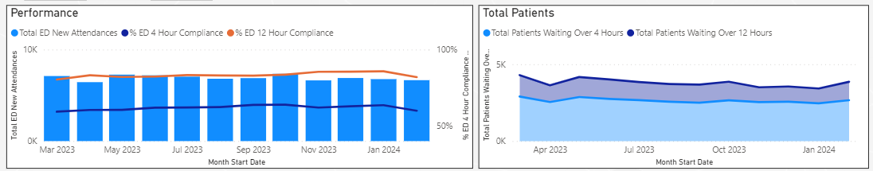

3.1 Ambulance attendance and handover delays >1 hour

- Ambulance handover is of significant concern and has been a key focus from Welsh Government. The UEC programme is addressing this matter as one of its most critical areas for improvement

36 months to 28th February 2024
Number of Emergency Ambulances Waiting for Handover

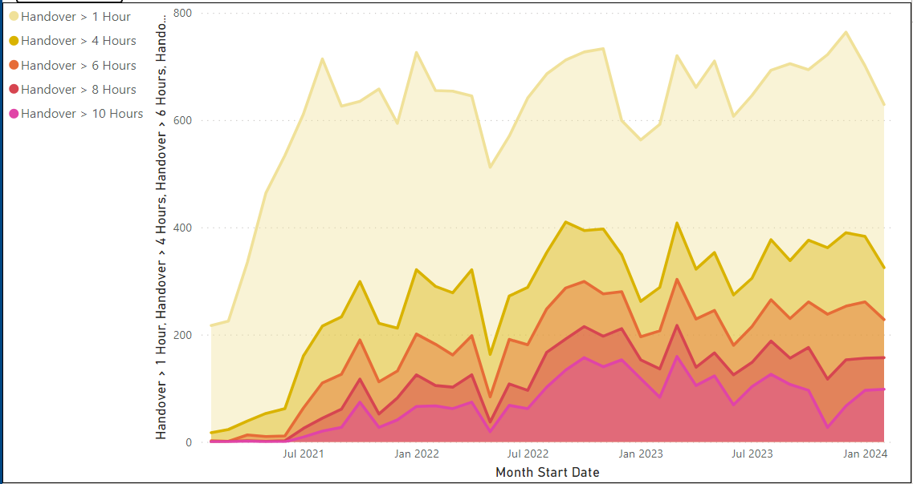

12 Months to 29th February 2024
Number of Emergency Ambulance Hours Lost Waiting for Handover
WEEKLY

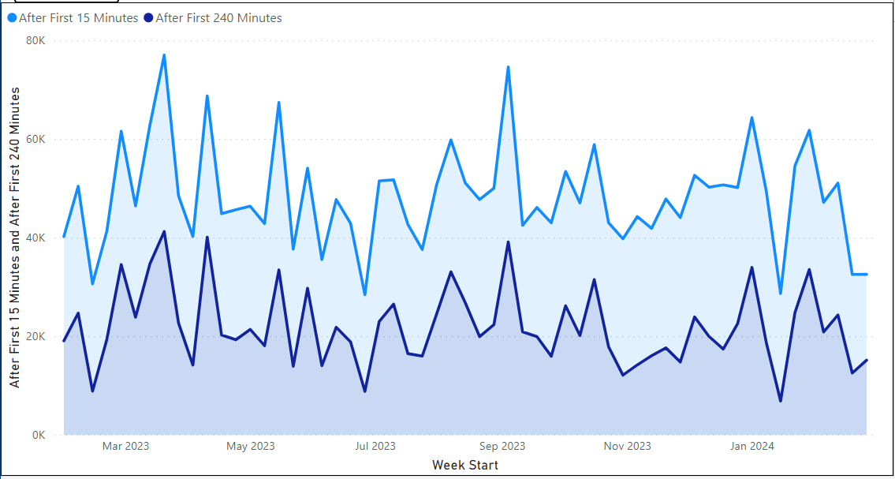

12 Months to 29th February 2024
Mean Number of Ambulances Waiting For Handover

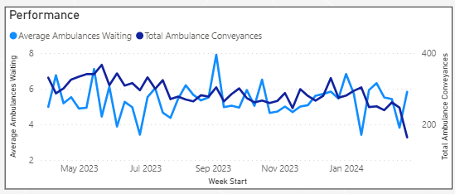

The reasons for the delays in handover are multi-factorial and include:
- Surges in demand from the ambulances or self-presenting patients – average ambulance arrivals have historically been 55-60 per day, increasing recently to 60-65 per day and reaching peaks of 80 per day over the last week;
- Availability of ED / AMU capacity to manage demand – both departments are regularly starting the day with 30 to 40 patients waiting to be admitted to down-stream wards.
- Onward flow to a hospital bed.
- Availability of onward hospital transfer
- High number of Clinically Optimised Patients (COPs) in the acute setting
3.2 Clinically optimised position

The clinically optimised position in the Health Board remains a critical issue with significantly high numbers of patients occupying acute beds waiting to move to more appropriate settings to continue their care pathway or waiting for community support/placement.

Morriston Hospital Clinically Optimised Patient Level 5th December 22 to 29th Feb 24
WEEKLY

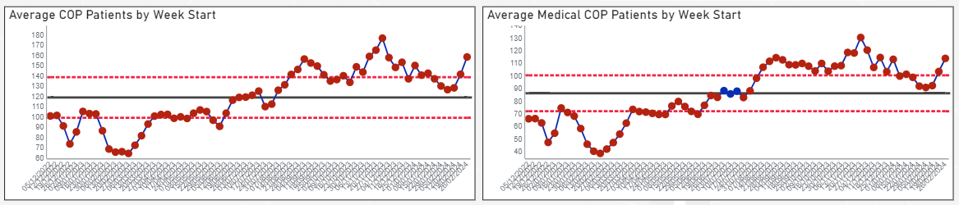

- Wider system measures and actions:
.
The Health Board has recently been placed into Targeted Intervention (TI) by Welsh Government for its performance and outcomes within the UEC system. The TI inception meeting took place on Monday 11th March 2024 and a final formal document outlining the measures to be monitored and the specific performance expectation to de-escalate is expected within the next two weeks.

It is anticipated that the expectations will mirror the HB’s own aspiration and the plan currently being developed to support system improvement. Our agenda listed below will consist of 4 key themes all linking to National 6 Goals Programme and a consistent thread linking the UEC programme boards GMO’S for 2024/25

- Admissions Avoidance
- Discharge & Transfer
- Front Door
- Inpatients

The UEC team has already engaged with National 6 goals representatives and NHS England transformation team colleagues as well as undertaking visits to other high performing Health Boards to learn and improve on a number of big-ticket innovation projects such as and not limited to;

- Formal Same Day Emergency Care (SDEC) review
- Development of a Frailty Strategy
  - A median Length of Stay of 8 days for Frailty specific wards (currently averages around 20 days across 3 wards)
- Redesign of the acute medical model to include improved in-reach sub-specialty reviews to the ED and AMU
  - Improved non-specialty admission rate (currently 55% of medical intake)
- Further development of the Continuous Flow Model
- Implementation of Criteria Led Discharge (CLD) in all wards
- Redesign of Inpatient wards and ED footprint
- Continued implementation and monitoring of D2RA / SAFER / Red to Green models of care
- Develop Operations hub for management of flow to include redesign of Silver On-Call Rota
- Increase capacity of Patient Assignment Team PAT) to 7-day working
- Pathway 1 Trusted Assessor development to improve bridging care opportunities
- Improved productivity measures for Community based ward
- Zero tolerance on using SDEC unit as surge capacity
- A reduction in healthcare acquired infections and outbreaks due to improved patient placement and flow
- Increased number of patients accessing/utilising
  - Bridging care opportunities
  - Trusted Assessor Model
  - Outreach
  - Home First
- Reduce re-attendances / re-admissions to the acute hospital setting (to include frequent flyers)

  - Management of Targeted Intervention Response and UEC Programme / Performance

To ensure senior oversight and input into The Chief Operation Officer has agreed to take the Senior Responsible Officer role for the response to targeted intervention and to support the UEC work programme a triumvirate of senior leaders has been established, as follows;

Operations Director Lead – Neil Cooper, Assistant Director of Ops (UEC)
Medical Director Lead – Mark Ramsey, Group Medical Director – Morriston SG
Nursing Director Lead – Emily Davies, Head of Nursing for Service Transformation

The team will also be supported by specialist business partners from Strategy, Finance, Workforce/OD and Informatics departments; details to be confirmed.

To supplement the TI response and UEC Programme Board and ensure timely review / escalation of actions, a weekly UEC delivery group is in place chaired by the leads highlighted above.

The UEC TI response builds on previous work undertaken by colleagues when experiencing similar intervention and the team would welcome comments and discussion on the governance arrangements related to this work.

Reflections and suggestions on how we provide grip and assurance on our work as follows;

- The UEC TI programme will need to be supported by individual work-streams
- Each area/theme should have an SRO, clinical lead and plan, with clear objectives /reporting requirements
- These will report into an overall Programme Board, a subgroup of Management Board and in this case could be UEC programme Board and through to Performance and Finance Committee and Management Board
- Clarity on what success will look like – and how this is articulated
- The SGDs are imperative to the success of this response and have to be fully engaged with all expectations
- There will be regular focussed meetings with Welsh Government colleagues where expected updates on the following will be available:
  - The plan
  - The progress
  - The assurance that mechanisms and systems are in place to succeed

- Recommendation
Members are asked to:
- NOTE the UEC performance position and the ongoing actions taken to support its recovery and Improvement.

Governance and Assurance

Link to Enabling Objectives  (please choose) | Supporting better health and wellbeing by actively promoting and empowering people to live well in resilient communities
Link to Enabling Objectives  (please choose) | Partnerships for Improving Health and Wellbeing |  | ☒
Link to Enabling Objectives  (please choose) | Co-Production and Health Literacy |  | ☐
Link to Enabling Objectives  (please choose) | Digitally Enabled Health and Wellbeing |  | ☒
Link to Enabling Objectives  (please choose) | Deliver better care through excellent health and care services achieving the outcomes that matter most to people
Link to Enabling Objectives  (please choose) | Best Value Outcomes and High Quality Care |  | ☒
Link to Enabling Objectives  (please choose) | Partnerships for Care |  | ☒
Link to Enabling Objectives  (please choose) | Excellent Staff |  | ☒
Link to Enabling Objectives  (please choose) | Digitally Enabled Care |  | ☒
Link to Enabling Objectives  (please choose) | Outstanding Research, Innovation, Education and Learning |  | ☒
Health and Care Standards
(please choose) | Staying Healthy |  | ☒
(please choose) | Safe Care |  | ☒
(please choose) | Effective Care |  | ☒
(please choose) | Dignified Care |  | ☒
(please choose) | Timely Care |  | ☒
(please choose) | Individual Care |  | ☒
(please choose) | Staff and Resources |  | ☒
Quality, Safety and Patient Experience
To improve the delivery of timely, safe patient care and the UEC care standards.

Financial Implications
There are no direct financial implications arising from the recommendations in this report.
Legal Implications (including equality and diversity assessment)
There are no direct legal implications arising from the recommendations in this report.
Staffing Implications
There are no direct staffing implications arising from the recommendations in this report.
Long Term Implications (including the impact of the Well-being of Future Generations (Wales) Act 2015)
Report History |  | N/A
Appendices |  | N/A

