

Meeting Date | 26th March 2024 |  | Agenda Item |  | 2.1
Report Title | Financial Report – Period 11 2023/24
Report Author | Samantha Moss, Deputy Director of Finance  Gemma Pearson, Finance Business Partner
Report Sponsor | Darren Griffiths, Executive Director of Finance and Performance, Acting Deputy Chief Executive
Presented by | Samantha Moss, Deputy Director of Finance
Freedom of Information | Open
Purpose of the Report | The report advises the Performance & Finance Committee of the Health Board on the financial position for Month 11 2023/24 (February 2024) and risks regarding current forecast revenue year end outturn.
Key Issues | The report invites the Performance & Finance Committee to note the detailed analysis of the financial position for Month 11 2023/24 (February 2024). The position reflects the part year impact of the application of an additional £60.8m allocation received as part of the redistribution of Welsh Government budgets.  The report includes a summary of the key drivers of the position either at Service level or by expenditure type (i.e. Non Pay/Pay). It also provides information of the current position with regards to Health Board reserves to ensure transparency in the overall Health Board position.  Discussions have been held with Welsh Government and the Board regarding the options available to deliver the Control Total set, which are summarised and managed through the document referred to as the 2023/24 Landing Plan. As part of this Landing Plan, all service areas have been issued with a run rate reduction target, which was formally communicated in a letter from the Chief Executive issued in December 2023.  Recovery meetings with Service Groups have focused on developing plans to achieve the required reductions in run rates, with positive progress in MHLD, PCT and NPST and limited progress within MSG, largely due to the outbreaks of Norovirus, COVID, Flu and C.difficile leading to some beds being closed in January and ongoing urgency and emergency care pressures. The managerial and financial impact of the Industrial Action has also had a significantly detrimental impact that requires further assessment.  Whilst in Month 11 the Health Board was successful in the delivery of key elements of the Landing Plan, and there were one-off benefits that partly offset the cost of the Industrial Action, overall the Month 11 financial position was £1.2m overspent and £1.1m higher than forecast. Therefore, work will need to continue to ensure all options within the plan are addressed. This level of risk regarding the deliverability of actions in the Landing Plan for Month 12 and the financial impact of the Industrial Action has resulted in the risk score in relation to the delivery of the financial plan in 2023/24 remaining at 20.  The risk score for capital has been reduced from 20 to 10 as there is now a clear line of sight to a balanced plan. The likelihood in this risk reducing from 4 to 2 but the impact of 5 remaining give the financial duty to balance.  Whilst the key messages are provided within the main body of the report, further information is provided in the Appendices.
Specific Action Required | Information | Discussion | Assurance | Approval
Specific Action Required | ☐ | ☐ | ☒ | ☐
Recommendations | Members are asked to:  - NOTE the agreed 2023/24 financial plan.  - Consider and comment upon the Board’s financial performance for Month 11 2023/24.  - NOTE the actions to ensure delivery of the financial forecast with a specific focus on savings delivery:  - Enhanced monitoring meetings in place above standard Finance & Performance Meetings to oversee and agree actions to mitigate run rates and deliver savings and issued Control Totals. Morriston / NPTS Service Group Directors  - Focused attention to ensure that 100% of the schemes were identified at the end of Q1 23/24. All Service Group Directors and Corporate Directors  - Focused attention to ensure that 100% of the schemes identified at the end of Q1 were green and amber by the end of Q2 23/24. All Service Group Directors and Corporate Directors  - Where savings delivery is not on track a further correspondence has been issued. All Service Group Directors and Corporate Directors  - NOTE actions to ensure the operational pressures are mitigated and areas return to financial balance.  - Enhanced monitoring meetings in place above standard Finance & Performance Meetings to oversee and agree actions to mitigate run rates and deliver savings and Control Totals. Morriston / NPTS Service Group Directors  - Embed and deliver opportunities identified via the Independent Financial support provided to the Service Group to review run rate and savings. Alongside the opportunities identified in the last 3 months by the Service Group itself. Morriston Service Group Directors  - NOTE the risks to the position at Month 11.  - NOTE the actions required to achieve Control Total (Appendix 4)  - NOTE the position with regards to Health Board Reserves.  - NOTE all actions and updates to support the management of the 2023/24 financial position.

FINANCIAL REPORT – MONTH 11

- SUMMARY OF REVENUE PERFORMANCE
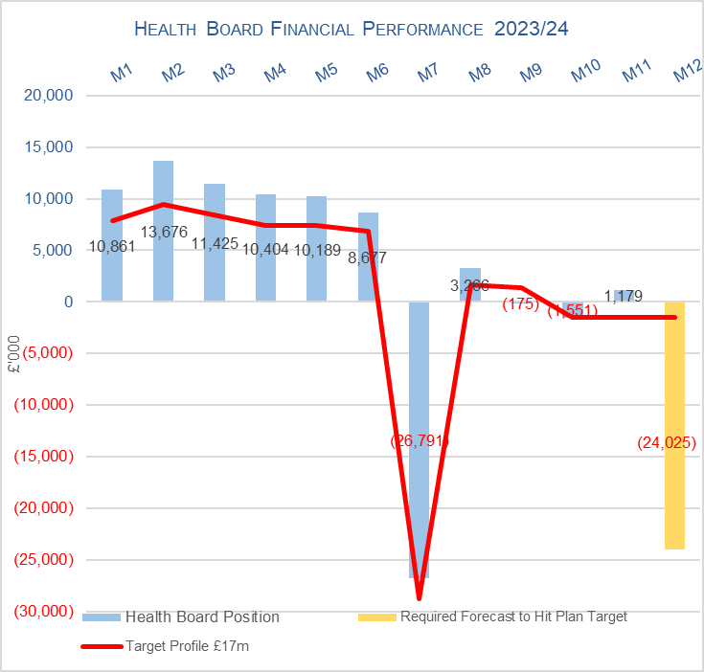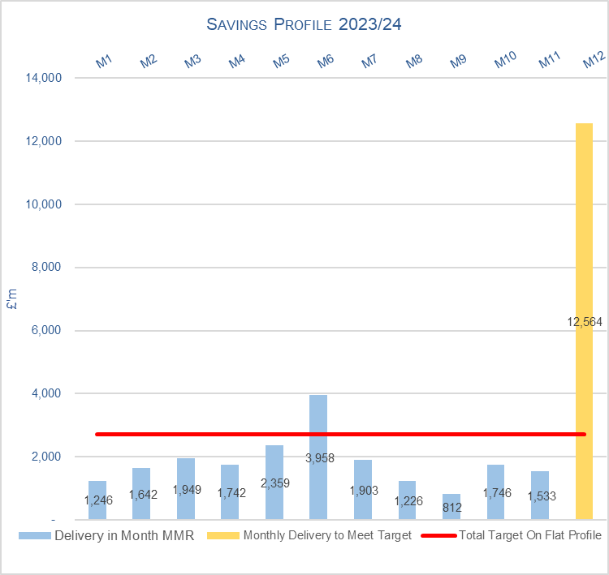

Target | In Month  £’m | Year To Date (YTD)  £’m
Delivery Against Revenue Resource Limit (RRL) DEFICIT / (SURPLUS) | 1.179 | 41.156
Delivery Against Total Savings Target In Ledger DEFICIT / (SURPLUS) | 0.931 | 9.004

Overall, the Month 11 financial position was £1.2m overspent, this was £1.1m higher than forecast in the landing plan.

Whilst in Month 11 the Health Board was successful in the delivery of key elements of the Landing Plan, and there were one-off benefits that partly offset the cost of both January and February’s Junior Doctor Industrial Action. The cost of the February Industrial Action has been assumed to be the same as January as the majority of payments for the cost of cover and reductions in salary for those taking Industrial Action will be made one month in arrears due to the timing of the payroll cycle.

Elements of the Landing Plan that were only partially delivered were linked to two items: (1) Capacity restrictions = Agency target (£2.1m) and (2) Targets Service Areas (£6.4m). Therefore, work will need to continue to ensure all options within the plan are addressed as there continues to remain risks regarding the items highlighted in red on Appendix 4.

- FINANCIAL PLAN 2023/24
The Health Board (HB) submitted a revised plan on 31st May 2023 that reported a deficit of £86.6m. Following the hard work undertaken within Welsh Government, NHS Wales has received £460m of additional funding of which Swansea Bay received £60.8m for 2023/24 (of which £43.3m is recurrent). For 2023/24 there is then a requirement for the HB to deliver a 10% reduction based on the original deficit plan value of £86.6m, to achieve a Control Total of £17.1m.

Since the publication of the additional funding as associated Control Total there have been discussions held with Welsh Government and the Board regarding the options available to deliver the target set, which are summarised and managed through the document referred to as the 2023/24 Landing Plan. This document not only outlines the actions to deliver the £17.1m but the profile of delivery from Month 8 to Month 12. Progress against each of the actions is summarised in Appendix 4.

- KEY PERFORMANCE AREAS
Performance is summarised from two different perspectives. Section 3.1 provides the reported position by Service Group/Directors and Section 3.2 onwards looks at the reported position from the components of the ledger i.e. Income, Pay and Non-Pay, with further details provided in Appendix 1.

  - Summary By Service Area

Table 3: Summary

Key points of notes by Service Area (based on new Service Structure):

- Morriston
The key variances:
- Income: Month 11 is £0.85m under-achieved and Year To Date (YTD) £1.750m underachieved. The in-month position benefited from a one off £0.6m YTD adjustment to WHSSC performance relating to the marginal rate applied to Cardiac surgery. The overspend YTD continues to be driven by overall WHSSC performance. Plans are being developed to recover this via the Enhanced Monitoring meetings but the reduced activity in January has impacted this month.
  - Pay: Month 11 is £2.100m overspent, which is a worsening of £0.690m from Month 10 and primarily driven by the recognition of the impact of both January and February’s Junior Doctor Industrial Action. YTD pay is overspent by £15.690m.
  - Non-Pay (excluding Savings): Month 11 is £0.755m underspent and YTD £6.582m overspent. Of the £6.582m YTD, over half of this (£3.96m) relates to Clinical Supplies (including Secondary Care Drugs) and £1.69m relates to Premises & Fixed Plant.
  - Savings: YTD position at Month 11 is a £5.96m shortfall.

- Neath Port Talbot & Singleton (NPTS)
The key variances:
  - Income: Month 11 is £0.054m under-achieved and YTD £0.694m under-achieved. This continues to be driven primarily by the loss of Private Patient income.
  - Pay: Month 11 is £0.750m overspent, primarily driven by the recognition of the impact of both January and February’s Junior Doctor Industrial Action. The YTD position is £6.348m overspent.
  - Non-Pay (excluding Savings): Month 11 is £0.104m underspent (£0.4m improvement from Month 10), however this is largely driven by the release of uncommitted reserves totalling £596k. This is a one off and non-recurrent benefit in-month. YTD Non pay remains overspent by £7.876m, which relates primarily to Primary Care Prescribing costs and Clinical supplies and services.
  - Savings: YTD position at Month 11 shows a £2.830m shortfall.

  - Summary By Type Expenditure

- Income
The Welsh Health Specialised Services (WHSSC) Income as a provider continues to impact on the performance against plan, with YTD underachievement of £1.8m. Month 11 saw a continuation of trends linked to reduced activity in February 2024.

As reported for the previous 10 months of 2023/24, the pressure as a result in the loss of Dental Contract Income continues, with the YTD shortfall increasing to £1.6m in Month 11.
- Pay
The Month 11 pay overspend has deteriorated from Month 10 and stood at £3.6m (an increase from Month 10 overspend of £2.3m), taking the YTD overspend to £20.5m. There has been a small decrease in WTEs between months, predominantly within Nursing. There has been a decrease in Overtime and Medical Agency, whilst both Non-Medical Agency and Bank have remained similar to Month 10. This includes both the cost of cover and reduced salary from the Junior Doctors’ Industrial Action in January and February; February estimates have been predominately manually accrued.

Therefore, the Health Board clearly needs to address both the underlying run rate issue and the continued expenditure on variable pay, which is driving the in-month and YTD pay variance.

- Prescribing
At Month 11 the in-month position reflected in the ledger on Prescribing is breakeven (Month 10 £0.8m overspent) and £5.7m YTD. The latest PAR continues to recognise the significant price reduction in Apixaban (the most commonly prescribed DOAC), however growth in both price and volume continue to offset the benefits. It is expected that the Category M position will improve in the final two months of the year to partly offset the YTD overspend; this data is not yet available to validate this assumption.

- Non-Delivery Savings
The Health Board has set a 3.5% savings target for 2023/24, after two years of achieving 4%. In additional there is a further £10.6m of unmet recurrent savings b/f from 2022/23. However there remains a gap in the delivery of savings to meet the target sets which has resulted in a £0.9m variance in Month 11, with a £9.0m YTD position.

  - Action being Taken to Mitigate Position

The previous reports detailed the actions being driven by the Health Board to mitigate the planned deficit and risks. Updates or additional actions above those reported in previous months are captured below:

- Landing Plan – The Health Board’s ‘Landing Plan’ to deliver the Control Total set by Welsh Government of £17.1m was presented to the Board on 30th November 2023. The Board supported the aspiration to deliver the Control Total and the opportunities and actions needed to deliver the target. The control target requirements for Service Groups have been formally communicated to Budget Holders in December 2023 via a letter from the Chief Executive. Recovery meetings with Service Groups have focused on developing plans to achieve the required reductions in run rates, with continued progress in Mental health and Learning disabilities (MHLD), Primary, Community and Therapy Services (PCTS) and Neath Port Talbot Singleton (NPST) and limited progress within Morriston Service Group (MSG), largely due to the outbreaks of Norovirus, COVID, Flu and C.difficile leading to some beds being closed and ongoing urgency and emergency care pressures. The managerial and financial impact of the Industrial Action has also had a significantly detrimental impact that requires further assessment. The Landing Plan will be used going forward to oversee the delivery of the Control Total up to the closedown on the Month 12 position.

- SAVINGS
Based on the latest saving position reported by the Savings Project Management Office (PMO), the schemes identified for delivery in 2023/24 by service areas are summarised below, with supplementary information provided in Appendix 3.

Table 4a In-year & recurrent performance against 2023/24 Requirements

- RISK
Two Board level financial risks:

- Achieving financial plan (HBR92) with the key elements as follows: -

  - Risk of delivery of savings quantum
  - Risk of operational overspend being in excess of funding available agreed via the Financial Plan
  - Risk of commitment of reserves (e.g. NICE) being above reserves available.
  - Risk of achieving the actions outlined in the 2023/24 Landing Plan.

All standard risks have been removed, with the exception of Industrial Action.

- Junior Doctors’ Industrial Action – The Month 11 position reported the impact of the first two Industrial Action periods (January and February). The Health Board was able to mitigate the January costs via N/R benefits above that needed in the Landing Plan and is looking for further opportunities to mitigate the February and March costs non-recurrently over the next few weeks. However, this will be a significant risk as we head into 2024/25.

Given the continued level of risk regarding the deliverability of all the actions in the Landing Plan for Month 12 and the financial impact of the Industrial Action it is proposed that the Health Board Corporate Risk Register current report risk score of 20 score is maintained.

- Availability of capital (HBR93). This risk was re-opened in 2022/23 given the reduction in discretionary capital allocation. Whilst work is underway to manage schemes to reduce commitments in 2023/24 and to produce a balanced plan, the risk varies during the year as more details on schemes emerge and potential slippage funding is made available by Welsh Government.

The Health Board now has plans to balance the CRL in 2023/24 and hence, in Month 11, this risk was reduced to a score of 10 (being 2 for likelihood and 5 for impact) as the team still needs to ensure that all planned receipt of funding and goods and services is received to deliver the plan. This work is intense from now until the year end with the position being confirmed in April 2024.

- RECOMMENDATIONS
Members are asked to:
- NOTE the agreed 2023/24 financial plan.
- Consider and comment upon the Health Board’s financial performance for Month 11 2023/24.
- NOTE the actions to ensure delivery of the financial forecast with a specific focus on savings delivery:
- Enhanced monitoring meetings in place above standard Finance & Performance Meetings to oversee and agree actions to mitigate run rates and deliver savings and issued Control Totals. Morriston / NPTS Service Group Directors
- Focused attention to ensure that 100% of the schemes were identified at the end of Q1 23/24. All Service Group Directors and Corporate Directors
- Focused attention to ensure that 100% of the schemes identified at the end of Q1 were green and amber by the end of Q2 23/24. All Service Group Directors and Corporate Directors
- Where savings delivery is not on track a further correspondence has been issued. All Service Group Directors and Corporate Directors
- NOTE actions to ensure the operational pressures are mitigated and areas return to financial balance.
- Enhanced monitoring meetings in place above standard Finance & Performance Meetings to oversee and agree actions to mitigate run rates and deliver savings and Control Totals. Morriston / NPTS Service Group Directors
- Embed and deliver opportunities identified via the Independent Financial support provided to the Service Group to review run rate and savings. Alongside the opportunities identified in the last 3 months by the Service Group itself. Morriston Service Group Directors
- NOTE the risks to the position at Month 11.
- NOTE the actions required to achieve Control Total (Appendix 4)
- NOTE the position with regards to Health Board Reserves.
- NOTE all actions and updates to support the management of the 2023/24 financial position.

Governance and Assurance

Link to Enabling Objectives  (please choose) | Supporting better health and wellbeing by actively promoting and empowering people to live well in resilient communities
Link to Enabling Objectives  (please choose) | Partnerships for Improving Health and Wellbeing |  | ☐
Link to Enabling Objectives  (please choose) | Co-Production and Health Literacy |  | ☐
Link to Enabling Objectives  (please choose) | Digitally Enabled Health and Wellbeing |  | ☐
Link to Enabling Objectives  (please choose) | Deliver better care through excellent health and care services achieving the outcomes that matter most to people
Link to Enabling Objectives  (please choose) | Best Value Outcomes and High Quality Care |  | ☒
Link to Enabling Objectives  (please choose) | Partnerships for Care |  | ☒
Link to Enabling Objectives  (please choose) | Excellent Staff |  | ☐
Link to Enabling Objectives  (please choose) | Digitally Enabled Care |  | ☐
Link to Enabling Objectives  (please choose) | Outstanding Research, Innovation, Education and Learning |  | ☐
Health and Care Standards
(please choose) | Staying Healthy |  | ☐
(please choose) | Safe Care |  | ☐
(please choose) | Effective Care |  | ☐
(please choose) | Dignified Care |  | ☐
(please choose) | Timely Care |  | ☐
(please choose) | Individual Care |  | ☐
(please choose) | Staff and Resources |  | ☒
Quality, Safety and Patient Experience
Financial Governance supports quality, safety and patient experience.

Financial Implications
The Board is reporting a forecast year-end deficit financial outturn.

Legal Implications (including equality and diversity assessment)
No implications

Staffing Implications
No implications

Long Term Implications (including the impact of the Well-being of Future Generations (Wales) Act 2015)
No implications

Report History |  | Updates on the financial position are provided at every meeting
Appendices |  | Appendices provide further detail

APPENDIX 1 – FURTHER DETAIL ON VARIANCES BY TYPE OF SPEND

- Overview of Income

- Overview of Pay Variances

Overall Variance by month

Note – movement between Month 2 and 3 and Month 4 and 5 budget relates to the one-off funding for the Recovery pay award and changes to the budget profiling linked to year-end accruals for Leave, Overtime and Time owing. Month 7 budget includes Medical & Dental Pay Award arrears (7/12th) for 2023/24.

Actual Variable Pay by month and type

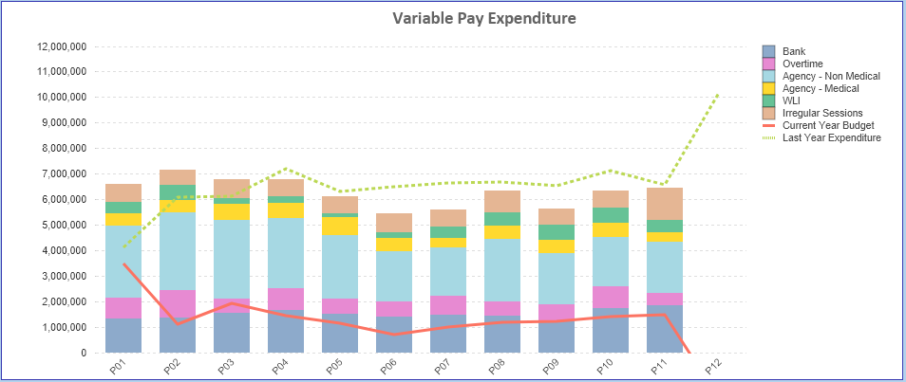

- Overview Non-Pay

Note – movement between Month 2 and 3 budget relates to the one-off adjustment for Losses, which is normally reflected at year-end only and so had to be adjustment between months. Month 7 reflects 7/12th of budget linked to the additional funding of £60.8m.

Below are further details on the key areas of Non-Pay (excluding savings that is addressed in main body):

  - Clinical Consumables
This area continues to be a significant pressure with a YTD variance of £8.2m. With the in-month position being higher than Month 10 (£0.3m) at £0.5m. There are 80+ subjective lines within this category including secondary care drugs but areas seeing most pressures YTD continue to be general consumables (M&SE), laboratory products and implants (which in part will be driven by activity).

  - Utilities
As noted previously whilst NWSSP continue to provide updates it is important to note that this forecast is not based on actual or predicted volume usage but industry averages. This becomes important given the Moriston site acquires a significant amount of its power from the Solar Farm, which if using industry averages would not be built into the forecast. In addition, the PFI costs for NPT Hospital are outside of the Crown Commercial Services (CCS) forecast.

Therefore the Health Board has an assessment of its predicted usage costed at the CCS rate and incorporating the PFI costs. The forecast in Table B for 2023/24 provides an updated estimate of £15.5m for 2023/24, including PFI (reduction of £0.4m since Month 10). We have used a bottom-up approach led by our Estates/Energy leads taking into consideration the actual and predicted usage and then applying the contract price provided by NWSSP. The HB is assuming the full funding for energy of £7.8m in its overall Landing Plan.

We will continue to monitor the HB assessment of the position and review the forecast monthly as the actual costs/invoices are processed.

  - CHC
The variance against budget for CHC is £0.187m overspent in-month and is £2.099m overspent YTD which reflects the impact of a small number of high-cost packages, predominantly in the Community and growth in MHLD.

An analysis of actual expenditure and patient numbers for 2023/24, along with the average values from 2023/24 is provided in table below.

CHC Analysis by Month

(Please note: PCT Group does not include the Singleton/NPT element. The NPTS element which covers Children and Young People CHC patients is provided internally by the Health Board and as such is part of the wider NPTS position and is not recorded in the ledger as PCT/MH/LD CHC is recorded)

  - Prescribing
See commentary in section 3.2 in the main body of the report.

  - LTA Performance
Historically LTA contracts have been based on a Cost and Volume approach, which reflects adjustments for under and over performance. From the start of the COVID pandemic in April 2020 all LTA agreements in both England and Wales transferred to a block arrangement, whereby commissioners funded providers on 2019/20 levels uplifted by nationally agreed rates with no adjustment for performance. From 1st April 2022 the previous block arrangements have ceased and a hybrid model adopted where under or over performance adjustments will become applicable above a tolerance level. This became relevant to both services we commission from other Health Boards and services commissioned from SBU HB. In 2022/23 the tolerance level was 10% but in 2023/24 the tolerance level has reduced to 5%.

The table below is the performance of Swansea Bay HB at the end of Month 9 as a provider, for services commissioned by other Health Boards. Under the previous Long Term Agreements the full year forecast for underperformance would be £1.304m, under the interim arrangements that risk has reduced and delivers a benefit of £1.384m.

The Table below is the performance of contracts provided by other Health Boards in Wales but commissioned by Swansea Bay. Here, under the previous LTA arrangements, we would have seen a benefit of £3.391m but under the interim arrangement that has reduced to £2.664m.

Of the net impact of £4.048m, some will already be accounted for in the YTD position, with the Landing Plan assuming there is further benefit delivered by the end of Financial Year. However, the final impact of LTA performance will not be known until the Intra NHS Exercise/Agreement of Balances is complete as part of the Year End Closedown across NHS Wales.

APPENDIX 2 – DETAILS ON RESERVES & CENTRAL BUDGETS

- SUMMARY RESERVES
Overall management of the reserves is as per the Health Board Budget Management document.

  - Balances Main & NICE
For 2023/24, the Health Board will hold two central reserves and the purpose of these reserves are below:
- Main – this holds funding from WG or the plan that has yet to be issued to Budget Holders. These items are not surplus but either due to timing have not been issued or is an area where funding is issued based on actual values consumed in future month.
- NICE – this holds the total Health Board funding for all of NICE costs (drugs and infrastructure) and is issued to the service each month based on the actual costs consumed as reported through the Pharmacy system.

Details on the balances and movements are provided in the Table below:

- COVID RECOVERY
As part of the Financial Plan £22.9m was set aside to support COVID Recovery (excluding Regional Investments). The £22.9m was funded through £15.2m from WG Annual Allocation letter issued in December 2023, and an additional £7.7m of Health Board discretionary revenue funding. The funding remains in Central Reserves, as recorded in Section 1 above. This funding is then issued to service areas based on the actual costs committed. A summary of the actuals to date and forecast costs against the £22.9m is summarised in the table below. This now shows a surplus of £2.56m which will meet the requirement of the Landing Plan detailed in Appendix 4.

- Changes to Deficit
The Board supported the original £86.6m deficit plan. The deficit was held centrally with an element reflected each month in the reported performance against RRL (see Section 3.4 on Non-Pay) on a tapered basis, as previously agreed with the Board. Following the announcement by WG the HB received £60.8m, which has been allocated against the opening deficit. This leaves the planned deficit at £25.7m. However, this does not include the additional 10% required to meet the Control Total.

APPENDIX 3 – DETAILED SAVINGS REPORT
Total HB Savings – By Risk Rating
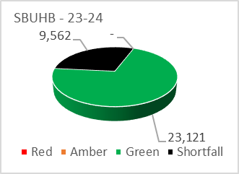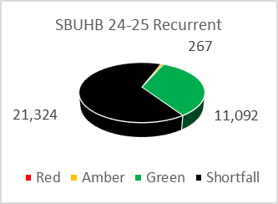

- The 2023/24 savings target is £32.7m (made up of £22.2m in year target and a brought forward sum of £10.5m).
- Current savings represent 71% of the in-year target and 35% of the recurrent target.
- Morriston has the largest recurrent shortfall against target (£9.4m), achieving 40% in the current year and 13% recurrently. NPTS have achieved 62% and 21% respectively, PCT 96% and 64% respectively, MHLD achieving 100% and 35% respectively.

Total Savings for SBUHB by Service Group and by Risk Rating

Total SBUHB Projected Savings Profile by Target (Target £32.6m, Forecast £23.1m)

Morriston
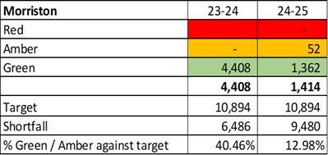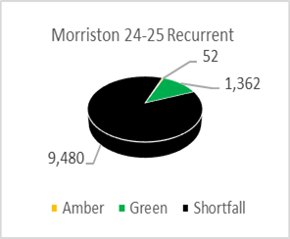

- Morriston forecasted savings are £4.4m in-year with a shortfall of £6.4m.
- Most recent change includes an increase identified for non-recurrent opportunities within the Burns ward Reconfiguration (£0.1m), Medicine (£0.02m) and CSSG (£0.02m)
- The recurrent savings have identified schemes of £1.4m with a shortfall at £9.5m (excludes red schemes).
- Pipeline CIP/Run Rate Opportunities include critical care bed alignment to demand, Plasma Exchange, ALAC, Pathology – Vitamin D, non-pay reviews-cardiology consumables, Private Patient Opportunities & Procurement.

NPTS
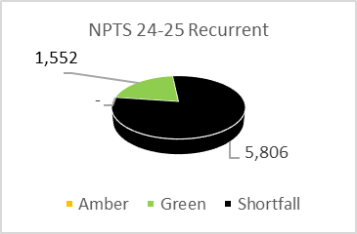

- The NPTS forecasted savings (excluding red schemes) are £4.6m, with an in-year shortfall of £2.8m. The recurrent shortfall remains at £5.8m.
- Pipeline schemes currently under discussion are to the sum of £0.07m.
- Ongoing work around SLAs for MPCE, MEMS and Cancer services in conjunction with Hywel Dda and Cwm Taf Morgannwg UHBs. Also, ongoing work on Theatres session and case data, Procurement review on Ophthalmology is soon to be finalised and will be presented at the next assurance meeting.

MHLD
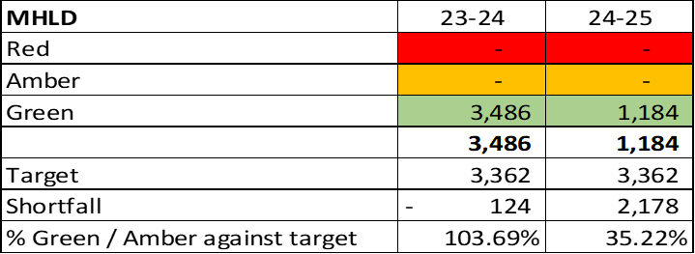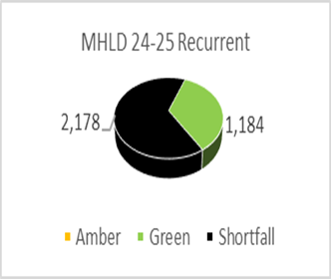

- MHLD forecasting savings hold in-year savings of £3.48m with no in-year shortfall, creating an overachievement against target of £0.12m. This success has come from the slippage from new funding streams. Recurrent savings remain at £1.18m.
- Work is currently on-going to identify recurrent saving schemes to fill the recurrent shortfall of £2.2m. Further work is being carried out reviewing variable pay and CHC (repatriations and benchmarking opportunities).

PCCT
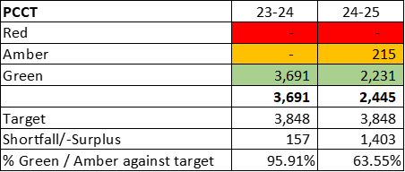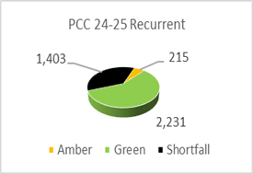

- PCC forecasted in-year savings are £3.7m, recurrent savings identified at £2.4m.
- Recurrent savings identified have a shortfall of £1.4m.
- The Group have focused on developing a recurrent savings plan with little non-recurrent activity. A number of new recurrent schemes (16) have recently been identified with a total value of £0.6m.

CORPORATE
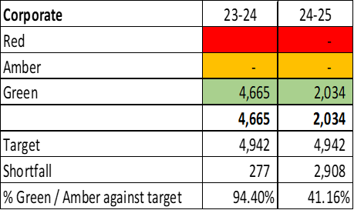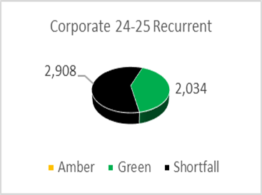

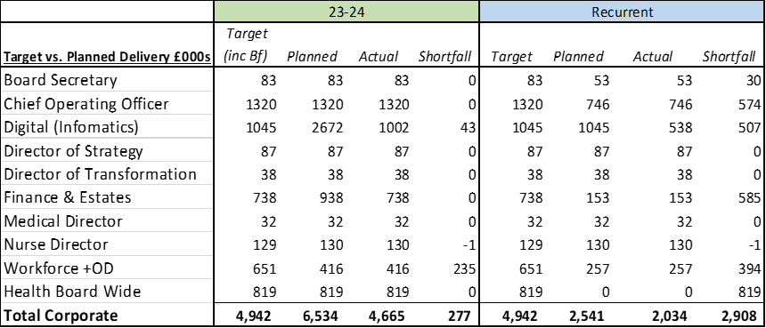

- Corporate Directorates forecast in-year savings identified are £4.7m (recurrent shortfall £2.9m).
- The in-year shortfall has increased to £0.27m due to an increase in identified savings in Digital for vacancy management periods, £0.07m offset by a decrease in identified savings in Finance & Estates for a supplier repayment (£0.2m) and Solar repayment (£0.01m).
- The anticipated progress with in year movements, particularly in Digital regarding the MS365 VAT savings have been delayed, however they may be achievable in 2024/25.
- The most challenging Directorates for achieving recurrent savings remain COO, Finance and Estates, HB wide.

APPENDIX 4: ACTIONS LANDING PLAN

