Meeting Date | 24 June 2025 |  | Agenda Item |  |  | 2.4
Name of Meeting | Performance & Finance Committee
Report Title | Capital Resource Plan Update
Report Author | Ian MacDonald, Assistant Director of Finance
Report Sponsor | Darren Griffiths, Executive Director of Finance & Performance
Presented by | Ian MacDonald, Assistant Director of Finance
Freedom of Information | Open
Purpose of the Report | To provide an update on the financial performance of the Health Board’s capital programme at month 2 and the impact of emerging risks and opportunities on the projected outturn position for 2025/26.
Key Issues | The Health Board approved a balanced capital financial plan for 2025/26 as part of the submitted Annual Plan.  The forecast outturn position reported at Month 2 shows an overspend position of £1.883m. Additional income from Welsh Government and disposals are anticipated to provide a balanced position.  Following the outcome of the national capital prioritisation exercise, the national funding situation remains unclear. A small number of urgent projects have commenced to scope immediate and interim solutions.  A small programme contingency is under pressure, as requests for additional capital funding continue to emerge from the service. The risk of the plan shifting from balance to imbalance remains material and is reflected in Risk 93 on the Health Board Risk Register
Specific Action Required  (please choose one only) | Information | Discussion |  | Assurance | Approval
Specific Action Required  (please choose one only) | ☐ | ☐ |  | ☒ | ☐
Recommendations | Members are asked to:  - ACKNOWLEDGE the month 2 reported financial position and forecast outturn.  - ACKNOWLEDGE the additional allocation bids submitted to Welsh Government.  - SUPPORT and DISCUSS the update on business cases.  - ACKNOWLEDGE the programme contingency of £254k

CAPITAL RESOURCE PLAN

- INTRODUCTION
This report provides an update to the financial performance of the Health Board’s capital programme and the impact of emerging risks and opportunities on the projected outturn position for 2025/26.

- BACKGROUND
The Health Board approved a balanced capital financial plan for 2025/26 as part of the Annual Plan submitted to Welsh Government (WG) in March 2025. The plan included an uplift of 24%/£2.7m to £13.875m. It also included income assumptions on the payback of business case fees from WG and disposals proceeds.

The forecast outturn position reported at month 2 shows an overspend position of £1.883m with anticipated allocations which would provide a balanced position.

The extensive £13m additional slippage bid funding provided by WG last year, alongside the national increase to discretionary allocations, mean the opening financial position is much more positive than at this stage over the last few years. There are however significant financial requests for additional funding for medical equipment replacement and estates and so the pressure to retain a balanced capital position will likely remain fragile as there is very little remaining flexibility in the programme to manage emerging service and infrastructure risks.

The national funding situation continues to be challenging following the outcome of the national capital prioritisation exercise, with several projects either on hold or working through interim solutions. There is also some uncertainty around the future approval of capital funding following recent correspondence from Welsh Government around the unapproved revenue financial plan for the Health Board as per Judith Paget’s letter of 6th June 2025.

Month 2 Position

The forecast outturn position reported at month 2 shows an over-commitment of £1.883m. Allocations shown below in table 1 are anticipated to provide a balanced position. The RAG risk rating on the income shows £300k as red and £1.226m as amber. Whilst the receipt of these income streams is required to ensure a balance position, they will be carefully monitored over the first 6 months, to ensure we are able to manage the resources appropriately and alongside fixing our individual Capital Resource Limit (CRLs) for individual projects with Welsh Government in October.

Table 1 - Month 8 Forecast Outturn Position 2025/26
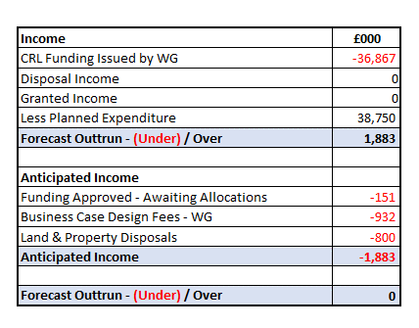
Table 2 - Anticipated Income 2025/26
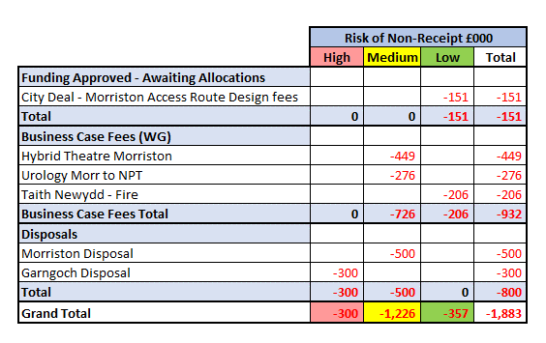
Capital Funding Allocations

The major schemes within the approved CRL are shown below in table 3, with the two major allocations approved towards the end of 2024-25.

Construction work on the new PET-CT at the West Wales Cancer Centre in Singleton is due to commence in September, with a 56-week programme. As discussions progress with the contractor to firm up the project cashflow, an element of the £13.286m funding will need to be returned to WG for re-provision in 2026-27.

The £7.292m Targeted Estates Fund (TEF) is part of an overall £16.349m approved investment over the next 2 years, which includes a 30% contribution from the Health Board’s discretionary capital. The funding this year will be for 30 projects across the Health Board estate, within Infrastructure, Fire, Decarbonisation, Decontamination, Mental Health and Infection Prevention Control. Whilst the funding injection in some key areas of estates infrastructure which ensure the Health Board can continue to deliver key clinical service throughout our estate on a day-to-day basis, the large number of projects inevitable means a certain element of diseconomies of scale, with different procurements, capital project manager and service inputs required. However, the success of delivering a similar number of schemes over the last two years through a number of targeted Welsh Government investments which involved close working relationships between the Capital Planning and Estates team does provide confidence in being able to deliver this scale of projects. Funding to continue the roof replacement on the Morriston nucleus roof is welcomed, although this will require the continued provision of ward decant facilities.

There are no approved allocations where allocations are outstanding.

Table 3 - Summary Approved Allocations 2025-26
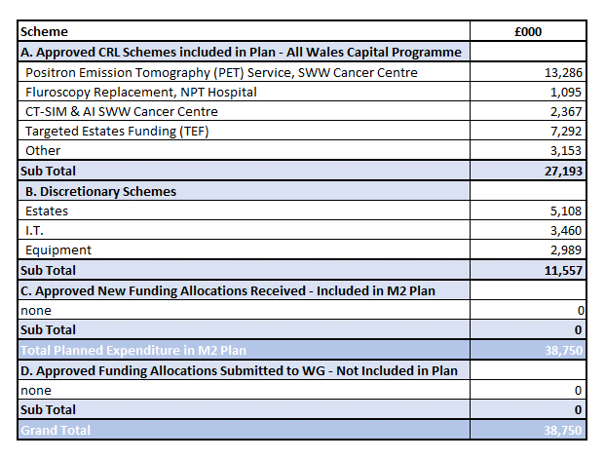
Additional funding bids have been submitted at the request of Welsh Government to accelerate some of the already approved TEF bids from 2026-27. The bid from the Health Board requests an additional £2.165m across 12 projects. Bids have also been submitted to the National Imaging Programme for £12.050m. The imaging schemes and estimated cost profile are shown below in Table 5.

Table 4 - Funding Bids Submitted
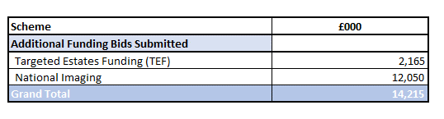
Table 5 – Breakdown of National Imaging Bids Submitted
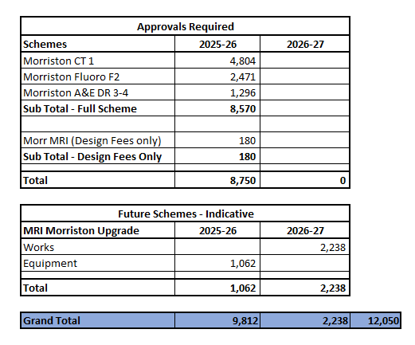

Equipment

The significant investment of £5.4m into digital last year from the Welsh Government slippage bids, allowed investment into some large service critical infrastructure projects, including replacement of the core network in Morriston & Singleton and replacement of the wireless network in NPT. The focus of the discretionary allocation this year is initially around replacement of devices and data centre systems.

Although the investment into medical equipment of £5.6m last year across 53 separate projects from Welsh Geoverment slippage bids was welcomed, there are still a large number of bids for replacement equipment that are being assesed by the Capital Prioritisation Group. Work is progressing on the procurement for 3 main replacement programmes included within the approved plan:-

- Anaesthetic Machine replacement, Morriston £800k (2 year programme)
- Pharmacy £1.160m. Replacement for the Pharmacy Robot, NPT and replacement of the automated medicine stock cabinets. (potentially a 2 year programme)
- Cardiology MacLab System Upgrade £540k

Programme Contingency

Although there are contingencies built into major projects across the capital programme, the remaining general discretionary programme contingency is only £254k.

Update on All Wales Capital Schemes

Following the outcome of the national Capital Prioritisation process for major business cases in January, the Estates Task Force group has continued to meet. As described in the submitted Annual Plan in March, the focus has been on developing funding solutions for the four urgent risk schemes and also developing plans for possible land and property disposals to support the national housing crisis.

Work is continuing on the four priority schemes and a detailed update with be provided through the Estates Taskforce into a future Performance and Finance Committee. In summary: -

- Adult Acute Mental Health Wards, Morriston. Immediate improvement works at Tawe clinic are being funded through the TEF allocation. Further funding is being sought as part of recently submitted TEF acceleration bids. Work has started on reviewing capital cost estimates for possible interim solutions.
- Emergency Department Improvements, Morriston. A number of interim solutions utilising the current estate are under consideration. Further design works will require capital funding support from Welsh Government.
- Regional Cellular Pathology. A regional Project Board has been established to review the site solution options for providing a regional solution.
- Taith Older Persons Ward, Glanrhyd. Following the fire last year, design work has commenced on a refurbishment. A fully designed and tendered solution is expected to be ready for Health Board and Welsh Government scrutiny in September. Welsh Government have agreed to support the capital refurbishment costs through the All-Wales Capital Programme.

Business Cases submitted to WG.
- Urology OR1 Theatres, NPT, September 2024 - £4.285m. Scrutiny comments received from Welsh Government. Awaiting final design and tendered costs from PFI partners.
- Hybrid Vascular Theatre, Morriston, May 2024 - £10.135m. Scrutiny comments received from Welsh Government. Awaiting internal agreement of a sustainable revenue funding plan.

Business Case in Production through Regional Partnership Board
- Dan y Deri Learning Disabilities £9.9m. Business Case on agenda for Performance & Finance Committee.
- Croeserw Health and Wellbeing Centre c£5.8m. Design nearing completion. Expected to shortly progress to tender, with a fully designed and tendered solution expected to be ready for Health Board and Welsh Government scrutiny in December.

Overall Assessment

Whilst the extensive £13m additional slippage bid funding provided by WG last year, alongside the national increase to discretionary allocations mean the opening financial position is much more positive than at this stage over the last few years, there remains significant financial requests for additional funding for medical equipment replacement and estates. With only a small programme contingency of £254k, the pressure to retain a balanced capital position will likely remain fragile as there is very little remaining flexibility in the programme to manage emerging service and infrastructure risks.

- GOVERNANCE AND RISK ISSUES
There is an increased possibility that new service requests, including those with a high-risk score will be unable to be receive capital funding during 2025/26 within the capital resources made available to the Health Board. These risks will continue to be assessed through the Capital Prioritisation Group and raised up through the Management Board.
A risk register entry (Risk 93) has been included in the Health Board risk register and is currently assessed as a 20-score risk.

- FINANCIAL IMPLICATIONS
The financial implications and funding risks are as detailed within the body of the report. In summary, the approved balanced capital plan is assuming additional funding of £1.883m. The remaining contingency in the plan is £254k.

Further design or buildings works on the four high priority building schemes will require capital funding support from Welsh Government.

- RECOMMENDATIONS
Members are asked to:
- ACKNOWLEDGE the month 2 reported financial position and forecast outturn.
- ACKNOWLEDGE the additional allocation bids submitted to Welsh Government.
- SUPPORT and DISCUSS the update on business cases.
- ACKNOWLEDGE the programme contingency of £254k

Governance and Assurance

Link to Enabling Objectives  (please choose) | Supporting better health and wellbeing by actively promoting and empowering people to live well in resilient communities
Link to Enabling Objectives  (please choose) | Partnerships for Improving Health and Wellbeing |  | ☐
Link to Enabling Objectives  (please choose) | Co-Production and Health Literacy |  | ☐
Link to Enabling Objectives  (please choose) | Digitally Enabled Health and Wellbeing |  | ☐
Link to Enabling Objectives  (please choose) | Deliver better care through excellent health and care services achieving the outcomes that matter most to people
Link to Enabling Objectives  (please choose) | Best Value Outcomes and High Quality Care |  | ☐
Link to Enabling Objectives  (please choose) | Partnerships for Care |  | ☐
Link to Enabling Objectives  (please choose) | Excellent Staff |  | ☐
Link to Enabling Objectives  (please choose) | Digitally Enabled Care |  | ☐
Link to Enabling Objectives  (please choose) | Outstanding Research, Innovation, Education and Learning |  | ☐
Health and Care Standards
(please choose) | Staying Healthy |  | ☐
(please choose) | Safe Care |  | ☐
(please choose) | Effective Care |  | ☐
(please choose) | Dignified Care |  | ☐
(please choose) | Timely Care |  | ☐
(please choose) | Individual Care |  | ☐
(please choose) | Staff and Resources |  | ☐
Quality, Safety and Patient Experience
Without additional funding support from WG, further requests for capital funding will not be affordable within the allocated resources. This may impact on new service requests for additional capital funding for estates, medical equipping and digital services.

Financial Implications
The financial implications and funding risks are as detailed within the body of the report. In summary, the approved balanced capital plan is assuming additional funding of £1.883m. The remaining contingency in the plan is £254k.

Further design or buildings works on the four high priority building schemes will require capital funding support from Welsh Government.

Legal Implications (including equality and diversity assessment)
None
Staffing Implications
None
Long Term Implications (including the impact of the Well-being of Future Generations (Wales) Act 2015)
n/a

Report History |  | None
Appendices |  | None

