

Meeting Date | 25th May 2024 |  | Agenda Item |  | 2.2
Report Title | Financial Report – Period 02 2024/25
Report Author | Samantha Moss, Deputy Director of Finance  Gemma Pearson, Finance Business Partner
Report Sponsor | Darren Griffiths, Executive Director of Finance and Performance, Acting Deputy Chief Executive
Presented by | Samantha Moss, Deputy Director of Finance
Freedom of Information | Open
Purpose of the Report | The report advises the Performance & Finance Committee of the Health Board on the financial position for Month 02 2024/25 (May 2025) and risks regarding current forecast revenue year end outturn.
Key Issues | The report invites the Performance & Finance Committee to note the detailed analysis of the financial position for Month 02 2024/25 (May 2024).  The report includes a summary of the key drivers of the position either at Service level or by expenditure type (i.e. Non Pay/Pay). It also provides information of the current position with regards to Health Board reserves to ensure transparency in the overall Health Board position.  Risk will have been considered on the basis of the information provided within the report and the score updated where necessary.  Whilst the key messages are provided within the main body of the report, further information is provided in the Appendices.
Specific Action Required | Information | Discussion | Assurance | Approval
Specific Action Required | ☐ | ☐ | ☒ | ☐
Recommendations | Members are asked to:  - To NOTE the agreed 2024/25 financial plan.  - Consider and comment upon the Board’s financial performance for Period 02 2024/25.  - TO NOTE the actions to ensure delivery of a balanced financial position for all service areas as per the accountability letters issued in May 2024, which now require:  - Re-submission of Financial Strategy by each Service Area on 28th June 2024. (Service Group Directors/ Corporate Directors)  - Following resubmission a summary of options to support financial balance to presented to July meeting. (Service Group Directors)  - TO NOTE the ‘saving’ reduction target set are per the accountability letters and ensure actions are logged on the savings trackers.  - All savings to be identified and on trackers by 31st May 2024 (Service Group Directors/ Corporate Directors)  - NOTE the risks to the position at Month 02.  - NOTE the position with regards to Health Board Reserves.  - NOTE all actions and updates to support the management of the 2024/25 financial position, including those in Appendix 4.

FINANCIAL REPORT – MONTH 02

SUMMARY OF REVENUE PERFORMANCE

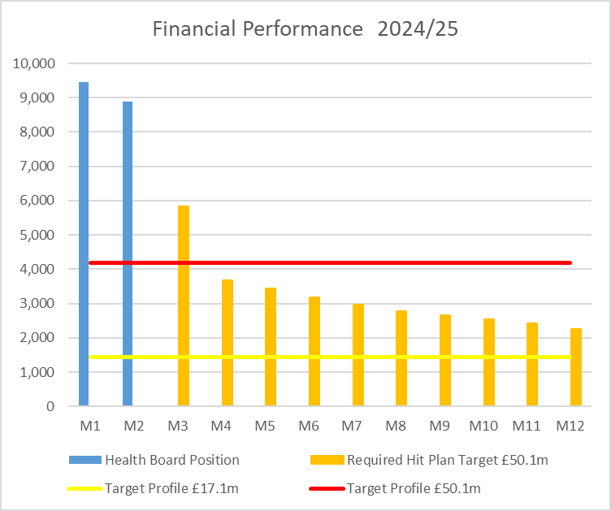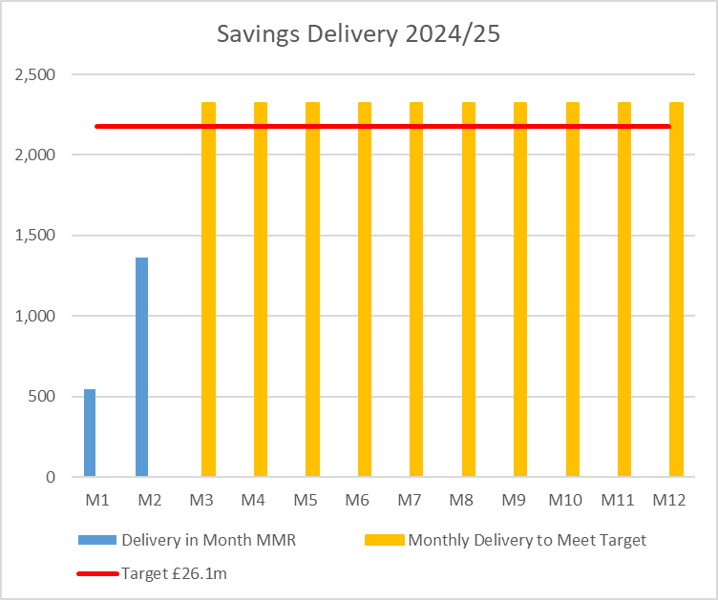

Target | In Month  £’m | Year To Date (YTD)  £’m
Delivery Against Revenue Resource Limit (RRL) DEFICIT / (SURPLUS) | 8.884 | 18.342
Delivery Against Total Run Rate/Savings Target In Ledger DEFICIT / (SURPLUS) | 1.362 | 1.906

In Summary the Month 2 financial position was £8.9m overspent, this was £4.7m higher than the forecast deficit for the month.

The Annual Plan submitted on 28th March 2024 reported a deficit of £50.1m after the delivery of £26.1m of savings. The expectation was that the in-month position would reflect a 12th of the £50.1m deficit. For Month 2 the Health Board (HB) has reported a deficit of £8.9m against a 12th of the deficit plan of £4.2m. Clearly this position is unacceptable and immediate actions are being taken.

The three component and the respective impact on the £8.9m are visualised in the chart below:

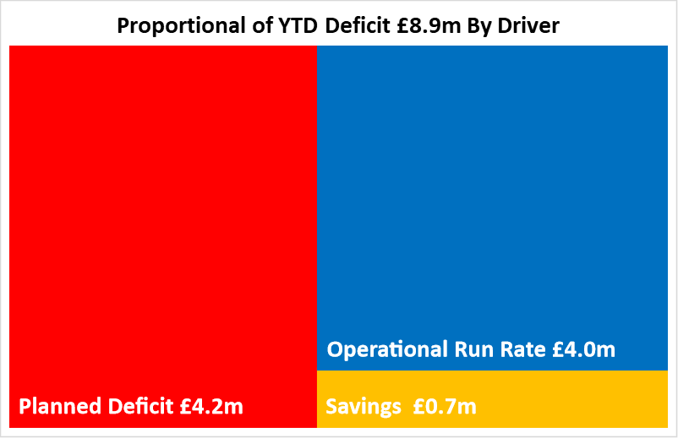

- FINANCIAL PLAN 2024/25
The Health Board submitted an Annual Plan on 28th March 2024 which reported a deficit of £50.1m. This has not been approved by Welsh Government (WG) with the request that as a minimum the Health Board reduces its deficit to £17m or better; work and discussions are ongoing. In order to meet the £50.1m deficit plan operational savings totalling £26.1m are required and all service areas are required to breakeven to their delegated budgets. This will require the need for a significant reduction to the Health Board’s run rate of expenditure.

A further review of the deficit in light of the month 1 position was undertaken to be considered alongside the thematic work programme to reduce the deficit. The Board was advised in May 2024 that whilst the thematic review work had identified some technical changes that could be made and some variable benefits which could be realised, in light of the emerging month 1 position there were not sufficient granular plans to reduce the forecast deficit as actions would first be required to de-risk the run rate.

- KEY DRIVERS OF THE IN MONTH POSITION
The key drivers of the month 2 position are summarised in the table below. Further detail at a Health Board level of expenditure on Income, Pay and Non-Pay, is also provided in Appendix 1.

  - Key Drivers By Service Area

  - Summary By Expenditure Type

- Income
The Welsh Health Specialised Services (WHSSC) Income as a provider improved in-month and achieved a breakeven position through delivery of an increase in Plastics and TAVI/Cardiology procedures. The YTD underachievement is £0.3m.

Dental Contract Income was accrued to breakeven in Month 1 as a holding position until the impact of the new pricing tariff was understood and in recognition of the likely (but not yet quantified) clawback from contractors in relation to underperformance in 2023/24. However, on receipt of the April 2024 data, the increase in income is 16% compared to the prior year; to achieve breakeven an increase of 69% would be required and therefore it is judged that the underachievement of £0.3m should be reported YTD in Month 2.

- Pay
The Month 2 pay overspend was £2.3m (Month 1, £2.8m), largely driven by Medical & Dental and Nursing across the acute sites and MH&LD in addition to Hotel Services within COO. The pay pressures are driven by a number of factors including the continuation of staffing surge bed capacity, pressures on services across the organisation and high levels acuity, coupled with high levels of sickness.
- Prescribing
At Month 2 the in-month position reflected in the ledger on Prescribing is an underspend of £0.4m (Month 1, breakeven) following the issuing of both growth and price inflationary investments within the Annual Plan, and in-month delivery of savings.

- Non Delivery Savings
The Health Board has set a 2.5% savings target for 2024/25 which has been issued to Service Areas. There is currently a gap in the identification, and therefore delivery, of savings to meet the target sets has resulted in a £0.7m (Month 1, £2.0m) variance in Month 2 (noting that PCT schemes recognised a YTD delivery in Month 2).

  - Action being Taken to Mitigate Position
The Chief Executive Office (CEO) set out a number of actions to address the run rate pressures and during May 2024 the CEO also established clear actions for each Executive Team member, which are in addition to the Thematic Programmes.

The additional actions above the Thematic Programmes, and associated Lead Executive, focus on:
- Medical Staffing Variable Pay – Acting Medical Director
- Nursing (Registered and Unregisters) Variable Pay – Director of Nursing
- Review Bank – Acting Director of Workforce
- Review Non Pay Outsourcing – COO
- Maximising Value & Sustainability opportunities – Director of Finance & Performance

As part of an Independent Members Financial Briefing post the Month 2 position, held on 11th June 2024 a series of further and immediate next steps were discussed and are underway. A final position on the actions below will be agreed upon the return of the CEO from planned leave on 17th June 2024:

- Compliance review on variable pay commitment following CEO instructions
- Corporate vacancy freeze
- Corporate positions to not commit further spend beyond Business As Usual (BAU)
- Urgent review of all cost pressures and inflation assumptions funded in this year’s plan
- NHSE support on medicines processes
- Prioritisation of surge capacity and bed modelling to most cost effectively right size UEC system
- Assess and then roll out options to engage and support budget holders
- Establishment of the internal run rate reduction team – DoF to discuss further with Chair
- Review of individual Service Area financial strategies and identification of options for the Board to consider
- Implementation of weekly reporting to monitor drivers of financial expenditure during the month and taking corrective action earlier in the month

The majority of the actions above, excluding the thematic programme work, focus on the management of run rate reduction and savings delivery. The Health Board recognises that work is also required on the assessment of the choices made to support sustainability as part of both in the 2023/24 Financial Plan and the 2024/25 Financial Plan. Work is required to review the financial support provided for sustainability of services and further details are provided in Appendix 4.

2.4 Local Plans
Service groups and Corporate Directorates were required to submit forecast outturns for 2024/25 as part of the governance process for 2024/25. These plans have been received and a number of plans do not achieve a balanced outturn. Correspondence has been sent to those areas to asked for plans which set out options and choices to delver a breakeven plan. These options and choices are required by 28th June 2024 for consideration in July 2024ahead of providing advice to the Board on decisions to be taken to potentially reduce the deficit.

- SAVINGS
Based on the latest Run rate reduction/savings position reported by the Savings Project Management Office (PMO), the schemes identified for delivery in 2024/25 by service areas are summarised below. For clarity the first call on savings will be to address the £26.1m target by area, any opportunities above this will be allocated to management of Run Rates.

Savings Table 1
Table 1 – reflects all opportunities including those identified as red along with pipeline ideas, which total £20.9m. Of this total £4.4m will mitigate run rate pressures outside of the £26.1m target set in the plan, which leave £16.4m to meet £26.1m 24/25 target. Overall this leaves a gap of £9.6m. Recurrently, £19.2m of opportunities have been identified, with £1m to mitigate run rate pressures, leaving £18.2m of schemes identified recurrently, and a recurrent shortfall of £7.9m.

Savings Table 2
Table 2 – reflects only those opportunities which are deemed Green and Amber schemes. As a result the overall total reduces to £13.6m at end of May. £2.1m of this is a reduction to run rate pressures outside of the £26.1m target set in the plan, which leaves £11.5m to meet the £26.1m 24/25 target. Overall this leaves a gap of £14.6m. Recurrently, £11.3m of opportunities have been identified, with £0.3m to mitigate run rate pressures, leaving £10.9m of schemes identified recurrently, and a recurrent shortfall of £15.1m.

Overal there is a material shortfall in the identification of opportunities to address the £26.1m target set in the 2024/25 Financial Plan, and this will form part of the focus of the monthly Financial Performance meetings.

- RISK
Two Board level financial risks:

- Achieving financial plan (HBR92) with the key elements as follows: -

  - Risk of delivery of savings quantum
  - Risk of operational overspend being in excess of funding available agreed via the Financial Plan
  - Risk of commitment of reserves (e.g. NICE) being above reserves available.
  - Risk of achieving the actions outlined in the 2023/24 Landing Plan.

Based on the financial performance at Month 2, it is proposed that the Health Board Corporate Risk Register retain the existing risk score to 25 given the unacceptability of the current financial plan and the variance from plan in months 1 and 2.

- Availability of capital (HBR93). This risk was re-opened in 2022/23 given the reduction in discretionary capital allocation. Whilst work is underway to manage schemes to reduce commitments in 2024/25 and to produce a balanced plan, the risk varies during the year as more details on schemes emerge and potential slippage funding is made available by Welsh Government.

A score of 20 is suggested at this stage as whilst the plan is now balanced, a number of schemes are on hold and the flexibility within the plan is extremely limited given the reduction in the allocation.

- RECOMMENDATIONS
Members are asked to:
- To NOTE the agreed 2024/25 financial plan.
- Consider and comment upon the Board’s financial performance for Period 02 2024/25.
- TO NOTE the actions to ensure delivery of a balanced financial position for all service areas as per the accountability letters issued in May 2024, which now require:
  - Re-submission of Financial Strategy by each Service Area on 28th June 2024. (Service Group Directors/ Corporate Directors)
  - Following resubmission a summary of options to support financial balance to presented to July meeting. (Service Group Directors)
- TO NOTE the ‘saving’ reduction target set are per the accountability letters and ensure actions are logged on the savings trackers.
  - All savings to be identified and on trackers by 31st May 2024 (Service Group Directors/ Corporate Directors)
- NOTE the risks to the position at Month 02.
- NOTE the position with regards to Health Board Reserves.
- NOTE all actions and updates to support the management of the 2024/25 financial position, including those in Appendix 4.

Governance and Assurance

Link to Enabling Objectives  (please choose) | Supporting better health and wellbeing by actively promoting and empowering people to live well in resilient communities
Link to Enabling Objectives  (please choose) | Partnerships for Improving Health and Wellbeing |  | ☐
Link to Enabling Objectives  (please choose) | Co-Production and Health Literacy |  | ☐
Link to Enabling Objectives  (please choose) | Digitally Enabled Health and Wellbeing |  | ☐
Link to Enabling Objectives  (please choose) | Deliver better care through excellent health and care services achieving the outcomes that matter most to people
Link to Enabling Objectives  (please choose) | Best Value Outcomes and High Quality Care |  | ☒
Link to Enabling Objectives  (please choose) | Partnerships for Care |  | ☒
Link to Enabling Objectives  (please choose) | Excellent Staff |  | ☐
Link to Enabling Objectives  (please choose) | Digitally Enabled Care |  | ☐
Link to Enabling Objectives  (please choose) | Outstanding Research, Innovation, Education and Learning |  | ☐
Health and Care Standards
(please choose) | Staying Healthy |  | ☐
(please choose) | Safe Care |  | ☐
(please choose) | Effective Care |  | ☐
(please choose) | Dignified Care |  | ☐
(please choose) | Timely Care |  | ☐
(please choose) | Individual Care |  | ☐
(please choose) | Staff and Resources |  | ☒
Quality, Safety and Patient Experience
Financial Governance supports quality, safety and patient experience.

Financial Implications
The Board is reporting a forecast year-end deficit financial outturn.

Legal Implications (including equality and diversity assessment)
No implications

Staffing Implications
No implications

Long Term Implications (including the impact of the Well-being of Future Generations (Wales) Act 2015)
No implications

Report History |  | Updates on the financial position are provided at every meeting
Appendices |  | Appendix 1 – Variances by Type of Spend  Appendix 2 – Reserves and Central Budgets  Appendix 3 – Savings  Appendix 4 – Further Actions

APPENDIX 1 – FURTHER DETAIL ON VARIANCES BY TYPE OF SPEND

- Overview of Income
A correction was made in Month 2 to reflect the subjective being used in R&D between Income & Non Pay totalling £3.9m

- Overview of Pay Variances

Overall Variance by month

Actual Variable Pay by month and type

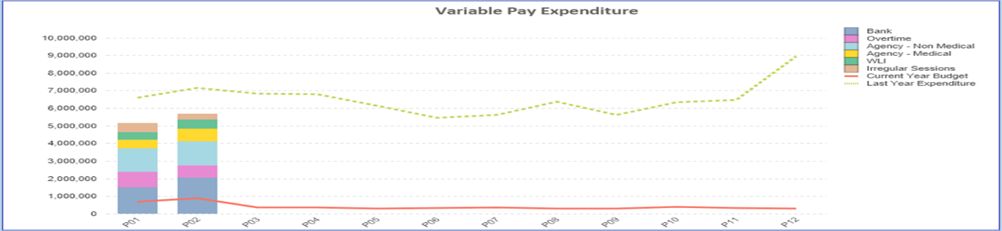

- Overview Non-Pay
A correction was made in Month 2 to reflect the subjective being used in R&D between Income & Non Pay totalling £3.9m

Below are further details on the key areas of Non-Pay (excluding savings that is addressed in main body):

  - Clinical Consumables
This area continues to be a significant pressure with an in-month position of £1.4m. There are 80+ subjective lines within this category including secondary care drugs but areas seeing most pressures YTD continue to be general consumables (M&SE), laboratory products and implants (which in part will be driven by activity).

  - Energy
An updated forecast has been received from NWSSP. Finance will work with colleagues in Estates to produce a revised in year forecast and update in Month 3.

  - CHC
The variance against budget for CHC is £0.572m overspent in-month. An analysis of actual expenditure and patient numbers for 2024/25, along with the average values from 2024/25 is provided in table below.

CHC Analysis by Month

Please note:
- The above numbers include Domiciliary care cases.
- PCT Group does not include the Singleton/NPT element. The NPTS element which covers Children and Young People CHC patients is provided internally by the Health Board and as such is part of the wider NPTS position and is not recorded in the ledger as PCT/MH/LD CHC is recorded.

  - Prescribing
See commentary in section 2.2 in the main body of the report.

  - LTA Performance
The LTA contracts will not be finalised and approved until the end of June and the initial assessment of performance against these contracts will not be known for a number of months. Therefore updates on LTA performance will be provided one data in available for Q2.

However below is a summary of the final 2023/24 position for information:

APPENDIX 2 – DETAILS ON RESERVES & CENTRAL BUDGETS

- SUMMARY RESERVES
Overall management of the reserves is as per the Health Board Budget Management document.

  - Balances Main & NICE
For 2024/25, the Health Board will hold two central reserves and the purpose of these reserves are below:
- Main – this holds funding from WG or the plan that has yet to be issued to Budget Holders. These items are not surplus but either due to timing have not been issued or is an area where funding is issued based on actual values consumed in future month.
- NICE – this holds the total Health Board funding for all of NICE costs (drugs and infrastructure) and is issued to the service each month based on the actual costs consumed as reported through the Pharmacy system.

Details on the balances and movements are provided in the Table below:

- COVID RECOVERY
As part of the Financial Plan WG Funded £15.2m for Local COVID Recovery and £19.5m for Regional COVID Recovery. The funding remains in Central Reserves, and reported in Main reserves in Section 1 above. This funding is then issued to service areas based on the actual costs committed. A summary of the actuals to date and forecast costs against the funding total of £34.7m is summarised in the table below. This currently demonstrates an over-commitment of £0.349m, with further discussions on the deployment of this resource to support TI ongoing.

APPENDIX 3 – SAVINGS

Following receipt of the Service Groups Financial Strategy Returns for 204/25, which are due for submission to the CEO and DOF on 31st May, further details above that provided in Section 3 will be provided for Month 3.

APPENDIX 4: Further Actions
As outlined in the main paper there are a Triad of actions that the Health Board needs to consider to support the Financial Plan, as per below:
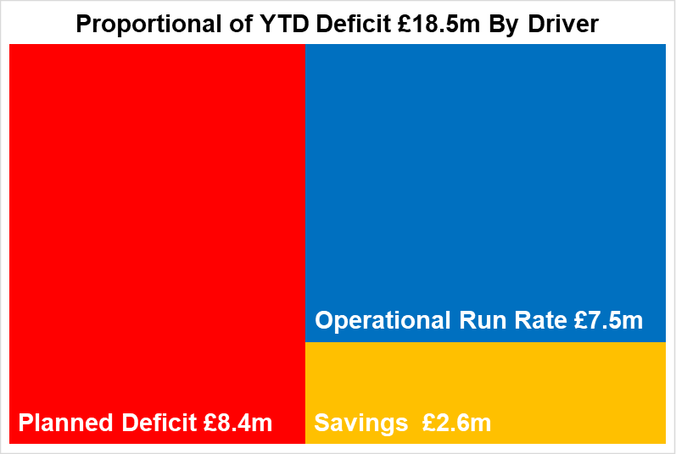
The recommended order in which the Health Board addresses these are:
- PRIORITY 1 = Reduce Run Rate – Service Groups (and Estates and Hotel Services) to remain within the funding envelop provided and approved by the Bpoard as part of the 2024/25 Financial Plan
- PRIORITY 2 = Savings – all areas to identify the delivery of their element of the £26.1m savings target.
- PRIORITY 3 = Reduction of the £50.1m deficit plan. This can only be considered once there is stability with the delivery of Run Rates and all savings have been identified
The table below details the actions needed following Month 2 and are in addition to those set by the CEO following the Month 1 position.
Triad | Actions - Post Mth 2
- Run Rate | Service Group (SG) Plan Submissions:  As part of the Budgetary Management Process for 2024/25 and as detailed in the accountability letters issued at the end of April 2024, the SGs were required to submit a plan to deliver a balanced position, on the basis that all funding was issued at the start of the financial year. Next steps in the process:  - Plans were received from all 4 Service Groups on 31st May 2024.  - Plans were reviewed in w/c 3 June. In summary none of the plans submitted provided a route to balance and so further work is required.  - Responses to the submissions are scheduled to be issued to SG on 18th June which outlined the following next steps:  - Plans submitted on 31st May to be presented at the June Finance Performance meeting for further discussions.  - Following June Finance Performance meetings the SGs are required to re-submit the plans on 28th June and to include ‘options’ that will to allow Health Board to make informed decisions on the actions required to achieve balance.  - This assessment of the options will be a two stages approach. Stage 1 – in w/c 8th July each SG will be required to attend a star-chamber event with DOF/CEO/DoN to discussion options. Those options the management team consider are ‘Just Do Its’ will be approved immediately and a summary presented to Board; and Stage 2 those options that need further consideration will be presented to PFC/Board for further discussion at the end of July.  - Post Stage 1 and 2 each SG will have a series of actions that will be tracked using the existing arrangements governance of:  - Savings trackers (provide list of all actions) which will feed the WG Monthly Monitoring Returns and the also summarised to PFC / Board  - Savings trackers action list used to monitor progress at the existing Finance Performance meetings and the quarterly SG presentations to PFC.
- Run Rate | ‘What Is’ Videos  Everyone within the Health Board has the ability to influence the financial position. To support a general understanding of Finance a short informative video will be compiled to ensure all members of staff, regardless of whether they are a Budget Holder or not have the same opportunity to be trained on ‘NHS Finance’.  The video will be a narrated presentation that will be publicised via in the CEO Mid-Week Message. This video will be available to all new staff across the Health Board.  Based on the success of this product the Board may consider replicating for other areas, to include general knowledge on areas such as Standing Financial Instructions and Finance Control Procedure, and a quarterly update on the financial position.
- Run Rate | Weekly Reporting  Linked to a request from the May Performance and Finance Committee work is underway to establish a report that tracks drives impacting the financial position on a weekly basis. This will utilise non-financial data as the majority of financial ledger data is only available monthly. Extract from the proposed design is provided in Annex A.
- Run Rate | Escalation Process  Aligned to the Budgetary Management Document and agreed governance process, following the completion of the actions under the ‘Service Group (SG) Plan Submissions’ detailed above the Service Group Financial Performance meeting will change frequency as per the escalation process.
- Savings | Reporting  Weekly updates on the value of opportunities identified will be provided through the Weekly Route, with a monthly detailed report included as an appendix to the Monthly Financial Performance Report to PFC and Management Board from the end of Q1.
- Savings | Management of Target  SG need to manage the delivery of their element of the £26.1m saving target and actions to reduce current run rates all of which will be reflected on the savings trackers.  For clarity the first call on savings will be to address the £26.1m 24/25 Financial Plan target, and any opportunities above, at Service Group level, will be allocated to management of Run Rates. Therefore the reporting to PFC/Board will split opportunities identified/delivered between Orange Target (£26.1m) and Blue Target (Run Rate), as detailed in section 3 above.
- £50.1m Deficit Plan | Thematic Approach  Focus on the delivery of these schemes, which were agreed by the Board as part of the wider planning assessment in March, and which would require Budgets to be removed from relevant Service Areas need to continue. Updates on progress to be provided quarterly and where appropriate optinos to adjust the plan presented to PFC/Board.
- £50.1m Deficit Plan | Review of Choices Linked Plans  The Financial Plan will include values required to support inflation, growth and national decisions. In addition the Health Board also considers options to support and sustain existing services. To sustain and stabilise existing services the financial plans for 2023/24 and 2024/25 reflected sustainability support, with further detail provided in Annex B.  To reduce the deficit plan, assessment of these choices need to be reviewed and where appropriate budgets de-commissioned once in year run rates are stable.

Appendix 4 Annex A: Weekly Reporting
Example of format at HB level. This would be replicated for each of the 4 Service Groups.

Appendix 4 Annex B: Sustainability Support Provided by Category from 2023/24 & 2024/25 Financial Plan

