

HEALTH BOARD RISK REGISTER
June 2025

RISKS ALLOCATED TO THE
PERFORMANCE & FINANCE COMMITTEE

Datix ID Number: 738 Current risk score reduced from 25  Health & Care Standard: |  |  | HBR Ref Number: 1  Risk Target Date: 31/12/2025 |  | Current Risk Rating  4 x 4 = 16
Objective: Urgent & Emergency Care (UEC) |  | BAF Ref: 2.4 | Director Lead: Deb Lewis, Chief Operating Officer  Assuring Committee: Performance & Finance Committee  For information: Quality & Safety Committee
Risk: Access to Unscheduled Care  If we fail to provide timely access to Unscheduled Care then this will have an impact on quality & safety of patient care as well as patient and family experience and achievement of targets. There are challenges with capacity/staffing across the Health and Social care sectors. (This risk includes ED, AMU and impact in community from ability to release ambulances at both front doors.) |  |  | Date last reviewed: Jun 2025
Risk Rating  (consequence x likelihood):  Initial: 4 x 5 = 20  Current: 4 x 4 = 16  Target: 3 x 4 =12 | 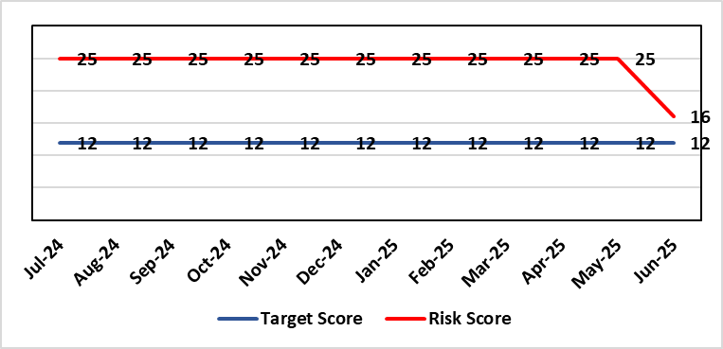 |  | Rationale for current score:  The UEC system continues to see high demand, with ambulance attendances higher than seen previously. However, this demand has been mitigated (beginning June 25) by improvement activity across the hospital resulting in improved flow away from ED. This improvement activity has been married with additional capacity at the front door (Ward) to decongest ED and resulted in the resultant reduced risk score (previously 25).
Level of Control  = 50% |  |  | Rationale for target score:  The HB is currently under escalating performance monitoring from WG (Targeted Intervention or TI) for delivery of UEC services. The improvement plan developed as a response to TI and that already included in the HB annual plan is to implement models of care that reflect best practice and focus on areas that will benefit patients, staff and the UEC system most. The implementation of this plan will improve patient flow, length of stay and reduce emergency demand.
Date added to the SBU HB risk register
Apr 2019
Controls (What are we currently doing about the risk?) |  |  | Mitigating actions (What more should we do?)
Five main areas of work within the plan:  - Frailty strategy (already achieved: Older Persons Assessment & Short Stay Unit stood up; Hub stood up to triage/stream/capture outcomes from incoming calls; standard operating procedures developed for Short Stay, Assessment Unit, Neck of Femur Pathways/beds, and Hub; Phase 1 capital works completed)  - Grip & control operational management and centralisation of patient flow resources  - Senior decision makers at front door services  - Pathway of care delays (PoCD) Implementation of Discharge-To-Reassess (D2RA)  - Home First  - Acute Care Team (ACT)  - Interface with local authority  - Urgent & Emergency Care redesign programme linked to capital expansion scheme.  - Development of a UEC Care Co-ordination Hub to promote pre-hospital triage redirection and streaming.  In addition to (Business As Usual) BAU improvement actions:  - Continued focussed roll-out of 6-Goals schemes of work  - D2RA / Trusted assessor model  - SAFER  - Criteria-led discharge  - Continuous Flow Model (CFM)  - Robust SDEC model  During June 25 improvement work (PDSA) was undertaken at Morriston Hospital including:  - Anglesey Ward to temporarily operate as a General Medical ward to help decompress the ED  - Streamlining ED assessment and direct referrals to medicine Redesigning the medical assessment model in the AMU  - Enhancing specialty assessment and patient allocation  - Implementing a 7-day Same Day Emergency Care (SDEC) model  - Reviewing and applying consistent criteria to reside  - Roll-out of a new Patient Flow Model: ‘Your Next Patient |  |  | Action | Lead |  | Deadline
 |  |  | Implementation of revised senior decision-making capacity within SDEC (Same Day Emergency Care) and AMU (Acute Medical Unit) | Group Medical Director, Morriston |  | 31/10/2025
 |  |  | Amended action: Review of community services being undertaken by Group Nurse Directors for PCT / Morriston to ensure return of investment ahead of expansion. (See below) | Group Nurse Directors (Morriston & PCT) |  | 31/10/2025
 |  |  | Implementation of UEC (Urgent & Emergency Care) Navigation Hub to decrease demand and implement right patient right place process | Chief Operating Officer |  | 31/09/2025  Pending WG funding-Six Goals
 |  |  | Focus on reducing pathway of care delays (PoCDs) as per the Care Action Committee 50-day Challenge | Associate Service Group Director, PCTS |  | 30/09/2025 (reduce to 100 Clinically Optimised Patients)
 |  |  | Further develop admission avoidance pathways with Welsh Ambulance Services Trust, focussing on Falls prevention and Respiratory conditions | Assistant Director Operations UEC |  | 30/09/2025 (linked to 6 Goals reporting & funding)
 |  |  | Reintroduce D2RA Principles across the Health Board with external consultancy support | Assistant Director of Operations UEC,  Associate Service Group Director PCTS |  | Complete
Assurances (How do we know if the things we are doing are having an impact?)  - Urgent & Emergency Care Board is meeting monthly chaired by the COO.  - Six Goals programme reviews the plan on a monthly basis  - UEC Redesign held 2-weekly to update on work streams  - UEC Summit meetings held x 2 with Executive Management Board – 3rd summit planned March 25.  - D2RA Executive meeting held Feb 25 – Memorandum of Understanding (MOU) re D2RA agreed. Operational workshop held Mar 25 with a plan to test D2RA principles pre-Easter weekend  - Ongoing delivery of the Integrated Discharge Hub with both front and back door focus – programme of work in progress to design sustainable solution  - Improved performance metrics (ambulance handover, patient time in ED department, flow & discharge) |  |  | Gaps in assurance (What additional assurances should we seek?)  Affordability of the UEC Care Co-ordination Hub pending approval of WG Six Goals funding.  Affordability of a sustainable D2RA model and right sizing of the community services and bedded facilities to support timely discharge.  Although the Test of Change initiatives have had a positive impact on ambulance handovers and flow through to down-stream wards, there remain unacceptably long delays for ED patients to be seen and treated. Therefore, the risk score remains as noted until improvement is made in this area. This now needs to be a focus in Q2.
Additional Comments / Progress Notes
11/07/2025: Action completed: Reintroduce D2RA Principles across the Health Board with external consultancy support. Significant progress made regarding key front door (e.g. ambulance handover, time in ED department etc) metrics coupled with reduced numbers bedding/ overcrowding front door services. Community services review has not been undertaken by the PCT Group Nurse Director as anticipated. Agreement with the END and DOF that additional support will be commissioned to undertake this crucial review. Anticipated start date of 1st August 2025, with review to run for 3 months.

Datix ID Number: 840 Current risk score reduced from 16  Health & Care Standard: |  |  | HBR Ref Number: 16  Risk Target Date: 31/03/2026 | Current Risk Rating  4 x 3 = 12
Objective: Planned Care |  | BAF Ref: 2.5 | Director Lead: Deb Lewis, Chief Operating Officer  Assuring Committee: Performance & Finance Committee  For information: Quality & Safety Committee
Risk: Access and Planned Care  There is a risk of harm to patients if we fail to diagnose and treat them in a timely way. |  |  | Date last reviewed: Jun 2025
Risk Rating  (consequence x likelihood):  Initial: 4 x 4 = 16  Current: 4 x 3 = 12  Target: 4 x 2 = 8 | 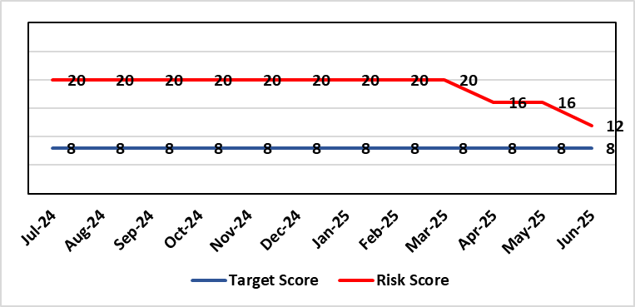 |  | Rationale for current score:  Patients are still waiting in excess of 104 weeks for surgical intervention, which is outside of national policy on RTT. However, the position is improving: targets set for 2024/25 were met and the Health Board de-escalated by Welsh Government from Targeted Intervention (TI) for delivery of Planned Care services, to Enhanced Monitoring. Current risk score reflects that improved position.
Level of Control
= 90%
Level of Control  = 90% |  |  | Rationale for target score:  There is scope to reduce the likelihood score to reduce the overall risk to an acceptable level. The risk target date indicates when we expect to see some reduction in waiting lists – albeit the overall risk level may remain as work continues.
Date added to the SBU HB risk register
Apr 2019
Controls (What are we currently doing about the risk?) |  |  | Mitigating actions (What more should we do?)
- There is a bi-weekly Targeted Intervention (TI) meeting specifically for assurance on the recovery of our elective programme.  - Specialty level capacity and demand models set out the baseline capacity and identify solutions to bridge the gap this financial year.  - A focused intervention is in train to support to the 10 specialties with the longest waits.  - Long waiting patients are being outsourced to the Independent Sector, where appropriate  - Additional internal activity is being delivered on weekends (via insourcing), although this is currently at risk due to changes in policy pertaining to the payment of enhanced rates to A4C staff.  - Planned care trajectories were developed and submitted to Welsh Government.  - Governance process put in place to monitor performance against trajectories internally, and with Welsh Government as part of Targeted Intervention.  - External & internal validation continues.  - All long waiting patients are receiving clinical reviews to ascertain continued need for surgery. |  |  | Action |  | Lead | Deadline
Assurances (How do we know if the things we are doing are having an impact?)  - TI dashboard developed to monitor performance in a live state  - Weekly TI monitoring meetings chaired by the Chief Operating Officer  - Bi-weekly planned care meetings chaired by the Chief Operating Officer  - Monthly TI monitoring meetings with Welsh Government |  |  | Gaps in assurance (What additional assurances should we seek?)
Additional Comments / Progress Notes
16/05/2025: Action complete: Theatre Optimisation Programme now in place to maximise efficient use of theatre capacity. Risk assessment revised to reflect improved performance and de-escalation by Welsh Government to Enhanced Monitoring status. Monitoring of continued delivery is ongoing.
18/07/2025: Risk score reduced in line with continued delivery of RTT targets.

Datix ID Number: 1761  Health & Care Standard: |  |  | HBR Ref Number: 50  Risk Target Date: TBC | Current Risk Rating  5 x 5 = 25
Objective: Cancer Care |  | BAF Ref: 2.6 | Director Lead: Deb Lewis, Chief Operating Officer  Assuring Committee: Performance & Finance Committee  For information: Quality & Safety Committee
Risk: Access to Cancer Services  There is a risk of delay in diagnosing patients with cancer, and consequent delay in commencement of treatment, which could lead to poor patient outcomes and failure to achieve targets.  The health Board remains unable to deliver on the target of 75% of patients being treated within 62 days and is currently under targeted intervention by Welsh Government to improve performance. |  |  | Date last reviewed: Jun 2025
Risk Rating  (consequence x likelihood):  Initial: 4 x 5 = 20  Current: 5 x 5 = 25  Target: 4 x 3 = 12 | 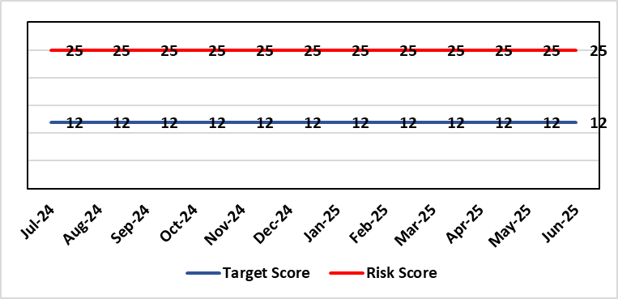 |  | Rationale for current score:  Risk score is based on being off trajectory for SCP.
Level of Control  = 70% |  |  | Rationale for target score:  Target score reflects the challenge this area of work presents the Board and where small numbers of patients impact on the potential to breach target.
Date added to the SBU HB risk register:
Apr 2019
Controls (What are we currently doing about the risk?) |  |  | Mitigating actions (What more should we do?)
- Tight management processes to manage each individual case on the Single Cancer Pathway (SCP). Enhanced monitoring & weekly monitoring of action plans for top 6 tumour sites.  - Initiatives to protect surgical capacity to support SCPs have been put in place  - Tumour sites have been given additional targets to achieve by the end of Qtr1:  - Achieve the 10-day 1st Outpatient target  - Deliver a decision to treat (DTT) by day 31  - A specific plan is being delivered to support Pathology services and ensure SCP tests are turned around within 5 days. |  |  | Action |  | Lead | Deadline
 |  |  | Following a review of governance processes for our Annual plan, Cancer monitoring will now be included in the Planned Care Board |  | Chief Operating Officer / Director of Planning Partnerships | 30/09/2025
Assurances (How do we know if the things we are doing are having an impact?)  - TI dashboard developed to monitor performance in a live state  - Weekly TI monitoring meetings chaired by the Chief Operating Officer  - Bi-weekly Cancer meetings chaired by the Deputy Chief Operating Officer  - Monthly TI monitoring meetings with Welsh Government |  |  | Gaps in assurance (What additional assurances should we seek?)  Performance and activity data monitored, but delays to treatment continue while sustainable solutions found.
Additional Comments / Progress Notes
16/05/2025: Action complete: Cancer Performance & Information Group to monitor improvement trajectories for both cancer backlog and SCP performance on a monthly basis. The Health Board missed the target of 70% for the end of March and delivered 62%. This will increase at the 3-month refresh point. Actions noted above will continue during 2025/26 to deliver sustainable improvements.

Datix ID Number: 1763  Health & Care Standard: |  |  | HBR Ref Number: 52  Risk Target Date: TBC |  | Current Risk Rating  4 x 3 = 12
Objective: People of Swansea Bay live healthier, equitable and more equal and prosperous lives |  | BAF Ref: 1 | Director Lead: Richard Thomas, Director of Communications and Engagement  Assuring Committee: Performance & Finance Committee
Risk: Impact Assessment Requirements  The Health Board does not have sufficient skills & resource in place to undertake integrated equality impact assessments in line with strategic service change and policy development. |  |  | Date last reviewed: Jun 2025
Risk Rating  (consequence x likelihood):  Initial: 4 x 4 = 16  Current: 4 x 3 = 12  Target: 4 x 2 = 8 | 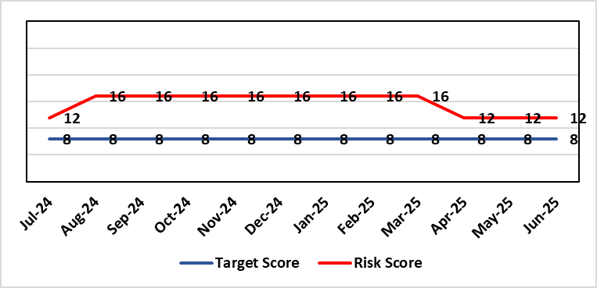 |  | Rationale for current score:  - Current lack of required skills / staff to deliver requirements.  - Impact assessment process has progressed
Level of Control  = 50% |  |  | Rationale for target score:  - All of these areas need to have adequate resourcing and robust processes / policies in place for the organisation to make robust plans, engage public confidence and meet our statutory and public duties.
Date added to the SBU HB risk register
Apr 2019
Controls (What are we currently doing about the risk?) |  |  | Mitigating actions (What more should we do?)
- Robust policies and processes to be in place for Impact Assessment going forward.  - EIA responsibilities incorporated into wider Impact Assessments.  - Development of Strategic Equality Group across organisation to support processes. |  |  | Action | Lead |  | Deadline
 |  |  | Action amended: Revised structure within Engagement team to ensure equity, diversity & belonging (EDB) issues coordinated across Health Board. | Assistant Director of Insight, Charity & Engagement & DICE |  | 01/08/2025
 |  |  | Revised structure agreed and posts appointed to. | Assistant Director of Insight, Charity & Engagement & DICE |  | 01/10/2025
 |  |  | Roll out Impact Assessment process across organisation. Training and integration with planning processes across the organisation will be required. | Assistant Director of Insight, Charity & Engagement & DICE |  | 30/09/2025
Assurances (How do we know if the things we are doing are having an impact?)  Advice on Equality Impact Assessment and then wider Impact Assessments available across organisation supported by robust policies and procedures, overseen by Strategic Equality Group. |  |  | Gaps in assurance (What additional assurances should we seek?)  Participation from across organisation in Strategic Equality Group.
Additional Comments / Progress Notes
09/07/2025: Risk reviewed. Rationale comments & action target refreshed.

Datix ID Number: 2522  Health & Care Standard: |  |  | HBR Ref Number: 75  Risk Target Date: TBC |  | Current Risk Rating  5 x 2 = 10
Objective: Care is high quality, safe, efficient, and delivers the best possible outcomes for people |  | BAF Ref: 2 | Director Lead: Deb Lewis, Chief Operating Officer  Assuring Committee: Performance & Finance Committee
Risk: Whole-Service Closure  Risk that services or facilities may not be able to function if there is a major incident or a rising tide that renders current service models unable to operate |  |  | Date last reviewed: Jun 2025
Risk Rating  (consequence x likelihood):  Initial: 5 x 4 = 20  Current: 5 x 2 = 10  Target: 5 x 1 = 5 | 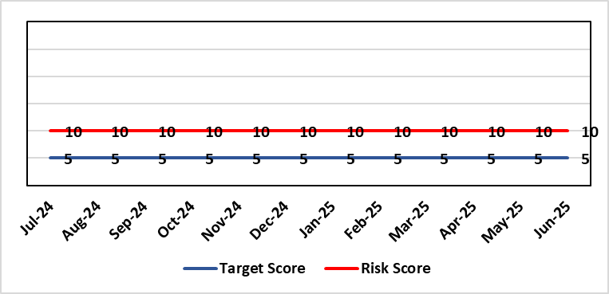 |  | Rationale for current score:  Risk reflects transition to business as usual as part of living with Covid strategy. BCP plans in place. There is still fluctuation in patient numbers and new variants continue to emerge so score maintained as watching brief.
Level of Control  = 25% |  |  | Rationale for target score:  The strategy of moving towards living with Covid will eventually lower the risk level to target.
Date added to the SBU HB risk register
May 2021
Controls (What are we currently doing about the risk?) |  |  | Mitigating actions (What more should we do?)
- Sites have business continuity plans and the impact of one site being overwhelmed by COVID demand has been reviewed.  - Monitoring of associated risks has been being transferred to appropriate forums such as UEC Board, Elective Care Board and Nosocomial Group with overall oversight by Management Board.  - Ongoing surveillance of epidemiology data for early warning and further change to risk level via live Covid dashboard. |  |  | Action | Lead |  | Deadline
 |  |  | Periodic review of risk | COO |  | See Notes Below
Assurances (How do we know if the things we are doing are having an impact?)  Monitored via Management Board for early warning signs. |  |  | Gaps in assurance (What additional assurances should we seek?)
Additional Comments / Progress Notes

Datix ID Number: 3444  Health & Care Standard: |  |  | HBR Ref Number: 92  Risk Target Date: 31/03/2026 | Current Risk Rating  5 x 5 = 25
Objective: The health board is a resilient, financially sustainable and responsible organisation |  | BAF Ref: 6 | Director Lead: Darren Griffiths, Director of Finance and Performance  Assuring Committee: Performance & Finance Committee
Risk: Forecast Deficit  Forecast deficit is not met due to (1) insufficient progress on run rate reduction, (2) the saving targets required across all areas are not achieved. |  |  | Date last reviewed: Jun 2025
Risk Rating  (consequence x likelihood):  Initial: 5 x 4 = 20  Current: 5 x 5 = 25  Target: 5 x 1 = 5 | 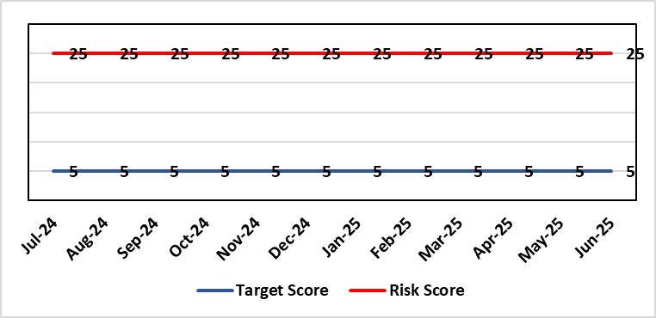 |  | Rationale for current score:  - Delivery of the deficit plan is predicated on a combination of savings and run rate reductions  - Consequence is significant as failure to deliver the plan could impact service delivery if cost reduction required later in the year  - A deficit plan is a failure to meet a statutory duty
Level of Control
= 25%
Date added to the SBU  HB risk register  June 2023 |  |  | Rationale for target score:  - The consequence will not change given the important of financial delivery and its relationship with the delivery of the Health Board recovery and sustainability plan  - Reducing likelihood to 1 supports a confidence that the deficit plan will be delivered.
Controls (What are we currently doing about the risk?) |  |  | Mitigating actions (What more should we do?)
The Health Board is doing the following:  - Accountability Letters and Budgetary Management Framework were issued to all Directors in April 2025, which set the expectation and budget for 2025/26.  - Introduced in Q3 of 2024/25 the Health Board has put in place further oversight via the Recovery & Sustainability Board, which reported directly to PFC and is chaired by the CEO. This Board is held bi-weekly.  - Supporting the R&S Board is the R&S Team, which for 2025/26 has dedicated resource to lead the programmes of work agreed for 2025/26, of which the Board has agreed on 5 key areas.  - Budgetary Management approach 2025/26 requires all Services Groups to produce a Financial Strategy by end May 2025.  - Continued transparent exchange of position with NHS Executive & Welsh Government, with both weekly and monthly meetings with the NHS Executive.  - Standard Day 5 Finance Reports on Variable Pay, Savings Performance and Flash report published via SharePoint site.  - Variable Pay Cap agreed by the organisation to deliver £32m of savings as set out in the Financial Framework dated 30th June 2025. |  |  | Action | Lead | Deadline
 |  |  | Commissioning of external support, in collaboration with Welsh Government, which will commence on 14th July 2025 | DOF | 14/07/2025
 |  |  | Financial Framework submitted to WG on 30th June clearly outlines recovery actions required by HB to meet WG expectations | DOF | 30/06/2025
Assurances (How do we know if the things we are doing are having an impact?)  The Health Board financial performance is reviewed and monitored through:  - WG Monthly Monitoring Returns and letter signed by CEO and DOF  - Monthly financial performance meetings  - Monthly performance meetings (New 2025/26)  - Performance & Finance Committee  - Independent Member briefings  - Recovery & Sustainability Board  - Routine reporting to Board of most recent monthly position and financial forecasts  - Weekly meetings with the NHS Executive  - Monthly TI Meetings with NHS Executive  - Face to Face meetings with Director Finance for NHS Wales |  |  | Gaps in assurance (What additional assurances should we seek?)
Additional Comments / Progress Notes
09/05/2025: Risk entry comprehensively refreshed for 2025/26 year.
06/06/2025: WG letter received setting out requirement for the HB to maintain the 2024/25 Outturn position of no greater than £42.5m for 2025/26
11/07/2025: Financial Framework submitted to WG on 30th June clearly outlines recovery actions required by HB to meet WG expectations

Datix ID Number: 3448  Health & Care Standard: |  |  | HBR Ref Number: 93  Risk Target Date: TBC |  | Current Risk Rating  5 x 4 = 20
Objective: The health board is a resilient, financially sustainable and responsible organisation |  | BAF Ref: 6 | Director Lead: Darren Griffiths, Director of Finance and Performance  Assuring Committee: Performance & Finance Committee
Risk: Reduced Capital Funds  Reduced National NHS funds available for major capital schemes requiring a restricted Capital Plan for 2025/26. |  |  | Date last reviewed: Jun 2025
Risk Rating  (consequence x likelihood):  Initial: 5 x 4 = 20  Current: 5 x 4 = 20  Target: 5 x 1 = 5 | 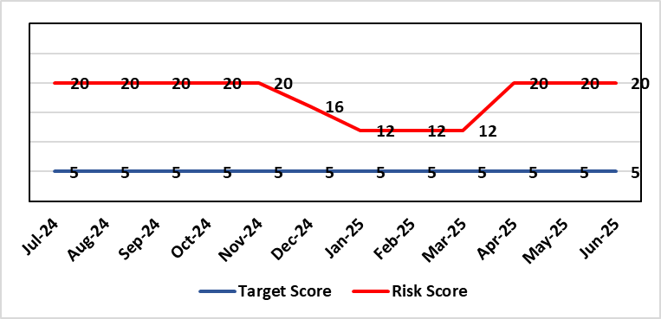 |  | Rationale for current score:  - The Health Board has been advised that its discretionary capital allocation for 2025/26 is £13.875m.  - The funding available within the Capital Resource Limit (CRL) will not meet the demands for capital investment. Discretionary capital is deployed to replace ageing medical devices & equipment; to address backlog maintenance of premises; and to support small scale, non-National service improvements with capital investments  - The outcome of the national capital prioritisation exercise means some major capital scheme business cases are on hold. A number of high-risk priority schemes will require funding support from WG, including interim measures for ED and Acute Adult Mental Health In-patients services.  - The approved plan assumes additional disposal income of £0.800m which is yet to complete.  - The approved plan assumes income of £0.749m from WG for expended business case fees.  - There is potential for further capital requirements arising from service model changes which will need to be managed.  - Potential consequences of this risk are the inability to achieve the ambitions set out within health board plans; the potential failure of ageing equipment leading to service disruption; the exposure to potential environmental health & safety risks.
Level of Control
= 25%
Date added to the SBU HB risk register  June 2023  (refreshed June 2024) |  |  | Rationale for target score:  The target score expresses the aspiration of the health board for addressing this risk. The target date indicated above reflects the point which the current actions are anticipated to reduce the risk, though knowledge of the actual funding available is required to reduce it further and this is not available until some months into the financial year.
Controls (What are we currently doing about the risk?) |  |  | Mitigating actions (What more should we do?)
The Health Board is doing the following:  - Regular dialogue with Welsh Government regarding capital requirements.  - Clear communication and reporting of the capital position, the risks and limitations.  - Close management of all schemes to ensure slippage is understood along with the impact on service.  - Clear prioritisation of any new requirements recognising the current constraints |  |  | Action | Lead |  | Deadline
 |  |  | Routine review and flexing of plan as spending is committed through the year. Routine monitoring processes will identify any potential slippage and will deploy this on risk-based basis. | Director of Finance & Performance |  | Monthly through the financial year as plan is dynamic
 |  |  | Examine the specific prioritisation and phasing of capital investment to meet health board objectives through the Capital & Estates Taskforce. | Director of Finance & Performance |  | Bi-Monthly
 |  |  | Maintenance of risks through the Capitalisation Prioritisation Group should additional WG funding become available later in the year. | Assistant Director of Finance (Strategy & Planning) |  | On-going
Assurances (How do we know if the things we are doing are having an impact?)  The Health Board capital position is reviewed and monitored through:  - Quarterly capital prioritisation group  - Performance & Finance Committee quarterly finance report  - Monthly Monitoring Returns to Welsh Government. |  |  | Gaps in assurance (What additional assurances should we seek?)  Reporting on impact of constraints to the capital programme on service delivery.
Additional Comments / Progress Notes
24/6/2025: Risk remains at 20 following Performance & Finance Committee meeting.
24/6/2025: Some uncertainty around the future approval of capital funding following WG letter of 6/6/25 on the unapproved revenue financial plan for the Health Board.

Datix ID Number: 3516  Health Care Standards: |  |  | HBR Ref Number: 94  Risk Target Date: TBC |  | Current Risk Rating  4 x 3 = 12
Objective: Mental Health & Learning Disability Services |  | BAF Ref: 2.3 | Director Lead: Deb Lewis, Chief Operating Officer  Assuring Committee: Performance & Finance Committee  For information: Quality & Safety Committee
Risk: CAMHS failure to meet required standards of performance  The CAMHS service is unable to meet the required level of performance due to workforce deficits in the team across all staff groups including medics, psychological therapies and nursing.  Links to other CAMHS risk register entries: (Ref: 3410/3373/3351/3346/3349/3350) |  |  | Date last reviewed: Jun 2025
Risk Rating  (consequence x likelihood):  Initial: 4 x 5 = 20  Current: 4 x 3 = 12  Target: 3 x 3 = 9 | 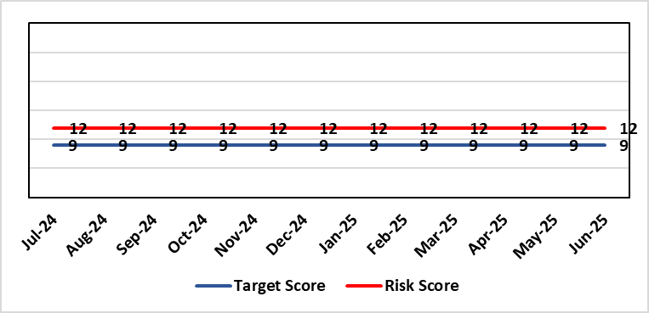 |  | Rationale for current score:  Marked improvement in the performance against the Mental health Measure for CAMHS. Data validation for new patients complete. Current risk score 12 in view of improved performance however this reflects the fragility in the workforce to deliver sustained performance. Work is still ongoing within CAMHs to maintain and improves the situation.
Level of Control  = % |  |  | Rationale for target score:  The rationale for the target score is linked to successful recruitment and more timely access to services for children and young persons which will reduce risk.
Date added to the SBU
HB risk register
October 2023
Controls (What are we currently doing about the risk?) |  |  | Mitigating actions (What more should we do?)
-Ongoing recruitment into all staff groups  -Temporary agency workforce in nursing at premium pay rates to sustain current levels of performance  -Recent appointment into psychological therapies lead posts.  -Recent appointments to substantive consultants psychiatrist posts.  -Moved vacancy nursing establishments into part 1 of the services to recruit and increase capacity. |  |  | Action | Lead |  | Deadline
 |  |  | Continued efforts at recruitment | Acting Associate Service Director |  | 31/05/2025
Assurances (How do we know if the things we are doing are having an impact?)  -Monthly CAMHS Directorate meeting in place where performance and workforce are scrutinised  -Reporting into Weekly Business Team and MH & LD management board.  -Reporting into SBU Performance & Finance Committee and IQPD (Integrated Quality & Performance Delivery) meeting with Welsh Government  -Ongoing validation of the waiting list to ensure robust reporting going forward |  |  | Gaps in assurance (What additional assurances should we seek?)
Additional Comments / Progress Notes
28/01/25: Compliance against Part 1a (national target 80%) of the measure has continued to improve Aug 84%, Sept 91%, Oct 89%, Nov 80% and while Dec is 77%, Jan prediction is back in target. This demonstrates ongoing improvement from when CAMHs transferred across to SBUHB from last April (23%).
We have recruited to some of the workforce for part 1a of the service awaiting start dates, which will also allow ceasing of agency staff that we inherited. There is wider recruitment continuing in relation to medical and psychology workforce which is also improving. With all this detail the risk score remains appropriate at 12 currently.
01/04/25: Welsh Government have now removed this part of CAMHs services out of targeted intervention. There was a dip in compliance in January 2025 which recovered in February - but this still demonstrates the fragility of the available workforce is this area which is still being addressed, so risk rating remains the same. Two nursing posts and two new consultant psychiatrists have been appointed – awaiting start dates. There is some further discussion regarding requirement to make the service provision sustainable so will review further in two months.
09/07/25: Review of all vacancy posts across CAMHs has been completed and vacant funds moved to Part 1 of the service to improve the potential capacity to meet the demand and maintain the performance against target. There was a reporting error in Part 1b which has now been rectified and additional control measure put in place to monitor the data and the activity on a weekly basis.

Datix ID Number: 3571  Health & Care Standard: |  |  | HBR Ref Number: 96  Target Date: 31/03/2026 |  | Current Risk Rating  4 x 5 = 20
Objective: The health board is a resilient, financially sustainable and responsible organisation |  | BAF Ref: 6 | Director Lead: Marie Davies, Executive Director of Planning & Partnerships  Assuring Committee: Performance & Finance Committee
Risk: Failure to Develop an Approvable IMTP (statutory compliance)  If we fail to have an approvable Integrated Medium-Term Plan (IMTP) for 2026/27 then we will not meet our statutory duty to break even and may lose public confidence. |  |  | Date last reviewed: Jun 2025
Risk Rating  (consequence x likelihood):  Initial: 4 x 5 = 20  Current: 4 x 5 = 20  Target: 4 x 2 = 8 | 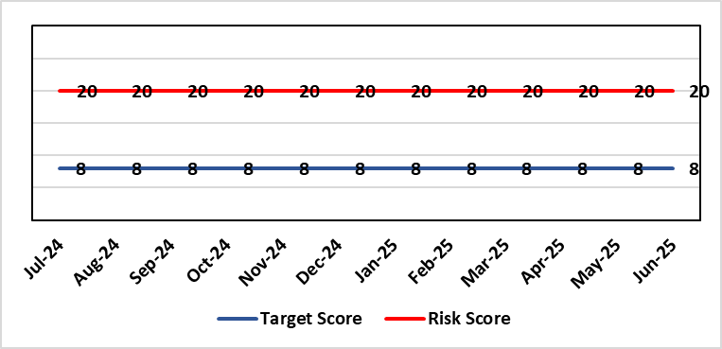 |  | Rationale for current score:  The Health Board does not have a WG approved IMTP and has been placed in enhanced monitoring for Finance, Strategy and Planning following the inability of the Health Board to submit a balanced IMTP since March 2023. Given the All-Wales financial context the Health Board was not able to submit an IMTP in March 2025. It has instead developed an Annual Plan 25/26 set in a three-year context.
Level of Control
= 70%
Date added to the SBU
HB risk register
October 2023
Date added to the SBU  HB risk register  October 2023 |  |  | Rationale for target score:  The target remains to develop a financially balanced IMTP so that we meet our statutory duties.
Controls (What are we currently doing about the risk?) |  |  | Mitigating actions (What more should we do?)
- As per the Welsh Government de-escalation criteria for Strategy and Planning, work has commenced to update and realign the Health Board’s strategy and clinical services strategic plan.  - As per the Welsh Government de-escalation criteria for Strategy and Planning, work has been undertaken to assess the Health Board against the planning maturity matrix and develop an action plan in response. This will be reported via the Board Planning & Partnerships formal report.  - The Recovery and Sustainability Board monitors delivery of agreed actions in relation to the financial position.  - The Annual Plan Oversight Group chaired by the COO, monitors delivery of Plan actions each quarter reporting to Management Board, Performance & Finance Committee and Board.  - Plan development will continue to be subject to robust challenge and scrutiny through regular briefings to Independent Members, Performance and Finance Committee (now meeting twice a month, once informally and once formally) and with detailed oversight from the Board itself. |  |  | Action | Lead |  | Deadline
 |  |  | A review of the planning process to produce the 2025/26 Annual Plan will be undertaken and recommendation for the 2026/27 Plan process will be developed. The review will be undertaken by the existing Integrated Planning Group and overseen by the IMTP Executive Steering Group. The process will report directly into Board | Executive Director of Planning & Partnerships |  | Complete
 |  |  | Review and update Health Board Organisational strategy | Executive Director of Planning & Partnerships/ Medical Director |  | Complete
 |  |  | Refresh Clinical Services Plan | Executive Director of Planning & Partnerships/ Medical Director |  | 31/03/2026
 |  |  | Strengthen governance and scrutiny of delivery of the plan through development of new performance management and accountability framework | Executive Director of Finance and Performance / Executive Director of Planning and Partnerships |  | Complete
 |  |  | Recovery and Sustainability Board to continue to focus on savings delivery and now shift to a more sustainable approaches in the longer term.  A new monthly performance review regime and Executive Team members to oversee thematic savings workstreams and support Service Groups to meet targets. | Executive Director of Finance and Performance |  | 31/03/2026
Assurances (How do we know if the things we are doing are having an impact?)  Progress against the delivery of the plan will be scrutinised through strengthened governance supported by a new performance management and accountability framework. |  |  | Gaps in assurance (What additional assurances should we seek?)
Additional Comments / Progress Notes
03/04/2025: Rationale, Control, Actions, Assurances refreshed
12/06/2025: No change
08/07/2025: Actions complete:
- Review of the planning process to produce the 2025/26 Annual Plan and recommendation for the 2026/27 Plan process to be developed - paper went to Management Board in June 2025.
- Review and update of Health Board Organisational strategy – it will be presented to Health Board Annual General Meeting in Sept 2025
- Strengthening of governance and scrutiny of delivery of the plan through development of new performance management and accountability framework (now in place)

Datix ID Number: 3692  Health & Care Standard: |  |  | HBR Ref Number: 98  Target Date: TBC | Current Risk Rating  5 x 4 = 20
Objective: Care is delivered in safe and appropriate settings |  | BAF Ref: 3 | Director Lead: Darren Griffiths, Executive Director of Finance & Performance  Assuring Committee: Performance & Finance Committee
Risk: Overall condition/compliance and suitability of Health Board Estate  6 FACET survey undertaken in 2022 confirmed the poor condition and suitability of premises where health care services are provided. The backlog maintenance costs are in excess of £200 million. The overall level of controllable risk is affected – compounded – by the resilience of the HB’s H&S infrastructure (Datix 2159) and the level of resourcing of Operational Estates, which influences the adequacy of capacity and capability for responding to priority risk mitigation (Datix 3444) |  |  | Date last reviewed: Jun 2025
Risk Rating  (consequence x likelihood):  Initial: 5 x 4 = 20  Current: 5 x 4 = 20  Target: 3 x 3 = 9 | 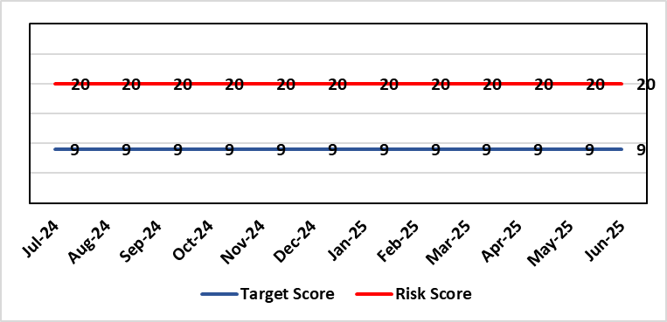 |  | Rationale for current score:  6 FACET survey  Estates Strategy and Development control plans  General compliance with fire regulations and WHTM/WHBN requirements.  Backlog maintenance  Health Board estates strategy and DCP task and finish group  Audit and Assurance limited assurance report  Access to funding  Ability to respond effectively to key HB initiatives such as the centralisation of medical records and the need to support mental health services and primary and community care services.
Level of Control  = 40% |  |  | Rationale for target score:  Through the 6 FACET survey a number of key items have been identified covering the Physical condition, Functional suitability, Space utilisation, Quality audit, Statutory compliance and Environmental management. All of which identified significant issues with the current estate, with very few areas achieving condition ‘B’. The overall backlog maintenance is in excess of £200m. The development of a plan to improve the capabilities of Operational Estates will allow a more proactive approach to risk mitigation.
Date added to the SBU HB risk register
07/02/2024
Controls (What are we currently doing about the risk?) |  |  | Mitigating actions (What more should we do?)
- Planned preventative maintenance, prioritising highest risk depending on funding available (EFAB Year 2, Targeted Estate Fund 25/27 (TEF), Discretionary) – linked to creation of decant space through service changes  - Planned preventative maintenance. Update Asset Register and review of all PPMs to ensure that these remain relevant and a good use of available resource  - Reactive maintenance.  - Address issues where practicable through EFAB/Discretionary capital  - Estates Strategy and development control plans task and finish group  - Regular reviews of the estate with reference to benchmarked best practice from NHS Wales/NHS England.  Further Developing Arrangements:  - Review 6 Facet conclusions with Oakleaf Consulting Ltd with reference to Operational Estates site knowledge and updated Asset Register, with a focus on the patient journey and patient safety.  - Develop partnership approach to working with Capital Planning to ensure that capital schemes are better informed of risks from an Operational Estates perspective.  - Develop Workforce Plan with HR/OD to address disproportionately high numbers of ‘retire and returns’ and loss of considerable experience, which is increasing in frequency.  - Review and make recommendations on structure of Operational Estates and investment plans, which will need to be cost neutral as far as reasonably possible.  - Continual review of the overall backlog maintenance and the risk to business continuity and where new risks are identified, re-prioritise to minimise impact on business continuity. |  |  | Action |  | Lead | Deadline
 |  |  | Maintain effective engagement with Welsh Government to provide funding to implement estates strategy and development control plans to address all areas outlined. |  | Assistant Director of Capital Planning | Achieved (TEF as below).  Engagement will remain ongoing
 |  |  | Work with Welsh Government (WG) to source alternative solutions to funding the HB estates strategy and development control plans i.e. Private Financial Investment (PFI) - Mutual Investment Model (MIM) or other investment sources. |  | Assistant Director of Capital Planning | Work with WG will remain ongoing
 |  |  | Review capacity and capability of Operational Estates and make recommendations on cost neutral investment in a longer-term plan to improve effectiveness. |  | Assistant Director of Estates | 30 September 2025  Plans are on track with the estates review.
 |  |  | Update Asset Register, review PPMs, and implement SFG20 (industry standard compliance management) to enhance approach to ensuring viability of core infrastructure and provide assurance on business continuity. Deadline dates to be reviewed 01/09/25 as progress varies by objective: SFG20 purchased; Asset register update currently cost prohibitive |  | Assistant Director of Estates | 30 September 2025
Assurances (How do we know if the things we are doing are having an impact?)  - Monitoring through quality & Safety, Audit & Assurance and Performance and Finance committee to receive assurance and or identify gaps for key compliance and adherence to applicable legislation.  - NWSSP internal audits  - Site visits/tours to identify compliance and gaps in compliances with NWSSP Shared Services  - Completion of FRA’s within targeted schedule  - Estates strategy and development control plans being implemented  - Half yearly Board oversight of strategy implementation. Consider appointment of Independent Member to support review of Operational Estates to provide advice to Officers and assurance to the Board on the range of proposed improvements.  Further Developing Arrangements:  - Complete review of capacity and capability of Operational Estates, which commenced in December 2024, and make recommendations on a way forward for improved effectiveness of resource utilisation and enhanced resilience.  - Complete review of Approve Persons and how duties are quality assured. This to also include action to address current gaps, i.e. AE Lifts and AE Pressure Vessels  - Continual review of the overall backlog maintenance and the risk to business continuity and where new risks are identified, re-prioritise to minimise impact on business continuity. |  |  | Gaps in assurance (What additional assurances should we seek?)  - Suitable funding to implement the estates strategy and development control plans and sufficient resource to ensure that Operational Estates is capable and competent with regard to critical risk mitigation. This will need to be planned and implemented iteratively over the longer term, say 5 to 10 years, etc.  - Allocate funds where available to address issues outlined  - Detailed work and level of resourcing available for supporting same to be commissioned to consider primary and community estates strategy along with mental health services
Additional Comments / Progress Notes
Through the 6 FACET survey a number of key items have been identified covering the Physical condition, Functional suitability, Space utilisation, Quality audit, Statutory compliance and Environmental management. The benefits of the 6 FACET survey will be enhanced through more detailed review of assets through updating the HB’s critical infrastructure asset register. All of which identified significant issues with the current estate, with very few areas achieving condition ‘B’. The overall backlog maintenance is in excess of £200m.
Key areas include ventilation and cooling with major infection control and other implications. Theatres/Wards/ED and general acute settings including mental health and learning disabilities being old and not compliant with the latest WHBN’s and WHTM’s. The heating, power and medical gas systems have also been identified as issues for concern in the 6 FACET surveys and from independent audits. The health board’s latest NWSSP estates audit received a limited assurance due to limited Welsh Government funding available to undertake backlog maintenance and implementation of estates strategy.
09/05/2025: Actions completed: Work with Welsh Government to source alternative solutions to funding the HB estates strategy and development control plans - TEF bids were successful with £16.3m funding agreed for 2025/26 & 2026/27. Health Board capital prioritisation submitted in May 2024 – WG approved 3 schemes to progress with business cases in Q4 2024/25: Emergency Department, OR1 Theatre NPTH, and Hybrid Theatre, Morriston Hospital.
Programme of works for approved TEF funding in place for next 2 years. AHU works commenced April 2025 at Singleton Hospital. Due to the scale of the backlog maintenance, there is no change in the overall risk score.
09/07/2025: TEF works continue to be rolled out over 2025/26 & 2026/27 covering, Infrastructure, Fire, IP&C, Decarbonisation, Decontamination and Mental Health &LD. This in in parallel with priority works identified by estates based on risk to coordinate works overall programme. Overall risk score remains the same.

Risk Score Calculation

For each risk identified, the LIKELIHOOD & CONSEQUENCE mechanism will be utilised. Essentially this examines each of the risks and attempts to assess the likelihood of the event occurring (PROBABILITY) and the effect it could have on the Health Board (IMPACT). This process ensures that the Health Board will be focusing on those risks which require immediate attention rather than spending time on areas which are, relatively, a lower priority.

