Meeting Date | 29 July 2025 |  | Agenda Item |  |  | 3.2
Meeting Title | Performance and Finance Committee
Report Title | Update on Medicines and Prescribing in Swansea Bay University Health Board
Report Author | Stuart Wyn Evans, Head of Medicines Governance and Value  Alan Clatworthy, Clinical Effectiveness and Formulary Pharmacist  Rhian Newton, Pharmacy Lead, Primary Care Prescribing  Rhys Howell, Pharmaceutical Advisor, Primary Care Prescribing  Judith Vincent, Clinical Director Pharmacy and Medicines Management
Report Sponsor | Richard Evans, Executive Medical Director
Presented by | Judith Vincent, Director of Pharmacy
Freedom of Information | Open
Purpose of the Report | The purpose of this report is to provide assurance to the Performance and Finance Committee on the work undertaken to deliver improvements in the management of prescribing to increase quality and reduce expenditure within the Health Board, with a focus on nationally agreed measures and recommendations.
Key Issues | This update considers SBUHB performance in four areas, namely:  - NHS Value and Sustainability (V&S) – Priorities for reducing medicines expenditure  - National Performance Indicators  - New Treatment Fund (NICE [National Institute for Clinical Excellence] approved and High-Cost Drugs)  - SBUHB Medicines Management Savings Plan
Specific Action Required  (please choose one only) | Information | Discussion |  | Assurance | Approval
Specific Action Required  (please choose one only) | ☐ | ☐ |  | ☒ | ☐
Recommendations | Members are asked to  - ACKNOWLEDGE the continuing progress made by SBUHB Medicines Management teams in delivering improvements in prescribing to increase quality and reduce expenditure within the Health Board across the 4 key areas;  - ACKNOWLEDGE the compliance with nine of the 10 Priorities in the Value and Sustainability Programme.  - ACKNOWLEDGE an improvement for all the National Performance prescribing indicators  - ACKNOWLEDGE Health Board full compliance with New Treatment Fund 60-day deadline to make a newly recommended medicine available for prescribing  - ACKNOWLEDGE the drug savings of £3.2M delivered in 2024-5, and the drug savings workplan for 2025-6

UPDATE ON MEDICINES AND PRESCRIBING IN SWANSEA BAY UNIVERSITY HEALTH BOARD.

- INTRODUCTION
This paper describes the Swansea Bay University Health Board (SBUHB) performance in achieving value from medicines within the overarching policies, recommendations and indicators set by Welsh Government.

- BACKGROUND
After pay, medicines represent the largest source of NHS expenditure. Medicines Management teams within SBUHB place significant emphasis on the importance of improving efficiency and reducing costs around drug prescribing, whilst ensuring quality of care standards.

This update considers SBUHB performance in four areas, namely:
- NHS Value and Sustainability – Priorities for reducing medicines expenditure
- National Performance Indicators
- New Treatment Fund (NICE approved and High-Cost Drugs)
- SBUHB Medicines Management Savings Plan

- GOVERNANCE AND RISK ISSUES

- NHS Value and Sustainability – Priorities for reducing medicines expenditure

Since October 2023, the NHS Value and Sustainability Board have issued recommended priority actions for Health Boards to progress to reduce medicines expenditure in Wales. These national priorities were reviewed last month, and a consolidated list of 10 areas for action in the remainder of this financial year was issued (Appendix 1).

A RAG rated summary of SBUHB current performance against the consolidated list is shown in Table 1, with a more in-depth evaluation provided in Appendix 2.

Table 1: Summary of SBUHB performance against Value & Sustainability priorities

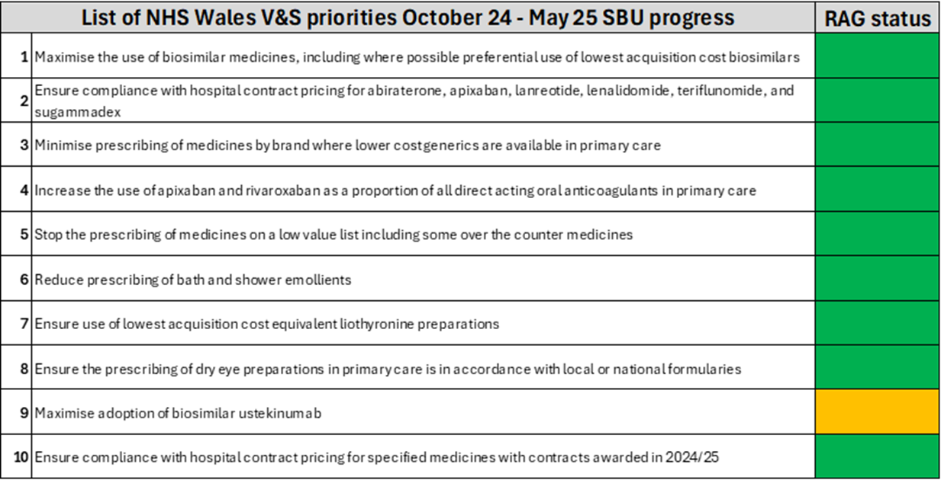

A recommendation that has seen significant improvement over the past months is reducing prescribing of bath and shower emollients. SBU was an outlier in this area; however considerable work has been undertaken by our primary care pharmacy team in GP practices that has led to a significant improvement in appropriate prescribing of bath emollients.

Bath and Shower Emollient basket

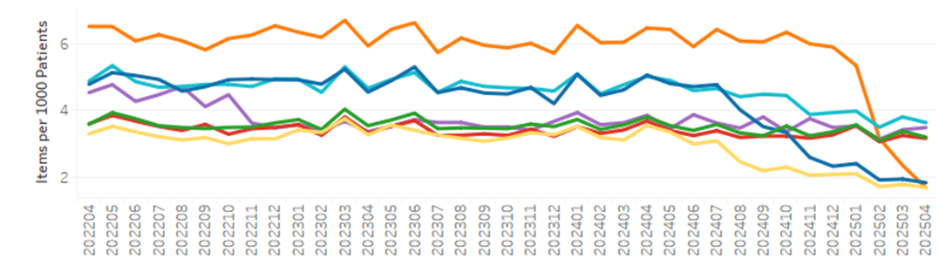
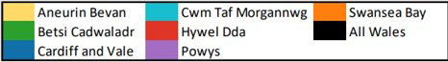

The recommendation that is RAG rated as amber is related to the adoption of the Ustekinumab biosimilar.

A biosimilar medicine is a type of medicine that is very similar to an already approved biological medicine (called the “reference” product). As biological medicines are made from living organisms, they can’t be copied exactly like regular drugs. A biosimilar medicine is developed to be highly similar and clinically equivalent to the reference product. Biosimilar products become available when the patent protection has expired on the reference product, and significant savings can be achieved by switching patient to biosimilar products.

The National Strategy for biosimilars in Wales states that:
- Biosimilar products are considered to be interchangeable with their reference product.
- Patients who are established on a reference biological medicine can be switched to a biosimilar medicine under the supervision of the specialist prescriber in consultation with the patient.

Ustekinumab is a biological medicine that is used to treat certain autoimmune diseases in gastroenterology, dermatology and rheumatology. A biosimilar product became available in Quarter 3 2024/5. As a Health Board, we set a target of 90% implementation by July 2025. As of July 1st, 86% of Ustekinumab patients have been registered to receive the biosimilar Ustekinumab preparation.

The V&S indicators are currently under review, with new recommendations expected to be issued in the next months.

- National Prescribing Indicators
The All Wales Medicines Strategy Group (AWMSG) endorse a number of National Prescribing indicators annually, which are used to highlight therapeutic priorities for NHS Wales and compare the ways in which different prescribers and organisations use particular medicines or groups of medicines. They are developed to promote rational prescribing of medicines in Wales. The choice of indicators is evidence-based and the indicators allow health boards, primary care clusters, GP practices and prescribers to compare their current prescribing practice against an agreed standard of quality.

Table 2 provides a summary of SBUHB performance against quality, safety and efficiency indicators for the latest quarter of data available (Quarter 4, 2024/25). Over the last 12 months, improvements have been seen in SBUHB for all National Indicators. The Health Board is placed in the top 3 performing Welsh HB for 10 of the 13 indicators (Appendix 3).

Table 2: Summary of SBUHB performance against National Prescribing Indicators

Prescribing Indicator | Performance over last 12 months | Rank in Wales HB 1= Best
4C antibacterial DDDs per 1,000 patients | Improvement | 3
Antibacterial DDDs per 1,000 STAR-Pus | Improvement | 2
Course duration Amoxicillin | Improvement | 2
Course duration Clarithromycin | Improvement | 2
Course duration Doxycycline | Improvement | 2
DPIs and SMIs as a percentage of all inhalers | Improvement | 5
Gabapentin and pregabalin DDDs per 1,000 patients | Improvement | 3
High Strength Opioid burden Total OME Per 1,000 Patients | Improvement | 2
Hypnotics and anxiolytics ADQs per 1,000 STAR-Pus | Improvement | 4
Low Value for Prescribing (UDG) spend (£) per 1,000 patients | Improvement | 1
Opioid burden Total OME Per 1,000 Patients | Improvement | 3
SABA as a percentage of all inhalers | Improvement | 6
Tramadol DDDs per 1,000 patients | Improvement | 3

- New Treatment Fund (NICE approved and High-Cost Drugs)

The Welsh Health Circular relating to the New Treatment Fund (NTF) requires Health Boards to make medicines recommended by (NICE or AWMSG available for use as reasonably practicable, and certainly within 60 days of the decision. SBUHB are fully compliant with these requirements, with implementation plans in place and formulary approval for all drugs.

The All Wales Therapeutic and Toxicology Centre (AWTTC) issue performance data relating to formulary status of NTF approved drugs, the latest document is included as Appendix 4.

NICE High-Cost-Drugs final year position for 2024/25 was £64.8 million which was in line with the forecast estimate against overall reserve.

Month 2 position for this year is £10,913,862 which is very early to compare to forecast growth, but is in line with previous years. The health board has already seen 25 NICE/AWMSG drug approvals this financial year which accords with horizon scan and infrastructure requirement estimate.

- SBUHB Medicines Management Savings Plan
The Medicines Management teams across the sectors consistently look to identify and implement initiatives for financial savings through medicines use. Details of the current savings plans are included as Appendix 5.

During 2024/25 the medicines management team delivered £2M savings against a target of £1.5M. This included a range of interventions including formulation changes, stopping prescribing in line with guidance, switching brand to generic, dose optimisation and review of quantities prescribed. Savings opportunities vary year on year and 2024/25 provided a significant combination of opportunistic as well as planned programme based opportunities with a particularly high savings yield.

The Primary care medicines management team were given a 6% uplift to the 2024/25 primary care prescribing budget. However, a 5% cost improvement target was then applied equivalent to £4.6M.

Currently Identified Savings stand at an estimated £2m with a further potential of £0.25m. In addition to this Rebate income of £0.24m is anticipated by year end.

The medicines management team continue to work at a local and national level to identify additional work streams that could lead to further cost improvements against this target.

In acute care, full year drug savings of £1.24M was achieved in 2024-5. For 2025-26, in-year savings of £1.7M have been identified in “green” schemes, with a further £0.45M in “amber” and “red” schemes. At month 3, cumulative acute care savings of £0.52 have been realised.

- FINANCIAL IMPLICATIONS
This report highlights the in-year savings achieved by the Medicines Management team that alleviates some financial pressures on medicines prescribing. Key to maintaining a grip on medicines expenditure is to ensure that pharmacy support is embedded into all Health Board groups where drugs are used, or use being considered, and this must include all instances where service delivery changes are planned.

- RECOMMENDATION
Members are asked to

- ACKNOWLEDGE the continuing progress made by SBUHB Medicines Management teams in delivering improvements in prescribing to increase quality and reduce expenditure within the Health Board across the 4 key areas;
- ACKNOWLEDGE the compliance with nine of the 10 Priorities in the Value and Sustainability Programme.
- ACKNOWLEDGE an improvement for all the National Performance prescribing indicators
- ACKNOWLEDGE Health Board full compliance with New Treatment Fund 60-day deadline to make a newly recommended medicine available for prescribing
- ACKNOWLEDGE the drug savings of £3.2M delivered in 2024-5, and the drug savings workplan for 2025-6

Governance and Assurance

Link to Enabling Objectives  (please choose) | Supporting better health and wellbeing by actively promoting and empowering people to live well in resilient communities
Link to Enabling Objectives  (please choose) | Partnerships for Improving Health and Wellbeing |  | ☒
Link to Enabling Objectives  (please choose) | Co-Production and Health Literacy |  | ☐
Link to Enabling Objectives  (please choose) | Digitally Enabled Health and Wellbeing |  | ☐
Link to Enabling Objectives  (please choose) | Deliver better care through excellent health and care services achieving the outcomes that matter most to people
Link to Enabling Objectives  (please choose) | Best Value Outcomes and High Quality Care |  | ☒
Link to Enabling Objectives  (please choose) | Partnerships for Care |  | ☒
Link to Enabling Objectives  (please choose) | Excellent Staff |  | ☒
Link to Enabling Objectives  (please choose) | Digitally Enabled Care |  | ☐
Link to Enabling Objectives  (please choose) | Outstanding Research, Innovation, Education and Learning |  | ☐
Health and Care Standards
(please choose) | Staying Healthy |  | ☐
(please choose) | Safe Care |  | ☐
(please choose) | Effective Care |  | ☐
(please choose) | Dignified Care |  | ☐
(please choose) | Timely Care |  | ☐
(please choose) | Individual Care |  | ☐
(please choose) | Staff and Resources |  | ☐
Quality, Safety and Patient Experience
Appropriate management of medicines spend will ensure value for money and enable patients to get the right treatment at the right time, reducing admissions and bed stays.

Financial Implications
The update highlights the in-year savings achieved by the Medicines Management team that alleviates some financial pressures on medicines prescribing. Key to maintaining a grip on medicines expenditure is to ensure that pharmacy support is embedded into all Health Board groups where drugs are used, or use being considered, and this must include all instances where service delivery changes are planned.

Legal Implications (including equality and diversity assessment)
The Health Board has a legal obligation to implement recent technologies within specified time limits for the population that it serves, regardless of budgetary constraints.

Staffing Implications
Maintaining a core of registered pharmacy professionals to manage medicines financial risks continues to be a challenge within the Health Board (Pharmacists are included on Home Office Occupation Shortage list). Pharmacy teams are fully engaged with HEIW (Health Education and Improvement Wales) and Welsh Schools of Pharmacy to increase the quality and volume of trainees needed to grow the local registrant workforce.
Long Term Implications (including the impact of the Well-being of Future Generations (Wales) Act 2015)
- Long Term – The Health Board will have strengthened governance and implementation of value-based health care in the utilisation of medicines thereby minimising avoidable costs, improving outcomes and improving quality (reducing harm)
- Prevention – Engagement of Pharmacy into any long-term planning of service and new technologies to support prevention will be incorporated at an early stage.
- Integration – Ensure the use of medicines across the system will be maximised.
- Collaboration – The approach being taken will encourage collaboration between Service Groups in the development of appropriate medicines utilisation.
- Involvement – Whole system involvement in the development of integrated pathways of care where medicines are used will produce a synergistic effect at a whole system level.

Report History
Appendices |  | Appendix 1  NHS Medicines Value & Sustainability-update and new actions 2 October 2024.  Appendix 2  SBUHB performance Value and Sustainability June 25  Appendix 3  Appendix 4  New Treatment Fund - Health board Summary April 2024 to March 2025  Appendix 5  SBUHB MM savings plan 2025-6

