Meeting Date | 29 July 2025 |  | Agenda Item |  |  | 3.2
Name of Meeting | Performance and Finance Committee
Report Title | Urgent and Emergency Care Report
Report Author | Neil Cooper, Assistant Director of Operations – Urgent and Emergency Care  Lee Elwell Urgent & Emergency Care Programme Manager  Alison Gallagher Associate Director Urgent & Emergency Care  Jonathon Baglow, Business Intelligence Analyst
Report Sponsor | Deb Lewis, Chief Operating Officer
Presented by | Neil Cooper, Assistant Director of Operations – Urgent and Emergency Care
Freedom of Information | Open
Purpose of the Report | To provide a summary of the Urgent and Emergency Care (UEC) improvement programme to improve the delivery of timely, safe patient care and the UEC care standards.
Key Issues | UEC performance has previously been escalated into Targeted Intervention by Welsh Government with the Chief Operating Officer holding oversight and assurance against developing and monitoring a UEC improvement programme.  The delivery of Tier 1 performance standards remains a key focus and the risk of patients coming to harm due to delays relating to timely handover of ambulances. Early assessment and treatment remain a key area for the Emergency Department (ED) and ward based clinical management teams. Overcrowding of the ED linked to poor flow and delayed admission of patients into the in-patient bed pool results in poor patient experience.  Significant recent improvement has been witnessed for several key system performance indicators associated with delivering timely and safe patient care and are discussed in the paper.  Service development schemes are in place and continue to be developed and implemented to support the recovery of UEC performance.  A structured approach in response to targeted intervention monitoring and the UEC programme, approved by NHS Wales 6 goals programme is in place to support, deliver and monitor the schemes reporting to the UEC Board
Specific Action Required  (please choose one only) | Information | Discussion |  | Assurance | Approval
Specific Action Required  (please choose one only) | ☒ | ☐ |  | ☐ | ☐
Recommendations | Members are asked to:  - CONSIDER the UEC performance position and the ongoing actions taken to support its recovery and Improvement.

URGENT AND EMERGENCY CARE REPORT

- INTRODUCTION
The report below describes urgent and emergency care (UEC) activity and performance to date including progress against the UEC care standards. Wider system indicators are also used to demonstrate the flow constraints that exist resulting in poor access to timely urgent and emergency care and poor patient experience. The report provides a detailed response to actions pertaining to the increased monitoring to of the UEC tier 1 performance targets and updates on the strategic and operational programme to improve the delivery of acute services to patients and on local improvement actions.

- BACKGROUND
The flow of Emergency patients within the Health Board and the wider UEC system, has very recently been compromised due to the high occupancy levels within its hospitals. This further exacerbated by the system flow challenges impacting patients transferring in a timely way into services outside the hospital sites which in turn increases delays in clinically optimised patients and increases the number of patients being treated outside of their core bed base. The impact of the lack of flow also had unintended consequences in other parts of the UEC system including:

  - Delay in patients transferring from ambulances into the Emergency Department (ED);
  - Delays in patients accessing inpatient beds
  - Increase in utilisation of surge capacity across the Hospital footprint and patients placed in inappropriate spaces i.e. SDEC
  - Delays in patients transferring to the next stage of their recovery – complex and general rehabilitation at peripheral sites
  - Discharge home

In line with the 6 goals programme, wider health board schemes targeting admission avoidance and earlier discharge are in place or have been in trial phase to support the wider system flow agenda.

More recently (June 25) a scheme of works has been implemented which have seen significant improvements to performance. Works undertaken have included:

  - Anglesey Ward to temporarily operate as a General Medical ward to help decompress the ED
- Streamlining ED assessment and direct referrals to medicine Redesigning the medical assessment model in the AMU
- Enhancing specialty assessment and patient allocation
- Implementing a 7-day Same Day Emergency Care (SDEC) model
- Reviewing and applying consistent criteria to reside
- Roll-out of a new Patient Flow Model: ‘Your Next Patient’

- PERFORMANCE – Tier 1 URGENT & EMERGENCY CARE STANDARDS

The Charts overleaf present performance against the ED Access Standards and Ambulance handover targets (12-month rolling position).
As noted works have been undertaken beginning 2nd June 2025 that have significantly improved performance, which has prior to this intervention been a challenging situation and performance against the 4-hour standard at Morriston Hospital which had translated operationally into a poor patient experience at our front door(s) with patients waiting several hours for assessment by a clinician during which period their condition may be more serious than as assessed at triage, or may have deteriorated. A summary position at present of key Targeted Intervention measures (correct as of 14th July 25) including:
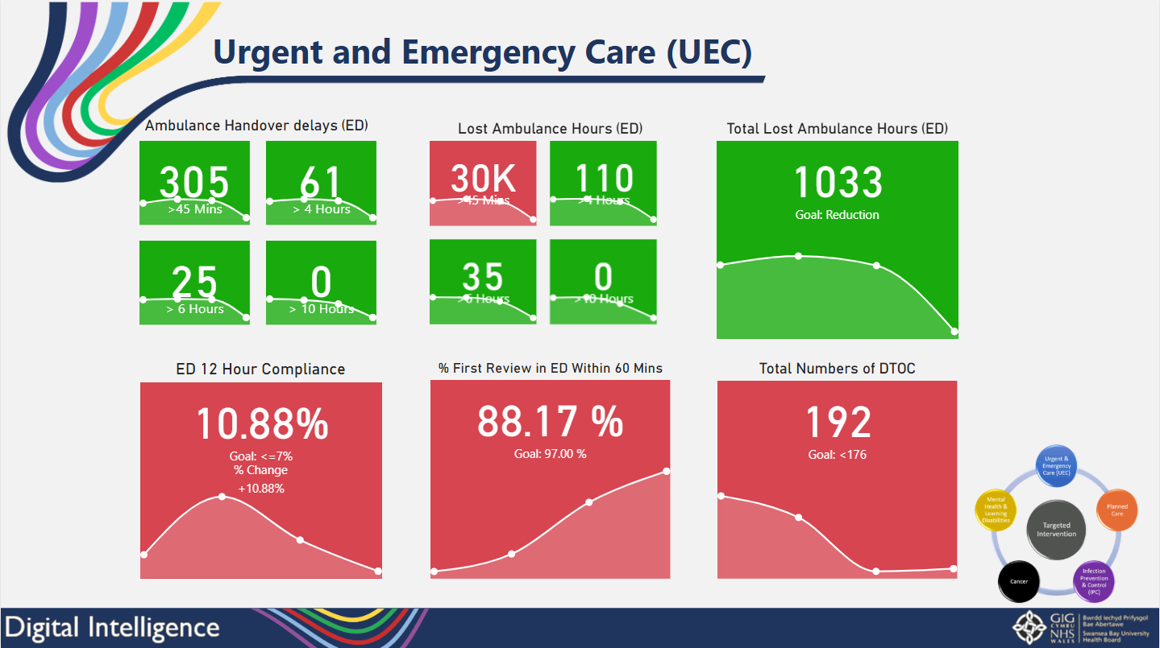

  - Ambulance Handover

1st Jan 2024 to 13th July 2025
URGENT AND EMERGENCY CARE (UEC) - Ambulance
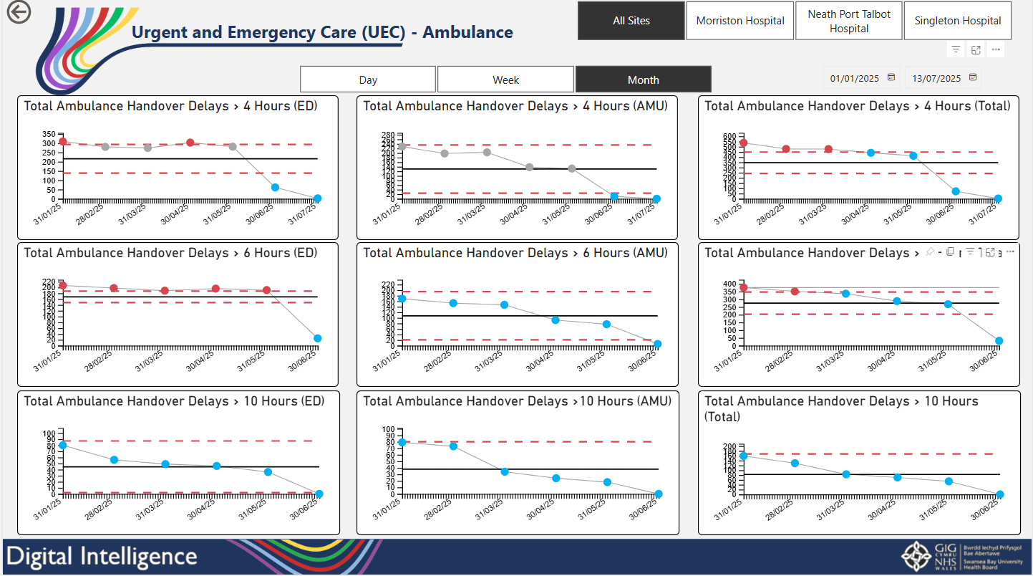

Ambulance handover had until recently been of significant concern and has been a key focus from Welsh Government. The SPC charts above demonstrate a stable overall position between January-May 2025 - testimony to the enhanced efforts across the whole system to manage UEC demand against ever increasing challenges.

However there has been a step-change improvement across key metrics during June following the implementation of Anglesey Ward operating as a general medical ward at the Morriston Hospital site coupled with additional PDSA cycles. These being:

- Streamlining ED assessment and direct referrals to medicine Redesigning the medical assessment model in the AMU
- Enhancing specialty assessment and patient allocation
- Implementing a 7-day Same Day Emergency Care (SDEC) model
- Reviewing and applying consistent criteria to reside

This then supplemented the roll-out of a new Patient Flow Model: ‘Your next Patient’ which has further assisted in improvements. The metrics monitored as part of the PDSA improvement cycles have been positive namely:

- Ambulance Handover Delays <45minutes: INCREASED to 41 per day from 18 per Day – 127% improvement
- Average time to Handover: REDUCED to 0hrs:47 minutes from 2hrs:43 minutes – 71% improvement (SOURCE: Joint Commissioning Committee)
- Deaths in ED: Significant decrease in the number of deaths within the Emergency Department – 11 in June 2025 compared to 28 in June 2024. (For reference, immediately prior to the test of change there were 30 deaths in the ED (May2025) – 63% reduction against May 25.
- Hours Lost: REDUCED from 163 Hours per day to 49 hours per day: 70% improvement (for context, we see 51 ambulance conveyances per day)
- ED Turnaround time (Total time spent in ED, daily): REDUCED from 2,496 Hours to 1,996 hours daily – 20% improvement
- Total number of patients awaiting admission at 9am: REDUCED from 49 Patients to 27 patients – 45% improvement
- Weekday (Medical) Discharges: – REDUCED VARIATION – providing greater confidence and assurance managing FLOW.
  - Variation has reduced from +/- 13 to +/- 7 discharges – a 46% improvement
- SDEC: INCREASED to 114 transfers from ED in June compared to 33 per month between Feb 25 and May 25

All above bullet points/ narrative relates to the pre (April to May 25) and post (June 25) test of change period, while all indictors measured at the 80th Percentile.

  - 12-Hour compliance & 1st Review within 60 Minutes

Further key performance indicators are highlighted in the charts overleaf, as per other key measures there has been improvement since the implementation of Anglesey Ward operating as a general medical ward coupled with the additional PDSA cycles.

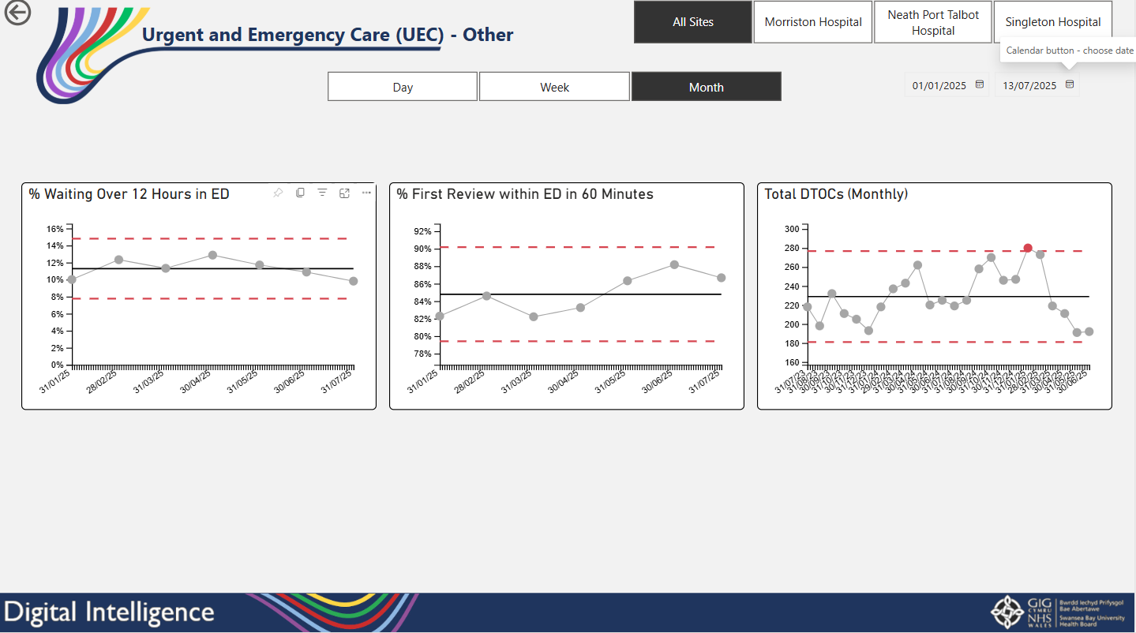

  - Clinically optimised position

The clinically optimised position in the Health Board remains an issue with high numbers of patients occupying acute beds waiting to move to more appropriate settings to continue their care pathway or waiting for community support/placement. The position had been deteriorating (at the time of the previous report in Jan. 25), however there are improvements noted since this time with a renewed and enhanced focus with alternative approaches being tested. This has resulted in a drop from a high of 264 (Jan 25) to a position as of 14th July of 194 COP with a 6 Month low of 176 (May 25). Efforts are continuing to reduce overall COP position by enhanced patient reviews and escalation to remove blockages. The Clinically Optimised Patient cohort is a key focus of the UEC programme of work sponsored by the national 6 goals team. A reduction in this number of patients is a critical factor in the success of patient flow and is high priority in 2025/ 26 for the improvement across all performance metrics.

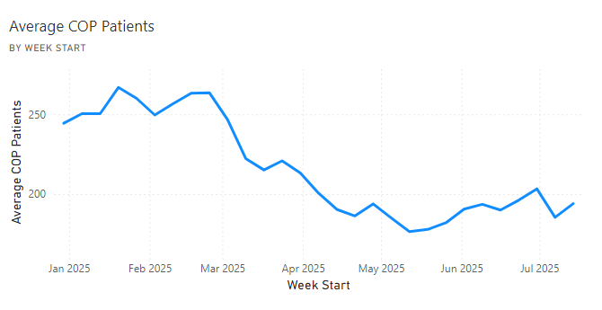
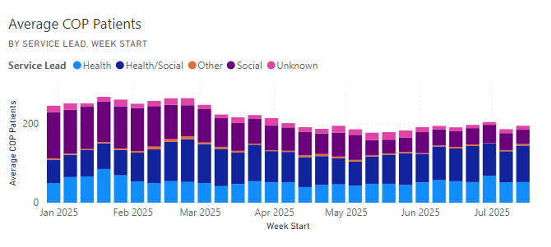

Aligned to reduction in COPs is the reduction of Pathway of Care Delays (POCD – previously known as Delayed Transfer of Care - DTOC). The following chart notes an improving position re POCD with a downward trend in number of Pathways of Care Delays since January 25. ‘Assessment delays’ (whether that be health or social care) continue to be the highest delay codes followed by care home placement arrangements.

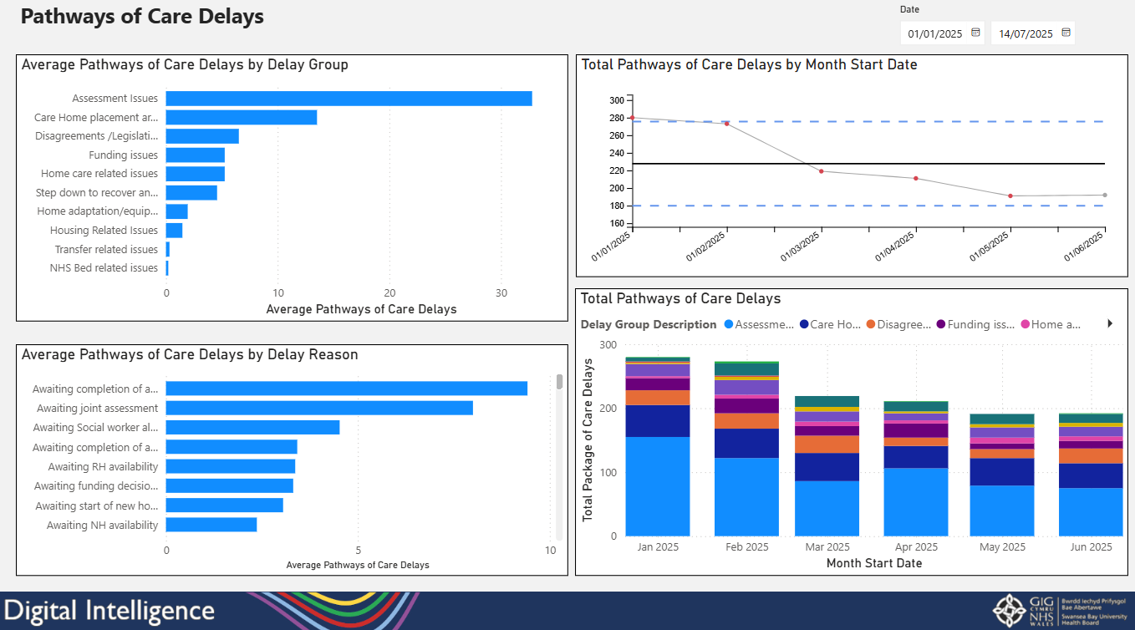

  - Bed Occupancy – Morriston Hospital

The following occupancy chart from Morriston Hospital again shows an improvement on key metrics. With a reduction in COP position there has been an overall reduction in those patients with a length of stay 22+ days (who would have likely been in this cohort) and a reduction on those patients 13-21 days. Conversely there has been an increase in patients with an LOS <48 hours indicating an improved ability to treat patients in a timely manner and turn around quickly back to their place of residence.

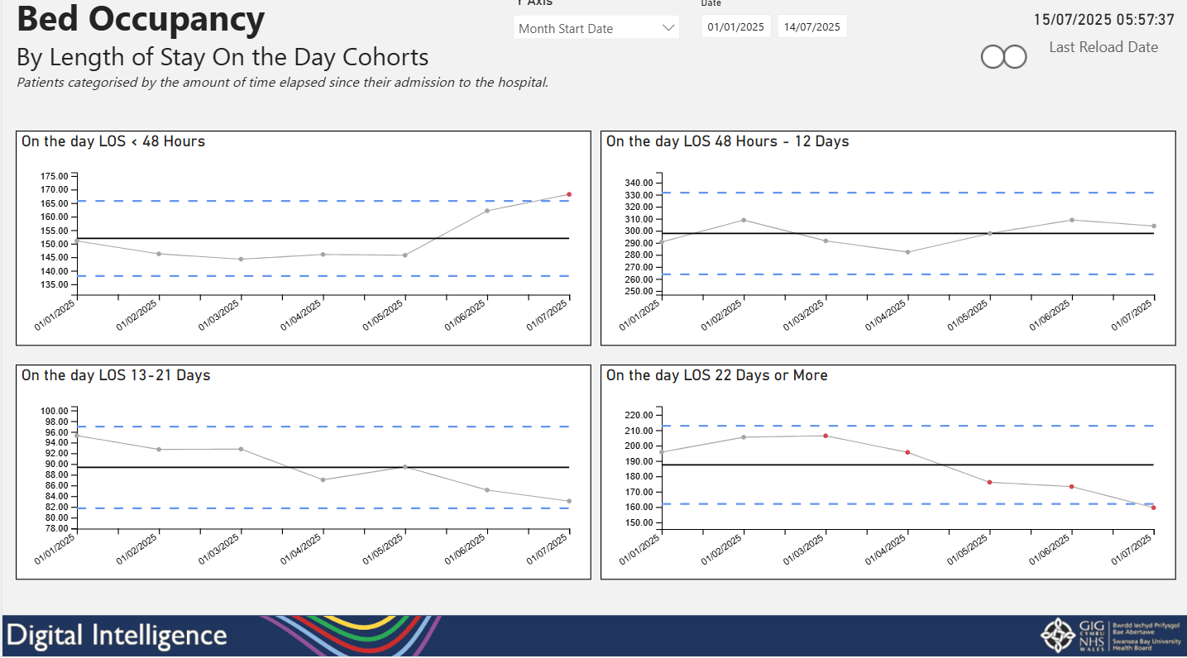

To facilitate this flow there has been the requirement to create additional capacity and this has been via the opening of Anglesey Ward (25 beds) as an additional General Medical Ward. Additionally, by agreeing a pre-emptive ‘boarding’ policy, and implementing the Your Next Patient’ patient flow model (circa 35 bed capacity) that pushes/ pulls patients away from ED on to specialities in a timely manner. This can bring with it inherent risks such as:

- Increased pressure on staff working in these environments
- There can be costs attached to short notice staffing requirements (in line with Safe Staffing Act)
- Increased Risks and Issues relating to Infection control measures
- Increased Risks and Issues relating to Health & Safety measures
- The Dignity and Privacy experienced by patients (Boarded on Wards) directly affected diminishes

However, these risks need to be compared with the severe risk that has historically been held with the Emergency Department at Morriston Hospital and poor time to clinician, poor ambulance handover times (which increase harm/ mortality) and risk being held in the community with ambulances previously being ‘trapped’ at the front door.

- Wider system measures and actions:
The Health Board has Targeted Intervention (TI) status as defined by Welsh Government for its performance and outcomes within the UEC system.

The TI expectations mirror the HB’s own aspiration, and the plan is to continue the works begun at Morriston Hospital in relation to improvements, whilst also working across the entire system (e.g. all acute sites, primary and community care, social care). This to treat those patients away from acute settings wherever suitable, ensure triage and signposting to the right place first time, appropriate flow through the system for those patients that need to be admitted and timely discharge back to a patients place of residence.

The criteria used for consideration to de-escalate out of TI is captured in the table below along with progress to date (last 3 months).

Criteria to Achieve | Current Performance
- A continuous reduction of ambulance handovers over an hour of at least 11% in three consecutive months and maintained for 3 months (Based on quarter 2 and 3 2023 baseline): | - April – 629 (13.3% Increase)  - May – 599 (4.8% reduction)  - June – 249 (58.4% reduction)
- Continuous improvement towards no more than 7% of patients waiting over 12 hours at each individual site and across the health board. | - April – 12.87%  - May – 11.71%  - June – 10.88%
- Median time from arrival at an emergency department to assessment by a clinical decision maker should not exceed 60 minutes | - April – 83.26%  - May – 86.33%  - June – 100%
- A continuous reduction in delayed pathways of care of 5% for three consecutive months and then maintained for three months (based on Oct-Dec 23 baseline): 215 | - April – 211  - May – 191  - June - 192
- Assessment of declared BCIs, including reasons why, actions taken, and lessons learnt. | - BCI declared 10th – 13th February 2025

As noted above there has been significant improvement against several measures which needs to be maintained along with improvement in certain metrics to exit Targeted Intervention status. Significant improvement has been witnessed re; ambulance handover times with a 58.4% reduction within June and 100% clinical decision maker assessments within 60 minutes, whilst delayed pathways of care continue to track under target. Improvement work is planned which is anticipated to improve the target relating to patients waiting over 12 hours

Actions being taken or underway to improve include:
- Full implementation of D2RA model – Executive agreement between Health & Social Care CEO’S to deliver a D2RA model. Test of change delivered pre-Easter with overwhelming evidence of success. Test of change has continued; a work programme structure has been developed and a formal OCP is required to substantively reorganise workforce. A workshop is planned for the 21^{st of} July 2025.
- Grip & control operational management – Full Capacity protocol and zero tolerance on chair and trolley waits in full operation with additional 3:30 huddle now in situ at Morriston Hospital but with reduced measures in place. Health Board launch of ‘Your next Patient’ commenced on Monday 16th June 2025 and it has shown significant improvements across patient flow.
- UEC Care co-ordination Hub – Funding application submitted to Six Goals to extend the role and function of the UEC care coordination hub over the seven-day period. Initial priority to deliver five-day Single Point of Access (SPOA) and to implement the national ticket to ride framework.
- Pathway of Care Delays (PoCD) – Focus on the delivery of actions to reduce PoCDs, COP deep dives and the recording of D2RA pathways on our SIGNAL digital system to enable increased understanding of bottlenecks within the system. Escalation to COO / Directors of Social Services on a weekly basis.
- Revised flow operating model/Anglesey Ward: Anglesey ward test of change commenced 2nd June. 25 bedded General Medical Ward opened as a key enabler to test changes in the operating model across the UEC pathway. Executive approval to sustain the test of change model at Morriston Hospital has been provided.
- Falls Pathway – Commenced in February 2025 – The opportunity to further improve access to the service has been achieved in line with the revised flow operating model outcomes as above.
- UEC capital redesign – Following executive discussion, letters sent from CEO to Judith Paget (NHS Wales CEO) to outline the current tests of change in progress that will influence the capital request. There is also an expression of interest to pursue a digital platform to underpin the UEC pathway and has been supported by a demonstration to clinical operational staff on 8th July 2025.

Further actions planned to further improve performance:
Multiple improvement plans have been developed to further improve UEC performance and all aligning to National 6 Goals Programme and Ministerial Priorities for 2025/ 26 financial year. These include within Morriston Hospital:
- Use of Your Next Patient Spaces – monitoring length of stay
- Use all capacity across SBUHB to ease pressures at the front door and in the community
- Develop robust night and weekend plans to ensure equity of care by day and night/weekends
- Ensure all specialities equally support their patients in ED in a timelier manner
- Release capacity in all assessment areas to ensure smooth transition from ED to specialities
- Improve flow through the Acute Medical Assessment Unit

Immediate next steps

PDSA | Next steps
Anglesey Ward | Keep Anglesey Ward open – end March 26 (review Oct 25)
Stop 7-day SDEC | Low referral numbers, need to do a focussed piece of work on the SDEC model-new PDSA
Trusted referral pathway ED to SDEC | Continue as the referral numbers on weekdays have improved
AMU assessment model | Further work is required as the tests of change have not improved flow through the AMU
Criteria to Reside | Redesign PDSA’s (?) Test closer to point of Decision to Admit
Criteria Led Discharge | Continue to refine/extend
Your Next Patient | Implement as ‘business as usual’.

Continuous improvement journey

Based on the learning, we need to | PDSA
Improve patient flow at ward level | Test the optimal hospital flow framework with support on one ward
Redesign the SDEC Clinical Model | Test the impact of Clinicians from ED and Acute Medicine in delivering a 5-day SDEC service
Improve AMU Patient Flow | Test different models of working in the AMU
Improve ways of working in the Emergency Department, with a particular focus on assessment | Design tests of change in the ED working model based on the learning from recent PDSA’s
Criteria to Reside | Redesign PDSA’s (?) test closer to point of Decision to Admit
Criteria Led Discharge | Continue to refine/extend the PDSA as early signs of improvement in weekend discharge
Reduce the number of patients conveyed from Care Homes | Test the implementation of ‘ticket to ride’ whereby paramedics attending an emergency call in a Care Home will discuss the case with Clinicians in the UEC Hub prior to conveyance

Aligned to the ongoing improvement (PDSA) activity within the Morriston Hospital Service Group are broader plans that sit across service groups and in some cases rolled out in conjunction with Local Authority partners. These include:
- D2RA: Redesigning patient discharge and transfer from hospital based on the D2RA principles (in conjunction with LA partners/ West Glamorgan Regional Partnership Board)
- SPOA: Development of a UEC Single Point of Access to promote pre-hospital triage and redirection to appropriate alternative pathways to admission
- Patient Flow: Centralisation of Patient Flow (to work across all sites)
- Pathway development: falls, respiratory and linked to SPOA
- Community Falls Service Development: Community based services linked to SPOA for pre-hospital triage and outreach (avoid conveyance – better outcomes for patients)
- Frailty strategy: Continue with approved activity – acute frailty services (OPAU) to include a move to 7-day frailty services and alignment of Virtual Wards and ACT to provide ‘Hospital at Home’ service
- Pathway of Care Delays (PoCD): Continue improvement activity (linked to D2RA actions) and reduce total number of delays and overall length of delays – key actions to include full implementation of trusted assessor model

- GOVERNANCE AND RISK ISSUES
In relation to Urgent and Emergency Care services risks are being reviewed on a weekly basis by the Operational Managers and Clinical Leads. Updates are provided at monthly Quality and Safety meetings and UEC/6G Programme Board to ensure progress details of the outcomes and confirm whether any mitigating actions will need to be taken as a result.

- FINANCIAL IMPLICATIONS
The Urgent and Emergency Care budget is split between Service Groups and the Chief Operating Officers Office. Summaries of financial implications that flow from any recommendations are picked up through the financial planning and escalation undertaken at Service Group level.

- RECOMMENDATION
Members are asked to:
  - CONSIDER the UEC performance position and the ongoing actions taken to support its recovery and Improvement
  - CONSIDER the next steps including actions to further improve services include work on pre-hospital triage (SPOA) and admission avoidance services/ pathways (e.g. falls) in-hospital improvement activity (PDSA’s) alongside the Discharge to Recover then Assess (D2RA) activity in conjunction with Local Authority colleagues via the West Glamorgan Regional Partnership Board governance structures.
Governance and Assurance

Link to Enabling Objectives  (please choose) | Supporting better health and wellbeing by actively promoting and empowering people to live well in resilient communities
Link to Enabling Objectives  (please choose) | Partnerships for Improving Health and Wellbeing |  | ☒
Link to Enabling Objectives  (please choose) | Co-Production and Health Literacy |  | ☐
Link to Enabling Objectives  (please choose) | Digitally Enabled Health and Wellbeing |  | ☒
Link to Enabling Objectives  (please choose) | Deliver better care through excellent health and care services achieving the outcomes that matter most to people
Link to Enabling Objectives  (please choose) | Best Value Outcomes and High Quality Care |  | ☒
Link to Enabling Objectives  (please choose) | Partnerships for Care |  | ☒
Link to Enabling Objectives  (please choose) | Excellent Staff |  | ☒
Link to Enabling Objectives  (please choose) | Digitally Enabled Care |  | ☒
Link to Enabling Objectives  (please choose) | Outstanding Research, Innovation, Education and Learning |  | ☒
Health and Care Standards
(please choose) | Staying Healthy |  | ☒
(please choose) | Safe Care |  | ☒
(please choose) | Effective Care |  | ☒
(please choose) | Dignified Care |  | ☒
(please choose) | Timely Care |  | ☒
(please choose) | Individual Care |  | ☒
(please choose) | Staff and Resources |  | ☒
Quality, Safety and Patient Experience
To improve the delivery of timely, safe patient care and the UEC care standards.
Financial Implications
There are no direct financial implications arising from the recommendations in this report.
Legal Implications (including equality and diversity assessment)
There are no direct legal implications arising from the recommendations in this report.

Staffing Implications
There are no direct staffing implications arising from the recommendations in this report.
Long Term Implications (including the impact of the Well-being of Future Generations (Wales) Act 2015)
Report History |  | N/A
Appendices |  | N/A

