Meeting Date | 29 July 2025 |  | Agenda Item |  | 2.4
Name of Meeting | Performance and Finance Committee
Report Title | Update on Stroke Performance
Report Author | Abi Landeg – Directorate Manager Medicine Specialties  Peter Slade – Stroke Clinical Lead
Report Sponsor | Deb Lewis, Chief Operating Officer and Neil Cooper, Assistant Director of Operations
Presented by | Peter Slade – Stroke Clinical Lead
Freedom of Information | Open
Purpose of the Report | This report includes an update on previously allocated funding and its usage. This report also includes an updated performance position and includes plans and timescales for improvement.
Key Issues | - Compliance against the 4-hour access target and the ring-fencing of beds for admission to the Acute Stroke Unit remains challenging due to system wide pressures.  - Lack of funding received to implement a 24/7 stroke consultant rota.  - A number of changes to KPI metrics introduced have resulted in lower compliance levels in the below areas:  - 14-hour consultant assessment (previously 24hr)  - CT within 20 minutes (previously 1 hour)  - Thrombolysis door to needle time <30 minutes (previously 45 minutes)  - Continued high compliance of thrombolysis rate, swallow assessments and therapeutic assessments.  - Reducing door to needle time for Thrombolysis is an area for improvement, more so since the introduction of the new KPI  - Increase of Mechanical Thrombectomy a priority.  - Embedding of CT Perfusion and MRI Perfusion.  - Stroke improvement plan revised.
Specific Action Required  (please choose one only) | Information | Discussion | Assurance | Approval
Specific Action Required  (please choose one only) | ☐ | ☒ | ☐ | ☐
Recommendations | Members are asked to:  - Accept the content of the report and endorse actions to improve performance

UPDATE ON STROKE PERFORMANCE

- INTRODUCTION

This report provides the committee with an update on previously allocated stroke funding and its usage. This report also provides an update on performance against the stroke pathway in SBUHB and identifies work currently taking place to improve performance and flow between Neath Port Talbot and Morriston Hospital.

Continued year-round pressures on acute hospitals such as Morriston mean that performance against access targets have been challenging to improve.
Whilst investment into the Stroke service was received in 2023/2024 the service is yet to receive the remaining agreed funding to allow recruitment into numerous consultant and therapy posts which will improve performance, and the overall service provided.

A Stroke services action plan (appendix 1) for performance recovery and improvement has been developed and enhanced to include updated performance measures taking effect in 2025.

- BACKGROUND

  - Stroke Investment

Stroke care in Swansea Bay University Health Board (SB), along with other health boards in Wales, falls short of the national clinical standards as measured by the Sentinel Stroke National Audit Programme (SSNAP). This is due to limited Early Supported Discharge (ESD), inadequate staffing levels that fall short of the national standards across the full multidisciplinary team (MDT). As a result, stroke services in the health board fall short of the expected Key Performance Indicators (KPIs).
In 2022/2023, the board committed to the below funding:
Phase 1: 2022/2023 = £500k recurrent (Received in full)
Phase 2: 2023/2024 = an additional £500k recurrent (Received in part)
Phase 3: 2024/2025 = an additional £500k recurrent (Not received)

2.1.1 Phase 1 - Utilisation of the 2022/2023 investment
Recruitment of 3 x ACPs were recruited in 22/23. These staff are now fully qualified and can prescribe and commence the hours of the stroke OOH ACP (advanced care practitioner) Rota.
Recruitment of 2 x Physician Associates (PA) who are involved in the acute management of stroke patients.
Recruitment of 1 x Speech and Language Therapist (SALT) to reduce the Length of Stay (LOS) at NPTH and to ensure outflow from the acute Morriston site.

2.1.2 Phase 2 - Utilisation of the 2023/2024 investment
Recruitment of an additional 3 x ACPs in 23/24 (total of 6 ACP’s which includes 22/23 allocation). Of these staff, 1x is fully qualified (Band 8A) who can prescribe and commence the hours of the stroke ACP (advanced care practitioner) Rota. However, 2x are currently still in training (Band 7) and are in a Clinical Nurse Specialist (CNS) role who are dedicated to the stroke team. This recruitment has allowed us to extend the availability of our ACP/CNS workforce allowing us to offer a service 7 days per week, between 07:30am – Midnight.
Recruitment of 1x Stroke Consultant Physician to support with delivery of acute stroke care.
Recruitment of several posts and therapy equipment and training to launch the Early Supported Discharge (ESD) service that provides rehabilitation to the mild-moderate cohort of patients within the community. Posts include:
- 1 WTE Occupational Therapist
- 1 WTE Speech and Language Therapist
- 1 WTE Dietitian
- 3 WTE therapies technicians
- 1x 0.4 WTE ESD Administration Support
Whilst the above was recruited to the division did not receive the full allocation of its expected allocation of £500k this was ‘top sliced’.

2.1.3 Phase 3 - Utilisation of the 2023/2024 investment (£500k)
We have not received this phase of funding however our plans would be to use it for the below posts:
- 2x Stroke Consultant Physician posts which would allow us to run a 24/7 stroke on-call rota. This would provide hyper acute stroke care to patients consistently 24 hours a day, 7 days a week something we are unable to provide at present.

- 2x Clinical Fellow posts to enhance the delivery of hyper acute stroke care.

2.2 Stroke Performance

Due to changes to the Sentinel Stroke National Audit Programme (SSNAP) data repository in October 2024, there have been significant challenges in extracting data from the national system. However, access has now been restored with updated indicators and reporting options. Despite this progress, the NHS Executives’ Quality Improvement Measures (QIM) portal will not be operational until August 2025 therefore this data will not be included in this report. In the interim, the service has implemented local arrangements to extract and report relevant data which is included within this report.

The tables below outlines the progress of each Stroke Key Performance Indictor (KPI) at Swansea Bay UHB:

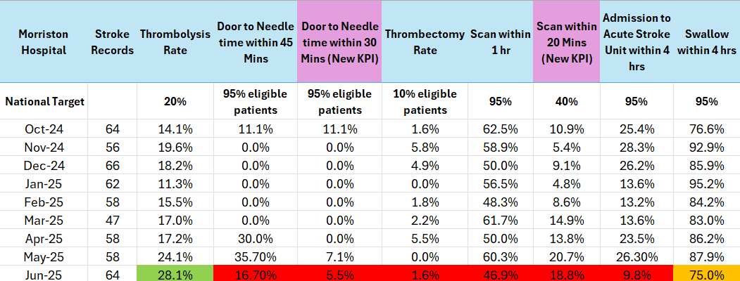

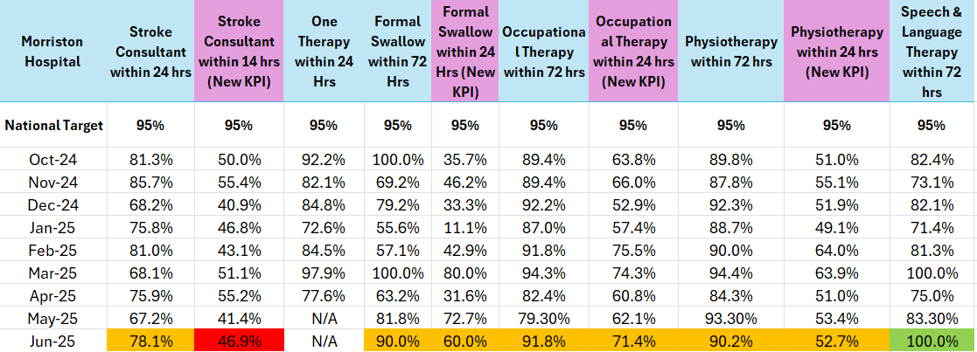

There are several issues impacting performance which include:
- Admission to the Acute Stroke Unit remains challenging due to system wide pressures.
- Inappropriate occupation of the stroke therapy space on Ward F at Morriston hospital due to regular surging of beds. This has resulted in therapeutic care being undertaken without the appropriate equipment at the bedside.
- Delays in patient's pathway onto rehab, step down beds increasing patient length of stay within Acute Stroke Unit (ward F)
- Funding required to implement a 24/7 stroke consultant rota.
- Several changes to KPI metrics introduced have resulted in lower compliance levels

There are several actions being taken to improve stroke performance via a PDSA Test of Change approach:
- Joint MDT Board Rounds with Morriston and NPT twice per week to improve flow with senior manager attendance.
- Streamlining the process of listing and accepting patients onto Ward B2 in NPTH
- Review of the stroke pathway, identifying delays and areas of potential improvement at weekly meetings
- Review of stroke/radiology pathways and interactions – focussing on the relevant KPIs
- Review of medical outliers and ability to maintain a stroke ring fenced bed within Morriston Hospital.
- Stroke bed profiling exercise to be reviewed
- Implementation and expansion of CT perfusion to improve access to thrombolysis
- Introduction of the use of Tenecteplase (over alteplase), to improve time to access thrombolysis
- Participation in the national stroke pre-hospital video triage pilot
- Implementation of stroke ACP/CNS pre-triage assessment
- Expansion of stroke specialist team – CNS/ACP cover 7.30-midnight 7 days in week, 2 further ACPs in training
- Continuation of the Early Supported Discharge Service (ESD) dealing with patients who have mild-moderate strokes.
- Development of an Integrated Community Stroke Service (ICSS) dealing specifically with moderate to severe strokes (business case development.

- GOVERNANCE AND RISK ISSUES

In relation to Stroke services, four main areas of risk are highlighted below. These include the inability to admit patients in a timely manner into the Acute Stroke Unit, inappropriate use of therapies space on Ward F, lack of equipment and lack of a dedicated consultant rota which affects KPI as highlighted in the paper.

These risks are being reviewed on weekly basis by the Directorate Manager and Clinical Lead. Updates are provided at monthly Quality and Safety meetings and Stroke Board to ensure progress. Current risks are:

Risk ID | Title | Risk Level | Risk Handler
2901 | Inability to admit patients in a timely manner to the ASU | High Risk – 20 | Abi Landeg
3340 | Lack Of Therapies space on Ward F and B2 in NPT | High Risk – 16 | Abi Landeg
2147 | Potential significant harm due to lack of senior stroke medicine on-call rota | High Risk – 12 | Abi Landeg

- FINANCIAL IMPLICATIONS
£1.5m expenditure plan over the next few years approved at management board in 2023. Funding previously agreed to and minuted in management board has not been forthcoming in 2024/25 which has hindered progress in this speciality.

- RECOMMENDATION
Members are asked to:
- Accept the content of the report and endorse actions to improve performance
Governance and Assurance

Link to Enabling Objectives  (please choose) | Supporting better health and wellbeing by actively promoting and empowering people to live well in resilient communities
Link to Enabling Objectives  (please choose) | Partnerships for Improving Health and Wellbeing |  | ☐
Link to Enabling Objectives  (please choose) | Co-Production and Health Literacy |  | ☐
Link to Enabling Objectives  (please choose) | Digitally Enabled Health and Wellbeing |  | ☐
Link to Enabling Objectives  (please choose) | Deliver better care through excellent health and care services achieving the outcomes that matter most to people
Link to Enabling Objectives  (please choose) | Best Value Outcomes and High Quality Care |  | ☒
Link to Enabling Objectives  (please choose) | Partnerships for Care |  | ☐
Link to Enabling Objectives  (please choose) | Excellent Staff |  | ☐
Link to Enabling Objectives  (please choose) | Digitally Enabled Care |  | ☐
Link to Enabling Objectives  (please choose) | Outstanding Research, Innovation, Education and Learning |  | ☐
Health and Care Standards
(please choose) | Staying Healthy |  | ☐
(please choose) | Safe Care |  | ☐
(please choose) | Effective Care |  | ☒
(please choose) | Dignified Care |  | ☐
(please choose) | Timely Care |  | ☒
(please choose) | Individual Care |  | ☐
(please choose) | Staff and Resources |  | ☐
Quality, Safety and Patient Experience
In relation to Stroke services, four main areas of risk are highlighted in detail in section 3 of this report. These include the inability to admit patients in a timely manner into the Acute Stroke Unit, inappropriate use of therapies space on Ward F, lack of equipment and lack of a dedicated consultant rota which affects Key Performance Indicator as highlighted in the paper. These risks are being reviewed on weekly basis by the Directorate Manager and in partnership with the clinical lead where appropriate. Updates are provided at monthly Quality and Safety meetings to ensure progress.

Financial Implications
£1.5m expenditure plan over the next few years approved at management board in 2023. Funding previously agreed to and minuted in management board has not been forthcoming in 2024/25 therefore the two further consultant posts that need to be recruited to may not be able to proceed.

Legal Implications (including equality and diversity assessment)
Not applicable

Staffing Implications
The inability to introduce a core service requirement (stroke consultant on call rota)

Long Term Implications (including the impact of the Well-being of Future Generations (Wales) Act 2015)
Briefly identify how the paper will have an impact of the “The Well-being of Future Generations (Wales) Act 2015, 5 ways of working.
- Long Term – Providing enhanced Stroke Services for the SBUHB region.
- Prevention – Enabling timely intervention in patient’s pathways resulting in better outcomes for Stroke survivors.
- Integration – Integrating with other hospital sites to ensure rehabilitation pathways are utilised.
- Collaboration - Acting in collaboration with any other areas such as other hospital sites and tertiary organisations such as the Stroke Association.
- Involvement – Stroke performance is monitored weekly by a range of staff from different backgrounds as well as being scrutinised before a regular executive board.
Report History |  | V1
Appendices |  | Appendix 1 – Stroke Improvement Plan

