Meeting Date | 29th July 2025 |  | Agenda Item |  |  | 2.2
Name of Meeting | Performance & Finance Committee
Report Title | Financial Report – Month 3 2025/26
Report Author | Samantha Moss, Deputy Director of Finance  Gemma Pearson, Finance Business Partner  Crystal Davies, Principal Finance Manager
Report Sponsor | Darren Griffiths, Executive Director of Finance and Performance
Presented by | Samantha Moss, Deputy Director of Finance
Freedom of Information | Open
Purpose of the Report | The report advises the Performance & Finance Committee of the Health Board on the financial position for Month 3 2025/26 (June 2025) and risks regarding the current forecast revenue year end outturn.
Key Issues | The report invites the Performance & Finance Committee to note the detailed analysis of the financial position for Month 3 2025/26 (June 2025).  The report includes a summary of the key drivers of the position either at Service level or by expenditure type (i.e. Non-Pay/Pay). It also provides information of the current position with regards to Health Board reserves to ensure transparency in the overall Health Board position.  Risk will have been considered on the basis of the information provided within the report and the score updated where necessary.  Whilst the key messages are provided within the main body of the report, further information is provided in the Appendices.
Specific Action Required  (please choose one only) | Information | Discussion |  | Assurance | Approval
Specific Action Required  (please choose one only) | ☐ | ☐ |  | ☒ | ☐
Recommendations | Members are asked to: -  - CONSIDER the 2025/26 Financial Plan, and the Health Board’s and Welsh Government’s inability to approve it given the planned deficit of £58.7m.  - CONSIDER the key messages and required actions regard to Welsh Government and the expectation that the Health Board will deliver a £42.5m deficit in 2025/26 in line with the 2024/25 Outturn.  - Consider and comment upon the Health Board’s financial performance for Month 3 2025/26 and the Year to Date (YTD) position.  - CONSIDER the risks to the position at Month 3.  - SUPPORT the position with regards to Health Board reserves.

FINANCIAL REPORT – MONTH 3 2025/26

- INTRODUCTION
The Annual Plan submitted to Welsh Government on 31 March 2025 included a financial assessment, as summarised in the table below:
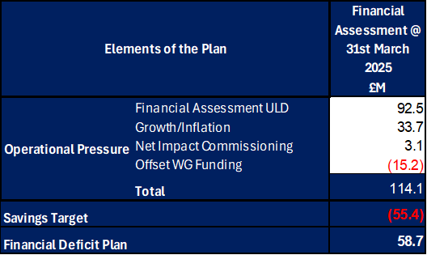

Welsh Government issued a letter to the Health Board on 6 June 2025 indicating that the planning process has been closed in order to focus on delivery and improvement. The letter sets out an expectation that the Health Board will deliver a £42.5m deficit in 2025/26 in line with the 2024/25 Outturn. Detailed action plans for the delivery of the planned level of were submitted to Welsh Government on 30 June 2025. At Month 3 the forecast remained as per the planned submission of £58.7m.

- FINANCIAL PERFORMANCE

TARGET | ACTUAL PERFORMANCE
Cash Balance Bank < £6.0m | £3.416m
In Month Performance Revenue Resource Limit < £58.7m | £7.123m
YTD Performance Revenue Resource Limit < £58.7m | £24.167m
YTD Performance Capital Resource Limit < £0m | £0.448m
YTD Performance Public Sector Payment Policy > 95% | 95.68%

FINANCIAL REPORT REVENUE – MONTH 3
The Health Board’s actual performance against the three components of the Plan (Operational Pressure, Savings Target, and Planned Deficit) for 2025/26 is provided in the table below. This table shows that in Month 3 the reported deficit was £7.123m, which is £2.23m above the £58.7m planned deficit. The YTD position reports a £24.167m deficit, which is £9.48m above £58.7m plan. The key driver of the YTD £9.48m deficit over the current plan is the non-delivery of savings. This shortfall was partly mitigated in Month 3 by non-recurrent in-month benefits for the Primary Care Service Group, a further underspend in the Corporate Directorates and the application of 10/12th of £2.7m non-recurrent opportunities.

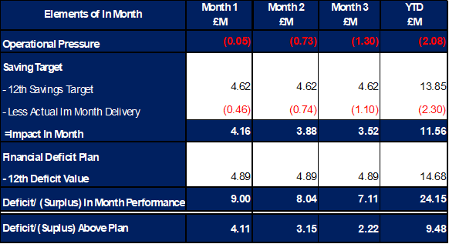

Graph 1 below reflects the actual delivery in each month, with the orange bars reflecting the performance requirements to achieve the original plan of £58.7m. Graph 2 outlines the savings delivered to date as the blue bars against monthly target set (red line), and the orange bars reflect the level of savings required in future months to achieve the £55.4m target aligned to the £58.7m plan.

Graph 1: Performance Graph 2: Savings

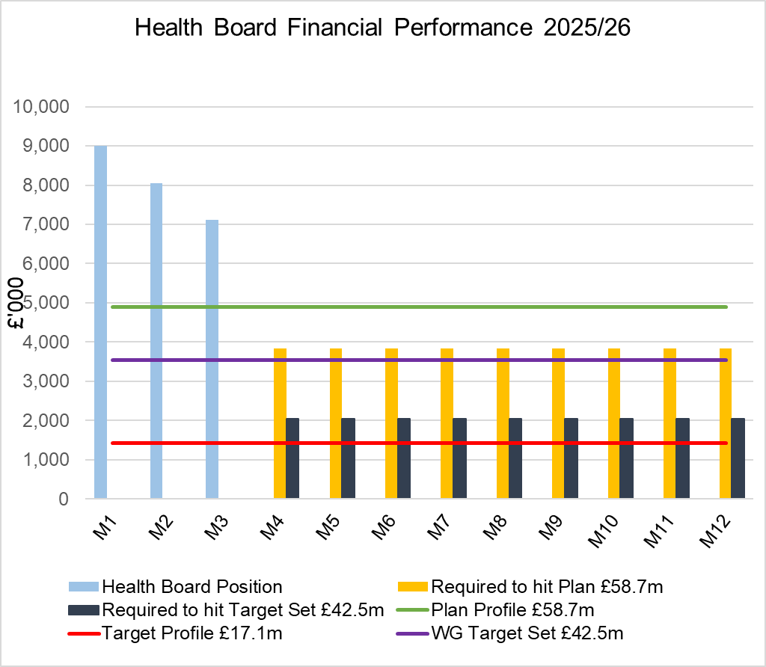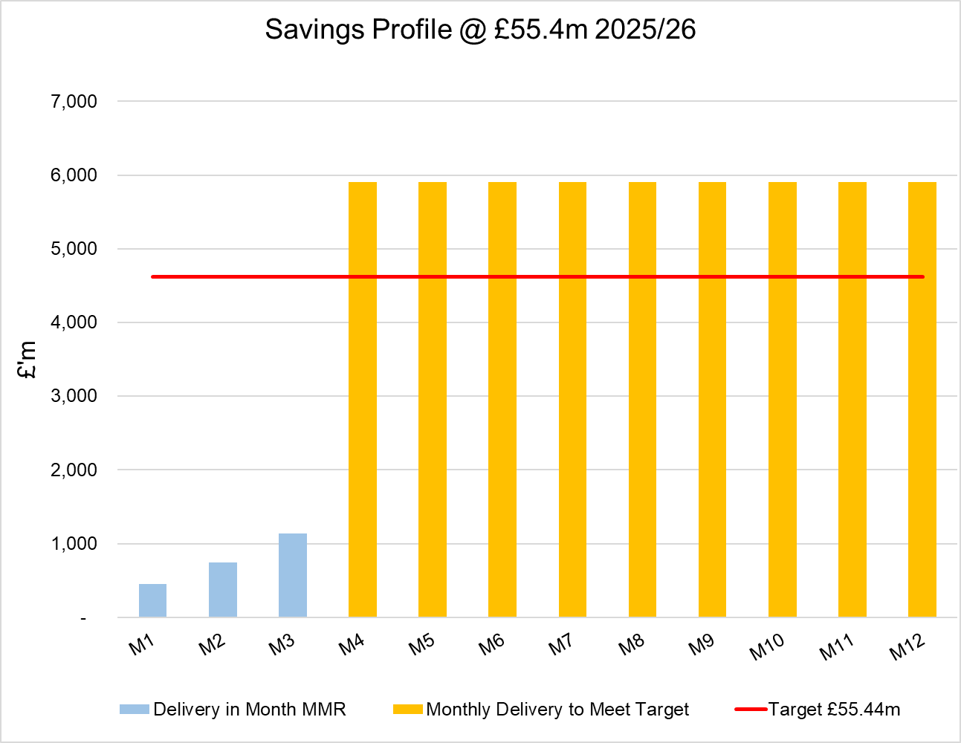

As per Graph 1, if the Health Board is to achieve the £58.7m plan it will need to recover the £9.5m during 2025/26 by delivering more savings in future months resulting in a lower variance for Month 4-12.

Throughout Quarter 1, the key risks for delivery of 2025/26 plan has remained savings. As seen in the YTD performance, savings have not been identified or delivered at the required pace. The savings position at Month 3 identified plans totalling £19.5m of savings (including £10.3m of Red schemes) and whilst Recovery & Sustainability Board continues to scrutinise delivery of these, there is a significant increase required to deliver the plan, and as per the Welsh Government letter from 6th June this the requirement increased further by £16.2m, taking the total savings to £71.6m.

The work of the external support will commence on the 14 July 2025 and will focus on the improved delivery of savings, alongside the other Recovery Actions included with the Financial Assessment to Welsh Government on 30th June. Updates on progress will be presented to the Health Board through July and August.

- KEY DRIVERS OF THE IN-MONTH POSITION
The key drivers of the Month 3 position are summarised in the table below. Further detail at a Health Board level of expenditure on Income, Pay and Non-Pay, is also provided in Appendix 1.

  - Key Drivers by Service Area In-Month

  - Key Drivers by Service Area YTD

  - Summary By Expenditure Type

- Income
The Joint Commissioning Committee (JCC) Income as a provider over-performed by £0.5m in month (£0.1m YTD) and this is driven by increased activity in high tariff areas, particularly TAVI & Cardiology).

Dental Contract Income underperformed in-month by £0.051m (YTD £0.2m)

- Pay
Month 3 Pay was slightly lower in-month, with vacancies primarily in Admin & Clerical driven by the Vacancy Freeze, predominately within the Corporate Directorates.

- Clinical Consumables
(see Appendix 1)

- Prescribing
(see Appendix 1)

- SAVINGS

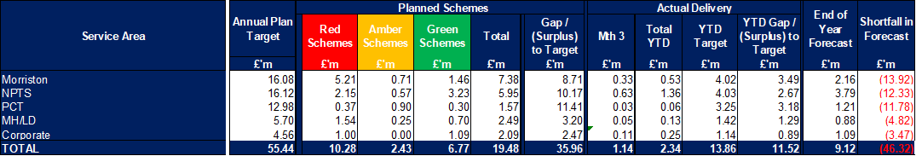

The above table reflects performance In Month and YTD, which clearly shows the shortfall delivery YTD. The forecast column of £9.12m reflects the Green and Amber savings as per the Savings Trackers at 4th July. There is a further £10.3m of planned Red/Pipeline Opportunities the Health Board is working to achieve.

Further details on savings, including the red schemes are provided in Appendix 3.

- GOVERNANCE AND RISK ISSUES
Two Board level financial risks:

Achieving financial plan (HBR92) with the key elements as follows: -

  - Risk of delivery of savings quantum
  - Risk of operational overspend being in excess of funding available agreed via the Financial Plan
  - Risk of commitment of reserves (e.g. NICE) being above reserves available.
  - Risk of achieving the actions and options outlined in the 2025/26 Financial Recovery & Sustainability Assessment.

Based on the financial performance at Month 3 and the shortfall in the identification of the savings required to deliver the deficit plan, it is recommended that the Health Board Corporate Risk Register continues to reflect a risk score of 25.

Schedule of the Risks incorporated within the Financial Assessment submitted to Welsh Government on 30th June, updated for known changes is provided in the table below:

Availability of capital (HBR93). This risk was re-opened in 2022/23 given the reduction in discretionary capital allocation. Due to the additional capital funding provided during 2024/25 the risk score was reduced to 12.

At the start of 2025/26, whilst there has been a 24% increase in discretionary capital, the outcome of the national prioritisation and interim solutions required for high risks projects included the Emergency Department and Adult Acute Mental Health, the assessment is that at this point in the year the risk score needs to increase to 20.

- RECOMMENDATIONS
Members are asked to:
- CONSIDER the 2025/26 Financial Plan, and the Health Board’s and Welsh Government’s inability to approve it given the planned deficit of £58.7m.
- CONSIDER the key messages and required actions regard to Welsh Government and the expectation that the Health Board will deliver a £42.5m deficit in 2025/26 in line with the 2024/25 Outturn.
- Consider and comment upon the Health Board’s financial performance for Month 3 2025/26 and the Year to Date (YTD) position.
- CONSIDER the risks to the position at Month 3.
- SUPPORT the position with regards to Health Board reserves.

Governance and Assurance

Link to Enabling Objectives  (please choose) | Supporting better health and wellbeing by actively promoting and empowering people to live well in resilient communities
Link to Enabling Objectives  (please choose) | Partnerships for Improving Health and Wellbeing |  | ☐
Link to Enabling Objectives  (please choose) | Co-Production and Health Literacy |  | ☐
Link to Enabling Objectives  (please choose) | Digitally Enabled Health and Wellbeing |  | ☐
Link to Enabling Objectives  (please choose) | Deliver better care through excellent health and care services achieving the outcomes that matter most to people
Link to Enabling Objectives  (please choose) | Best Value Outcomes and High Quality Care |  | ☐
Link to Enabling Objectives  (please choose) | Partnerships for Care |  | ☐
Link to Enabling Objectives  (please choose) | Excellent Staff |  | ☐
Link to Enabling Objectives  (please choose) | Digitally Enabled Care |  | ☐
Link to Enabling Objectives  (please choose) | Outstanding Research, Innovation, Education and Learning |  | ☐
Health and Care Standards
(please choose) | Staying Healthy |  | ☐
(please choose) | Safe Care |  | ☐
(please choose) | Effective Care |  | ☐
(please choose) | Dignified Care |  | ☐
(please choose) | Timely Care |  | ☐
(please choose) | Individual Care |  | ☐
(please choose) | Staff and Resources |  | ☐
Quality, Safety and Patient Experience
Financial Governance supports quality, safety, and patient experience

Financial Implications
The Board is reporting a forecast year-end deficit financial outturn.

Legal Implications (including equality and diversity assessment)
No implications

Staffing Implications
No implications

Long Term Implications (including the impact of the Well-being of Future Generations (Wales) Act 2015)
No implications

Report History |  | Updates on the financial position are provided at every meeting.
Appendices |  | Appendix 1 – Variances by Area and Type of Spend  Appendix 2 – Reserves and Central Budgets  Appendix 3 – Savings  Appendix 4 – Accountability Letters
APPENDIX 1 – FURTHER DETAIL ON VARIANCES BY AREA & TYPE OF SPEND

- Overview Financial Position

- Overview of Income

The table below compared the income performance in Month 3 to the average levels of 2023/24 and 2024/25.

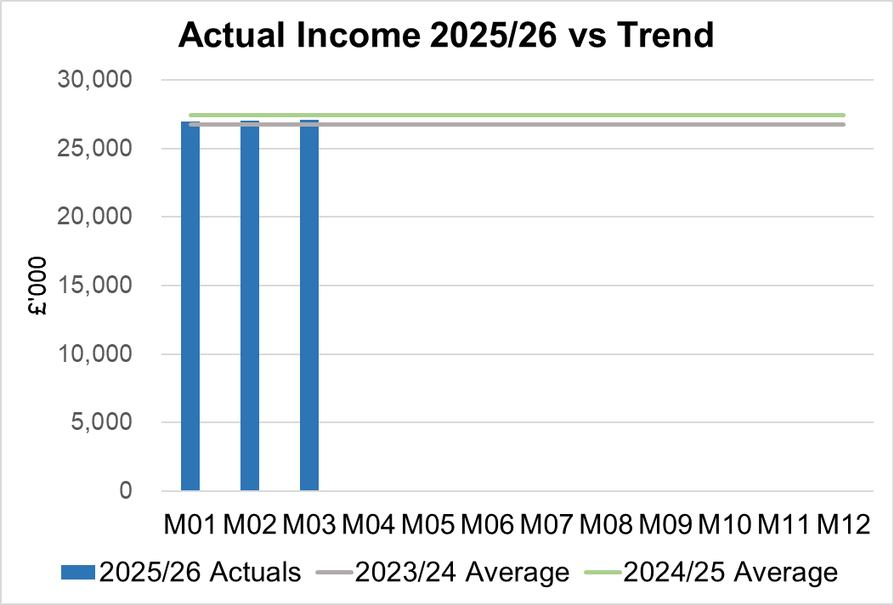

  - Anticipated Income
The below table highlights anticipated income the Health Board expects to receive during 2025/26. The current deficit plan of £58.7m is predicated on receipt of these Welsh Government funds at the levels anticipated. At the point of closing Month 3 the Health Board had not received confirmation of the NI funding. However, it has subsequently been notified of the allocation which is £3.1m less that the assessed cost of the NI changes. This is currently reflected within the Risk table in section 5 of the core report, but will be phased into the financial position from Month 4 onwards..

- Pay, Agency & Other Variable Pay Expenditure

Total Pay

The Month 3 total is higher than the prior two years average (as shown in the graph below). However, the Month 3 total is lower than Month 2 (£0.593m reduction), with vacancies primarily in Admin & Clerical driven by the Vacancy Freeze, predominately within the Corporate Directorates.

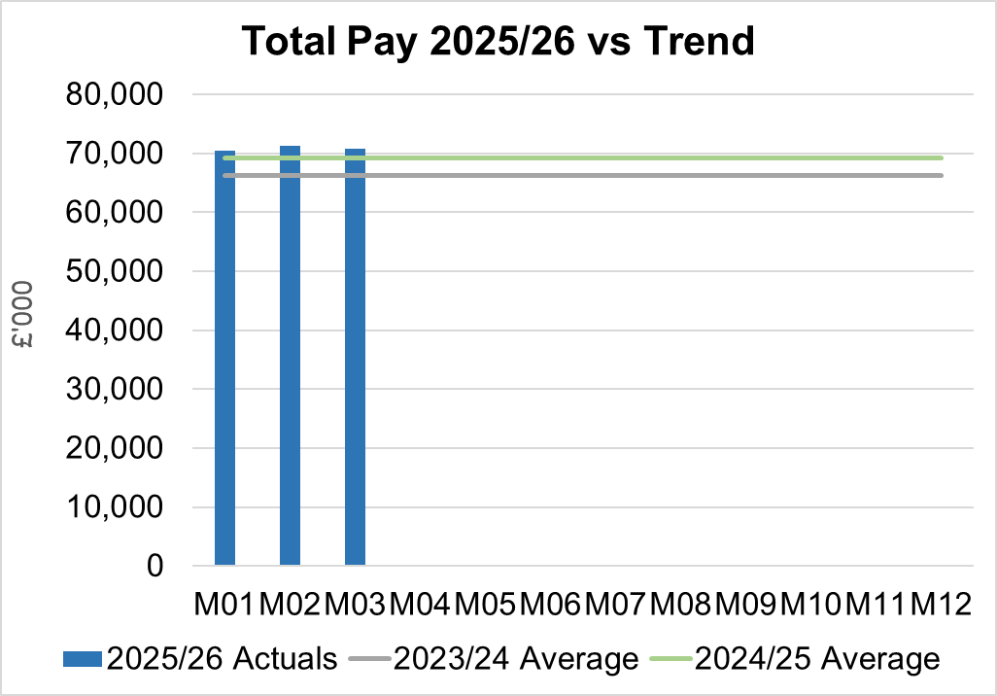
Note - 2023/24 average value has been notional increased by 5% to allow for comparison to 2024/25 and current value of 2025/26 pay value.

Variable Pay

Variable pay is £0.26m lower in Month 3 2025/26 (£5.088m vs £5.347m) when compared to the same period last year (graph below shows this year’s actual versus prior year’s average), it is £0.2m lower than Month 2.

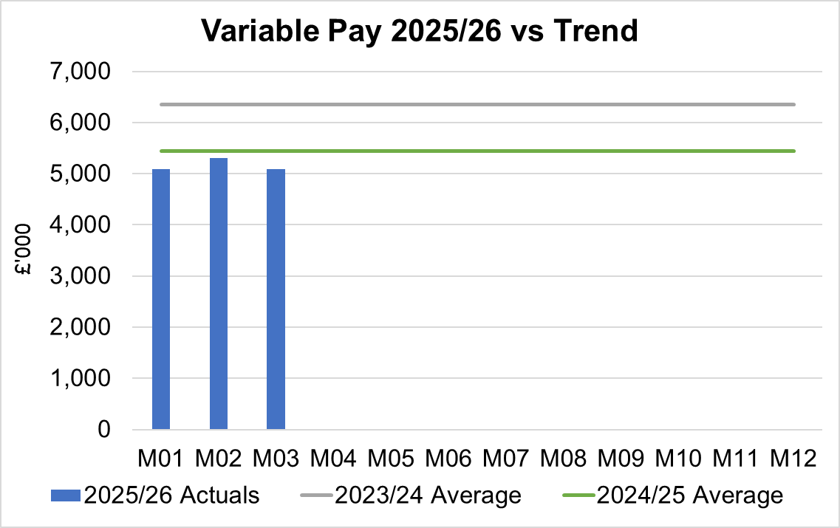

Variable Pay is classified by the Health Board into the following categories: Agency, Bank, Overtime, Waiting List Initiatives (WLI) and Irregular Sessions, a breakdown of the spend into these categorise is provided below.
Variable Pay by Expenditure Type

Performance against the Variable Pay Cap agreed as part of 30th June Financial Assessment is summarised in the table below. As the Health Board did not meet this cap in Month 3 the level of the cap will need to reduce further for the remaining months of the Financial Year, if the level of spend reduction is to be achieved.

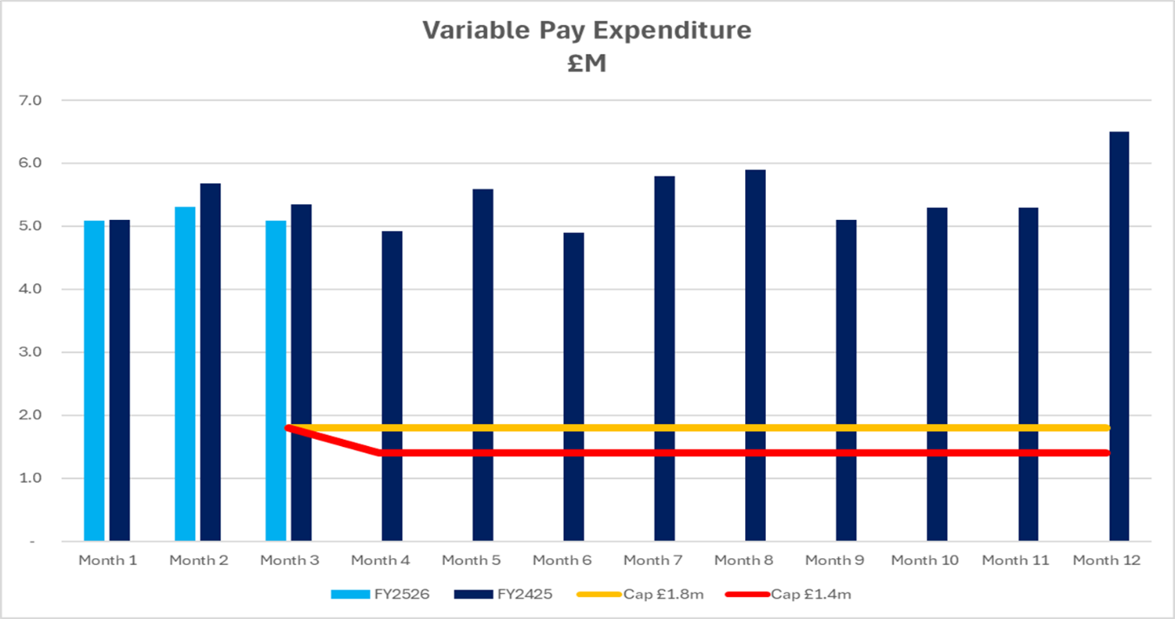

- Overview Non-Pay

Actual Non-Pay expenditure for Month 3 is higher than the prior two year’s average spend (as shown in the graph below):

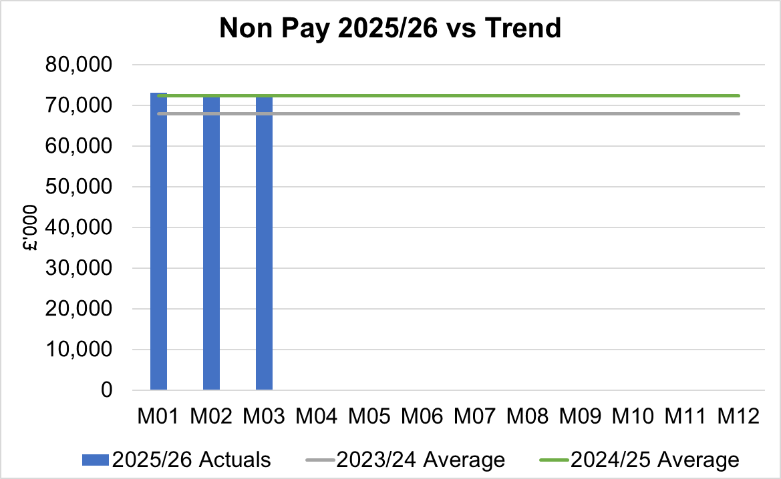

Below are further details on the key areas of non-pay:

  - Clinical Consumables
This area overall has an in-month position of an overspend of £0.4m, partly driven by the increased JCC activity in-month. There are 80+ subjective lines within this category, including secondary care drugs.

  - Primary Care Prescribing
Prescribing is providing a further small underspend in-month resulting in a breakeven position YTD following receipt of the latest datasets (April 2025). It has now been possible to validate the previously Amber scheme in relation to prescribing and YTD delivery has all been recognised in Month 3 (£0.24m in-month).

  - CHC
In Month 3 CHC was overspent by £0.5m (YTD £1.6m) and as per last month is driven by the temporary Adult Mental Health placements with external providers (25 beds in June) due to demand being more than the Health Board’s internal bed capacity. This pressure was partly offset by the Looked After Children position within the PCT Service Group. An analysis of actual expenditure and patient numbers for 2025/26, along with the average values from 2024/25 is provided in table below.

CHC Analysis by Month

Please note:
- The above numbers include Domiciliary care cases.
- PCT Group does not include the Singleton/NPT element. The NPTS element which covers Children and Young People CHC patients is provided internally by the Health Board and as such is part of the wider NPTS position and is not recorded in the ledger as PCT/MH/LD CHC is recorded.

  - Maternity Review
The total costs for this are allocated to a dedicated Cost Centre (6F34). Total expenditure YTD at Month 3 (2025/26) is £0.24m.

  - Z Codes (Section 1,3-4 Table Point 1 Appendix 1)
The narrative below groups together the key elements of the Z codes detailed in Point 1 of this appendix.

- Contracting: SLA /LTA performance: JCC (previously WHSSC), LTA and SLA contract income and expenditure are transacted within this area and financial performance reported. NICE approved high-cost drugs and associated LTAs are also transacted and monitored against targets set. In addition to this, non-contracted activity income in relation to English foundation trusts invoiced on a quarterly basis are reported.

- Capital: The Finance Capital Team manage a number of cost centres covering the PFI, IFRS16 and Depreciation charges for assets both owned and donated are transacted here.

- RRL and Central Reserves: The Welsh Government funding received at the start of the year is tracked within this area. Any anticipated allocations in year are also transacted through these codes. Other HB wide funding received from HEIW and SIFT is also captured in here. All central reserves remain within the Z cost centres and details of these are provided in Appendix 2.

- Corporate income and expenditure. Any income and expenditure that is not service group specific is transacted and reported through a number of corporate Z cost centres, examples include, payroll and pension costs, VAT recovery, losses and receipts in relation to funding from Welsh Risk Pool, overseas visitors’ income and Road Traffic Accident income.

  - LTA Values & Forecast performance
This will be reported from Month 4 as the quarter 1 data was not available at the time of completing this report.

APPENDIX 2 – DETAILS ON RESERVES & CENTRAL BUDGETS

- SUMMARY RESERVES
Overall management of the reserves is as per the Health Board Budget Management document.

  - Balances: Main & NICE
For 2025/26, the Health Board will hold two central reserves and the purpose of these reserves are below:
- Main – this holds funding from Welsh Government or the plan that has yet to be issued to Budget Holders. These items are not surplus but either due to timing have not been issued or is an area where funding is issued based on actual values consumed in future month.
- NICE – this holds the total Health Board funding for all NICE costs (drugs and infrastructure) and is issued to the service each month based on the actual costs consumed as reported through the Pharmacy system.

Details on the balances and movements are provided in the Table below:

- COVID RECOVERY
As part of the Financial Plan Welsh Government Funded £15.2m for Local COVID Recovery and £19.5m for Regional COVID Recovery. The funding remains in Central Reserves and is reported in Main reserves in Section 1 above. This funding is then issued to service areas based on the actual costs committed. A summary of the actuals to date and forecast costs against the original funding total of £34.7m is summarised in the table below:

WG are also issuing additional non-recurrent funding to support the reduction of the 52 week and 104 week target, alongside diagnostic targets. This is in addition to the original Planned Care Recovery £34.7m detailed in the table above. This non-recurrent funding for Planned Care is held in main reserves until the cost are committed at which point funding is issued to the relevant budget line.
APPENDIX 3 – SAVINGS

Neither section below reflects the revised Welsh Government expectation of achieving a deficit of £42.5m, which would require an additional £16.2m of savings or run rate, above current plan.

- Summary of Savings Position as at June 2025 (Month 3)

The below table provides a summary of the achievement against the 5% savings target.

Green and Amber saving schemes acheived in Month 3 were £1.14m, as a result the shortfall of £3.48m against plan was significant and will need to be absorbed in future months if the Health Board is going to achieve its savings target of £55.44m and deficit plan of £58.7m.

- Savings schedule as at June 2025
The below table provides a summary of the planned, actual, and forecast achievement against the 5% savings target (including Red schemes).

The end of year forecast delivery for Green and Amber schemes as per the tracker is currently £9.1m, which is a shortfall of £46.3m against the target of £55.4m. This represents a significant risk to the Health Board’s delivery of the plan.

The Health Board trackers detail a further £10.3m of Red/Pipeline schemes that are being developed to support the achievement of the £55.4m target. Further opportunities need to be identified and delivered at pace to close the gap.

APPENDIX 4 – SUMMARY OF THE REPLIES TO THE ACCOUNTABILITY LETTERS (@10th July 2025)

No: | Name | Date Proforma Returned
 | Ceri Gimblett – NPTS | 13/05/25 – signed proforma + covering letter to CEO / DoF
 | Sue Moore – Morriston | 12/05/25 – no proforma, but a letter to CEO
 | Dermot Nolan – MH&LD | 09/05/25 – proforma signed + narrative added
 | Craige Wilson – PCTSG
 | Hazel Lloyd – Corporate Governance | 28/04/25
 | Deb Lewis – COO | 07/05/25
 | Richard Thomas – DICE
 | Matt John – Digital | 10/06/25
 | Richard Evans – Medical | 30/04/25
 | Liz Rix – Nursing | 28/04/25
 | Gill Richardson – Public Health | 22/05/25 – no proforma, but a letter to CEO
 | Marie Davies – Planning & Partnerships | 27/06/25
 | Tina Ricketts – W&OD | 13/05/25
 | Darren Griffiths – Finance and Estates | 20/04/25
 | Christine Morrell – Allied Health Professions & Health Science | 14/05/25

