

CORPORATE RISK REGISTER
December 2025

Risks allocated to the
Performance & Finance Committee

Datix ID Number: 1763  Date Opened: Apr 2019 |  | Date Last Reviewed: December 2025 |  | HBR Ref Number: 52  Risk Target Date: TBC |  | Current Risk Rating  4 x 3 = 12
Objective: People of Swansea Bay live healthier, fairer and more prosperous lives |  |  | SRR Ref:  1.1 | Director Lead: Richard Thomas, Director of Communications and Engagement  Assuring Committee: Performance & Finance Committee
Risk: Impact Assessment Requirements
The Health Board does not have sufficient skills & resource in place to undertake integrated equality impact assessments in line with strategic service change and policy development.
Risk Rating  (consequence x likelihood):  Inherent: 4 x 4 = 16  Current: 4 x 3 = 12  Target: 4 x 2 = 8 | 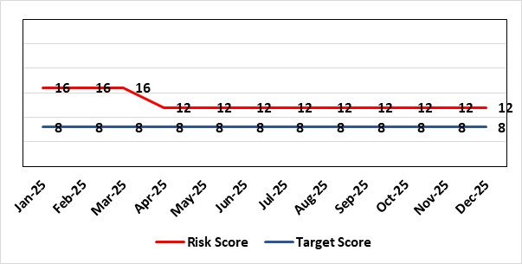 |  |  | Rationale for current score:  - Current lack of required skills / staff to deliver requirements.  - Risk lowered to 12 because new Integrated Impact Assessment process developed and being tested across a range of issues.
Rationale for target score:
- All of these areas need to have adequate resourcing and robust processes / policies in place for the organisation to make robust plans, engage public confidence and meet our statutory and public duties.
Controls (What is currently in place to manage the risk?) |  |  |  | Further Actions (What more are we going to do to address the risk?)
- Robust policies and processes to be in place for Impact Assessment going forward.  - EIA responsibilities incorporated into wider Impact Assessments.  - Development of Strategic Equality Group across organisation to support processes. |  |  |  | Action | Lead |  | Deadline
 |  |  |  | Roll out Impact Assessment process across organisation. Training and integration with planning processes across the organisation will be required. | Assistant Director of Insight, Charity & Engagement & DICE |  | 31/01/2026
Assurances (How do we know if the things we are doing are having an impact?)  Advice on Equality Impact Assessment and then wider Impact Assessments available across organisation supported by robust policies and procedures, overseen by Strategic Equality Group. |  |  |  | Gaps in assurance (What additional assurances should we seek?)  Participation from across organisation in Strategic Equality Group.
Additional Comments / Progress Notes
29/10/2025: Actions in relation to new structure not taken forward at this stage – further discussions required with Chief Executive and Director of W&OD as part of roll out of Organised for Success. Roll out of IIA (Integrated Impact Assessment) training delayed as a result of staff absence within DICE but targeted support being provided to high profile changes where IIAs are required e.g. Gorseinon.

Datix ID Number: 3444  Date Opened: June 2023 |  | Date Last Reviewed: December 2025 |  | HBR Ref Number: 92  Risk Target Date: 31/03/2026 |  | Current Risk Rating  5 x 5 = 25
Objective: The health board is a resilient, sustainable and responsible organisation |  |  | SRR Ref:  5.1 | Director Lead: Darren Griffiths, Director of Finance and Performance  Assuring Committee: Performance & Finance Committee
Risk: Forecast Deficit
Forecast deficit is not met due to (1) insufficient progress on run rate reduction, (2) the saving targets required across all areas are not achieved.
Risk Rating  (consequence x likelihood):  Inherent: 5 x 4 = 20  Current: 5 x 5 = 25  Target: 5 x 1 = 5 | 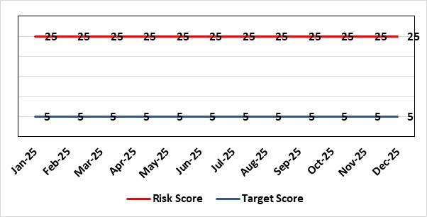 |  |  | Rationale for current score:  - Delivery of the deficit plan is predicated on a combination of savings and run rate reductions  - Consequence is significant as failure to deliver the plan could impact service delivery if cost reduction required later in the year  - A deficit plan is a failure to meet a statutory duty
Rationale for target score:
- The consequence will not change given the important of financial delivery and its relationship with the delivery of the Health Board recovery and sustainability plan
- Reducing likelihood to 1 supports a confidence that the deficit plan will be delivered.
Controls (What is currently in place to manage the risk?) |  |  |  | Further Actions (What more are we going to do to address the risk?)
The Health Board is doing the following:  - Accountability Letters and Budgetary Management Framework were issued to all Directors in April 2025, which set the expectation and budget for 2025/26.  - Introduced in Q3 of 2024/25 the Health Board has put in place further oversight via the Recovery & Sustainability Board, which reported directly to PFC and is chaired by the CEO. This Board is held bi-weekly.  - Supporting the R&S Board is the R&S Team, which for 2025/26 has dedicated resource to lead the programmes of work agreed for 2025/26, of which the Board has agreed on 5 key areas.  - Budgetary Management approach 2025/26 requires all Services Groups to produce a Financial Strategy by end May 2025.  - Continued transparent exchange of position with NHS Executive & Welsh Government, with both weekly and monthly meetings with the NHS Executive.  - Standard Day 5 Finance Reports on Variable Pay, Savings Performance and Flash report published via SharePoint site.  - Variable Pay Cap agreed by the organisation to deliver £32m of savings as set out in the Financial Framework dated 30th June 2025 as well as further enhancements of controls agreed through Q2, Q3 via Recovery & Sustainability Board.  - Strengthening of the Recovery & Sustainability governance and controls aligned to the initial recommendations from work by Deloitte (external partner).  - The Health Board has developed with its strategic external partner (Deloitte) a clear plan to deliver the £55.4m savings required for 2025/26. |  |  |  | Action | Lead |  | Deadline
 |  |  |  | Extension to commissioning of external support (Deloitte), in collaboration with Welsh Government, which commenced on 14th July 2025. Provide further support for core areas of financial delivery for 2025/26 and establishment of a sustainable position into 2026/27. | Director of Finance & Performance |  | 28/02/2026
 |  |  |  | Assessment of the action to address the gap to deliver £58.7m was provided to both Performance & Finance Committee and at a special meeting of the Board in mid-December. Following the agreed actions the Finance Team will provide updates on progress against these as part of the core monthly reporting for the remainder of 2025/26. | Director of Finance & Performance |  | 31/03/2026
Assurances (How do we know if the things we are doing are having an impact?)  The Health Board financial performance is reviewed and monitored through:  - WG Monthly Monitoring Returns and letter signed by CEO and DOF  - Monthly financial performance meetings  - Monthly performance meetings (New 2025/26)  - Performance & Finance Committee  - Independent Member briefings  - Recovery & Sustainability Board  - Routine reporting to Board of most recent monthly position and financial forecasts  - Weekly meetings with the NHS Executive  - Monthly TI Meetings with NHS Executive  - Face to Face meetings with Director Finance for NHS Wales |  |  |  | Gaps in assurance (What additional assurances should we seek?)
Additional Comments / Progress Notes
21/10/2025: First formal feedback from our external strategic partner has been held jointly with the Health Board and Welsh Government, aligned to the deliverables of the contract. Feedback was initially in draft, and work is ongoing to finalise the reports.
03/11/2025: Service Group Directors and Finance Business partners were required to provide robust forecast for 2025/26 and recurrent impact, including savings delivery for Check & Challenge meeting with Director of Finance & Performance on 4 November. This work was put in place to support the wider assessment of the Health Board’s forecast to 31st March 2026. Work has been completed and the gap to deliver £58.7m assessed and presented to Performance & Finance Committee at end November.

Datix ID Number: 3448  Date Opened: June 2024 |  | Risk score reduced from 20  Date Last Reviewed: December 2025 |  | HBR Ref Number: 93  Risk Target Date: 31/03/2026 | Current Risk Rating  4 x 3 = 12
Objective: The health board is a resilient, sustainable and responsible organisation |  |  | SRR Ref:  5.1 | Director Lead: Darren Griffiths, Director of Finance and Performance  Assuring Committee: Performance & Finance Committee
Risk: Reduced Capital Funds
Reduced National NHS funds available for major capital schemes requiring a restricted Capital Plan for 2025/26.
Risk Rating  (consequence x likelihood):  Inherent: 5 x 4 = 20  Current: 4 x 3 = 12  Target: 5 x 1 = 5 | 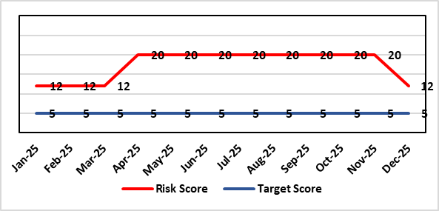 |  |  | Rationale for current score:  - The Health Board has been advised that its discretionary capital allocation for 2025/26 is £13.875m.  - The funding available within the Capital Resource Limit (CRL) will not meet the demands for capital investment. Discretionary capital is deployed to replace ageing medical devices & equipment; to address backlog maintenance of premises; and to support small scale, non-National service improvements with capital investments  - The outcome of the national capital prioritisation exercise means some major capital scheme business cases are on hold. A number of high-risk priority schemes will require funding support from WG, including interim measures for ED and Acute Adult Mental Health In-patients services.  - All assumed income to achieve a balanced plan has now been received from Welsh Government.  - Slippage funding of £4.8m received from Welsh Government in November.  - Additional funding bids £4.4m submitted to Welsh Government 11th December.  - Potential consequences of this risk are the inability to achieve the ambitions set out within health board plans; the potential failure of ageing equipment leading to service disruption; the exposure to potential environmental health & safety risks.  - Following the receipt of additional funding which reduces the immediate in-year pressure on the medical equipment and digital replacement programmes, and with all income risks removed, the risk rating is lowered from 20 to 12.
Rationale for target score:
The target score expresses the aspiration of the health board for addressing this risk. The target date indicated above reflects the point which the current actions are anticipated to reduce the risk, though knowledge of the actual funding available is required to reduce it further and this is not available until some months into the financial year.

Controls (What is currently in place to manage the risk?) | Further Actions (What more are we going to do to address the risk?)
The Health Board is doing the following:  - Regular dialogue with Welsh Government regarding capital requirements.  - Clear communication and reporting of the capital position, the risks and limitations.  - Close management of all schemes to ensure slippage is understood along with the impact on service.  - Clear prioritisation of any new requirements recognising the current constraints | Action | Lead | Deadline
 | Routine review and flexing of plan as spending is committed through the year. Routine monitoring processes will identify any potential slippage and will deploy this on risk-based basis. | Director of Finance & Performance | Monthly through the financial year as plan is dynamic
 | Examine the specific prioritisation and phasing of capital investment to meet health board objectives through the Capital & Estates Taskforce. | Director of Finance & Performance | Bi-Monthly
 | Maintenance of risks through the Capitalisation Prioritisation Group should additional WG funding become available later in the year. | Assistant Director of Finance (Strategy & Planning) | On-going
Assurances (How do we know if the things we are doing are having an impact?)  The Health Board capital position is reviewed and monitored through:  - Quarterly capital prioritisation group  - Performance & Finance Committee quarterly finance report  - Capital & Estates Taskforce  - Capital & Estates Board  - Capital Management Group  - Monthly Monitoring Returns to Welsh Government. | Gaps in assurance (What additional assurances should we seek?)  Reporting on impact of constraints to the capital programme on service delivery.
Additional Comments / Progress Notes
16/10/25: There are new constraints on the national funding position which is putting pressure on the local in-year capital plan. Decisions made on fixing the in-year CRL position on 31st October with WG will need to take account of the new unfunded local pressures.
23/11/25: Risk remains at 20 following Performance & Finance Committee meeting 28/10/25. CRLs fixed with WG 30/10/25. Additional £4.780m in-year funding bids submitted to WG 6/11/25.
17/12/25: Slippage funding of £4.8m received from Welsh Government in November. Following the receipt of additional funding which reduces the immediate in-year pressure on the medical equipment and digital replacement programmes, and with all income risks removed, the risk rating is lowered from 20 to 12.

Datix ID Number: 3516  Date Opened: October 2023 |  | Date Last Reviewed: December 2025 |  | HBR Ref Number: 94  Risk Target Date: TBC |  | Current Risk Rating  4 x 3 = 12
Objective: Care is high quality, safe, efficient, and delivers the best possible outcomes for people in partnerships |  |  | SRR Ref:  2.7 | Director Lead: Deb Lewis, Chief Operating Officer  Assuring Committee: Performance & Finance Committee  For information: Quality & Safety Committee
Risk: CAMHS failure to meet required standards of performance
The CAMHS service is unable to meet the required level of performance due to workforce deficits in the team across all staff groups including medics, psychological therapies and nursing. Data quality review has been completed and new processes are in place to ensure it is accurate.
Links to other CAMHS risk register entries: (Ref: 3373 (ADHD)/ 3346 open / 3350 open)
Risk Rating  (consequence x likelihood):  Inherent: 4 x 5 = 20  Current: 4 x 3 = 12  Target: 3 x 3 = 9 | 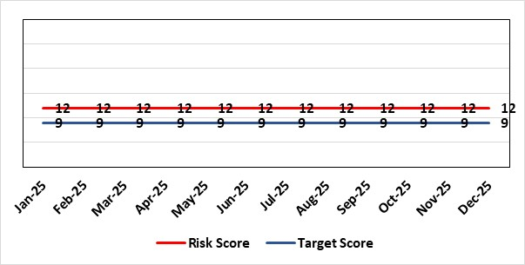 |  |  | Rationale for current score:  Marked improvement in the performance against the Mental health Measure for CAMHS. Data validation for new patients complete. Current risk score 12 in view of improved performance however this reflects the fragility in the workforce to deliver sustained performance. Work is still ongoing within CAMHs to maintain and improves the situation.
Rationale for target score:
The rationale for the target score is linked to successful recruitment and more timely access to services for children and young persons which will reduce risk.
Controls (What is currently in place to manage the risk?) |  |  |  | Further Actions (What more are we going to do to address the risk?)
Ongoing recruitment into nursing and medical staff groups. Psychology and Therapies are fully recruited.  Use of temporary agency workforce in nursing at premium pay rates to sustain current levels of performance  Recent appointment into psychological therapies lead posts.  -Exploring fixed term appt of Band 5 psychological therapies support staff to improve performance. |  |  |  | Action | Lead |  | Deadline
 |  |  |  | Continued efforts at recruitment.  Recovery Plan in place. | Associate Service Director |  | 31/01/2026
Assurances (How do we know if the things we are doing are having an impact?)  As above with controls.  -Monthly CAMHS Directorate meeting in place where performance and workforce are scrutinised  -Reporting into Weekly Business Team and MH & LD management board.  - Mental Health Division Quarterly Performance Review  -Reporting into SBU Performance & Finance Committee and IQPD (Integrated Quality & Performance Delivery) meeting with Welsh Government |  |  |  | Gaps in assurance (What additional assurances should we seek?)
Additional Comments / Progress Notes
11/12/2025
CAMHS 1a: remains generally consistent.
CAMHS Part 1B:
Recruitment to vacancies has been successful, however additional vacancies and maternity leave weakens the capacity pool to almost pre-recruitment levels
Despite this, the recovery plan roll out is underway, which includes changes to the delivery of the initial therapeutic offer for 1:1 intervention, which enables young people to commence support more quickly.
This has resulted in 3 months of small, but consistent improvement in the Part 1B performance irrespective of staffing challenges, which is now at 66% (Submitted for Nov 2025)
Weekly meetings continue over booking and utilisation of capacity and using our staffing resource as flexibly as possible

Datix ID Number: 3571  Date Opened: October 2023 |  | Date Last Reviewed: December 2025 |  | HBR Ref Number: 96  Target Date: 31/03/2026 |  | Current Risk Rating  4 x 5 = 20
Objective: The health board is a resilient, financially sustainable and responsible organisation |  |  | SRR Ref:  5.1 | Director Lead: Marie Davies, Executive Director of Planning & Partnerships  Assuring Committee: Performance & Finance Committee
Risk: Failure to Develop an Approvable IMTP (statutory compliance)
If we fail to have an approvable Integrated Medium-Term Plan (IMTP) for 2026/27 then we will not meet our statutory duty to break even and may lose public confidence.
Risk Rating  (consequence x likelihood):  Initial: 4 x 5 = 20  Current: 4 x 5 = 20  Target: 4 x 2 = 8 | 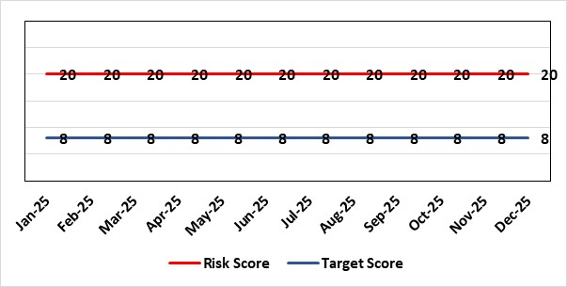 |  |  | Rationale for current score:  The Health Board does not have a WG approved IMTP and has been placed in enhanced monitoring for Finance, Strategy and Planning following the inability of the Health Board to submit a balanced IMTP since March 2023. Given the All-Wales financial context, the Health Board was not able to submit an IMTP in March 2025. It has instead developed an Annual Plan 25/26 set in a three-year context.
Rationale for target score:
The target remains to develop a financially balanced IMTP so that we meet our statutory duties.
Controls (What are we currently doing about the risk?) |  |  |  | Mitigating actions (What more should we do?)
- As per the Welsh Government de-escalation criteria for Strategy and Planning, work has commenced to update and realign the Health Board’s strategy and clinical services strategic plan.  - As per the Welsh Government de-escalation criteria for Strategy and Planning, work has been undertaken to assess the Health Board against the planning maturity matrix and develop an action plan in response. This will be reported via the Board Planning & Partnerships formal report.  - The Recovery and Sustainability Board monitors delivery of agreed actions in relation to the financial position.  - The Annual Plan Oversight Group has been superseded by the Integrated Planning and Performance Review Meeting which takes on a quarterly basis and is chaired by the CEO with the purpose of providing formal management oversight to the delivery of the Annual Plan, and to act as a forum for future planning discussions.  - Plan development will continue to be subject to robust challenge and scrutiny through regular briefings to Independent Members, Performance and Finance Committee (now meeting twice a month, once informally and once formally) and with detailed oversight from the Board itself. |  |  |  | Action | Lead |  | Deadline
 |  |  |  | Refresh Clinical Services Strategic Plan | Executive Director of Planning & Partnerships/ Medical Director |  | 31/03/2026
 |  |  |  | Recovery and Sustainability Board to continue to focus on savings delivery and now shift to a more sustainable approaches in the longer term.  A new monthly performance review regime and Executive Team members to oversee thematic savings workstreams and support Service Groups to meet targets. | Executive Director of Finance and Performance |  | 31/03/2026
Assurances (How do we know if the things we are doing are having an impact?)  Progress against the delivery of the plan will be scrutinised through strengthened governance supported by a new performance management and accountability framework. |  |  |  | Gaps in assurance (What additional assurances should we seek?)
Additional Comments / Progress Notes
17/12/2025: Register entry reviewed & updated.

Datix ID Number: TBC  Date Opened: October 2025 |  | Date Last Reviewed: December 2025 |  | HBR Ref Number: 106  Target Date: TBC |  | Current Risk Rating:  4 x 5 = 20
Objective: The health board is a resilient, sustainable and responsible organisation |  |  | SRR Ref:  N/A | Director Lead: Marie Davies, Director of Planning & Partnerships  Assuring Committee: Performance & Finance Committee
Risk: Emissions Reduction
If we do not identify funding and implement appropriate actions effectively and in a timely way, there is a risk that we will not deliver the emissions reduction targets of 16% by 2025 and 34% by 2030 as determined in the NHS Wales Decarbonisation Strategic Delivery Plan (DSDP 2021). This could result in failure to achieve Health Board targets, undermine achievement of national targets, and expose the Health Board to potential reputational damage in the eyes of Welsh Government and the wider public.
Risk Rating  (consequence x likelihood):  Inherent: 4 x 5 = 20  Current: 4 x 5 = 20  Target: 4 x 3 = 12 | 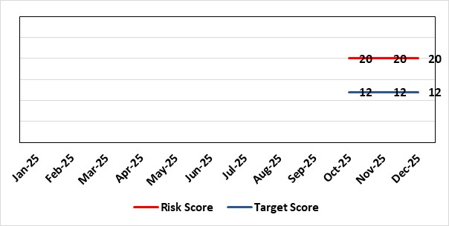 |  |  | Rationale for current score:  Consequence: 4 – based on Governance and Assurance domain outcome of: Low performance rating (low confidence of external stakeholders and Welsh Government connected to potential delay slippage/delay in delivery of targets)  Likelihood: 5 – We are expecting to miss first targets.
Rationale for target score:
Likelhood: 3 - Reduced likelihood of low performance rating through actions taken and engagement with stakeholders nationally.
Controls (What is currently in place to manage the risk?) |  |  |  | Further Actions (What more are we going to do to address the risk?)
- Board leadership is provided by the Executive Director of Planning and Partnerships. There is a supporting governance structure in place.  - There is a Climate Action Plan (CAP) 2024-26.  - A Climate Action Plan Implementation Group manages the delivery of improvement actions, reporting to the Swansea Bay Steering Group prior to Management Board.  - Measures required to achieve emissions reduction objectives are integrated into other strategies and plans, including: Estates Strategy; IMTP; Quality Strategy; Sustainable Travel Strategy; Healthy & Sustainable Catering Strategy; Value Based Healthcare, People Strategy; Population Health Strategy  - Climate change & decarbonisation is a component part of the prioritisation for Capital Projects across NHS Wales organisations.  - Health Board takes part of the wider Welsh Government Health and Social Care Climate Emergency Programme governance through membership and participation on:  - Buildings, Estates, Land Use Planning Programme Board  - Transport and Procurement Programme Board  - Approach to Healthcare Programme Board  - Adaptation Programme Board  - Community of Experts  - Adaptation Accelerator Programme  - DSDP Refresh Working Group  - The Health Board has contracted three ‘Sustainability Clinical Leads’ including an ED (Emergency Department) Consultant, a Consultant Anaesthetist, and NAU (Neurology Ambulatory Unit) Manager. They are driving sustainable healthcare work in the health board including Green ED, Greener Theatres, Green Group and other initiatives as well as wider NHS Wales and Royal College networks.  - Participation on the Public Services Boards in Swansea and Neath Port Talbot sharing best practice and investigating opportunities for collaboration. |  |  |  | NHS Wales Shared Services Partnership led: Working with suppliers on carbon reduction plans. NWSSP require any contract over £5 million have a Carbon Reduction Plan, that can then provide a more accurate emissions factor supporting calculation. Furthermore, there is a Health Board responsibility not to over purchase items and ensure stock is utilised prior to reorder to remove any waste/expiry of dates. | Director of Planning & Partnerships  (SRO, but action led by NWSSP) |  | Ongoing
 |  |  |  | Appropriate lead within the CAP will meet with potential funders and partners, and ongoing sourcing of funding / collaboration opportunities identified. | Director of Planning & Partnerships |  | Ongoing
 |  |  |  | A Revised national DSDP is expected to be published in September 2025. The Health Board will be able to re-assess its position and alignment with refresh of the CAP which is being undertaken concurrently. | Director of Planning & Partnerships |  | 31/03/2026
Assurances (How do we know if the things we are doing are having an impact? |  |  |  | Gaps in assurance (What additional assurances should we seek?)
- Annual carbon emissions data: This is reported to Welsh government annually, based on a financial year. There are three emissions measures reported. The Health Board has some success in meeting the target for Scope 1 and 2 emissions, but the scope 3 emissions are off target. See Additional Comments at foot of this template for definition of measures and performance figures.  - CAP Delivery Plan & RAID (Risks Actions Issues & Decisions) log: Implementation of the CAP is reviewed and updated monthly and received at Climate Action Plan Implementation group. CAP actions are on track.  - DSDP Delivery Plan & RAID log: Implementation of the DSDP is reviewed and updated monthly and received at Climate Action Plan Implementation group. DSDP elements are amber/red due to external constraints, particularly around funding.  - DCR reporting and benchmarking: Bi-annual reporting (Q1/2 and Q3/4) on DSDP-only actions is benchmarked against other NHS Wales Organisations, comparing progress, risks, and issues. This is not currently comparable due to differences in interpretation of the RAG system.  - Benchmarking: An annual review is undertaken within SBU against progress in the wider health sector and other relevant developments in sustainability and climate related work. This highlights that the Health Board is aware of work, but it can be hard to replicate. This will be partially addressed through the established Sustainable Healthcare Working, led by the Deputy Medical Director.  - Annual CAP reporting: Progress report and assurance to Welsh Government around local Health Board actions as detailed in the CAP being undertaken in addition to those in the DSDP.  - NWSSP internal audit review: Audit conducted for period Sep-23 to Apr-24 reported Limited assurance due to Welsh Government not having any dedicated funding stream. This risk has been continuously reflected in the DCR reporting process to WG. In addition, periodic updates are provided internally to the Head of Compliance which informs reporting to Audit Committee. |  |  |  | - Source of emissions: The Health Board has made significant reductions on the emissions from the Estates with the RE:Fit programme and development of the solar farm powering Morriston Hospital. However, most Health Board emissions are indirect, predominantly from the Supply Chain, and harder to reduce.  - Funding stream: The SBU Climate Action Plan (CAP) has been developed to be achievable cost neutrally.  However, the NHS Wales Decarbonisation Strategic Delivery Plan (DSDP), published in 2021, was developed by the Carbon Trust and directly targets emissions from buildings. However, suitable resource to implement the actions was not provided by Welsh Government or NHS Wales to support delivery of the plan. There is an expectation that additional funding be absorbed into Health Board financial plans. This is not feasible, recognising decarbonising buildings costs more than £60 million.  - Funding stream: The SBU Climate Action Plan (CAP) has been developed to be achievable cost neutrally.  However, the NHS Wales Decarbonisation Strategic Delivery Plan (DSDP), published in 2021, was developed by the Carbon Trust and directly targets emissions from buildings. However, suitable resource to implement the actions was not provided by Welsh Government or NHS Wales to support delivery of the plan. There is an expectation that additional funding be absorbed into Health Board financial plans. This is not feasible, recognising decarbonising buildings costs more than £60 million.
Additional Comments: Targets Explained:
Public Sector Emissions Reporting:
Annual carbon emissions reporting to Welsh Government calculating emissions associated with Health Board Activities (based on financial year).
• Scope 1: Direct emissions from owned or controlled sources including natural gas, fleet, fluorinated gases and anaesthetic gases
• Scope 2: Indirect emissions from the purchase and use of electricity
• Scope 3: All other indirect emissions that occur in the upstream and downstream activities of an organisation this includes supply chain, business travel, commuting, waste, water, and processes associated with electrical distribution and extracting fossil fuels.
Context: Climate Emergency was declared by Welsh Government in 2019, leading to the Net Zero Wales ambition for the Welsh public sector to collectively reach net zero by 2030. In response NHS Wales developed a ‘Decarbonisation Strategic Delivery Plan (DSDP)’ (published in 2021).
The Health Board has some success in meeting the target for Scope 1 and 2 emissions, largely driven by the development of the solar farm and Re:Fit energy efficiency programme managed by Estates. This is despite new categories being added since establishment of the baseline including kerosene, fluorinated gases and anaesthetic gases. A total of 76% of the Health Board’s emissions are part of the supply chain – emissions reductions in this space will be dependent on suppliers actively working on reducing their own emissions and sharing this information with the Health Board. NWSSP is leading on this with all contracts over £5million requiring a carbon reduction plan. In 2023/24 this data (tier 2 / supplier specific) was available for 223 suppliers reducing total emissions by 35,954.54 tCO2e. Supply chain data was also removed where it would be reported by another NHS Wales organisation or wider Welsh Public Sector body.
Annual carbon emissions data is reported to Welsh government annually, based on a financial year. This calculates emissions associated with health board activities (and so reflects outcome of activities aimed at managing risks to delivery). Most recent performance (2023/24) against WG revised 2018/19 baseline is:
Scope |  | 2018/19* (tCO₂e) | 2023/24 (tCO₂e)
1 | Direct emissions from owned or controlled sources incl. natural gas, gas oil, kerosene, fleet, fluorinated gases, anaesthetic gases | 26,123.40 | 21,444.26
2 | Indirect emissions from the purchase/use of electricity incl. grid electricity | 26,123.40 | 21,444.26
3 | All other indirect emissions (up/downstream) incl. supply chain, commuting, business travel, water, waste, well to tank and transmission and distribution (grid) | 110,063.30 | 120,499.95
Total |  | 136,186.70 | 141,944.21
*Readjusted baseline from WG, based on the change in footprint: ABMU to SBU

Progress Notes

Datix ID Number: TBC  Date Opened: October 2025 |  | Date Last Reviewed: December 2025 |  | HBR Ref Number: 107  Target Date: TBC |  | Current Risk Rating:  5 x 4 = 20
Objective: The health board is a resilient, sustainable and responsible organisation |  |  | SRR Ref:  N/A | Director Lead: Marie Davies, Director of Planning & Partnerships  Assuring Committee: Performance & Finance Committee
Risk: Emergency Preparedness, Resilience and Response, (EPRR) and Recovery
If the health board lacks adequate and effective emergency preparedness, planning, response and recovery at both corporate and operational levels, there is a risk that it may not be able to respond and recover promptly, efficiently, or effectively to a major incident, business continuity, or critical incident. This could lead to: Negative impacts on patient care delivery in both acute and non-acute settings; Potential harm or injury to patients and/or staff; Non-compliance with statutory obligations under the Civil Contingencies Act 2004; Legal actions and financial penalties; Reputational damage and diminished public trust.
Risk Rating  (consequence x likelihood):  Inherent: 5 x 5 = 25  Current: 5 x 4 = 20  Target: 4 x 4 = 16 | 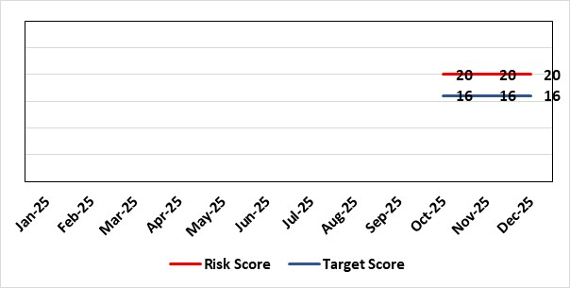 |  |  | Rationale for current score:  The current score is aligned with the Wales Risk and Preparedness Register and reflects the Health Board’s compliance with statutory obligations under the Civil Contingencies Act and NHS Wales EPRR standards. It also considers assurance processes in place, including regular audits, training compliance, and business continuity planning. These controls provide a robust framework for preparedness; however, residual risk remains due to external dependencies, inter-agency coordination challenges, supply chain vulnerabilities, and the evolving nature of threats such as cyber incidents, climate-related events, and public health emergencies.
Rationale for target score:
Achieving the target score will require enhanced compliance with EPRR training, strengthened governance, and fully embedded business continuity arrangements across all critical services. In addition, improved interoperability with partner agencies, robust assurance processes, and investment in risk mitigation measures, such as cyber security, supply chain resilience, utilities and climate adaptation, will further reduce organisational vulnerability. These actions will collectively support effective preparedness, coordinated response, and timely recovery in the event of major incidents or emergencies, aligning with national standards and statutory obligations. The target score also reflects a commitment to continuous improvement through regular exercising and testing of plans, lessons learned from incidents, and ongoing engagement with stakeholders to ensure resilience remains dynamic and responsive to emerging risks.
Controls (What is currently in place to manage the risk?) |  |  |  | Further Actions (What more are we going to do to address the risk?)
- There is an Executive Director nominated as lead for Civil Contingences (the Director of Planning & Partnerships).  - A comprehensive business continuity management (BCM) process is in place, allowing services to assess and manage risks across the five key business continuity (BC) areas (premises, people, service, utilities, and supplies) and implement suitable mitigations. The BC framework serves as a guide for departments to develop their own specific BC procedures.  - An overarching Strategic BC Procedure outlines the management processes, escalation protocols, and response structures to ensure effective command, control, and coordination during a significant disruption. In addition, each Service Delivery Group has an overarching Tactical BC Procedure outlining the tactical management processes, escalation protocols and response structures for effective command and control and coordination.  - A Emergency Preparedness, Resilience, and Response (EPRR) strategy and program is in place to oversee and ensure enhanced assessment, preparedness, prevention, response, and recovery strategies. These aim to ensure there is the capacity and capability to be resilient, prepared and for staff to have the right skills and to have the correct plans to safely and effectively respond and recover from emergencies. This has been shaped by consideration of lessons identified from previous emergency incidents and exercises; the management of shared risks; and the impacts outlined in the EPRR risk and preparedness register.  - The organisation has fully established emergency preparedness, resilience, and response (EPRR) measures, with the EPRR work and training programs aligned to meet Civil Contingency statutory requirements. Oversight is provided by the EPRR Oversight Group.  - A range of emergency response protocols, including a major incident procedure, has been developed. To support, there is a suite of emergency procedures at national and regional levels to address and mitigate national, regional, and local risks as effectively as possible. These risks are identified in the Health Board EPRR Risk and Preparedness register and aligned to National Risk Register, Wales Risk and Preparedness Register, Local Resilience Forum (LRF) Community Risk Register, and respective local authority risk registers.  - The Health Board actively participates in the NHS Executive Health Emergency Planning Advisory group and its sub-groups, which provide a platform for discussing and advancing NHS emergency preparedness and planning policies. Additionally, the HB is involved in the Wales Resilience Partnership Group and South Wales Local Resilience Forum and contributes to various pan-Wales/regional groups. The Health Board works closely with local partners and is a member of both Neath Port Talbot and Swansea Local Authority risk groups.  - The HB EPRR arrangements are aligned to the HB Strategic vision and objectives. EPRR not only helps the HB to comply with the legal requirements but also reinforces the delivery of high-quality, safe, and equitable services, as well as supports the long-term sustainability and resilience of the organisation.  - There is a holistic approach to building, strengthening, and maintaining the EPRR work programme with consideration to leadership and governance (and ensuring these are up to date to ensure clear accountability), training and workforce development, scenario planning and exercises, risk management, community engagement and continuous improvement, including the conduct of regular audits and assurance checks against NHS Wales EPRR standards. This allows delivery of care to be of high quality, efficient, resilient, and adaptable during times of crisis.  - Exercising & Continuous Improvement: Scheduling regular internal training and exercises simulations; capturing lessons identified from incidents and exercises and integration into plans. |  |  |  | Amended: Training & Competency:  ⦁ Ensure full compliance with EPRR training requirements for all relevant staff.  ⦁ Refresher training and scenario-based learning for key roles, | Executive Director of Planning and Partnerships |  | 31/03/2026
 |  |  |  | Amended: Business Continuity Management:  ⦁ Embed and test business continuity plans across all critical services.  ⦁ Ensure plans include critical resilience and alternative arrangements. | Executive Director of Planning and Partnerships |  | 31/03/2026
Assurances (How do we know if the things we are doing are having an impact? |  |  |  | Gaps in assurance (What additional assurances should we seek?)
- The EPRR Strategy Group is responsible for overseeing the strategy and implementation of the EPRR work plan. It operates under the coordination of the corporate Strategy Directorate, with the programme focused on achieving Civil Contingency responsibilities, conducting thorough risk assessments, and facilitating training, exercises, and lessons learned. A digital dashboard is in place to support the monitoring of the EPRR work programme.  - The HB delivers various exercises to test the effectiveness of current arrangements and response procedures and key training programmes. A comprehensive HB training and exercise strategy is established, covering operational, tactical, and strategic response levels.  - Local procedures (including Major Incident and Emergency Response procedures) are regularly reviewed to incorporate the latest UK and national guidance, as well as lessons identified from actual events. Following each live incident, a debrief is conducted, and the findings are documented in the SBUHB lessons identified register.  - As part of the EPRR Work Programme and within the Digital Dashboard, the EPRR Strategy Group monitors and ensures that all business continuity procedures are kept up to date. Identified gaps in business continuity management are taken forward by the respective Service Delivery Group and cross cutting services EPRR  - The EPRR Strategy Group oversees the HB EPRR risk register, which includes the necessary mitigations for consequence management. This informs the EPRR work programme and training and exercising strategy.  - Risks associated with health included in the Wales Risk and Preparedness Register are included on the South Wales Local Resilience Forum Risk Register and the specific health risks are discussed in the Loal Resilience Health Group. This work informs multi-agency, regional resilience, and response arrangements.  - The EPRR Strategy Group currently provides annual updates to the Management Board, with a summary to the Health Board. This includes presenting the Major Incident Procedures, which are reviewed each year, submitting the NHS Executive Annual Report for approval, and offering a comprehensive EPRR update. The update covers challenges, achievements, and other emergency response arrangements.  - The six statutory duties shape the overarching EPRR work programme, with progress monitored through the Digital Dashboard and discussed at the EPRR Strategy Group. Indicator of achievement of 2025/26 objective is: As a Category 1 Responder organisation under the Civil Contingencies Act 2004, HB meets the six statutory duties. Assurance of this is provided through the NHS Executive Annual Report, which is signed by the HB CEO and presented to the Management Board. The report also includes an update on the delivery of the HB EPRR work programme.  - Business Continuity audit report  - Additionally, to support the HB EPRR Training and Exercising Strategy, HB takes every opportunity to participate in national and regional exercises. These exercises are then discussed in the various resilience forums, as mentioned earlier. |  |  |  | - EPRR is a corporate function and must be recognised as a vital, cross-cutting service to ensure EPRR considerations are integrated into all HB operations. Progress is being made in this area, but further work is needed. Service Delivery Groups must designate appropriate managerial resources to take on EPRR responsibilities within their respective services. These individuals should have the necessary seniority to make decisions and drive the required work programme forward. Additionally, EPRR mapping has been undertaken for the HB Strategic vision and objectives evidencing where HB-wide work programmes need to incorporate resilience, with EPRR clearly defined as a critical pillar in supporting these efforts. However, further clarity is needed regarding the specific gaps or challenges hindering the full integration and effectiveness of EPRR within these processes.
Additional Comments / Progress Notes
06/11/2025: Management are looking to Increase general staff awareness of roles & responsibilities in the event of an emergency by mandating the NHS Wales “Introduction to Emergencies” e-learning within the health board.
27/11/2025: Rationales and actions updated.
05/12/2025: Controls and actions sections revised.

Risk Score Calculation

For each risk identified, the LIKELIHOOD & CONSEQUENCE mechanism will be utilised. Essentially this examines each of the risks and attempts to assess the likelihood of the event occurring (PROBABILITY) and the effect it could have on the Health Board (IMPACT). This process ensures that the Health Board will be focusing on those risks which require immediate attention rather than spending time on areas which are, relatively, a lower priority.

