Meeting Date | 27 January 2026 |  | Agenda Item |  |  | 4.1
Name of Meeting | Performance and Finance Committee
Report Title | Capital Resource Plan Update Month 9 and  Draft 2026-27 Capital Resource Plan.
Report Author | Ian MacDonald, Assistant Director of Finance
Report Sponsor | Darren Griffiths, Executive Director of Finance & Performance
Presented by | Ian MacDonald, Assistant Director of Finance
Freedom of Information | Open
Purpose of the Report | To provide an update on the financial performance of the Health Board’s capital programme at month 9 and the impact of emerging risks and opportunities on the projected outturn position for 2025/26.  To present an updated draft 2026/27 Capital Resource Plan for discussion.
Key Issues | The Health Board approved a balanced capital financial plan for 2025/26 as part of the submitted Annual Plan.  The forecast outturn position reported at Month 9 shows an overspend position of £0.140m. Additional income from Welsh Government is anticipated to provide a balanced position. Additional in-year funding from Welsh Government has provided stability to manage additional requests from service. This has allowed the risk of the plan shifting from balance to imbalance to be reduced and is reflected in Risk 93 on the Health Board Risk Register which has been reduced from 20 to 12.  Due to slippage on a small number of major capital projects, additional allocations have been approved to provide a forecast balanced outturn position.  Following the outcome of the national capital prioritisation exercise, the national funding for major projects through the All-Wales Capital Programme remains unclear. A small number of projects have received approval, and some urgent projects have commenced to scope immediate and interim and alternative solutions.  A draft Capital Resource Plan for 2026/27 based on the latest allocations has been developed for discussion. Options are presented to achieve a balanced 2026/27 position, with further work required on plans from the Service Delivery Units.
Specific Action Required  (please choose one only) | Information | Discussion |  | Assurance | Approval
Specific Action Required  (please choose one only) | ☐ | ☐ |  | ☒ | ☐
Recommendations | Members are asked to:  - ACKNOWLEDGE the month 9 reported financial position and forecast outturn.  - ACKNOWLEDGE the additional allocation bids approved by Welsh Government and the reduced risk score on material imbalance.  - SUPPORT and DISCUSS the update on business cases.  - ACKNOWLEDGE the programme contingency has been fully utilised.  - SUPPORT and DISCUSS the draft capital resource plan for 2026/27.

CAPITAL RESOURCE PLAN – Month 9 2025/26

- INTRODUCTION
This report provides an update to the financial performance of the Health Board’s capital programme and the impact of emerging risks and opportunities on the projected outturn position for 2025/26.

- BACKGROUND
The Health Board approved a balanced capital financial plan for 2025/26 as part of the Annual Plan submitted to Welsh Government in March 2025. The plan included an uplift of 24%/£2.7m to £13.875m. It also included income assumptions on the payback of business case fees from Welsh Government and disposals proceeds.

The forecast outturn position reported at month 9 shows an overspend position of £0.140m with anticipated allocations which would provide a balanced out-turn position.

The national funding situation continues to be challenging following the outcome of the national capital prioritisation exercise on major capital projects, with several projects either on hold or working through interim and alternative solutions. As a result of the national funding pressures during September and October, several capital bids were placed on hold and additional bids to reinvest additional VAT recovery into capital projects were rejected.

Following the national fixing of all CRLs (Capital Resource Limit) on 30 October 2025, the in-year national funding position has improved, with additional allocations provided to support the replacement programmes for digital, estates and medical equipment.

Month 9 Position

The forecast outturn position reported at month 9 shows a much-reduced over-commitment of £0.140m from the £2.250m in the last report at month 6. These allocations shown in table 1 & 2 are anticipated to provide a balanced year-end outturn position, with no risk of non-receipt. The monthly monitoring return narrative and CRL are included in Appendix A and B.

Table 1 - Month 9 Forecast Outturn Position (exc IFRS 16) 2025/26

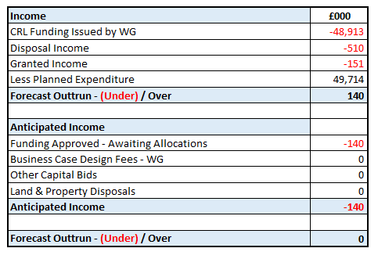
Table 2 - Anticipated Income 2025/26

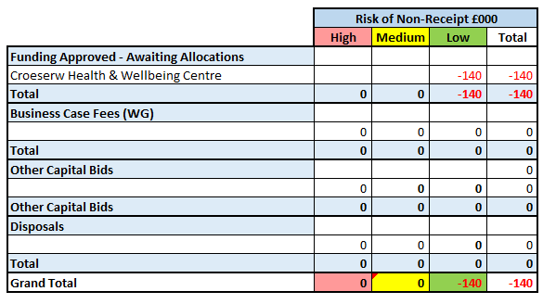

Capital Funding Allocations

There has been a net increase of £9.403m funding received into the CRL since month 6 as detailed in the table below.

Table 3 - Summary Approved Allocations 2025-26 Quarter 3
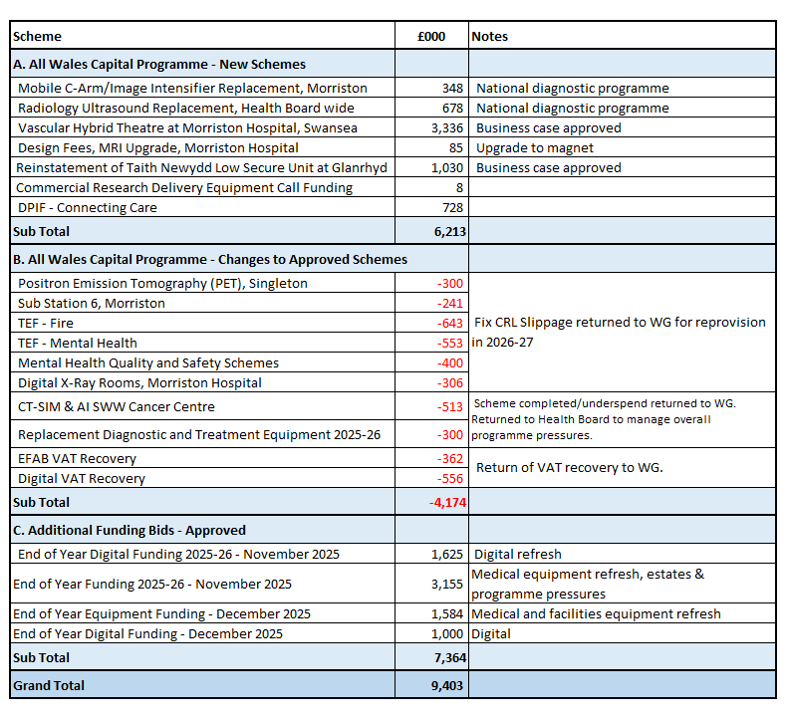

A number of additional allocations for £6.213m (section A) were received for new business cases and national programme funding. The new business cases approved, include funding to commence the build phase of the new Vascular Hybrid Theatre, Morriston and the reinstatement of the fire damaged Taith Low Secure Ward, Glanrhyd.

As part of the usual national fixing of the CRL position on 30th October 2025, £4.174m was returned to Welsh Government (section B). This included slippage of £2.443m on AWCP project to be re-provided by Welsh Government in 2026/27, £0.813m for underspends on completed schemes and £0.918m returned for VAT recovery.

Following the submission of additional funding bids to Welsh Government, an additional £9.403m was allocated in November 2025 and December 2025. Notification has also been received on 8th January 2025 of an additional £1.421m for digital device refresh and medical equipment refresh.

The receipt of this additional £10.8m over the last 2 months will allow a major in-road to be made to the backlog replacement for digital and medical equipment. Whilst the TEF (Targeted Estates Funding) has made a welcome contribution to the backlog estates maintenance, as highlighted in the Capital & Estates Strategy Implementation Update to the November Health Board meeting, significant pressures remain within estates, which will require to be reflected in the 2026/27 discretionary capital plan.

Equipment

The 2025/26 approved discretionary programme, supplemented with the additional WG funding bids has allowed orders to be placed for a number of major medical equipment and digital refresh programmes, including: -

- Anaesthetic Machine replacement, Morriston £1.9m. Phase 1 delivery was received this month and phase 2 is anticipated to be delivered in February.
- Pharmacy £1.160m. Replacement for the Pharmacy Robot, NPT and replacement of the automated medicine stock cabinets. Orders were placed in November, with delivery expected in March.
- Cardiology MacLab System Upgrade £450k. The upgrade was completed in December.
- Local Area Network (LAN) equipment in Morriston Hospital £2.3m. This equipment is the next stage of the Health Board’s network refresh programme; a major technical revamp of the infrastructure moving it to a software defined platform and providing the latest cyber security protections.

Programme Contingency

Due to some unplanned slippage on a small number of major capital projects in the All-Wales Capital Programme (AWCP), additional allocations of £1.2m have been approved this month to mitigate these risks and provide a path to a balanced year-end outturn position. These slippage commitments will be recognised in the 2026-27 Capital Programme.

Update on All Wales Capital Schemes

Following the outcome of the national Capital Prioritisation process for major business cases in January 2025, the Health Board Estates Task Force group has continued to meet. As described in the submitted Annual Plan in March, the focus has been on developing funding solutions for the four urgent risk schemes and developing plans for possible land and property disposals to support the national housing crisis. Work is continuing the four priority schemes, and a detailed update was provided to the last meeting of the Capital & Estates Task Force meeting on 13 January 2026. Appendix C provides the latest updates on the major business cases in the AWCP. The position in summary for the four urgent risk schemes: -

- Adult Acute Mental Health Wards, Morriston.
  - Immediate improvement works at Tawe clinic estimated project outturn £2.9m. A funding and commercial solution are in place, with £1.9m to be provided in the 2026/27 Capital Discretionary Programme. Minor works and Phase 1 works completed. Phase 2 and Phase 3 works due to commence February 2026.

  - Interim and Long-Term Solution. Following presentations at the November Health Board meeting, two meetings have taken place with Welsh Government officials. Initial advice has been received from the PFI Project Company on the proposed Options 4 works at NPT hospital, which make it unlikely the works could proceed. Further discussions with WG officials are scheduled this month.

- Emergency Department Improvements, Morriston. A request for Welsh Government funding support in three priority areas has been to be submitted to Welsh Government.
  - Implement a digital EHR (Electronic Health Record) to support the UEC pathway.
  - Design fees for the refurbishment and reconfiguration of Wards A & B.
  - Design fees to support the production of a SOC (Strategic Outline Case) for a new ED department.

- Regional Cellular Pathology. Following the report on the two off-hospital site options presented to both Health Boards in September, additional technical feasibility work is being undertaken. The work now includes a 3rd viable site option. An options workshop is scheduled for 2nd February, with a decision on the preferred option expected to be submitted to Welsh Government in February following governance by the Joint Regional Committee (JRC) and both Health Boards.

- Taith Newydd Older Persons Ward, Glanrhyd (Fire reinstatement). The business case was approved by Welsh Government in November and works commenced on site on 5th January 2026, with completion following a commissioning period scheduled for February 2027.

Overall Assessment
The forecast outturn position reported at month 9 shows a much-reduced over-commitment of £0.140m, with no risk of non-receipt of the allocations anticipated to provide a balanced year-end outturn position.

Additional in-year funding from the Welsh Government, including £10.8m additional bids, has provided stability to manage additional requests from the service for digital and medical equipment replacement. Significant pressures remain within estates, which will require to be reflected in the 2026/27 discretionary capital plan.

Whilst some unplanned slippage on a small number of major capital projects in the All-Wales Capital Programme (AWCP) has been mitigated with additional discretionary allocations, the Capital Planning and Capital Finance Teams will continue to closely monitor the year-end landing path through the well-established processes to ensure any further slippage is identified and managed as early as possible.

DRAFT 2026-27 CAPITAL RESOURCE PLAN

An initial draft of the 2026/27 Capital Resource Plan, along with indicative allocations for 2027/28 and 2028/29 is included here for discussion. The plan has been developed from the usual sources of information, including contractual commitments, bids through the Capital Prioritisation Group (CPG), and major equipment replacement work programmes including digital and estates. A detailed slide pack is in included in Annex D.

Financial context
The Health Board is aiming for breakeven in 2025/26. Recent in-year allocations of £10.8m from the Welsh Government for medical equipment and digital refresh have significantly eased the in-year pressure on emerging service and infrastructure risks and will allow the 2026-27 plan to start from a more stable base. The ability to respond to national slippage bids has allowed us to pull forward spend of £1m allocated from the 2026-27 discretionary programme for phase 2 of the Anaesthetic Machine replacement programme in Morriston and £1.7m for the upgrade of the LAN (local area network) IT switches in Morriston.

The 2026/27 discretionary plan includes assumptions on the repayment of business case design fees from the Welsh Government.

Further work is required to assess the level of disposal proceeds from the sale of property that may be expected.

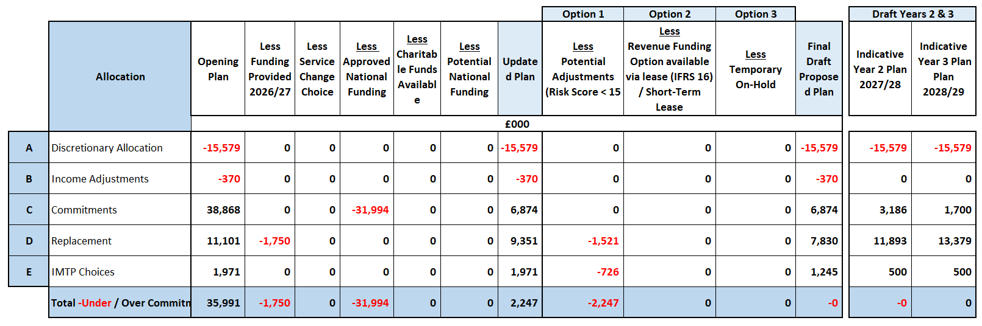

Key financial challenges and opportunities

Significant national capital funding constraints remain following the completion of the national capital prioritisation for major capital projects from the AWCP (All Wales Capital Programme) In January 2025.

The level of discretionary funding has been eroded against inflation and continued growth in the fixed asset base in medical equipment and digital devices, with no national uplift to discretionary allocations since 2010. Following the 2022/23 national reduction in core capital funding of 24%/£100m, the local reduction was fully reinstated in 2024/25. A further 24%/£2.7m increase in 2024/25 has been followed by a further increase in 2026/27 of 12.3%/£1.704m.

Alongside already approved national TEF (Targeted Estates Fund) funding of £8m for major replacement schemes priorities, the focus in 2026/27 for the discretionary programme will require a substantial increase for estates business continuity issues as highlighted by the Capital & Estates Strategy Implementation Update presented to the November Health Board meeting, and a contribution of £1.9m to the Tawe Clinic Adult Acute MH Inpatient Wards Immediate Works at Cefn Coed (recent briefing).

National allocations continue for the Diagnostic Equipment Replacement Programme £15m and Digital Replacement Programme £10m. Bids have already been submitted to these programmes.

The PFI contract for Neath Port Talbot hospital has a fixed £1.261m contribution to the lifecycle replacement programme [note: ends from 2028/29].

Further Work

Further work is required to,
- Assess the level of disposal proceeds from the sale of property that may be expected.
- Estates Infrastructure (Business Continuity) risks. It is likely that further risks will be identified/funding required, although this is unlikely to be deliverable without increases to the estates workforce and provision of decant facilities.
- Design fee funding
- Review of the annual plan priorities.
- Review and prioritisation of the 10-year capital plan for major capital schemes requiring funding through the All-Wales Capital Programme (AWCP).
Summary

An increased discretionary funding allocation, alongside significant additional capital bid funding from the Welsh Government in both 2024/25 & 2025/26 provide a much healthier outlook for the capital programme. However there remains a significant challenge in maintaining the existing building & engineering estate. A significant increase to Estates Infrastructure (Business Continuity) is required, alongside allocations for design fees.

- GOVERNANCE AND RISK ISSUES
The additional in-year funding from the Welsh Government has provided stability to manage additional requests from service. This has allowed the risk of the plan shifting from balance to imbalance to be reduced and is reflected in Risk 93 on the Health Board Risk Register which has been reduced from 20 to 12.

New service requests, including those with a high-risk score will continue to be assessed through the Capital Prioritisation Group.

- FINANCIAL IMPLICATIONS
The financial implications and funding risks are as detailed within the body of the report. In summary, the approved balanced capital plan is assuming additional funding of £0.140m to deliver a balanced outturn position. The remaining contingency in the plan has been fully utilised.

A draft Capital Resource Plan for 2026/27 based on the latest allocations has been developed for discussion. Options are presented to achieve a balanced 2026/27 position, with further work required on plans from the Service Delivery Units.

- RECOMMENDATIONS
Members are asked to:
- ACKNOWLEDGE the month 9 reported financial position and forecast outturn.
- ACKNOWLEDGE the additional allocation bids approved by Welsh Government and the reduced risk score on material imbalance.
- SUPPORT and DISCUSS the update on business cases.
- ACKNOWLEDGE the programme contingency has been fully utilised.
- SUPPORT and DISCUSS the draft capital resource plan for 2026/27.

Governance and Assurance

Link to Enabling Objectives  (please choose) | Supporting better health and wellbeing by actively promoting and empowering people to live well in resilient communities
Link to Enabling Objectives  (please choose) | Partnerships for Improving Health and Wellbeing |  | ☐
Link to Enabling Objectives  (please choose) | Co-Production and Health Literacy |  | ☐
Link to Enabling Objectives  (please choose) | Digitally Enabled Health and Wellbeing |  | ☐
Link to Enabling Objectives  (please choose) | Deliver better care through excellent health and care services achieving the outcomes that matter most to people
Link to Enabling Objectives  (please choose) | Best Value Outcomes and High-Quality Care |  | ☐
Link to Enabling Objectives  (please choose) | Partnerships for Care |  | ☐
Link to Enabling Objectives  (please choose) | Excellent Staff |  | ☐
Link to Enabling Objectives  (please choose) | Digitally Enabled Care |  | ☐
Link to Enabling Objectives  (please choose) | Outstanding Research, Innovation, Education and Learning |  | ☐
Health and Care Standards
(please choose) | Staying Healthy |  | ☐
(please choose) | Safe Care |  | ☐
(please choose) | Effective Care |  | ☐
(please choose) | Dignified Care |  | ☐
(please choose) | Timely Care |  | ☐
(please choose) | Individual Care |  | ☐
(please choose) | Staff and Resources |  | ☐
Quality, Safety and Patient Experience
Further requests for capital funding will not be affordable within the allocated resources. This may impact on new service requests for additional capital funding for estates, medical equipping and digital services.

Financial Implications
The financial implications and funding risks are as detailed within the body of the report. In summary, the approved balanced capital plan is assuming additional funding of £0.140m to deliver a balanced outturn position. The remaining contingency in the plan has been fully utilised.

Legal Implications (including equality and diversity assessment)
None
Staffing Implications
None
Long Term Implications (including the impact of the Well-being of Future Generations (Wales) Act 2015)
n/a
Report History |  | Month 6 position, Management Board 17 December 2025 (as November meeting cancelled)  Month 6 position, Performance & Finance Committee 28 October 2025
Appendices |  | Appendix 1 WG Monitoring Return Capital M9 2025-26  Appendix 2 Capital Board Report and CRL M9 2025-26  Appendix 3 Capital & Estate Taskforce Presentation 13/1/2026  Appendix 4 Draft 2026-27 Capital Resource Plan

