Meeting Date | 27 January 2026 |  | Agenda Item |  |  | 2.2
Name of Meeting | Performance and Finance Committee
Report Title | Monthly Recovery and Sustainability Update
Report Author | Deborah Longman – Head of Recovery and Sustainability  Samantha Moss – Deputy Director of Finance
Report Sponsor | Darren Griffiths, Executive Director of Finance and Performance
Presented by | Darren Griffiths, Executive Director of Finance and Performance
Freedom of Information | Open
Purpose of the Report | The report is provided to update the committee on the current actions and work in progress of the Recovery & Sustainability Board.
Key Issues | The report invites the Performance & Finance Committee to note the work undertaken by the Recovery & Sustainability programme, overseen by the Recovery & Sustainability Board.  The report includes an overview of the key actions arising from the latest Recovery & Sustainability Board as well as an update on the thematic programmes and details on the 26/27 planning process. It also provides high level information on the delivery regarding the Health Board savings.
Specific Action Required  (please choose one only) | Information | Discussion |  | Assurance | Approval
Specific Action Required  (please choose one only) | ☐ | ☐ |  | ☒ | ☐
Recommendations | Members are asked to: -  - ACKNOWLEDGE the updated report for ASSURANCE of ongoing delivery associated with the Recovery and Sustainability Programme
MONTHLY RECOVERY & SUSTAINABILITY PROGRAMME UPDATE

- PURPOSE
The paper provides the monthly formal update to the committee regarding the actions and progress within the Recovery and Sustainability (R&S) programme.

- INTRODUCTION
Phase 2 of the external strategic support commissioned by the Health Board in collaboration with the Welsh Government commenced on 9 October 2025 and is scheduled to end on the 28 February 2026. Part of the remit of this phase 2 work has been to support the 26/27 planning process to ensure a focus on financial recovery, aligned to thematic executive led workstreams.

A summary of the Phase 1 work from Deloitte’s is being produced for 26 January, and updates on this will be included in future reports.

- UPDATE R&S PROGRAMME

  - R&S Board 14 January 2026
The board focussed on the Executive Led Thematic updates and the Month 9 financial position, which is provided in a separate report. There were also additional items looking at the financial allocation for 2026/27 and a Gateway process for approving savings schemes for the 2026/27 annual plan.

Key points included:
- A gateway based assurance process has been established to control progression of 2026/27 savings schemes.
- As part of the 2026/27 savings process a “Plan on a Page” exercise will provide a comprehensive long list of savings opportunities across all expenditure areas, including potential service and capacity changes, building on the thematic approach from 2025/26. Initial Plan on a Page are due for submission on 21 January 2026.
- Approved schemes will undergo full development in February 2026, including impact assessments, risk and dependency analysis, and detailed, phased financial delivery plans.
Thematic progress reports were provided:
Workforce overarching
- Variable pay in non-clinical areas shows a downward trend, but reductions are not yet at the required level, with further strengthening of workforce governance and oversight needed.
- Ongoing reliance on overtime in some services remains a key risk, compounded by system limitations in accurately capturing all overtime, requiring improved controls and reporting.
- The Variable Pay Steering Group is providing increased assurance through targeted deep dives and clearer accountability, with further measures in development to support sustained reduction.
Workforce – Nursing
- HCSW vacancies (315 WTE) and exceptionally high sickness and roster unavailability are the primary constraints, significantly limiting further reductions without decisions on vacancy release, service deescalation and escalation capacity.
- Work is progressing through the workforce board to rebase establishments, improve roster efficiency and set trajectories; however, further reduction is contingent on organisational decisions beyond nursing and midwifery control.
Workforce – Medical
- Medical variable pay and ADH spend continue to reduce with average of £647k versus a £766k baseline, although agency spend remains static at circa £0.5m and represents a key residual risk.
- Work continues to strengthen breach identification, return to work compliance and valuation of breaches, alongside further analysis of vacancy management to identify opportunities to reduce variable and agency spend.
CHC and Complex Care
- Work is progressing on a joint funding matrix to improve transparency, consistency and pace of Continuing Healthcare (CHC) and joint funding decisions, reduce disputes (including Section 117 cases), and support more effective partnership working.
- A deep dive session is scheduled for 4 February 2026 to ensure executive visibility of complexity, financial impact and strategic options ahead of further decisions.

Urgent and Emergency Care (UEC)
- The planned transfer of 30 patients from Morriston to Ward 4 took place as planned. With the plan to close Acute Medical Unit (AMU) surge capacity by the end of January 2026, with further work required to quantify the financial impact for February–March.
- The key opportunity sits within Pathway 2, supported by audit work and Deloitte analysis, with scenarios in development to assess capacity, workforce configuration and cost releasing redesign.
Procurement
- The £3.4m cash releasing non pay savings target has been exceeded, with an additional £1m delivered.

- Further savings have been constrained by inflationary pressures (National Living Wage, National Insurance) and limited scope for contract cost reductions.

- A new regional role has been established to maximise regional savings via NWSSP Procurement.
Planned Care
- Strong progress has been made on theatre productivity, supported by a Deloitte developed toolkit, improving operational and clinical engagement and embedded change management, with delivery plans in place and the focus now on execution and realisation of savings.
  - Savings Delivery and £55.4m
On 7 January 2026 progress against the £55.4m target aligned to the 11 September plan is summarised in the table below. Full details on the savings performance can be found in Agenda item 2.2 on the Month 9 financial position.

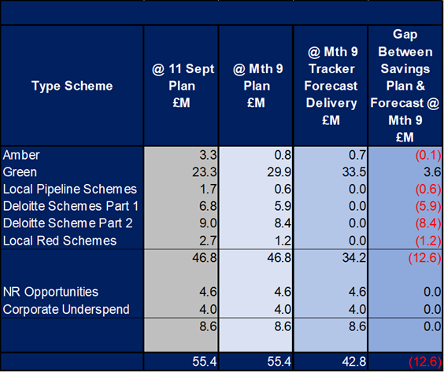

- GOVERNANCE AND RISK ISSUES
The work summarised in section 3.2 provides the Heath Board with a line of sight to £55.4m savings required, which addresses the plan submitted on 31 March 2025. From the 11 September paper and submission to the Welsh Government, which provided plans with a combined savings value of £55.4m, work must ensure this delivers in full. The 11 September, and subsequent monthly financial position papers (Agenda item 2.2) also incorporate the full level of financial risks both national and local, and any further actions required to address the shortfall in savings delivery for 2025/26.

- FINANCIAL IMPLICATIONS
The financial implications of this report are set out within it.

- RECOMMENDATION
Members are asked to:
- ACKNOWLEDGE the updated report for ASSURANCE of ongoing delivery associated with the Recovery and Sustainability Board.

Governance and Assurance

Link to Enabling Objectives  (please choose) | Supporting better health and wellbeing by actively promoting and empowering people to live well in resilient communities
Link to Enabling Objectives  (please choose) | Partnerships for Improving Health and Wellbeing |  | ☐
Link to Enabling Objectives  (please choose) | Co-Production and Health Literacy |  | ☐
Link to Enabling Objectives  (please choose) | Digitally Enabled Health and Wellbeing |  | ☐
Link to Enabling Objectives  (please choose) | Deliver better care through excellent health and care services achieving the outcomes that matter most to people
Link to Enabling Objectives  (please choose) | Best Value Outcomes and High-Quality Care |  | ☒
Link to Enabling Objectives  (please choose) | Partnerships for Care |  | ☐
Link to Enabling Objectives  (please choose) | Excellent Staff |  | ☐
Link to Enabling Objectives  (please choose) | Digitally Enabled Care |  | ☐
Link to Enabling Objectives  (please choose) | Outstanding Research, Innovation, Education and Learning |  | ☐
Health and Care Standards
(please choose) | Staying Healthy |  | ☐
(please choose) | Safe Care |  | ☒
(please choose) | Effective Care |  | ☒
(please choose) | Dignified Care |  | ☐
(please choose) | Timely Care |  | ☒
(please choose) | Individual Care |  | ☒
(please choose) | Staff and Resources |  | ☒
Quality, Safety and Patient Experience
No Implications
Financial Implications
No Implications
Legal Implications (including equality and diversity assessment)
No Implications
Staffing Implications
No Direct Implications
Long Term Implications (including the impact of the Well-being of Future Generations (Wales) Act 2015)
No Implications

Report History |  | Routine report to Performance and Finance Committee
Appendices |  | None.

