Meeting Date | 27 January 2026 |  | Agenda Item |  |  | 2.2
Name of Meeting | Performance & Finance Committee
Report Title | Financial Report – Month 9 2025/26
Report Author | Samantha Moss, Deputy Director of Finance  Gemma Pearson, Finance Business Partner  Crystal Davies, Principal Finance Manager
Report Sponsor | Darren Griffiths, Executive Director of Finance and Performance
Presented by | Samantha Moss, Deputy Director of Finance
Freedom of Information | Open
Purpose of the Report | The report advises the Performance & Finance Committee of the Health Board on the financial position for Month 9 2025/26 (December 2025) and risks regarding the current forecast revenue year end outturn.
Key Issues | The report invites the Performance & Finance Committee to note the detailed analysis of the financial position for Month 9 2025/26 (December 2025).  The report includes a summary of the key drivers of the position either at Service level or by expenditure type (i.e. Non-Pay/Pay). It also provides information of the current position with regards to Health Board reserves to ensure transparency in the overall Health Board position.  Risk will have been considered on the basis of the information provided within the report and the score updated where necessary.  Whilst the key messages are provided within the main body of the report, further information is provided in the Appendices.
Specific Action Required  (please choose one only) | Information | Discussion |  | Assurance | Approval
Specific Action Required  (please choose one only) | ☐ | ☐ |  | ☒ | ☐
Recommendations | Members are asked to: -  - CONSIDER the 2025/26 Financial Plan, and the Health Board’s and Welsh Government’s inability to approve it given the planned deficit of £58.7m.  - CONSIDER the actions in place with regards to Welsh Government’s expectation that the Health Board delivers the £55.4m savings to support the delivery of the 2025/26 Financial Plan.  - Consider and comment upon the Health Board’s financial performance for Month 9 2025/26 and the Year to Date (YTD) position.  - CONSIDER the risks to the position at Month 9.  - SUPPORT the position with regards to Health Board reserves.

FINANCIAL REPORT – MONTH 9 2025/26

- INTRODUCTION
The Annual Plan submitted to Welsh Government on 31 March 2025 included a financial assessment, as summarised in the table below:
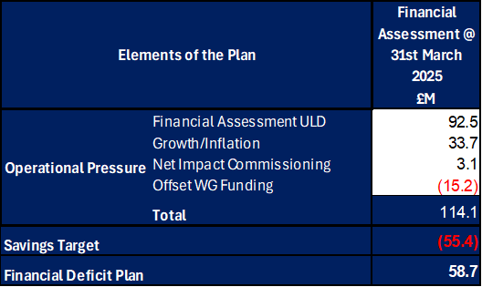

The Welsh Government issued a letter to the Health Board on 6 June 2025 indicating that the planning process has been closed in order to focus on delivery and improvement. The Welsh Government issued a further letter on 18 August requesting an update on the Annual Financial Plan and actions being taken by the Health Board for submission by 11 September. This document was presented at the Special Board Meeting on the 11 September which provided full details of the actions and milestones to achieve the original £55.4m savings to support the delivery of the original plan submission made in March 2025. Progress against this Plan is detailed in sections below. Therefore, at Month 9 the forecast for 2025/26 remains as per the original plan submission of £58.7m.

- FINANCIAL PERFORMANCE

KEY PERFORMANCE INDICATORS
TARGET | ACTUAL PERFORMANCE
Cash Balance Bank < £6.0m | £1.275m
In Month Performance Revenue Resource Limit ≤ 1/ 12th £58.7m | £3.826m
YTD Performance Revenue Resource Limit ≤ £ 9/12th 58.7m | £55.193m
YTD Performance Capital Resource Limit ≤ £0m | (£1.383m)
YTD Performance Public Sector Payment Policy > 95% | 96.4%

FINANCIAL REPORT REVENUE – MONTH 9

The Health Board’s assessment on performance against the £58.7m deficit has three components Operational Pressure, Savings Target, and Planned Deficit. Performance against these three elements at Month 9 is summarised in Table 1 below. At Month 9 there was an In-Month deficit of £3.8m, which is £1.0m below the £58.7m planned deficit, with the YTD position reporting a £55.2m deficit, which is £11.2m above £58.7m plan.

Table 1: Overall Performance
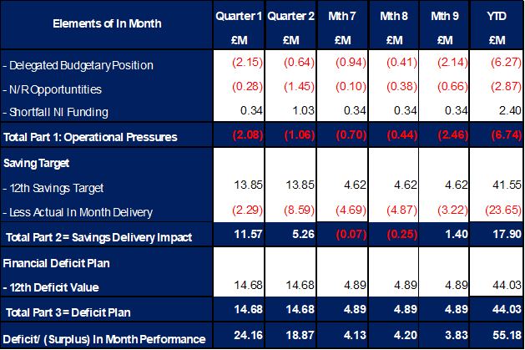

It is clear from the Table above that the Year-to-Date issue remains the non-delivery of savings. This shortfall in delivery YTD is in part mitigated by ‘Delegated Budget’ position underspending and the central N/R opportunities as set out in the 11 September submission delivering (as reported in the Table above). Whilst excluding the non-delivery of saving most areas are within the delegated operational budgets, the key exception to this is Mental Health & LD Services. Throughout the year there have been pressures linked to pay and CHC but also Temporary Adult Placements. The latter issue has resulted in an in-month pressure of £0.7m, with YTD expenditure of £5.3m. During November the service saw the highest number of patients in Temporary Adult Placements at 33, which at the time of closing the ledger for Month 9 was at 25. This pressure will need to continue to reduce through Q4 and managed alongside the other pressures linked to Employers National Insurance (ENIC) and Nurse Streamline numbers that the Health Board will need to mitigate in-year.

On savings performance the submission made on 11 September 2025 set out the Plan to deliver the £55.4m savings in 2025/26. This was a combination of (1) Part A - budgetary releasing savings delivery supported by our external strategic partner; alongside (2) Part B - delivery of underspends in the operational budgets specifically around the corporate directorates and N/R opportunities. The monitoring of the performance for Part A is undertaken through the existing governance arrangements, using the Health Board’s savings trackers. This data is then used to complete the Welsh Government Monthly Monitoring Return (MMR) Savings Tables. However, as Part B are improvements in run rate and not a formal budgetary savings this element of the plan is not reported in Savings Tables of the Welsh Government MMR or standard trackers. A summary of the assessed performance and the profile of delivery over 2025/26 is provided in tables 2a and 2b below:

Table 2a: Summary Performance against £55.4m
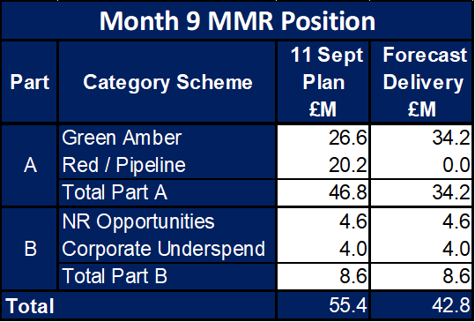

Table 2b: Profile of the delivery of the £8.6m, along with the RAG rating is provided below:

With regard to the delivery of the £46.8m the top section of Table 2c below demonstrates the original plan at 11 September 2025, the plans as per the trackers at Month 9 and the forecast delivery at Month 9. The scheme type is split based on the Amber and Green as per the Monthly Monitoring Return (MMR), Local Red schemes, Local Pipeline ideas and those schemes presented by Deloitte. As the Local Red schemes, Local Pipeline ideas and those schemes presented by Deloitte move to Green and Amber the value of the Plan figure will reduce. As you will see from the table there is still significant work to be completed to ensure the two parts of the Deloitte schemes translate to Green and Amber.
Table 2c: Summary of Savings Plan and Forecast Delivery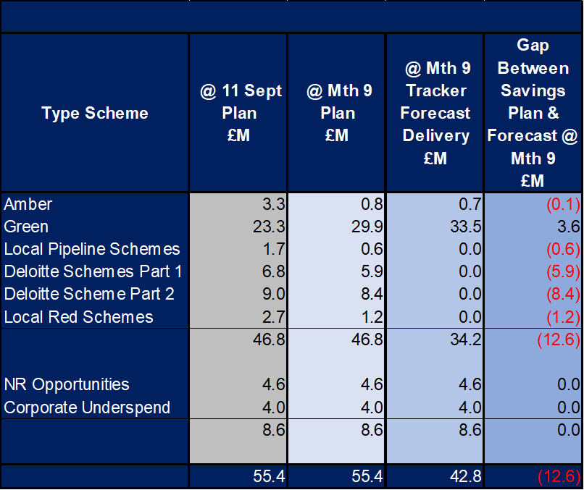

The focus on savings is critical both in terms of supporting the 2025/26 delivery but also on mitigating the impact on the Underlying Deficit, particularly given the £6.9m Deloitte Part 1 Plan had a recurrent impact of £29m.

Post Month 9 closedown the Health Board undertook an assessment of the 2025/26 outturn based on data provided by Service Areas in November 2025 and the actual trend over Quarter 3. Without further the further planned intervention and actions delivered, the Health Board will likely end the year £10m-£12m above plan. The actions and mitigations needed are detailed below and are no different to those previously agreed and acknowledged by the Board and are summarised below:

- 16 December Special Board meeting, approved a paper that set out the actions to address the savings shortfall. In summary the actions to address the savings shortfall agreed were:
  - Urgent emergency Care (UEC) – reconfiguration of beds to manage Clinically Optimised Patients via a new model to be in place 5 January 2026.
  - CHC - continued focus on repatriation of patients and address Social Work support for package reviews by 16 January 2026.
  - Variable Pay minimum 50% reduction in nursing variable pay with cap within Allocate in place by 15 December 2025.
  - Variable Pay - other staff group minimum 50% reduction (excluding WLI and some ADH) to be enacted by 19 December 2025.
  - Bans effective from 15 December 2025 building on previous controls already agreed to increase certainty:
    - all travel, except those directly linked clinical care
    - all Printing/Stationery/Books except those directly linked to clinical care
    - all Study leave that not mandated/urgent via professional CPD
    - catalogue restriction with ban on areas such as Furniture and Fittings except in exceptions circumstances
    - Deferral of discretionary spend where possible 7.

Of the above list the majority of this was due to commence from the end of Month 9, although there was a £0.5m reduction in variable pay in Month 9. Delivery will be tracked and reported from Month 10 and incorporated within this report.

- Further Opportunities Non-Recurrent managed centrally: these are summarised in the table below and will continue to be assessed to establish viability and value to support the delivery of the £58.7m on a non-recurrent basis.

Table 3: Summary N/R Opportunities @ Month 9
The likely outcome is that the delivery of the £58.7m will be met through a combination of the actions agreed at 16 December Special Board meetings and materialisation of some of the further opportunities, although it is the first set actions that will be critical in delivering the recurrent position in 2026/27.

With regards to the overall financial performance, Graph 1 below reflects the actual financial performance in each month, with the orange bars reflecting the performance required to achieve the original plan of £58.7m. Graph 2 outlines the savings delivered to date as the blue bars against the monthly target set (red line), and the orange bars reflect the level of savings required in future months to achieve the £55.4m target aligned to the £58.7m plan.
Graph 1: Performance Graph 2: Savings
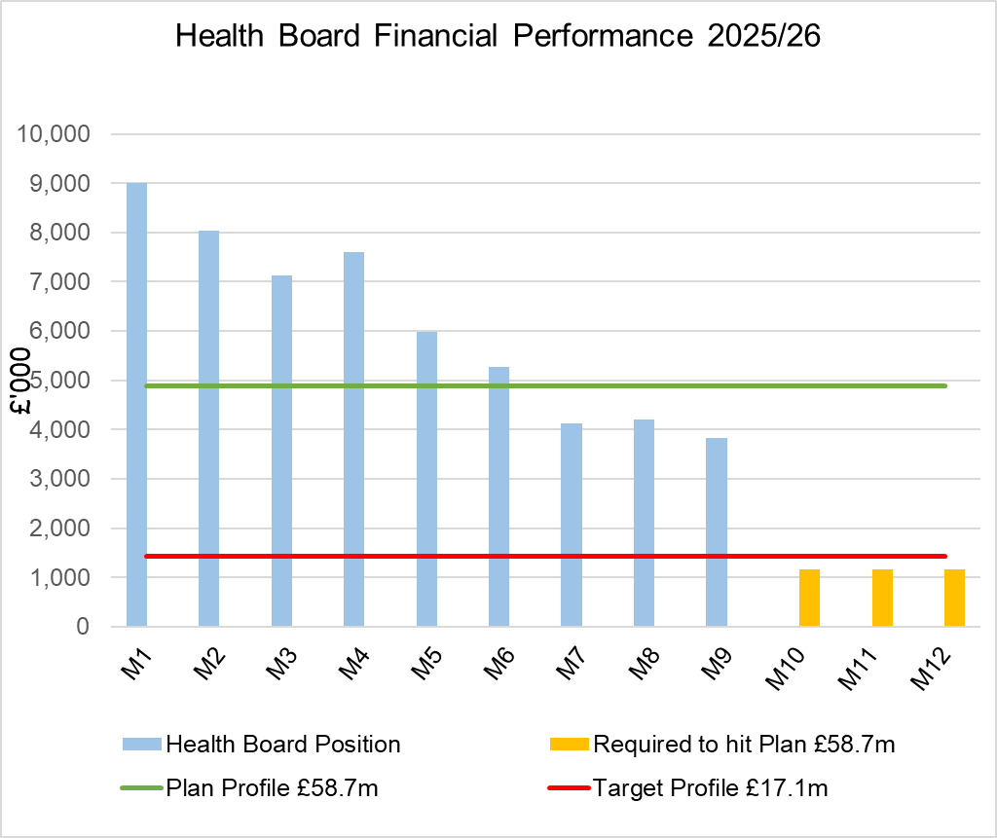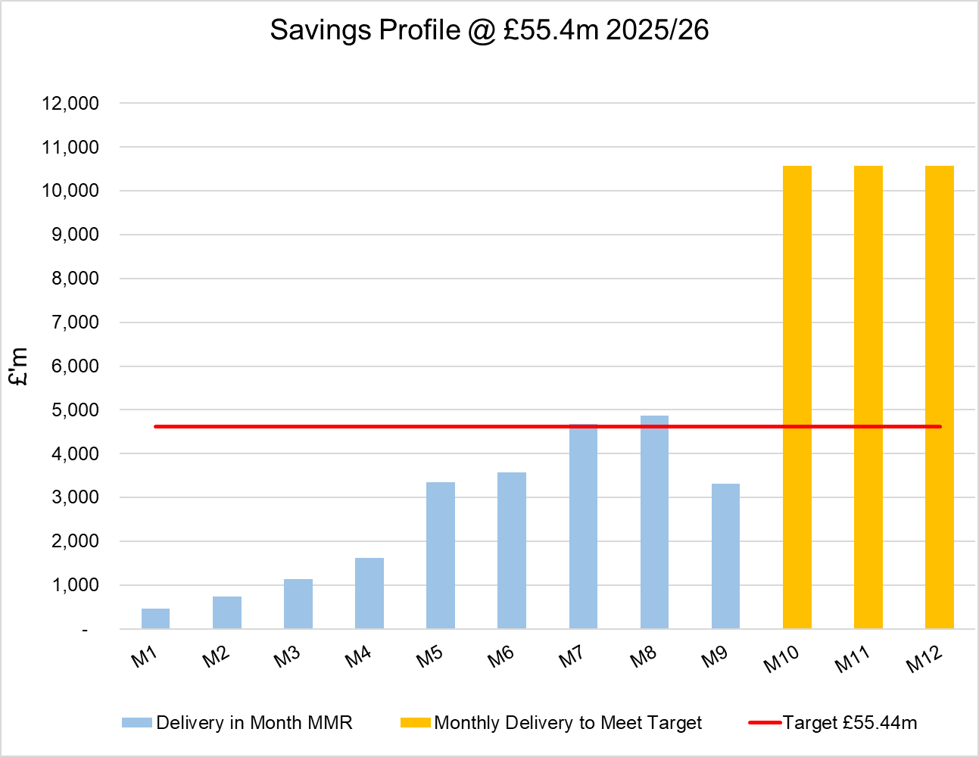

- KEY DRIVERS OF THE IN-MONTH POSITION

The key drivers of the Month 9 position are summarised in the table below. Further detail at a Health Board level of expenditure on Income, Pay and Non-Pay, is also provided in Appendix 1.

  - Key Drivers by Service Area In-Month

  - Key Drivers by Service Area YTD

  - Summary By Expenditure Type

- Income
The Joint Commissioning Committee (JCC) Income as a provider over-performed by £0.6m in-month (£2.1m over-performance YTD). This has been driven by TAVI and Cardiology activity in Morriston.

- Pay
Month 9 pay is broadly in line with the prior month; the continued vacancy freeze primarily in Admin & Clerical and other Pay Controls being the driver for this. Variable pay expenditure has reduced in Month 9, as detailed in Appendix 1.

- Clinical Consumables
(see Appendix 1)

- Prescribing
(see Appendix 1)

- SAVINGS
Full details on savings are provided Appendix 3, but in summary the in-month delivery in Month 9, was £3.32m against a target of £4.62m; on a Year To Date (YTD) basis the undelivered savings gap is £17.99m and remains the key driver of the Health Board overspend.
Part C Actions
- Part C1: Savings Trackers Red & Corporate Stretch @ 4 September 2025
- Part C2: Savings Trackers Pipeline @ 4 September 2025
- Part C3: In-year impact of the thematic Scheme Summaries (adjusted to avoid double count)
Further Actions
- Additional interventions to close the gap to the original savings plan
  - Exec oversight of variable pay
  - Additional capacity reduction
  - Non pay bans / restrictions

- GOVERNANCE AND RISK ISSUES
Two Board level financial risks:

Achieving financial plan (HBR92) with the key elements as follows: -

  - Risk of delivery of savings quantum
  - Risk of operational overspend being in excess of funding available agreed via the Financial Plan
  - Risk of commitment of reserves (e.g. NICE) being above reserves available.
  - Risk of achieving the actions and options outlined in the 2025/26 Financial Recovery & Sustainability Assessment.

Based on the financial performance to Month 9 and the shortfall in the delivery of savings YTD, to deliver the deficit plan of £58.7m, it is recommended that the Health Board Corporate Risk Register continues to reflect a risk score of 25.

Within the YTD and assessment to 31st March 2026 the Health Board is managing the following pressures: -

  - ENIC Shortfall Funding
  - Nurse Stream Lining (144 WTE)
  - Mental Health and Learning Disabilities Service Group (MHLD SG) Temporary Adult Placements
  - MHLD SG Operational Pressures Variable Pay and CHC

Whilst these may currently be mitigated on a non-recurrent basis there will be a recurrent impact on the Underlying Deficit.

The key risks to the in-year position, yet to be mitigated are:
  - Non-delivery of the current Planned and Unplanned mitigations totalling £12.2m
  - Ongoing pressures aligned to further MHLD SG Temp Adult Placements
  - JCC Caswell Provider = £1.2m+
  - JCC General Risk = £0.5m
  - Planned Care Recovery Funding shortfall = £0.8m

Availability of capital (HBR93). This risk was re-opened in 2022/23 given the reduction in discretionary capital allocation. Due to the additional capital funding provided during 2024/25 the risk score was reduced to 12. The score was increased in June 2025 to reflect risks regarding Emergency Department and Adult Acute Mental Health. The current assessment is to continue with the risk score of 20.

- RECOMMENDATIONS
Members are asked to:
- CONSIDER the 2025/26 Financial Plan, and the Health Board’s and Welsh Government’s inability to approve it given the planned deficit of £58.7m.
- CONSIDER the actions in place with regards to Welsh Government’s expectation that the Health Board delivers the £55.4m savings to support the delivery of the 2025/26 Financial Plan.
- Consider and comment upon the Health Board’s financial performance for Month 9 2025/26 and the Year to Date (YTD) position.
- CONSIDER the risks to the position at Month 9.
- SUPPORT the position with regards to Health Board reserves.

Governance and Assurance

Link to Enabling Objectives  (please choose) | Supporting better health and wellbeing by actively promoting and empowering people to live well in resilient communities
Link to Enabling Objectives  (please choose) | Partnerships for Improving Health and Wellbeing |  | ☐
Link to Enabling Objectives  (please choose) | Co-Production and Health Literacy |  | ☐
Link to Enabling Objectives  (please choose) | Digitally Enabled Health and Wellbeing |  | ☐
Link to Enabling Objectives  (please choose) | Deliver better care through excellent health and care services achieving the outcomes that matter most to people
Link to Enabling Objectives  (please choose) | Best Value Outcomes and High Quality Care |  | ☐
Link to Enabling Objectives  (please choose) | Partnerships for Care |  | ☐
Link to Enabling Objectives  (please choose) | Excellent Staff |  | ☐
Link to Enabling Objectives  (please choose) | Digitally Enabled Care |  | ☐
Link to Enabling Objectives  (please choose) | Outstanding Research, Innovation, Education and Learning |  | ☐
Health and Care Standards
(please choose) | Staying Healthy |  | ☐
(please choose) | Safe Care |  | ☐
(please choose) | Effective Care |  | ☐
(please choose) | Dignified Care |  | ☐
(please choose) | Timely Care |  | ☐
(please choose) | Individual Care |  | ☐
(please choose) | Staff and Resources |  | ☐
Quality, Safety and Patient Experience
Financial Governance supports quality, safety, and patient experience

Financial Implications
The Board is reporting a forecast year-end deficit financial outturn.

Legal Implications (including equality and diversity assessment)
No implications

Staffing Implications
No implications

Long Term Implications (including the impact of the Well-being of Future Generations (Wales) Act 2015)
No implications

Report History |  | Updates on the financial position are provided at every meeting.
Appendices |  | Appendix 1 – Variances by Area and Type of Expenditure  Appendix 2 – Reserves and Central Budgets  Appendix 3 – Savings  Appendix 4 – Accountability Letters

APPENDIX 1 – FURTHER DETAIL ON VARIANCES BY AREA & TYPE OF EXPENDITURE
- Overview Financial Position

- Overview of Income

The table below compared the income performance in Month 9 to the average levels of 2023/24 and 2024/25.

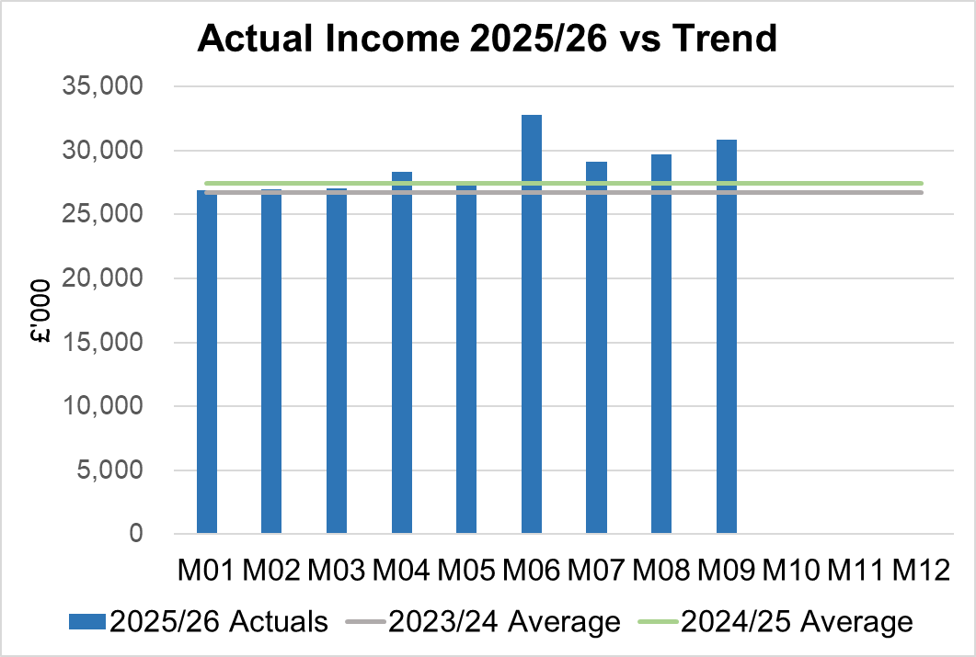

Income had increased in Month 9 due to rebates relating to the price increase in the Mounjaro drug and additional income received within the Clinical Research Unit and additional funding received for the Clinical Medial school (SIFT).

2.1 JCC Income

The Health Board monitors performance on a monthly basis for JCC activity, which is predominantly delivered via the Morriston Service Group. Throughout the financial year there are variance movements linked to performance. The table below provides a summary of the performance at Month 9 for each speciality area.

  - Anticipated Income
The below table highlights anticipated income the Health Board expects to receive during 2025/26. The current deficit plan of £58.7m is predicated on receipt of these Welsh Government funds at the levels anticipated.

- Pay, Agency & Other Variable Pay Expenditure

Total Pay

The Month 9 total remains higher than the prior two years average (as shown in the graph below). Within Month 9 actuals are the recognition payments and arrears linked to the Band 2-3.

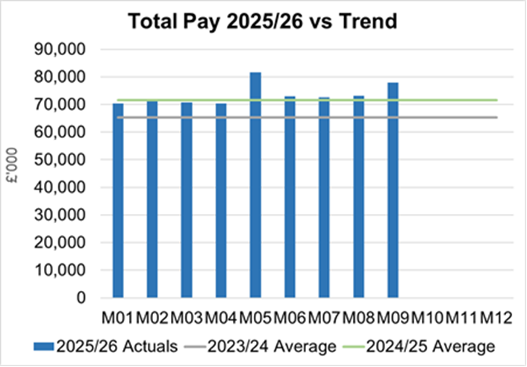
Note - 2023/24 and 2024/25 values have been notionally increased by pay award uplifts to allow for comparison to current value of 2025/26 pay value.

Variable Pay

Variable pay is £0.9m lower in Month 9 2025/26 (£4.161m vs £5.065m) when compared to the same period last year (graph below shows this year’s actual versus prior year’s average) and is £0.5m lower that Month 8 2025/26.

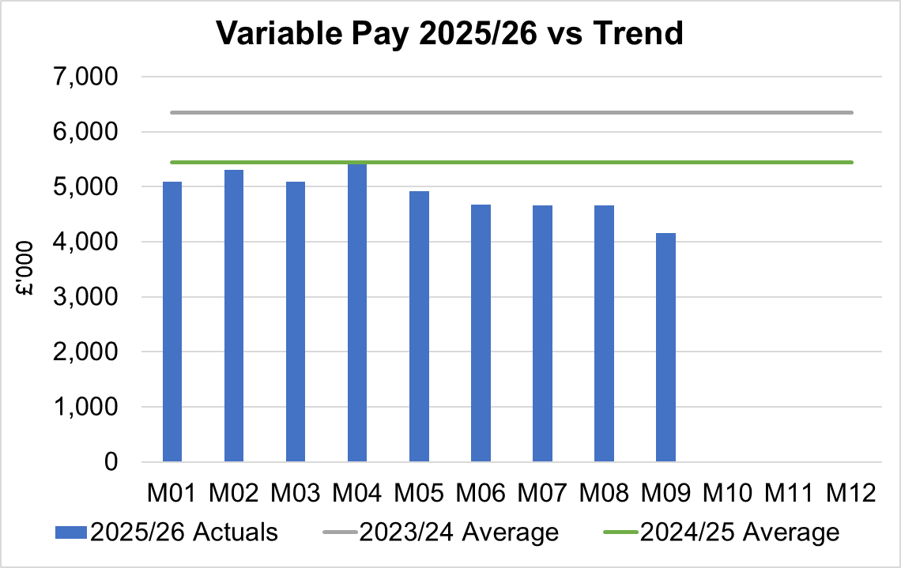

Variable Pay is classified by the Health Board into the following categories: Agency, Bank, Overtime, Waiting List Initiatives (WLI) and Irregular Sessions, a breakdown of the expenditure into these categorise is provided below.

Variable Pay by Expenditure Type

- Overview Non-Pay

Actual Non-Pay expenditure for Month 9 is higher than the last 2 year’s average expenditure levels (as shown in the graph below). This increase is linked to payments made via LTA, which will include pass through costs for JCC, reflection of uplift to the GMS contract for 25/26 (£3.5m) and Dental Contract for 25/26 (£1.0m) both of which are funded by the Welsh Government.

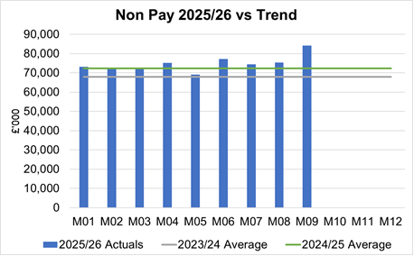

Below are further details on the key areas of non-pay:

  - Clinical Consumables
This area overall has an in-month overspend of £0.7m. Within the ledger the gross income is reflected within the income lines and not netted off against expenditure and so overall the Health Board position is not adversely affected. The main drivers within this category of clinical consumable expenditure include heart valves & pacemakers. This category also includes secondary care drugs, a breakdown of the categories of Clinical Consumables is provided below:

  - Primary Care Prescribing
Prescribing was slightly overspent (£0.04m) in-month and YTD at a £0.2m overspend following receipt of the latest dataset (October 2025).

  - CHC
In Month 9 CHC was overspent by £1.2m (YTD £6.2m). Expenditure on Adult Mental Health placements remained broadly unchanged in-month to £0.8m. The pressure continues at £0.5m for growth (Month 8 £0.3m) more than the Plan after the recognition of some retrospective charges in-month.

An analysis of actual expenditure and patient numbers for 2025/26, along with the average values from 2024/25 is provided in table below.

CHC Analysis by Month

Please note:
- PCT Group numbers are based on bed days
- MHLD Group are based on cases
- PCT Group does not include the Singleton/NPT element. The NPTS element which covers Children and Young People CHC patients is provided internally by the Health Board and as such is part of the wider NPTS position and is not recorded in the ledger as PCT/MH/LD CHC.

  - Maternity Review
The total costs for this are allocated to a dedicated Cost Centre (6F34).

  - Z Codes (Section 1,3-4 Table Point 1 Appendix 1)
The narrative below groups together the key elements of the Z codes detailed in Point 1 of this appendix.

- Contracting: SLA /LTA performance: JCC (previously WHSSC), LTA and SLA contract income and expenditure are transacted within this area and financial performance reported. NICE approved high-cost drugs and associated LTAs are also transacted and monitored against targets set. In addition to this, non-contracted activity income in relation to English foundation trusts invoiced on a quarterly basis are reported.

- Capital: The Finance Capital Team manage a number of cost centres covering the PFI, IFRS16 and Depreciation charges for assets both owned and donated are transacted here.

- RRL and Central Reserves: The Welsh Government funding received at the start of the year is tracked within this area. Any anticipated allocations in year are also transacted through these codes. Other Health Board wide funding received from HEIW and SIFT is also captured in here. All central reserves remain within the Z cost centres and details of these are provided in Appendix 2.

- Corporate income and expenditure. Any income and expenditure that is not service group specific is transacted and reported through a number of corporate Z cost centres, examples include, payroll and pension costs, VAT recovery, losses and receipts in relation to funding from Welsh Risk Pool, overseas visitors’ income and Road Traffic Accident income.

  - LTA Values & Forecast performance
The table below is based on Month 8 activity undertaken by other Health Boards and Trusts for Swansea Bay residents (SBU Commissioner) and activity undertaken by Swansea Bay for residents of other Health Boards.

The above figures include the annual contract values plus invoices relating to patient activity. SBU Commissioner Performance variances are based on information received from each organisation. Forecast performance variances are subject to fluctuations and exclude NICE drug recharges.

APPENDIX 2 – DETAILS ON RESERVES & CENTRAL BUDGETS

- SUMMARY RESERVES
Overall management of the reserves is as per the Health Board Budget Management document.

  - Balances: Main & NICE
For 2025/26, the Health Board will hold two central reserves and the purpose of these reserves are below:
- Main – this holds funding from Welsh Government or the plan that has yet to be issued to Budget Holders. These items are not surplus but either due to timing have not been issued or is an area where funding is issued based on actual values consumed in future month.
- NICE – this holds the total Health Board funding for all NICE costs (drugs and infrastructure) and is issued to the service each month based on the actual costs consumed as reported through the Pharmacy system.

Details on the balances and movements are provided in the Table below:

- COVID RECOVERY
As part of the Financial Plan Welsh Government Funded £15.2m for Local COVID Recovery and £19.5m for Regional COVID Recovery. The funding remains in Central Reserves and is reported in Main reserves in Section 1 above. This funding is then issued to service areas based on the actual costs committed. A summary of the forecast costs against the original funding total of £34.7m is summarised in the table below:

The Welsh Government are also issuing additional non-recurrent funding to support the reduction of the 52 week and 104 week target, alongside diagnostic targets. This is in addition to the original Planned Care Recovery £34.7m detailed in the table above. This non-recurrent funding for Planned Care is held in Main or Service Group local reserves until the costs are committed at which point funding is issued to the relevant budget line.
APPENDIX 3 – SAVINGS

The section below reflects performance against the original £55.4m requirement taken from the Savings Trackers.

- Summary of Savings Position as at December 2025 (Month 9)

The below graph clearly shows the gap between the YTD savings target in red and the level of actual savings delivered in green, with full details provided in the table.

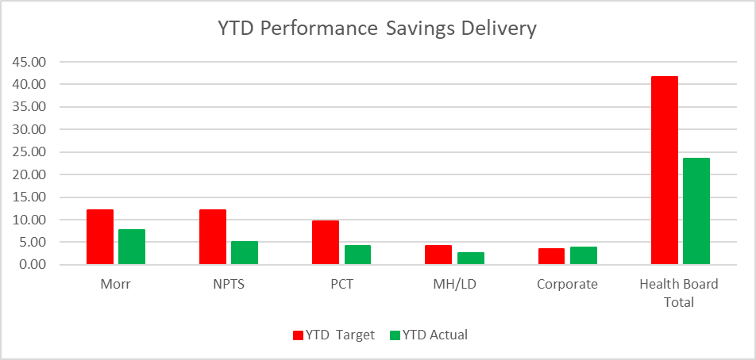

In summary the £58.7m plan required the Health Board to deliver £55.4m of savings. In Month 9 there was an underachievement of savings totalling £1.3m. YTD there remains a shortfall of £18m. This is the key issue in the delivery of the 2025/26 financial position.

- Planned Savings schedule as at Month 9
An element of £55.4m plan submitted on the 11 September was not going to be delivered through savings, a proportion was to be achieved via Non-Recurrent Opportunities and underspend in operational budgets, which relates to the Gap reported in the first table. This table provides a summary of the planned savings schemes, which total £46.8m, broken down by Pipeline, Red, Amber and Red. The second table provides the full reconciliation of the £55.4m. The forecast against the plan of £55.4m is noted in a table under section 2 of this report.

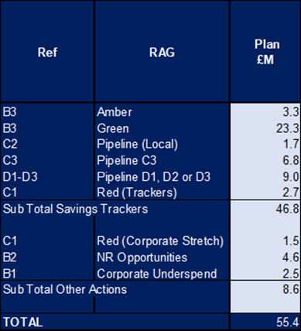

APPENDIX 4 – SUMMARY OF THE REPLIES TO THE ACCOUNTABILITY LETTERS (@14th January 2025)

No: | Name | Date Proforma Returned
 | Ceri Gimblett – NPTS | 13/05/25 – signed proforma + covering letter to CEO / DoF
 | Sue Moore – Morriston | 12/05/25 – no proforma, but a letter to CEO
 | Dermot Nolan – MH&LD | 09/05/25 – proforma signed + narrative added
 | Craige Wilson – PCTSG | Outstanding
 | Hazel Lloyd – Corporate Governance | 28/04/25
 | Deb Lewis – COO | 07/05/25
 | Richard Thomas – DICE | 01/10/25
 | Matt John – Digital | 10/06/25
 | Richard Evans – Medical | 30/04/25
 | Liz Rix – Nursing | 28/04/25
 | Gill Richardson – Public Health | 22/05/25 – no proforma, but a letter to CEO
 | Marie Davies – Planning & Partnerships | 27/06/25
 | Tina Ricketts – W&OD | 13/05/25
 | Darren Griffiths – Finance and Estates | 20/04/25
 | Christine Morrell – Allied Health Professions & Health Science | 14/05/25

