


Meeting Date | 23 January 2024 |  | Agenda Item |  |  | 2.4
Report Title | Capital Resource Plan Q3 Update
Report Author | Ian MacDonald, Assistant Director of Finance (Strategy & Planning)
Report Sponsor | Darren Griffiths, Director of Finance & Performance
Presented by | Ian MacDonald, Assistant Director of Finance (Strategy & Planning)
Freedom of Information | Open
Purpose of the Report | To provide an update on the Quarter 3 financial performance of the Health Board’s capital programme and the impact of emerging risks and opportunities on the projected outturn position for 2023/24.
Key Issues | The Health Board approved a balanced capital financial plan for 2023/24 as part of the approved Recovery and Sustainability Plan.  The forecast outturn position reported at Month 9 shows an overspend position of £0.453m. Additional income from WG (Welsh Government) is anticipated to provide a balanced position.  Funding constraints in WG have now increased the risk level on some of the assumed income, although some have been mitigated by the release of other funding streams, slippage and some transfers into 2024/25. The impact of the WG reductions to the discretionary capital funding over the last two years remain present. A small programme contingency is under pressure, as requests for additional capital funding continue to emerge from the service.  The risk of the plan shifting from balance to imbalance remains material, although the emergence of some additional limited funding opportunities is providing some short-term mitigation. This is reflected in Risk 93 on the Health Board Risk Register
Specific Action Required  (please choose one only) | Information | Discussion |  | Assurance | Approval
Specific Action Required  (please choose one only) | ☒ | ☐ |  | ☒ | ☐
Recommendations | Members are asked to:  - NOTE the month 9 reported position of the capital plan.  - NOTE the emerging funding risks and the material risk of the plan shifting from balance to imbalance.  - NOTE the mitigating actions that will require further exploration.  - NOTE the contingency sum to maintain the balanced plan is £98k.

QUARTER 3 CAPITAL UPDATE

- INTRODUCTION
To provide an update on the Quarter 3 financial performance of the Health Board’s capital programme.

- BACKGROUND
The Health Board approved a balanced capital financial plan for 2023/24 as part of the Recovery and Sustainability Plan submitted to Welsh Government (WG) in March 2023.

The plan included a positive uplift of 50%/£1.3m against the previous years’ reduction in discretionary capital of 24%/£2.671m (following the national £100m reduction in the core capital budget allocated to the Health and Social Care department within WG).

The national funding situation continues to be challenging, with very little uncommitted capital funding remaining; this could have an impact on not just the Health Board’s discretionary capital programme, which is primarily for replacement of the existing asset base, but also larger service continuity, service recovery and service change schemes, including those contained within the recently identified within the approved Health Board Estates Strategy.

The additional national slippage funding provided during Q4 in 2022/23 was much lower than expected from previous years, meaning little headway was made with high-risk backlog equipment replacement as would normally have been expected – which is having a large impact this year.

The approved plan also included the repayment of existing commitments from the All- Wales Capital Programme of £5m. These included: -

- Reprovision of funding for schemes that had slipped during the last quarter of 2022/23 and where the Health Board had to manage the slippage across years through its discretionary programme,
- Gamma Camera/SPEC-CT replacement in Morriston, where discretionary repaid £1.8m following agreement to use the WG funding to support the 2022-23 discretionary capital position.
- Over the last 2 years, discretionary funding has also been utilised to either enhance the funding provided by WG for some of the COVID recovery schemes or in some schemes provide the full funding. Although this pressure was mainly focussed on last year, the position today reflects the direction of resources to these key strategic projects.

The approved plan also includes income assumptions, including the receipt of business case fees from WG and disposals proceeds.

Month 9 Position

The forecast outturn position reported at month 9 shows a much reduced overspend of £0.453m (reduced from month 6 £2.983m). Allocations shown below in table 1 are anticipated to provide a balanced position. There continue to be risks to the income assumption due to the national funding challenges, although this is much reduced from the month 6 position.

Locally the impact of the reductions to the discretionary capital funding continues to have an impact. The ability to retain a balanced capital position remains challenging as there is very little remaining flexibility in the programme to manage emerging service and infrastructure risks.

Table 1 Month 9 Forecast Outturn Position 2023/24
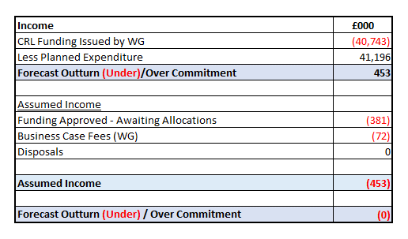

Funding Risks

The approved plan contained assumptions of additional income to offset planned in-year spend and the repayment of business case fees incurred in prior-years. An update on the risk of receipt is shown below in table 2. This is an improving position with the outstanding amount reduced by £2.530 to £0.453m. Of the outstanding amount only £72k for business case fees remains at a high risk of non-receipt this year. The risk has already been factored into the remaining programme contingency.

It should be noted that a large proportion of this income risk, £1.7m has moved into 2024/25. This has been possible due to unplanned slippage this year on some schemes funded through the AWCP (All Wales Capital Programme), where the Health Board has to manage the slippage within its overall capital programme. Whilst this risk has merely moved into next year, nearly £1m of the income risk is related to the recently signed City Deal Campuses business case and this income will be available in 2024-25.

Table 2 Anticipated Income 2023/24
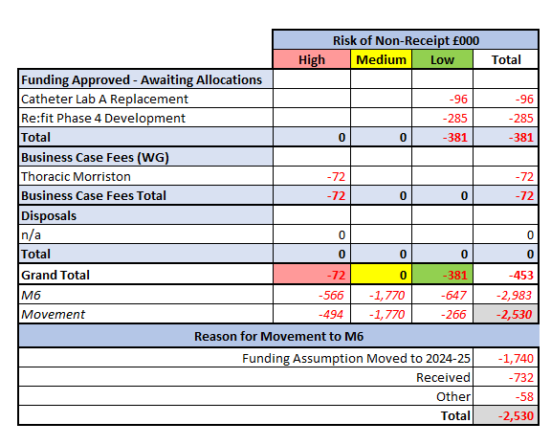
Approved Business Cases & National Funding Allocations

Additional allocations of £5.179m have been received over the last quarter. These include a mixture of national equipment allocations, regional minor projects, business case design fees and major capital building works.

Although not included below, WG advised on 8th January that approval had been given for the business case to replace Catheter Lab A in Morriston. The capital allocation of £2.996m will be allocated over the next two years.

Table 3 Additional Capital Allocations Received Q3 2023/24
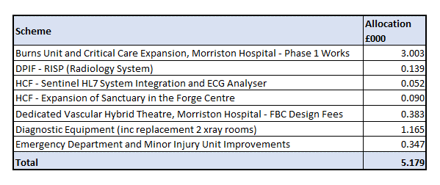
Overall Assessment

Through careful budgetary management, scheme slippage, scheme underspends and additional national funding opportunities, it has been possible to allocate an additional £1.3m during Q3 to cover off the most urgent risks for replacement medical equipment and digital services. The level of risk continues to be overseen by the Capital Priority Group.

After accounting for known risks a small contingency of £98k remains in the capital programme.

It is also pleasing to report that as part of the national EFAB (Estates Funding Advisory Board) £2.7m allocation provided for backlog maintenance in 2023/24 - through good budgetary management and engagement with NHS Wales SES (Specialist Estates Services) by our Capital Planning Team, we received approval to reinvest a £0.379m underspend into additional schemes. These included additional asbestos removal in Singleton, an increase from 3 to 4 nurse call systems in Morriston and annex & kitchen refurbishment works in 2 of our Learning Disability bungalows - as well as allowing patients to be placed closer to home, these will also reduce our external placement expenditure.

There is a small amount of national end of year funding slippage available from WG and bids were submitted in early January by the Health Board for £1.258m, which covered medical equipment, estates infrastructure and digital services. Whilst it is not expected that the full submission can be supported, any approvals will reduce down the ask for replacement items from the 2024-25 capital replacement programme.

National Capital Funding Outlook

WG have indicated that the national capital funding challenges are expected to remain in the short to medium term. In November a new NHS All Wales Capital Prioritisation process was issued. When organisations submitted their original 10-year investment plans in March 2022, they suggested a requirement each year of more than treble the £375m annual All Wales Capital Programme budget (2023-24). The element related to Swansea Bay formed part of the Estates Strategy 10-year plan approved by the Board in May 2023, which estimated a capital investment of £812m. Work has commenced on the prioritisation process as part of the Health Board’s IMTP planning process and it has been agreed to re-convene the Estates Strategy Task and Finish Group to oversee the process and to report into this Committee in February.

- GOVERNANCE AND RISK ISSUES
There is an increased possibility that new service requests, including those with a high-risk score will be unable to be receive capital funding during 2023/24 within the capital resources made available to the Health Board. These risks will continue to be assessed through the Capital Prioritisation Group and raised up through the Management Board.

A risk register entry (Risk 93) has been included in the Health Board risk register and is currently assessed as a 20 score risk.

- FINANCIAL IMPLICATIONS
The financial implications and funding risks are as detailed within the body of the report. In summary, the approved balanced capital plan is assuming additional funding of £0.453m.

The remaining contingency in the plan is £98k. Without additional funding support from WG and/or additional internal mitigations, further requests for capital funding may not be affordable with the allocated resources.

- RECOMMENDATION
Members are asked to:
- NOTE the month 9 reported position of the capital plan.
- NOTE the emerging funding risks and the material risk of the plan shifting from balance to imbalance.
- NOTE the mitigating actions that will require further exploration.
- NOTE the contingency sum to maintain the balanced plan is £98k.

Governance and Assurance

Link to Enabling Objectives  (please choose) | Supporting better health and wellbeing by actively promoting and empowering people to live well in resilient communities
Link to Enabling Objectives  (please choose) | Partnerships for Improving Health and Wellbeing |  | ☐
Link to Enabling Objectives  (please choose) | Co-Production and Health Literacy |  | ☐
Link to Enabling Objectives  (please choose) | Digitally Enabled Health and Wellbeing |  | ☐
Link to Enabling Objectives  (please choose) | Deliver better care through excellent health and care services achieving the outcomes that matter most to people
Link to Enabling Objectives  (please choose) | Best Value Outcomes and High Quality Care |  | ☒
Link to Enabling Objectives  (please choose) | Partnerships for Care |  | ☐
Link to Enabling Objectives  (please choose) | Excellent Staff |  | ☐
Link to Enabling Objectives  (please choose) | Digitally Enabled Care |  | ☐
Link to Enabling Objectives  (please choose) | Outstanding Research, Innovation, Education and Learning |  | ☐
Health and Care Standards
(please choose) | Staying Healthy |  | ☐
(please choose) | Safe Care |  | ☐
(please choose) | Effective Care |  | ☐
(please choose) | Dignified Care |  | ☐
(please choose) | Timely Care |  | ☐
(please choose) | Individual Care |  | ☐
(please choose) | Staff and Resources |  | ☒
Quality, Safety and Patient Experience
Without additional funding support from WG, further requests for capital funding will not be affordable within the allocated resources. This may impact on new service requests for additional capital funding for estates, medical equipping and digital services.

Financial Implications
The financial implications and funding risks are as detailed within the body of the report. In summary, the approved balanced capital plan is assuming additional funding of £0.453m. Without additional funding support from WG and/or additional internal mitigations, further requests for capital funding may not be affordable within the allocated resources.

Legal Implications (including equality and diversity assessment)
None
Staffing Implications
None
Long Term Implications (including the impact of the Well-being of Future Generations (Wales) Act 2015)
n/a
Report History |  | Approved Capital Plan (R&S Plan) Board March 2023  Q2 Capital Resource Plan Update P&FC October 2023
Appendices |  | None

