

Meeting Date | 25 February 2025 |  | Agenda Item |  |  | 4.2
Name of Meeting | Performance and Finance Committee
Report Title | Urgent and Emergency Care Report
Report Author | Neil Cooper, Assistant Director of Operations – Urgent and Emergency Care  Alison Gallagher, Associate Director Urgent & Emergency Care  Lee Elwell, Urgent & Emergency Care Programme Manager  Jonathon Baglow, Business Intelligence Analyst
Report Sponsor | Deb Lewis, Chief Operating Officer
Presented by | Neil Cooper, Assistant Director of Operations – Urgent and Emergency Care
Freedom of Information | Open
Purpose of the Report | To provide a summary of the Urgent and Emergency Care (UEC) improvement programme to improve the delivery of timely, safe patient care and the UEC care standards.
Key Issues | UEC performance has been escalated into Targeted Intervention by Welsh Government with the Chief Operating Officer holding oversight and assurance against developing and monitoring a UEC improvement programme.  The delivery of Tier 1 performance standards remains a significant challenge and the risk of patients coming to harm due to delays relating to timely handover of ambulances. Early assessment and treatment remain a key focus for the Emergency Department (ED) and ward based clinical management teams.  The overcrowding of the ED linked to poor flow and delayed admission of patients into the in-patient bed pool results in poor patient experience.  There are key system performance indicators that explain the challenges associated with delivering timely and safe patient care and thus the required levels of performance and these are discussed in the paper.  Service development schemes are in place and continue to be developed and implemented to support the recovery of UEC performance.  A structured approach in response to targeted intervention monitoring and the UEC programme, approved by NHS Wales 6 goals programme is in place to support, deliver and monitor the schemes reporting to the UEC Board
Specific Action Required  (please choose one only) | Information | Discussion |  | Assurance | Approval
Specific Action Required  (please choose one only) | ☒ | ☐ |  | ☐ | ☐
Recommendations | Members are asked to:  - NOTE the UEC performance position and the ongoing actions taken to support its recovery and Improvement.

Urgent and Emergency Care Report

- INTRODUCTION
The report below describes urgent and emergency care (UEC) activity and performance to date, including progress against the UEC care standards. Wider system indicators are also used to demonstrate the flow constraints that exist resulting in poor access to timely urgent and emergency care and poor patient and staff experience. The report provides a detailed response to actions pertaining to the increased monitoring to of the UEC tier 1 performance targets and updates on the strategic and operational programme to improve the delivery of acute services to patients and on local improvement actions.

- BACKGROUND
The flow of Emergency patients within the Health Board and the wider UEC system, continues to be significantly compromised due to the high occupancy levels within its hospitals. This is further exacerbated by the system flow challenges impacting patients transferring in a timely way into services outside the hospital sites, which in turn increases delays for clinically optimised patients and increases the number of patients being treated outside of the core bed base. The lack of flow also has unintended consequences in other parts of the UEC system including:

- Delay in patients transferring from ambulances into the Emergency Department (ED);
- Delays in patients accessing downstream, inpatient beds
- Increase in utilisation of surge capacity across the hospital footprints and patients placed in inappropriate spaces i.e.SDEC
- Delays in patients transferring to the next stage of their recovery – complex and general rehabilitation at peripheral sites
- Delays in patients being discharged home

In line with the 6 goals programme, wider Health Board schemes targeting admission avoidance and earlier discharge are in place or in trial phase to support the wider system flow agenda.

- PERFORMANCE – Tier 1 URGENT & EMERGENCY CARE STANDARDS

The Charts below represent performance against the ED Access Standards and targets for ambulance handover (12-month rolling position).
Despite the improvement, the ongoing challenging situation and generally poor performance against the 4-hour standard at Morriston Hospital, translates operationally into poor patient and staff experience. Patients can wait several hours for assessment by a clinician during which period their condition may be more serious or have deteriorated since triage.

  - Ambulance Handover

1st April 2024 to 31st January 2025
URGENT AND EMERGENCY CARE (UEC) - Ambulance

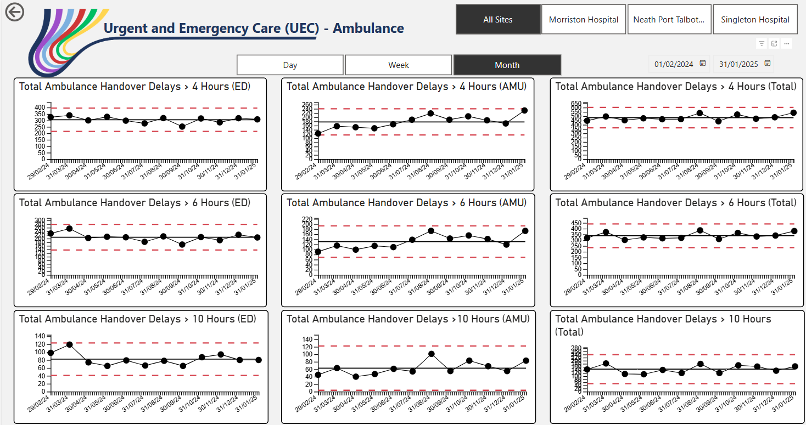

Although the SPC charts above denoted no change in trend, ambulance handover delays remain of significant concern and has been a key focus from Welsh Government. The UEC programme is addressing this matter as one of its most critical areas for improvement.

The stable overall position outlined is testimony to the enhanced efforts across the whole system to manage UEC demand against ever increasing challenges.

The reasons for the delays in handover are multi-factorial and include:
- Availability of ED / AMU capacity to manage demand – both departments are regularly starting the day with 30 to 40 patients waiting to be admitted to down-stream wards.
- Onward flow to a hospital bed - every ward/specialty operating [significantly] beyond allocated capacity
- Availability of onward hospital transfer
- High number of Clinically Optimised Patients (COPs) in the acute setting

  - 12-Hour compliance & 1st Review within 60 Minutes

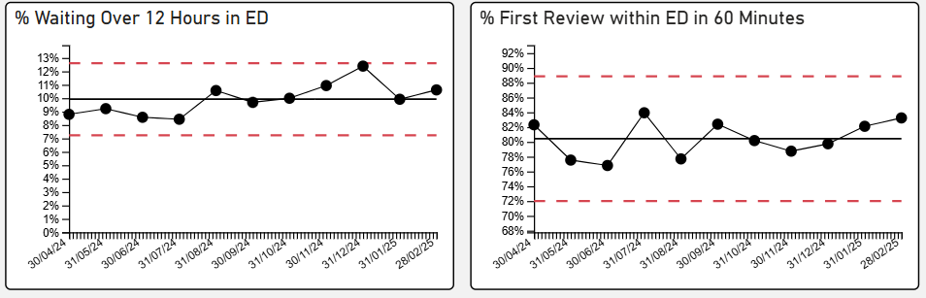

- Further targeted intervention KPIs are highlighted in the charts above, with performance remaining static in performance on 12 hours waits in ED with an improvement in first review times due to the implementation of the internal professional standards in November 2024

  - Clinically optimised patient (COP) position

The clinically optimised patient position in the Health Board remains a critical issue with significantly high numbers of patients in the wrong bed; either occupying acute beds waiting to move to more appropriate settings to continue their care pathway or waiting for community support / placement. The position has been deteriorating since August 2024, despite enhanced focus and alternative approaches being tested and new services implemented.

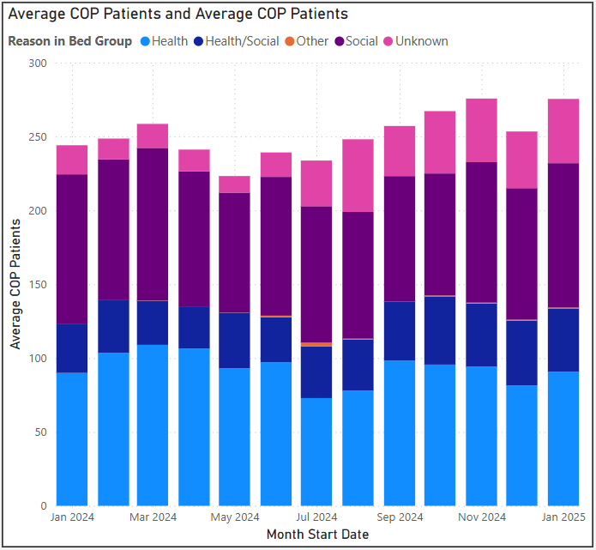

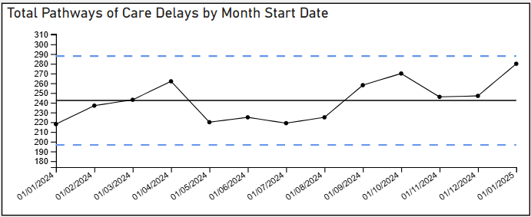

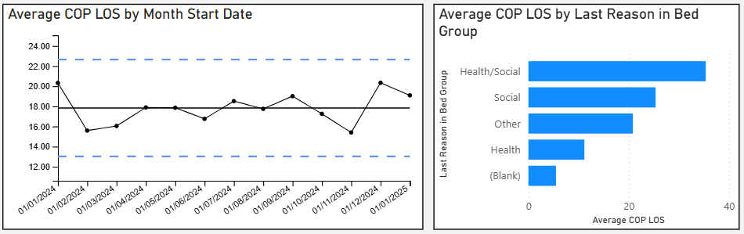

- The Clinically optimised patient is a key focus of the UEC programme of work sponsored by the national 6 goals team. A reduction in this number of patients is a critical factor in the success of patient flow and is the number 1 priority in 2025 for the improvement across all performance metrics

  - Bed Occupancy – Morriston Hospital

The following occupancy chart from Morriston Hospital shows a direct consequence of the challenging COP position, especially within the 22+ LOS category (where >95% of these patients have been categories as a COP). All sites occasionally open ‘surge’ capacity, and implement the pre-emptive ‘boarding’ policy, but the level within Morriston Hospital is particularly acute.

This continued expansion of operational capacity brings within it inherent risks and challenges, such:-

- Increased pressure on staff working in these environments
- Significant associated costs attached to short notice staffing requirements
- Severe lack of flow available for admitting and assessing patients (eg AMU, ED, OPAU)
- Increased risks and issues relating to infection control measures
- Increased risks and issues relating to health and safety measures
- The dignity and privacy experienced by patients directly affected, diminishes.

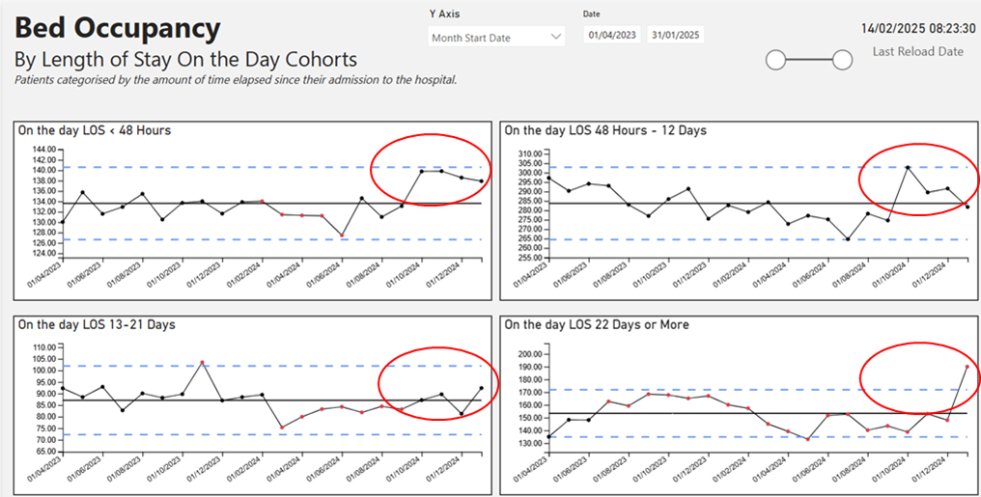

The combined occupancy levels across the Morriston Hospital footprint is currently circa +50 patients. This is IN ADDITION to those patients awaiting admission within the ED (circa 45 patients each day), AMU (circa 15 patients each day), and those patients in ITU awaiting transfer to a ward for step-down care (circa 5 patients daily).

- Wider system measures and actions:

The Health Board has been placed into Targeted Intervention (TI) by Welsh Government for its performance and outcomes within the UEC system.

The expectations mirror the HB’s own aspiration and the plan currently being developed to support system improvement. The agenda listed below will consist of 4 key themes all linking to National 6 Goals Programme and a consistent thread linking the UEC programme boards GMO’S for 2024/25

- Admissions Avoidance
- Discharge & Transfer
- Front Door
- Inpatients

The criteria used for consideration to de-escalate out of TI is captured in the table below along with progress to date:

Criteria to Achieve | Current Performance  (RAG rated)
- A continuous reduction of ambulance handovers over an hour of at least 11% in three consecutive months and maintained for 3 months  (Based on quarter 2 and 3 2023 baseline): 61% | - Nov 24: 63%  - Dec 24: 64%  - Jan 25: 65%
- Continuous improvement towards no more than 7% of patients waiting over 12 hours at each individual site and across the health board. | Health Board  - Nov 24: 11%  - Dec 24: 12%  - Jan 25: 10%
- Median time from arrival at an emergency department to assessment by a clinical decision maker should not exceed 60 minutes.  - (Based on quarter 2 and 3 2023 baseline): 79% | Health Board  - Nov 24: 79%  - Dec 24: 80%  - Jan 25: 82%
- A continuous reduction in delayed pathways of care of 5% for three consecutive months and then maintained for three months  (based on Oct-Dec 23 baseline): 215 | Health Board  - Nov 24: 246  - Dec 24: 247  - Jan 25: 280
- Assessment of declared BCIs, including reasons why, actions taken, and lessons learnt. | - One episode of BCI declared, w/c 10/2/2025

Despite little by way of improvements in all performance metrics in November, December (24) and January (25) this has been the HB’s most challenging period over recent months, with;
- Escalating IPC position across all hospital sites
- An increase in ED attendances
- An increase in hospital admissions

This has not been an issue for Swansea Bay alone and the recent Wales Government report shows SBUHB as second only to Cardiff & Vale UHB in Ambulance handover metrics and 12-hour waits as detailed below

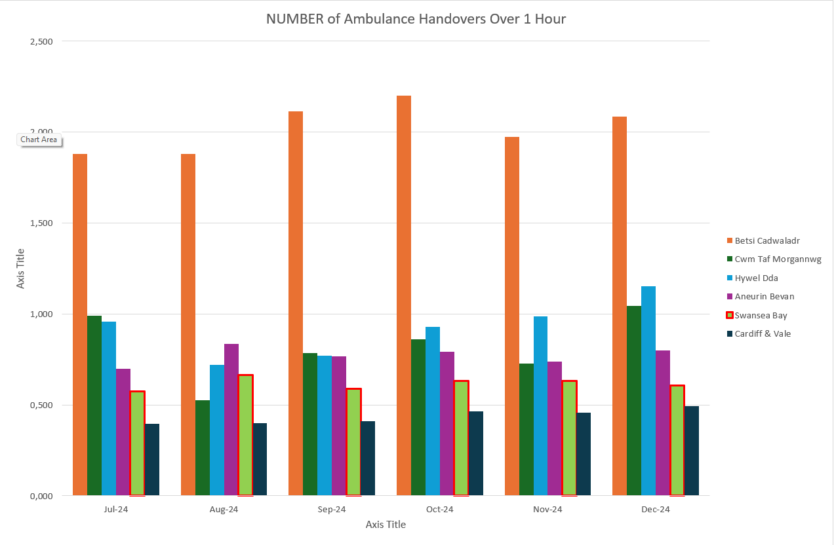

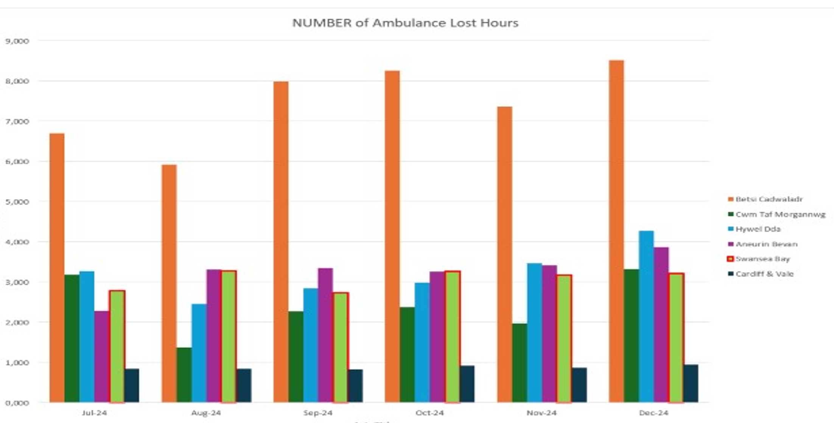

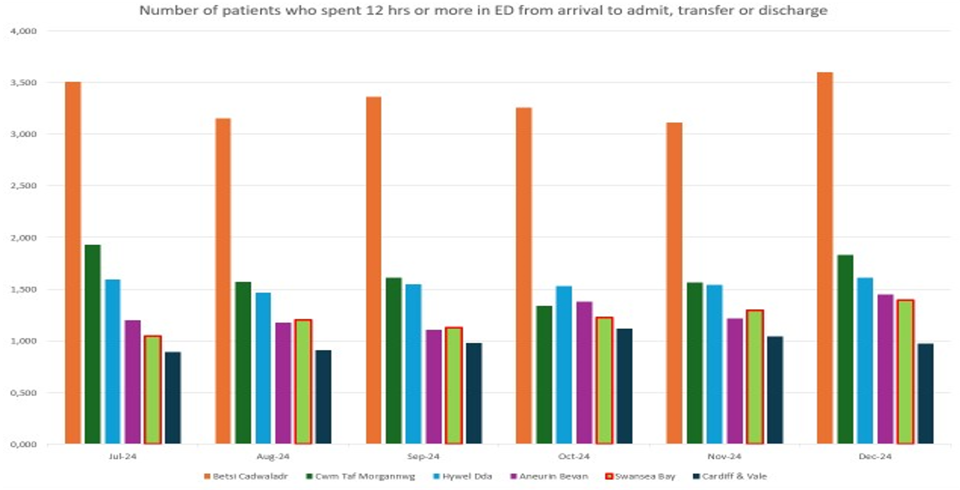

Actions being taken to improve include:

Frailty strategy – approved via Management Board – activity underway:
- Dedicated area and identity for frailty developed
- Frailty Unit opened before end of Q2
- Work to develop flow models around streamlining frailty underway/ ongoing
- Continued recruitment and maximising of job planning to increase sessions into frailty
- Older Persons Assessment Unit (OPAU) service now operating as ‘Business as Usual’
- Challenges re; assessment areas being bedded within OPAU
- Next steps to include a move to 7 days frailty services (this requires COTE rota to be independent of the GIM rota)
- Alignment of Virtual Wards and ACT to provide ‘Hospital at Home’ service

Senior decision makers at front door services
- Discussions are ongoing regarding the restructuring of the ACP rota
- New speciality hot clinics commenced from SDEC with gastro being the first speciality to go live in December with additional specialities due to go live early 2025
- Implementation of fractured NOF direct pathway commenced with ring fenced NOF spaces available.
- All improvement work linked to sustainable medical rota – linked to revision of acute medical rota with potential for greater speciality medicine involvement

Reconfiguration of Emergency Dept:
- New paediatric area including resuscitation completed and in operation
- Current capital programme in progress to include environmental refresh (I.e. painting), improved signage, development of a treatment area (HIW recommendation) and provision of sanitary facilities (I.e. addition of a dirty utility area, new shower and washing facilities for patients)
- WG funding available to move to Design phase for new build

Grip & control operational management:
- Designated consultant/ matron and operational manager allocated to each ward to drive actions
- Weekly COO led COP meeting held with Service Group Directors

Revised flow operating model:
- Continuous Flow Model methodology used at daily Tactical meetings – top 10 patient waits reviewed and pushed across hospital site away from ED (spreading risk away from ED)
- UEC Navigation Hub operational, incorporating WAST, GPs, ANPs from OPAU, and the medical workforce.
- Redesigned current SDEC/ AMU corridor footprint to improve flow and patient experience.
Discharge to Recover then Assess
- Taskforce developed to include all Service Groups & Local Authority partners to expedite rapid transfer of clinically optimised patients
- Health Board and Local Authority colleagues in discussion regarding joint programme of works

Pathway of Care Delays (PoCD) – POCD Action Plan refreshed following December’s census data. Continued activity updates and owner identification provided to programme support:
- Leads have committed to a reduction of Total Delays by 43
- Routine review of patients by severity of delay established
- Enhanced scrutiny at ROAG
- POCD site Audits undertaken 01/25
- Challenging position as at January 2025 Census namely:
  - Increase in Total Days Delayed for West Glamorgan region - 13,175 (Nov. 24), 13,729 (Dec. 24); 16,698 (Jan. 25))
  - Increase in Total POCD Delays for West Glamorgan region 246 (Nov. 24); 247 (Dec. 24); 280 (Jan. 25)
  - Total Assessment wait Delays for West Glamorgan region increased 139 delays (Nov. 24); 140 (Dec. 24); 181 (Jan. 25)
- Seeking additional LA workforce solution to address gaps in social work provision and thus improve delays

- Recommendation
Members are asked to:
- NOTE the UEC performance position and the ongoing actions taken to support its recovery and Improvement
- NOTE the level of risk now managed across the Morriston Hospital site – increased COP position and Boarding across the Wards is allowing for performance measures at the front door(s) to remain largely static. However, challenging discharge profile (and challenging POCD position) results in increased risk being held on the hospital site.

Governance and Assurance

Link to Enabling Objectives  (please choose) | Supporting better health and wellbeing by actively promoting and empowering people to live well in resilient communities
Link to Enabling Objectives  (please choose) | Partnerships for Improving Health and Wellbeing |  | ☒
Link to Enabling Objectives  (please choose) | Co-Production and Health Literacy |  | ☐
Link to Enabling Objectives  (please choose) | Digitally Enabled Health and Wellbeing |  | ☒
Link to Enabling Objectives  (please choose) | Deliver better care through excellent health and care services achieving the outcomes that matter most to people
Link to Enabling Objectives  (please choose) | Best Value Outcomes and High Quality Care |  | ☒
Link to Enabling Objectives  (please choose) | Partnerships for Care |  | ☒
Link to Enabling Objectives  (please choose) | Excellent Staff |  | ☒
Link to Enabling Objectives  (please choose) | Digitally Enabled Care |  | ☒
Link to Enabling Objectives  (please choose) | Outstanding Research, Innovation, Education and Learning |  | ☒
Health and Care Standards
(please choose) | Staying Healthy |  | ☒
(please choose) | Safe Care |  | ☒
(please choose) | Effective Care |  | ☒
(please choose) | Dignified Care |  | ☒
(please choose) | Timely Care |  | ☒
(please choose) | Individual Care |  | ☒
(please choose) | Staff and Resources |  | ☒
Quality, Safety and Patient Experience
To improve the delivery of timely, safe patient care and the UEC care standards.

Financial Implications
There are no direct financial implications arising from the recommendations in this report.
Legal Implications (including equality and diversity assessment)
There are no direct legal implications arising from the recommendations in this report.
Staffing Implications
There are no direct staffing implications arising from the recommendations in this report.
Long Term Implications (including the impact of the Well-being of Future Generations (Wales) Act 2015)
Report History |  | N/A
Appendices |  | N/A

