

Meeting Date | 25 February 2025 |  | Agenda Item |  |  | 4.1
Name of Meeting | Performance and Finance Committee
Report Title | Planned Care Performance Update
Report Author | Deb Lewis Chief Operating Officer
Report Sponsor | Deb Lewis Chief Operating Officer
Presented by | Deb Lewis Chief Operating Officer
Freedom of Information | Open
Purpose of the Report | In May 2022, Welsh Government set out its ambitious intention for planned care recovery. The output of that ambition was a requirement for Health Boards to submit recovery trajectories against two specific priority areas:  - No patient will wait more than 52 weeks for a first outpatient appointment by end of 2022.  - Patients will wait less than 104 weeks for treatment within most specialties by the end of 2022/23  These targets were subsequently revised to October 2023 for 52 weeks outpatient waiting times and March 2024 for 99% of 104 week waiting times at all stages. The new target is for zero 104 week waits by the end of March 2025  This paper provides an update on improvement plans to deliver against these targets.
Key Issues | SBUHB achieved the delivery of the 52-week target and maintained this position since October 2023. The HB Achieved a 97.8% compliance against the required 99% of patients waiting less than 104-weeks by the end of March 2024.  The Health Board has cleared all 156 waits at the end of August 24.  The HB remains on track to deliver the target of zero patients waiting more than 104 week by 31st March 2025. This represents a significant achievement for the HB. The target for 25/26 is sustained delivery of this maximum wait but there are risks around the total volume of patients within the cohort for 25/26.
Specific Action Required  (please choose one only) | Information | Discussion |  | Assurance | Approval
Specific Action Required  (please choose one only) | ☒ | ☒ |  | ☐ | ☐
Recommendations | Members are asked to:  To note the progress made to date to achieve the 2024/25 Ministerial Targets and the associated risk to sustained delivery.

Planned Care Performance Update

- INTRODUCTION

In May 2022, Welsh Government set out its ambitious intention for planned care recovery. The output of that ambition was a requirement for Health Boards to submit recovery trajectories against two specific priority areas:
- No patient will wait more than 52 weeks for a first outpatient appointment by end of 2022.
- Patients will wait less than 104 weeks for treatment within most specialties by the end of 2022/23
These targets were subsequently revised to October 2023 for 52 weeks outpatient waiting times and March 2024 for 99% of 104 week waiting times at all stages. The new target is for zero 104 week waits by the end of March 2025
This paper provides an update on improvement plans to deliver against these targets and plans for sustaining into 2025/26.

- BACKGROUND

The Recovery and Sustainability (R&S) Plan 2022-25 was endorsed by Management Board on March 2022, approved by Board, and subsequently submitted to Welsh Government for consideration.

One of the core components of the R&S Plan was the recovery of planned care, which had been impacted significantly by the pandemic. The WG recovery plan ask assumed that planned care activity levels have resumed to pre-pandemic levels (19/20) and will be exceeded as a result of the additional recovery funded provided.

The Health Board submitted initial trajectories but highlighted that further work would be undertaken to refine the modelling and strengthen the plan in the following areas:

- Strengthening GP led services to prevent referral to secondary care and diagnose and/or treat at source.
- Developing demand management solutions across our systems of care.
- Considering the application of referral management criteria to be applied to existing lists and new referrals.
- Increasing core capacity for open pathways by diverting capacity previously assigned to follow up pathways as a result of:
  - modernisation of follow up system,
  - better use of clinic slots through partial bookings,
  - individual consultant productivity and
  - rigorous enforcement of DNA protocols
- The opening of further planned capacity in our system at Neath and Port Talbot

The Health Board achieved the delivery of the 52-week target by the end of October 2023, as required. This has been maintained on a monthly basis since October 2023. The HB also delivered a max wait less than 156 weeks at the end of August and has committed to achieving a max wait of 104 weeks by the end of March 2025. This follows 97.8% compliance against the required 99% of patients waiting less than 104-weeks by the end of March 2024.

- CURRENT POSITION

Stage 1
At the end of October 2023 zero-breach position for 52 weeks for a first outpatient appointment was achieved and this has been maintained with the exception of single patient breaching in Sept and November due to patient choice.

All Stages
The confirmed position for the end of December at all stages against the 104-week target is as follows:

Specialty | Waits over 104 weeks
Gynaecology | 282
T&O / Spinal | 350
Plastics | 90
ENT | 101
General Surgery | 147
Urology | 11
Total | 981

The delivery of the 104-week maximum wait by the end of March 2025 means the HB has to treat the remainder the 24/25 cohort, which is outline below:

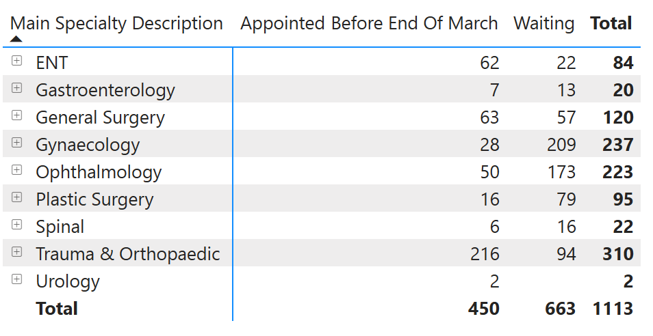

Of the 1,113 total, you can see that 450 are already appointed and of the 663 remaining, 81 patients are with the private sector hospitals. This leaves a total of 582 left to date. The breakdown of that is shown below:

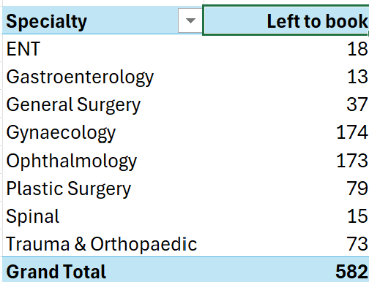

Directorates have given assurances that plans are in place to deliver the zero position the HB committed too.

Diagnostics and Therapy Waits

The HB has maintained its positive delivery against both the 8-week diagnostic and 14-week therapy targets. The end of December position is as outlined below:

Service | Breaches | Total waiting list | % within target
Diagnostics 8-week Target
Endoscopy | 2328 | 3434 | 32.3%
Cardiology | 636 | 2746 | 77%
Total diagnostics | 2964 | 11926 | 75.1%
Therapies 14-week Target
Podiatry | 407 | 1940 | 79%
Total therapies | 407 | 5369 | 99%

Planned Care 2025 -2026

The majority of planned care targets for 25/26 are rolled over from the 24/25 Performance Framework. However, there are some new editions. The full list of Planned Care Performance Framework measures is noted below:

Measure | Target (time) | Target (%) | Change from 24/25 | New / Existing
RTT full pathway | >104 weeks | zero | None | Existing
RTT stage 1 (new outpatients) | 52 weeks | 100% | None | Existing
Delayed Follow-up | >100% | Reduction | None | Existing
Diagnostic Investigations | >8 weeks | Zero | Was 80% | Existing
Therapy interventions | 14 weeks | 100% | Was 80% | Existing
Adult waits for all audiology pathways | >14 weeks | Reduction |  | New
Children waiting for audiology pathways | >6 weeks | Reduction |  | New

Whilst the main planned care target of 104 weeks for treatment remains unchanged this financial year, it should be noted that the total number of patients within the cohort this year will be different to that last year. Therefore, demand and capacity analysis is underway to review risks to sustained delivery. The HB will also be reviewing whether further improvement in waiting times will be possible within current resource envelopes.

  - Scrutiny and Assurance Process

The dynamic nature of the recovery necessitates scrutiny and monitoring, both internal and external to the organisation. The following outlines the monitoring and reporting structure that is in place and the mechanism for directorates to be held to account for delivery.

External Monitoring
Monthly monitoring meetings are scheduled with WG / NHS Executive officials and HB is represented at the monthly meetings by the COO and Deputy COO.

The monthly meetings focus on:
  - Validation
  - Treat in turn
  - Plans for longest waits
  - Detailed speciality discussions / issues / areas of concerns
  - Progress on HB transformation measures
  - Progress on developing patient support and communication

Internal Monitoring
There are fortnightly meetings led by the Service Groups where service leads are held to account for delivery of the trajectories. Escalation for the non-delivery against the submitted levels will be to the Chief Operating Officer in the first instance.

- Operational monitoring - the current performance management meetings:
  - monitor delivery of the trajectories and the areas of efficiency noted above
  - ensure core capacity is at or above 2019/20 levels
  - ensure robust housekeeping is in place for RTT pathways
  - further develop recovery plans as required for approval via Planned Care Board

- Formal monitoring / assurance
  - Service Group Performance Reviews
  - Planned Care Board
  - Management Board via the Performance Report
  - Performance & Finance Committee

To help support directorates a Planned Care Dashboard has been developed with specialty level performance information.

- FINANCIAL IMPLICATIONS

The full resource envelope will have been utilised to achieve the waiting list reductions within planned care services this year. As noted previously, the demand for 2025/26 is being reviewed against the capacity available within core services and also against the finances available for delivery in 2025/26.

- RECOMMENDATION

The Committee is asked to:
- NOTE the progress made to date to achieve the 2024/25 Ministerial Targets and the risks associated with the sustained delivery of 104-week waiting time target into 2025/26

Governance and Assurance

Link to Enabling Objectives  (please choose) | Supporting better health and wellbeing by actively promoting and empowering people to live well in resilient communities
Link to Enabling Objectives  (please choose) | Partnerships for Improving Health and Wellbeing |  | ☒
Link to Enabling Objectives  (please choose) | Co-Production and Health Literacy |  | ☐
Link to Enabling Objectives  (please choose) | Digitally Enabled Health and Wellbeing |  | ☐
Link to Enabling Objectives  (please choose) | Deliver better care through excellent health and care services achieving the outcomes that matter most to people
Link to Enabling Objectives  (please choose) | Best Value Outcomes and High Quality Care |  | ☒
Link to Enabling Objectives  (please choose) | Partnerships for Care |  | ☒
Link to Enabling Objectives  (please choose) | Excellent Staff |  | ☒
Link to Enabling Objectives  (please choose) | Digitally Enabled Care |  | ☐
Link to Enabling Objectives  (please choose) | Outstanding Research, Innovation, Education and Learning |  | ☐
Health and Care Standards
(please choose) | Staying Healthy |  | ☒
(please choose) | Safe Care |  | ☒
(please choose) | Effective Care |  | ☒
(please choose) | Dignified Care |  | ☒
(please choose) | Timely Care |  | ☒
(please choose) | Individual Care |  | ☒
(please choose) | Staff and Resources |  | ☒
Quality, Safety and Patient Experience
The successful implementation of the plans outlined have the ability to improve the quality and safety of services and in turn patient experience. However, the report has outlined a number of risks, which have the potential to delay benefit realisation.

Financial Implications
There is a significant risk that the financial allocation in 2023/24 for the Planned Care Recovery Programme will limit the progress that the Health Board is able to make in reducing waiting times further.

Legal Implications (including equality and diversity assessment)
There are no legal implications to consider as a direct result of this report.

Staffing Implications
A number of the improvement plans are facing challenges with recruitment and the availability of re-current funding.

Long Term Implications (including the impact of the Well-being of Future Generations (Wales) Act 2015)
This paper outlines how service areas within the Planned Care Programme are working in collaboration not only to look at the short term, but also to develop services across Swansea Bay in the long-term including the new theatres and the plans to enhance innovation and new ways of working.

Report History |  | May 23 – Planned Care Update
Appendices |  | Nil

