Meeting Date | 16 December 2025 |  | Agenda Item
Report Title | Cancer Performance Update
Report Author | Marisa Bennett, Cancer Performance & Information Manager
Report Sponsor | Hannah Parsons, Assistant Director of Operations, Planned Care
Presented by
Freedom of Information | Open
Purpose of the Report | - A deeper understanding of the performance figures which would include the impact of patient choice on the backlog etc.  - An overview of the action plans in place across each tumour site for improvement/delivery  - A deep dive into the Urology Tumour site to outline what is influencing the high figures and detailed plans for recovering the position.
Key Issues | This report will highlight current performance for both backlog and Single Cancer Pathway.
Specific Action Required  (please choose one only) | Information | Discussion |  | Assurance | Approval
Specific Action Required  (please choose one only) | ☐ | ☐ |  | ☒ | ☐
Recommendations | Members are asked to:  - NOTE the performance and backlog volumes in the main tumour sites.  - NOTE the additional work required to improve both performance and backlog.

CANCER PERFORMANCE UPDATE

- INTRODUCTION

In October 2022 Welsh Government (WG) initiated the enhanced monitoring (EM) intervention process for the Health Board (HB) due to quality issues relating poor performance and long waiting times. In January 2024 the HB was escalated to targeted intervention (TI) within several areas, including performance against the Suspected Cancer Pathway (SCP). The HB meets with WG TI on a monthly basis. The areas of greatest focus both locally and nationally for improvement are:
- Lower Gastrointestinal, Gynaecological, Urological, Skin and Breast

To be de-escalated from TI, 60% of patients must be treated within 62 days for three consecutive months. The HB has only met this requirement at quarterly resubmission until Summer 2025, when the HB achieved 61%, 61% & 60% respectively between July and September 2025 at first submission. However, performance fell in October 2025 to 56%.

- BACKGROUND

The HB monitors two primary metrics for the single cancer pathway:
- % Performance within the 62-day target
- Backlog volumes (patients waiting over 62 days)

Performance 2024/25
The graph below shows the HB’s SCP performance since July 2024. It represents the patients receiving first definitive treatment (FDT) within the 62-day target against the target of 75%.

Graph 1 – SCP Performance 24-25

The table below shows the breach volumes and performance by Tumour Site since April 2025, the top 5 priority tumour sites for Wales highlighted.
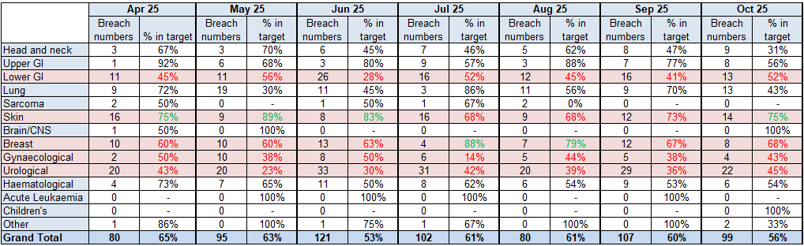

Although Skin performs well overall, this is largely due to the relative simplicity of the pathway, many dermatology referrals are first seen in a ‘see and treat’ clinic, meaning that the pathway is often concluded at first attendance. With waits to first assessment increasing over the Summer because of expected seasonal increased demand and reduced activity, this has led to a reduction in performance which in turn impacts overall HB performance.

Backlog

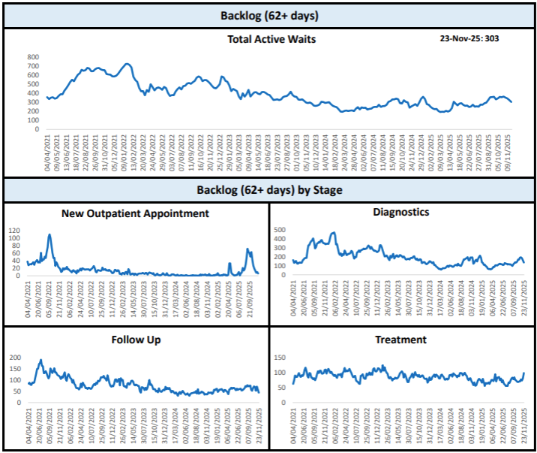
NHS P&I, Cancer Performance Briefing, SBUHB 23/11/2025

The above graphs show the backlog position for the HB by pathway stage. As shown, a significant spike in first OPA volumes over the summer period, which is primarily explained by the dermatology first appointment issue. Diagnostic volumes and treatment volumes have also been increasing.

The table below demonstrates the backlog position on 23rd November 2025 for the top 10 tumour sites. Lower GI has the largest volume of patients; most patients under Lower GI have presented via the Bowel Screening Wales pathway and are waiting screening colonoscopy.

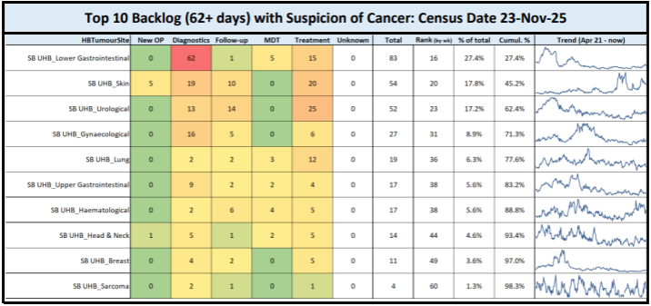
NHS P&I, Cancer Performance Briefing, SBUHB 23/11/2025

- GOVERNANCE AND RISK ISSUES

Concerns impacting performance
Patient unavailability
CWT (Cancer Waiting Times) performance is the waiting time from referral to start of first definitive treatment without any adjustments. As such, patient unavailability whether medical or social, and inability to contact patients can impact performance greatly. Cancer Trackers are asked to record periods of unavailability to help explain unavoidable delays.
The graph below demonstrates what our performance would look like considering patient unavailability, typically performance would improve between 2-5%

Taking a closer look at October 2025, the most recently reported position; 18% (41 individual cases) of newly diagnosed patients receiving FDT had periods of unavailability ranging from 3 to 56 days in total duration. In totality 794 days were lost on pathway as demonstrated in the table below by tumour site.
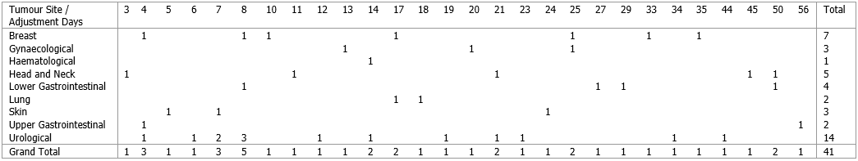
Urological cancers had the most documented adjustments, not necessarily unexpected as prostate patients take time to think, knowing the disease is usually slow growing, they are able to safely take the time to make a considered decision regarding treatment.
Similarly, backlog is also affected by unavailability as shown in the graph below, volumes would reduce by approx. 14%-16% week to week on an adjusted view.

Even when considering adjusted pathways, backlog volumes remain considerably higher than desired due to other impacting factors.
New Outpatient Stage
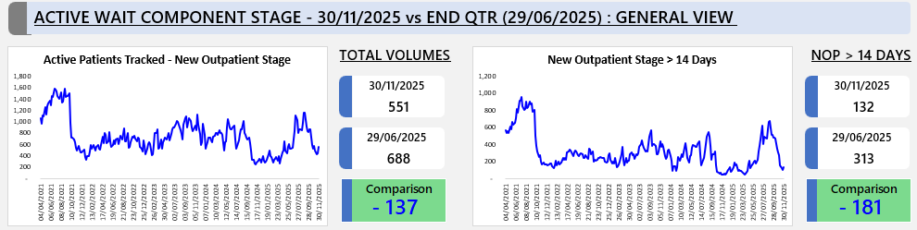
NHS P&I, SCP Component Wait Dashboard, SBUHB

First outpatient volumes are reducing once more, aided by increased tracking resource following recruitment. And the number of patients waiting over 14 days for their first appointment has reduced by 58% when compared with end of Q1 24/25. It is worth noting this number remains high however will include patient unavailability.
Diagnostic stage
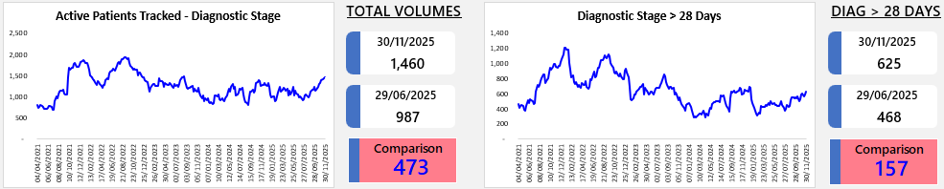
In contrast to reducing first appointment waits, diagnostic volumes are increasing and the number of pathways over 28 days in a diagnostic stage are also on the rise. There is some correlation between the reduction in stage 1 and the increase here, where skin pathways appointed to a ‘see and treat’ type clinic are updated to ‘diagnostic one stop’ for the purpose of tracking.
This administrative transaction is not the only reason for increasing volumes. Using our local information, we can demonstrate that volumes are increasing across all categories.

Pathology
In addition to patient care, pathology reporting turnaround times is a significant risk to our performance. Not only to decision making in relation to the patients active on pathway, but to the end of month confirmed cancer performance position.
To declare a closed ‘treated’ pathway for performance purposes, a new diagnosis of cancer must be confirmed. Each month we treat patients surgically without prior histological confirmation of malignancy, the volume of specimens at month close that are still awaiting reporting has been significant. Inevitably, there will also be unexpected ‘incidental findings’ of cancer on histology that we need to capture. We do have the ability at quarterly resubmission to reflect the change in position; however, it is noted the SBU uplift is higher than other HB’s.
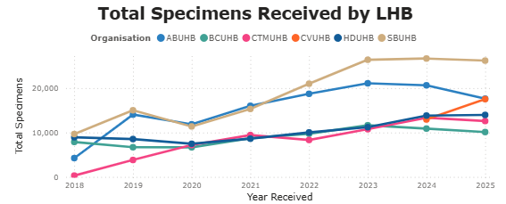
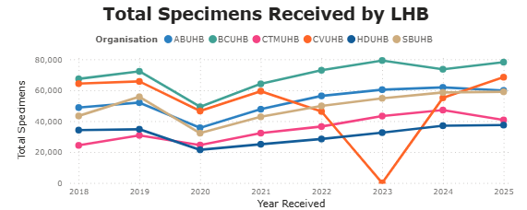
The graph on the left side below demonstrates USC demand on our pathology laboratory in comparison to the rest of Wales and total demand on the right side.
Since the pandemic, our USC demand is disproportionately higher than any other HB, indicating a possible misuse of the USC priority and the inability to ‘fast track’ reporting of the most appropriate specimens.
The graph below shows the turnaround times from receipt of specimen to first authorised date for USC samples, again demonstrating the HB to be an outlier in this area.
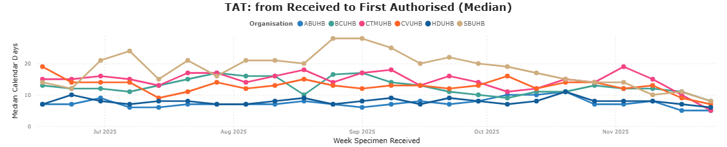
Increased outsourcing of reporting was agreed in the Autumn, and the chart above would suggest a recovering position, however caution should be taken as the chart below shows large volumes of unreported USC specimens (labelled undetermined) and still high volumes waiting 15 or more days for results.
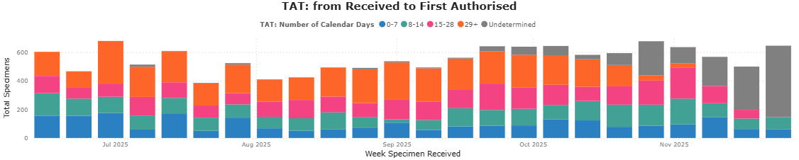
Endoscopy
Waiting times to USC endoscopy (Colonoscopy, Sigmoidoscopy and Gastroscopy) for SBU is shown below. Most patients are scoped within 2 weeks. Local scrutiny of waits indicates a median wait of approx. 12-14 days, where waiting times exceed two weeks, this has been associated with patient unavailability. Week to week we also note inability to contact patients affecting pathways.
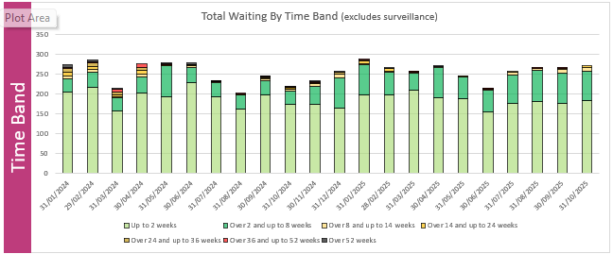
All HB’s are required to include Bowel Screening Wales (BSW) referrals for their resident population within SCP waiting times data. Our local information suggests approximately 7% of BSW referrals result in a malignant diagnosis. The pathway starts on confirmation of a positive FIT result, a letter is issued, telephone contact made, and an appointment arranged with one of the SSP’s. A referral for endoscopic assessment is added to WPAS and thereafter an appointment with endoscopy arranged.
The screening pathway and SCP are not aligned and the accreditation process to become a BSW endoscopist does not support simple waiting list management mitigation. Waits across Wales for index colonoscopy are long and increasing, as demonstrated in the chart below for waiting times since April 2025; SBUHB has some of the longest waiting times, beyond that of the whole SCP, explaining the increasing backlog volumes.
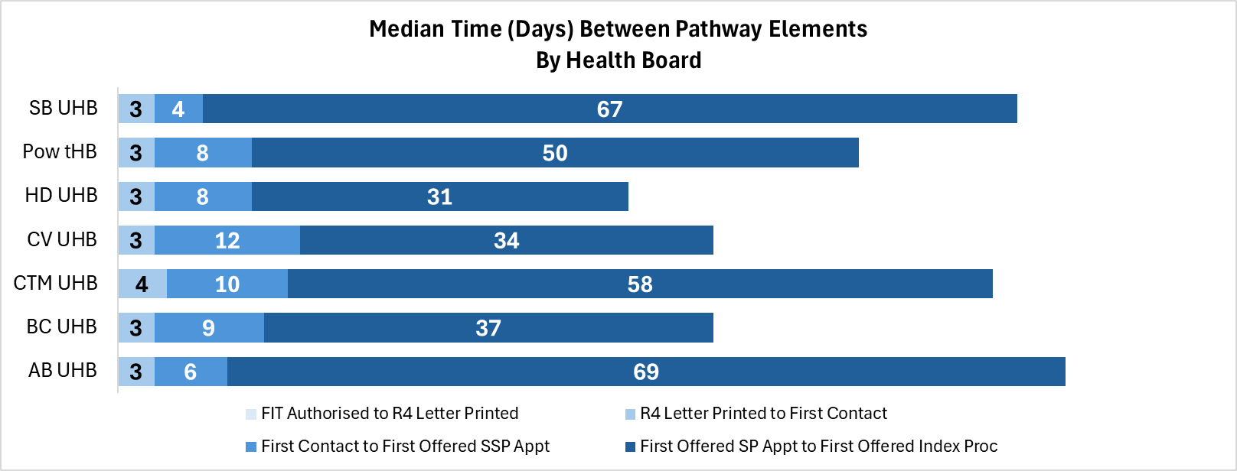
Radiology
USC waiting times from referral to authorised report are shown below. 59% of scans were performed within 7 days of referral; 41% percent of reports were authorised the same day or day after scan, meaning 34% of USC scans are performed and reported within 7 days and 78% up to 14 days. Where more than one scan is required for diagnostic and staging, this can easily amount to 28 days within radiology alone.
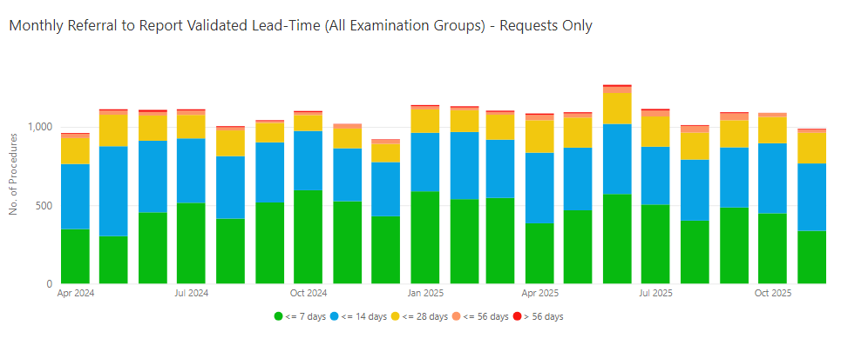
Further risk to the SCP is because of non-USC reporting waiting times. The SCP definition of the point of suspicion for diagnostic imaging which is suspicious of a diagnosis of cancer whereby the original referral or request was not suspicious of cancer (i.e. Incidental finding), is the date of scan. This is becoming more notably problematic over recent months on the Lung cancer pathway as an example, whereby nodules are kept under radiological surveillance by non-USC repeat CT, reporting times have been noted in the region of 6-8 weeks, if there is evidence of growth or other concerning features, the scan is the point of suspicion and pathway wait thereafter not recoverable.

USC radiology waiting times at Hywel Dda impact our own cancer waits, particularly for the H&N pathway for OMFS referrals who are directly referred to SBU by primary care but have their radiological diagnostic/staging scans performed locally. Waiting times for USC scans including CT, MRI and US Neck are in the region of 4 weeks currently despite escalation.
Urological Tumour Site
No HB is performing well in this tumour site across Wales, 41% of patients are treated within target at SBUHB over the past 12 months. Overall, the tumour site is made up of 5 tumour subsites with Prostate and Bladder the most common cancers, and Prostate and Renal the poorest performing. As a high volume, poor performing subsite, the prostate pathway is a key focus area.
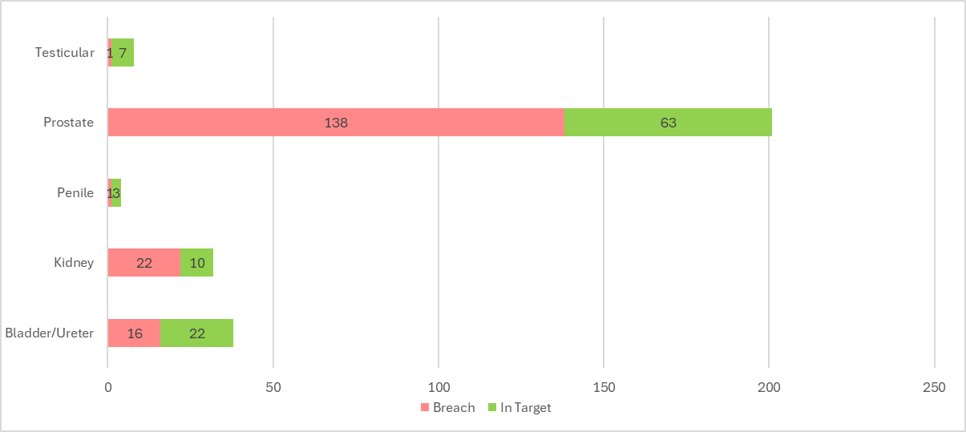
The chart below shows a breakdown of 10 prostate breaches as an example of waiting time at each stage against the National Optimal Pathway (NOP) for reference. Typically, the wait up to and including histology result is more than the NOP timeframe of concluding diagnostics by day 28 or the HB standard to reach decision to treat by day 31; often decision to treat is not reached until near to, or after day 62.
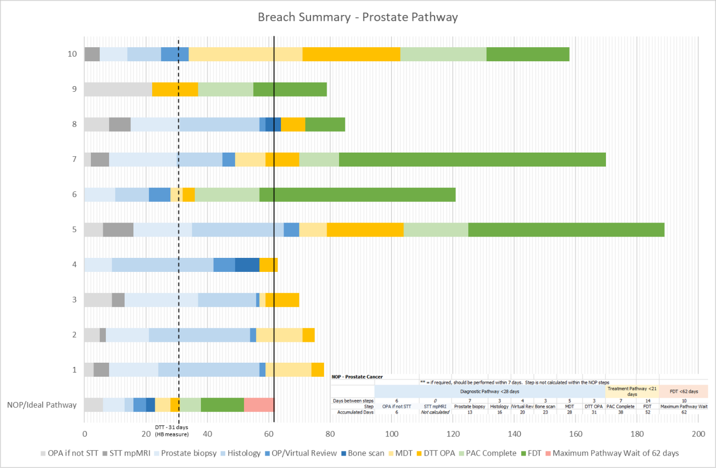
Where waits to MDT appear longer than desired, this can be associated with additional investigations such as PET, that is not routinely included as an investigation in all, or even the majority, of cases. Where there are no green bars in the above chart, treatment was commenced the same day as the decision to treat was made, i.e. Active Monitoring or Hormone Therapy.
For treated pathways between April 2025 and October 2025, the majority received hormone therapy or active monitoring, meaning ‘treatment waits’ of decision to treat to treatment are not a significant factor in our pathways, however, where surgery or radiotherapy is the FDT of choice, overall pathway waiting times are exceptionally long.
Treatment | Breach | In Target | Grand Total
Hormone Therapy | 75 | 40 | 115
Active Monitoring | 35 | 13 | 48
Surgery | 19 | 8 | 27
Radiotherapy | 8 | 2 | 10
Brachytherapy | 1 |  | 1
Grand Total | 138 | 63 | 201

All prostatic cancer surgery is undertaken robotically, with SBUHB providing treatment for Hywel Dda and Princess of Wales Hospital also. Whilst the information below indicates median waits are reducing, we have treated fewer patients in the same period, albeit robotic surgery was introduced in house in during May 2024 and there was a short period of time between ceasing operating at UHW and commencement of services at Morriston. Surgical waits remain far beyond the 21-day NOP recommended maximum wait.
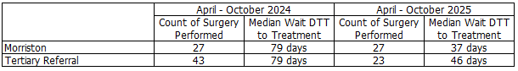
The HB welcomed colleagues from NHS PI to the HB during October 2025 to undertake a review of the prostate pathway. Key findings include:

- Service Fragility & Workforce Risks
- The prostate cancer service is highly fragile, with several critical functions reliant on single individuals (CNS triage, booking, tracking, PET scanning/reporting, surgical assistant for robotic surgery).
- Multiple single points of failure create operational and clinical risks.
- Workforce shortages across Urology and Pathology remain significant constraints.
- Capacity & Infrastructure
- Capacity is closely tied to capital assets (e.g. surgical robot), with financial pressures compounding these issues.
- Governance & Data
- The tracking role is poorly defined, leading to inefficiencies in communication and data management. This is not unique to SBUHB, and recognition that supporting roles such as cancer tracking and MDT coordination is lacking clear definition nationally as well as lacking support and training to develop skills in this role. As such NHS P&I will be taking an action on this.

The group felt there were improvement opportunities for the HB to progress, including:
- Map staff capacity to NOPs to identify workforce and capital gaps
- Prioritise workforce planning, service assurance, and capital investment through Health Board/IMTP processes.

Our immediate priorities should focus on:
- Strengthening workforce sustainability and service resilience.
- Providing assurance for the new triage model.
- Addressing capital and infrastructure constraints

Improvement action plans

Urology actions in progress include
- Implementing a telephone triage for new referrals to ensure prompt referral within 5 days for MpMRI.
The prostate NOP recommends a STT MRI pathway to facilitate this, a short triage call is being trialled to ensure appropriate access to MpMRI and reduce risk of a false positive result leading to further unnecessary or ill-timed investigation. To further support this model, we will be trialling a text messaging service from January 2026, notifying patients to expect a call from the CNS regarding their referral.
- Protecting CNS USC capacity by ensuring non-USC conditions such as LUTS, ED and chronic pain are redirected to alternative pathways
- Protected MpMRI slots are allocated on a weekly basis with the aim to ensure a 7-day turnaround to reported scan. This will be monitored over the next 6 weeks to evaluate their impact on overall lead-times.
- Consideration to train a Band 7 CNS in LATP biopsy, however, backfill for training and re-banding once qualified are matters that need to be worked through.
- The diagnostic phase of pathway is heavily reliant on a single individual (8a CNS). The surgical phase of pathway is heavily dependent on a single Surgical Care Practitioner whose role has been externally funded for 2 years, ending this financial year. In the current financial climate, urgent decisions are required to support sustainable service provision.

Lower GI actions in progress include
- We currently have 3 employed accredited BSW endoscopists, but due to LTS only have 2 consultants carrying out weekly lists. Another clinician is currently participating in the accreditation process and due to be re-assessment in February 2026. There is a need to increase BSW sessions and a requirement for insourcing due to the increased demand and growing waiting lists.
- MDM efficiencies are required to support timelier MDT discussions with diagnostic reports being available and maximise effective use of MDT resources. There is wider MDT engagement to refine how patients are listed and early identification of unreported investigations that are being trialled from 11th December 2025.
- Early identification of patients to PAC for earlier assessment on suitability for treatment was adopted in September 2025. Discussions on robust methods to cast a wider net for early identification of prehabilitation opportunities are underway, mitigating lost days later in the pathway at the treatment stage where patients are identified to need intervention.
- TSG to ratify short notice changes SOP for theatres listing. Due to pre-assessment waits cancer lists are not being fully utilised for cancer patients and with 6-4-2 processes, this is having a knock-on effect and extending waiting times further.

Gynaecological actions in progress include
- Discussions initiated for disaggregation of PMB services with CTMUB. Work is ongoing on service demand and capacity modelling with a meeting planned for January 2026 to finalise an impact assessment.
- HSBUK to continue to provide PMB capacity through to March 2025 with a view to be included in plans for 25/26 financial year.
- Establish opportunities on Ward 16 for additional Outpatient Clinics/Hysteroscopy/Minor Op clinics to take place. Included within Theatre Business case with Welsh Government. No formal response received.
- The service has appointed a Cancer Unit Lead who has commenced in post in November 2025.
- A locum gynae-oncology surgeon has been working with the gynae-oncology team, this is to remain in place through to end of financial year, expecting long term provision of complex gynaecological cancer services to continue to progress through to implementation from April 2026.
  - Phase 1 – Preparation & Communication (August 2025 – October 2025)
Data gathering, engagement strategies
  - Phase 2 – Business Case Development (October 2025 – January 2026)
Model development with stakeholders including 6-week public engagement
  - Phase 3 – Launch Plan (January 2026 – March 2026)
Operationalise planning

Skin actions in progress include
- Several Dermatology WLI’s have been held over recent months to mitigate capacity shortfall. Most recently a clinic was held on the 3rd December 2025 (30 patients) and a further larger clinic is scheduled for the 10th January 2026 (80 patients).
- Improved position for Plastic Surgery, with process in place for weekly meetings with booking team and service manager, as well as robust escalation process for capacity shortfalls.
- Skin was a targeted area for outsourcing of pathology reporting due to backlogs. The impact of this work to our skin pathways is to be confirmed.
- X2 Locum Plastic Surgeons appointed to support RTT delivery at stage 1 and delivery of SCP including running PSTC lists to maximise throughput, one in post in November 2025, the other due to commence Feb 2026.
- Seeking agreement from Theatre Board for additional 2x weekly Morriston lists (originally requested March 2024)
- HCSE team currently undertaking demand & capacity gap analysis, findings due by the end of this month.
- SCF replacement of vacant post is being shortlisted currently, interviews to be scheduled in December.

Breast actions in progress include
- Radiology to progress appointment of a substantive full-time radiologist to be advertised by radiology or consideration of appointing an NHS locum to fill this post. Is currently filled by high-cost agency locum.
- A meeting with Breast Test Wales scheduled for 11th December 2025 will be rescheduled. The HB made this request to explore delays in referral and inconsistencies.
- Streamline pathways between breast services, BTW and plastic surgery for patients requiring immediate reconstruction, reducing delays to surgery.

Progress against MAG recommendations

 | Comment | RAG
Capsule sponge  (minimum of 25 pr HB) | X2 ANP’s underwent training 8th October supported by Dr Haboubi and now qualified.  16 pts underwent procedure 8th October (2 session list)  8 pts planned for 19th November (1 session list) | Plans through to end of March 26 and from March 2026 are being developed.
Symptomatic Fit  (80% of suspected LGI cancer referrals are accompanied by a FIT test) | From symptomatic FIT dashboard – SBU. 80.6% | Complete
UBHRT/PMB  (HB undertakes a quarterly audit of the pathway) | Plans & SOP drawn up in conjunction with primary care, radiology and gynaecology services. Approval process November 2025. For dissemination December 2025.  Impact on sonographer workforce mitigated by utilising current capacity in a different way. | Go live planned Jan 2026
BPOP  (HB undertakes a quarterly audit of the pathway) | Plan developed and submitted buy COO November 2025 | Awaiting feedback from NHS P&I
Teledermatololgy  (95% of suspected skin cancer referrals are accompanied by a good quality image) | Unable to monitor use of Teledermatololgy. Assurance of MAG recommendation can only be achieved by audit and survey of HB’s at present tie.  Nationally, development of a National Telederm Dashboard is under consideration. | Complete. All referrals are accompanied by an image.

- FINANCIAL IMPLICATIONS
There are no direct financial implications associated with this paper. The outputs from the modelling work or service initiatives and improvements will inform the development of the Health Board’s IMTP and financial plans for sustainable services.

- RECOMMENDATION

The Committee is asked to:

- NOTE the performance and backlog volumes in the main tumour sites.
- NOTE the additional work required to improve both performance and backlog

Governance and Assurance

Link to Enabling Objectives  (please choose) | Supporting better health and wellbeing by actively promoting and empowering people to live well in resilient communities
Link to Enabling Objectives  (please choose) | Partnerships for Improving Health and Wellbeing |  | ☒
Link to Enabling Objectives  (please choose) | Co-Production and Health Literacy |  | ☐
Link to Enabling Objectives  (please choose) | Digitally Enabled Health and Wellbeing |  | ☒
Link to Enabling Objectives  (please choose) | Deliver better care through excellent health and care services achieving the outcomes that matter most to people
Link to Enabling Objectives  (please choose) | Best Value Outcomes and High Quality Care |  | ☒
Link to Enabling Objectives  (please choose) | Partnerships for Care |  | ☒
Link to Enabling Objectives  (please choose) | Excellent Staff |  | ☒
Link to Enabling Objectives  (please choose) | Digitally Enabled Care |  | ☒
Link to Enabling Objectives  (please choose) | Outstanding Research, Innovation, Education and Learning |  | ☐
Health and Care Standards
(please choose) | Staying Healthy |  | ☐
(please choose) | Safe Care |  | ☒
(please choose) | Effective Care |  | ☒
(please choose) | Dignified Care |  | ☐
(please choose) | Timely Care |  | ☒
(please choose) | Individual Care |  | ☐
(please choose) | Staff and Resources |  | ☒
Quality, Safety and Patient Experience
Accurate, comprehensive demand and capacity plans can increase safety and quality whilst reducing risk and can lead to efficiency gains within clinical services. They will also facilitate more timely treatment of patients and enhance patient experience.

Financial Implications
There are no direct financial implications associated with this paper. Inputs (additional activity) into the demand and capacity models are funded via Recovery Money. However, the outputs from the modelling will inform the development of the Health Board’s IMTP and financial plans for sustainable services.

Legal Implications (including equality and diversity assessment)
There are no legal implications to consider.

Staffing Implications
There are no immediate staffing implications as a result of this paper but there is a need to be mindful that this is a very specialist area and we need to build robust and sustainable capacity in this area.

Long Term Implications (including the impact of the Well-being of Future Generations (Wales) Act 2015)
Report History |  | Previous reports have been presented to Management Board in November 2021 and February / August 2022 / October 2023 / February 2024
Appendices |  | No Appendices

